Promoting Physical Activity in Skoolzout Centres
Survey for Parents

Dear parent, Thank you for participating in this study. Please answer the following questions.

- Your child’s unique ID number. If you have more than one child participating in this study, please fill in one survey for each child.

___________________________________________________________
- Childs date of birth (DD/MM/YYYY): ___-___-___

- Your date of birth (DD/MM/YYYY): ___-____-___

- What is your sex? (please tick one) ₁ Male ₂ Female

- Postcode of residence:__________

- What is the main language you speak at home? (please tick one)
₁ English
₂ Other (please specify) _______________________

- What is your highest level of schooling? (please tick one only)
₁ No formal qualifications
₂ Year 10 or equivalent (e.g. School Certificate)
₃ Year 12 or equivalent (e.g. Higher School Certificate)
₄ Trade/apprenticeship/certificate (e.g. hairdresser, chef, plumber)
₅ Diploma (e.g. Business/Accounting)
₆ University degree
₇ Post-graduate qualification (e.g. Graduate Diploma, Masters, PhD)

- Are you currently: (Please tick one)
₁ Employed full time
₂ Employed part time
₃ Home-duties full time
₄ A student
₅ Unemployed
₆ Other (please specify) _______________________

- What is your current marital status?
₁ Single ₂ Married ₃ Divorced
₄ Separated ₅ Widowed

- Do you or your partner have a Health Care Card or Pension Card (from Centrelink)? (Please tick one)
₁ Yes ₂ No

- How many week days does your child attend after-school care?
₁ 1 ₂ 2 ₃ 3 ₄ 4 ₅ 5

- How many hours per night does your school age child usually sleep at the moment? (Please write the number)
_____________________hours
Thinking about the last month, which of the following indoor LEISURE activities does your child USUALLY do during a typical WEEK? For this question, please think about the time your child is not at school.
Please circle either ‘Yes’ or ‘No’ for each item.
For items you have circled ‘Yes’, please write the TOTAL time your child participates in the activity for the WHOLE working/school week (that is, Monday + Tuesday + Wednesday + Thursday + Friday). Please also write the TOTAL time your child participates in the activity for the WHOLE weekend (that is, Saturday + Sunday). If you circle ‘Yes’ for an activity and your child only participates in that activity during either the working/ school week or the weekend, please write ‘0’ in the TOTAL hours column for the period they do not do that activity.
Here is an example
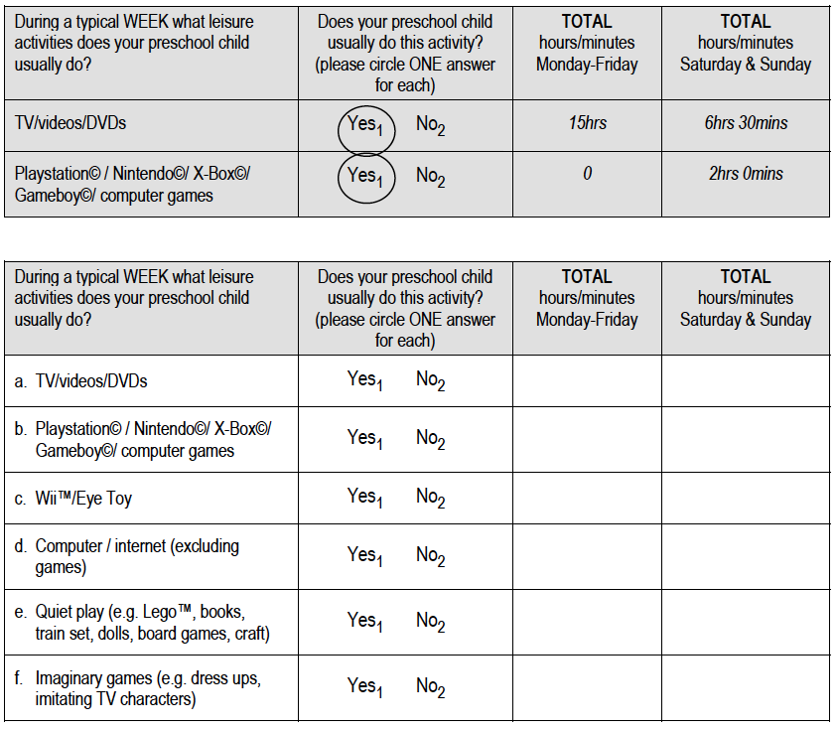
- IPad, Tablet/ Ipod.Reading, looking at books or being read to | Yes₁ No₀
Thank you very much for taking the time to complete this survey – Please return when your child next attends childcare.

