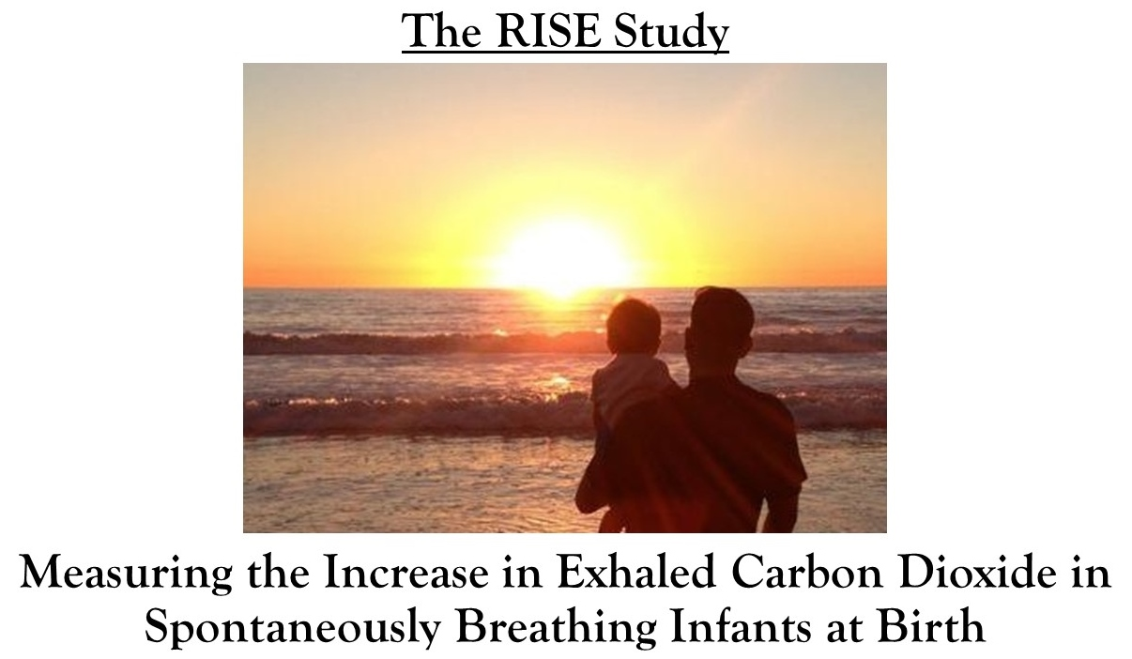

PRINCIPLE INVESTIGATORS

Dr Douglas BLANK
Dr Omar KAMLIN
Mr Kevyn NYLAND
Dr Jennifer DAWSON
Dr Stefan KANE
Dr Graeme POLGLASE
Prof Stuart HOOPER
Professor Peter DAVIS

TRIAL CO-ORDINATOR

Dr Douglas BLANK

The Division of Newborn Services, Royal Women’s Hospital,

Telephone: (03) 8345 3776 Fax: (03) 8345 3789

Email

douglas.blank@thewomens.org.au
omar.kamlin@thewomens.org.au
kevyn.nyland@thewomens.org.au
jennifer.dawson@thewomens.org.au
Stefan.Kane@thewomens.org.au
graeme.polglase@monash.edu
stuart.hooper@monash.edu
pgd@unimelb.edu.au

HYPOTHESIS

Exhaled carbon dioxide (ECO₂) in spontaneous breathing infants at birth increases from 0 mmHg to a stable level over the first ten minutes of life.

AIM

To measure and characterize exhaled carbon dioxide in spontaneously breathing term and late preterm infants who transition without needing resuscitation.

RESEARCH PLAN

We plan to obtain serial exhaled carbon dioxide measurements in infants at low risk for needing resuscitation during the first 10 minutes of life, at 1-2 hours of life and at 12-72 hours of life when transition would be consider to be completed. This will be a single centre observational study at the Royal Women’s Hospital.

PRIMARY OBJECTIVE

To determine if exhaled carbon dioxide has a predictable increase during the first ten minutes of life in term and late preterm babies who transition from the womb without needing resuscitation.

SECONDARY OBJECTIVES

1) To compare the change in ECO₂ from birth to the change in exhaled tidal volume (TV) from birth.

2) To compare the change in ECO₂ from birth to the change in heart rate (HR) from birth.

3) To compare the change in ECO₂ from birth to the change in saturation of peripheral oxygenation (SpO₂) from birth.

4) Investigate if the change in ECO₂ in the first minutes of life is affected by the timing of umbilical cord clamping.

5) Investigate if the change in ECO₂ in the first minutes of life is affected by the timing of the baby’s first cry.

5) To compare the ECO₂ during first 10 minutes of life to the ECO₂ levels at 1-2 hours and again at 12-72 hours when babies without respiratory distress would be expected to have completed cardiopulmonary transition.

RATIONALE

During birth, the infant must transition from a fluid filled lung that depends on the placenta for oxygenation and the elimination of carbon dioxide to an aerated lung that successfully exchanges oxygen and carbon dioxide.¹²

Carbon dioxide (CO₂) is produced in the tissue, transported in blood to the lung and eliminated from the lung during exhalation. Therefore, CO₂ can only be detected in expired gas if effective gas exchange has occurred. Presence of ECO₂ is dependent on airway patency, adequate pulmonary blood flow and gas exchange.

To date no study has attempted to characterize the changes in exhaled CO₂ at birth in spontaneously breathing infants from the infant’s first breath until transition has been completed. Describing the typical range of ECO₂ in healthy infants at birth is the first step in a process to investigate the clinical utility of ECO₂ in the delivery room.

BACKGROUND

Non-invasion exhaled carbon dioxide (ECO₂) can be measured in the delivery room during neonatal resuscitation and both quantitative and colorimetric ECO₂ have been used to indicate endotracheal tube placement, airway obstruction, mask leak, and lung aeration.¹⁻⁸

An increase in heart rate is the most important indicator of improvement during neonatal resuscitation.¹⁷⁻²¹ Two studies have demonstrated that ECO₂ is undetectable at birth and rises as ventilation is established and gas exchange in the lung begins. In both studies, the investigators monitored ECO₂ in newborns from birth with bradycardia using either a quantitative or colorimetric ECO₂. ECO₂ increased prior to a rise in heart rate (Figure 1), therefore, an increase in ECO₂ may be the earliest marker of infant well-being at birth.^{8,9} In addition, in clinical practice, ECO₂ may be easier to recognize than an increase in heart rate because ECO₂ is zero during the first few breaths prior to clearing the fluid from the neonatal lung.

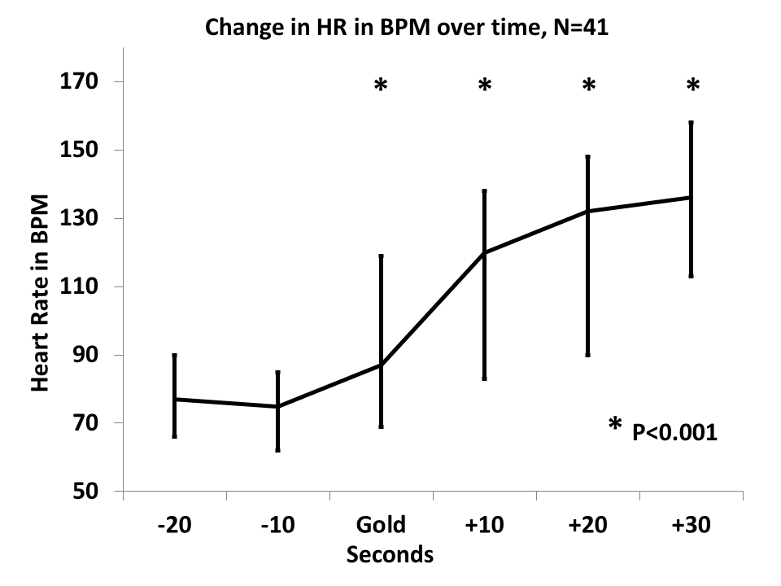
Figure 1: Median HR for 41 babies at birth receiving mask ventilation with a colorimetric ECO₂ detector in line with the breathing circuit. Ten seconds prior to initial ECO₂ detection (Gold) the HR was 75 BPM (62-85) and increased to 87 BPM (69-119), 120 BPM (83-138), 132 BPM (90-148) and 136 BPM (113-158), at PGC and at 10, 20 and 30 seconds after initial ECO₂ detection (Gold) respectively (p<0.001 for all comparisons).

Effective ventilation is the most effective maneuver during neonatal resuscitation to stimulate breathing, improve heart rate, and increase saturation of peripheral oxygenation.¹⁷⁻²⁰ Non-invasive monitoring of ECO₂ has been shown to be a direct measure of lung inflation and therefore can guide ventilation (Figure 2 and 3).⁸ It is possible that measuring ECO₂ levels may provide an important indicator of how well the distal gas exchange units are being ventilated. We hypothesize that monitoring carbon dioxide continuously may help to improve ventilation in the delivery room.

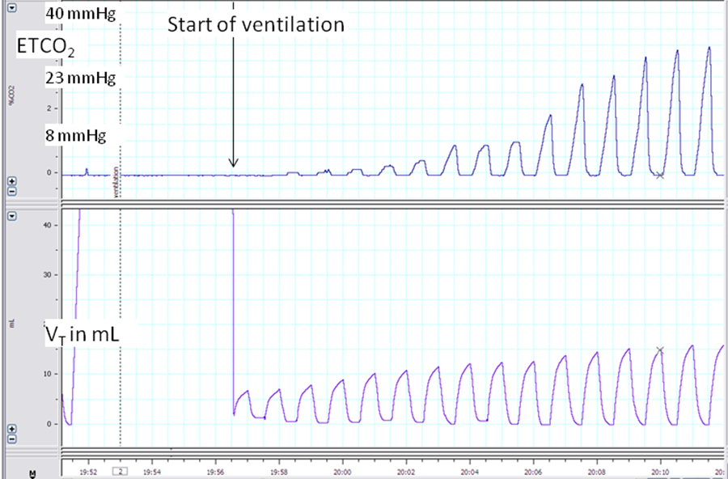
Figure 2: Positive pressure ventilation of a near term lamb. The initially delivered inflations with a positive inflating pressure of 35 cm H2O only result in marginal ETCO2 (end tidal carbon dioxide) levels. With continuing ventilation CO2 is detected.

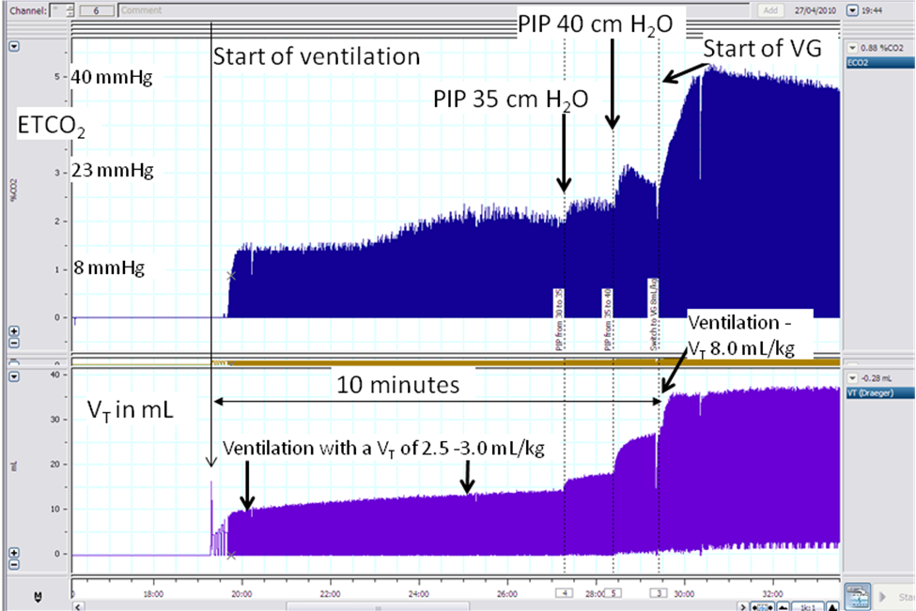
Figure 3: Positive pressure ventilation of a near term lamb. Initially five sustained inflations of each 3 seconds are applied. However, the ETCO₂ (end tidal carbon dioxide) shows no exhaled CO₂. With continuing ventilation CO₂ is measured. The initial exhaled CO₂ levels are low and only increase once the inflating pressure is increased. The initial delivered tidal volume (V_{T}) is very low, around 2.5 - 3.0 mL/kg which mainly reflects dead space ventilation. At 10 minutes of age, the ventilation mode is changed to deliver a tidal volume of 8 mL/kg. This results in a rapid increase in exhaled CO₂.

Studies sampling umbilical cord blood gases of infants at birth have reported a carbon dioxide range of 50-56 mmHg in the umbilical artery.¹²⁻¹³ Successful inflation of the neonatal lung must occur for ECO₂ to approximate blood values of CO₂. An ECO₂ that is much lower than expected may indicate an under aerated lung and prompt clinicians to perform recruiting maneuvers.

ECO₂ monitoring by capnography is a continuous and non-invasive measurement to monitor exhaled CO₂ tension. Capnography is done by either sidestream or mainstream gas sampling. A sidestream capnometer uses a sampling line that attaches to an adapter at the airway opening, through which the instrument continually aspirates tidal airway gas for analysis of CO₂. The disadvantages of the sidestream method are delay between sampling and measurement of ETCO₂, falsely low ETCO₂ if high aspirating flow rates are used, and possible contamination of the analyser with mucus or water.²⁵⁻²⁸ In comparison a mainstream capnometer has an airway adaptor attached in-line, which is close to the patient’s airway (Figure 4). The adapter consists of an infrared light source and sensor that senses carbon dioxide absorption to measure CO₂. As a result, the estimation of PaCO₂ is relatively poor when a sidestream monitor is used, but good with mainstream capnography.^{25,28-30}

Continuous non-invasive CO₂ monitoring has become an important bedside tool in adult and pediatric intensive care units to guide management of ventilated patients,^{31,32} intubation,³²⁻³⁷ cardiopulmonary resuscitation,³⁸⁻⁴⁰ and transport of critical ill patients.^{32,41-44} However, studies in newborn infants have had conflicting results, primarily because of effects of ventilation perfusion mismatching and technical limitations of the devices used to measure CO₂ in infants who generate small tidal volumes.^{25,29,45-46} In two studies, one of infants at two weeks of age and another of infants without lung disease that were mechanically ventilated for surgery, investigators demonstrated that ECO₂ underestimated PaCO₂ by less than 10% and ECO₂ correlated well with arterial blood gas values.^{16,33}

In a randomized study investigating ECO₂ monitoring of preterm infants to guide mask ventilation in the delivery room, the authors reported that the ECO₂ level prior to leaving the delivery room was more than 20% lower than the first PaCO₂ value obtained.¹⁵ This discrepancy indicates that even by the time a baby is stable after resuscitation, transition has not been completed and the ECO₂ has not reached a steady state.

To date no study has attempted to characterize the changes in exhaled CO₂ at birth in spontaneously breathing infants from the infant’s first breath until transition has been completed. Defining typical range of ECO₂ in healthy infants at birth is the first step in a process to investigate the clinical utility of ECO₂ in the delivery room.

STUDY POPULATION:

All inborn infants, term and preterm >34^{6/7}/40 weeks gestation, who are not expected to require respiratory support at birth, are eligible for this study.

EXCLUSION CRITERIA:

Infants will be excluded from analysis if they have a congenital abnormality or condition that might have an adverse effect on breathing or respiratory drive including: infants born to mothers receiving general anesthesia and congenital diaphragmatic hernia. Infants will also be excluded if their parents refuse to give consent to this study. During the study, if there are any signs of respiratory compromise, the study will be abandoned and ventilatory support given according to the Australian Neonatal Resuscitation guidelines⁴⁴.

RESEARCH PROTOCOL

This is a prospective, observational study of spontaneously breathing term and late preterm infants in the delivery room. The primary outcome will be the measured exhaled carbon dioxide levels in the first ten minutes of life.

A combined neonatal CO₂/Flow sensor (Neonatal CO2 Flow Sensor, Phillips Healthcare, Massachusetts, USA) will be attached to a face mask (Laerdal round mask, Laerdal, Stavanger, Norway or Neonatal Resuscitation Masks, Fisher&Paykel, Auckland, New Zealand). Immediately after birth, a face mask will be placed over the mouth and the nose (Figure 4). Infants will breathe through the mask.

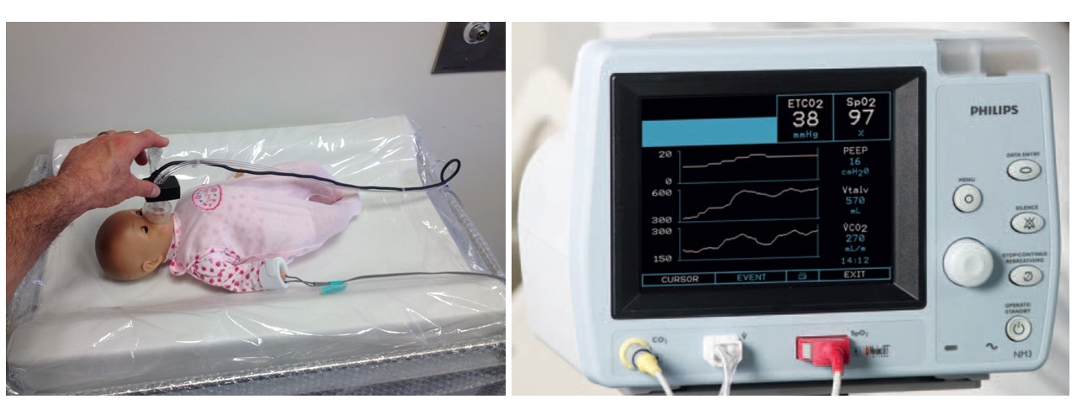
Figure 4: Mannequin with the facemask applied on a resuscitation trolley with a warming mattress and display of the NM3 Respiratory Profile Monitor. Analog data will converted to digital using a custom software program (created specifically for this project by co-investigator Mr. Kevyn Nyland) and analyzed using Stata software.

The NM3 Respiratory Profile Monitor (Phillips Healthcare, Massachusetts, USA). consists of a combined CO₂/Flow sensor which measures exhaled carbon dioxide with an infrared light beam at different wavelengths in order to precisely determine gas concentrations in the expired breaths. In addition, the monitor can record pulse and SpO₂ via pulse oximetry, with a 2 second averaging time. The respiratory gas measurements are obtained by continuously measuring the infrared light absorption in gas flow through an adapter in the breathing circuit. Gas flow, tidal volume, respiratory rate and airway pressures are measured with a flow sensor. The dead space of the CO₂/Flow neonatal sensor is less than 1 mL according to the manufacturer and unlikely to interfere with breathing.

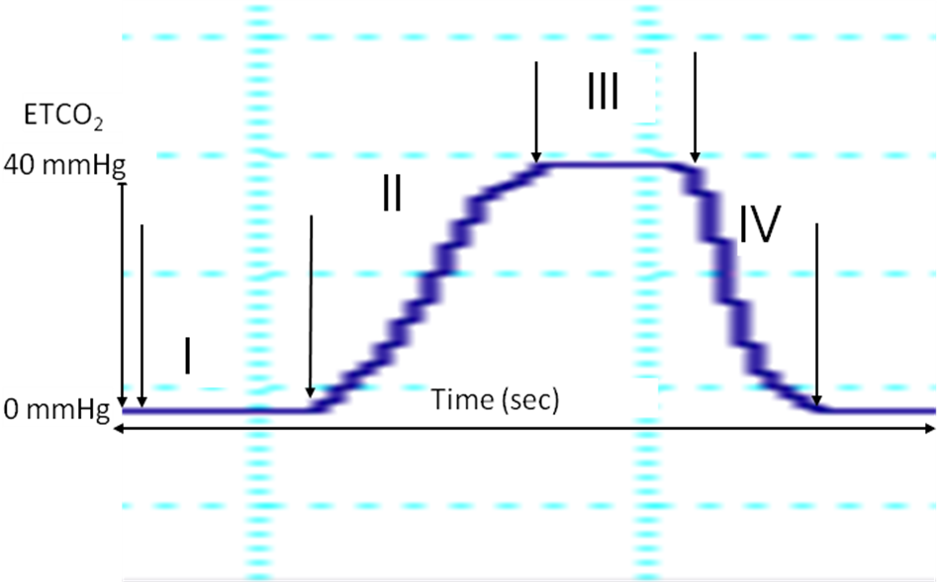
Figure 5: The normal capnogram is the measurement of CO₂ at the airway opening during a breathing cycle. Phase I (Inspiratory baseline) reflects inspired gas, which is normally devoid of carbon dioxide. Phase II (expiratory upstroke) is the transition between gas in the dead space, which does not participate in gas exchange and alveolar gas from the respiratory bronchioles and alveoli. Phase III is the alveolar plateau. Finally, Phase IV is the inspiratory down stroke, the beginning of the next inspiration.

We plan to obtain the measurements immediately after the baby is delivered and continue whilst the baby is lying on the mother’s chest. The purpose of the study is to measure exhaled carbon dioxide during the transition of a healthy newborn, starting with the baby’s first breath. The natural transition of the healthy newborn includes bonding with the mother after birth. To minimize interference with the normal monitoring and stabilization of preterm and term infants after birth, we will record respiratory measurements for the first 60 seconds of life, then record 10-20 breaths every 1 minute for the first ten minutes of life, at 1-2 hours of life, and at 12-72 hours of life.

The intermittent application of the facemask during the first 10 minutes of life will reduce the small risk of rebreathing carbon dioxide in the circuit’s dead space and will allow for a more natural neonatal transition. During data collection, breaths will be counted if the investigator feels that there is a proper mask seal and leak is minimal. During the study, if there are any signs of respiratory compromise, the study will be abandoned and ventilatory support given according to the Australian Neonatal Resuscitation guidelines⁴⁴.

After a vaginal delivery, data will be collected whilst the baby is on the mother’s chest. If the baby cannot be held by the mother (or other family member), the baby can be positioned close to the mother and placed on a dedicated research trolley with a warming mattress during data collection.

In the event of a caesarian section delivery, we will also collect data immediately after delivery. One of the researchers will scrub and don sterile gown and gloves and stand next to the delivering consultant. A dedicated research trolley with a warming mattress and sterile drapes will be placed close to the surgical field. A plastic sterile sheathing will be placed over the flow sensor tubes and wires. Two holes will be cut into the sheath and secured with sterile ties, one for a sterile mask to connect to the flow sensor and one for the distal end of the flow sensor. If the obstetric team feels that we are interfering with patient care, the study will be abandoned.

After the baby is placed onto the research trolley with a warming mattress and moved out of the sterile field, a pulse oximetry sensor will be placed on the infant’s right hand or wrist. Once the baby is out of the sterile field, the process of data collection after a caesarean delivery will be the same as for a vaginal delivery. The study should not preclude skin to skin contact of babies with their mothers after a caesarean delivery in the first ten minutes of life. The data acquisition system that will be used for this study is portable and will be housed on a research trolley with a warming mattress that can move with the baby from the sterile field to the resuscitation bed for evaluation and then to the head of the bed so that the baby can bond with the mother. The natural transition of the healthy newborn includes bonding with the mother after birth. Our goal is to minimize interference with this process.

The pulse oximeter will record continuously for the first 10 minutes of life, then the sensor will be removed. We will record the baby’s temperature at 10-12 minutes of life. The pulse oximeter will be reapplied at the 1-2 hour and 12-72 hour recordings.

We aim to record the exact timing of several events that occur in the first 2 minutes after the birth of the neonate, including the time the facemask is applied, the time the cord is clamped, the time the baby first breaths/cries, and the time that the pulse oximetry sensor is placed on the baby’s write. After some trial and error recording events during routine deliveries, we feel that we will achieve a high fidelity accounting of these events after birth by making a de-identified audio recording of the investigator dictating the sequence of events into an audio recorder (an iphone placed in the investigators chest pocket). Immediately after the delivery, we will record the timing of events onto a patient data form and erase the audio recording. If available, we will also record the umbilical arterial cord blood gas for analysis.

The signals of airway flow, tidal volumes, airway pressure, breathing pattern, exhaled carbon dioxide, heart rate, and SpO₂ will be converted from analog to digital signal and recorded at 100Hz using a custom built software program by Mr. Nyland which presents the data in graphical and table form. Measurements recorded will be analyzed using Stata Software (StataCorp, College Station, Texas, USA) for statistical analysis.

We plan to review the data collected after enrolling 10, 20, and 50 babies. The purpose will be to review patient safety and efficacy of data collection. Specifically, we will monitor the baby’s temperature at 10-12 minutes, the risk of breaking the sterile field in caesarian sections, the potential of interfering with patient care, and need for resuscitation (apart from routine drying and stimulation).

The research team has over 10 years of experience studying neonatal transition in the delivery room, including 2 studies approved by the RWH Human Ethics Committee in which a facemask was used to measure to measure respiratory parameters in spontaneously breathing infants immediately after birth.^{46, 47} No adverse outcomes, including the need to provide resuscitation measures, was reported.

The measurements obtained from this cohort of babies constitutes an observational study. This data will provide valuable information on exhaled carbon dioxide in the first minutes after birth.

STUDY PERIOD AND DATA ANALYSIS:

Infants will be recruited over a period of 12 months. Approximately another month will be required to collect hospital data on all infants enrolled. Medical data on each infant will be collected on Case Report Forms (Patient Data Form, RISE Study, included). De-identified information will be collected via the NM3 Respiratory Profile Monitor (Phillips Healthcare, Massachusetts, USA).

We aim to record the exact timing of several events that occur in the first minutes after the birth of the neonate, including the time the facemask is applied, the time the cord is clamped, the time the baby first breaths/cries, and the time that the pulse oximetry sensor is placed on the baby’s right wrist. We will account for these events by making a de-identified audio recording of the investigator dictating the sequence of events into an audio recorder (an iPhone placed in the investigator’s shirt pocket). Immediately after the delivery, we will record the timing of events onto a patient data form and erase the audio recording. All this information will then be entered into Stata database for analysis.

The primary outcome for this study will be the average ECO₂ levels obtained every minute for the first ten minutes of life, than once at 1-2 hours of life and at 12-72 hours of life. ECO₂ will be averaged over 10 breaths that correspond closest to each time point. Only values obtained with minimal facemask leak (less than 20% determined by analysis of inspiratory versus expiratory tidal volume) will be eligible for analysis. We will use a mean (SD) for continuous variables (birth weight, gestational age) and post hoc analysis of waveforms data to describe changes of expired CO₂ after birth.

RECRUITMENT

The co-investigators will all be involved in recruitment. Consent will be sought after admission to birth suites and initial assessment of the obstetric team or during the final prenatal visit in the case of routine caesarian sections. Consent will only obtained if not in established labour.

To alleviate the risk of the parents finding the data collection confronting, we will have a manikin and study materials available to help explain the study to the parents when they are approached for antenatal consent. This creates the potential opportunity to practice the act of placing the mask on the baby’s face while the baby is being placed on the mother’s chest if the parents desire. There is also a figure to demonstrate the process of data collection in the consent form.

The Human Research and Ethics Committees of The Royal Women’s Hospital have previously granted permission to pursue respiratory function monitoring and ECO₂ monitoring at birth in spontaneously breathing infants using a facemask. te Pas et al. recruited 41 infants to describe different patterns of breathing at birth⁴⁶ (RWH Research & Ethics application number 7/23) and Schmölzer et al. measured and correlated exhaled carbon dioxide during different breathing patterns during the first 90 seconds of life in 20 infants (RWH Research & Ethics application number 34/2010).⁴⁷ We are proposing protocol very similar to the study by Schmölzer and colleagues. In that study, no infant required positive pressure ventilation or other resuscitation maneuvers apart from routine drying, warming, and stimulation (N=20).

SAMPLE SIZE AND POWER CALCULATION:

This is the first study that attempts to characterize and define ECO₂ values in spontaneously breathing infants from birth through the first day of life. We plan to recruit a convenience sample of 100 infants, 50 infants born via vaginal delivery and 50 infants born via caesarian section, during a 12 month period of study. According the RWH annual report, there were over 7,000 deliveries in 2013, over 5,000 of which would be eligible to approach for consent. We believe that 100 patients will allow us to obtain sufficient data to describe the patterns of exhaled CO₂.

SIGNIFICANCE:

Ten percent of babies born worldwide will require assistance to breath in the first minutes of life.²⁰⁻²⁴ Birth asphyxia claims 800,000 babies annually, most deaths occurring in resource limited countries. With proper ventilation, death from birth asphyxia is rare.²¹⁻²⁴ Establishing breathing and oxygenation as soon as possible is vital for the survival and long-term health of newborn infants. Based on the previous studies, many conducted by our research department, we theorize that exhaled carbon dioxide can be a useful tool during neonatal resuscitation to indicate airway patency, gas exchange, and improving cardiorespiratory dynamics.

The intention of this observational study is to define expected values and ranges for ECO₂ during transition, so that the utility of ECO₂ monitoring can be tested in subsequent clinical trials. With the knowledge gained about the exhaled carbon dioxide in the first minutes after birth, more efficient ways of providing respiratory support for infants can be developed. The ability to monitor ECO₂ via qualitative colorimetric carbon dioxide detectors is currently available in every birth center in Australia. These devices can easily be added to virtually any ventilator apparatus and may be a practical modality of monitoring ECO₂ to determine respiratory status during mask ventilation.

References:
- Aziz HF, Martin, JB, Moore JJ. The pediatric disposable end-tidal carbon dioxide detector role in endotracheal intubation in newborns. J Perinatol. 1999: 110-113.
- Leone TA, Lange A, Rich W, Finer NN. Disposable colorimetric carbon dioxide detector use as an indicator of a patent airway during noninvasive mask ventilation. Pediatrics. 2006;118(1):e202-4
- Garey DM, Ward R, Rich W, Heldt G, Leone TA, Finer NN. Tidal volume threshold for colorimetric carbon dioxide detectors available for use in neonates. Pediatrics. 2008; 121(6): e1524-7
- Finer NN, Rich W, Wang C, Leone TA. Airway obstruction during mask ventilation of very low birth weight newborns during neonatal resuscitation. Pediatrics. 2009 Mar; 123(3):865-9
- Schmölzer GM, Dawson JA, Kamlin CO, O’Donnell, Morley CJ, Davis PG. Airway obstruction and gas leak during mask ventilation of preterm infants in the delivery room. Arch Dis Child Fetal Neonatal Ed. 2011. 96: 254-257
- Hawkes GA, O’Connell BJ, Livingston V, Hawkes CP, Ryan CA, Dempsey EM. Efficacy and user preference of two CO₂ detectors in an infant mannequin randomized crossover trial. Eur J Pediatr. 2013. S00431-013 2057-9
- Schmölzer GM, Poulton DA, Dawson JA, Kamlin CO, Morley CJ, Davis PG. Assessment of flow waves and colorimetric CO₂ detector for endotracheal tube placement during neonatal resuscitation Resuscitation. 2011; 82: 307-12
- Hooper SB, Fouras A, Siew ML, Wallace MJ, Kitchen MJ, te Pas AB, Klingenberg C, Lewis RA, Davis PG, Morley CJ, Schmölzer GM. Expired CO₂ Levels Indicate Degree of Lung Aeration at Birth. PLoS One. 2013; 8 (8): e70895
- Blank DA, Rich W, Leone TA, Garey DM, Finer NN. Pedi-cap color change precedes a significant increase in heart rate during neonatal resuscitation. Resuscitation, accepted Sept 2014.
- Levine RL, Wayne A, Miller C. End-tidal carbon dioxide and outcomes of out-of-hospital cardiac arrest. NEJM 1997.
- Chalak LF, Barber CA, Hynan L, Garcia D, Christie L, Wyckoff MH. End-Tidal CO2 Detection of an Audible HR During Neonatal CPR After Asystole in Asphyxiated Piglets. Peds Res. 2011; 69: 401-405
- te Pas AB, Davis PG, Hooper SB, Morley CJ. From liquid to air: breathing after birth. J Pediatr. 2008; 152: 607-11
- Armstrong L, Stenson B. Use of umbilical cord blood gas analysis in the assessment of the newborn. Arch Dis Child Fetal Neonatal Ed. 2007 Nov;92(6):F430-4.
- Armstrong L, Stenson B. Effect of delayed sampling on umbilical cord arterial and venous lactate and blood gases in clamped and unclamped vessels. Arch Dis Child Fetal Neonatal Ed 2006;91:F342–F345
- Kong J, Rich W, Finer N, Leone T. Quantitative End-Tidal Carbon Dioxide Monitoring in the Delivery Room: A Randomized Controlled Trial. JPeds, May 2013, 104-108.
- Tingay D, Mun K, Perkins E. End tidal carbon dioxide is as reliable as transcutaneous monitoring in ventilated postsurgical neonates. Arch Dis Child, March 2013, 161-164.
- International Liason Committee on Resuscitation (ILCOR) consensus on science with treatment recommendations for pediatric and neonatal patients: neonatal resuscitation. Pediatrics 2006;117(5);978-86.
- Richmond S, Wyllie J. European Resuscitation Council Guidelines for Resuscitation 2010 Section 7. Resuscitation of babies at birth. Resuscitation. 2010;81:1389–1399
- Australian Resuscitation Council. Section 13. ARC Manual of Guidelines. Neonatal Guidelines . http://www.resus.org.au/ 2006
- Kattwinkel J, ed. Textbook of Neonatal Resuscitation. 5th ed. Elk Grove, Il: American Academy of Pediatrics/American Heart Association Neonatal Resuscitation Program; 2005.
- Singhal N, et al. Helping Babies Breathe: global neonatal resuscitation program development and formative education evaluation. Resuscitation. 2012: 83 (1): 90-96
- Msemo G, et al. Newborn mortality and fresh stillbirth rates in Tanzania after helping babies breathe training. Pediatrics. 2013;131(2):e353-60
- Goudar SS, et al. Stillbirth and newborn mortality in India after Helping Babies Breathe training. Pediatrics. 2013; 131; e344-52
- Matthews TJ, MacDorman MF. Infant Mortality Statistics from the 2009 Period Linked Birth/Infant Death Data Set. National Vital Statistics Reports. 2013; 61 (8): 1-28
- Anderson CT, Breen PH. Carbon dioxide kinetics and capnography during critical care. Crit Care 2000; 4(4):207-215.
- Hand IL, Shepard EK, Krauss AN, Auld PA. Discrepancies between transcutaneous and end-tidal carbon dioxide monitoring in the critically ill neonate with respiratory distress syndrome. Crit Care Med 1989; 17(6):556-559.
- Pascucci RC, Schena JA, Thompson JE. Comparison of a sidestream and mainstream capnometer in infants. Crit Care Med 1989; 17(6):560-562.
- Nangia S, Saili A, Dutta AK. End tidal carbon dioxide monitoring--its reliability in neonates. Indian J Pediatr 1997; 64(3):389-394.
- Watkins AM, Weindling AM. Monitoring of end tidal CO2 in neonatal intensive care. Arch Dis Child 1987; 62(8):837-839.
- Wu CH, Chou HC, Hsieh WS, Chen WK, Huang PY, Tsao PN. Good estimation of arterial carbon dioxide by end-tidal carbon dioxide monitoring in the neonatal intensive care unit. Pediatr Pulmonol 2003; 35(4):292-295.
- Bhende MS. End-tidal carbon dioxide monitoring in pediatrics: concepts and technology. J Postgrad Med 2001; 47(2):153-156.
- Bhende MS. End-tidal carbon dioxide monitoring in pediatrics - clinical applications. J Postgrad Med 2001; 47(3):215-218.
- Schmölzer GM, Hooper SB, Crossley KJ, Allison BJ, Morley CJ, Davis PG. Assessment of gas flow waves for endotracheal tube placement in an ovine model of neonatal resuscitation. Resuscitation 2010.
- Bhende MS, Thompson AE, Howland DF. Validity of a disposable end-tidal carbon dioxide detector in verifying endotracheal tube position in piglets. Crit Care Med 1991; 19(4):566-568.
- Bhende MS, Thompson AE, Cook DR, Saville AL. Validity of a disposable end-tidal CO2 detector in verifying endotracheal tube placement in infants and children. Ann Emerg Med 1992; 21(2):142-145.
- Bhende MS. Colorimetric end-tidal carbon dioxide detector. Pediatr Emerg Care 1995; 11(1):58-61.
- Aziz HF, Martin JB, Moore JJ. The Pediatric Disposable End-Tidal Carbon Dioxide Detector in Endotracheal Intubations in Newborns. J Perinatol 1999; 19(2):110-113.
- Bhende MS, Karasic DG, Menegazzi JJ. Evaluation of an end-tidal CO2 detector during cardiopulmonary resuscitation in a canine model for pediatric cardiac arrest. Pediatr Emerg Care 1995; 11(6):365-368.
- Bhende MS, Thompson AE. Evaluation of an end-tidal CO2 detector during pediatric cardiopulmonary resuscitation. Pediatrics 1995; 95(3):395-399.
- Bhende MS, Karasic DG, Karasic RB. End-tidal carbon dioxide changes during cardiopulmonary resuscitation after experimental asphyxial cardiac arrest. Am J Emerg Med 1996; 14(4):349-350.
- Bhende MS, Thompson AE, Orr RA. Utility of an end-tidal carbon dioxide detector during stabilization and transport of critically ill children. Pediatrics 1992; 89(6 Pt 1):1042-1044.
- Bhende MS, LaCovey DC. End-tidal carbon dioxide monitoring in the prehospital setting. Prehosp Emerg Care 2001; 5(2):208-213.
- Bhende MS, Allen WD, Jr. Evaluation of a Capno-Flo resuscitator during transport of critically ill children. Pediatr Emerg Care 2002; 18(6):414-416.
- Bhende MS, LaCovey DC. End-tidal carbon dioxide monitoring in the prehospital setting. Prehosp Emerg Care 2001; 5(2):208-213.
- Badgwell JM, Heavner JE. End-tidal carbon dioxide pressure in neonates and infants measured by aspiration and flow-through capnography. J Clin Monit 1991; 7(4):285-288.
- Te Pas AB, Wong C, Kamlin CO, Dawson JA, Morley CJ, Davis PG. Breathing patterns in preterm and term infants immediately after birth. Pediatr Res 2009; 65(3):352-356.
- Schmölzer GM, Wong C, Kamlin CO, Dawson JA, Davis PG, Hooper SB. Exhaled carbon dioxide and its relationship to breathing pattern in infants immediately after birth. Study approved in 2010 and conducted at the RWH. Publication pending.

Patient Data Form - RISE Study Name:

Study Number: MR Number:

Gestational age: Date:

Weight: Gender:

Mode of Delivery: ROM:

Time of Birth | 0 Seconds
Time face mask applied
Time to umbilical cord clamping
Time to 1st audible cry
Time to apply SpO2 sensor
Temperature at 10-12 minutes of life
Did the baby receive resuscitation more than routine drying and stimulation?
Was there any interference of patient care?
Was there any disruption to the sterile field?
Umbilical Arterial Cord Gas (when available) | pH: CO₂: O₂: BE: L:

Time | ECO2 | Tidal Volume | Leak% | HR | SpO2
15 sec
30 sec
45 sec
1
2
3
4
5
6
7
8
9
10
1-2 Hours
12-72 Hours


Participant Information and Prospective Consent Form
The Royal Women’s Hospital

Principal Researcher: Dr Douglas Blank

1. Introduction

You are invited to take part in this research project. We are recruiting healthy babies born at 35 weeks or older.

When we breathe, we take in oxygen and get rid of carbon dioxide. Based on previous studies, many done at the Royal Women’s Hospital, we believe that monitoring carbon dioxide that the baby breathes out may be a useful tool to improve our ability to help babies breathe at birth.

The purpose of this study is to measure and define the common values of carbon dioxide that a healthy baby breathes out during the first ten minutes of life. Carbon dioxide will be measured whilst your baby breathes into a mask, intermittently, during the first ten minutes of life. With the knowledge gained about how much carbon dioxide is breathed out in the first minutes after birth, more effective ways of helping babies breathe at birth can be developed.

Please read this information carefully. Ask questions about anything that you don’t understand or want to know more about. Before deciding whether or not to take part, you might want to talk about it with a relative, friend or healthcare worker. Participation in this research is voluntary.

If you don’t wish to take part, you don’t have to. Your baby will continue to receive the best possible care whether you take part or not. If you decide you want to take part in the research project, you will be asked to sign the consent section.

By signing it you are telling us that you:
• understand what you have read;
• consent for your baby to take part in the research project;
• consent for your baby to participate in the research processes that are described;
• consent to the use of your baby’s personal and health information as described

You will be given a copy of this Participant Information and Consent Form to keep.

As the ‘person responsible’ for your baby, you are invited to consider their participation in this research project. Victorian law allows the person responsible for a patient to consent to the patient taking part in medical research where the patient is unable to provide consent for themselves

2. What is the purpose of this research project?

The purpose of this study is to measure and describe the common values of carbon dioxide that a healthy baby breathes out during the first ten minutes of life. Carbon dioxide will be measured whilst your baby breathes into a mask intermittently during the first ten minutes of life. With the knowledge gained about how much carbon dioxide is breathed out in the first minutes after birth, more effective ways of helping babies breathe at birth can be developed.

3. What does participation in this research project involve?

The study is an observational study of healthy babies during the first ten minutes of life. Carbon dioxide levels will be measured by having your baby breathe into a mask. A monitor will measure the carbon dioxide level and send the information to a computer for analysis. Two members of the research team will be present at the delivery.

Your baby will be placed on your chest or close to you as soon as possible after your baby is born. We can collect the information for the study whilst your baby is lying on your chest. One member of the research team will position the mask on your baby’s face for the first minute of life. We will also place a pulse oximetry sensor on your baby’s hand or wrist to measure the baby’s heart rate and oxygen levels. We plan to take these measurements whilst your baby is on your chest or lying close to you. Our goal is to collect the information without interfering with your experience as you introduce a new member to your family.

During the next 9 minutes, we will have the baby breathe into the mask for about 10-20 seconds every minute until 10 minutes has passed. We will also continue to monitor your baby’s heart rate and oxygen levels using the pulse oximetry sensor. After 10 minutes, we will take your baby’s temperature and take off the pulse oximetry sensor. We will then leave.

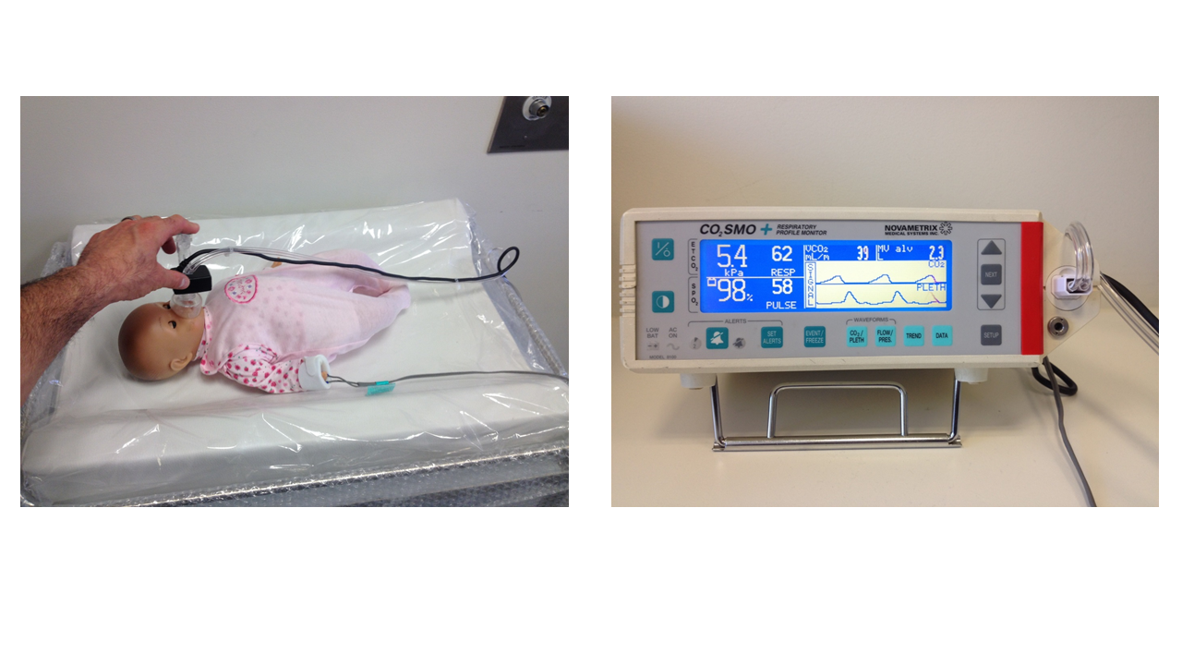
The picture above uses a doll to show you what it would look like to have your baby breathe into a mask and to show you what a pulse oximetry sensor looks like. Your baby will be placed on your chest or close to you as soon as possible after your baby is born. We can collect the information for the study whilst your baby is on your chest. In this example, the baby is lying on a special warming bed developed for this study.

One member of the research team will then visit you twice more, once between 1 and 2 hours after your baby is born and one final measurement between 12 and 72 hours after your baby is born. During these visits, the researcher will measure the carbon dioxide levels of your baby’s breathe using the mask and the heart rate and oxygen level using the pulse oximetry sensor for 1 minute each.

Our goal is to accurately record events of the first minutes of life, for example, when the umbilical cord is clamped, when the facemask is first applied to your baby, and when your baby first cries. One investigator will speak into an audio recorder, located in the investigators shirt pocket, to record the timing of these events. During the audio recording your voice may be recorded. The audio recording will be analyzed on the day your baby is born and immediately deleted.

4. What are the possible benefits?

We do not anticipate that your baby will receive any benefits from this research. The results of this study will be important in helping us to know how to care for other babies in the future.

5. What are the possible risks?

Measuring carbon dioxide levels by having a baby breathe into a mask might distress the baby. We will reduce the chance of distress by only measuring carbon dioxide for 10-20 seconds at a time after the first minute of life.

6. Do I have to take part in this research project?

No, your baby’s participation in any research project is voluntary. If you do not wish your son or daughter to take part you don’t have to. If you decide to take part and later change your mind, you are free to withdraw from the project at any stage. Your decision whether to take part or not to take part, or to take part and then withdraw, will not affect your baby’s treatment or your relationship with any of the medical/nursing team involved in their care.

7. How will I be informed of the results of this research project?

If you would like to know about the results of the research, please let the research team know, because at the completion of data analysis, we can send you a written account of the results. Group results only (and not individual) will be reported.

8. What will happen to information about my baby?

Any information obtained in connection with this research project that can identify you or your baby will remain confidential and will only be used for the purpose of this research project. It will only be disclosed with your permission, except as required by law.

In any publication and/or presentation, information will be provided in such a way that your baby cannot be identified, except with your permission. The records for this study will be kept in a locked filing cabinet and the computer records will only be accessible by a password known to the research team. Once the information has been collected it will be stored with a study number but not your baby’s name.

Information about your baby’s participation in this research project may be recorded in their health records.

9. How can I access my baby’s information?

In accordance with Australian and/or Victorian privacy and other relevant laws, you have the right to access the information collected and stored by the researchers about your baby. You also have the right to request that any information, with which you disagree, be corrected. Please contact one of the researchers named at the end of this document if you would like to access your baby’s information.

10. What happens if my baby is injured as a result of participating in this research project?

This study only involves collecting data by having your baby breathe into a mask and by placing a pulse oximetry sensor on your baby’s hand or wrist. The masks and pulse oximetry sensors are standard pieces of equipment used in every hospital, every day in Australia to take care of babies. All other treatments for your baby are part of routine care. It is extremely unlikely that harm could come to your baby as a result of this study. However if your baby suffers an injury as a result of participating in this research project, hospital care and treatment will be provided by the public health service at no extra cost to you.

11. Is this research project approved?

The ethical aspects of this research project have been approved by The Human Research Ethics Committee of The Royal Women’s Hospital.

This project will be carried out according to the National Statement on Ethical Conduct in Human Research (2007) produced by the National Health and Medical Research Council of Australia. This statement has been developed to protect the interests of people who agree to participate in human research studies.

If you would like more information about this project or if you need to contact a member of the research team in an emergency, the person to contact is

Dr Douglas Blank (principal researcher) Tel: 8345 3776
Dr Omar Kamlin Tel: 8345 3769
Dr Jennifer Dawson Tel: 8345 3791

If you have any concerns about the project or the way it is being conducted and would like to speak to someone independent of the project, please contact

The Royal Women’s Hospital Consumer Advocate
Telephone: 8345 2290
Email: advocate@thewomens.org.au
Participant Information and Prospective Consent Form
The Royal Women’s Hospital


Principal Researcher: Dr Douglas Blank

Prospective Consent
I have read, or have had read to me in a language I understand this document, and I understand the purposes, procedures and risks of this research project as described within it. I have had an opportunity to ask questions and I am satisfied with the answers I have received.

I give my permission for …………………………………………………….............................. (Insert Baby’s Name) to participate in this research project according to the conditions as outlined in this document.

I understand that I will be given a signed copy of this document to keep.

Name of person giving consent ………………………………………………………………………………………

Relationship to participant: ………………………………………………………………………………………
Signature Date

Name of witness to parent/guardian signature …………………………..………………………………
Signature Date

Declaration by researcher*: I have given a verbal explanation of the research project, its procedures and risks and I believe that the participant’s parent/guardian has understood that explanation.

Researcher’s name …………………………….……………………………………………………………………

Signature Date

*A member of the research team must provide the explanation and provision of information concerning the research project.
- Note: All parties signing the consent section must date their own signature. I would like a copy of the summarised results posted / emailed** to me

** Email address: …………………………………………………………………………………

