***ANNEX FOUR – Application form for full submission for research ethics approval***

***Department for Health***

***Research Ethics Approval Committee for Health***

|  |  |
| --- | --- |
| **Title of study** | Neuromuscular, physiological and perceptual responses to linear vs. multidirectional high intensity running sessions in academy rugby union players. |
| **Chief investigator**  **(for research student projects, put research supervisors name here)**  **(for undergraduate**  **projects, put project**  **supervisors name here)** | *Name:* Liam James Robinson  *e-mail:* [liam.james.robinson@gmail.com](mailto:liam.james.robinson@gmail.com)  *Telephone:* (Australia) +61 (0) 413 034 270 |
| **Other investigators**  **(for research student**  **projects, put students**  **name here)**  **(for undergraduate**  **projects, put student(s)**  **name here)** | *Name:* Dr. Craig Twist (Principal Supervisor)  *e-mail:* [c.twist@chester.ac.uk](mailto:c.twist@chester.ac.uk)  *Telephone:* (UK) +44 (0) 1244 513 441 |
| **Other investigators**  **(for research student**  **projects, put students**  **name here)**  **(for undergraduate**  **projects, put student(s)**  **name here)** | *Name:* Dr. Keith Stokes (Secondary Supervisor <5%)  *e-mail:* [k.stokes@bath.ac.uk](mailto:k.stokes@bath.ac.uk)  *Telephone:* (UK) +44 (0) 1225 384 190 |
| **Other investigators**  **(for research student**  **projects, put students**  **name here)**  **(for undergraduate**  **projects, put student(s)**  **name here)** | *Name:* Prof. Aaron Coutts (3rd Supervisor & Australian Based)  *e-mail:* [Aaron.Coutts@uts.edu.au](mailto:Aaron.Coutts@uts.edu.au)  *Telephone:* (Aus) +61 (0) 427 652 815 |
| **Source of funding for the study** | At this stage – nil. Self-Funded. But the requirement for funding is low.  Equipment required is a dynamometer, blood lacate machine and single GPS unit which, I am able to borrow from the club in which I do some work if need be. Otherwise, I will purchase for the requirement of the study.  In addition, I am however eligible to apply for a research grant through the Australian Physiotherapy Association which I have submitted an application to (28.03.15). This grant would be to cover the above listed equipment and a decision is expected late April.  <http://www.physiotherapy.asn.au/APAWCM/Research_and_Publications/PRF/APAWCM/Research_and_Publications/PRF/Fund.aspx> |
| **Proposed dates of**  **Study** | June for Data Collection if Ethics passed in April. |
| **Research question** | Does the inclusion of accelerations, decelerations and changes of direction alter the physiological, neuromuscular and perceptual response to a typical rugby high intensity exercise running programme? |
| **Background (less than 100 words)** | Rugby union is a sport characterised by repeated, high-intensity work periods of relatively short duration. At the elite level, while the development and implementation of an effective training programme is deemed essential with regards to both rehabilitation and preparation purposes to meet the physical demands of the sport, the complexity in its delivery lies within establishing a correct balance between its volume and content.  A more thorough understanding of the multidimensional fatigue responses towards typically prescribed high intensity exercise programs could therefore have important implications for future specific training prescriptions. |
| **Methods (less than 300 words)** | *Methodology:*  Using a randomized, repeated measures crossover design, ~25 male Australian academy rugby players will perform two running protocols; A (Linear) and B (Multidirectional) 8 days apart. Measures of muscle function (i.e. knee flexion, extension, shallow range eccentric hamstrings and adductor squeeze) will be recorded before and immediately after both protocols. Blood lactate concentration ([La]), rating of perceived effort (RPE), heart rate (HR), perceptual measure of fatigue and movement characteristics via a 10Hz GPS system will also be recorded. Subjects will run at maximal speed during 30m shuttles set up in accordance to either protocol A or B. Each 30m of running will be followed by 30m walking at <1m/s. Subjects will run a total distance of 1500m and neuromuscular markers will be reassessed at 48 hours.   * Quantitative Study * A randomised repeated measures crossover design will use the same subjects for each trial of the research (see below) whilst maintaining a controlled environment in which the research project will take place. These aspects both aim to minimize participant bias and thus aid confidence in the potential findings. * Measurements will be taken using previously validated (in research) measuring equipment that has will be calibrated according to the manufactures instructions before use during this project. * The main researcher (myself) will be the primary (and only) assessor for all neuromuscular measures of strength, minimizing any assessor bias   *Significance:*  Despite much being known regarding the gross demands of field sports, little is understood regarding how fatigue markers respond in a rugby environment inclusive of multiple changes of direction.  It is hoped that the findings might enable coaches and trainers to better understand the loads imposed on the body by multidirectional movements, ultimately presenting potential implications for future specific training prescriptions. |
| **Sample size** | ~25 male Australian academy rugby players |
| **Proposed Analysis** | Official Testing Days:  At an organised familiarisation day, all participants will be issued an assessment start time for the official testing days (Prog A and Prog B). This time will be used for both assessment days and will be recorded by the research team. Text messages and a reminder phone call will be delivered to each participant at 48 and 24 hours prior to the testing commencing.  After arrival and registration, each participant, in time order will report to a team member. Participants will then give additional consent on the day and then begin a standardized 10 minute warm-up procedure designed by a strength and conditioning coach (helper 2). Participants neuromuscular assessments will then begin in the procedure as outlined below. This procedure will take place immediately after the 10 minute warm up (prior to any running) and then at 4 minutes post completion of the shuttle run program (as [BLa] will be taken at 3 minutes post).  ***Procedures & Equipment:***  *Neuromuscular Assessment (****A****):*  Via: Baseline© Electronic Push/Pull dynamometer Model 12-0343 and rated to 225 kg (Fabrication Enterprises Inc., NY, USA).  *Procedure:*  A hand held dynamometer (Baseline© Electronic Push/Pull dynamometer Model 12-0343) is to be used in the data collection for neuromuscular assessment of isometric quadriceps contraction at 30◦ of knee flexion seated, isometric hamstrings contraction at 30◦ of knee extension seated, and shallow range eccentric hamstrings contraction between 45◦ and 15◦ of knee flexion prone. This equipment will be calibrated prior to use according to the manufacturer’s operational manual and all measures using this equipment will be conducted by the main researcher only.  *Neuromuscular Assessment (****B****):*  Via: Commercially available (Welch Alyn) Sphygmomanometer: Pre-Inflated to 20mm Hg.  *Procedure:*  Upon completion of neuromuscular assessment (A), participants will then be required to perform the thigh adductor squeeze test immediately after. Participants will be requested to lie in the supine position upon the provided plinth and the main researcher will facilaite placing the participant’s hips in the position of 45° hip flexion and knees at 90° of flexion. Both these angles will be measured by the main researcher using a goniometer. As discussed, this method used is adapted from the paper by Delahunt et al (2011) and is in line with best practice.  The sphygmomanometer will be pre-inflated to 20mmhg as outlined by Delahunt. Once the patient is comfortable and the researcher is ready, the sphygmomanometer cuff will be placed between the knees of the supine participant.  On instruction, the participant will be asked to squeeze the cuff as hard as they can. The main researcher will monitor the reading and record the value. The main researcher will then repeat the same test 3 times with the maximum value being recorded.  *Blood Lactate:*  Via: Lactate Pro/Plus Portable Analyser – (Arkray Inc, Japan).  Procedure:  [BLa] will only be required to be taken once during both Prog A and Prog B. As participants complete the shuttle run testing, they will then be asked (by a team helper) to walk towards the [BLa] assessment station. The helper will commence a stopwatch timer upon completion of the shuttle run programme and at 3 minutes post shuttle completion will assess the [BLa] using the outlined lactate analyser machine.  Using the lactate analyser, participants will provide a 5µl capillary blood sample from a fingertip for analysis of blood lactate concentration ([BLa]) 3 min after completion of the running protocol  The taken sample will be placed into the analyser and onto the machine test strips, where the recorded value will be noted by the team helper. After use, the used test strips and sample tester will be disposed of in a blood and sharps designated bin which, after completion of all samples will be disposed of in a correct manor in line with such hazardous medical waste.  The accuracy of the analyzer will be checked before each test using standards provided with the machine and will also be calibrated prior to each test session (A) and (B) according to the manufacturer’s instructions. The suitability and reproducibility of this analyzer has been previously established throughout the physiological range of 1.0 – 18.0 mmol.L−1.  *RPE:*  Via; BORG 6-20 & Session RPE 1-10  Procedure:  Participants will be asked to measure their rate of perceived exertion at pre-determined times during the data collection days. These times are outlined below.  With the RPE scales printed out, each participant will be asked by a designated team helper to rate, on the given scale, how they perceive their current level of exertion at the times as stated. This rating will then be recorded by the team helper.  The pre-determined times are as follows and is correct for both Prog A and Prog B:  *6-20 Scale RPE:*  Prior to Warm Up  Post Warm Up  At active recovery walk (30s) on the 300m, 600m and 1200m and 1500m (completion) mark.  *1-10 Session RPE:*  15 minutes post completion of running protocol.  At completion of the running protocol, a team helper will then commence a stopwatch timer for the given participant. The participant will then undergo [BLa] assessment at 3 minutes post completion of the running program, and then neuromuscular assessment A and B immediately after. With session RPE being required to be taken at 15 minutes after completion of the shuttle running, the team helper will then ask for a perceived exertion score on the 1-10 session RPE scale when the stopwatch reaches 15 minutes.  *GPS:*  Via: 10Hz GPS units (MinimaxX s5, Catapult Innovations, Scoresby, VIC, Australia)  Procedure:  At the assessment day, participants will be fitted with the GPS units by the *GPS Co-ordinator (additional team helper). Subjects will wear a vest in which the GPS will sit, placed at the middle of the upper back. GPS units will be switched on and monitored by the GPS helper person.  Physical movement patterns during each running protocol will be measured using the GPS device. Measurements of distance, speed (peak and average), acceleration, and deceleration will be monitored and recorded via the manufacturer’s software on a laptop being operated by the GPS Co-ordinator.  Data Analysis:  Data/statistical analysis will be completed on the generated data using software tools such as SPSS (v.15, SPSS© Inc., Chicago, IL, USA), Microsoft© Excel (Office 2014) and GPS manufacturer software (Sprint 5.0, Catapult© Innovations, Australia).  Statistical Analysis:  All data is to be assessed with both Microsoft Excel and SPSS so that data can be expressed in terms of standard deviation (SD) and means. The normality distribution of the data will be examined using an appropriate statistical test (Shapiro-Wilk) and homogeneity of variance will be verified using again an appropriate test (Levene test).  After confirming normal distribution, a paired t-test will likely be used to analyse the pre & post neuromuscular assessment findings along with heart rate and rate of perceived exertion responses.  A one-way analysis of variance (ANOVA) with repeated measures will then be used (likely) to compare all values obtained in the 2 running protocols (A) and (B) upon completion of (B) with statistical significance being set at p≤0.05. In addition an order of testing will also be assessed for, aiding the statistical analysis and discussion. |
| **Potential risks to volunteers** | Due to the repeated 30m running drills in both protocol A and B, there is potential, (small), for MSK injury to occur such as muscle injury, ligament strain etc…given participants will be asked to run at maximal speeds throughout the running sessions.  MSK assessment prior to inclusion in the study will therefore aim to further minimise this risk. The project design is based on a typical rugby training type exercise program so will be appropriate towards a ‘normal’ session for the subjects recruited. |
| **Potential for pain/discomfort** | Distance covered will be 1500m worth of running and is atypical to a training session that subjects would normally compete during time within the academy. |
| **Benefits to participants** | *Implications:*  Knowing the physiological and fatigue characteristics when using linear vs. shuttle running practices will enable coaches to design effective training programs and better understand potential mechanisms for injury in rugby players. |
| **How will participants be recruited?** | Proposed Plan:  All participants will be registered members of the academy at which the main author works ad-hoc (Super Rugby Club). Permission to invite members of the u20s to participate in this research has been granted by the club.  All academy players (~30) will be addressed by the main researcher (lead academy physiotherapist) well in advance as to the research project proposal (once ethics confirmed). At this stage, the academy players will receive a short presentation by the lead researcher and be given the ‘participant information sheet’ which will outline all aspects of the project described.  Subjects will then be asked to volunteer for the project prior to a defined date if they feel they would like to take part based from the provided information. The initial phase of subject recruitment will be that of identifying willing subjects and then commencing Musculoskeletal Screening (MSK) as per Inclusion/Exclusion criteria.  Subjects will therefore be required to volunteer and then consent (via informed consent form) to phase 1 of subject recruitment (MSK screen).  From those consenting volunteers, a MSK screen will be completed by the lead researcher. After MSK screening is complete, those players who then still meet the inclusion criteria will be invited to formally participate in the research and further written information regarding the research will be issued along with additional informed consent forms. |
| **Exclusion/inclusion criteria** | ***Exclusion Criteria:***  • All players will be assessed prior to any inclusion for injury and selection for potential invitation will ultimately rely on the main author (7 years post graduate physiotherapist) clearing the players via a formal, in-use (within club), musculoskeletal (MSK) assessment.  • Only players that would otherwise be involved in full contact/non-restricted/non-modified training sessions at the time which the study is being conducted will be selected as invitees for participation.  • Any player not given permission by the club will also be excluded, despite them being eligible based on MSK assessment. The parent club will have ultimate say on inclusion of the player in the outlined study.  ***Inclusion Criteria:***  • The player must be within the u20s academy squad for the 2015 season and must have had MSK clearance from the assessing physiotherapist prior to being invited for consideration of participation.  • Participant must also have clearance from the club prior to being invited – (after MSK screening has been completed) |
| **How will participants consent be taken?** | *Considerations:*  Potential subjects will be from the academy group at a place of work of the main researcher. The academy will be contacted via internal means and a short presentation by the main researcher to the potential group will occur once ethical approval has been granted.  At the group presentation, potential subjects will be issued a **participant information sheet** which outlines all aspects of the project including a *statement of data protection*. To those subjects then indicating their willingness to be involved they must then *volunteer* to be included within the study.  To those subjects then volunteering, a ***consent form*** will be issued, and be asked to be read and signed before being later collected by the main researcher. This consent will then form the basis for which the volunteers then give permission for phase 1 of the recruitment process – Musculoskeletal Screening by the lead researcher. MSK assessment data will only be used for the purposes of deciding inclusion/exclusion criteria for the outlined project. The consent form will include the a statement expressing permission to record and store data including GPS measurement within accepted data protection policies for the purposes of this research in a confidential and protected manor.  After MSK screening has been finalised and inclusion/exclusion criteria applied to the participants, the remaining subjects will then be informed of their eligibility to continue participating in the outlined project.  These participants will then be issued a second ***consent form(2)*** with which consent will again be requested to continue within the project –  All subjects will be over 18 years old. |
| **How will confidentiality be ensured?** | Confidentiality:  **Subject information sheet** will have details of who will have access to data and in what way it will be used. Also how it will be stored and who will have access to this. This will also outline both a **statement of confidentiality assurance** & **a statement of data protection assurances.**  **Statement of Confidentiality assurances** will be included in the information sheet handed to all participants and will also be outlined on the consent forms  **Statement of data protection** will be included in the information sheet handed to all participants and will also be outlined on the consent forms.  All data will be recorded primarily on a Microsoft© Surface 3 Pro tablet computer and will be maintained by the main researcher – Mr Liam James Robinson. This computer will be password protected.  All collected data will be stored in individual files (Word/Excel) and will also be password protected.  The only 4 people to have access to these files at all times will be the main author (LR) and supervisors (CT), (KS) & (AC). While the main author will password protect the main computer to be used, data discussion may be necessary between the research team.  Any data interpreted by SPSS data will be maintained in a password protected SPSS file. This will be stored on password protected computers only and be discussed between the research team only.  All raw data will be backed up and stored on an external password protected hard drive in case of system malfunction. One will be issued to LR and one to CT & KS in case of loss of data.  The only 4 people to have access to these files at all times will be the main author (LR) and supervisors (CT), (KS) & (AC). While the main author will password protect the main computer to be used, data discussion may be necessary between the research team.  *Bloods:*  All blood materials used will be disposed of in a correct hazardous material waste bin and will be sent to a hazardous waste disposal unit after use – this will be the responsibility of the main researcher and will also be outlined on the consent forms. |

**Signed by:** **Principal Investigator** or Student Supervisor

* ______LIAM JAMES ROBINSON ____________

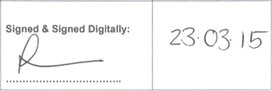

**Signed by:** Student or other researchers (**Supervisors**)

* __________DR. CRAIG TWIST__________ *(Lead Supervisor (UK))*

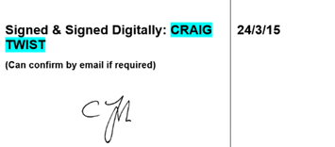

* ________PROF. AARON COUTTS______ *(3rd Supporting Supervisor (AUS))*

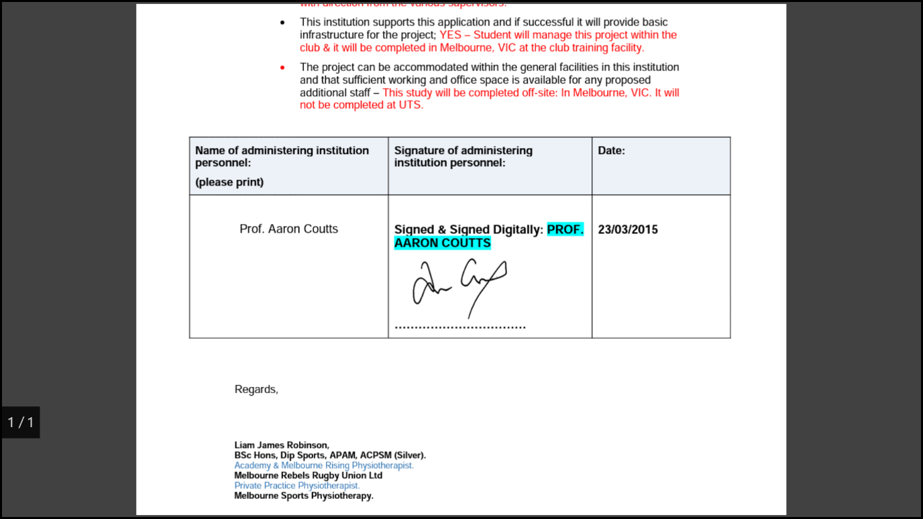

Considered by REACH at meeting on:

________________________________________

Decision of REACH:

|  |
| --- |
|  |

Action Required:

|  |
| --- |
|  |

**Appendix**

*Attach the following (where relevant):*

1. **Participant information sheet**

2. **Consent Form**

3. Health history questionnaire – **MSK Assessment**

4. Poster/promotional material

5. Copy of questionnaire/ proposed data collection tool (questionnaire; interview schedule/ observation chart/ **data record sheet**/ participant record sheet)

* 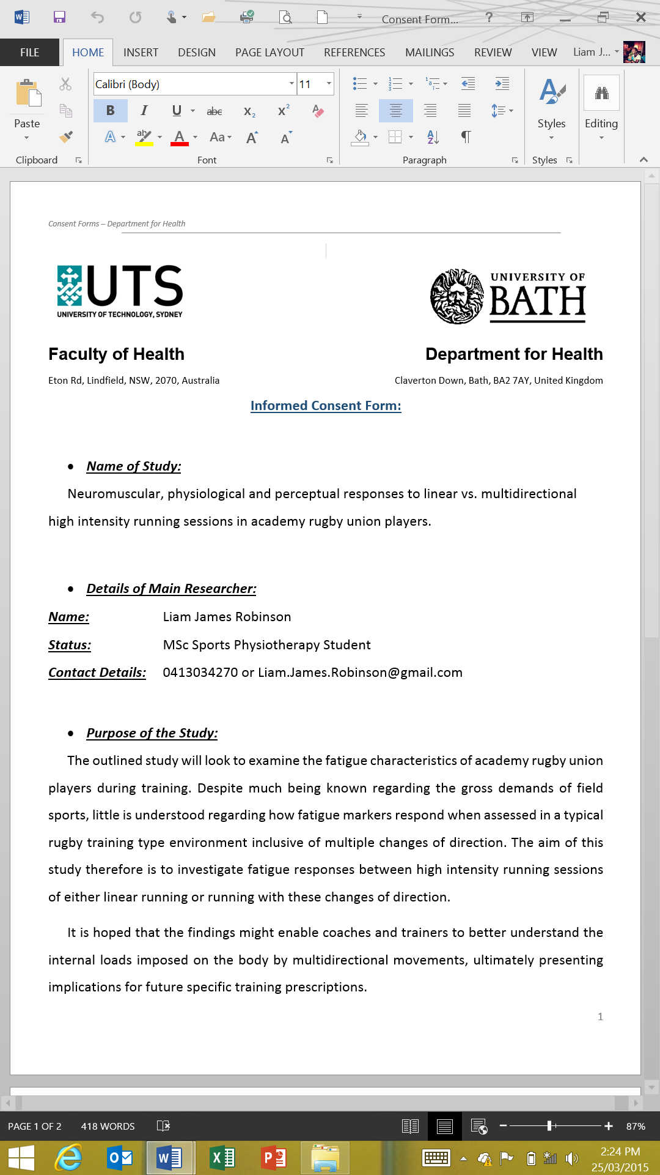Consent Forms (page1)
* 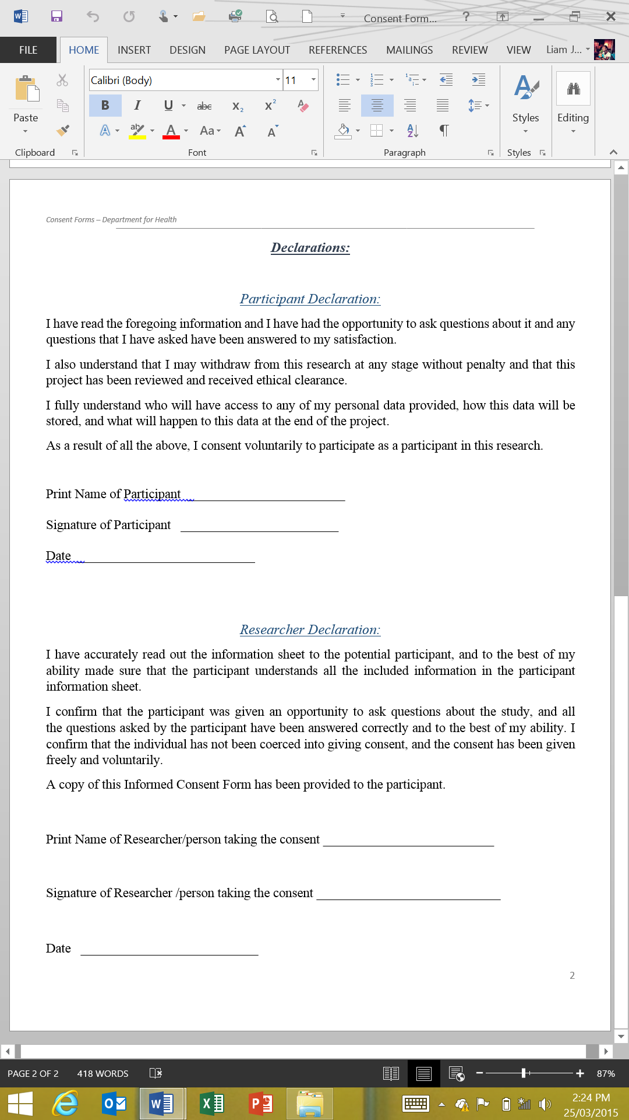Consent Forms (page2)
* Participant Information Sheets (7 pages)
* 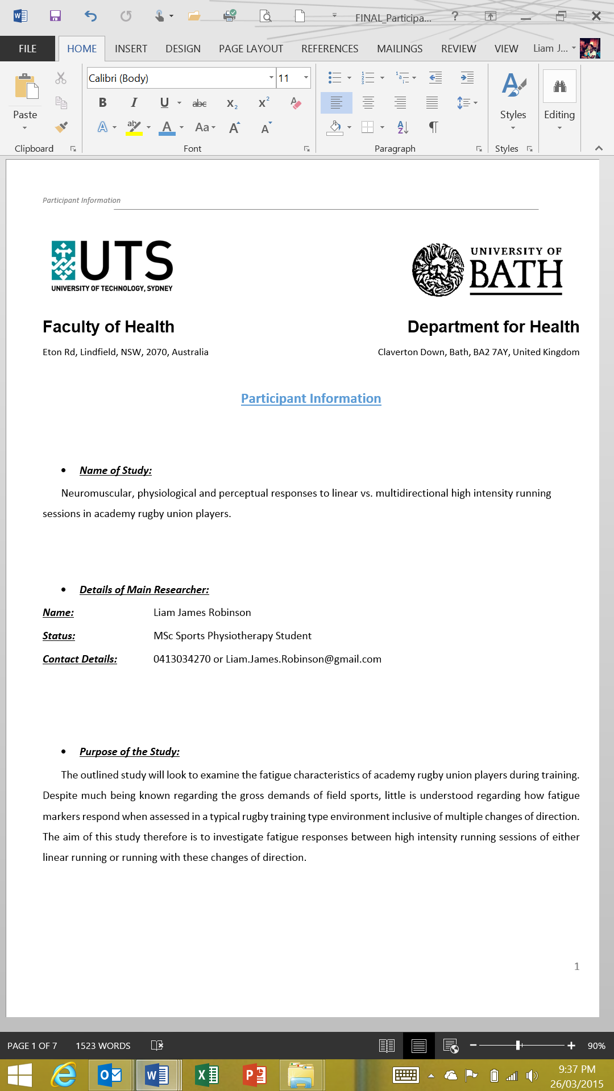Page 1
* 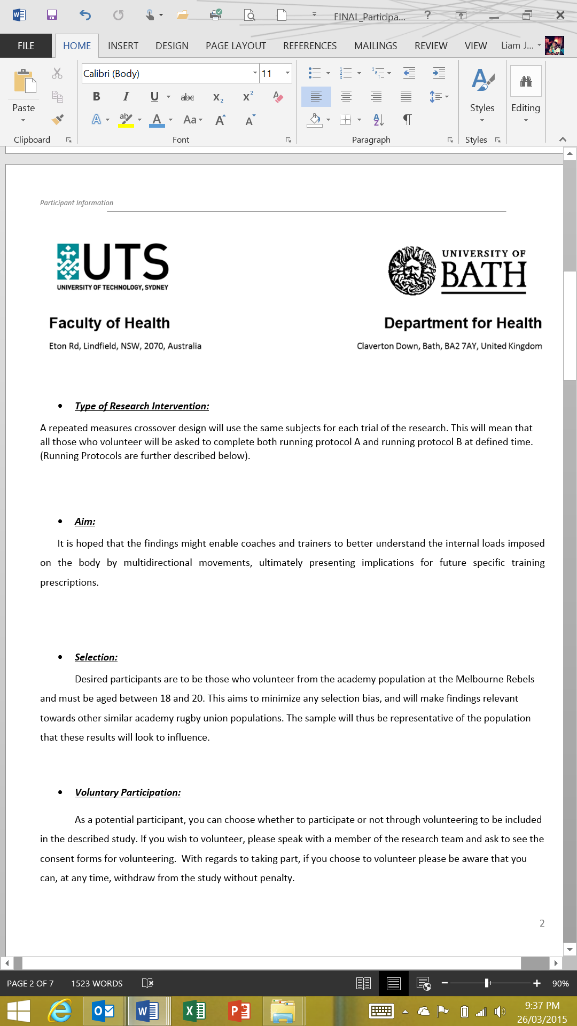Page 2
* 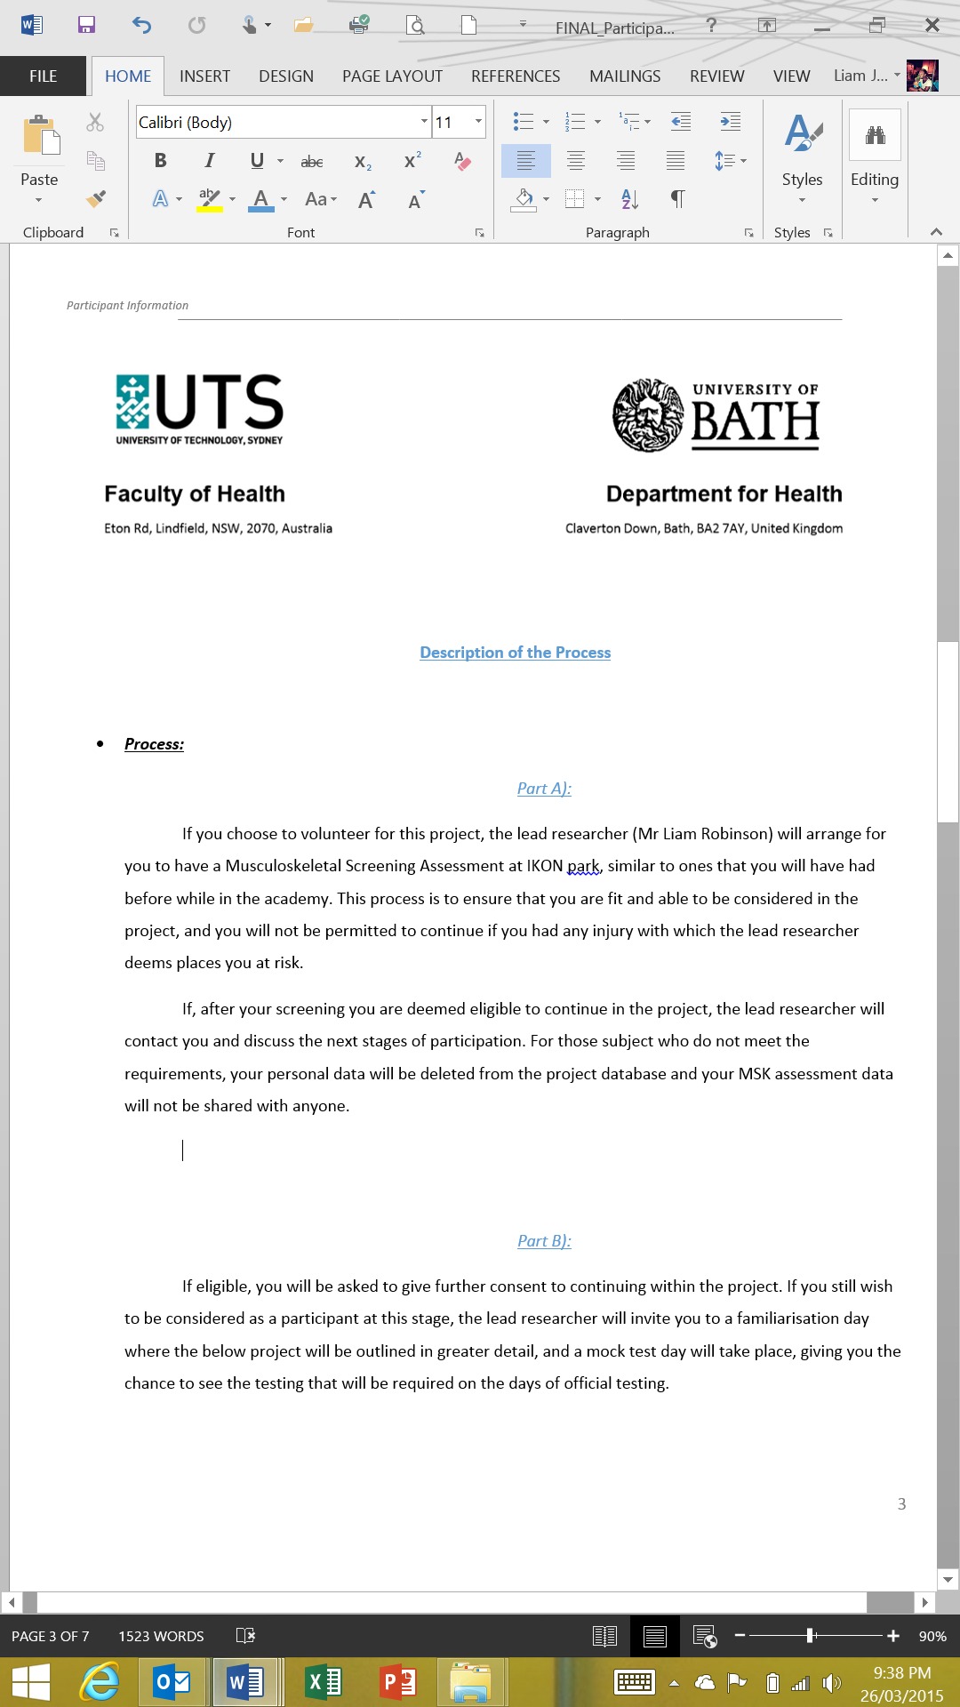Page 3
* 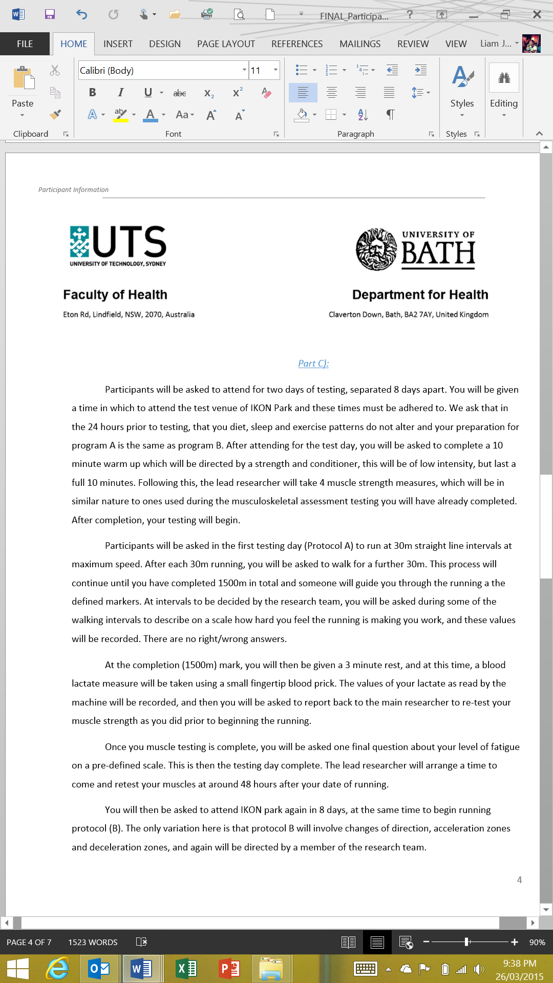Page 4
* 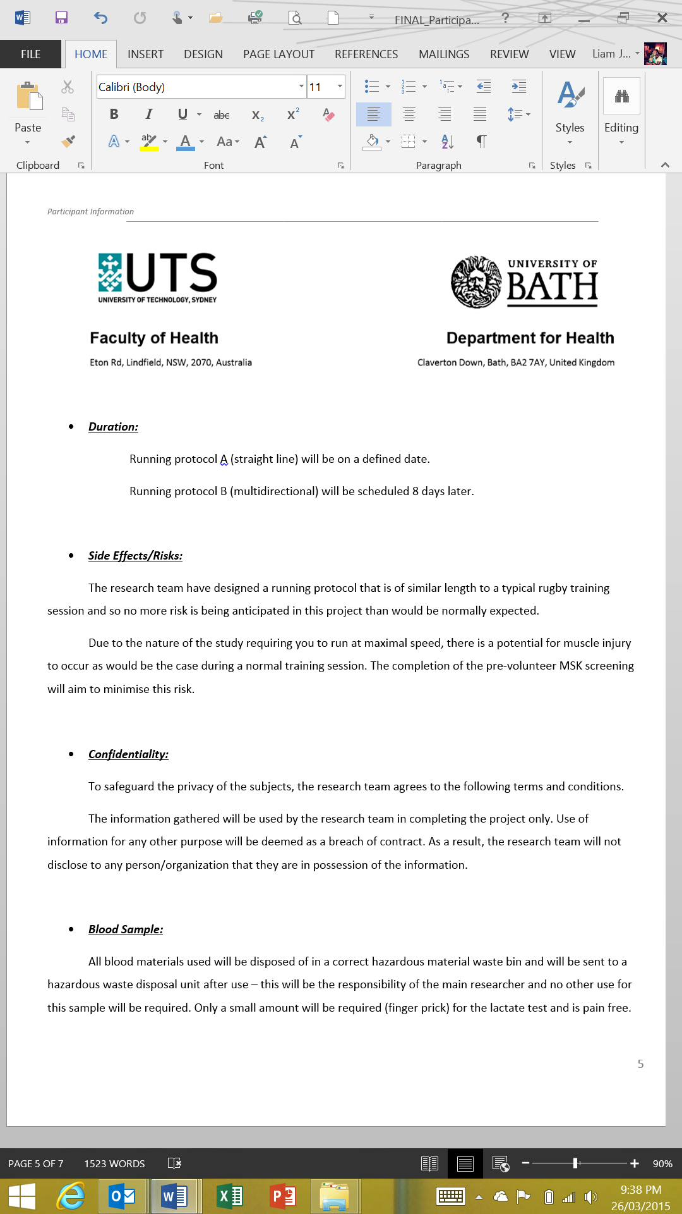Page 5
* 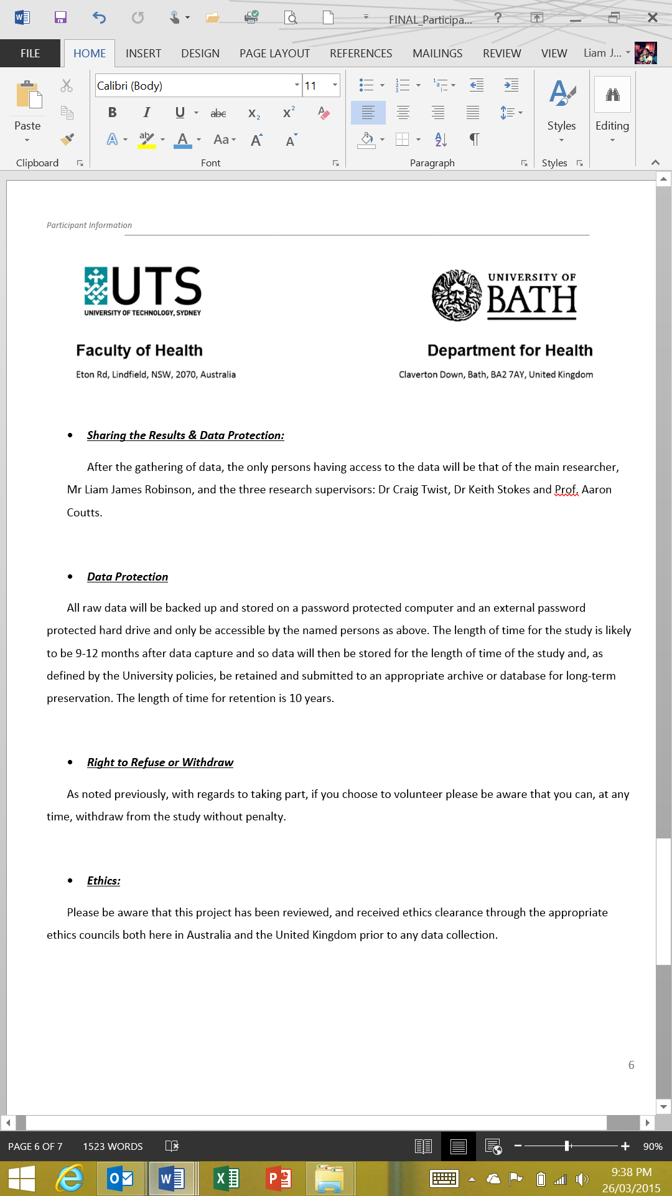Page 6
* 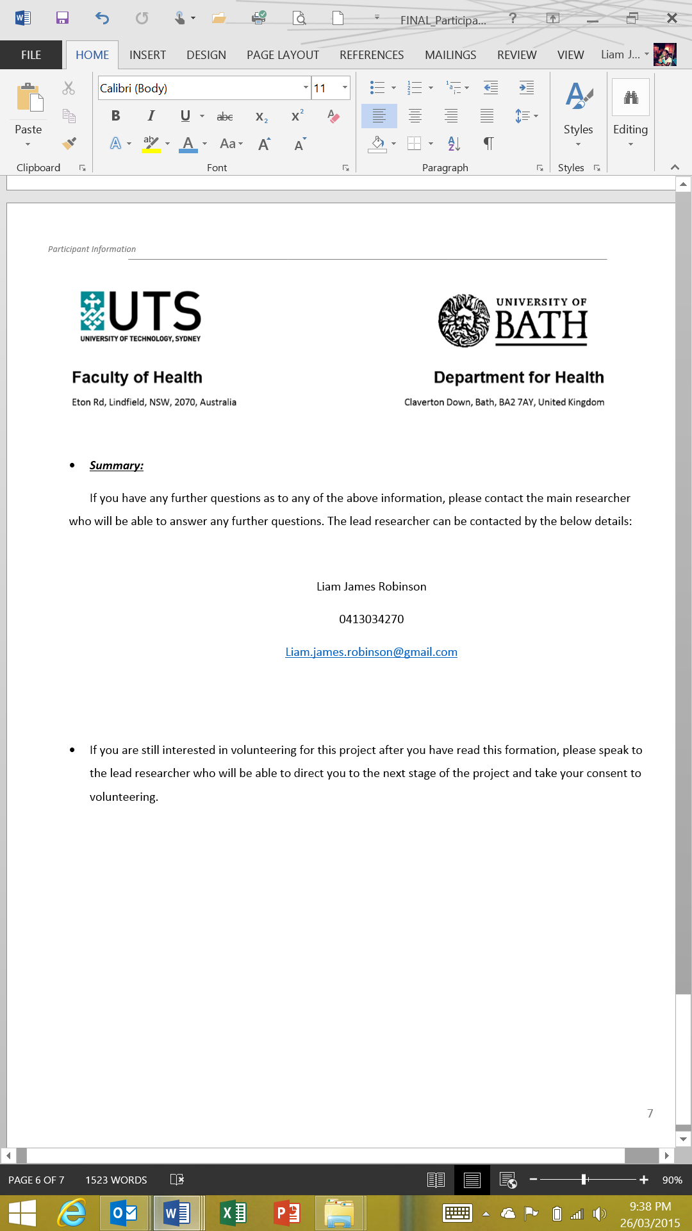Page 7
* 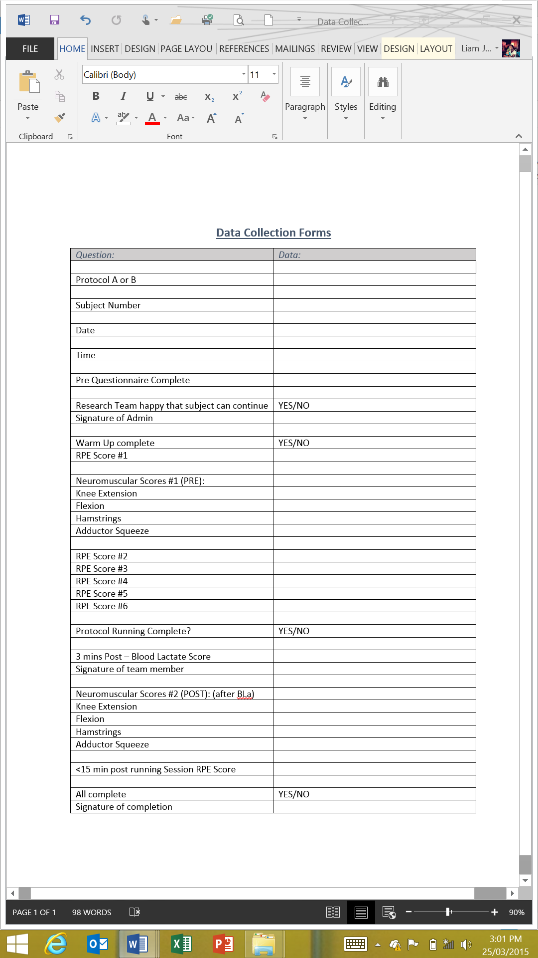Data Collection Forms
* MSK Screening Template (page 1)

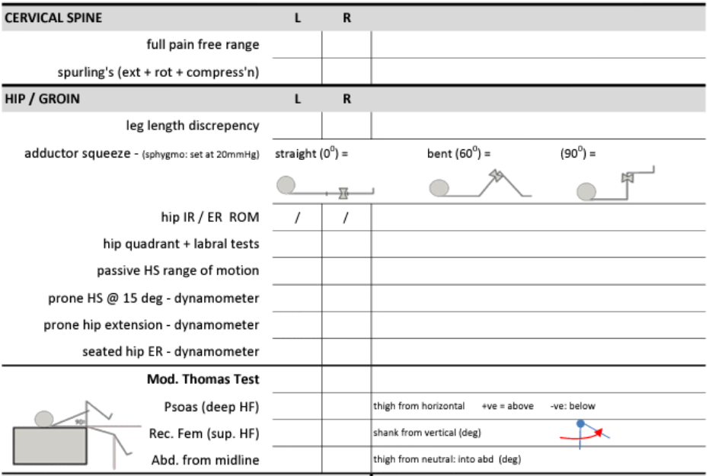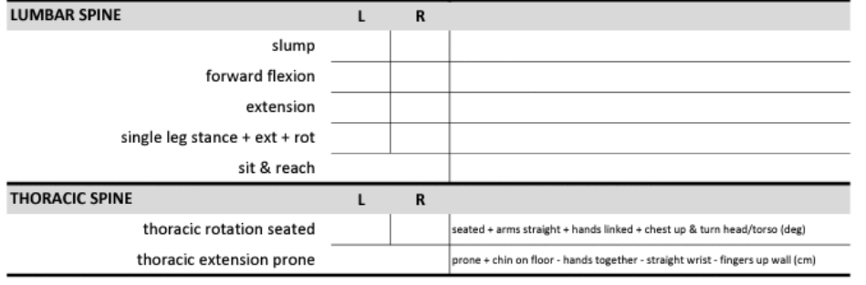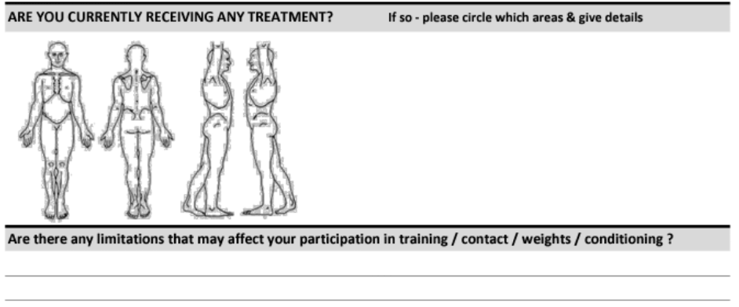***MSK SCREENING: (must pass to be considered as a subject in the study)***

* MSK Screening Templates (page 2)

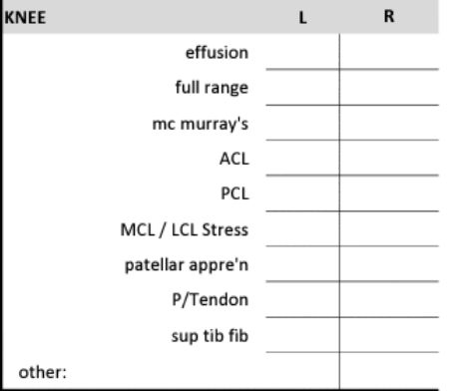

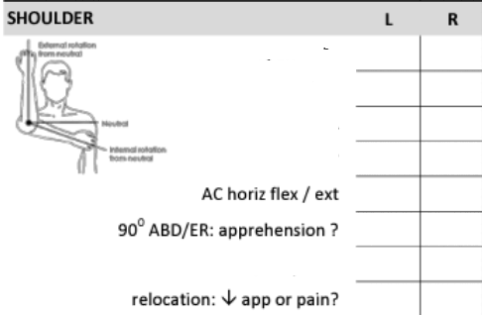

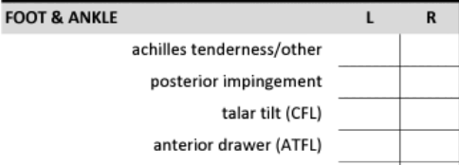

* Pre Protocol Quality Assurance/Medical Questionnaire:

***On admission to protocol A and B***

|  |  |
| --- | --- |
|  | ***PLEASE CIRCLE*** |
|  |  |
| **Do you wish to still be included in the study and take part in today’s testing?** | **YES/NO** |
|  |  |
| **Have you had developed any new injury/illness that we should be aware of prior to you taking part today, and since you initial screening?** | **YES/NO** |
|  |  |
| **If so – please give details: (if yes, please talk to the main author)** |  |
|  |  |
|  |  |
|  |  |
|  |  |
| **Have you maintained you normal dietary habits in the last 24 hours?** | **YES/NO** |
|  |  |
| **Have you maintained your normal sleeping habits in the last 24 hours?** | **YES/NO** |
| **Have you refrained from exercised in the last 24 hours as advised?** | **YES/NO** |
|  |  |
|  |  |
|  |  |
|  |  |
|  |  |
| **Print Name _________________________________________** |  |
|  |  |
|  |  |
| **Sign Name __________________________________________** |  |
|  |  |
|  |  |
| **Date ______________________________________________** |  |

* Perceptual Measure of Fatigue

