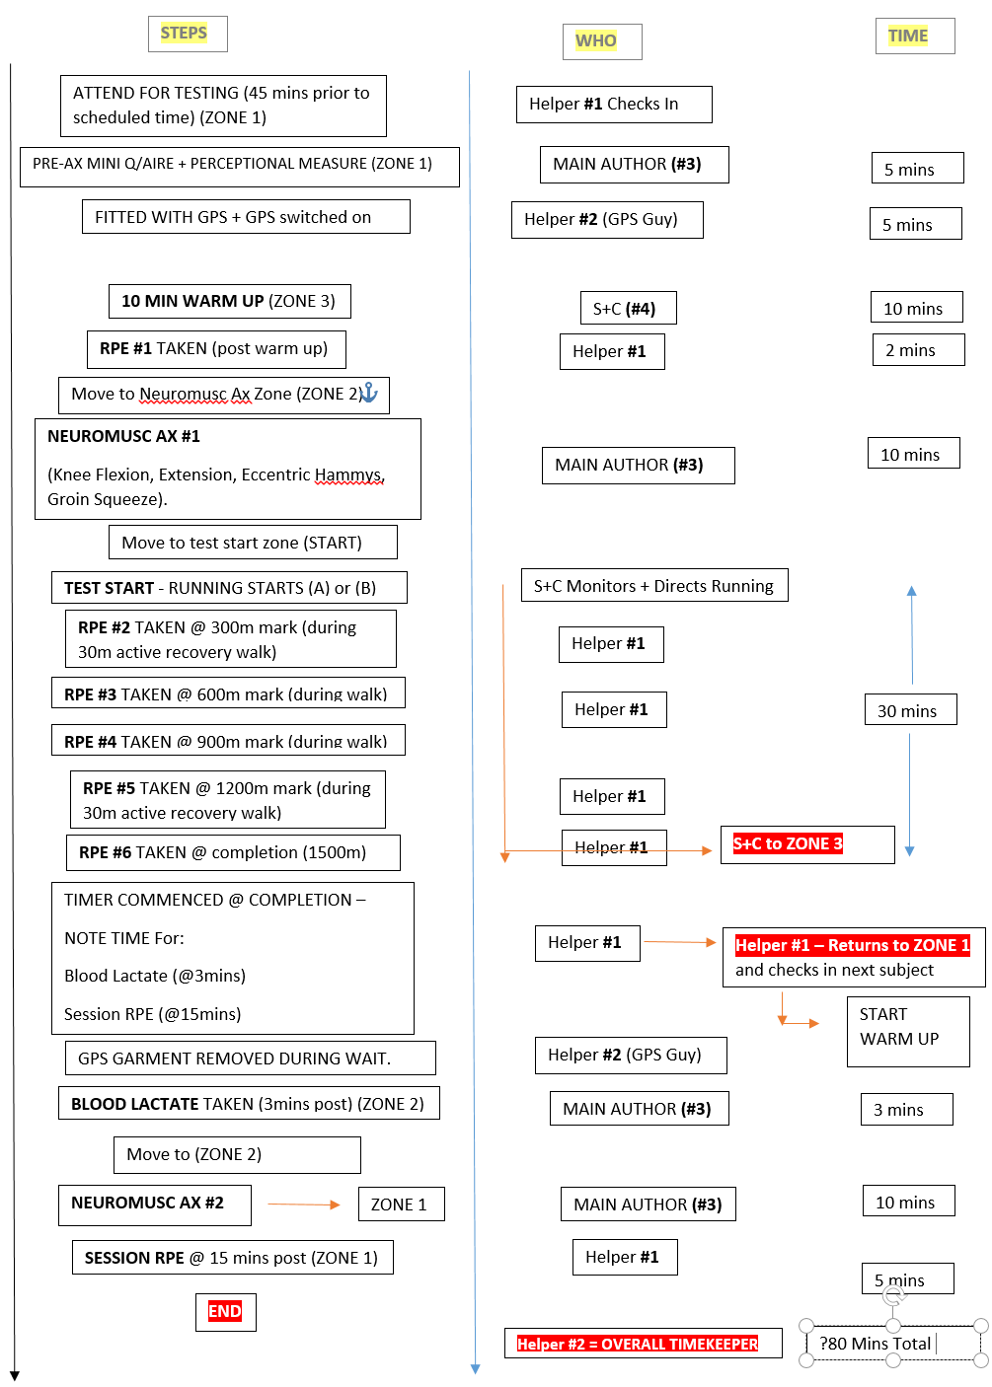
Assessment Protocol for (A) and (B) (Testing Days)
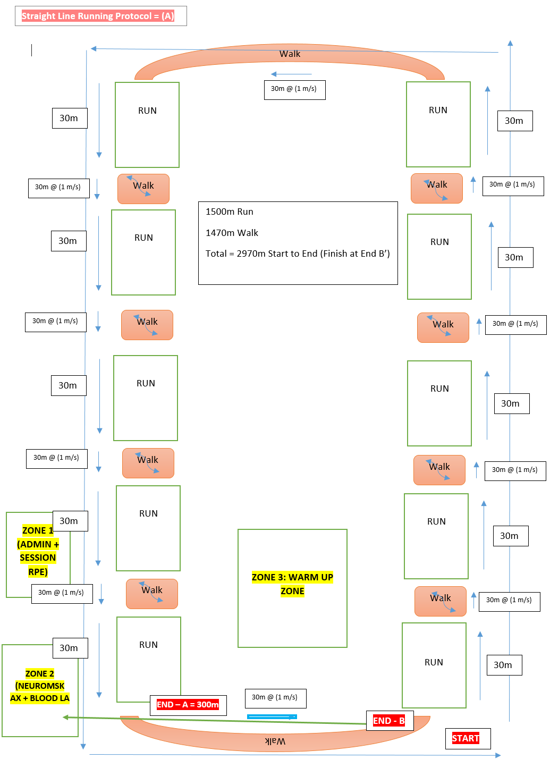

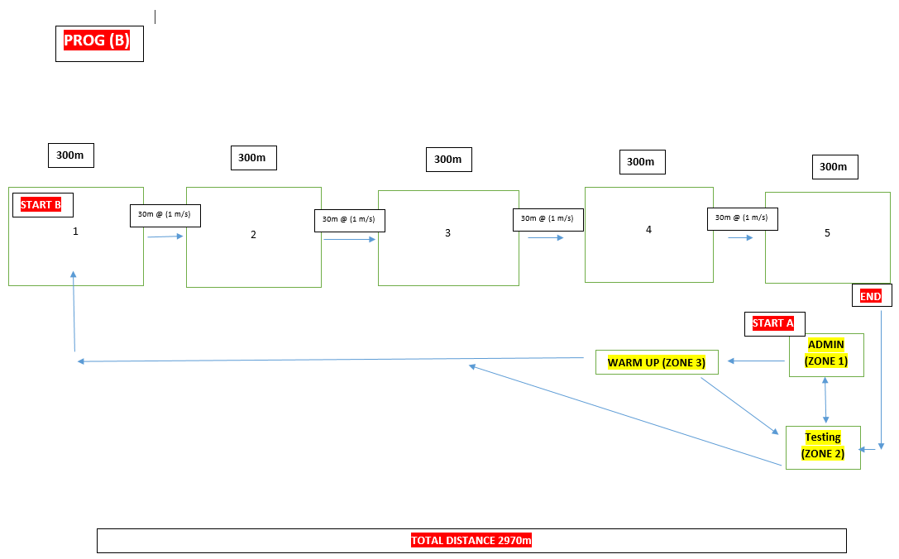
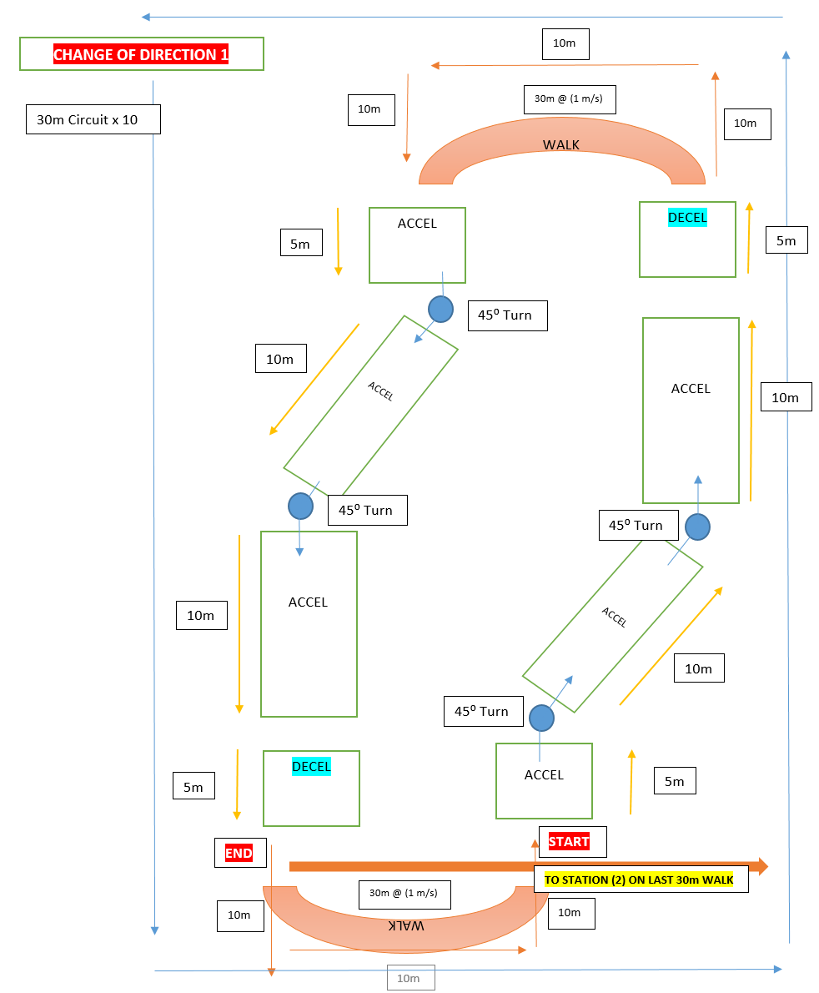
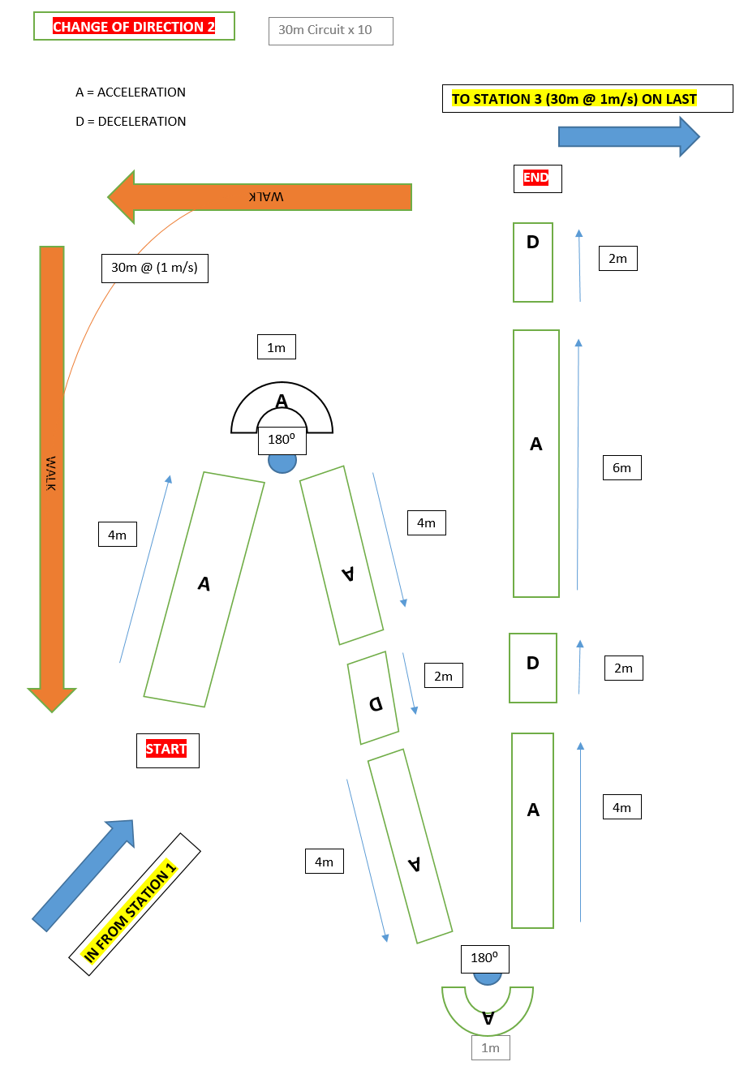

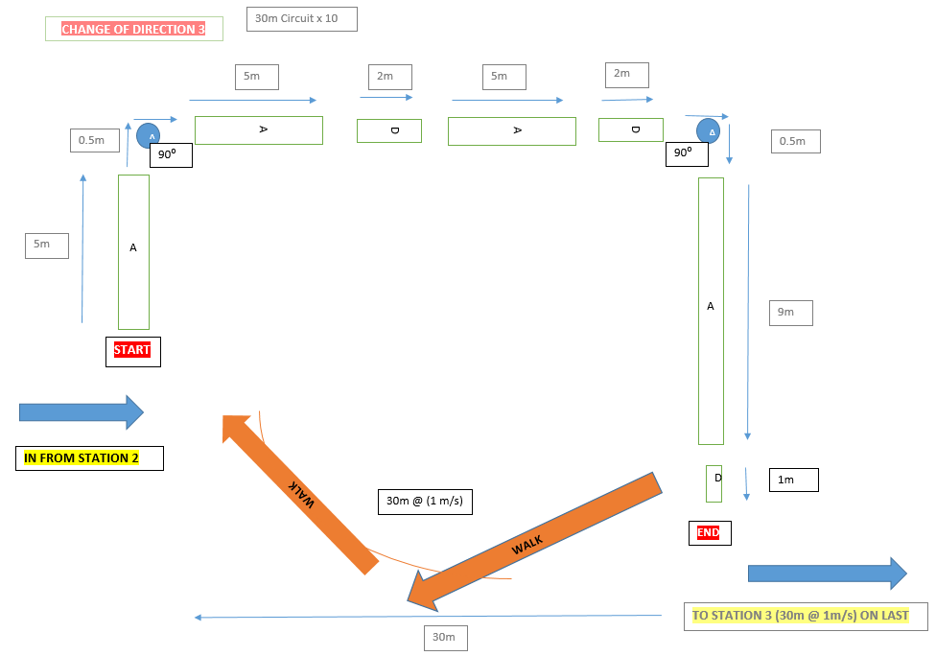

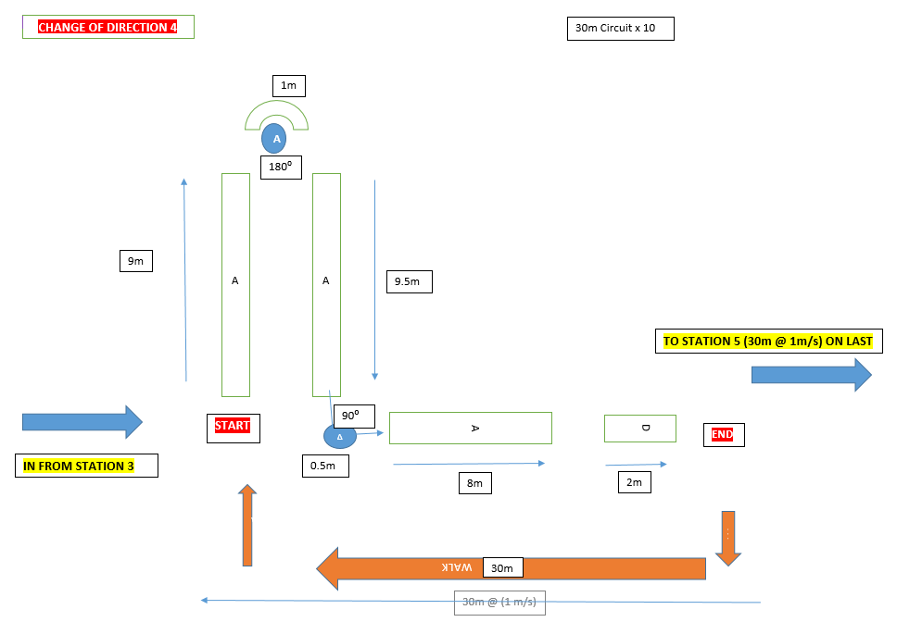
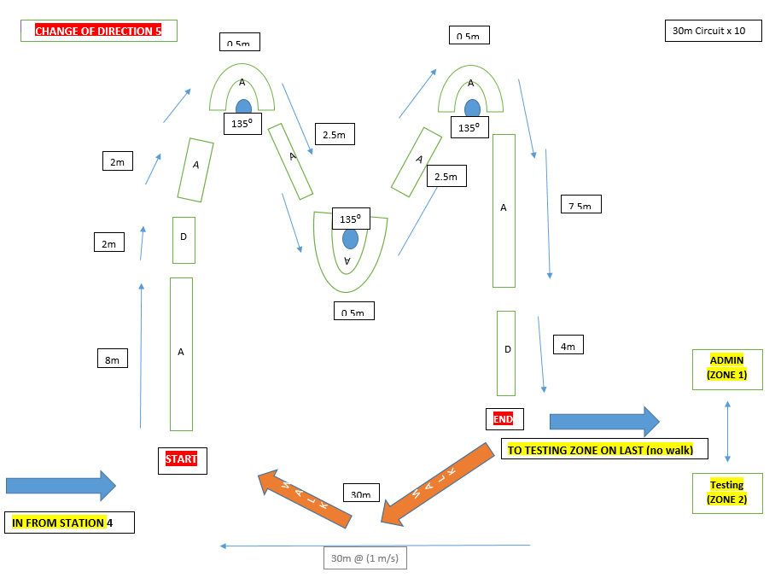
DISTANCES (MATHS) Straight Line Running (A)
5 x 300m circuits
30m Running, 30m walking x 10 = 300m (1 circuit)
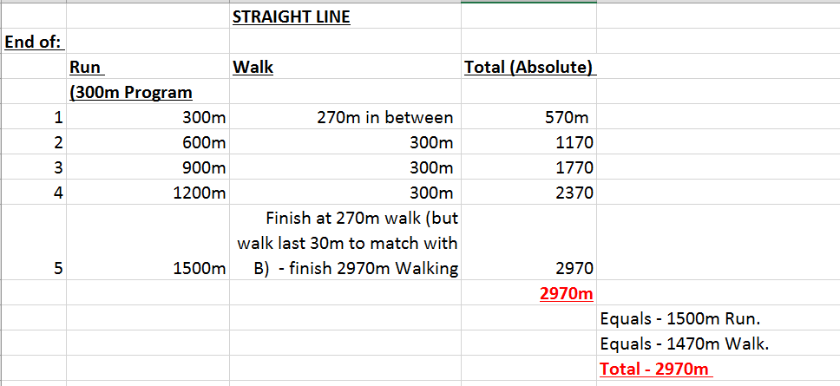
Total Distance: 2970m

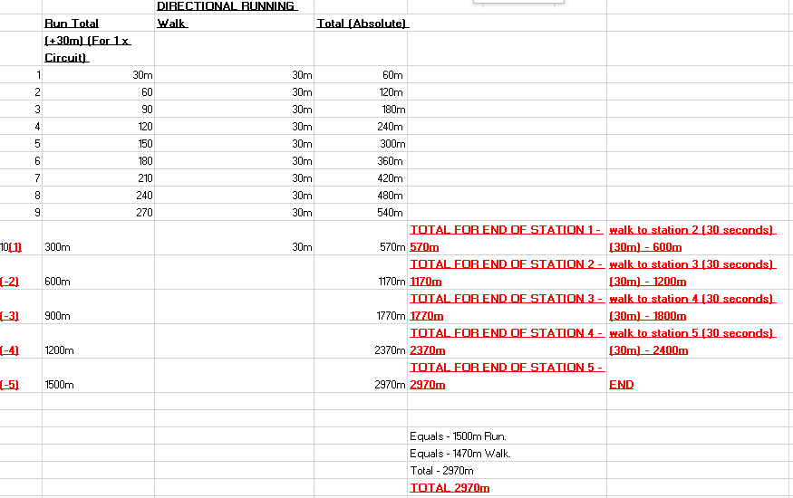

COD (B)
5 x 300m circuits
30m Running, 30m walking x 10 = 300m (1 circuit)
Total Distance: 2970m

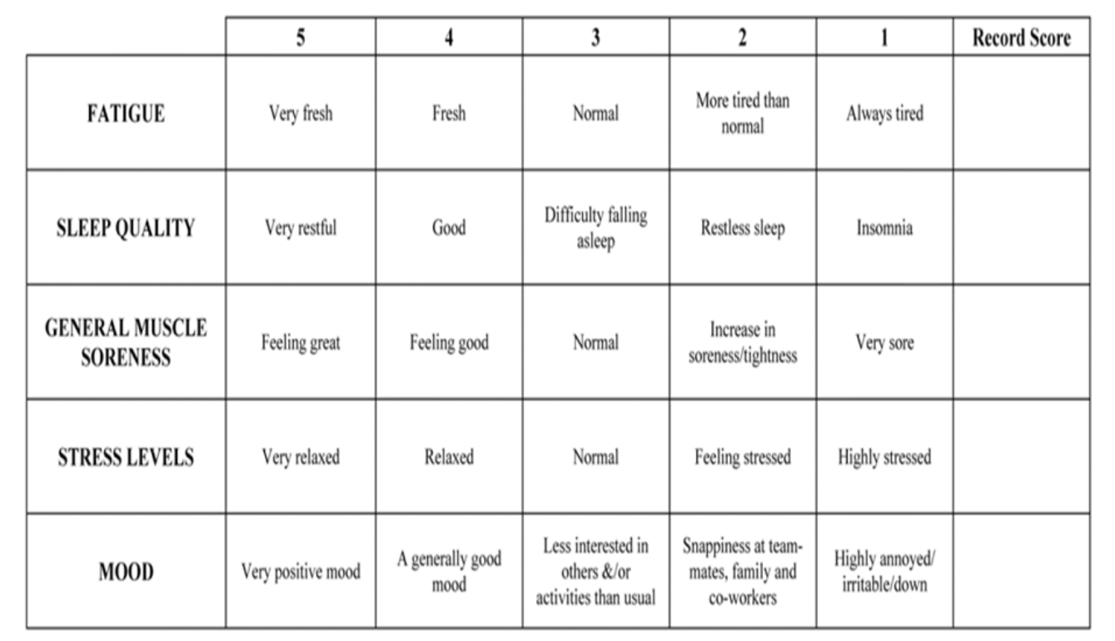
PERCEPTUAL FATIGUE MEASURE – PRE RUNNING:

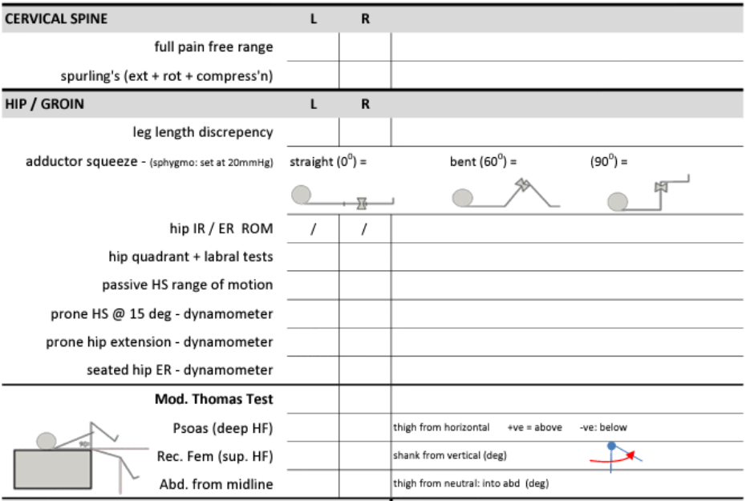
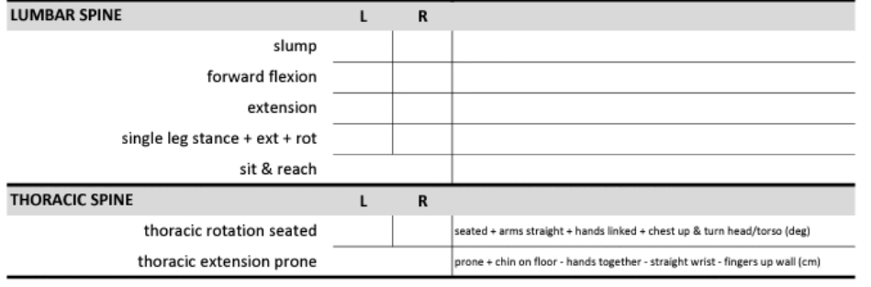
BASIC MSK SCREENING: (must pass to be considered as a subject in the study)
Screen completed by main author. (Adapted from below) -
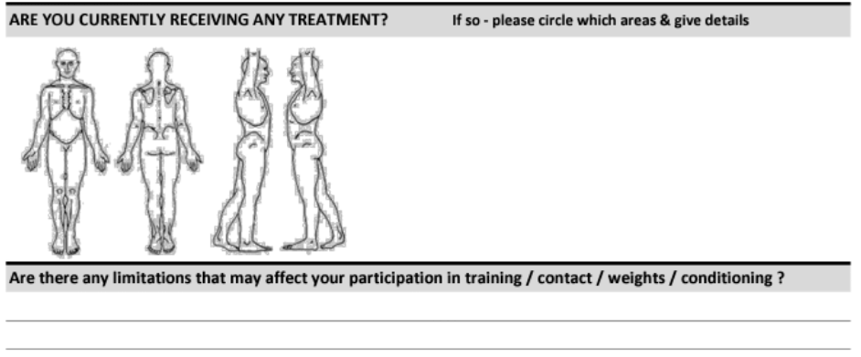

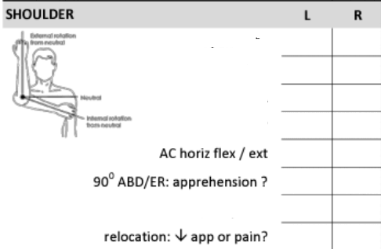
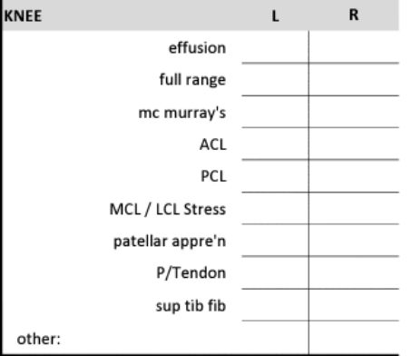

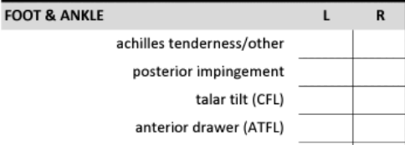

PRE-AX MINI QUESTIONNAIRE:
(For QUALITY control) – asked upon attendance for the running protocol.

 | PLEASE CIRCLE
Do you wish to still be included in the study and take part in today’s testing? | YES/NO
Have you had developed any new injury/illness that we should be aware of prior to you taking part today, and since you initial screening? | YES/NO
If so – please give details: (if yes, please talk to the main author)
Have you maintained you normal dietary habits in the last 24 hours? | YES/NO
Have you maintained your normal sleeping habits in the last 24 hours? | YES/NO
Have you refrained from exercised in the last 24 hours as advised? | YES/NO

SUBJECT INFORMATION SHEET:
(adapted from the WHO standards)
(To contain the below information)

Introduction
Purpose of the research
Type of Research Intervention
Participant selection
Voluntary Participation
Indication (clearly) that they can choose to participate or not.
Procedures and Protocol

B. Description of the Process

Duration
Side Effects
Risks
Benefits
Reimbursements
Confidentiality
Sharing the Results
Data Protection
Right to Refuse or Withdraw
Who to Contact

CERTIFICATE OF CONSENT:
(adapted from the WHO standards)

I have read the foregoing information and I have had the opportunity to ask questions about it and any questions that I have asked have been answered to my satisfaction. I consent voluntarily to participate as a participant in this research.

Print Name of Participant__________________
Signature of Participant ___________________
Date ___________________________
Day/month/year

Statement by the researcher/person taking consent:

I have accurately read out the information sheet to the potential participant, and to the best of my ability made sure that the participant understands that the following will be done:
1.
2.
3.
I confirm that the participant was given an opportunity to ask questions about the study, and all the questions asked by the participant have been answered correctly and to the best of my ability. I confirm that the individual has not been coerced into giving consent, and the consent has been given freely and voluntarily.

A copy of this ICF has been provided to the participant.

Print Name of Researcher/person taking the consent________________________
Signature of Researcher /person taking the consent__________________________
Date ___________________________
Day/month/year

STATEMENT OF CONFIDENTIALITY:
(Will be placed on consent form documents)

This agreement is made on the ____________________, between: _________and_________
To safeguard the privacy of the subjects, both parties have agreed to the following terms and conditions.
The information will be used by ___________(researcher) in completing the project only. Use of information for any other purpose will be deemed as a breach of contract.
__________________(researcher) will not disclose to any person/organization that they are in possession of the information.
Both parties have read all the terms and conditions of this agreement and give their consent to its execution.

