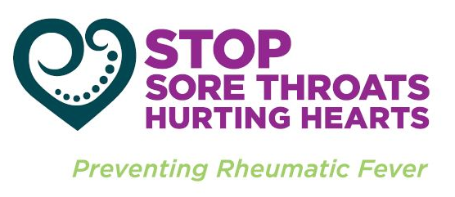

* Your child and whānau /family will have a chance to learn more about sore throats
* …and how sore throats can lead to Rheumatic Fever
* Sore throats caused by Group A strep will be treated **FREE** of cost during the study
* The children will receive the BLIS lozenges **FREE** of cost for a four week period
* Knowledge, that there is a **natural probiotic** that can help stop sore throats
* If this study is successful, it is hoped that BLIS will be made available to all children at risk of developing rheumatic fever.

# **The benefits of this project our help**

# **How many children will be in this Study?**

We hope that all of the children in the three schools named will be part of this study.

* On each school day for four weeks the children who have been given consent to participate, will get a BLIS probiotic lozenge.
* All of the children will have throat swabs to check for Group A strep, before and after the four weeks of taking BLIS.

**One or two further swabs may be taken to check again for strep throat**

* For those children whose throat swabs show Group A Streptococcus (strep throat), the bacteria that can lead to Rheumatic Fever, their family will be contacted and offered **FREE** of cost the appropriate antibiotic treatment (in consultation with the family GP).

#### BLIS is available for sale in pharmacies here and overseas and has been for some years

# **How will the study be done?**

Strawberry flavoured, pleasant taste. Does not contain sugars that harm the teeth. Can help prevent tooth decay

#### BLIS is a natural probiotic (a good type of bacteria) found to protect people from Group A streptococcal sore throats.

We would like to invite your child to take part in the natural probiotic BLIS K12 study. This probiotic has been found to contribute to the prevention of sore throats that can cause Rheumatic Fever. We are inviting **all children** enrolled at Te Kura Kaupapa Māori o Te Oriini, Te Kura o Te Paroa and James Street Primary School to join this study.

Is a natural probiotic in the form of a small lozenge that is sucked

BLIS is very safe, with no known problems

##### **Is BLIS safe?**

##### **What does it taste like?**

##### **What is BLIS?**

Participant information sheet

# WE WOULD LIKE YOUR HELP

*A study to help protect children from sore throats*

BLIS Probiotics To Help Stop Sore Throats in

Whakatane Children

# This study has bee approved by the Central Health and Disability Committee: Ref No.

# (0800 4 ETHICS Email [hdecs@moh.govt.nz](mailto:hdecs@moh.govt.nz)

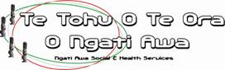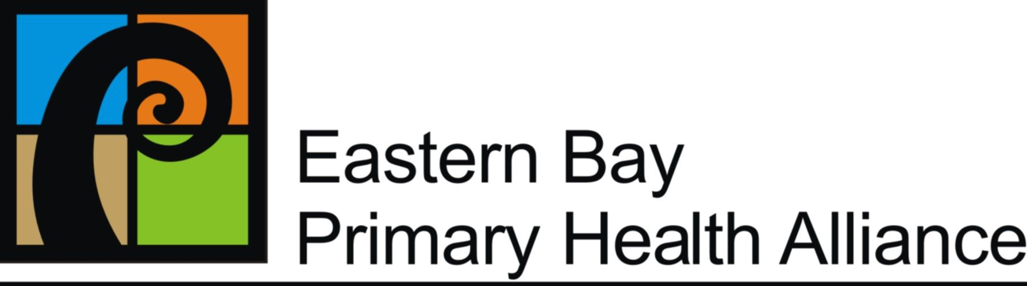

We seek permission to be able to view the results of the throat swabs taken throughout the study. Firstly to organise antibiotics if the swab is positive for strep A throat, secondly to check the effectiveness of BLIS K12 over 3-4 months.

Brief phone surveys will be made to some whānau/family to help understand what is known about sore throats, and rheumatic fever.

**If your child has an allergy, or a medical condition and/or been admitted to hospital with a serious illness, please let us know and we will contact you to discuss this before they take part.**

***‘Sore Throat Rapid Response’***

For those children who get a sore throat during the course of the study, we recommend they visit their family doctor/nurse or the new ***‘Sore Throat Rapid Response’* clinic (Med Central, Kopeopeo).** Alternatively a community health worker associated with the *‘Sore Throat Rapid Response’* clinic will visit the school twice each week to check for sore throats.

**WHO IS DOING THE STUDY**

***The study is being conducted in partnership with:*** Paediatrics Whakatane Hospital BOP District Health Board, Eastern Bay Primary Health Alliance and Te Tohu o Te Ora o Ngati Awa.

***The children’s throat swabbing will be led by experienced community throat swabbing team, which includes registered nurses and community health workers.***

#### **Contact the Research Team**

#### Dr John Malcolm (Paediatrician) (Lead Investigator) – Whakatane Hospital Paediatrics M: 021 2222190

#### Pareake O’Brien (Registered Nurse) - Te Tohu o Te Ora o Ngati Awa PH: 07 306 0096 M: 0272 550386

#### Sandra Ball (Registered Nurse) - Eastern Bay Primary Health Alliance PH: 07 3062300 M: 0273 634126

#### Melissa Bennett (Study - Research Assistant) - Eastern Bay Primary Health Alliance PH: 07 323 7965

#### Tui Edwards, MPH (Study - Research Coordinator) - Te Tohu o Te Ora o Ngati Awa PH: 07 306 0096

***What if my child misses a day or two taking BLIS?*** It’s OK. We know children will miss a few days when away; we don’t think this will be a problem. Aim for Blis K12 most days!

***Can I stop the study if I want to?***

YES. You can ask us to stop and take your child out of the study at any time.

***What will happen at the end of the study?***

If the study shows that BLIS prevents strep sore throats we hope that it will be made available to all children at risk of developing rheumatic fever. We are also pleased that other stop sore throat programmes are being made available for Whakatane children too.

***Can I discuss the study with the researchers?***

YES. By phone or text any time.

# **Frequently Asked Questions**

What else is required?