Figure 1: Study protocol
Study design: A randomized controlled trial.

Study setting: Collaborative Drug Discovery Research (CDDR) Group, Faculty of Pharmacy UiTM Puncak Alam
UiTM Puncak Alam

Subject recruitment and intervention: Physiotherapy Clinic at UiTM Puncak Alam

EXCLUSION CRITERIA
1. Nerve involvement or compression
2. Spinal disorders (e.g. spondylolisthesis, herniated nucleus pulposus, spondylosis, spinal fracture, back surgery)
3. Neurological deficit (e.g. multiple sclerosis, hemi/ para-paresis or myelopathy)
4. Infectious diseases (e.gs skin problem)
5. Menstruation during research, pregnancy, smokers and febrile
6. Receive any LBP medication and seek any treatment for LBP.

INCLUSION CRITERIA

1. Age between 20 – 40 years old
2. Non-specific LBP ≥ 4 weeks
3. Pain scale (VAS) ≥ 4
4. BMI: 18.5 kg/m² – 29.9 kg/m²
4. Willingness to participate in this study

Group A (n=32)
(LBP)

Group B (n=32)
(LBP)

Pre-test:
1. Blood sample: substance P & cytokine
2. Saliva sample: substance P & cytokine
3. Visual Analogue Scale (VAS)
4. Rolland-Morris Disability questionnaire

Relaxation technique
1. | Supine lying  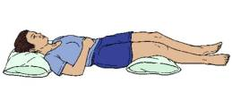  Figure 7
2. | Relaxation position within 30 minutes prior assessment.
Group A

Group B

Traditional Malay Massage (TMM) technique

1 | - The TMM treatment will be 30 minutes.  - Ask patient’s permission to expose an  affected area.  Figure 1  - Position: Prone lying with pillow under  stomach and heels.
2. | a) Fan stroking  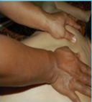  Figure 2  - Place both hand (side by sides) on the lower back with full palmar and finger surfaces. Move both hands upward (until upper shoulder) gently and smoothly.  - Practitioner needs to keep a straight back and lean forward on practitioner hands on body to apply a steady pressure.  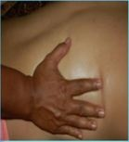  Figure 3  - Then, move both hands downwards with fan hands out to both sides of the body from upper shoulders  - Move down until lower back, molding them to the contours of the body with reducing the pressure.  - Pull hands up towards each other and swivel around to begin effleurage again. Repeat several times within 9 minutes.
3. | b) Basic kneading  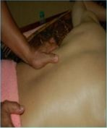  Figure 4  - Place practitioner hands flat on body with elbows apart and fingers pointing away.  - Gently grasp some flesh (muscle) using right hand and release it into left hand  - Let left hand take the flesh and then release it into right hand.  - Repeat several times to keep rhythmic within 7 minutes.
4. | c) Thumb stroking  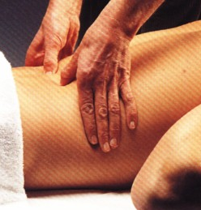  Figure 5  - Stroke firmly from lower back and moving upward and out to the side with left thumb.  - Then, follow with right thumb, stroking little higher.  - Make the stroke in circulation motion cross the muscle fiber and repetitively, building up a steady rhythm.  - Repeat several times within 7 minutes.
5. | d) Static pressure  Figure 6  - Give a static pressure on right lower back using right hand.  - Then release slowly and glide to the next point.  - Do the same steps on left lower back.  - Repeat several times within 7 minutes.

Post-test:
1. Blood sample: substance P & cytokine
2. Saliva sample: substance P & cytokine
3. Visual Analogue Scale (VAS)
4. Rolland-Morris Disability questionnaire (after 1 day treatment)

