**Protocol Title**

The effects of a new GLP-1 agonist on appetite and gastric emptying in Prader-Willi syndrome

Version Number: 2

Date of Protocol: 25/03/2016

**SYNOPSIS**

Protocol title: **The effects of a new GLP-1 agonist on appetite and gastric emptying in Prader-Willi syndrome**

Protocol version: 1

LIST OF INVESTIGATORS

Chief Investigator: Professor Lesley Campbell

Signature: Date:

Organisation: Garvan Institute of Medical Research

Address: 384 Victoria St, Darlinghurst NSW 2010

Telephone no.: 02 8382 4658

Email: [l.campbell@garvan.org.au](mailto:l.campbell@garvan.org.au)

Principal Investigator: A/Prof Alexander Viardot

Signature: Date:

Organisation: Garvan Institute of Medical Research

Address: 384 Victoria St, Darlinghurst NSW 2010

Telephone no: 02 8382 2622

Email: [a.viardot@garvan.org.au](mailto:a.viardot@garvan.org.au)

Associate Investigator 1: Dr Louise Purtell

Signature: Date:

Organisation: Garvan Institute of Medical Research

Address: 384 Victoria St, Darlinghurst NSW 2010

Telephone no: 02 9295 8218

Email: [l.purtell@garvan.org.au](mailto:l.purtell@garvan.org.au)

Associate Investigator 2: A/Prof Tania Markovic

Signature: Date:

Organisation: Royal Prince Alfred Hospital

Address: Missenden Rd, Camperdown NSW 2050

Telephone no: 02 9519 7605

Email: [tania.markovic@sydney.edu.au](mailto:tania.markovic@sydney.edu.au)

Associate Investigator 3: Ms Georgina Loughnan

Signature: Date:

Organisation: Royal Prince Alfred Hospital

Address: Missenden Rd, Camperdown NSW 2050

Telephone: 02 9515 4230

Email: [Georgina.Loughnan@sswahs.nsw.gov.au](mailto:Georgina.Loughnan@sswahs.nsw.gov.au)

Associate Investigator 4: Ms Tegan Picone

Signature: Date:

Organisation: Royal Prince Alfred Hospital

Address: Missenden Rd, Camperdown NSW 2050

Telephone: 02 9515 4231

Email: [Tegan.Picone@sswahs.nsw.gov.au](mailto:Tegan.Picone@sswahs.nsw.gov.au)

Associate Investigator 5: Dr Lyn Chan

Signature: Date:

Organisation: St Vincent’s Hospital

Address: Victoria St, Darlinghurst NSW 2010

Telephone: 0412 818 685

Email: [lynchan26@yahoo.com.au](mailto:lynchan26@yahoo.com.au)

Associate Investigator 6: A/Prof Louise Emmett

Signature: Date:

Organisation: St Vincent’s Hospital

Address: Victoria St, Darlinghurst NSW 2010

Telephone: 02 8382 2621

Email: [Louise.Emmett@svha.org.au](mailto:Louise.Emmett@svha.org.au)

Associate Investigator 7: Dr Amanda Hor

Signature: Date:

Organisation: Garvan Institute of Medical Research

Address: 384 Victoria St, Darlinghurst NSW 2010

Telephone: 02 9295 8218

Email: [a.hor@garvan.org.au](mailto:a.hor@garvan.org.au)

**Summary**

|  |  |
| --- | --- |
| **Study title** | The effects of a new GLP-1 agonist on appetite and gastric emptying in Prader-Willi syndrome |
| **Protocol version** | 2 |
| **Objectives** | Primary: To determine the gastrointestinal safety of exenatide extended release (exenatide ER) treatment in PWS by assessing its effects on gastric emptying.  Secondary: To assess the effects of weekly administration of exenatide ER on appetite, body weight, behaviour and cognition in PWS. |
| **Study design** | Prospective study |
| **Planned sample size** | PWS group: n=20  Obese group: n=10  Lean group: n=10  Total: n=40 |
| **Selection criteria** | PWS group: age 18-65; genetic diagnosis of PWS  Obese group: age 18-65; healthy; BMI>30  Lean group: age 18-65; healthy; BMI<25 |
| **Study procedures** | Anthropometric measurements, dual-energy X-ray absorptiometry, gastric scintigraphy, food and behaviour questionnaire, tablet-based cognitive function tests, blood sampling. |
| **Statistical considerations** | Sample size calculations:  To detect a difference in 4-hour gastric retention between groups with statistical power 1- β>0.85, we will require 8 individuals in each group. Allowing for a drop-out rate of 20%, this requires 10 participants for each of the control groups. As we anticipate that some PWS participants may not be eligible to enter the treatment arm of the study, we aim to recruit 20 individuals in the PWS group initially.  Analysis plan:  Baseline differences between groups in gastric emptying rate and anthropometric measurements will be analysed by one-way ANOVA. Changes in body weight, waist and hip circumference and cognitive function test scores in the PWS group throughout the course of the study will be analysed by repeated measures ANOVA. |
| **Study duration** | 16 months |

**1. BACKGROUND**  6

1.1. DISEASE BACKGROUND 6

1.2. RATIONALE FOR PERFORMING THE STUDY 6

**2. STUDY OBJECTIVES** 6

2.1. PRIMARY OBJECTIVE 6

2.2. SECONDARY OBJECTIVES 6

**3. STUDY DESIGN** 7

3.1. DESIGN 7

3.2. STUDY GROUPS 7

3.3. NUMBER OF PARTICIPANTS 7

3.4. NUMBER OF CENTRES 7

3.5. DURATION 7

**4. PARTICIPATION SECTION**  7

4.1. INCLUSION CRITERIA 7

4.2. EXCLUSION CRITERIA 7

**5. STUDY OUTLINE** 8

5.1. STUDY FLOW CHART 8

5.2. INVESTIGATION PLAN 9

5.3. STUDY PROCEDURE RISKS 11

5.4. ENROLMENT PROCEDURE 12

5.5. RANDOMISATION PROCEDURE 12

**6. SAFETY** 12

6.1. ADVERSE EVENT REPORTING 12

6.2. DATA SAFETY AND MONITORING BOARD 13

**7. STATISTICAL CONSIDERATIONS** 13

**8. CONFIDENTIALITY AND STORAGE AND ARCHIVING OF STUDY DOCUMENTS**  13

**9. OTHER STUDY DOCUMENTS** 14

**10. REFERENCES** 15

**1. BACKGROUND**

1.1 DISEASE BACKGROUND

Prader-Willi Syndrome (PWS) is a rare genetic disorder (prevalence ~1:25 000) which results in morbid obesity from early childhood due to a disturbed regulation of appetite and therefore uncontrolled food intake. There are currently no effective anti-appetite drugs to treat the hyperphagia of people with PWS. The development and testing of novel anorexigenic agents for use in PWS therapeutics is therefore urgently needed – not only to target food intake but also food-related behavioural problems, hence improving quality of life.

1.2 RATIONALE FOR PERFORMING THE STUDY

We have shown that a GLP-1 agonist (currently used in the treatment of type 2 diabetes) increases postprandial fullness in adults with PWS, and following on from our proof-of-principle study this family of drugs has also been reported to improve glycaemic control and body weight (1, 2, 3). These drugs, however, act in part by slowing gastric emptying. As it has been suggested by some investigators that individuals with PWS have delayed gastric emptying, it is possible that further increasing gastric transit time could be hazardous during an episode of uncontrolled eating, potentially increasing the risk of gastric necrosis. Thus it is important to determine the rate of gastric emptying in individuals with PWS using the most accurate method to ascertain whether GLP-1 analogue therapy is feasible in PWS. The proposed project will use the gold standard measure of gastric scintigraphy to assess gastric emptying rate in a group of adults with PWS compared to both a lean and obese control group, which has never been done before and will provide important new information.

Currently there is no consensus as to whether reported delayed gastric emptying is an intrinsic characteristic of PWS; studies in children suggested reduced gastric motility while one study in adults did not (4, 5, 6). Nevertheless, there are a number of documented cases of acute gastric dilation and gastric rupture in PWS, exacerbated by a decreased incidence of vomiting in syndromic individuals. There are number of ways to measure or approximate gastric motility and gastrointestinal transit time, including paracetamol absorption and magnetic resonance imaging, but the most reliable and validated method is gastric emptying scintigraphy. This allows for direct, non-invasive measurement and the use of a solid meal, mimicking the normal physiological postprandial condition.

**2. STUDY OBJECTIVES**

2.1 PRIMARY OBJECTIVE

To determine the gastrointestinal safety of exenatide ER treatment in PWS by assessing its effects on gastric emptying.

2.2 SECONDARY OBJECTIVES

To assess the effects of weekly administration of exenatide ER on appetite, body weight, behaviour and cognition in PWS.

**3. STUDY DESIGN**

3.1 DESIGN

Prospective study.

3.2 STUDY GROUPS

The three groups will be 1) people with PWS (“PWS”), 2) obese healthy controls (“Obese”) and 3) lean healthy controls (“Lean”).

3.3 NUMBER OF PARTICIPANTS

There will be 20 participants in the PWS group, 10 in the Obese group and 10 in the Lean group.

3.4 NUMBER OF CENTRES

Two – St Vincent’s Hospital and the Garvan Institute of Medical Research

3.5 DURATION

The duration of the study will be 16 months. Start date: 01/05/16; End date: 31/08/2017

**4. PARTICIPANT SECTION**

4.1 INCLUSION CRITERIA

PWS: Age range 18-65; genetically confirmed PWS

Obese: Age range 18-65; BMI>30

Lean: Age range 18-65; BMI<25

4.2 EXCLUSION CRITERIA

PWS: Uncontrolled access to food in current living situation; history of psychological illness within previous 12 months; pregnant women.

Obese: unstable body weight within previous 3 months (+/- 2kg or greater); pregnant women.

Lean: unstable body weight within previous 3 months (+/- 2kg or greater); pregnant women.

**5. STUDY OUTLINE**

5.1 STUDY FLOW CHART (FIGURE 1)

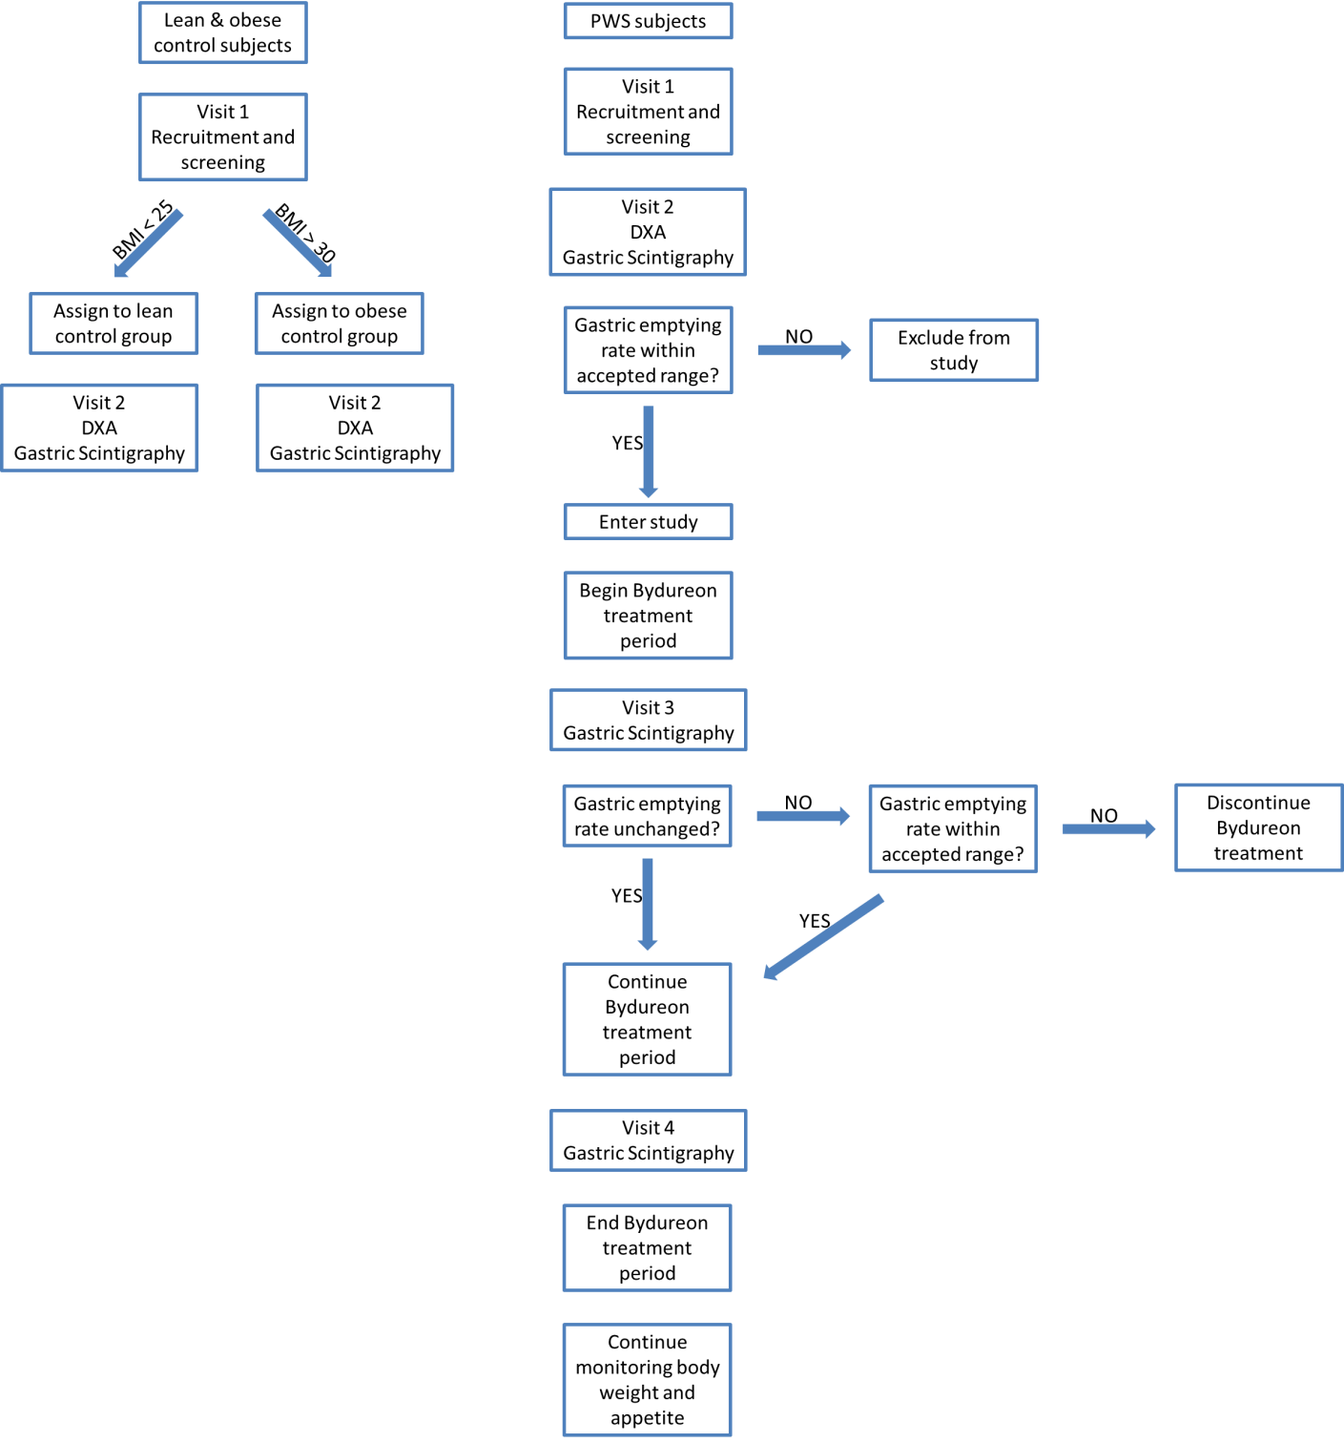

*4 weeks*

*12 weeks*

5.2 INVESTIGATION PLAN

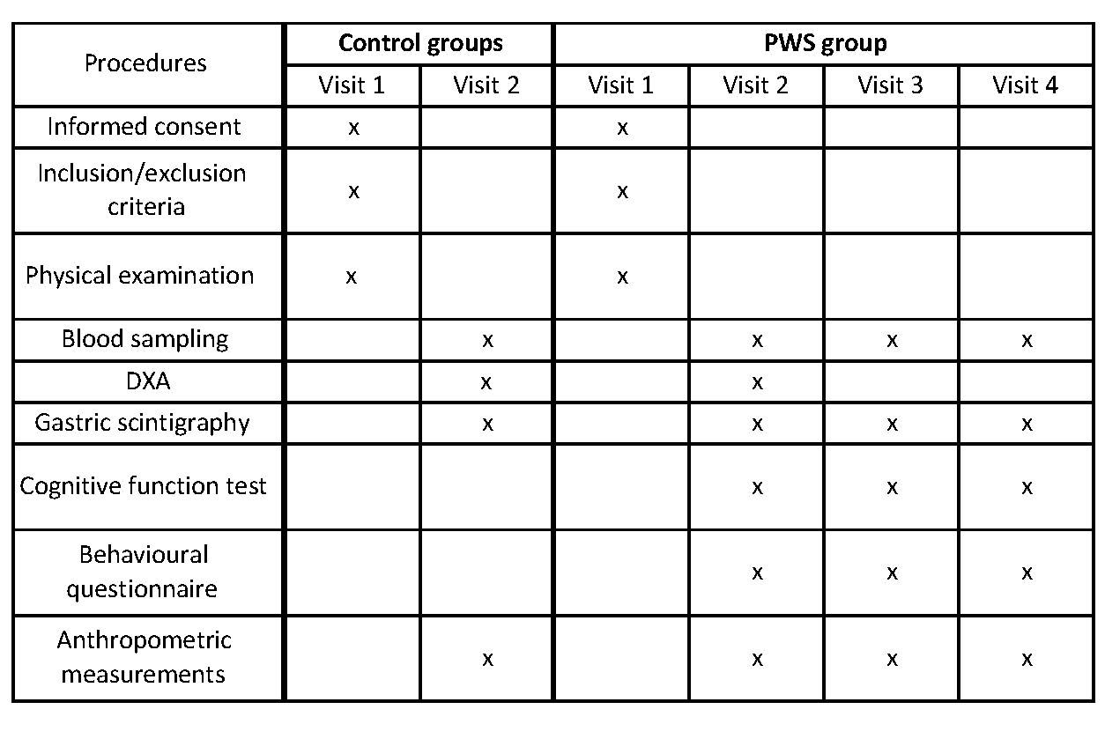

Table 1: Procedures performed at the Garvan Clinical Research Facility during the study.

Study visits:

*Lean and obese control subjects*

Visit 1 – Screening and enrolment: After initial contact by phone in response to newspaper advertisement, control subjects will undergo screening at the Garvan Institute Clinical Research Facility. A clinical assessment will be performed and, if suitable for the study and willing to participate, subjects will give informed consent and enter the study.

Visit 2 – Gastric scintigraphy study: Participants will fast from 10:00pm the night before the study and, upon arrival at the Garvan Institute Clinical Research Facility at 8:00am on the study day, height, weight and waist and hip circumference will be measured, and fasting blood samples will be drawn. Participants will be taken across the road to St Vincent’s Hospital where they will undergo a gastric scintigraphy study, which involves insertion of an intravenous cannula, eating a 99mTc-labelled breakfast and having blood samples collected at regular intervals. After completion of the scintigraphy study, participants will have a DXA scan at St Vincent’s Hospital to quantify lean mass and fat mass.

*PWS subjects*

Visit 1 (week 0) – Screening and enrolment: After initial contact by phone in response to communication via letter, PWS subjects will undergo screening at the Garvan Institute Clinical Research Facility. A clinical assessment will be performed and, if suitable for the study and willing to participate, subjects’ parents/guardians will give informed consent and subjects will enter the study. Participants will have a practice run of a brief tablet-based test of cognitive function (in the form of three simple, interactive games) to familiarise them with the test, which will be used at visits 2 and 4.

Visit 2 (week 0) - Participants will fast from 10:00pm the night before the study and, upon arrival at the Garvan Institute Clinical Research Facility at 8:00am on the study day, height, weight and waist and hip circumference will be measured, and fasting blood samples will be drawn. Participants will be taken across the road to St Vincent’s Hospital, where they will undergo a gastric scintigraphy study, which involves insertion of an intravenous cannula, eating a 99mTc-labelled breakfast and having blood samples collected at regular intervals. After completion of the scintigraphy study, participants will have a DXA scan at St Vincent’s Hospital to quantify lean mass and fat mass. Participants will complete the cognitive function assessment and their parents/guardians will complete a feeding behaviour questionnaire and receive instructions from one of the study doctors (Dr Amanda Hor) on how to perform the weekly exenatide ER injection on the person in their care. This drug will be prescribed by one of the study doctors, and procured and supplied by pharmacists at St Vincent’s Hospital. The 12-week exenatide ER treatment period will begin after this visit.

Visit 3 (week 4) – Participants will undergo gastric scintigraphy at St Vincent’s Hospital as per visit 2.

Visit 4 (week 12) – Participants will undergo gastric scintigraphy and cognitive assessment at St Vincent’s Hospital and parents/guardians will complete the questionnaire as per visit 2.

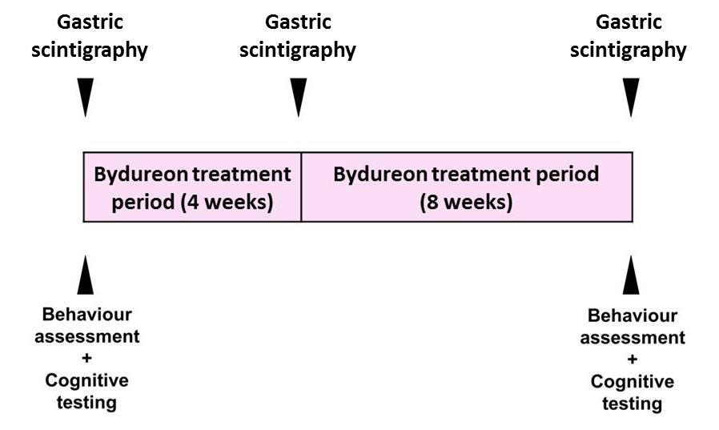

Figure 2: Study design and procedures for PWS participants

Details of study procedures:

*Gastric scintigraphy*

Participants will fast from 10:00pm the night before the study. On the day of the study, height, weight and waist and hip circumference will be measured, and fasting blood samples will be drawn. In St Vincent Hospital’s nuclear medicine unit, a cannula will be placed in participants’ arms and they will be given a meal (scrambled eggs with potato, ricotta and cheese) labelled with 99mTc Calcium Phytate Colloid and asked to eat it within 10 minutes. Participants will then lie supine during four 10-minute scans: immediately after eating the meal and at 1 hour, 2 hours and 4 hours postprandial. Blood samples will be collected prior to meal ingestion and immediately before each scanning time point. Plasma and serum will be obtained from blood samples collected during the study by centrifugation and stored at -80⁰C until being analysed for levels of glucose, insulin, gut hormones and lipids. Appetite will be assessed using hunger and fullness visual analogue scales before and hourly after the meal. After completion of the scintigraphy study, participants will have a DXA scan to quantify lean mass and fat mass.

*DXA*

Body composition (specifically fat mass, lean mass and bone mineral density) will be performed by whole body DXA at St Vincent’s Hospital. Participants will lie supine in the scanner for approximately 5 minutes while the scan is performed.

*Cognitive assessment*

Cognitive function will be assessed via the use of three tablet-based games (Cambridge Neuropsychological Automated Testing Battery (CANTAB) software, Cambridge, UK) which will take approximately 20 minutes to complete. These tasks measure learning, reaction time and special working memory, and are validated for use in people with intellectual impairment (7). A member of the research team will use a standardised script that accompanies the software to instruct participants how to complete the test.

5.3 STUDY PROCEDURE RISKS

*IV cannulation*

Placement of the IV cannulas may cause some pain and/or discomfort. The participant may choose to have an anaesthetic cream applied to the skin before insertion of the needle. There is a slight chance of skin irritation, bruising and/or infection at the cannulation site, however this risk is minimised by using sterile technique and appropriate haemostasis and advising participants to avoid heavy lifting after study visits.

*Exenatide ER injection*

The weekly subcutaneous injection of exenatide ER could cause slight pain, minor bruising and/or itching of the skin. Occasionally, a small, painless bump or hardening of the skin can form at the injection site. These are harmless, and usually disappear within a few weeks.

*Exenatide ER treatment*

Some people who take exenatide ER experience mild to moderate nausea. This usually decreases over time. Other possible side effects include vomiting, diarrhoea, constipation and low blood sugar levels. These symptoms are unlikely to occur; if experienced, they are not usually harmful. Nevertheless, any side effects will be closely monitored throughout the course of the study. There is a possibility that exenatide ER could have an effect on gastric emptying rate. Given the fact that delayed gastric emptying has been reported in PWS (although only in children), a further slowing would be undesirable in PWS. To minimise this risk, standard gastric emptying rates in healthy people will be established using both lean and obese control subjects. The gastric emptying rate of PWS participants will be assessed at baseline; those whose 4-hour gastric retentions fall above the 95th percentile of the standards established by controls will not enter the treatment arm of the study. For those that go on to commence exenatide ER treatment, a second gastric scintigraphy study will be performed 4 weeks into the treatment period to determine whether their gastric emptying rate has changed from baseline. If it has slowed to above the 95th percentile of the control standards, treatment will be discontinued in these participants. Those participants whose gastric emptying rate remains unchanged will continue with exenatide ER treatment to the end of the study.

*Scintigraphy and DXA scanning*

Study participants will be exposed to a minimal dose of radiation. The effective dose from these procedures is about 1.5 mSv. At this dose level, no harmful effects of radiation have been demonstrated as any effect is too small to measure. The risk is believed to be very low.

RECRUITMENT AND SCREENING

Public advertisement (control groups) and personal communication (PWS group) will be used to identify potential participants. Participants in the Lean and Obese groups will be contacted through advertisement in newspapers. Contact with the parents of potential PWS participants will be made by letter by the research team members involved in the RPA PWS clinic. Screening will be conducted by a member of the research team as per the inclusion/exclusion criteria listed above.

INFORMED CONSENT

Participants in the Obese and Lean groups will give informed consent on their own behalf. Since some people with PWS have intellectual disability and may have difficulty understanding the details and context of the study, consent for these participants will be given by their parents and/or guardians (only if the participant is willing to be enrolled in the study).

Participants (and their parents/carers in the case of the PWS group) will be given a detailed description of the research study and the participation experience. Any scientific or technical terms will be explained. Participants will be informed of the risks and benefits of being involved in the study, and the confidentially of research data will be made clear. They will be given contact details for seeking further clarification or reporting adverse events, and they will be assured that their potential participation in the study is completely voluntary and that they can withdraw from the study at any time without consequences. Sufficient time for participants (and parents/carers) to read the provided Patient Information Sheet and opportunity to ask questions will be given. If the participant decides to join the study, they (or their parents/carers) will sign the study consent form at this time.

5.4 ENROLMENT PROCEDURE

Public advertisement (control groups) and personal communication (PWS group) will be used to identify potential participants. Participants in the Lean and Obese groups will be contacted through advertisement in newspapers. Contact with the parents of potential PWS participants will be made by letter by the research team members involved in the RPA PWS clinic.

5.5 RANDOMISATION PROCEDURE

This study does not involve any randomisation.

**6. SAFETY**

6.1 ADVERSE EVENT REPORTING

Participants will be provided with contact details for Professor Lesley Campbell and Associate Professor Alexander Viardot, the chief and principal investigators, in case of any adverse event. If there is an adverse event, it will be reported to the St Vincent’s Hospital Human Research Ethics Committee in accordance with the requirements of the National Health and Medical Research Council, Australian Health Ethics Committee (AHEC) Position Statement “*Monitoring and reporting of safety for clinical trials involving therapeutic products*”. An adverse event can be any unfavourable or unintended sign, symptom or condition and/or an observation that may or may not be related to the study treatment.

6.2 DATA SAFETY AND MONITORING BOARD

As this project is a small-scale, investigator-initiated study, a data and safety monitoring board will not be used. Instead, collected data will be monitored monthly by an independent clinician, Dr Paul Lee (endocrine staff specialist at St Vincent’s Hospital).

**7. STATISTICAL CONSIDERATIONS**

*Sample size calculations*

To detect a difference in 4-hour gastric retention between groups with statistical power 1- β>0.85, we will require 8 individuals in each group. Allowing for a drop-out rate of 20%, this requires 10 participants for each of the control groups. As we anticipate that some PWS participants may not be eligible to enter the treatment arm of the study, we aim to recruit 20 individuals in the PWS group initially.

*Analysis plan*

A multi-centre study that established a set of international controls values for the assessment of gastric emptying by gastric scintigraphy designated ‘slowed gastric emptying’ as the 95th percentile of gastric retention at a given timepoint (8) and this approach has been recommended by The Society of Nuclear Medicine and The American Neurogastroenterology and Motility Society (9). Thus in the current study a standard set of values will be established by the obese and lean control groups, and the 95th percentile of gastric retention at 4 hours will be used as the cut-off value for the safe range for the individuals with PWS. Members of the PWS group with gastric retention above this value at Visit 1 will not enter the treatment arm of the study; those with gastric retention above this value at Visit 2 will discontinue treatment.

Baseline differences between groups in gastric emptying rate and anthropometric measurements will be analysed by one-way ANOVA. Changes in body weight, waist and hip circumference and cognitive function test scores in the PWS group throughout the course of the study will be analysed by repeated measures ANOVA.

**8. CONFIDENTIALITY AND STORAGE AND ARCHIVING OF STUDY DOCUMENTS**

Paper copies of collected information from the study will be stored in a locked filing cabinet and digital files will be stored on a password-protected secure server, both of which can only be accessed by the research team. Identifiers will be removed before analysis and dissemination of results. De-identified biospecimens will be stored in a freezer in a secure room with restricted access and stocktake of stored specimens will be periodically undertaken by a member of the research team. Collected data and biospecimens will be stored for 15 years, after which time they will be destroyed.

**9. OTHER STUDY DOCUMENTS**

* NEAF
* Radiation safety report
* Participant information sheet
* Consent form
* Study advertisement
* Initial contact letter for PWS participants

**10. REFERENCES**

1. [Seetho IW](http://www.ncbi.nlm.nih.gov/pubmed/?term=Seetho%20IW%5BAuthor%5D&cauthor=true&cauthor_uid=21227526), [Jones G](http://www.ncbi.nlm.nih.gov/pubmed/?term=Jones%20G%5BAuthor%5D&cauthor=true&cauthor_uid=21227526), [Thomson GA](http://www.ncbi.nlm.nih.gov/pubmed/?term=Thomson%20GA%5BAuthor%5D&cauthor=true&cauthor_uid=21227526), [Fernando DJ](http://www.ncbi.nlm.nih.gov/pubmed/?term=Fernando%20DJ%5BAuthor%5D&cauthor=true&cauthor_uid=21227526) (2011) Treating diabetes mellitus in Prader-Willi syndrome with Exenatide. [Diabetes Res Clin Pract](http://www.ncbi.nlm.nih.gov/pubmed/21227526) 92(1):e1-2.
2. Sze L, Purtell L, Jenkins A, Loughnan G, Smith E, Herzog H et al. (2011) [Effects of a single dose of exenatide on appetite, gut hormones, and glucose homeostasis in adults with Prader-Willi syndrome.](http://www.ncbi.nlm.nih.gov/pubmed/21632815) J Clin Endocrinol Metab 96(8):E1314-9.
3. Fintini D, Grugni G, Brufani C, Bocchini S, Cappa M, Crinò A (2014) [Use of GLP-1 receptor agonists in Prader-Willi Syndrome: report of six cases.](http://www.ncbi.nlm.nih.gov/pubmed/24652737) Diabetes Care 37(4):e76-7.
4. Choe YH, Jin DK, Kim SE, Song SY, Paik KH, Park HY et al. (2005) [Hyperghrelinemia does not accelerate gastric emptying in Prader-Willi syndrome patients.](http://www.ncbi.nlm.nih.gov/pubmed/15657368) J Clin Endocrinol Metab 90(6):3367-70.
5. Hoybye C, Barkeling B, Naslund E, Thorén M, Hellstrom PM (2007) [Eating behavior and gastric emptying in adults with Prader-Willi syndrome.](http://www.ncbi.nlm.nih.gov/pubmed/17622785) Ann Nutr Metab 51(3):264-9.
6. [Arenz T](http://www.ncbi.nlm.nih.gov/pubmed/?term=Arenz%20T%5BAuthor%5D&cauthor=true&cauthor_uid=21175084)1, [Schwarzer A](http://www.ncbi.nlm.nih.gov/pubmed/?term=Schwarzer%20A%5BAuthor%5D&cauthor=true&cauthor_uid=21175084), [Pfluger T](http://www.ncbi.nlm.nih.gov/pubmed/?term=Pfluger%20T%5BAuthor%5D&cauthor=true&cauthor_uid=21175084), [Koletzko S](http://www.ncbi.nlm.nih.gov/pubmed/?term=Koletzko%20S%5BAuthor%5D&cauthor=true&cauthor_uid=21175084), [Schmidt H](http://www.ncbi.nlm.nih.gov/pubmed/?term=Schmidt%20H%5BAuthor%5D&cauthor=true&cauthor_uid=21175084) (2010) Delayed gastric emptying in patients with Prader Willi Syndrome. [J Pediatr Endocrinol Metab](http://www.ncbi.nlm.nih.gov/pubmed/?term=arenz+prader+willi) 23(9):867-71.
7. van Nieuwpoort IC, Deijen JB, Curfs LM, Drent ML (2011) [The relationship between IGF-I concentration, cognitive function and quality of life in adults with Prader-Willi syndrome.](http://www.ncbi.nlm.nih.gov/pubmed/21223969) Horm Behav 59(4):444-50.
8. Tougas G, Eaker EY, Abell TL, Abrahamsson H, Boivin M, Chen J et al. (2000) [Assessment of gastric emptying using a low fat meal: establishment of international control values.](http://www.ncbi.nlm.nih.gov/pubmed/10894578) Am J Gastroenterol 95(6):1456-62.

Abell TL, Camilleri M, Donohoe K, Hasler WL, Lin HC, Maurer AH (2008) [Consensus recommendations for gastric emptying scintigraphy: a joint report of the American Neurogastroenterology and Motility Society and the Society of Nuclear Medicine.](http://www.ncbi.nlm.nih.gov/pubmed/18028513) Am J Gastroenterol 103(3):753-63.