

**School of Health Sciences**

**Information Sheet**

**Title:** The Effects of Simulated Military Land Transit on Physical Performance.

**Invitation to participate:** You are invited to take part in a study exploring the effects of simulated land transit on physical performance. As part of this study you will be exposed to a period of simulated military land transit using a six-degree-of-freedom simulation platform like those commonly seen as flight simulators. You will also complete a battery of physical performance tests that will test jump height, sprint speed, agility, strength and flexibility.

**Study overview:**  You will be required to complete a physical performance testing protocol, consisting of a depth jump, 20 m sprint, reactive agility test, hand-arm steadiness test, isometric deadlift, and sit and reach test. Once you have completed the protocol you will be strapped into a six-degree-of-freedom simulation platform unit similar to those used as military training units. The simulation unit will then expose you to one of four randomly selected exposure conditions lasting two hours. Once the two hours has been completed you will then repeat the same physical performance testing protocol as previously mentioned.

**Eligibility criteria:** You should be male, aged 18 to 24. At your familiarisation visit, you will be required to complete the ADF pre-entry fitness assessment which includes reaching level 7.5 on the Multistage Fitness Test (beep test), completing 15 push ups and 45 sit ups (feet held).

**Familiarisation session**: Prior to the testing protocol you will be required to complete a familiarisation session. During this session you will be required to pass the ADF pre-entry fitness assessment to ensure that your physical fitness is up to the same standards as those recruited into the army, and in the situation that you are unable to you will not be included in the study. Along with this you will be familiarised with the testing protocol to minimise the possibility of a learning effect when completing the test protocol. This will involve you completing the protocol a number of times until you feel comfortable with the techniques and demands. The familiarisation session will be completed either as a group or an individual and will take no longer than one hour. Once complete you will be randomly allocated to one of the four exposure conditions; positive control (strapped in but no vibrations), negative control (no vibrations and not strapped in), exposure group 1 (strapped in and exposed to smooth road conditions), and exposure group 2 (strapped in and exposed to rough road conditions). A date and time will then be organised for you to complete the testing protocol.

**Testing protocol:** The testing protocol will be complete on an individual basis and will take no longer than three hours. As part of the protocol we are interested in measuring the muscle activity of a number of muscles during exposure conditions and as such you will be required to have a number of muscle sites located and identified for surface electromyography (EMG). Surface EMG is a non-invasive method whereby the sites have to be first abraded using soft sand paper and then wiped clean with an alcohol wipe. An adhesive electrode will then be attached to the site and used to measure the activity of that muscle.

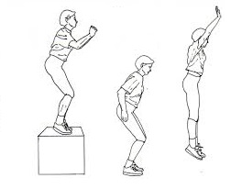Before exposure to either the control conditions or land transit simulations you will complete the following physical performance test protocol in the order stated below:

*i) Depth jump (DJ).* You will be required to land from a height of 0.65 m and immediately rebound, performing a maximal vertical jump.

*ii) 20 m sprint.* Following the DJ, you will perform a 20m sprint starting from a stationary standing position. Time will be recording using a set of timing gates positioned at the start and finish of the sprint

*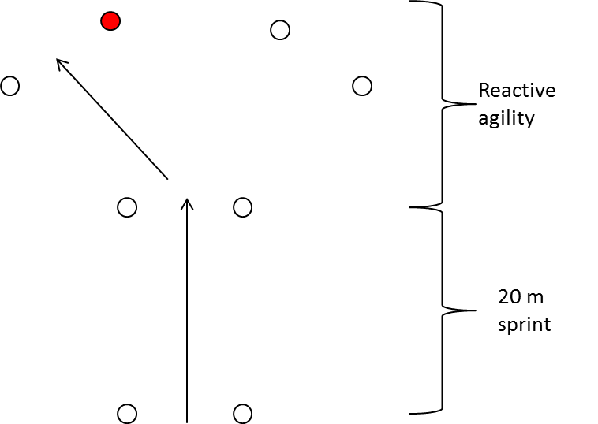iii) Reactive agility drill.* Upon crossing the final set of timing gates of the 20m sprint a signal light will activate on one of two additional sets of timing gates positioned 5 meters apart from each other and 5 meters from the 20m finish forming a ‘Y’ if looking at the gates from above. In reaction to the signal light you must then perform a change of direction and cross through the corresponding set of timing gates as quickly as possible.

*iv) 1 minute arm-hand steadiness test.* For the purpose of this study arm-hand steadiness is defined as the ability to maintain the muzzle end of a replica weapon in a steady position with the weapon held at the shoulder whilst in the standing position. You are required to stand in front of a metal plate set at shoulder height, and maintain a 2mm stylus within a 4mm hole in the plate without touching the sides. Performance will be measured by the number of contacts the stylus makes with the plate.

*v) Isometric deadlift.* You will be instructed as to the safest deadlift technique and practice this technique during the familiarisation session. During the protocol you will be required to pull a bar fixed to a load cell as hard as possible for five seconds. The load cell will be fixed to floor at one end via a dynabolt, with a short bar that can commonly be found in commercial gyms attached to the opposite end.

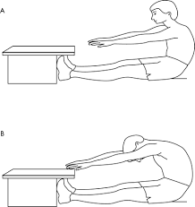

*vi)Sit and reach test.* Following the isometric deadlift you will be required to perform a sit and reach test. This test requires that you sit with legs out straight and feet flat against a box. Placing your hands one on top of the other so that your fingers line up you will then reach forward as far as possible in one smooth movement without bouncing.

Once the protocol has been completed you will then be strapped into the Bushmaster seat position atop the simulation platform and be exposed to two hours of simulated land transit. Once the two-hour exposure is complete you will then repeat the testing protocol as outlined above.

**Post study:** Following completion of the study your test data can be provided upon request via email. If it is of interest the study results can also be made available to you at a later date via email.

**Risk:** Due to the nature of the testing there is small risk of physical injury associated with the physical performance testing, however this risk is no higher than if you were to participate in sport or physical activity. Along with the risk of injury related to the testing protocol there is also a small risk of injury due to the forces you will be exposed to during the simulated land transit exposure, however international standards (ISO 2631) have been followed to ensure that the whole body vibrational forces to not exceed the root mean squared value of 1.6 m·s-1 as suggested for an exposure of this duration, thus minimising any risk of injury.

**Compensation:** It is predicted that the combined familiarisation and testing protocol will take no more than four hours total andas compensation for your time we are offering a single payment of $100. This payment will be transferred directly to a bank account of your choice at the completion of the study.

**Publication:** The results from this study may be published in conference papers, scientific journals, and a PhD thesis or other venues as appropriate at a later date. Your personnel information and results will remain confidential and no information which may lead to the identification of individuals will be released unless required by law

**Withdrawal:** You are free to withdraw from this study at any point if you wish to do so. Withdrawal at any point will have no negative affect on any current or future relationships you have with the university. Any data collected prior to your withdrawal may still be used, however this data will be de-identified prior to publication or presentation maintaining your confidentiality.

**Outcomes:** It is hoped that this research will provide the ADF with valuable information regarding the influence of military land transit on the physical performance of their personnel, which in turn may inform decisions related to vehicle purchase, normal operating procedures and tactical training.

**Ethical approval:** This project has been approved by the University of South Australia’s Human Research Ethics committee. If you have any ethical concerns about the project or questions about your rights as a participant please contact the Executive Officer of the Committee, Tel: +61 8 8302 3118; Email: vicki.allen@unisa.edu.au

**Contact:**

The primary contact for this study is the primary researcher, Mr Thomas Debenedictis. Additional contact details are also included below.

**Primary researcher: Primary supervisor**

Mr Thomas Debenedictis Dr Dominic Thewlis

PhD Student Senior Lecturer in Human Movement

School of Health Sciences School of Health Sciences

University of South Australia University of South Australia

Ph: +61 8 830 22083 Ph: +61 8 830 21540

Email: thomas.debenedictis@mymail.unisa.edu.au Email: Dominic.Thewlis@unisa.edu.au

**Co-Supervisor Co-Supervisor**

Dr Steven Milanese Dr Grant Tomkinson

Program Director: Bachelor of Health Sciences Senior Lecturer

School of Health Sciences School of Health Sciences

University of South Australia University of South Australia

Ph: +61 8 830 21053 Ph: + 61 8 830 21407

Email: Steve.Milanese@unisa.edu.au Email: grant.tomkinson@unisa.edu.au

**Associate Supervisor Associate Supervisor**

Dr Daniel Billing Mr Alistair Furnell

Physical performance team leader Ergonomics Team Leader

Defence Science and Technology Group Defence Science and Technology Group

Ph: 03 9626 8588 Ph: 03 9626 8411

Email: Daniel.billing@dsto.defence.gov.au Email: Alistair.Furnell@dsto.defence.gov.au