Research Plan: Exercise rehabilitation and functional recovery following reverse total shoulder arthroplasty

Background, Rationale and significance
Reverse total shoulder arthroplasty (RSA) is an end-stage surgical treatment option for patients with rotator cuff arthropathy and/or massive rotator cuff tears with who have significant difficulty in moving their shoulder and undertaking daily activities. RSA has demonstrated good success at relieving pain, improving range of motion, functional capacity and overall satisfaction,^{1,2} and with expanding indications and successful midterm outcomes, it is now being performed in a wider patient demographic, including younger patients.^{3,4}

As with other joint replacement surgery, a well-planned postoperative rehabilitation program, in combination with a correctly performed surgical procedure, is essential in optimising patient outcomes.⁸ While rehabilitation is generally recommended following RSA, these recommendations are based on expert opinion only,¹¹ with no studies having investigated the effect of structured postoperative rehabilitation at an evidence level of 1 or 2. Following RSA, patients with greater isokinetic shoulder strength participate in higher demand recreational or sports activity and report fewer difficulties with activities of daily living,¹⁰ and conversely, lower isokinetic shoulder strength is known to be a major factor in reduced range of motion (ROM),⁷ and is also associated with inferior clinical outcomes following RSA.⁷ Furthermore, with the evolution of reverse implant designs, rehabilitation has since not evolved to exploit the greater benefit to patients. In particular, in modern designs showcasing a lateralized humeral offset, these change moment arms and muscular fiber alignment now allow for greater external rotation, than past implant previously allowed. Torrens et al reported small improvements in postoperative rotation are perceived to be beneficial by patients, whereas large improvements are required in forward elevation for patients to perceive a benefit. Therefore, on top of standard deltoid rehabilitation, rehabilitation programs should also target external rotation to a greater degree than previous.

Return to sports and physical activity is increasingly being evaluated as a factor in judging orthopaedic surgical outcomes. An increase in patient activity intensity post-surgery may reflect greater function associated with clinical improvements in range of motion, strength, pain and / or overall physical function. Conversely, patients avoiding high intensity activities may represent deteriorating function associated with clinical impairments.⁵ A variety of different methods are routinely employed to assess patient function after RSA, such as self-reported questionnaires. Previous studies have demonstrated relationships between strength and self-reported activity and functional outcomes,⁶⁻⁸ however self-reported outcome evaluations are dependent on patient recall and perception of activity performance which do not inherently capture detailed functional movement data. Furthermore, within-clinic assessments fail to capture an accurate representation of upper limb function during activities of daily living in a patient’s natural living environment. The use of activity monitors in measuring function and limb use after injury to assess the impact of disease on movement, and the effectiveness of intervention in normalising limb use has grown to involve the upper extremity, including those scheduled for RSA.⁹ Using body-worn activity monitors in the upper extremity as an alternative method for evaluating patient function post-surgery, may allow for a more objective measurement of the frequency, duration, and intensity of shoulder function in patients after RSA.

This research aims to investigate the benefit of a structured, post-operative exercise program in patients following RSA, compared with control subjects who receive the usual conservative course of management. Furthermore, this study will also investigate the effectiveness of using upper limb activity monitors to objectively capture upper extremity function in patients following RSA.

2. Statement of the Purpose and Aims of the Project
This research will comprise of two primary studies. The first part of this research is a prospective RCT investigating the benefit of a structured post-operative exercise rehabilitation program in patients undergoing RSA. The purpose of this study is to investigate the capacity in which a structured post-surgery exercise program can improve patient strength, active range of motion (AROM) and early functional recovery after RSA, compared with control subjects who receive the usual course of care.

Specifically, this study will examine:

- The extent to which patients with rotator cuff dysfunction, with or without arthropathy, tolerate and comply with an exercise rehabilitation post-surgery.
- The value of exercise rehabilitation on the patient’s rate of improvement in strength, active range of motion and function after surgery
- The value of exercise rehabilitation on the patient’s final level of improvement in upper extremity function and other aspects related to quality of life after surgery, including sports and recreation.

The following research hypotheses will be tested:

- Participants in the exercise group will demonstrate improvement in baseline strength, AROM and upper extremity function following the preoperative exercise program
- Patients in the exercise (EM) group will demonstrate relatively greater improvement in pre-operative AROM and upper extremity function at 3, 6 and 12 months’ post-surgery, compared to the usual management group (UM).
- Patients in the exercise EM group will report higher levels of post-operative satisfaction at 3, 6 and 12 months’ post-surgery, compared to the UM group.

The second part of this research will seek to evaluate the effectiveness of using body-worn upper limb activity monitors to objectively capture upper extremity function in patients after RSA and to a.) compare activity data between the operated and non-operated limb, b.) evaluate the proportion of time spent in low, moderate and high intensity activities, and c.) correlate this data with self-reported functional scores from common clinical questionnaires and satisfaction surveys across the postoperative timeline.

The specific aims of this study include:

- Evaluating upper limb function in patients with rotator cuff dysfunction, with or without arthropathy, scheduled for RSA using activity monitors worn on the upper limb, and comparing them to a separate healthy control group.
- Evaluating upper limb function in patients at 3-, 6- and 12 months’ post-RSA using activity monitors worn on the involved limb and comparing them to their uninvolved limb, as well as a separate healthy control group.
- Determining whether the level of activity, including volume and intensity, correlates with self-reported, perceived function post-RSA and subsequent rehabilitation.

The following research hypotheses will be tested:

- Overall functional limb use will significantly improve in patients undergoing RSA, from baseline to 3-, 6-, and 12 months’ post-surgery
- Overall functional limb use will significantly improve in patients after RSA randomised to the EM rehabilitation group, compared to the usual care (UM) care group, at 3-, 6-, and 12 months’ post-surgery
- Greater overall functional limb use / activity will correlate with greater self-reported physical activity and functional scores

3. Methods

Study 1

3.2.1 Study population, informed consent and recruitment

This is a prospective RCT investigating two different postoperative management regimens in patients following RSA and, therefore, patients scheduled for RSA that fit the below inclusion study criteria and at the discretion of their surgeon, will be invited to participate in this trial.

Participants will be invited to be part of the study after consultation with their surgeon having confirmed rotator cuff dysfunction or tear, with or without arthropathy, via clinical examination and magnetic resonance imaging (MRI). After being scheduled for surgery, patients will be informed of the study and referred to the study investigator, whereby contact will be made, either in person or over the phone, to explain the study in more detail. The Patient Information Sheet (Appendix 1), a pre-operative Patient Questionnaire and a verbal summary of the study and patient expectations, with reference to the two different rehabilitation pathways, will be presented to the patients. Patients willing to participate will then complete the Patient Consent Form (Appendix 1), a pre-operative Patient Questionnaire the and will then be randomized to one of the two rehabilitation arms of the study: usual management (UM) group or the exercise management (EM) group. Ethical approval has been obtained from the St John of God (SJOG) Research Ethics Committee, as well as the University of Western Australia Research Ethics Committee. The written, informed consent from each patient will be collected prior to or immediately after surgery.

Patients meeting the following criteria will be eligible for inclusion in this study:
- Male or female, between 55 and 80 years and local to the Perth metropolitan area
- Patients with a massive rotator cuff tear, with or without arthropathy, subsequently scheduled for RSA
- Pseduoparalysis of the affected shoulder, including forward elevation <90 degrees
- All patients require preoperative MRI

Patients with the following criteria will be excluded from participation:
- Require a revision shoulder arthroplasty
- Recent or previous fractures of the shoulder complex
- Adhesive capsulitis
- Present with pre-existing conditions associated with upper extremity pain, including ongoing infection, carpal tunnel syndrome, cervical neuropathy or other nerve pathology
- Clinically verified polyarthritis, rheumatoid arthritis and/or fibromyalgia
- Failed medical clearance to participate in exercise
- Are likely to have problems with follow-up (i.e. patients with no fixed address, report a plan to move out of town, or intellectually challenged patients without adequate support network)
- Do not read and speak English
- The individual is unable or unwilling to follow the designated pre- and/or post-operative rehabilitation protocol

Withdrawal Criteria
As outlined on the Patient Consent Form, patients will be free to withdraw from the study without prejudice or altered post-operative care.

Sample Size Calculation
A power analysis using G power software¹⁸ was performed to calculate the sample size required for this study. Assuming a 5% significance level, a power of 0.8 a sample of 31 patients in each group was required to detect a 10-point difference in ASES scores¹⁹, To account for a 5% drop out rate, a total of 66 patients (33 in each group) has been proposed.

3.1.2 Procedures:

As outlined above, patients will first be seen at pre-operatively or immediately post-operatively at HFRC Rehabilitation Clinic (“The Clinic”) or the private practices of Mr Allan Wang and Mr Peter Honey two weeks after their scheduled surgery. Patients being offered RSA that meet the inclusion criteria for this study will be invited to participate in the trial. The Patient Information Sheet and a verbal summary of the study and the expected participation will be presented to the patients. Those patients willing to participate will then complete the Patient Consent Form (Appendix 1), a pre-operative Patient Questionnaire, and will be randomised to either the EM or UM groups. The pre-operative Patient Questionnaire contains a series of validated questionnaires pertaining to shoulder pain, function, movement and strength, as well as a general baseline assessment involving previous injuries, medical history, demographics and activity level. A summary of the study design is outlined in Figure 1.

Figure 1. Study flow chart

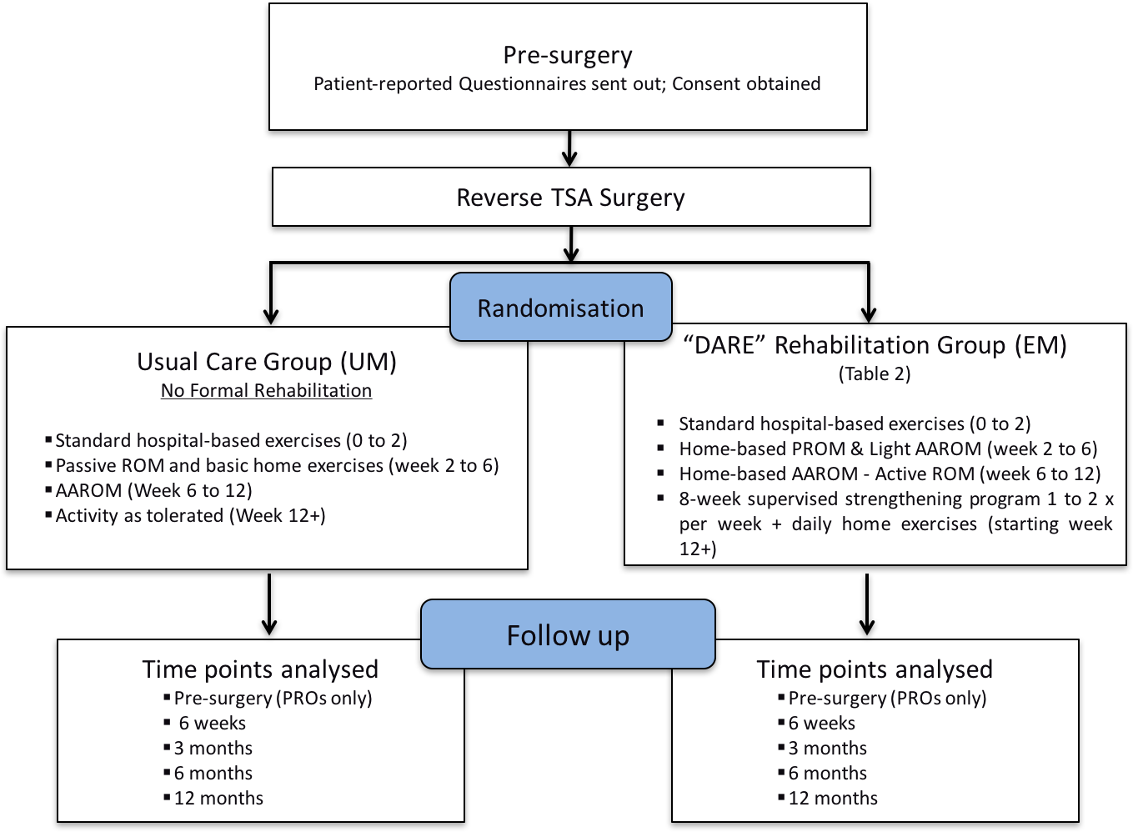

The Surgical Technique

All patients will undergo RSA under general anesthesia in a semi–beach chair position with routine antibiotic prophylaxis. A deltopectoral approach will be used in all cases. The subscapularis tendon will be tagged and mobilised. A limited tenotomy of the superior edge of the pectoralis major tendon will be performed for mobilization of the proximal humerus and to improve exposure of the glenoid. RSA will be performed using a medial glenoid, lateral humerus design (Equinoxe Reverse Shoulder Design, Exactech, Inc; Gainesville, FL) in all cases.

Post-operative Exercise Rehabilitation

Initially, all patients will be placed in an immobilisation sling for 4 to 6 weeks and instructed to adhere strictly to the activity restrictions set by their surgeon. All patients will be educated on optimal management for reducing pain and/or swelling, as well as safely removing and fitting of the sling and clothing, and all contraindications and precautions associated with the surgical procedure. In-patient exercises will focus on safe passive range of motion (PROM) of the shoulder, as well as AROM of the hand, wrist and elbow. As mentioned above, these exercises will also be developed into a home exercise program (HEP) for patients to continue with in the comfort of their home.

Following hospital discharge, all patients be followed up by their respective surgeon 2 weeks’ post-surgery to tend to the surgical wound, and then again at 6 weeks’ post-surgery for routine follow-up. From the 2-week time point, patients randomised to the usual management group (UM) will receive routine mobility exercises aimed at progressing their shoulder movement (Table 2). Patients randomised to the DARE exercise group, will receive these same standard exercises, with additional light, submaximal muscle contractions around the shoulder to boost early strength (Table 2). Patients will be required to complete these home-exercises two to three times daily, lasting for approximately 30 minutes up until the 6-week time point At the 6-week time-point, after the patients a reviewed by their surgeon and have their immobilisation sling removed, patients in each respective group will have their exercises progressed accordingly (Table 2). Patients will be required to complete these home-exercises two to three times daily, lasting for approximately 30 minutes up until the 12-week time point. Patients will all receive a “post-surgery home exercise guide” as a reference, but also acting as a patient diary to record all exercises done over the 12 weeks. All patients will continue to be monitored throughout the post-surgery timeline, irrespective of the group they have been assigned.
At 12-weeks post-surgery, patients randomised to the EM group will be referred to the Clinic (HFRC), to begin an 8-week supervised, strengthening exercise program, consisting of 30 to 60 minute sessions, once or twice per week. This program of intensified strength and conditioning will look to advance deltoid and internal, and external rotator strength to improve functional elevation & active rotation, as well as scapula stability training and cardiovascular exercise under the supervision of an Exercise Physiologist. Patients will also be required to complete daily home exercises, which will again be referenced in the “post-surgery home exercise guide.” A brief overview of goals, exercises and guidelines for the EM group is demonstrated in Table 2.

Patient Evaluation

The following measures will be undertaken following surgery at the designated time points.

- Patient-reported Outcome (PRO) Assessments

Patients in both the EM and UM groups will be required to attend follow-up clinical assessments at 6 weeks, as well as 3, 6, and 12 months post-surgery. A series of short, validated PROs will be employed to evaluate post-treatment outcomes. These will include:

- The Constant-Murley Subjective Questionnaire
- The American Shoulder and Elbow Surgeons Questionnaire (ASES)
- The Australian Quality of Life Questionnaire (AQoL)
- The Godin Physical Activity Questionnaire
- The Hospital for Special Surgery’s Shoulder Surgery Expectations Survey
- The Self-Efficacy for Rehabilitation Outcome Scale
- The Patient Satisfaction Questionnaire

Table 2. Proposed post-surgery rehabilitation protocol for the Exercise Management (EM) group.
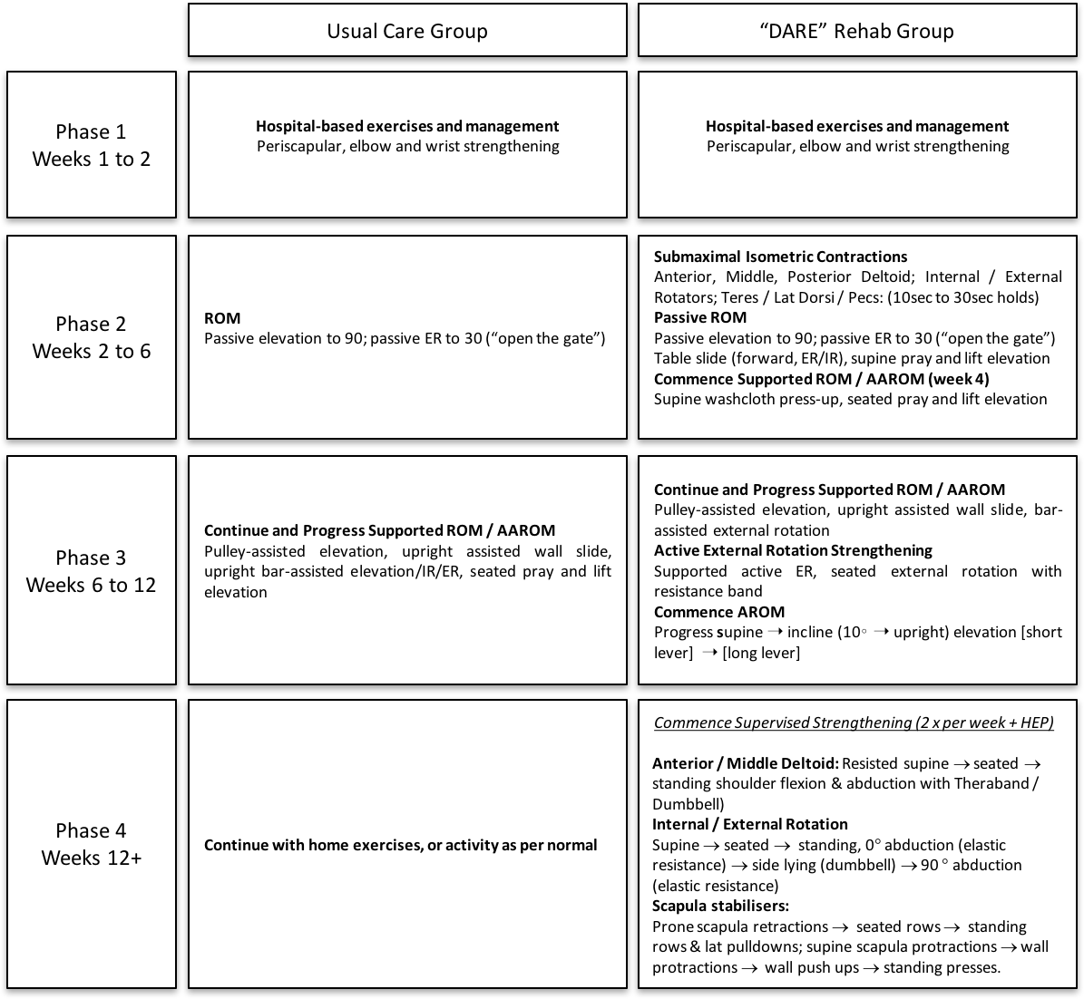

- Functional Patient Assessment

Patients’ bilateral AROM will be measured in all planes (abduction, flexion, internal and external rotation) using a fluid inclinometer or standard goniometer at 3-, 6- and 12 months’ post-surgery. AROM will be measured within the patients’ pain tolerance to minimize any risk of injury or discomfort. The Constant Score will also be evaluated, which is a shoulder-specific tool using a combination of subjective and objective components to assess shoulder function. The maximum score of 100 points consists of 35 points based on subjective assessments of pain and activities of daily living and 65 points based on examiner-derived measurements of shoulder strength and ROM. The higher the score, the higher is the quality of function. Strength in abduction will be measured via a strain gauge with the patient in a standing position with the arm in the scapular plane and 90° of elevation, with the hand and forearm pronated. The measurement should be pain-free and the highest value out of three is used.

All participants at 12 months post-surgery undergo evaluation of isokinetic shoulder strength using a Biodex System 3 Pro dynamometer (Biodex Medical Systems, New York, NY , USA) at the University of Western Australia. Three protocols of shoulder movement will be tested: internal and external rotation, abduction and adduction, and forward flexion and extension. For each protocol, patients will be tested within a locked range of motion predetermined by their limit of comfort. The isokinetic testing was performed with the dynamometer velocity set to 60°/s. Each protocol will consist of 1 practice motion to ensure comfort and technique. After 2 minutes of rest, 3 consecutive repetitions of the movement at maximum power will be performed and measurements will be recorded.

C. Activity Data Assessment

Functional limb activity will be measured using four ActiGraph GT9X+ Link (ActiGraph, Pensacola, FL) activity monitors secured bilaterally to the upper arms at the mid-biceps, and the lower arms at the wrist as per previous recommendations⁹. Activity data will be collected over three consecutive at 3-, 6- and 12 months’ post-surgery in patients’ natural living environment, but not including time spent sleeping or showering The accelerometer sampling rate will be set at 100 Hz (as recommended by the manufacturer). The vector magnitude (VM) physical of activity counts from each accelerometer will be calculated with ActiLife software (ActiGraph, Pensacola, FL). The ActiLife VM physical activity counts will be exported to an Excel spreadsheet using 15-second epochs during the entire data collection. The average activity for each limb segment will be determined each day by calculating the arithmetic mean of the epoch activity value within 1 day for each subject. A within-subject average activity value will subsequently be calculated for each limb segment over the 3 days of collection. Novel techniques used to determine limb asymmetries and activity intensities will also be applied.^{5,9}

3.1.3 Data handling, statistical analysis and reporting of results

Paper records will be kept under lock and key in a metal filing cabinet in the SJOG Hospital. Computer records will be stored in the assessor database and will be password protected. The patients consulting surgeon and the study investigators will only have access to hand written and electronic records. Records will be kept for 15 years after which, paper records will be shredded and computer records will be permanently deleted including back-up copies. The result of the research will be made available through medical journals or meetings, but all patient information will be de-identified and no private information will be identified outside the investigator office.

Statistical analysis will be performed using SPSS software (SPSS, Version 11.5, SPSS Inc., USA). A series of repeated measures analysis of variance (ANOVA) will be used to investigate primary and secondary clinical outcome measures between the two rehabilitation groups at baseline, and at 3, 6, and 12 months’ post-surgery. Where a significant interaction effect is found, post-hoc independent t-tests will be used to determine time-points at which the two groups differ. Statistical significance will be determined at p ≤ 0.05.

At baseline, a series of one-way analyses of variance (ANOVA) will be performed to determine if initial differences exist between the two patient groups. To determine the efficacy of a pre-surgery exercise program, a series of one-way analysis of variance (ANOVA) will be performed in conjunction with post-hoc paired t-tests in the results obtained between the pre-intervention and pre-operative time points, and then again at 3-, 6-, and 12 months’ post-surgery. When comparing the effectiveness of the surgery plus the exercise intervention, against the surgery plus usual care, a series of two-factor ANOVAs (group and time) will be taken at pre-surgery, 3-, 6-, and 12 months’ post-surgery.

Study 2

3.2.1 Study population, informed consent and recruitment

Thirty patients from the same RSA cohort as described above will be recruited for this study, as well as a control group consisting of thirty “apparently healthy” participants.

All control group participants are required to have no upper extremity injury at the time of testing, no symptoms in either upper extremity, and no history of shoulder surgery to either arm. Individuals who did not meet all participation criteria will not be eligible for study enrollment. Ethical approval will be obtained from St John of God Human Research Ethics Committee and the written, informed consent from each patient will be collected prior to surgery

3.2.2 Procedures:

Functional limb activity will be measured using five ActiGraph GT9X+ Link (ActiGraph, Pensacola, FL) activity monitors secured bilaterally to the upper arms at the mid-biceps, the lower arms at the wrist, and on the waist of each participant, as per previous recommendations.⁹ Activity data will be collected over three consecutive days preoperatively and at 3-, 6- and 12 months’ post-surgery in patients’ natural living environment, but not including time spent sleeping. After activity data collection, patients will complete the Oxford Shoulder Score (OSS), the Simple Shoulder Test (SST), and the American Shoulder and Elbow Surgeons evaluation form (ASES). An activity participation questionnaire and a patient satisfaction questionnaire used in previous studies will be employed, as well and a Global Rating Scale for Perceived Function.^{24,26} Mean, minimum and maximum daily physical activity counts will be evaluated for the lower and upper arm between the patient group and the control group over the three days. Limb asymmetries and activity intensities assessing the amount of time participants are inactive, and engaged in low-intensity and high-intensity activity using previously described algorithms^{5,9} will be compared between the control and patient groups.

3.2.3 Data handling, statistical analysis and reporting of results

Between group differences will be evaluated for the lower and upper arm for minimum, mean, and maximum activity counts with a univariate ANOVA. A paired samples t-test will be applied to the asymmetry indices results to compare between the control and patient groups for the lower and upper arm separately. Between group differences were also evaluated for the time spent across activity bins. When statistical significance was achieved, post hoc testing will be performed using independent samples t-test to determine where differences were occurring. For all measures alpha will be set a priori at p≤0.05. Pearson correlation coefficients will be computed between patient-reported outcome scores and the accelerometer scores.

4. References

1. Drake GN, O'Connor DP, Edwards TB. Indications for reverse total shoulder arthroplasty in rotator cuff disease. Clin Orthop Relat Res. 2010;468(6):1526–1533.
2. Naveed MA, Kitson J, Bunker TD. The Delta III reverse shoulder replacement for cuff tear arthropathy: a single-centre study of 50 consecutive procedures. J Bone Joint Surg Br. 2011;93(1):57–61.
3. Mulieri P, Dunning P, Klein S, Pupello D, Frankle M. Reverse shoulder arthroplasty for the treatment of irreparable rotator cuff tear without glenohumeral arthritis. J Bone Joint Surg Am. 2010;92(15):2544–2556.
4. Garcia GH, Taylor SA, DePalma BJ, et al. Patient Activity Levels After Reverse Total Shoulder Arthroplasty: What Are Patients Doing? Am J Sports Med. 2015;43(11):2816–2821.
5. Hurd WJ, Morrow MM, Kaufman KR. Tri-axial accelerometer analysis techniques for evaluating functional use of the extremities. J Electromyogr Kinesiol. 2013;23(4):924–929.
6. Wang AW, Bauer S, Goonatillake M, Breidahl W, Zheng MH. Autologous tenocyte implantation, a novel treatment for partial-thickness rotator cuff tear and tendinopathy in an elite athlete. Case Reports. 2013;2013(jan11 1):bcr2012007899–bcr2012007899.
7. Alta TDW, Veeger DHEJ, de Toledo JM, Janssen TWJ, Willems WJ. Isokinetic strength differences between patients with primary reverse and total shoulder prostheses: muscle strength quantified with a dynamometer. Clin Biomech (Bristol, Avon). 2014;29(9):965–970.
8. de Toledo JM, Loss JF, Janssen TW, et al. Kinematic evaluation of patients with total and reverse shoulder arthroplasty during rehabilitation exercises with different loads. Clin Biomech (Bristol, Avon). 2012;27(8):793–800.
9. Hurd WJ, Morrow MM, Miller EJ, Adams RA, Sperling JW, Kaufman KR. Novel approaches to objectively assess shoulder function. J Shoulder Elbow Surg. 2014;23(10):e251–e255.
10. Wang A, Doyle T, Cunningham G, et al. Isokinetic shoulder strength correlates with level of sports participation and functional activity after reverse total shoulder arthroplasty. J Shoulder Elbow Surg. April 2016.
11. Boudreau S, Boudreau ED, Higgins LD, Wilcox RB. Rehabilitation following reverse total shoulder arthroplasty. J Orthop Sports Phys Ther. 2007;37(12):734–743.
12. Ainsworth R. Physiotherapy rehabilitation in patients with massive, irreparable rotator cuff tears. Musculoskelet care. 2006;4(3):140–151.
13. Ainsworth R, Lewis JS. Exercise therapy for the conservative management of full thickness tears of the rotator cuff: a systematic review. BJSM online. 2007;41(4):200–210.
14. Ainsworth R, Lewis J, Conboy V. A prospective randomized placebo controlled clinical trial of a rehabilitation programme for patients with a diagnosis of massive rotator cuff tears of the shoulder. Shoulder & Elbow. 2009.
15. Levy O, Mullett H, Roberts S, Copeland S. The role of anterior deltoid reeducation in patients with massive irreparable degenerative rotator cuff tears. J Shoulder Elbow Surg. 2008;17(6):863–870.
16. Kuhn JE, Dunn WR, Sanders R, et al. Effectiveness of physical therapy in treating atraumatic full-thickness rotator cuff tears: a multicenter prospective cohort study. J Shoulder Elbow Surg. 2013;22(10):1371–1379.
17. Wiater BP, Koueiter DM, Maerz T, et al. Preoperative deltoid size and fatty infiltration of the deltoid and rotator cuff correlate to outcomes after reverse total shoulder arthroplasty. Clin Orthop Relat Res. 2015;473(2):663–673.
18. Faul F, Erdfelder E, Lang A-G, Buchner A. G*Power 3: a flexible statistical power analysis program for the social, behavioral, and biomedical sciences. Behav Res Methods. 2007;39(2):175–191.
19. Mulieri PJ, Holcomb JO, Dunning P, et al. Is a formal physical therapy program necessary after total shoulder arthroplasty for osteoarthritis? J Shoulder Elbow Surg. 2010;19(4):570–579.
20. Edwards P, Ebert J, Joss B, Bhabra G, Ackland T, Wang A. Exercise rehabilitation in the non-operative management of rotator cuff tears: a review of the literature. Int J Sports Phys Ther. 2016;11(2):279–301.

