ZESPRI
Study Protocol
Effects of long-term kiwifruit consumption on metabolic outcomes
A randomised, cross-over, clinical intervention pilot study in healthy participants
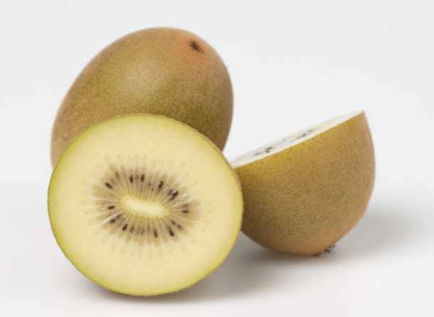
Principal Investigators:
Principal Investigator: John Monro, Plant and Food Research, New Zealand
Co-Investigators: Suman Mishra, Odette Shaw, Kerry Bentley Hewitt, Plant & Food Research, New Zealand.
Bernard Venn, Alexandra Lubransky, University of Otago, New Zealand.
Sally Poppitt, Auckland University, New Zealand.

Project Management:
Project Manager: Suman Mishra, Plant and Food Research, New Zealand

1. Introduction

Introduction
Fruit, including kiwifruit, are a valuable component of the human diet because of the wide range of vitamins, minerals and other bioactives that they supply. They are also generally rich in sugars, in particular fruit sugar (fructose) and glucose. Now that glucose intolerance and diabetes are becoming global megatrends there is a growing challenge of how to include fruit in the diets of glucose-intolerant consumers, especially in Asian markets for kiwifruit, in which the incidence of diabetes is expected to reach >400 million by 2030. Glucose may increase exposure to glycaemia and risk of long-term medical complications typical of diabetes. On the other hand, fructose, although less glycaemic, may raise blood triglycerides. Therefore, a concern is that reduced exposure to glycaemia as a result of ingesting fruit in place of more glycaemic foods may be counteracted by unfavourable changes in blood lipids. The challenge is, therefore, multifaceted:
- How to increase fruit intake without adversely increasing exposure to glucose-induced postprandial glycaemia (the primary outcome).
- How to do so without unfavourably altering plasma lipids due to an increase in fructose intake,
- How to use whole kiwifruit to gain the protective benefits of fruit bioactives against processes leading to diabetic complications.
The associated research questions are:
- Can kiwifruit be included in the diet without exacerbating exposure to postprandial glycaemia?
- Can the fructose-rich sugars in kiwifruit be regularly consumed without plasma lipid changes associated with increased disease risk?
- Can it be shown that regular consumption of kiwifruit in fact counteracts the systemic biochemical processes through which glycaemia leads to medical complications typical of long-term diabetes, which are believed to be mediated by glycation, inflammation and oxidative stress, and counteracted by fruit bioactives such as phenolics and vitamin C?

2. Proposed study
A principal investigator has been assigned to the study and will be responsible for the overall conduct of the study and preparation of the final report.
2.1 Objectives
- To determine, in a group of healthy individuals, the influence of consuming 2 kiwifruit per day over an extended period on:
  - Biomarkers of exposure to glycaemia (the primary objective).
  - Biomarkers of cardiovascular disease
  - Metabolomic profile
  - Biomarkers of exposure to oxidative stress
  - Biomarkers of systemic inflammation
  - Markers of absorption and metabolism of kiwifruit phytochemicals
  - Plasma vitamin C concentrations
- To obtain data on the variability of the above measurements in response to kiwi fruit intake in order to appropriately power upcoming trials.
- To estimate compensatory adjustments to food intake as a result of consuming two kiwifruit per day

2.2 Hypotheses
- Two kiwifruit per day may be incorporated into the diet without increasing cardiovascular disease risk factors such as circulating triglycerides indicated by blood lipid concentrations.
- Two kiwifruit per day may be incorporated into the diet without increasing long term exposure to glycaemia measured as HbA_{1c}.
- Consuming two kiwifruit per day reduces inflammatory responses and oxidative stress as indicated by appropriate biomarkers.
- Consuming two kiwifruit per day leads to a compensatory decrease in intake of other foods resulting in no net change in long term total energy intake.
- Even if compensatory decreases in intake of other foods occurs when two kiwifruit are included in the diet, plasma vitamin C concentrations are increased as a result of kiwifruit ingestion.
2.3 Study design
This is a pilot study is designed to provide a number of types of information that will be useful in larger, longer trials on long term effects of kiwifruit consumption planned for 2017 and 2018. It provides an opportunity to measure, and obtain experience in measuring a number of parameters relevant to the role of kiwifruit in health, which may be measured in the trials of 2017 and 2018. They include:
- Size of effects on biomarkers of health outcomes, and associated variability, as a result of ingesting two kiwifruit per day for an extended period.
- Compensatory adjustment to the intake of other foods in the diet as a result of consuming two kiwifruit. These results will show whether effects on carbohydrate and/or energy intake are near neutral, or whether food intakes will need to be more tightly controlled.
- Baseline variability of various biomarkers of health outcomes in the absence of kiwifruit intervention measured in a control group.
- Effects of ingesting two kiwifruit per day on nutrient status measured as plasma vitamin C concentrations.
- Whether consuming two kiwifruit per day leads to an increase in fructose intake and whether there is any change in plasma lipids that might indicate a metabolic effect of fructose.
- Tolerance of participants to continued long term consumption of two kiwifruit per day in terms of maintaining intakes and compliance.
- Plasma concentrations of phytochemicals in diets involving ingestion of two kiwifruit per day, relevant to concurrent study of pancreatic β-cell function.
- Practical information gleaned from the experience of running a long-term intervention study.

The research involves twenty subjects randomly allocated to two treatments, control and kiwifruit intervention, with the groups crossed over after a washout period. The duration of the intervention will be six weeks. There will be a three week lead in and a three week washout at cross over, and an additional three week kiwifruit-free follow-up at the completion of the trial (Figure 1). The kiwifruit intervention will require consuming two kiwifruit per day. The control and washout periods will involve ingesting no kiwifruit. All subjects will be asked to not consume vitamin supplements during the course of the trial. Otherwise, the intervention and control groups will be allowed to consume their customary diets but will be requested to fill out a food diary on the three days leading up to their visits to the clinic for blood sampling (Figure 1).
The primary outcomes in this intervention trial are plasma lipids and HbA1c.
Blood samples and a urine specimen will be taken from the kiwifruit intervention and control groups (i) at the end of the lead-in period (3 weeks), at the end of the first treatment arm (9 weeks), after the three week washout at crossover (12 weeks), after the second treatment arm (18 weeks), and after the concluding three week washout (Figure 1).

2.4. Power Calculation
This is a pilot study for which one of the aims is to obtain measures of variability of a number of parameters that will contribute to power calculations for later studies. The sample size of n = 20 per group is the maximum possible within the constraints of the trial, but has been adequate to provide significant differences in numerous trials of the effects of dietary fibres on plasma lipids and glucose responses, and in more recent trials of inflammatory markers in blood.

2.5. Statistical methods
This will be an intention to treat analysis (ITT), where data from all participants is included in the statistical analysis.
2.5 Subject recruitment
Twenty subjects will be recruited, online within Plant & Food Research, by flyer posted at Plant & Food and Massey University, and by advertising in a local newspaper, in all of which the study will be briefly described. Volunteers will be pre-screened by the Plant & Food staff who will ask initial recruitment questions in order to determine the suitability of the volunteers to take part in the study. The nature of the study and the involvement and responsibilities of participants will be described to the volunteers. Eligible volunteers who are willing to participate will be invited to attend the Plant & Food clinic. Their blood glucose and HbA1_{c} concentrations will be measured using a finger-prick capillary blood sample to make sure that they are within the normal range. In advance of the study each volunteer will be presented with an information sheet, containing study details, and an informed consent form.

Inclusion criteria:
Age: Aged between 20 and 60 years.
Gender: Male
Glucose tolerance: No history of diabetes (type I or II) or evidence of glucose intolerance in a preliminary oral glucose tolerance screening test.
Body Mass Index (BMI): between 20 and 35 kg/m², ie. normal weight and overweight
Health: Healthy as gauged by self-assessment using the General Health Questionnaire.
Agreement: Written informed consent to comply with the conditions of the trial.

Exclusion criteria:
Glucose intolerance: Any history of diabetes or evidence of glucose intolerance in a preliminary test.
Intolerance of kiwifruit.
Any illness or gastrointestinal disorder within the 3 weeks prior to the trial.

2.6 Assignment to treatment groups
From all eligible respondents 20 participants will be selected randomly to take part in the trial, and randomly assigned to the initial intervention and control arms of the trial.
2.7 Participant instructions
Participants will be assigned randomly to two groups of 10 subjects each. The first group will be asked to continue with their customary diet for twelve weeks (3 weeks lead in, 6 weeks control, 3 weeks washout) after which they will commence the kiwifruit treatment, consuming two kiwifruit per day for six weeks followed by a three week washout. The kiwifruit intervention group will be asked to consume no kiwifruit for three weeks (lead in) and to then consume two SunGold kiwifruit per day for six weeks (intervention), after which they will be asked to consume no kiwifruit for 12 weeks (3 weeks washout, 6 weeks control, 3 weeks follow up). Both groups will be asked to not take vitamin supplements during the course of the trial, but to otherwise consume their normal diets. During the lead in, control, washout and follow-up periods all subjects will be allowed to return to their customary diets with the exclusion of kiwifruit and vitamin supplements (Figure 1).
Participants will be asked to attend the Plant & Food Research clinic in the mornings of the 3rd, 9th, 12th 18th and 21st weeks of the trial to provide blood and urine samples for analysis. They will therefore be expected to attend the clinic five times during the trial (Figure 1).
Participants will also be asked to fill out a three day food diary five times, covering the three days leading up to each the of the visits to the clinic.

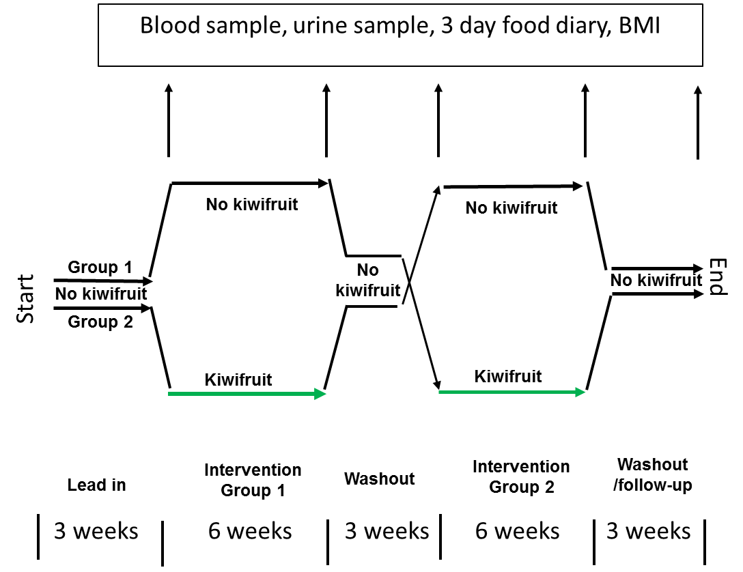

Figure 1 Plan of study

2.8 Kiwifruit supply
Kiwifruit variety ‘SunGold’ of export quality graded fruit will be supplied by Zespri International Limited as required over the course of the trial. The weight of a random sample of 12 fruit from each shipment will be recorded.
The composition of the kiwifruit will be accurately measured at the time of their receipt, but based on previous analyses the fruit are likely to contain about 12 g of sugars per 100 g edible portion, consisting of approximately equal proportions of glucose and fructose.
The fruit will be distributed to participants in the kiwifruit intervention group in weekly lots (14 kiwifruit).
2.9 Blood sampling and analytes
On five visits to the clinic the participants will be asked to provide fasting venous blood samples which will be taken by a trained phlebotomist. Subjects will be seated and once relaxed and comfortable venous blood will be withdrawn from the anterior cubital fossa into three 10 ml Vacutainer™ tubes. Total blood volume collected at each clinic visit is 30mL.

The blood samples will be measure the following:
- Serum lipids
- Glucose and HbA1c
- Biomarkers of oxidative stress and inflammation.
- Metabolites, using metabolomics platform.
- Plasma vitamin C
A urine sample will also be requested.

2.9 Analysis of results and publication
All statistical analysis will be completed by a statistician at Plant & Food Research, who will be blinded to treatment allocation. Statistical analysis will describe the differences between the kiwifruit intervention and control groups, and also the changes within the intervention group from baseline as a result of kiwifruit consumption and at follow up after washout.
The primary outcome will be changes in plasma lipids and HbA1c. P values ≤0.05 will be considered significant. Following statistical analysis the data will be presented in a report to the internal to the Kiwifruit Royalty Investment Program management. The findings of the study will also be prepared for publication in an appropriate peer-reviewed public health or nutrition journal.

3. Safety Issues

3.1. Possible intolerance to kiwifruit
This study focuses on the effects of a natural commonly consumed food on various biomarkers of health and does not use any pharmaceutical products, so there is little associated risk. The kiwifruit will be handled in a dedicated food preparation facility and all appropriate food safety regulations observed. As the subjects at selection were excluded if they had any history of intolerance to kiwifruit, it is unlikely that there will be any adverse reaction to the test foods in the selected subjects.

3.2. Blood testing and urine collection
The venous blood sampling will be carried out in the Plant & Food Research clinical suite with great care, under sterile conditions, by an experienced person trained in phlebotomy. Antiseptic procedures and practices to prevent cross contamination will be scrupulously adhered to. The same levels of hygiene will be observed in handling urine samples.

4.1. Participation and confidentiality
Participation in the study is voluntary. The participants may withdraw from the study at any time without having to explain why and this is stated in the information sheet. No material that could personally identify the participant will be used in any reports on this study. All information collected in all parts of the study is confidential and will not be available to anyone other than the principal investigator and the co-investigator. The samples and data will be identified by study ID number only and will be stored in a lockable filing cabinet on a security-carded floor. Approval from the necessary Ethics Committees will be sought for this study. The trial will be registered on the Australian New Zealand Clinical Trials Registry (www.anzctr.org ).
All participants will be required to understand and sign an informed consent form (Appendix A).

4.2. Payment of participants

The participants will receive a small remuneration for taking part in the study in the form of a $20 supermarket voucher at the initial screening and a $20 voucher for each testing session.

In the unlikely event of a physical harm as a result of receiving the intervention treatments compensation is available from Plant & Food Research in line with industry guidelines. Source of compensation is contingent on type of harm and cause.

5 Conclusion

The proposed study will determine whether the prolonged inclusion of kiwifruit will lead to changes in biomarkers of diabetes and cardiovascular disease, inflammation and oxidative stress, and to compensatory changes in intake of other foods in the diet.

