

# PARTICIPANT INFORMATION SHEET

|  |  |  |  |
| --- | --- | --- | --- |
| Study title: | **Effects of long-term kiwifruit consumption on metabolic outcomes** | | |
| Locality: | **Plant and Food Research, Palmerston North** | Ethics committee ref.: |
| Lead investigator: | **Dr John Monro** | Contact phone number:  06 3556137 |

You are invited to consider taking part in a study on the effect of consuming kiwifruit on indicators of good health. If you do want to take part now, but change your mind later, you may pull out of the study at any time.

This Participant Information Sheet will help you decide if you’d like to take part. It sets out why we are doing the study, what your participation would involve, what the benefits and risks to you might be, and what would happen after the study ends. We will go through this information with you and answer any questions you may have. You do not have to decide today whether or not you will participate in this study. Before you decide you may want to talk about the study with other people, such as family, whānau, friends, or healthcare providers. Feel free to do this.

If you agree to take part in this study, you will be asked to sign a Consent Form, which is a record that you joined the study voluntarily, but it is not binding. You will be given a copy of both the Participant Information Sheet and the Consent Form to keep.

This document is five pages long. Please make sure you have read and understood all the pages.

What is the purpose of the study?

Our research has shown that if kiwifruit is partly replaces breakfast cereal in a meal, without changing the total amount of carbohydrate eaten, the blood glucose response to the meal is much reduced. The research looked at the response to kiwifruit in a single meal. However, we want to know what happens when kiwifruit is eaten over a long period of time as part of the normal diet. There are a number of beneficial changes that could happen if blood glucose response is reduced daily by kiwifruit. The nutrient content of the diet may change, the body may adapt to the daily intake of fruit. Food intakes may also naturally alter to adjust to the addition of kiwifruit so that energy intake does not change.

The overall purpose of this study is to be able to identify how the adaptation to a daily intake of kiwifruit leads to changes in the body that reflect your state of health. The research is important to the health of all consumers. And it is very relevant to the large number of people who suffer from glucose intolerance of various forms, such a pre-diabetics and diabetes.

What does the study involve?

The study is a randomized cross over trial in which participants will be randomly assigned to 2 groups. Each group will consume 2 kiwifruit per day for 6 weeks, or continue with their customary diet, but in a different order. One group will be asked to consume no kiwifruit for 3 weeks, then consume kiwifruit for 6 weeks, before returning to a no-kiwifruit diet for 12 weeks. The other group will be asked to not consume kiwifruit for 9 weeks, followed by a 6 week period of consuming 2 kiwifruit per day, followed by a final 3 week period of consuming no kiwifruit. The study is summarised in Figure 1.

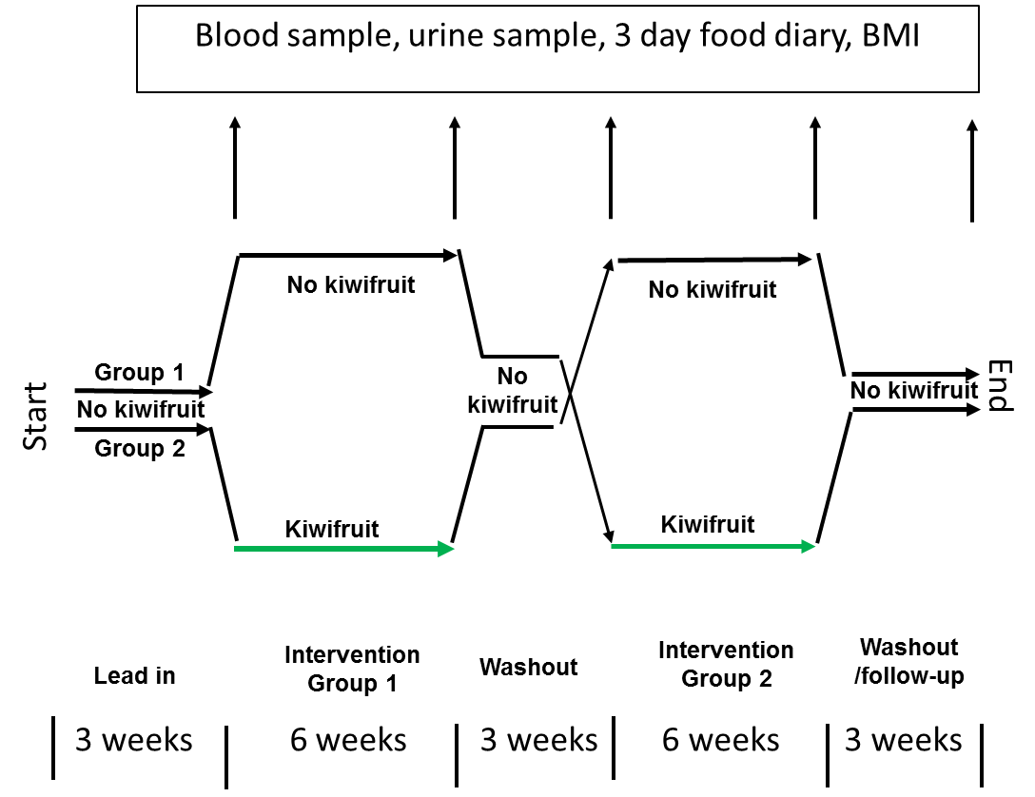

Figure 1. Plan of kiwifruit randomised cross-over study

The study involves five visits to the Plant and Food Clinical Research Unit over a period of 21 weeks. At each visit you will be weighed and asked to provide a blood sample taken by a trained and certified staff member, and provide a urine sample. You will be asked to keep a food diary for three days before each visit to the clinic. Each visit to the clinic will require about half an hour of your time.

Kiwifruit will be provided by Zespri International Ltd. They will be of high quality and delivered to you weekly.

A meal will be provided free at the conclusion of each visit to the clinic.

Individuals will be chosen to participate in the study if they are within the age bracket (30-60) and considered to be generally healthy. Health status will be determined initially by the use of a health questionnaire, which asks about your current and past health issues.

**Participants**: The age range is 30 to 60 years and the BMI range is 20 to 35 kg/m2. BMI means “body mass index”. It is used to estimate a healthy weight range for individuals based on weight and height. BMI is your weight in kilograms divided by your height (in meters) squared.

All participants will need to:

* Have no known allergy to, or intolerance of, kiwifruit.
* Have a BMI between 20 and 35.
* Be willing to consume two kiwifruit per day for 6 weeks.
* Be willing to not consume vitamin supplements during the course of the study.
* Not suffer from diabetes.
* Be healthy, as confirmed by a short medical questionnaire.
* Be willing to visit the Plant & Food clinic 5 times during the trial
* Be willing to fast from 10.00 pm the evening before each visit to the clinic.
* Be willing to not do any vigorous activity in the morning of the clinic visit.
* Be willing to provide a blood sample and a urine sample on each visit to the clinic.
* Be willing to keep a food diary for 3 days before each visit.

The research in this project will be undertaken in a culturally sensitive manner. All aspects of the trial will be explained in full to you in a manner most suitable to you. We will be available to answer questions throughout the study and will seek advice from appropriate advisory groups should it be necessary. You will be given access to interpreters at any time in the study should you require them. The opportunity for whanau support is available at all times.

What we expect from you?

**Screening**: If you agree to take part in this study, we will make an initial appointment for you to come into Plant & Food Research in Palmerston North. At this appointment we will measure your height and weight. We will also ask you some questions about your general health. This is so we can assess if you are eligible to participate in the study. If you are eligible we will ask you to have a quick blood glucose test to check that your blood glucose is in the normal range (ie HbA1c). The test involves taking a small finger prick sample of blood and testing it, as is done by people with diabetes at home.

possible benefits and risks from this study

This study focuses on the effects of a natural commonly consumed food on health indicators. It does not use any pharmaceutical products. The risks of side-effects is therefore minimal. As subjects with a history of kiwifruit intolerance will have been screened out it is unlikely that there will be any adverse reaction to the foods. If you think you are intolerant of kiwifruit or wheat products you would be advised not to take part in the study.

Blood sampling will involve inserting a small needle into a vein in the arm, and drawing samples into three 10 ml Vacutainer tubes. The procedure is sterile and causes minimal discomfort. It will be carried out by a person trained in the procedure (phlebotomist) and experienced.

A benefit from the study is that participants will receive feedback and gain some information of their metabolic state.

Published results from the study may be very useful for people with diabetes who wish to consume kiwifruit while managing blood glucose responses. They results may also help in education of consumers generally, on how best to incorporate fruit into the diet for health benefits.

Your participation

Your participation in this study is completely voluntary. We are happy for you to bring along a support person to each of the clinic appointments if you would like. We will give you a $20 supermarket voucher for the initial screening visit. If you are accepted onto the study you will be given a further $20 voucher each time you visit the clinic to provide a sample to partly make up for your time and travel your travel. This will make a total of $100. In addition you will be able to select from a choice of lunches at the end of each session. You may decide to take part, but later change your mind. You are free to withdraw at any time without having to give a reason.

Compensation

If you were injured as a result of treatment given as part of this study, which is unlikely, you **won’t** be eligible for compensation from ACC. However, compensation would be available from Plant & Food Research in line with industry guidelines. We can give you a copy of these guidelines if you wish. You would be able to take action through the courts if you disagreed with the amount of compensation provided.

This trial is being conducted by Plant & Food Research. If participants suffer physical harm from the kiwifruit being tested, liability for compensation is borne by Plant & Food Research. If participants suffer any harm from any other aspects of the trial, for example from blood sampling by the researchers (very unlikely), liability is borne by Plant & Food Research, in both instances subject to appropriate application or legal processes. If you have private health or life insurance, you may wish to check with your insurer that taking part in this study won’t affect your cover.

You may obtain further information concerning medical treatment for injuries by contacting the Principal Investigator.

Confidentiality

No material that could personally identify you will be used in any reports on this study. A code that identifies you to the research team will be used on all study documentation. During the study your file will be held in a locked cupboard or filing cabinet when not in use. At the end of the study, your files will be kept for 10 years in secure document storage, and then destroyed by shredding.

Rights

Participation in this study is completely voluntary, and you have the right to decline to participate, or to withdraw from the research at any stage, without the need to give reason and also without experiencing any disadvantage.

As some personal information is obtained from you during this study, you have the right to access the information that we have collected about you at any stage. You will also be informed of your own blood glucose readings as soon as they become available; we would tell you if there was reason for concern. Information obtained, from the questionnaire and blood samples, will be kept completely confidential at all times. Only the investigators of the study will have access to these records.

If any new information arises about adverse or beneficial effects related to this study that may have an impact on health, then you will be informed straight away.

If you have any queries or concerns about your rights as a participant in this research study you can contact an independent health and disability advocate. This is a free service provided under the Health and Disability Commissioner Act.

Telephone (NZ wide): 0800 555 050

Free Fax (NZ wide): 0800 2787 7678 (0800 2 SUPPORT)

Email (NZ wide): advocacy@hdc.org.nz

If you have any questions about the study at any time please do not hesitate to call Suman Mishra (06 3556146) or John Monro (06 3556137)

This study has been given approval by the New Zealand Health Ethics Committee.

Contact details

Dr Suman Mishra (Trial coordinator) contact numbers: (06) 3556146 (day),   
or 0211644660 (anytime)

Dr John Monro (Principal investigator) Contact number (06) 355 6137