**RESEARCH PROPOSAL SUMMARY DOCUMENT:** Version 2.3

**STUDY TITLE**

Lateral skin incision, reduces skin dysaesthesiae and improves kneeling post total knee arthroplasty: A randomised controlled trial in simultaneous bilateral total knee athroplasty

**ABBREVIATED TITLE**

Lateral incision and kneeling study in Bilateral TKA

PROJECT SUMMARY

The initial skin incision performed to expose the knee during total knee arthroplasty(TKA) is centred over the patella for ease of access to the joint. This places the scar directly over the bony points of the knee that bear load when kneeling, leaves the skin on the lateral side (outside) of the scar with reduced sensation and sometimes the skin on the medial side (inside) of the scar with painfully altered sensation (dysaesthesiae / neuromata). Placing the skin incision lateral to the edge of the patella (kneecap) avoids the necessity of kneeling on a scar and has been shown to reduced dysaesthesiae and neuromata in other knee procedures.

Primary Aim:

To prove that lateral skin incision improves ability to kneel in patients following bilateral total knee arthroplasty

Secondary Aim:

1.Investigate whether lateral skin incision has improved retention of skin sensation.

2.Investigate the ability to kneel after TKA.

3.Investigate if there is improved deep flexion.

4.Investigate whether there is decreased pain and better satisfaction as per patient reported outcome measures (PROM)

Research Design:

Prospective, Randomized Controlled Trial.

Patient Demographic: Eligible patients aged between 40-90 years of age with bilateral, tri-compartmental osteoarthritis (OA),undergoing simultaneous bilateral TKA. Patients with previous knee arthrtomy will be excluded.

Patients' limbs will be randomized for surgery into two groups; (1) Mid-line Incision Group and (2) Lateral Incision Group.

Outcomes: (measured at three, six, nine and 12 months post-operatively.

- Knee flexion and extension.

- Kneeling Grade Assessment (according to the novel Grading Assessment; Refer to Study Protocol).

- Area of skin dysaesthesia (uncomfortable change in skin sensation) will be mapped and analyzed (Refer to Study Protocol).

- Neuroma formation.

- PROMs (patient reported outcome measures)

**STUDY IDENTIFICATION**

Registered with ANZCTR (Australian and New Zealand Clinical Trials Registry)

Registered by Dr Peter McEwen

**SPONSOR**

ORIQL (Orthopaedic Research Institute of Queensland)

**ADMINISTERING INSTITUTION**

ORIQL

Street Address: 7 Turner Street, Pimlico, QLD 4812

Telephone: 0413 685 331

Website: [www.oriql.com.au](http://www.oriql.com.au)

Email: research_coordinator@oriql.com.au

**Investigators and Institutions**

Dr Peter McEwen ORIQL, James Cook University

Dr Kenji Doma James Cook University

Dr Matthew Wilkinson ORIQL, James Cook University

Dr Kaushik Hazratwala ORIQL, James Cook University

Associate investigators:

Andrea Grant ORIQL

Dr Ryan Faruque ORIQL

GLOSSARY OF ABBREVIATIONS AND TERMS:

Dysaesthesiae – uncomfortable altered skin sensation

JCU – James Cook University

MUA – Manipulation under Anaesthetic

Neuroma (plural neuromata) – A painful growth of nerve cells

NSAIDs – Non-steroidal anti-inflammatory drugs

Patella - Knee cap

TKA – Total Knee Arthroplasty

ROM – Range of movement

UKA – Unicompartmental Knee Arthroplasty

RATIONALE AND BACKGROUND INFORMATION

TKA is a reliable and efficacious procedure for reducing pain and improving function in the context of severe knee osteoarthrits. The return to basic activities of daily living is largely predictable following the procedure. The ability to kneel and smoothly return to a standing position is less predictable, often not comfortable if achieved and if ever comfortable is late in becoming so. The ability to kneel becomes even more important when required for a return to unrestricted occupational tasks. The ability to kneel may be affected by routine use of an anterior midline incision which, although utilitarian as far as ease of access to the underlying joint goes, leaves a scar directly over the bony points that take load when kneeling. Moreover, the skin on the lateral aspect of the scar universally has reduced sensation and the skin medial to the scar may develop painfully altered sensation in the form of dysaesthesia and neuroma and therefore further limit the ability to knee. A link also exists between dysaesthesia and postoperative stiffness that can prolong recovery and negatively impact on the final result.

In 1991 Berg et al(3)looked at dysaethesiae (abnormal sensation) over the patella in patients with ligamentous injuries who had undergone surgical correction. Half of the patients were explored by a medial parapatellar incision (incision made toward the inner side of the knee cap) and 31 by long lateral parapatellar incision (incision made towards the outside of the knee cap). The authors assessed the length and breadth of dysaethetic area (authors defined this as sensibility) with a sharp needle. Investigators also looked to identify discomfort during kneeling and painful neuromas at three and six years post-operative. They found evidence of dysaethesia in the lateral incisions at three years, most of which completely resolved at six years, whereas only one of the medial incisions resolved. Lateral incisions produced fewer neuromas and fewer difficulties kneeling.

Hassaballa and colleagues(4) compared post-operative changes in skin sensation of knees following TKA and UKA (unicompartmental knee arthroplasty) using three different incision types and the effect on kneeling ability. Area of skin with sensory change, the length of incision, and kneeling ability were recorded and compared between three different types of incision. Investigators observed that the larger area of hypersensitivity the less patients could kneel. Furthermore, longer incisions placed more medially produced significantly greater areas of reduced sensation.

Finally, Jenkins et al(5) attempted to see if kneeling advice would be enough to instigate this function in patients after surgery. Investigators reviewed patients who underwent partial knee arthroplasty (PKA), half of the patients received education as part of their post-operative rehabilitation on kneeling, the other half without. At one year, investigators reported significantly better kneeling ability by the group who received advice and education on kneeling.

No study has compared the ability to kneel after TKA using either an incision lateral to the patella or an anterior midline incision has been conducted previously.

STUDY HYPOTHESIS

**Primary Hypothesis**

That patients’ ability to kneel post TKA will be greater following a lateralised skin incision compared to a traditional midline incision.

AIMS

**Primary Aim**:

Prove that lateral skin incision improves ability to kneel in patients with bilateral total knee arthroplasty population

**Secondary Aims**:

1. Investigate whether lateral skin incision has improved retention of skin sensation
2. Investigate return to previous kneeling activities
3. Investigate if there is a greater increase in deep flexion as compared to midline incision
4. Investigate whether there is decreased pain and better satisfaction as per patient reported outcome measures (PROM)

STUDY DESIGN

We plan to conduct a prospective, multi-surgeon, randomised controlled trial on patients undergoing simultaneous bilateral TKA. Patients’ knees will be randomised to two incision protocols; lateral and midline incision. Three surgeons will perform the surgeries following HREC approval at the Mater Health Services North QLD Ltd. Participants will be recruited between September 2016 to September 2018

METHODS

Setting

Mater Health Services North Queensland Ltd

Population

***Selection Criteria***

Inclusion Criteria:

Patients scheduled to undergo bilateral knee arthroplasty

Male and female

Age 40-90

Able to provide informed consent

Exclusion Criteria:

Conditions causing altered sensation up to knee- Diabetic Neuropathy, regional pain syndrome

Previous open surgical procedure to knee

Patients with inflammatory arthritis

Patients not suitable for patella resurfacing

Recruitment

Potential participants who fit the selection criteria will be approached in clinic by the investigating surgeon and provided information on the study, with an opportunity to ask questions. Willing participants will be asked to provide consent for inclusion.

Consent

All participants shall provide consent prior to participation in Gait Laboratory Assessment, they will also be required to consent for investigators to electronically capture and store information for current and future use in ORIQL research following HREC approval.

Randomisation and blinding

Randomization will be performed at the time of patient consent during the initial consult at the clinic. A online randomisation random number generator will be used to create a list of random numbers. These numbers will be assigned on of the two study groups in sealed envelopes. At the time of recruitment the participant will be given a randomization number to identify them and the sealed envelope will have the side that will receive the lateral incision. Blinding to the patient is not possible because the side that will have the lateral incision will be apparent to them on their skin.

Time Points

Patients will undergo several pre-operative assessments such as knee flexion and extension, sensation deficit over the knee (see ‘*Knee Sensation Method*’) and kneeling ability (to lower oneself and then rise from that position unaided/aided [see ‘Kneeling Grade Method’]). Patient reported outcomes measures will be taken before surgery, at six months after surgery and at the yearly mark.

|  |  |  |  |  |  |
| --- | --- | --- | --- | --- | --- |
|  | **Study Visits** | | | | |
|  | Pre-Surgery | Surgery | 6 weeks later | 6 months later | 12 months |
| Informed Consent/clinical exam | x | TKR | x | x | x |
| PROMS | x |  | x | x |
| Clinical assessment (Kneeling and Sensation) | x |  | x | x |

Patient Information and Demographic Data

Patient information and demographic data will be gathered and used to identify patients during the study. After data has been collected, patients will be de-identified. The only identifier used will be their randomisation number.

Kneeling Grade Method (Primary Outcome)

The Oxford Knee Score question seven specifically questions’ with regards to kneeling. However the act of kneeling requires several movements before a full kneel can be performed. As kneeling is a complex movement, and there is no objective grading system to quantify the level of movement possible, we have devised a novel grading system (*see Figure 1*).Patient will be asked to reach the furthest position they can comfortably and then stand up from it. We will aim to validate this grading scale by comparing it to PROMs.

|  |  |  |  |  |  |
| --- | --- | --- | --- | --- | --- |
| Grade | 1 | 2 | 3 | 4 | 5 |
|  |  |  |  |  |  |
|  | Partial Squat | Full Squat | Split Kneel | 90 Kneel | Full Kneel |

*Figure 1:* Kneeling Grade Method

Knee Sensation (Secondary Outcome)

Sensation will be tested using a pin prick. Patients will have areas lateral to the incision tested for abnormal feeling. This area will be drawn with a marker at each assessment time point(see study visits table). An image will be taken with a ruler next to the knee for size reference and the open source ImageJ® program will be used to map and calculate this area for both knees.

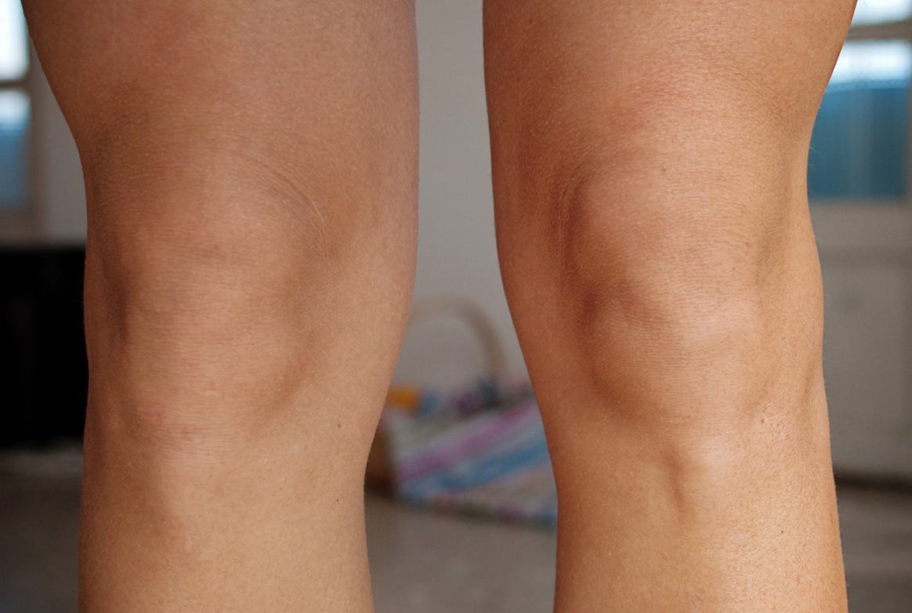

*Figure 2: The incisions made over the skin. The right knee has the lateral incision and the left knee has the midline incision.*

The presence of a painful neuroma (growth of nerve cells) and level of pain relief requirement for this pain will be assessed by following grading system

|  |  |
| --- | --- |
| None | Nil/Ice pack/Heat pack |
| Mild | occasional NSAIDs |
| Moderate | Regular NSAID/neuropathic |
| Severe | Regular NSAID + breakthrough Opiate |
| Very Severe | Regular NSAID + Regular Opiate |

Clinical Assessments:

* Knee flexion and extension range
* Sensation deficit checked over the knee
* Length of incision
* Kneeling ability to lower oneself and rise unaided/ aided will be assessed

Patient Reported Outcome Measure (PROM) scores

1. KOOS Junior
2. Oxford Knee score (OKS)
3. Visual-analogue-scale (VAS) pain score
4. Kujala Anterior Knee Pain Score
5. Forgotten Joint Score (FJS)
6. EQ-5D score

Surgical Procedure

The bilateral simultaneous TKA will be performed as per normal protocols by the consultant orthopaedic surgeons. All patient patellas will be resurfaced. The only difference between the two knees is that one will have a skin incision towards the outer side of the knee (lateral) and the other will have a skin incision over the midline of the knee. (see figure 2)

Surgical Data

1. Navigated alignment
2. Tibial slope
3. Degree of flexion and extension
4. Tibial and femoral cuts
5. Medial and lateral flexion and extension gaps
6. Varus/valgus alignment
7. Internal/external rotation
8. Size of tibial and femoral implant

Power calculation

The expected surface area of loss of innervation of 66cm2 with SD of 30 cm2 for the midline incision as found by Borely et al6, as there is are no published observational data for lateral skin incisions, we assumed loss of skin sensation of 44cm with same SD of 30 cm2 with lateralskin incisions. Assuming Type I error (alpha) to 5% (p = 0.05) and Type II error (beta) to 0.2 (power equal to 80%), the sample size calculated was 30 knees in each group, therefore 60 knees. We will investigate 66 knees to compensate for 10% expected loss to follow-up. As we are using bilateral knees, we will need 33 patients.

Statistical analysis

All data will be analysed using the Statistical Sciences (SPSS, Version 22). Analysis using chi-squared test for significance between lateral skin incisions and medial patellar skin incisions:

1) The length of scar (in centimetres, cm)

2) The ability to kneel (using grading system as above)

3) The area of altered sensation (in square centimetres, cm2)

4) The average grade of altered sensation (using grading system as above)

5) The ROM- flexion range pre-operatively and post-operatively (using a digital inclinometer)

6) PROMs

DATA MANAGEMENT

Data may be captured and monitored by one of two methods.

1. ORIQL/FORCE DB: Data collected by Investigator, including mandatory identification data and assessments will be input directly onto the ORIQL/FORCE database. Patients will answer PROMS assessment questionnaires electronically either in practice or by email. Patients will be randomised post consent, and provided with a patient study number. (Pending HREC approval)

2. Patient Study Folders: Data will be recorded into patient study case report forms (study folders). During data monitoring phase, the data will be transcribed and entered into patient database. Patients' details will be stored on an orthopaedic specific research database at ORIQL (SOCRATES), which will include name and date of birth as mandatory identifiers. This will allow easy identification of patients to review the data collected during the research process. The database is password protected with limited access only to the named investigators.

ETHICAL CONSIDERATIONS

This study will be submitted to the Principal Investigators Ethics Committee, Mater Health Services North Queensland Ltd Human Research Ethics Committee.

The study will be registered prior to trial commencement with the ANZCTR.

FEASIBILITY

The administrating institution has conducted multiple research projects on patients undergoing bilateral TKA. At present ORIQL has completed recruitment for all bilateral TKA studies with ethics approval thus patient pool will ensure projected timeframes as reasonable. There is no learning curve associated with the change in initial surgical incision.

DISSEMINATION OF RESULTS AND PUBLICATION

The results of the study will be presented at national and international orthopaedic scientific meetings such as the Australian Orthopaedic Association (AOA) Annual Scientific Meeting. Results will be published in a high impact surgical journal and will be disseminated via various forms of media.

Authorship will be under the name of Investigators from ORIQL contributing to this research project.

References

1. Hassaballa, M. ., Porteous, a. ., Newman, J. . & Rogers, C. . Can knees kneel? Kneeling ability after total, unicompartmental and patellofemoral knee arthroplasty. *Knee* **10,** 155–160 (2003).

2. Sharkey, P. F. & Miller, A. J. Noise, Numbness, and Kneeling Difficulties After Total Knee Arthroplasty. Is the Outcome Affected? *J. Arthroplasty* **26,** 1427–1431 (2011).

3. Berg, P. & Mjoberg, B. A lateral skin incision reduces peripatellar dysaesthesia after knee surgery. *J. Bone Jt. Surg. Br.* **73,** 374–376 (1991).

4. Hassaballa, M., Artz, N., Weale, A. & Porteous, A. Alteration in skin sensation following kneHassaballa, M., Artz, N., Weale, A., & Porteous, A. (2012). Alteration in skin sensation following knee arthroplasty and its impact on kneeling ability: A comparison of three common surgical incisions. Knee Surger. *Knee Surgery, Sport. Traumatol. Arthrosc.* **20,** 1983–1987 (2012).

5. Jenkins, C., Barker, K. & Pandit, H. (2008) After Partial Knee Replacement, Patients Can Kneel, But They Need to Be Taught to Do So: A Single-Blind Randomized Controlled Trial. *Physical Therapy*. **88**, 1012-1021.

6. Borley, N., Edwards, D. & Villar, R. (1995). Lateral skin flap numbness after total knee arthroplasty. *J. Arthroplasty*. **10**, 13-14.