**Improving independence in driving for people with Autism Spectrum Disorder**

Individuals with autism spectrum disorders (ASD) face social and cognitive difficulties that affect their ability to establish relationships, maintain employment and participate in community activities. Difficulties in community mobility act as barriers to their social inclusion. Driving is often difficult for people with ASD, as it requires the individual to make quick decisions and solve problems in response to road conditions and unpredictable traffic. There is currently a lack of understanding on how learner drivers with ASD read and respond to traffic and hazards on the road. The problem is further confounded as there are currently no established standards in Australia for assessing driving behaviours.

**Aim**

The aim of the proposed research is to address community mobility challenges experienced by young adults with ASD by designing, pilot testing and evaluating the feasibility, appropriateness and effectiveness of an ASD-specific *driver training package* in supporting learner drivers with ASD to obtain a driver’s license and maintain on-road safety.

The driving project will involve four studies. Each study will involve consultation with the research advisory group of adults with ASD established through Curtin University. The study aims are:

**Study 1:** Scoping the literature and obtaining end-user and expert opinion:

* Summarise current knowledge on the driving behaviours of learner drivers with ASD.
* Identify and evaluate international and local resources that address the driving needs of people with ASD.
* Understand end-user and stakeholder perspectives on the difficulties learner drivers with ASD encounter while learning to drive; the driving behaviours they exhibit; and the strategies they use to support safe driving behaviours.

**Study 2:** Assess off- and on-road driving behaviours of learner drivers with ASD.

**Study 3:** Develop and pilot test the feasibility and appropriateness of a driver training package containing ASD-specific on- and off-road training sessions in supporting learner drivers with ASD to obtain a driver’s licence and maintain on-road safety.

**Study 4:** Test the effectiveness and appropriateness of the driver training package in:

* Reducing the number of attempts learner drivers with ASD take to successfully obtain a provisional licence.
* Reducing the number of face-to-face practice training sessions learner drivers with ASD require before obtaining a driver’s licence.
* Improving driving behaviour, hazard perception skills and attitude to risk taking of learner drivers with ASD.
* Improving learner drivers’ reflection on their driving.

Based on the findings of Study 4 of the Driving project, the ASD-specific driver training package will be updated and packaged for release in the CRC.

**Setting**

The driving project will be coordinated by researchers at Curtin University, Perth, Western Australia. The randomised controlled trial to evaluate the effectiveness of an ASD-specific driver training package will occur in Western Australia and New South Wales.

**Significance**

Australian young adults with ASD face inequalities in completing school education, participating in employment and being included in society. An understanding of the complex issues faced by people with ASD in driving needs to be explored from their perspective and key individuals in their lives. The proposed community mobility projects will adopt an end-user driven approach to design, pilot test and evaluate the preliminary effectiveness of end-user driven products in promoting independence in driving among adults with ASD. The driver training package provides an intervention which can be used to improve the likelihood that learner drivers with ASD will safely and successfully receive their driver’s licence and access the community with ease. Improving community access has the potential to increase community participation for individuals with ASD, facilitate their participation in education, employment, and leisure pursuits and positively influence their mental health and wellbeing.

**Methodology**



**Study 1:**

***Design:*** A scoping review of the literature (peer reviewed and grey) and semi-structured focus groups with parents of learner drivers with ASD, OT-trained driving assessors and traditional driving instructors will be undertaken to meet the aims of Study 1.

**Study 2:**

***Design:*** Observational studies to assess off- and on-road driving behaviours of learner drivers with ASD*.*

***Specific components*** of the off- and on-road driving assessments include:

* Assess the driving performance of learner drivers with ASD using a series of neurocognitive tasks.
* Understand how learner drivers with ASD perform with regards to hazard perception, divided attention tasks, visuomotor coordination, and reading and recognizing social cues in traffic.
* Determine the fixation frequency and duration on relevant environmental cues while driving using eye-tracking equipment.
* Evaluate the use of the Performance Analysis of Driving Ability questionnaire (P-Drive) in assessing driving behaviour of learner drivers with ASD [1].
* Examine intra-individual variability as a statistical measure of moment-to-moment cognitive and driving performance.

***Inclusion criteria***: Learner drivers aged 16 to 35 diagnosed with ASD (*N* = 30), who intend to learn driving, but have not started any formal driving training, together with their driving instructors or parents, will be invited to participate in the study. The recruitment venues include driving schools, end user organisations and existing network that the researchers have already established within the community. Participants’ medical records will be cited prior to including them in the study. As the group will also participate in off- and on-road driving assessments, they will be required to fulfil set criteria for inclusion and complete a series of screening tests to ascertain eligibility (Appendix B). Recruitment will be via end user organisations and existing networks that the researchers have within the community.

***Off-road setting, procedure, equipment and measurements:***

* Neurophysiological clinical tests, based on findings of a driving pilot study at Curtin University, will be used to assess cognitive and visuomotor skills related to driving [2] (Appendix C).
* Data collection will occur in a driving simulator lab housed within the School of Occupational Therapy and Social Work, Curtin University. The STISIM Driving Simulator will collect information on the number of off-road crashes, on-road collisions, pedestrians hit, speeding, stop-signs missed, centre-line crossings, road edge excursions, and stops at traffic lights. ASD specific driving scenarios will be informed by Study 1 and the PhD pilot study at Curtin University (Appendix D). The head-mounted Arrington View Point™ eye tracker will collect information on eye movements (i.e., number and duration of fixations relative to areas of interest) (Appendix D).
* The P-Drive will be used to assess driving behaviours that are not collected by the simulator [1] (Appendix E).
* The Driver Behaviour Checklist [3] will be used to assess safe driving behaviour, based on the Goals for Driver Education Matrix’s operational and tactical levels of driving, in line with the National Road Transport Commision of Australia’s requirements [4] (Appendices E, F, G1, G2). The strategic level of driving that includes driving goals and context will not be explicitly examined in this phase, as the route and driving conditions within the simulator will be pre-determined by the researcher.

***On-road setting, procedure, equipment and measurements****:*

* A standardised route at or around Curtin University will be used to assess on-road driving behaviours. The route has been specifically designed in collaboration with the Curtin University Department of Spatial Science using Global Navigation Satellite System (multi-GNSS) and Geographic Information Systems (GIS) technologies (Appendices H1-H4). Participants will complete the route in a dual controlled fitted car with a Trimble R10 GNSS receiver to obtain precise data on vehicle positioning and pathway trajectory (Appendix H4). A mobile, head mounted Arrington ViewpointTM eye-tracking device will be used to assess driver behaviour and visual processing while driving.
* Participants will be shown the route on a map and driven along the course by a member of the research team, before being allowed to complete the course themselves.
* A qualified occupational therapist who is trained in using the P-Drive observational checklist [1] (Appendix E); and a licenced driving instructor will accompany the participants during the on-road assessment for safety and verification purposes.
* The Driving Behaviour Checklist [3] will be used to assess observed driver behaviour, in particular risk taking / risk aversion, which will not be captured using moment-to-moment GNSS/GPS data (Appendix E).
* The Manchester Driving Behaviour [5-7] will be used to obtain self-report information on how frequently learner drivers with ASD engage in careless, reckless or aggressive behaviours (Appendix E).
* On completion, all participants will be asked to complete the NASA Task Load Index questionnaire as a measure of perceived workload [8] (Appendix E).

***Data Analyses:***Descriptive and inferential statistics will be used to summarise the profiles of study participants. The data from the GPS device includes speed points and vehicle trajectory and will be mapped using GIS software. Data will be analysed based on a predefined criteria of driving actions [9]. Eye movements and visual stimuli from the eye-tracker will be analysed and compared to the GPS data to objectively assess moment-to-moment driver reaction and behaviour. These outcome measurements will then be analysed for relative driving consistency by using regression models, as well as reporting the standard driving performance statistics [10]. Scores from the driver behaviour checklist, GPS and eye-tracking data will be triangulated to qualify driver behaviour. Separate multivariate models will be run, which account for confounding variables and according to each outcome of interest to determine the association between objective measures of speed control and variation, lateral lane behaviour, driver hesitation, traffic manoeuvrers, efficiency of way-finding and route planning to eye movements. Data from the neuropsychological assessment battery and driving simulator will be compared to data from the on-road driving assessment using multivariate regression in order to measure the consistency and predictability of driver performance. Data from the GPS will be collated cleaned and mapped using Microsoft Excel© and ArcGIS©. The data will be analysed using MATLAB [11] and SPSS v.22 [12]. All outcomes variables will be compared with established norm values.

**Study 3**:

***Design:*** Development of the driver training package will be informed by the preceding stages of the study and by a reference panel consisting of: a) expert consultants in the Department of Transportation; b) specialised training schools, including occupational therapists, who teach driving to people with disabilities (e.g., The Independent Living Centre); c) local driving instructors; and d) parents of learner drivers with ASD. In-kind expertise from traffic safety expert clinicians and researchers across Australia and Sweden will be sought. The existing Project Advisory groups in WA and UWS will be actively involved in this process. Development of the driving training package will be coordinated by the research team situated at Curtin University.

***Contents of the ASD specific driver training package:*** It is likely that the training package will contain 10-week step by step training sessions based on the Goals for Driver Education Matrix framework [13] (Appendix F). The package will have three components: 1) face-to-face component; 2) on-line training component; 3) on-road driving training component. The driver training package will be pilot tested with 10 participants with ASD for feasibility and appropriateness.

**Study 4:**

***Design***: Randomised-controlled trial design is proposed.



***Recruitment of participants:*** The study will recruit two groups of 30 learner drivers with ASD (*N* = 60) across WA and NSW, using the same criteria as outlined in Study 2 of the driving project. During recruitment, participants will be informed that expenditure for both the training packages (Traditional driver training and ASD-Specific training package) will be covered by funding provided by the CRC. It is hoped that the incentive of obtaining free-driver training will encourage people to participate. Based on a Cohen’s *d* of 0.8, given a Cronbach’s *α*-value of 0.05 and a 1-*β* of 0.8, 30 people with ASD in each group (*N* = 60) will be required in order to generate sufficient power.

***Procedure:*** Participants will be assigned to either the driver training as usual group (Group 1) or the ASD-Specific driver training package intervention group (Group 2), using a fixed randomisation scheme. The intervention will be delivered by two driving instructors (WA and NSW) who will be trained by the project leaders Dr Lee and Ms Chee, who are experienced OT-driver training expert instructors. Parents in the intervention group will be trained in the use of the ASD-specific training package prior to the commencement of the intervention.

***Intervention***: The ASD-specific driver training package developed in Study 3 constitutes the intervention. The control group will undergo routine training in their local driving schools.

***Randomisation*:** Randomisation will be stratified by state. The population size for the greater Sydney is 4,921,000, whereas the population size for the greater Perth area is 2,039,200 [14]. Given that the greater Sydney area population (NSW) is approximately 2.4 times the size of the greater Perth area (WA), a 1 : 2.4 recruitment ratio will be used for the respective states. Thus for a total sample size of 60, the subgroup sample size is 24 for WA and 36 for NSW (see schema below for a visual representation). A treatment allocation sequence for each state will be developed using a permuted random blocks strategy. The purpose of the blocking is to accumulate participants to each arm of the study at an approximately equal rate (1:1 ratio), and the purpose of the random block length (an even number between 2 and 8) will be used to make prediction of the next treatment allocation impossible. The sequences will be created using computer-generated random numbers (using the SAS version 9.2 software). See Appendix J



When participants enrol in the study, a baseline assessment will be scheduled over the phone. Only information regarding the inclusion criteria and the assessment date/time will be collected prior to randomisation. Demographic data will collected after group allocation; thus the intervention group participants will not be matched with the control group participants on any demographic or other variables. A set of sealed envelopes, each containing a treatment allocation (on the inside of the sealed envelope) and a study numbered representing sequence of enrolment (on the outside of the envelope), will be provided to the research officer in each state. After each new participant is checked for eligibility, provided consent to take part in the study, and has baseline measurements taken, they will be assigned a study number and the relevant envelope will be opened to reveal their allocated treatment. During the baseline assessment, both the researchers and participants will be blinded to group allocation.

***Baseline post-test outcome measures***: A standardised repeated measure will be administered at pre-test (baseline), post-intervention to assess the impact of the intervention. The evaluation for the pre- and post-periods will include the Driving Behaviour [3]. Baseline measures will include the Barratt Impulsiveness Scale [15], and NASA Task Load Index [16]. The post-test only evaluation will consist of the Manchester Driving Behaviour [5-7] and the Adelaide Driving Self-Efficacy Scale (ADSES) [17, 18] (Appendix E). Interviews with instructors and people with ASD in the intervention group will be conducted to determine the appropriateness of the driver training package and identify possible areas of improvement. The number of attempts participants in each group took to successfully obtain a provisional licence will be used to provide an objective, un-biased estimate of the effectiveness of the package. Following study 4, the package will be refined for release in the CRC.

***Data Analyses***

Descriptive statistics will be used to summarise the profile and baseline characteristics of the participants. Independent samples *t*-tests and Pearson χ² tests will be used to compare differences between groups (intervention vs control) at baseline. The primary outcome (pass vs fail the driving test) will be compared between groups with the Chi-square test. Changes in driving performance scores from baseline to post-test will be calculated for each participant and compared between groups with either the t-test or Wilcoxon 2-sample test (if the changes are skewed). Differences between groups with regard to the number of driving lessons required before passing the driving test, number of attempts at the driving test, and post-test outcomes (the Manchester Driving Behaviour and the Adelaide Driving Self-Efficacy Scale) will be compared using either the t-test or Wilcoxon test. The proportions of participants who are not able to pass the test, even with repeated attempts, and decide to abandon their goal to gain a driving licence will be assessed using either the Chi-square test or Fisher’s Exact test (as the numbers are expected to be small). Data will be analysed using the SPSS© version 22 software and MPlusTM and, following convention, a p-value <0.05 will be taken to indicate a statistically significant association in all tests.

**Ethics**

Ethical permission will be obtained from the Curtin University Human Ethics Committees. Participation in the research project is based on informed consent from the participants. Experienced researchers will conduct the interviews and assist the participants with completing the measurement instruments. While there are no obvious perceived risks associated with this research project, participants have an option to withdraw for any reason, at any time, should they not wish to continue to participate. Although the research requires identified data for the interviews, once the interviews are completed, the data will be-identified before analysis occurs. In the interests of privacy, results will be published in such a way that no individual can be identified. Only aggregated results will be published.

The data will be stored in Curtin University and the University of Western Sydney and managed storage facilities with controlled access mechanisms. The universities have systems and policies in place to comply with the Australian Code for the Responsible Conduct of Research Practice. All hard copy forms will be securely locked in the office of the project leaders to meet the requirements of the NHMRC guidelines [19]. Electronic data files will be stored securely in a personal password protective computer of the researchers. Data will be stored for a period of seven years following publication of the findings, before being securely disposed in accordance with the Western Australian University Sector Disposal Authority.

**References**

1. Patomella A-H, Caneman G, Kottorp A, Tham K. Identifying scale and person response valitiy of a new assessment of drivign ability Scandinavian Journal of Occupational Therapy. 2004;11(2):70-77.

2. Selander H, Lee HC, Johansson K, Falkmer T. Older drivers: On-road and off-road test results. Accident Analysis & Prevention. 2011;43(4):1348-1354.

3. Chee DY, Lee HC, Lee AH, Falkmer T. Performance of drivers with Parkinson's Disease under the effect of cognitive overloading: insinuation for assessment and training. Advances in Transportation Studies. 2013(29).

4. National Road Transport Commision. Assessing fitness to drive. In: Commision NRT, editor. 3rd ed. Sydney: Austroads Incorporated; 2003.

5. Lawton R, Parker D, Manstead A, Stradling S. The role of affect in predicting social behaviors: the case of road traffic violations. Journal of Applied Social Psychology. 1997;27(14):1258-1276.

6. Reason J, Manstead A, Stradling S, Baxter J, Campbell K. Errors and violations on the roads: a real distinction? Ergonomics. 1990;33(10-11):1315-1332.

7. Davey J, Wishart D, Freeman J, Watson B. An application of the driver behaviour questionnaire in an Australian organisational fleet setting. Transportation Research Part F: Traffic Psychology and Behaviour. 2007;10(1):11-21.

8. Hart SG, Staveland LE. Development of NASA-TLX (Task Load Index): Results of empirical and theoretical research. Human Mental Workload. 1988;1(3):139-183.

9. Lee HC, Lee AH, Cameron D. Validation of a driving simulator by measuring the visual attention skill of older adult drivers. The American Journal of Occupational Therapy. 2003;57(3):324.

10. Bloomfield JR, Carroll SA. New measures of driving performance. Contemporary Ergonomics. 1996:335-340.

11. Mathworks T. MATLAB User’s Guide. Natick, Inc, MA1998.

12. IBM Corporation. IBM SPSS Statistics for Windows, Version 21.0. Armonk, NY: IBM Corp.; 2012.

13. Hatakka M, Keskinen E, Gregersen NP, Glad A. Theories and aims of educational and training measures. In: Siegrist S, editor. Driver training, testing and licensing- towards thery based managemnt of young drivers' injury in road traffic Report 40 Berne: Schweizerische Beratungsstelle; 1999.

14. Australian Bureau of Statistics. 3218.0 - Regional Population Growth, Australia, 2014-15 2016. Available from: <http://www.abs.gov.au/ausstats/abs@.nsf/mf/3218.0>.

15. Barratt ES. Anxiety and impulsiveness related to psychomotor efficiency. Perceptual and motor skills. 1959;9(3):191-198.

16. Hart SG, Staveland LE. Development of NASA-TLX (Task Load Index): Results of empirical and theoretical research Human Mental Workload. 1988;1(3):139-183.

17. George S, Clark M, Crotty M. Development of the Adelaide driving self-efficacy scale. Clinical Rehabilitation. 2007;21(1):56-61.

18. Rike P-O, Johansen HJ, Ulleberg P, Lundqvist A, Schanke A-K. Exploring associations between self-reported executive functions, impulsive personality traits, driving self-efficacy, and functional abilities in driver behaviour after brain injury. Transportation research part F: traffic psychology and behaviour. 2015;29:34-47.

19. National Health and Medical Research Council, Australian Research Council, Committee AV-C. National Statement on Ethical Conduct in Human Research. In: Council NHaMR, editor. Canberra, ACT: Attorney-General's Department; 2007.

20. Davies DK, Stock SE, Holloway S, Wehmeyer ML. Evaluating a GPS-based transportation device to support independent bus travel by people with intellectual disability. Intellectual and developmental disabilities. 2010;48(6):454-463.

21. Dudley C, Emery H, Nicholas D. Mind the Gap: The Missing Discussion Around Transportation for Adolescents and Adults With Autism Spectrum Disorder. 2012.

22. Wasfi R, Levinson D. The transportation needs of people with developmental disabilities. University of Minnesota Center for Transportation Studies. 2007.

23. Feeley C, editor Transportation and Mobility of Individuals with Autism Spectrum Disorder: An Analysis of Barriers to Travel. Transportation Research Board 93rd Annual Meeting; 2014.

24. Monahan M, McGuire M, Schold Davis E. Evaluating and treating adolescents with special needs. American Occupational Therapy Association's Driving and Community Mobility: Occupational Therapy Strategies Across the Lifespan. 2012.

25. Classen S, Monahan M. Evidence-based review on interventions and determinants of driving performance in teens with attention deficit hyperactivity disorder or autism spectrum disorder. Traffic injury prevention. 2013;14(2):188-193.

26. Cox NB, Reeve RE, Cox SM, Cox DJ. Brief Report: Driving and young adults with ASD: Parents’ experiences. Journal of autism and developmental disorders. 2012;42(10):2257-2262.

27. Reimer B, Fried R, Mehler B, Joshi G, Bolfek A, Godfrey KM, et al. Brief Report: Examining Driving Behavior in Young Adults with High Functioning Autism Spectrum Disorders: A Pilot Study Using a Driving Simulation Paradigm. Journal of Autism and Developmental Disorders. 2013;43(9):2211-2217.

28. Sheppard E, Ropar D, Underwood G, van Loon E. Brief report: Driving hazard perception in autism. Journal of autism and developmental disorders. 2010;40(4):504-508.

29. Wade J, Bian D, Zhang L, Swanson A, Sarkar M, Warren Z, et al. Design of a Virtual Reality Driving Environment to Assess Performance of Teenagers with ASD. In: Stephanidis C, Antona M, editors. Universal Access in Human-Computer Interaction Universal Access to Information and Knowledge. Lecture Notes in Computer Science. 8514: Springer International Publishing; 2014. p. 466-474.

30. Ranner TA. Models of driving behaviour: A review of their evolution. Accident Analysis and Prevention. 1994;26(6):733-750.

31. Michon JA. A critical review of driving behaviour models: what do we know and what we should do? In: Evan LS, editor. Human behaviour and traffic safety. New York 1985. p. 485-520.

32. Hatakka M, Keskinen E, Gregersen NP, A G. Theories and aims of educational and training measures. In: Siegrist S, editor. Driver training, testing and licensing- towards thery based managemnt of young drivers' injury in road traffic Report 40 Berne: Schweizerische Beratungsstelle; 1999.

33. Weinstock-Ziotnick G. Bottom-up or top down evaluation: is one better than the other? American Journal of Occupational Therapy. 2004;58(5):594-599.

34. Yale SH, Hansotia P, Knapp D, Ehrfurth J. Neurologic conditions: Assessing medical fitness to drive Clinical Medicine & Research. 2003;1(3):177-188.

35. Lee HC. The validity of driving simulator to measure on-road driving performance of older drivers. Transport Engineering in Australia. 2003;8(2):89.

36. Lee HC, Lee AH. Identifying older drivers at risk of traffic violations by using a driving simulator: A 3-year longitudinal study The American Journal of Occupational Therapy. 2005;59(1):97-100.

37. Marshall SC, Molnar F, Man-Son-Hing M, Blair R, Brosseau L, Finestone HM. Predictors of driving ability following stroke: A systematic review. Topics in Stroke Rehabilitation. 2007;14(1):98-114.

38. Stedmon A, Young M, Hasseldine B, editors. Keeping it real or faking it: The trials and tribulations of real road studies and simulators in transport research. Contemporary Ergonomics 2009:Proceedings of the International Conference on Contemporary Ergonomics 2009; 2009: CRC Press.

39. Harbluk JL, Noy YI, Eizenman M. The impact of cognitive distraction on driver visual behaviour and vehicle control. Ontario, Canada: 2002 00942271.

40. Son J, Oh H, Park M. Identification of driver cognitive workload using support vector machines with driving performance, physiology and eye movement in a driving simulator. International Journal of Precision Engineering Manufacturing. 2013;14(8):1321-1327.

41. Young AH, Hulleman J. Eye movements reveal how task difficulty moulds visual search. Journal of Experimental Psychology: Human Perception and Performance. 2013;39(1):168-190.

42. Lundqvist A. Neuropsychological aspects of driving characteristics. Brain Injury. 2001;15(11):981-994.

43. National Road Transport Commision. Assessing fitness to drive. 3rd ed. Sydney: Austroads Incorporated; 2003.

44. Chee DYT, Lee HC, Lee AH, Falkmer T. Performance of drivers with Parkinson's disease under the effect of cognitive overloading: insinuation for assessment and training. Advances in Transportation Studies 2013;A 29:5-18.

45. Davies J, Lee H, Falkmer T. An investigation into the impact of Parkinson's disease upon decision making ability and drivign performance In: Dushanova J, editor. Diagnostics and Rehabilitation of Parkinson's disease. Europe: InTech; 2011. p. 309-338.

46. Precision Vision. Revised 2000 Series ETDRS Charts-- 2 meters: Precision Vision; 2000 [cited 2013 6 May]. Available from: <http://precision-vision.com/index.cfm/category/34/etdrs-charts.cfm?CFID=34718261&CFTOKEN=87c96276a5c3005e-78591027-A015-34B9-7B01A7CB930534D5>.

47. Constantino JN. Social Responsiveness Scale. Los Angeles, CA: Western Psychological Services; 2005.

48. Constantino JN, Gruber CP. Social Responsiveness Scale (SRS) Manual. Los Angeles, CA:: Western Psychological Services; 2005.

49. Murray MJ, Mayes SD, Smith LA. Brief report: Excellent agreement between two brief Autism Scales (Checklist for Autism Spectrum Disorder and Social Responsiveness Scale) Completed independently by parents and the Autism Diagnostic Interview-Revised Journal of Autism Developmental Disorders. 2011;41:1586-1590.

50. Bölte S. Brief Report: The Social Responsiveness Scale for Adults (SRS-A): Initial Results in a German Cohort. Journal of Autism and Developmental Disorders. 2012;42(9):1998-1999.

51. Pearl A, Murray MJ, Smith A, M A. Assessing adolescent social competence using the Social Responsiveness Scale: Should we ask both parents or will just one do? Autism. 2012;17(6):736-742.

52. Delis DC, Kramer JH, Kaplan E, Holdnack J. Reliability and validity of the Delis-Kaplan Executive Function System: An update. Journal of the International Neuropsychological Society. 2004;10(02):301-303.

53. Witkin HA, Oltman PK, Raskin E, Karp SA. A manual for the embedded figures tests. Palo Alto, CA: Consulting Psychologists Press; 1971.

54. Shah A, Frith U. Why do autistic individuals show superior performance on the block design task? Journal of Child Psychology and Psychiatry. 1993;34(8):1351-1364.

55. Edwards JD, Vance DE, Wadley VG, Cissell GM, Roenker DL, Ball KK. Reliability and Validity of Useful Field of View Test Scores as Administered by Personal Computer. Journal of Clinical and Experimental Neuropsychology. 2005;27(5):529-543.

56. Myers RS, Ball KK, Kalina TD, Roth DL, Goode KT. Relation of useful field of view and other screening tests to on-road driving performance. Perceptual and Motor Skills. 2000;91(1):279-290.

57. Benton AL. A Visual Retention Test for Clinical Use: Psychological Corporation; 1946.

58. Allen R, Aponso, Park. Scenaros produced by procedural methods for driving research, assessment and training applications 2003 Driving Simulator Conference; September 12; Dearborn, Michigan: System Technology, Inc; 2003.

59. Duchowski AT. Eye tracking methodology, theory and practice. London: Springer; 2003.

60. Falkmer M, Bjällmark A, Larsson M, Falkmer T. The influences of static and interactive dynamic facial stimuli on visual strategies in persons with Asperger syndrome. Research in Autism Spectrum Disorders. 2011;5(1):935-940.

61. Groner R. Eye movements, attention and visual information processing: Some experimental results and methodological considerations. In: Luer G, Lass U, Shallow-Hoffman J, editors. Eye Movement Research: Physiological and Psychological Aspects. Zurich: CJ Hogrefe; 1988.

62. Patomella A-H, Tham K, Kottorp A. P-drive: assessment of driving performance after stroke. J Rehabil Med. 2006;38:273Á279.

63. Chee DYT, Lee HC, Lee AH, Falkmer T. Performance of drivers with Parkinson’s Disease under the effect of cognitive overloading: insinuation for assessment and training. Advances in Transportation Studies an International Journal. 2013;Section A 29:5-18.

64. Lee HC, Chee DY, Selander H, Falkmer T. Is it reliable to assess visual attention of drivers affected by Parkinson's disease from the backseat?—a simulator study. Emerging Health Threats Journal. 2012;5.

65. Sun QC, Xia JC, Purwaningsih MS, Vaz S, Falkmer T, Foster J, et al. Unpacking Older Drivers’ Manoeuvre at Roundabouts: Their Visual-motor Coordination and the Underlying Neuropsychological Mechanisms. Transportation Research Part F: Traffic Psychology and Behaviour. [In Press]

# Appendix A: Rationale

### Importance of community mobility.

Despite the challenges associated with their condition, adults with Autism Spectrum Disorders (ASD) should be able to ‘*find a place in society’.* To reach this goal, community mobility through transportation is critical, as it enables access to employment, leisure activities, community participation and engagement in social relationships. Independent use of conventional modes of transportation such as cars, trains and buses is sometimes difficult for people with ASD [20-22]. Without adequate access to transportation, people with ASD face challenges in securing competitive employment, attending their preferred vocational and educational programs, using health-care services, or participating in an integrated community life [23]. This further imposes economic and psychological costs on themselves and their families and fosters negative stereotypes [23].

### Driving and ASD

Driving is a complex task involving numerous visual (acuity, ocular motor), executive function (interpretation of nonverbal cues, anticipation, planning and prioritisation), visual-cognitive (divided and selective attention, visual perception, visual information processing), and motor components (gross motor coordination, postural control) [24]. Picking up subtle traffic behaviours while driving influences drivers’ response during emergencies. While getting behind the wheel of a car is a rite of passage for many teenagers; for people with ASD, this task may prove difficult. For example, emerging evidence suggests that youth and young adults with High- functioning Autism (HFA) ASD demonstrate behaviours that could lead to unsafe driving practices [25-28]. In virtual reality paradigms when compared to their typically developing counterparts, teenagers with HFA/AS have been found to be less likely to recognise driving hazards involving people, more likely to experience higher levels of anxiety, and more likely to respond to multi-tasking demands by shifting visual attention away from the front of the road towards unimportant areas of the visual scene [27, 29]. Studies with pre-driving teenagers with ASD and comorbid Attention Deficit Hyperactivity Disorder have also been reported to make more driving errors related to lane-maintenance and speed-regulation than their typically developing counterparts [25]. Thus, emerging evidence suggests that youth and young adults with HFA might exhibit behaviours on the road that could put them and their fellow commuters at risk.

### Models for teaching driving

Driving models emerged in the early 1970s in an attempt to provide a theoretical framework to explain the skills and behaviour of drivers [30]. The Michon’s model of car driving [31] purports three main levels of driving behaviours: 1) *strategic level* that often occurs before driving such as route planning; 2) *tactical level* that occurs while driving, such as regulation of speed; and 3) *operational level* such as maintaining lane positioning, keeping a safe distance between the car in front and reacting appropriately to dangerous scenarios. The Goals for Driver Education Matrix [32], builds on the Michon model, and emphasises the importance of higher level behavioural control over lower levels in order to promote safe drive practice (Appendix F). The Goals for Driver Education Matrix is the chosen theoretical framework for this study [32]. The matrix suggests that in order to improve road safety, drivers need to possess not only knowledge and skills relating to the actual driving task or the physical and mechanical skills of driving (Level 1) and negotiating through traffic (Level 2) but more significantly, skills to self-evaluate personal risks associated with individual journeys (Level 3) and the personal values and goals that influence their behaviour in traffic (Level 4). Drivers need to understand risk increasing factors and develop skills in self-evaluation so that they can understand how their beliefs and behaviours increase their risk of being involved in a crash [32]. To date, there is a dearth of understanding of both the lower level (Levels 1-3 of Goals for Driver Education Matrix) and higher level (Level 4 of Goals for Driver Education Matrix) driving skills of drivers with ASD. Whether these skills can be or are being broken down or learned by individuals with ASD, is largely unknown.

### Driving assessments for people with disability in Australia

In Australia, people who have medical conditions that impact on their ability to drive are obliged to report to the Department of Transport. Typically, these people are required to complete a battery of neuropsychological paper and pencil tests, which are designed to screen and assess driving abilities in the areas of cognition and visiomotor skills related to driving [2, 33]. This is usually done before the individual can proceed to on-road driving assessments. Emerging evidence suggests that the historically used paper and pencil tests are not very reliable predictors of risk for on-road crashes [34]. Although on-road driving tests are the ‘gold-standard’ for driving assessment; they are often expensive and time consuming [35-37]. Driving simulation is one of the most heavily utilised measures of driving performance as it is able to reliably measure driving performance whilst ensuring driver safety and eliminating extraneous variables such as traffic density and weather conditions [35, 38]. Eye-tracking software is also frequently used in driving research as it is able to provide further information into a number of driving-related processes such as visual search and cognitive workload [39-41]. A combination of neuropsychological cognitive and visuomotor tests, and driving simulator off-road assessments have been found to be reliable predictors of on-road driving performance in population subgroups such as elderly drivers [35, 37, 42]. Therefore, the development of a sensitive and reliable off-road assessment, using a combination of neuropsychological and driving simulator scenarios, could lend itself as a cost-efficient modality of predicting driving performance in people with ASD. The proposed driving project endeavors to validate an established battery of tests currently employed at Curtin University, and test its effectiveness in predicting on-road driving behaviours of learner drivers with ASD. The effectiveness of a driver training package, specifically designed to support learner drivers in obtaining a provincial drivers’ license will be evaluated. If found to be effective, the deliverables of the driving project can be commercialised for use by health and medical practitioners, driving instructors, researchers and drivers alike.

# Appendix B: Proposed screeners for youth and young drivers with ASD

|  |  |  |  |
| --- | --- | --- | --- |
| **Screening Tools** | **Purpose** | **Rationale** | **Psychometric properties** |
| **Demographic information** | Collect socio-demographic details | To describe the sample and adjust statistical analysis for potential confounders | Developed by researchers based on past studies |
| **Medical Checklist** | To screen for confounding variables such as co-morbidities, medications and dosage, chronic fatigue etc. | Based on medical history assessments used at driving assessment facilities in Western Australia and the Australian driving regulations [43]. | The questionnaire has been used in adults with Parkinson’s disease [44, 45]. |
| **2 Meter 2000 Series Revised ETDRS Chart [46]** | Measures visual acuity. | The test is designed for use in clinical studies and low vision evaluations [46]. It assesses the minimum standard for on-road driving is 6/12 correct visions [43]. | ‘Gold Standard’ for accurate visual acuity measurement. |
| **Social Responsiveness Scale- Adults (SRS- A) [47, 48]** | Quantitative measure of autistic traits  To be completed by parents and participants with ASD that measures the severity of ASD symptoms. | SRS offers a valid and cost effective alternative to lengthy and expensive measurements of ASD severity that could facilitate research [49, 50]. | The five subscales to be measured include 1) Social Awareness 2) Social Cognition 3) Social Communication 4) Social Motivation and 5) Autistic Mannerisms. Empirical examinations of the SRS indicate that it displays adequate reliability and validity [47, 48, 51] |

**Appendix C: Commonly used off-road clinical tests to screen for visuoperceptual and cognitive deficits in ASD [46]**

|  |  |
| --- | --- |
| **Tests** | **Purpose** |
| **Delis-Kaplan Executive Function System (D-KEFS) [52]** | Standardised set of tests to evaluate higher level cognitive functions in both children and adult.  The test was developed to provide neuropsychologists with reliable and valid normative data which cover a range of executive functions, including flexibility of thinking, inhibition, problem solving, planning, impulse control, concept formation, abstract thinking, and creativity. The D-KEFS provides a valid and reliable means to measure individual executive functioning. |
| **Block Design Test/Embedded Figures Test [53]** | Measure of Weak Central Coherence Theory: Superior segmentation hypothesis [54], superior spatial or weak central coherence |
| **Useful Field of View test [55, 56]** | Computer-based test measuring detection time for three subtests (visual processing speed, divided attention, and selective attention) which involves attentional tasks of increasing difficulty [55]. THE UFOV has been found to serve as an indicator of the need for further driving assessment [56]. |
| **The Benton Visual Retention Test (or simply Benton test or BVRT) [57]** | The Benton Visual Retention Test is an individually administered test for people aged from eight years to adulthood that measures visual perception and visual memory. It can also be used to help identify possible learning disabilities among other afflictions that might affect an individual's memory. |

# Appendix D: Driving project: Equipment & Apparatus

**STISIM Driving Simulator:** An interactive low-cost STISIM driving simulator [58] will be used to assess off-road driving performance in this study. The simulator consists of a mid-sized sedan cabinet with adjustable seat, brake and acceleration pedals, steering wheel and an automatic transmission interface. A programmable scenario definition language (SDL) for designing driving courses and gathering data on one’s driving performance makes the set-up of the machine for data collection efficient. The simulator also includes a digital audio output that presents auditory stimuli of real-life driving audio environments such as surrounding wind, police sirens and engine noise. Visual information is displayed at a rate of 60Hz and variable information recorded a rate of 2Hz. The driving simulator will be calibrated to ensure high quality data collection during the experiment. To avoid learning effects, scenarios for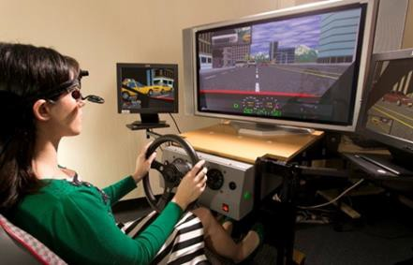

Figure 1. *The Curtin University driving simulator and*

*TM*

each simulator run will be rearranged randomly. The validity of the STISIM driving simulator has been established through the assessment of driving performance of older drivers [35].

*head-mounted Arrington ViewPoint*

*eye tracker.*

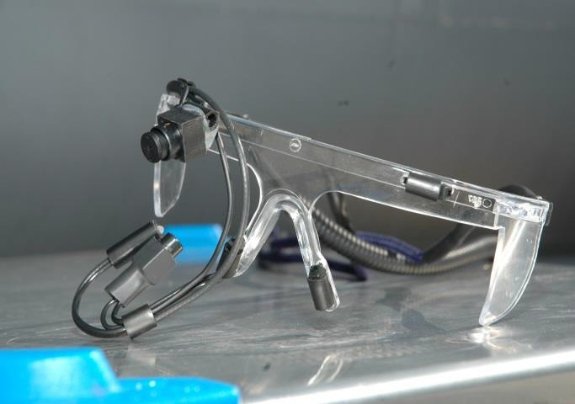**Eye-tracker:** A mobile head-mounted Arrington ViewPointTM eye tracker (see figures 1 and 2) will be used to measure the movements of participants’ eyes in 60 Hz. Measurements will include the number of fixations and fixation durations [59-61]. The eye tracker will be set to record movements of the right eye, following a visual tracking screen to verify that the participants’ eyes move smoothly and congruently. A 16-point calibration of the eye tracker will be conducted prior to commencing the test items; and in order to ensure that calibration is maintained throughout the trial, accuracy will be constantly monitored on-line. When necessary, the eye tracker will be worn over participants’ glasses. The accuracy of the eye-tracker is 0.2 degrees in the visual field [60].

Figure 2. *The head-mounted Arrington ViewPointTM eye tracker.*

# Appendix E: Commonly used off-road and outcome measures

|  |  |
| --- | --- |
| **Psychometric tests** | **Purpose** |
| **The Performance Analysis of Driving Ability (P-Drive) [62]** | Assess safe driving behaviours of participants with ASD. The P-Drive was developed based on three main theoretical frameworks: 1) measuring driving behaviour using a top-down approach rather than measuring for underlying performance components; 2) using an activity analysis approach to measure driving behavior; and  3) measuring the items in a hierarchical order based on the Michon model of driving and on theories of attention and information processing [31, 63] (Appendix G). The protocol consists of 27 items or driving actions and are scored on a scale from 1 to 4, where 4=competent driving ability, 3=questionable, 2=problematic, 1= incompetent driving ability [64]. The P-drive has been found to have not only have properties of internal scale validity and person response validity but also demonstrates a good reliability [64]. The P-drive is also capable of differentiating between people of different driving abilities. |
| **Driving Behaviour Checklist [65] (Appendices G, H1, H2)** | Assess observed driver behaviour, in particular risk taking / risk aversion that is not able to be collected using moment-to-moment GNSS/GPS data and will be recorded using a driving behaviour checklist [63]. This will be a checklist based on the well-established model of driving. The checklist has specific criteria that investigate driving-related rules and regulations, risk management and intersection maneuvering and has been previously utilised in research investigating older drivers with pathology conditions. |
| **The Manchester Driving Behaviour [5-7]** | Obtain a self-report on how frequently learner drivers with ASD engage in careless, reckless or aggressive behaviours. |
| **NASA Task Load Index [8]** | Assess participant perceived cognitive workload or the amount of effort required on 6 different levels: mental demand, physical demand, temporal demand, performance, effort and frustration. The NASA Task Load Index will be used after the run in the driving simulator and after the on-road assessment. |
| **Adelaide Driving Self Efficacy Scale (ADSES) [15, 16]** | Self-efficacy in driving is hypothesised to predict on-road driving test performance. The ADSES asks participants to rate confidence levels about driving situations, including roundabouts, driving in high-speed areas, and driving to a new destination**.** |
| **The Barratt Impulsiveness Scale V.11 [14]** | Assess impulsivity, as well as sub-scores of attention, lack of planning and motor impulsivity can be calculated. |

**Appendix F: The Goals for Driver Education Matrix (GDEM) matrix**

|  |  |  |  |  |
| --- | --- | --- | --- | --- |
|  | **Knowledge and skills** | **Risk-increasing factors** | | **Self- evaluation** |
| Goals for life and skills for living (general) | Knowledge about/ control over how life-goals and personal tendencies affect driving behaviour   * lifestyle/life situation * peer group norms * motives * self-control, other characteristics personal values | Risky tendencies   * acceptance of risks * self-enhancement through driving * high level of sensation seeking * complying with social pressure * use of alcohol and drugs values, attitudes towards   society | | Self-evaluation/ awareness of   * personal skills for impulse control * risky tendencies * safety-negative motives personal risky habits |
| Driving goals and context (journey-related)  Michon’s strategic level | Knowledge and skills concerning   * effects of journey goals on driving * planning and choosing routes * evaluation of requested driving time * effects of social pressure inside the car * evaluation of necessity of the journey | Risks connected with   * driver’s condition (mood, BAC, etc.) * purpose of driving * driving environment (rural/urban) * social context and company   additional motives (competitive, etc.) | | Self-evaluation/ awareness of   * personal planning skills * typical driving goals typical risky driving motives |
| Mastery of traffic situations  Michon’s tactical level | Knowledge and skills concerning   * traffic regulations * observation/selection of signals * anticipation of the development of situations * speed adjustment * communication * driving path * driving order * distance to others/safety margins | Risks caused by   * wrong expectations * risk-increasing driving style (e. g., aggressive) * unsuitable speed adjustment * vulnerable road-users * not obeying regulations/ unpredictable behaviour * information overload * difficult conditions (e.g., darkness, etc.) * insufficient automatism or skills | | Self-evaluation/ awareness of   * strong and weak points of basic traffic skills * personal driving style * personal safety margins * strong and weak points for hazard situations realistic self-evaluation |
| Vehicle manoeuvring  Michon’s operational level | Knowledge and skills concerning   * control of direction and position * tyre grip and friction * vehicle properties, physical phenomenon | Risks connected with   * insufficient automatism or skills * unsuitable speed adjustment   difficult conditions (low friction, etc...) | | Awareness of   * strong and weak points of basic manoeuvring skills * strong and weak points of skills for hazard situations   realistic self-evaluation |
| **The Michon model is included in the GDE matrix and is highlighted in grey** | | |  | |

**Appendix G1: On-Road Assessment Criteria**

|  |  |  |  |
| --- | --- | --- | --- |
| Area to assess | Task to complete | GPS/GIS Measurement scores | Max points |
| Lane Keeping | Double lanes flat road. Where participant’s car was on the right lane. 5 KEEP LEFT signs displayed every 50 m to prompt participants to go back to the inner lane. | Calculated from the ratio between the driving distance recorded and the distance of road alignment (50m). For each section, if (ratio -1) <=0.02, which means the real driving distance is close to 50m, score 1 point, up to 5 points. | 5 |
| Detect unstable steering over the whole trajectory, such as driving from one side to another side without any reasons. | Calculated from the ratio between the driving distance recorded and the distance of road alignment over each road sections. For any road section where (ratio -1) >0,2, subtract 1 point, up to -5 points, or else, score 5 points. | 5 |
| Traffic Sign Compliance | Driving through a Stop | If speed points show approaching slowly (deceleration), score 4 points; stopping (=>3 seconds), score 2 points; and passing steadily (acceleration), score 4 points. | 10 |
| Driving through a GIVE WAY | If speed points pattern show: Approaching slowly, score 3 points; stopping or without stopping then passing steadily, score 2 points. | 5 |
| Driving through a pedestrian crossings | If speed points pattern show: approaching slowly, score 3 points; stopping or without stopping then passing steadily, score 2 points. | 5 |
| Driving Speed | Maintain a speed close to the speed limits | Calculated from the percentage of GPS points matching the speed limits, if any over speed limit detected, subtract 2 points from the total of 10 points. | 10 |
| Detect abrupt acceleration and deceleration (confirm if caused by any unexpected traffic situation) | If each abrupt acceleration or deceleration (compare the speed changes, and the distance between a sequence GPS points) detected, subtract 2 points from total 10 points | 10 |
| Driving Manoeuvres | In a roundabout | If speed points show smooth pattern, score 4 points, slowly entering, score 2 points, if keep in the right lane around the roundabout smoothly, score 4 points. | 10 |
| Before and through a T-junction with left turn | If maintaining turning speed about 5 – 10 km/h, score 4 points, if no hesitation detected, score 2 points, if taking the right lane smoothly, score 4 points. | 10 |
| Before and through an Intersection with right turn | If maintaining turning speed around 8 km/h, score 4 points, if crossing the lanes smoothly, score 4 points, if taking the right lane smoothly, score 2 points. | 10 |
| Navigation and Wayfindings | Plan a driving route and execute the driving and return. | Driving distance recorded matching the distance planned, subtract 2 points if taking one different road section, up to -10 points; or else, score 10 points for no difference. | 10 |
| Spatial Memory | Recall 5 street names and 5 manoeuvres and marked on the map. | Each correct name and manoeuvre marked, score 1 point, up to 10 points. | 10 |

# Appendix G2: Driving Behaviour Checklist [63]

ID: Date of assessment: Assessor(s)

Time: (start) (finish)

|  |  |
| --- | --- |
| **Initial observations** |  |
| Seat adjustment |  |
| Mirror adjustments |  |
| Seatbelt |  |
| Ignition |  |
| Handbrake |  |
| Confidence/awareness |  |
| Fatigue/frustration |  |

|  |  |  |  |  |  |  |  |
| --- | --- | --- | --- | --- | --- | --- | --- |
| **Round-about (turn left)** |  | **Turning into small street** |  | **Eye-tracker**  **RE-CALIBRATION CHECK POINT** |  | **Give way (right turn)** *Tricky junction with constant flow of traffic* |  |
| Approach left lane |  | Signal (turning right) |  |  |  | Signal right |  |
| Indicate/signal left before advancing |  | Stopped at appropriate position (not blocking oncoming traffic) |  | **Round-about (turn right)** |  | Decelerate when approaching sign |  |
| Exit in left lane after round- about |  | Check oncoming traffic (head turns) |  | Approach left lane |  | Check oncoming traffic (head turns) |  |
| **Pedestrian crossing** |  | Proceed when way is clear |  | Indicate/signal right before advancing |  | Go when way is clear |  |
| Slow down when approaching |  | **Stop sign** |  | Exit in left lane after round-about |  | **Dual lane round about (U-turn)** |  |
| Give way to pedestrians |  | Obeyed stop sign |  | **Round-about (turn left)** |  | Slow down when approaching |  |
| Go when way is clear |  | Stopped before & close to the line |  | Approach left lane |  | Indicate right before entering |  |
| **Speed bump** |  | Come to a complete stop before proceeding |  | Indicate/signal left before advancing |  | Appropriate signaling |  |
| Decelerate when approaching |  | Check oncoming traffic (head turns) |  | Exit in left lane after round-about |  | **T-junction (turn left)** |  |
| Did not hit speed bump/ give way to pedestrians |  | Proceed when way is clear |  | **Speed bump/pedestrian** |  | Decelerate before junction |  |
| Complied with km/hr rule |  | **Round about (straight on Hayman Rd)** |  | Decelerate when approaching |  | Appropriate signal |  |
| **T-junction** |  | Slow down when approaching |  | Did not hit speed bump, give way to pedestrians |  | Proceed when way is clear |  |
| Decelerate before junction |  | **Dual lane round-about (turn left)** |  | Complied with km/hr rule |  | **Parking (Bay 7)** |  |
| Appropriate signal |  | Approach left lane |  | **Round about (straight)** |  | Check for traffic behind using rear mirror |  |
| Proceed when way is clear |  | Indicate/signal left before advancing |  | Slow down when approaching |  | Slow down |  |
| **Traffic lights** |  | Exit in left lane after round-about |  | Maneuvering around round about is  smooth |  | Correct signalling |  |
| Decelerate when approaching |  | **Parking**  **(Marquis street near canning college)** |  | **Round about (straight)** |  | Apply handbrake |  |
| Stop at appropriate distance to car in front |  | Check for traffic behind using rear mirror |  | Slow down when approaching |  |  |  |
| Noticed lights; stopped (red)or go (green) as indicated |  | Slow down |  | Maneuvering around round about is smooth |  |  |  |
| Proceed when way is clear |  | Correct signaling |  |  |  |  |  |
|  |  | Apply handbrake |  |  |  |  |  |

|  |  |  |  |  |  |  |  |
| --- | --- | --- | --- | --- | --- | --- | --- |
| Generic checklist (to be completed after session) | | | | | | | |
| **Normal driving** | Y | N | **Steering** | Y | | N | **Non-verbal communication (if observed)** |
| Kept reasonably to left |  |  | No erratic movement of steering wheel |  | |  | Appropriate hand gestures to communicate with other on-road users : |
| Drove with appropriate speed |  |  | Steering for good lane placement |  | |  | Appropriate hand gestures to communicate with other on-road users : |
| Maintained appropriate distance between car in front |  |  | Correct positioning of hands on wheel |  | |  |  |
| Adhered to speed limit |  |  |  |  | |  |  |
| **Unexpected hazardous/Critical Scenarios (e.g. road block, accident); How did driver react?** | | | | | | | |
|  | | | | |  | | |

# Appendix H1: Satellite map with arrows depicting the on-road assessment route

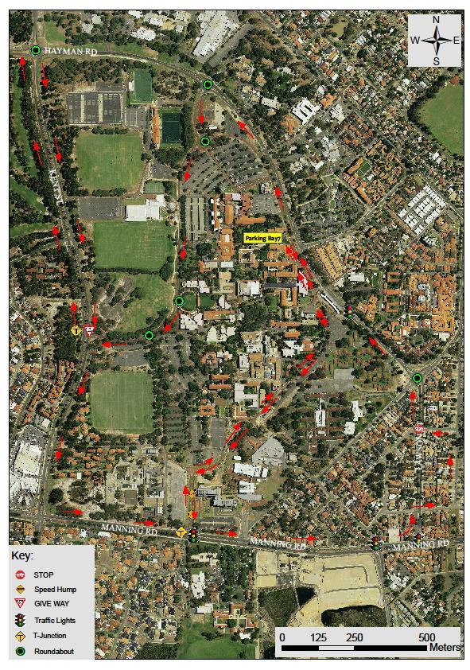

**Appendix H2:GIS / GPS Output**

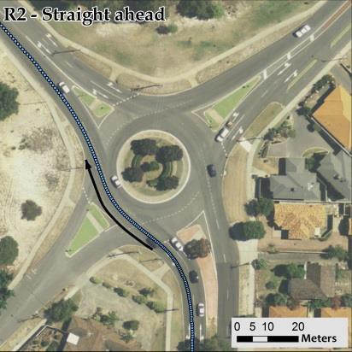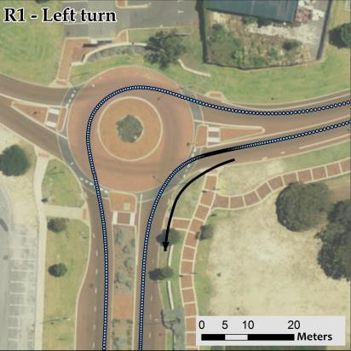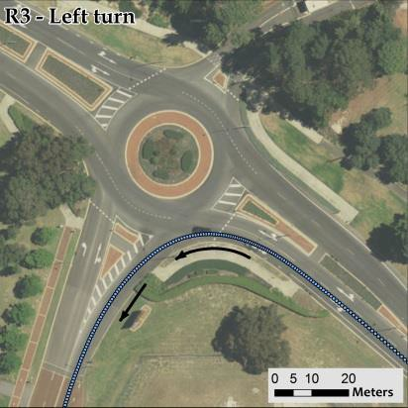

Study sites incorporating with various roundabout maneuvers: Entry/Exit points and negotiating paths

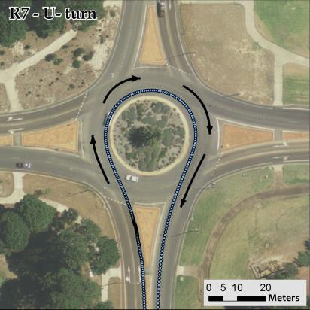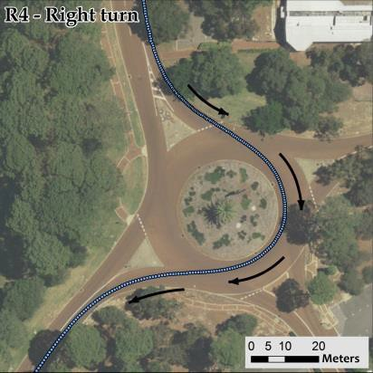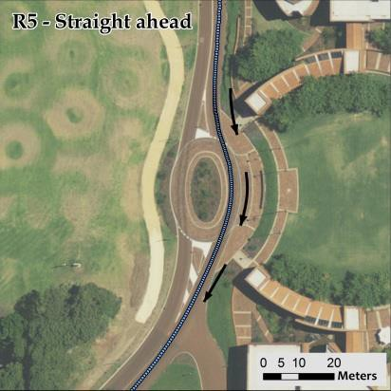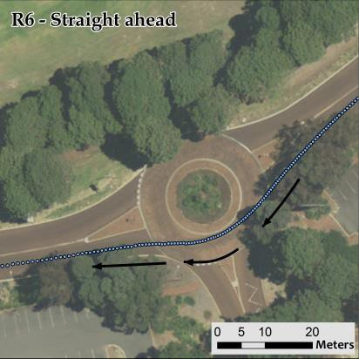

(Left to right and top to bottom: R1, left turn; R2, straight-ahead; R3, left turn; R4, right turn; R5, straight-ahead; R6, straight-ahead; and R7, U- turn. Table 1 shows the geometry of the roundabout and the negotiating curvature at each roundabout maneuvers. The black arrows show the driving directions and red arrows for the start and end points of the maneuvers. The continuous dots are the driving trajectories of participants processed using RTK multi-GNSS

# Appendix H3: GIS / GPS Output [74]

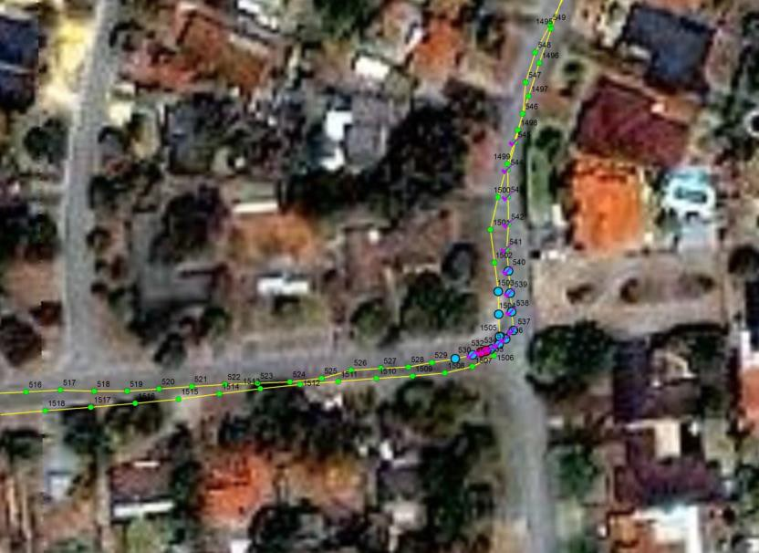

An example of moment-to-moment GIS / GPS rendered map analysis of left turn maneuvers trajectory in an on-road assessment.

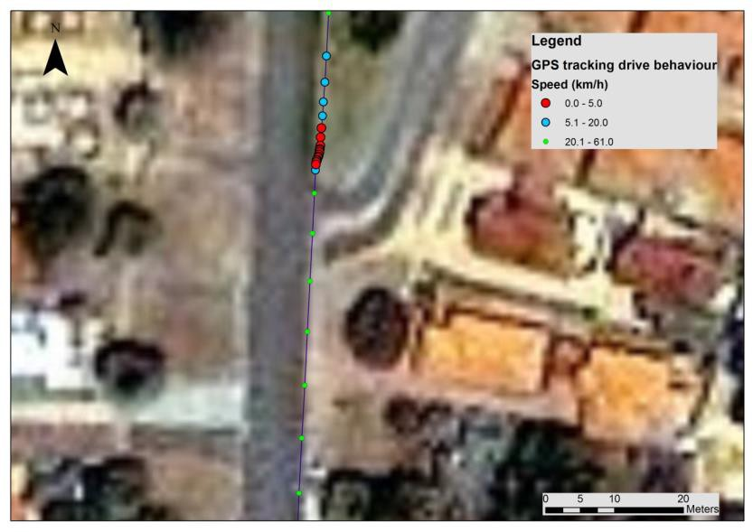

An example of moment-to-moment GIS / GPS rendered map analysis of acceleration (green dots) and rapid deceleration (red points) in an on-road assessment.

# Appendix H4: Context of driving in a dual-controlled car with Global Navigation Satellite System (multi-GNSS) and Geographic Information Systems (GIS) technologies.

### GNSS receivers

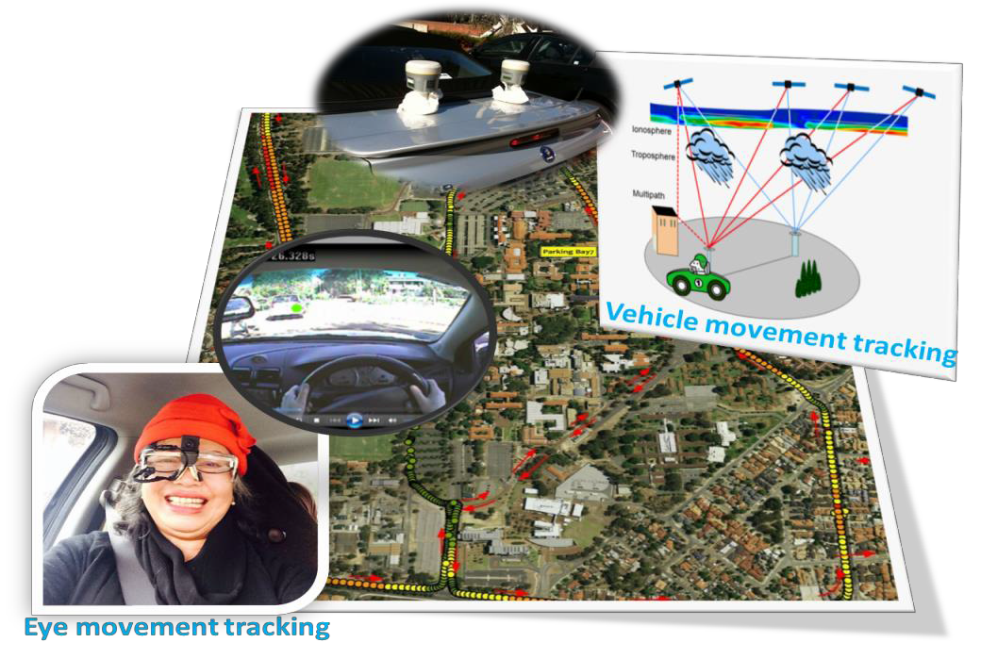

***Eye tracker***

**Appendix I: Adverse Events Management Plan**

**Preventative Measures:**

* Participants will be provided with information about what to do if distressed at all studies of the project, i.e. in the observational studies and surveys in Study 2 of Project One, surveys and interviews (randomised control trial) in Study 4 of Project One; focus groups and interviews in Study 2 and Study 3 of Project Two.
* Participants will be supported by the people and services that regularly assist them.

Steps taken if a participant becomes distressed during an interview, a survey or while completing the on-road driving:

1. **Identify** – Early identification of distress will be ensured by the researcher observing any visual or verbal signs of distress (i.e. significant changes in behaviour, teary eyes, changes in voice, etc.).
2. **Stop** – If the participant is becoming upset or distressed, state:

‘I can hear/see that you are becoming upset, I will stop the interview/driving for now.’

1. **Empathy/Comfort** –

‘I can see that must be very difficult for you.’

‘It sounds like this a hard time for you.’

1. **Ensure Stable** – once the participant has calmed down the researcher will ensure that they are stable by asking ‘Are you feeling ok?’
2. The researcher will ask about the person’s normal coping strategies for when they are distressed or upset:

‘What do you normally do when you are upset? Is there someone you would like to talk to?’

1. If they identify something they normally would do, the researcher will suggest they partake in these activities after they leave.
2. If the person wants to speak to someone, be it a friend, family member or health service, the researcher will ask if they can assist the participant to get in touch with them:

‘Would you like me to contact this person for you?’

1. If the participant declines the researcher’s assistance to contact some:

‘I would encourage you talk to a friend of family member after you leave today.’

1. Ask the participant if they would like to continue or postpone the interview/driving or withdraw from the study.
2. If they wish to continue, the researcher will ensure the participant is ok and continue with the interview/driving.
3. If they wish to postpone: ‘When would be a good time to call you to discuss another time to complete the interview/driving?’

Once the interviewer has established a date and time: ‘I would like to thank you for your time today and will call you (insert time and day here). Would it be alright if I contact you tomorrow to check you are ok?’

1. If they wish to withdraw: ‘I would like to thank you for your time today. As discussed, I would encourage you to do what you would normally do if you are feeling upset or distressed.’

‘Would it be alright if I contact you tomorrow to check you are ok?’

If yes, the research will contact them the following day.

1. Refer – At the end of the interview/driving, or if at any time the participant appeared to be significantly distressed:

‘If this feeling of distress continues, you can access support from any of the following:’

* Your local GP;
* Lifeline (13 11 14);
* Local counselling services like Relationships Australia (1300 364 277); or
* The autism association in your state.

**Appendix J**

**Randomised allocation of participants in NSW and WA.**

NSW WA

|  |  |  |  |  |
| --- | --- | --- | --- | --- |
| Number | Treatment |  | Number | Treatment |
| 1 | Intervention |  | 1 | Intervention |
| 2 | Control |  | 2 | Control |
| 3 | Intervention |  | 3 | Intervention |
| 4 | Control |  | 4 | Control |
| 5 | Control |  | 5 | Control |
| 6 | Control |  | 6 | Intervention |
| 7 | Control |  | 7 | Intervention |
| 8 | Control |  | 8 | Intervention |
| 9 | Intervention |  | 9 | Control |
| 10 |  |  | 10 |  |
| 11 |  |  | 11  Detail of the randomisation order removed from this Appendix for confidentiality. Lead Project Leader keeps a copy in password protected PC until the RCT is implemented |  |
| 12 |  |  | 12 |  |
| 13 |  |  | 13 |  |
| 14 |  |  | 14 |  |
| 15 |  |  | 15 |  |
| 16 |  |  | 16 |  |
| 17 |  |  | 17 |  |
| 18 |  |  | 18 |  |
| 19 |  |  | 19 |  |
| 20 |  |  | 20 |  |
| 21 |  |  | 21 |  |
| 22 |  |  | 22 |  |
| 23 |  |  | 23 |  |
| 24 |  |  | 24 |  |
| 25 |  |  | 25 |  |
| 26 |  |  | 26 |  |
| 27 |  |  | 27 |  |
| 28 |  |  | 28 |  |
| 29 |  |  | 29 |  |
| 30 |  |  | 30 |  |
| 31 |  |  | 31 |  |
| 32 |  |  | 32 |  |
| 33 |  |  | 33 |  |
| 34 |  |  | 34 |  |
| 35 |  |  | 35 |  |
| 36 |  |  | 36 |  |
| 37 |  |  |  |  |
| 38 |  |  |  |  |
| 39 |  |  |  |  |
| 40 |  |  |  |  |