PARTICIPANT DIARY NO.

CONFIDENTIAL

Comparative Effectiveness Study of the Clinical and Cost Outcomes of Massage for the Management of Chronic Low Back Pain in Australia.

Protocol Number ETH16-0812

Participant’s Initials

Allocation Number

Baseline Date
d d m m y y
Please complete this diary each day indicating your maximum pain level and medication taken. Record any treatments on the second page.
Week  Day | Date | 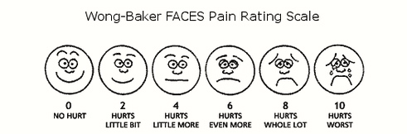 | Pain medication
 | d d m m y y |  | Type/Name | No. tablets/day
1 |  | 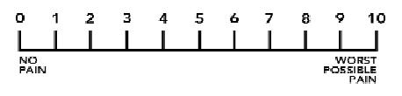
2
3
4
5
6
7
Usual care | Date | Therapy/modality (eg. GP, physiotherapist) | Notes

Please complete this diary each day indicating your maximum pain level and medication taken. Record any treatments on the second page.
Week  Day | Date |  | Pain medication
 | d d m m y y |  | Type | No. tablets/day
1
2
3
4
5
6
7
Usual care | Date | Therapy/modality (eg. GP, physiotherapist) | Notes
Please complete this diary each day indicating your maximum pain level and medication taken. Record any treatments on the second page.
Week  Day | Date |  | Pain medication
 | d d m m y y |  | Type | No. tablets/day
1
2
3
4
5
6
7
Usual care | Date | Therapy/modality (eg. GP, physiotherapist) | Notes
Please complete this diary each day indicating your maximum pain level and medication taken. Record any treatments on the second page.
Week  Day | Date |  | Pain medication
 | d d m m y y |  | Type | No. tablets/day
1
2
3
4
5
6
7
Usual care | Date | Therapy/modality (eg. GP, physiotherapist) | Notes
Please complete this diary each day indicating your maximum pain level and medication taken. Record any treatments on the second page.
Week  Day | Date |  | Pain medication
 | d d m m y y |  | Type | No. tablets/day
1
2
3
4
5
6
7
Usual care | Date | Therapy/modality (eg. GP, physiotherapist) | Notes
Notes:

