**Participant Information Sheet**

*Orthopaedic Research Institute of Queensland*

|  |  |
| --- | --- |
| **Title** | Navigated medial opening wedge high tibial osteotomy versus navigated lateral closing wedge high tibial osteotomy: A randomised control trial |
| **Short Title** | Nav HTO MOvLC |
| **Protocol Number** | Version 1.2 |
| **Project Sponsor** | Orthopaedic Research Institute of Queensland(ORIQL) |
| **Coordinating Principal Investigator/ Principal Investigator** | Dr Peter McEwen |
| **Associate Investigator(s)** | Dr Kenji Doma  Dr Matthew Wilkinson  Dr Kaushik Hazratwala  Andrea Grant  Dr Ryan Faruque |
| **Location** | Mater Health Services North Queensland Ltd |

**Part 1 What does my participation involve?**

**1 Introduction**

This Participant Information Sheet tells you about the research study, explaining the tests and treatments involved as well as the storage and use of the research data captured, so you can make an informed decision about whether or not you want to take part in the research.

Participation in this research is voluntary. You will receive the best possible care whether or not you are involved in the study.

If you decide you do want to take part in the research study, you will be asked to sign the consent section attached. By signing it you are telling us that you:

• Understand what you have read

• Consent to take part in the research project

• Consent to have the tests and treatments that are described

• Consent to the use of your personal and health information as described.

**2 Background and aim of the research study**

If you have been invited to be part of this research project you have medial knee arthritis and a bowed leg that is to be treated by a high tibial osteotomy (HTO). This operation changes the shape of the limb so weight is transferred from the damaged medial (inside) part of the knee to the undamaged lateral (outside) part of the knee.

We know that the results of the operation are dependent on the accuracy of the correction. We also know that computer-assisted-surgery is the most reliable way of achieving this correction. The research project compares two techniques of achieving the same correction. Both techniques are computer assisted but have not previously been compared using the computer-assisted technique.

The two techniques aim to produce the same limb shape but do so in different ways. The two techniques are;

1. Medial opening wedge HTO.
2. Lateral closing wedge HTO.

*Medial Opening Wedge HTO (Figure1).*

This technique works by lengthening the medial column of the tibia by creating a triangular defect (an open wedge) in the medial side of the top of the tibia (shin bone). Once the correct limb angle is achieved the correction is held with a strong metal plate. The triangular defect fills in with bone in the same way a broken bone heals. This technique is popular because the correction can be easily adjusted until the angle is correct.

*Lateral Closing Wedge HTO (Figure 2).*

This technique has been used for decades. It works by removing a triangle of bone (a closed wedge) from the lateral side of the top of the tibia. This technique has in the past been less accurate because the size of the wedge is harder to adjust once made. However by removing a slightly larger wedge than needed the closing wedge can be adjusted with the same accuracy as a medial wedge. Once the correct angle is achieved the correction is held with a similar device to that described for the other technique.

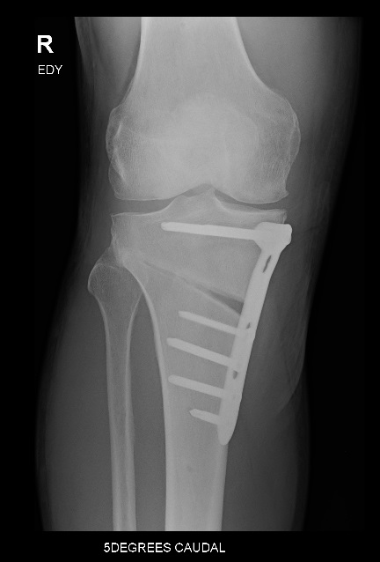 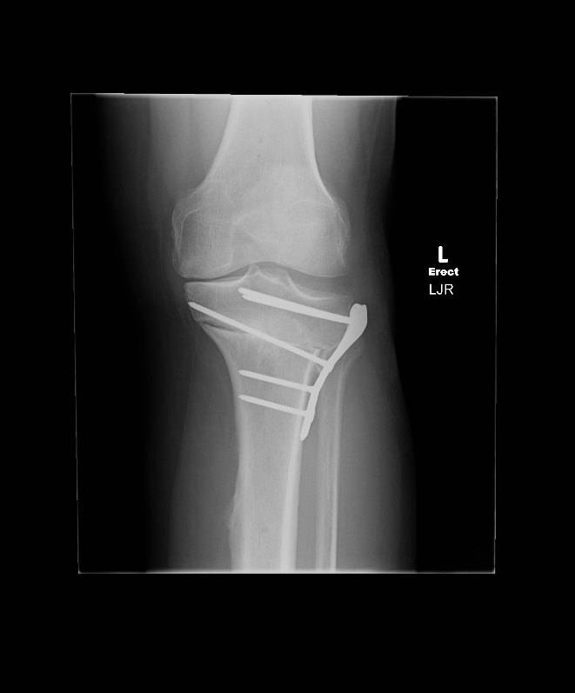

Figure 1 Figure 2.

*Differences Between the Techniques*

* The skin cut is larger for the lateral closing technique.
* Limb length increases slightly with a medial opening and decreases slightly with a lateral closing wedge.
* The metal plate is under the skin with the medial opening technique but under muscle for the lateral closing. The plate may therefore be more likely to cause irritation with the medial opening technique.
* The medial opening technique will produce a larger gap that bone has to grow into than the lateral closing technique. This may affect the time to get off crutches and the number of x-rays that are taken after the surgery.

*What Are the Aims of the Research?*

The aims of the project are to determine whether one technique is superior to the other. Specifically we want to know if there are differences in;

1. The angle of correction achieved in surgery and the angle of correction produced when you stand on the leg.
2. The time to walk without crutches.
3. The time for the bone to be healed on x-ray.
4. Any residual symptoms caused by the metal plate.
5. The way force is transmitted across the knee when walking.
6. Pain relief and your satisfaction with the operation.

These outcomes are measured with x-rays, questionnaires and gait laboratory assessment. The x-rays and questionnaires are routine assessment tools. The gait laboratory assessment is at James Cook University and under the supervision of Dr Kenji Doma.

**3 What does participation in this research involve?**

If you decide to participate in the research, you will first be randomly allocated to either one of two study groups, either the lateral closing wedge HTO group or the medial opening wedge HTO group. Random allocation is necessary to ensure the patients are placed in either group in a fair manner. You will be asked to have x-rays and complete several questionnaires that will also be completed after surgery for comparison. No x-rays will be required that are not routinely required of the surgery.

Pre-Surgery:

You will provide consent to participate in research and agree to the Terms and Conditions of accessing FORCE THERAPEUTICS. Your consent will be obtained verbally and electronically. Consent will be obtained prior to any study assessments and procedures. The study doctor will take a medical history and determine eligibility for recruitment to the study.

Please see table below for an outline of pre-surgical assessments required as part of the study protocol.

During Surgery:

The surgery will be done according to your randomization group, either a lateral closing wedge HTO or a medial opening wedge HTO. Modern anaesthetic, surgical and pain relief techniques will be used.

Post-Surgery:

You will need to attend your study doctor’s clinic for follow up appointments, please refer to the study visits log below.

FORCE THERAPEUTICS: You will become familiar with patient assessment questionnaires following your surgery. Please ensure you complete these either in clinic as part of your routine assessment or online through your FORCE THERAPEUTICS profile.

Please see the table below with details on each study visit.

|  |  |  |  |  |  |
| --- | --- | --- | --- | --- | --- |
|  | **Study Visits** | | | | |
|  | Pre-Surgery | Surgery | 6 weeks later | 6 months later | 12 months later |
| Informed Consent | x | Surgery |  |  |  |
| Clinical exam | x | x | x | x |
| Lab Assessment | x |  | x |  |
| Questionnaires | x | x | x | x |
| X-ray | x | x | x | x |

Lab Assessments:

Gait Laboratory: Investigate regarding what effect on gait pattern, if any, MO HTO versus LC HTO has had based on the changes in:

1. Ground reaction force
2. Adductor moment
3. Abductor moment

Functional Outcomes:

1. Type of osteotomy
2. Pre- and post- operative mobility
3. ROM- measured by inclinometer
4. Time to weight bear (Defined as time, in days post operatively, that the patient was able to bear weight on the operated limb)
5. Time to weight bear without crutches (Defined as time, in days post operatively, patient is comfortable to walk and gait pattern normalised, not requiring crutches as indicated by physiotherapist)
6. Scar size (Length measured in centimetres)

Radiological Outcomes:

1. Hip knee ankle angle (HKA) from long leg weight bearing films
2. Posterior tibial slope
3. Patellar height
4. Time to union

Patient Reported Outcome Measure (PROM) scores

1. Knee injury and Osteoarthritis Outcome score (KOOS)
2. Oxford Knee score (OKS)
3. Visual-analogue-scale (VAS) pain score

*Removal of metal*

At the 12-month mark it may be necessary to remove the metal plate if it causes discomfort. This is a day procedure that does not require use of crutches afterwards.

Costs:

There are no additional costs associated with participating in this research project, nor will you be paid. You may be reimbursed for any reasonable travel or parking costs associated with visits to the gait laboratory.

**4 Other information about the research study**

We aim to recruit a total of 20 patients in the study, which will be conducted at the Mater Health Service North Queensland Ltd between September 2016 and September 2018.

**5 Do I have to take part in this research study?**

Participation in any research study is voluntary. If you do not wish to take part, you do not have to. If you decide to take part and later change your mind, you are free to withdraw from the study at any stage. Your decision on whether or not to take part, or to take part and then withdraw, will not affect your routine treatment or your relationship with those treating you. You may wish to continue to use FORCE THERAPEUTICS as part of your continuation of care if you decide to not continue in a research project.

**6 What are the alternatives to participation?**

You do not have to take part in this research study to receive treatment at this hospital or surgeon.

1. **What are the possible benefits to me of taking part?**

There are no added benefits to you if you take part in the study. The research is mainly to advance understanding and knowledge about the procedure.

**8 What are the possible risks and disadvantages to me of taking part?**

The major risks to you are those inherent of the anaesthetic and surgical procedure. Your surgeon will explain these risks to you. There are no additional risks or disadvantages to you by taking part in this study.

**9 Are there possible side effects from x-rays?**

This research study involves exposure to a small amount of radiation by x-rays. This exposure however, the x rays you will undergo are standard for the procedure and thus does not put you at an increased risk of side effects.

**10 Can I have other treatments during this research project?**

Whilst you are participating in this research project, you may not be able to take some or all of the medications or treatments you have been taking for your condition or for other reasons. It is important to tell your study doctor and the study staff about any treatments or medications you may be taking, including over-the-counter medications, vitamins or herbal remedies, acupuncture or other alternative treatments. You should also tell your study doctor about any changes to these during your participation in the research project. Your study doctor should also explain to you any treatments or medications that need to be stopped for the time you are involved in the research project.

**11 What if I withdraw from this research project?**

If you decide to withdraw from the project, please notify your surgeon or practice nurse.

**12 Could this research project be stopped unexpectedly?**

This research project may be stopped unexpectedly for a variety of reasons. These may include reasons such as:

* Unacceptable side effects
* Decisions made in the commercial interests of the sponsor or by local regulatory/health authorities.

**Part 2 Frequently asked questions**

**1 What will happen to information about me?**

By providing consent to the study doctor and relevant research staff, you consent to collection and use of personal health information for the research project. Any information obtained in connection with this research project that can identify you will remain confidential. The data collected from this project will be stored on the password protected ORIQL Database’s and may be pooled (de-identified) for further retrospective research projects (following HREC approval). In such instances you will not be contacted to obtain permission for de-identified data to be used.

Information about you may be obtained from your health records held at this and other health services for the purpose of this research. By signing the consent form you agree to the study team accessing health records for the purpose of verifying the procedures and the data relevant to this Participant Information Sheet.

It is anticipated that the results of this research project will be published and/or presented in a variety of forums. In any publication and/or presentation, information will be provided in such a way that you cannot be identified, except with your permission. Information about your participation in this research project may be recorded in your health records.

You have the right to request access to your information collected and stored by the research team. You also have the right to request that any information with which you disagree be corrected.

**2 Complaints**

If you suffer any injuries or significant event whilst you are a part of or participating in this research project, you should contact the study team as soon as possible and you will be assisted with arranging appropriate management.

**3 Who is organising and funding the research?**

The Orthopaedic Research Institute of Queensland (ORIQL) is funding this research project. The ORIQL is a not-for-profit registered charity limited by guarantee. The organisation conducts clinical and scientific research in the field of orthopaedic surgery and musculoskeletal medicine under a board of orthopaedic surgeons. ORIQL researchers do not receive a personal financial benefit from your involvement research projects.

**4 Who has reviewed the research project?**

This research project has undergone Human Research Ethics Committee (HREC) review. The ethical aspects of this research project have been approved by the HREC of Mater Health Services North Queensland Ltd.

**5 Further information and who to contact**

If you have any concerns or problems regarding involvement in the study please contact the persons below. If you are facing any medical problems or concerns about your joint replacement or surgery please contact your surgeon’s office or your care team through FORCE THERAPEUTICS:

**Clinical contact person**

|  |  |
| --- | --- |
| Name | *Andrea Grant* |
| Position | *Research Coordinator* |
| Telephone | *0413 685 331* |
| Email | *Research_coordinator@oriql.com.au* |

For matters relating to research at the site at which you are participating, the details of the local site complaints person are:

**Complaints contact person**

|  |  |
| --- | --- |
| Position | *Governance Officer* |
| Telephone | *07 4727 4444* |
| Email | *research.ethics@matertsv.org.au* |

For more information on participating in clinical trials you can consult the Australian Clinical Trials website: [www.australianclinicaltrials.gov.au](http://www.australianclinicaltrials.gov.au) The website was developed by the National Health and Medical Research Council (NHMRC) and the Department of Industry and Science which provides general information about clinical trials for consumers, health care providers, researchers and industry.