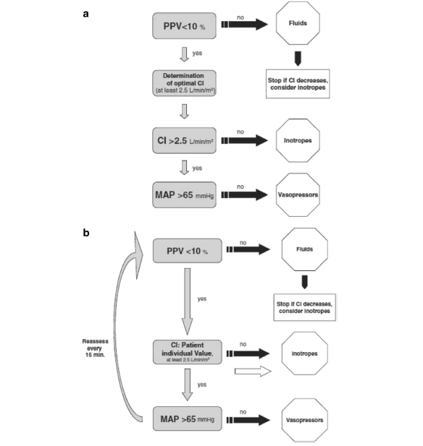
From: Salzwedel C, Puig J, Carstens A, Bein B, Molnar Z, Kiss K, et al. Perioperative goal-directed hemodynamic therapy based on radial arterial pulse pressure variation and continuous cardiac index trending reduces postoperative complications after major abdominal surgery: a multi-center, prospective, randomized study. Crit Care. 2013;17:R191.

