Contact Us  Please contact the research team with any queries:  Chloe Maxwell-Smith  Phone: 0449 768 269  Email: chloe.maxwell-smith@postgrad.curtin.edu.au  Sarah Hardcastle  Phone: 0439 226 015  Email: sarah.hardcastle@curtin.edu.au |  |  | Physical Activity for Cancer Survivorship  Information & exercise booklet

Table of Contents  Introduction 1  Physical Activity 2  How much? 2  How hard should I exercise? 3  Incidental exercise 3  Benefits 4  Examples of aerobic physical activity................................................................... 4  Physical activity for you 5  Working towards the guidelines 6  SMART Goals: Goal-setting criteria 7  Setting your own goals: Short-term goals 8  Setting your own goals: Long-term goals 9  Action planning 10  Barriers 11  Rewards 12  Rewards for you 13  Resources 14 |  |  | Goal-setting criteria  Forming realistic and specific goals for physical activity can be an effective step towards living a healthier life.  Effective goals must be SMART.  Specific  Exactly what do you wish to accomplish? (Who, what, when, where, how)  Measurable  How will you measure progress towards the goal? How will you know once you have achieved this goal? How many minutes/times/days are you aiming for?  Achievable  Are you realistically able to achieve this goal in the time frame you have specified? Do you have the means necessary, and is your body capable?  Relevant  How does this goal align with your long-term plans? Is it worthwhile? Will this goal fit with your lifestyle?  Time-oriented  How long will it take you? Does your goal include a realistic timeframe?
 |  |  | 7

Working towards the guidelines  Despite the benefits of physical activity for improving health and preventing cancer recurrence, few cancer survivors are currently meeting the recommended physical activity guidelines. Cancer survivors are at increased risk of secondary cancers, cardiovascular disease and other health risks compared to those without a cancer history.  Health behaviour interventions that incorporate psychological components such as goal-setting, group and peer interactions, counselling and feedback to influence behaviour change have yielded promising findings.  Employing psychological techniques such as goal-setting and self-monitoring can motivate survivors to increase their physical activity levels. |  |  | Introduction  This booklet has been designed to assist individuals who have been recruited into our physical activity and cancer survivorship trial.  Please use the following information and tools to help you set and work towards your physical activity goals.  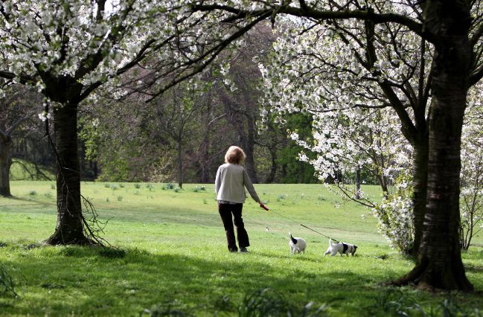
6 |  |  | 1

Physical activity  How much should I exercise?  According to the Australian Government guidelines, the optimal level of aerobic physical activity per week for adults aged 18-65 is 150-300 minutes of moderate intensity physical activity, or 75-150 minutes of vigorous intensity physical activity, or an equivalent combination of the two. Although this may seem like a lot, it can be broken down into daily chunks. For example, 30 minutes of moderate physical activity on 5 days per week would meet these guidelines.  For adults aged 65 and over, 30 minutes of moderate intensity physical activity on most days is recommended. It is also suggested that older adults engage in a range activities to improve strength, fitness, balance and flexibility.  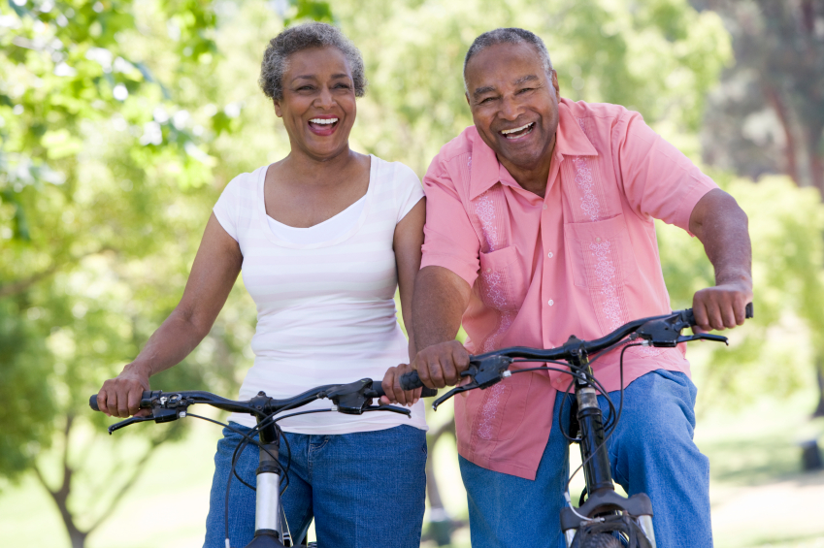  “Doing any physical activity is better than doing none. If you currently do no physical activity, start by doing some, and gradually build up to the recommended amount.” —Australian Government, Department of Health |  |  | How hard should I exercise?  Moderate intensity exercise should make you breath a little harder, but not make you feel completely out of breath. If you are doing moderate intensity aerobic activities such as brisk walking, you should be walking at an intensity where you can talk, but cannot sing.  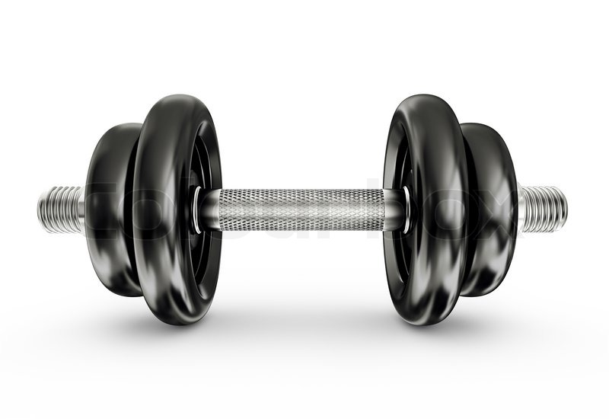  If you are doing moderate intensity strength activities such as lifting weights, you should be able to complete 8-12 repetitions before you need to take a break.  Incidental exercise  Some regular daily activities such as housework or gardening may count towards your weekly target of 150 minutes. These activities are referred to as incidental exercise. Incidental exercises will still count towards your weekly goal, if they are at least moderate in intensity. Remember, this means a shortness of breath, feeling warm, or breaking a light sweat.  Examples of daily incidental exercise to include in your routine:  - Using the stairs instead of an elevator/escalator  - Parking further away from destination to increase walking  - Walking to nearby destinations instead of driving (school, shops, post-box)  - Walking the dog  - Household tasks such as cleaning or vacuuming  - Getting off the bus a few stops early to walk the rest of the way
2 |  |  | 3

Setting your own goals…  With the SMART criteria in mind, please create some of your own goals below.  My short-term goal  Write down a short-term goal that you would like to work towards. For example, write down the exercise you would like to do this week.  I will exercise/start exercising on _____________________________________. I will ____________ ___________________________________ (type of exercise) for ____________________ minutes, __________________ times a week. If I do this for _________________weeks, I will reward myself by _______________________________________________________________.  For example, “I will start exercising on Tuesday. I will go swimming or walking for 30 minutes, five times a week. If I do this for five weeks, I will reward myself by getting a massage or manicure!” |  |  | Setting your own goals…  With the SMART criteria in mind, please create some of your own goals below.  My long-term goal  Write down a long-term goal that you would like to work towards. For example, what long-term bene t you would like to achieve from exercising, and when you would like to achieve it by.  I would like to _________________________________________________  by ___________________________________. My reward will be  __________________________________________________________________.  For example, “I would like to lose 5 kilograms before my birthday this year. If I manage to do this, I will reward myself by booking a weekend trip away.”  7
8 9
Rewards  It is important to reward yourself when you make progress towards a goal. Although some rewards cost money, other rewards are just as satisfying – and virtually free!  Remember, some rewards may be unhealthy or will be counter-productive in helping you reach your goals. For example, do not reward your weight loss with a big slice of cake!  Cost money Do not cost money  Buying a new outfit Having a bubble bath  Going out for dinner Inviting friends over  Going to the cinema Watching your favourite film/television program  Going away for the weekend Asking family to look after the kids so you can have some time to yourself  Having your hair done Going to the beach or out for a walk |  |  | Barriers  It is likely that you will encounter some barriers along the way. Please list below any psychological, social, physical, or environmental barriers you may encounter while aiming to increase your physical activity, and a possible solution to help you overcome each barrier.  Barrier Solution  1 I won’t want to walk outside when it is raining. I could do a home-based exercise DVD instead.  2  3  4  5  7
12 11

Physical activity for you  Please list below some forms of exercise that would be enjoyable and suitable for you. You may want to use some from the list on page 4, or you may have some other ideas.  1  2  3  4 |  |  | Resources  Australian Government Guidelines for Physical Activity  http://www.health.gov.au/internet/main/publishing.nsf/content/health-pubhlth-strateg-phys-act-guidelines  Cancer Council WA Life Now Exercise Program  https://www.cancerwa.asn.au/patients/support-and-services/life-now/  Cancer Counselling Services  Phone: 13 11 20  Diet and Exercise for Cancer Survivors  https://www.cancercouncil.com.au/cancer-prevention/diet-exercise/
5 14

Benefits  The benefits of being physically active in accordance with the recommended guidelines include reduced risk of:  - Cardiovascular disease  - Type 2 diabetes  - Psychosocial problems  - Musculoskeletal problems  Being consistently physically active may also result in:  - Prevention of unhealthy weight gain  - Prevention of some cancers & cancer recurrence  Examples of aerobic physical activity…  - Brisk walking - Water aerobics  - Jogging - Rowing  - Cycling - Dancing  - Swimming - Gym classes  - Yoga/Pilates - Group sports  4 | Action planning  Forming a detailed plan about how you will achieve your goal will help you to measure your progress and re-evaluate your plan if you go off track.  My overall goal  I would like to _________________________________________________  by ___________________________________.  My action plan  Where am I going to do it?  _________________________________________________________________  When am I going to do it?  _________________________________________________________________  With whom am I going to do it?  _________________________________________________________________  10

Rewards for you

Please list below achievements that you would reward yourself for and what those rewards would be.
Achievement | Reward
1 I have exercised for at least 10 days in a 2-week period. | Go for a walk or a coffee with a friend.

2

3

4

5

13

