**Appendix A – Participant information Sheet and Consent**

Departments of Neurosurgery,

6th Floor, Dunedin Hospital,

201 Great King St, Dunedin,

New Zealand.

Principal Investigator: Professor Dirk de Ridder

Telephone: 64 (03) 474 9337

Fax: 64 (03) 474 9337

Ethics committee ref: 17/NTB/61

Date: 20/April/2017

**INFRA-SLOW NEUROFEEDBACK FOR FOOD ADDICTION IN WOMEN**

**PARTICIPANT INFORMATION SHEET**

**Investigators**

1. Professor Dirk De Ridder, Department of Surgical Sciences, Neurosurgery, Otago University
2. Associate Professor Patrick Manning, Department of Medicine, Otago University
3. Mark Smith, Neurofeedback Services of New York, New York, USA
4. Assoc. Professor Sven Vanneste, School of Behavioral and Brain Sciences, University of Texas at Dallas, USA
5. Dr. Theresia Stöckl, Pediatric Neurodevelopmental Clinic, Gauting/Munich, Germany
6. Dr Sook Ling Leong, Department of Surgical Sciences, Neurosurgery, Otago University
7. Dr Joyce Lim, Department of Surgical Sciences, Neurosurgery, Otago University
8. Samantha Ross, Department of Medicine, Otago University

Thank you for showing an interest in this project. Please read this information sheet carefully before deciding whether or not it is appropriate for you to take part. Your participation is entirely voluntary. If you decide not to take part, it will not affect any future care or treatment. If you do agree to take part in the study, you are free to withdraw at any time without having to give a reason and this will in no way affect any future health care. The following sheet explains what the study will involve.

Please read the information in the rest of this information sheet carefully.

**What is the aim of the project?**

The aim of this study is to attempt to reduce cravings related to food addiction using infra-slow neurofeedback , ISF neurofeedback (a non-invasive neuromodulation).

It is known that there are several areas in the brain related to reward processing which encourage overeating. This has been shown via brain activity imaging studies, which have found that certain patterns of activity seen in obesity are similar to those shown in addiction. One such area is called the posterior cingulate cortex (PCC) which appears to function abnormally in individuals who are addicted to food. We believe that ISF neurofeedback can help reduce food craving in people with food addiction who have abnormalities in the function of the PCC. ISF neurofeedback utilises real time display of brain activity to allow self-regulation of brain function by individuals.

We will use ISF neurofeedback to target the PCC as part of the ‘default mode network’ in overweight and obese food-addicted individuals (as defined by the Yale Food Addiction Scale, YFAS) to investigate the effects on craving and brain activity. It is of note that no clinical benefits are expected as a direct result of the study aside from a transient decrease in food craving.

**What will participants be asked to do?**

Potential participants will be asked to fill out the YFAS to determine if you are a suitable candidate for the study. You will be fully informed about the study and given an opportunity to ask questions and time to consider whether you wish to participate. If you agree to participate you will be asked to sign a consent form.

The following procedures will be performed:

* Multiple questionnaires to assess your craving, and psychological state.
* Brain wave tests (EEG) will be performed during screening, after three and six session as well as 2 and 4 weeks after treatment.
* ISF neurofeedback will commence after screening. You will be randomised to either real or sham/placebo ISF and you will be asked to attend 6 ISF sessions in 3 weeks. In sham/placebo, a simulation protocol will be administered instead of real ISF.

**What type of participants are we looking for?**

* Women, aged 18-60 years
* BMI > or = 25
* Score >3 (food addicted) on Yale Food Addiction Scale (YFAS)
* Right handed

**Research staff will assess you for these exclusion criteria. Meeting any of these exclusions will make you ineligible for participation in this study:**

* Major weight gain or loss (> 5kgs) in the last 6 months
* Antidepressants and other psychotic medications
* Recent significant head injuries. e.g. concussion where consciousness is lost or surgery
* Psychiatric disorders with psychotic symptoms or manic symptoms
* Other health problems-diabetes, cancer, heart disease, uncontrolled hypertension
* Females who are or intend to become pregnant
* History of epilepsy
* Metal implants or implanted electronics (pacemaker)
* Recurring headaches
* Previous bariatric surgery
* Previous diagnosis of an eating disorder

**What are the side effects and risk?**

There are no known serious side effects and risks associated with EEG and ISF neurofeedback aside from a seldom occurring headache after ISF.

**Will I be paid for my participation on this project?**

No, you will not be paid to participate in this study however we will reimburse any out-of-pocket expenses that you incur from participating e.g., travel expenses to attend appointments.

**Can participants change their mind and withdraw from the project?**

You may withdraw from this project at any time and without any disadvantage of any kind. In addition, the study staff may decide to withdraw you from the study if you have any unexpected side effects from the treatment or if they have any other concerns.

**What information will be collected and what use will be made of it?**

We will be collecting and storing all information mentioned above. Information from all these assessments will be stored and analysed. The results from this study will be published in international scientific journals. The data included in publications will in no way be linked to any specific participant and your identity will not be recorded with the data. We will send you a copy of the results at the end of the study should you wish. If you were to request assessment results before the end of the study, we may have to remove your dataset given that the researchers may be able to link your identification number to your identity before the end of the study.

The data collected will be securely stored in such a way that only those involved in the research program will be able to gain access to it. At the end of the project any personal information will be destroyed immediately except that, as required by the University’s research policy, any raw data on which the results of the project depend will be retained in secure storage for ten years, after which it will be destroyed.

**ACC statement**

If you were injured in this study, which is unlikely, you would be eligible for compensation from ACC just as you would be if you were injured in an accident at work or at home. You will have to lodge a claim with ACC, which may take some time to assess. If your claim is accepted, you will receive funding to assist in your recovery.

If you have private health or life insurance, you may wish to check with your insurer that taking part in this study won’t affect your cover.

**What if you have any questions?**

If you have any questions about our project, either now or in the future please feel free to contact us via:

**Sook Ling Leong** on (03) 470 9911 or [sookling.leong@otago.ac.nz](mailto:sookling.leong@otago.ac.nz)

Principal Investigator: **Professor Dirk de Ridder** on (03) 474 9337

Department Surgical Sciences, Neurosurgery, 6th Floor, Dunedin Hospital, 201 Great King Street, Dunedin

**If you want to talk to someone who isn’t involved with the study, you can contact an independent health and disability advocate on:**

**Phone: 0800 555 050**

**Fax: 0800 2 SUPPORT (0800 2787 7678)**

**Email: advocacy@hdc.org.nz**

**If there is a specific Maori issue/concern please contact the Whanau Support Person, Linda Grennnell at 0800 377 766.**

**You can also contact the health and disability ethics committee (HDEC) that approved this study on:**

**Phone: 0800 4 ETHICS**

**Email: hdecs@moh.govt.nz**

This project has been reviewed and approved by the Northern B Health and Disability Ethics Committee (Ref: 17/NTB/61).

**.**

**SCHEDULE OF ACTIVITIES**

|  |  |  |  |  |  |  |  |  |  |  |  |
| --- | --- | --- | --- | --- | --- | --- | --- | --- | --- | --- | --- |
|  | **Week 0** | **Week 1** | | | **Week 2** | | | **Week 3** | | **Week 5** | **Week 7** |
| **Activity** | **Screening** | **S1**  **(Mon)** | **S2**  **(Tues)** | **S3**  **(Fri)** | **FU 1 (Mon)** | **S4 (Tues)** | **S5 (Fri)** | **S6 (Mon)** | **FU 2**  **(Thurs)** | **FU 3**  **(Mon)** | **FU 4**  **(Mon)** |
| Time (minutes) | **60 mins** | **30 mins** | **30 mins** | **30 mins** | **30 mins** | **30 mins** | **30 mins** | **30 mins** | **30 mins** | **30 mins** | **30 mins** |
| Informed consent | x |  |  |  |  |  |  |  |  |  |  |
| Anthropometry | x |  |  |  |  |  |  |  |  |  |  |
| Adverse events |  | x | x | x | x | x | x | x | x | x | x |
| EEG (Mitsar 202) | x |  |  |  | x |  |  |  | x | x | x |
| Questionnaires | x |  |  |  | x |  |  |  | x | x | x |
| ISF randomisation |  | x | x | x |  | x | x | x |  |  |  |

**INFORMATION FOR ISF NEUROFEEDBACK**

The ISF neurofeedback is carried out with you sitting up in a comfortable chair.

The first step is to apply the electrode cap on the scalp. These are placed in standard positions according to an internationally agreed convention.

The electrodes on the cap, which are like little cup-shaped discs, are kept in place with a special conducting jelly put on them before attached to the scalp.

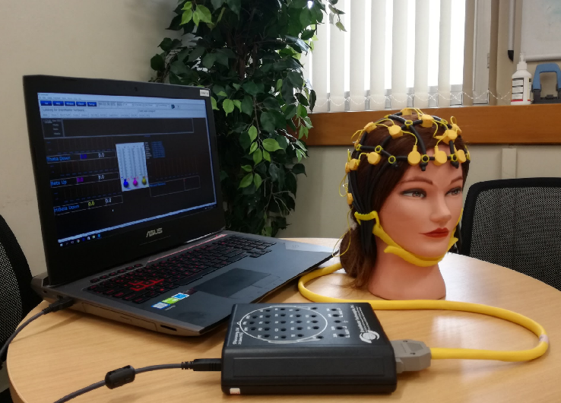

The electrode cap will be connected to an amplifier and a computer which allow the recording of ISF brain activity.

You will be asked to relax and listen to the sound being played.

**INFRA-SLOW NEUROFEEDBACK FOR FOOD ADDICTION IN WOMEN**

**CONSENT FORM**

**If you need an INTERPRETER, please tell us.**

**Please tick to indicate consent to the following:**

|  |  |
| --- | --- |
| I agree to take part in the research study titled above having had time to consider participation. | 🞏  Yes |
| I have read and understand the participant information sheet dated 20/4/2017 for volunteers taking part in the study using infra-slow neurofeedback (ISF) to target areas associated with reward and craving. | 🞏  Yes |
| I have had the opportunity to discuss this study with the study doctor/nurse. I am satisfied with the answers I have been given and that I have had sufficient time to consider whether to participate. | 🞏  Yes |
| I have had the opportunity to use whanau/family support or a friend to help me ask questions and understand the study. | 🞏  Yes |
| I understand that taking part in this study is voluntary (my choice) and that I may withdraw from the study at any time. This will not affect my continuing health care. | 🞏  Yes |
| I understand that my participation in this study is confidential and that no material, which could identify me personally, will be used in any reports on this study. | 🞏  Yes |
| I understand that my involvement in this study will be stopped if it should appear harmful. | 🞏  Yes |
| I understand the compensation provisions for this study. | 🞏  Yes |
| I know who to contact if I have any side effects from the study. | 🞏  Yes |
| I know who to contact if I have any questions about the treatments used in the study or the study in general. | 🞏  Yes |
|  |  |
| I agree to my GP being notified of my participation in this study and to my GP / specialist providing relevant information as requested by the study site. | 🞏 🞏  Yes No |
| I wish to see a copy of the results from the study. | 🞏 🞏  Yes No |

I ________________________________________hereby consent to take part in this study.

(Full name of participant)

Signature of participant: ____________________________ Date: _______________________

**Project explained by: ______________________________Investigator/Research Nurse**

Signature: ______________________________________ Date: _______________________

Name: ___________________________

This project has been reviewed and approved by the Northern B Health and Disability Ethics Committee (Ref:XXXXX).