Study Protocol
The effect of implementing a bundle for anaesthetists to reduce postoperative infections: a stepped wedge cluster randomised multi-site trial: the Anaesthetists Be Clean (ABC) Study
Alan F. Merry^{1,2*}, Simon J. Mitchell^{1,2}, Derryn A. Gargiulo^{1,3}, Ian Bissett⁴, Shay McGuinness⁵, Elsa Taylor⁶, Kerry English², David Cumin¹, Jacqueline Hannam⁷, Richard Hamblin⁸, Matthew Moore¹, Papaarangi Reid⁹, Sally Roberts¹⁰ and Chris Frampton¹¹ for the ABC Study Group.
The ABC study group
Siouxsie Wiles, Cornelius Kruger, Jacob Munro, Paget Milsom, Rocco Pitto, Tim Wilcox, Christine Walsh, Tim Skinner, Nadia Scott, Laura Jackson, Colin Sweetman, Helen Lindsay, Jane Torrie, Ian Chapman, Francois Stapelberg, Helen Houston, Sue Olliff, Stuart Walker, Andrew Love, Nav Sidhu, Lara Hopley, Janie Sheridan.
* Correspondence a.merry@auckland.ac.nz
The full list of author information, and a list of appendices, is available at the end of the article

Abstract
Background: Postoperative infection is a serious problem in New Zealand (NZ), and internationally with considerable human and financial costs. Also, in NZ, certain factors that contribute to postoperative infection are commoner in Māori and Pacific populations. To date, most efforts to reduce postoperative infection have focused on surgical aspects of care and on antibiotic prophylaxis, but recent research shows that anaesthesia providers may also have an impact on postoperative infection. Some of the many intravenous (IV) medications drawn up and administered to each patient become contaminated during this process. These contaminating bacteria could be filtered at the point of infection. In addition, these providers sometimes have imperfect hand hygiene and frequently transfer the blood or saliva of their patients to their work environment. Working with anaesthetists, anaesthetic technicians, microbiologists and others, we have developed an evidence-informed infection prevention bundle to improve key aseptic practices by anaesthetists. The bundle includes the use of 0.2μm filters for all IV bolus medications during anaesthesia, except propofol.
Methods: We will continue to build local consensus on the content of our bundle, refine it if necessary, and seek support for its implementation from senior anaesthesia and hospital leadership and departmental “champions”. We will implement our bundle in patients undergoing hip or knee arthroplasty or cardiac surgery in a five-site, stepped wedge, cluster randomised quality improvement design, comparing approximately 5000 patients before implementation of our bundle with approximately 5000 patients after its implementation. Consent will not be sought from participating patients. The required data will be collected from existing national database systems and hospital databases. Our primary outcome will be days alive and out of hospital to 90 days, which is expected to reflect the rate of all serious postoperative infections. Out secondary outcome will be the rate of surgical site infections as defined by the NZ National Surgical Site Infection Improvement Surveillance Programme. Relevant aseptic practices will be observed in sampled cases in each cluster before and after implementation of the bundle and filters. Data on surgical site infection in Maori and Pacific patients will be used to inform future studies in these groups.
Discussion: If effective, our bundle may offer a practical clinical intervention to reduce postoperative infection and its associated substantial human and financial costs.
Trial registration: Trial Registration: Australian New Zealand Clinical Trials Network Registry (ANZCTR): TBA
Trial funding: project grant 18/012 from the Australian New Zealand College of Anaesthetists and an unrestricted grant in kind (in filter units, intravenous connectors and prefilled flushing syringes) from Becton, Dickinson and Company.
Keywords: postoperative infection, anaesthesia, surgery, patient safety, prevention, stepped wedge, cluster randomized.

Background and rationale
Postoperative infection, which includes surgical site infection, pneumonia and sepsis, is a serious problem internationally with considerable human and financial costs worldwide^{1,2}. In New Zealand (NZ) alone the cost of postoperative infections exceeds $136 million per year¹. Surgical site infection occurs after up to 5% of even “clean” operations³. Patients may face weeks with discharging wounds, time off work and often re-admission to hospital⁴. In some cases, implanted artificial joints or heart valves may need to be removed and replaced. Haematogenous seeding of infection may lead to pneumonia. In the worst cases, sepsis may develop, with widespread inflammation, damage to organs and sometimes life-threatening “septic shock”.
In May 2017, the 70th World Health Assembly adopted a resolution on sepsis, urging member states “to reinforce existing strategies or develop new ones leading to strengthened infection prevention and control programmes, including… ...infection prevention practices in surgery”⁵. This followed a 2015 statement from a Lancet Infectious Diseases Commission which emphasised the global burden of sepsis and stressed global concerns over increasing pathogen resistance to antimicrobial therapies⁶. Worryingly, post-operative sepsis has increased in NZ from 7 per 1000 at-risk admissions between 2005 and 2009, to 11 per 1000 in 2013⁷. The prevention of sepsis starts with the prevention of infections in general, notably after surgery. Thus, in NZ, reducing surgical site infection is a priority for the Health Quality and Safety Commission, the Accident Compensation Corporation the Ministry of Health and the country’s District Health Boards, with national programmes to this end. In 2015-16, 35% of Accident Compensation Corporation treatment injury costs ($9.8m of $28m) were directed towards infections following surgery.
Ethnic disparities in healthcare outcomes are substantial in NZ: outcomes are, in general, worse in Māori and Pacific peoples than non-Māori/non Pacific counterparts⁸ ⁹. Some factors identified as contributing to infection after surgery include comorbidities such as obesity, diabetes¹⁰ and skin infections, and these problems are more prevalent in Māori and Pacific populations⁴ ¹¹. In addition, there could possibly be differences in relevant aspects of their care both within hospital ¹² ¹³ and outside hospital (e.g., access to care for wound reviews after going home from hospital).
Efforts to reduce postoperative infection have traditionally focussed on aspects of surgical technique and care, on hand hygiene, and on antibiotic prophylaxis. However, researchers in the United States ¹⁴⁻²⁰ have recently demonstrated that anaesthesia providers also have a direct impact on bacterial transmission and infection rates in surgical patients. It is relevant that the work of anaesthetists may be very demanding. For example, anaesthetists administer a surprisingly high number of IV medications – on average ten injections per patient ²¹, and frequently many more. Often this is done under considerable pressure of time. Similarly, techniques involved in securing patients’ airways to ensure adequate oxygenation after the administration of neuro-muscular blocking medications may be time-critical and technically difficult. In this setting, hand hygiene and the management of contaminated airway equipment may sometimes seem secondary to other more pressing requirements to keep patients alive. Anaesthetists’ hands frequently contact saliva in patients’ mouths, pharynxes, nares, and blood spilt during the insertion of lines into veins and arteries. Hand hygiene may occur less than once per hour¹⁵. Anecdotal observation suggests that gloves are often seen as a substitute for hand hygiene and that, under pressure of workflow, anaesthetists often move from tasks that contaminate their gloves to adjusting their anaesthetic machines, handling syringes or undertaking various other activities. Similarly, contaminated laryngoscopes and other instruments may be inadvertently returned to clean surfaces rather than designated trays. One way or another, anaesthetists rapidly and widely contaminate their work environment¹⁶.
Twelve to 16% of multiuse injection ports through which medications are administered contain bacteria within six hours²². Crucially, there is an association between contamination of these ports and postoperative mortality¹⁹. Recent data²³ ²⁴ from our own group suggest that the methods by which anaesthetists typically draw up and administer IV medications to patients undergoing surgery may also be an important, but previously unsuspected, contributor to postoperative infection. In highly realistic simulated surgical cases using real medications and standard practices our group cultured staphylococci, gram negative and other micro-organisms associated with postoperative infections from 5 of 38 bags (13%) of collected injectate from IV medications²³. Then, in a clinical setting at Auckland City Hospital, we asked anaesthetists to inject their IV bolus medications via a 0.2μm filter unit inserted into the IV line of 300 patients undergoing surgery ²⁴. We isolated similar micro-organisms from 6% of these filters and from 2.4% of syringes retained for reuse during the anaesthetics. Thus, the injection of micro-organisms into patients may arise from deficiencies in aseptic techniques in the handling of IV medications as well as from contamination of IV injection ports. Loftus et al have investigated the use of novel devices for hand sanitisation, device disinfection, IV catheter management and stopcock design and demonstrated reduced bacterial contamination leading to a decrease in postoperative infection¹⁵ ¹⁸ ²⁰. However, these approaches may not address failures in aseptic technique during the drawing up and injecting of IV medications, whereas all sources of infection associated with these processes could be simultaneously and substantially addressed by injecting all IV boluses of medications through a commercially available 0.2µm filter unit of the sort often used with epidural injections. Even if the injection ports on these units become contaminated, they are proximal to the filters, and the filters are fine enough to capture most micro-organisms²⁵. We have shown that it is practicable for anaesthetists to inject most IV medications through these filters, with a rated difficulty of 3 out of 10 (10 being the most difficult)²⁴.
Unfortunately, it is not possible to manage the commonly used anaesthetic induction agent propofol in this way. Propofol is typically provided in lipid emulsion, composed of droplets with a mean (range) size of 0.19 (0.15-0.3) µm.²⁶ and the manufacturers (Fresenius Kabi, AstraZeneca, and AFT Pharmaceuticals), recommend that the emulsion should not be injected through microbiological filters (manufacturer’s product information sheets). This is particularly problematic because lipid emulsions provide a rich source of nutrients for bacterial growth. An association between propofol and postoperative infections began to be reported in the early 1990’s²⁷⁻³¹. In response, the then manufacturer provided an extensive educational programme for anaesthesia personnel, and changed the product information to include explicit handling instructions. These instructions included the use of alcohol to decontaminate the neck of ampoules or rubber bungs of vials, drawing up the emulsion “aseptically”, single patient use, and replacing infusion systems after six hours³⁰. Ethylene-diamine-tetra-acetic acid (EDTA) was added to the formulation in 1996³². EDTA does not prevent micro-organisms from contaminating the formulation, but does retard their growth³³. The product currently available in NZ does not contain any preservative and is presented in both vials and ampoules.
It seems, therefore, that a multi-faceted approach is called for to address the potential contribution of anaesthesia providers to PI. Strong precedent for the potential of a bundle of measures to reduce infection is to be found in the “Keystone Project”, in which strict adherence to a few simple, evidence-based practices in the insertion and subsequent management of central venous lines substantially and sustainably reduced the median rate of catheter-related bloodstream infections per 1,000 catheter-days (from 2.7 pre-intervention to zero at three months)³⁴. Wide spread implementation of this bundle has been associated with reductions in mortality³⁵ and healthcare costs³⁶. Impressive results were again obtained in a more recent study focussed on reducing catheter-associated bloodstream infections in patients travelling between the operating room and intensive care unit³⁷.
A key aspect of the “Keystone Project” was its use of the principles of implementation science³⁴. Similar principles have been articulated in the recent World Health Organization publication “Guidelines on Core Components of Infection Prevention and Control Programmes”³⁸. Drawing from these sources, guiding principles have been developed for this study (Table 1).

Table 1: The principles of implementation science guiding this study (adopted from Pronovost et al³⁴).
1 | The relevant practitioners should agree that the problem matters, and therefore that the response is warranted.
2 | The evidence supporting or informing the requested practices should be convincing.
3 | The things asked should make sense, be possible, and preferably be easy to do.
4 | Buy-in and support should be obtained at all levels, notably from practitioners and from senior clinical and managerial leadership: to this end as much engagement as possible should occur with all relevant participants at every stage of the implementation process.
5 | Once the intervention has been agreed to, compliance should not be negotiable.

In line with principles 2, 3 and 4, we have already worked collaboratively with anaesthetists, anaesthetic technicians, microbiologists and others from each of our study hospitals to develop an evidence informed, multi-faceted, practicable infection prevention bundle (see Box 1), which combines a selection of key aseptic practices with the routine use of 0.2μm filters for all IV medications during anaesthesia, except propofol. We now aim to implement our bundle progressively in these three institutions, as a quality improvement project, and to evaluate the impact of this implementation on the rate of postoperative infection.

Box 1: The development of the infection prevention bundle
Candidate elements for our infection prevention bundle were identified through a preliminary process of literature review and consultation with a group of relevant experts and practitioners. A focus group meeting was then held with anaesthetists and anaesthetic technicians from each participating department. Rather than priming the participants with a suggested bundle, an open-ended invitation was given to make any suggestions on how to improve aseptic practices relevant to anaesthesia and to discuss any aspects relevant to any putative bundle. The importance of practicability and ease of implementation was emphasised by the facilitator, but no suggestions were disallowed. Notes were taken and the preliminary bundle modified by the investigators on the basis of reflexion on this discussion. A second focus group was then held at which participants were presented with a draft of a proposed bundle, and asked to comment on and discuss each aspect of this. Notes were taken again. A penultimate draft of the bundle was then prepared, reflecting the published evidence, the discussions at both focus groups, the practicality and acceptability of each elements of the bundle, and the likely impact of these elements on postoperative infection.
This draft was then circulated by email to all invited participants in the focus groups, the chief medical officers of each hospital, and the clinical directors of all participating departments with a brief outline of the above process and a structured request for feedback (see Appendix 5). After reviewing and the responses to the feedback from this request, the bundle was finalised (see Box 2). Appendix 6 also lists the dates, invitees and participants of each stage of this process.

Primary hypothesis
We hypothesise that the implementation of a bundle that combines a selection of key aseptic practices with the routine use of 0.2μm filters for all IV medications during anaesthesia except propofol will reduce clinically relevant postoperative infections in a targeted group of high risk patients. Clinically relevant implies infections severe enough to require prolonged hospitalisation or readmission to hospital.

Methods

Ethics approval and informed consent
This study is a quality improvement project. In general, quality improvement projects involve the implementation of practices that are a) supported by evidence or strong consensus; b) very unlikely to result in harm; and c) practicable to adopt. In essence, the aim is to achieve improvement in practice and the point of evaluation is to show the real-world effectiveness of the implementation of change. It follows that it should not be necessary to obtain informed consent from individual patients for such initiatives. This principle is widely accepted – for example, see Pronovost et al 2006 ³⁴.
The only element of our bundle that is not already generally acknowledged as good practice is the use of the inline filters. Justification for this measure has been summarised above. The filters are commercially available and their use for injection of medications into the epidural space is well established, so safety is not in question. It is our position, therefore, that this element can also be viewed as a quality improvement measure rather than a novel intervention requiring informed consent.
Hence, approval will be sought from New Zealand’s Health and Disability Ethics Committee on the basis that this study will be an evidence informed, quality improvement initiative and will not require informed consent from individual patients or from participating clinical and technical staff. Instead, we will seek site approval from each participating hospital, support from senior hospital leadership and agreement from participating departments to take part in the study.

Trial registration
The trial will be registered with the Australian New Zealand Clinical Trials Registry, www.anzctr.org.au.

Design
Our study does not lend itself to the randomisation of individual patients - it would be unreasonable to ask that practices widely accepted as desirable be done in a haphazard fashion. Instead, we will randomise clusters. To maintain separation of anaesthetists following usual practice from those who have adopted the aseptic practices in our bundle, we will cluster by departments. This implies a small number of large clusters. Quite substantial differences in practices and case mix may exist between departments, so intra-cluster correlation is likely to be quite high. Thus, we will use a real world, multi-site (five departments in four hospitals), stepped wedge, cluster randomised quality improvement design to compare participants’ usual anaesthetic practices with practices that include our bundle³⁹.

Setting and participants
The study will be conducted in five departments (our clusters) in four large metropolitan hospitals in Auckland, New Zealand: Auckland City Hospital, StarShip Childrens Hospital, Middlemore Hospital, and North Shore Hospital (Table 2). The participants will be the patients undergoing hip or knee arthroplasty or cardiac surgery in these hospitals during the duration of the study and the anaesthetists and anaesthetic technicians who manage their anaesthetic care. These surgical subgroups have been chosen because of the existence in our jurisdiction of well-developed systems for reporting surgical site infection to national databases in these particular subgroups. In addition, these patients are subject to moderately high rates of postoperative infection, and the consequences of infection when it occurs is indisputably devastating. For example, deep surgical site infection may require the removal of an implanted prosthesis after arthroplasty, or mediastinitus after cardiac surgery.

Table 2: Participating District Health Boards, hospitals and departments, with number of target cases per year and comments on the types of cases done. The case numbers have been taken from Surgical Site Infection Improvement Programme, national orthopaedic and cardiac surgical site infection reports (available from www.hqsc.govt.nz).
District Health Board | Hospital  (Department) | Targeted surgical group | Number of target cases per year  (per month) | Number of specialist anaesthetists | Number of trainee anaesthetists
Auckland | 1) Starship | Paediatric cardiac surgery | 352 (29) | 25 | 7
 | 2) Auckland City Hospital  (Level 8) | Adult arthroplasty | 604 (50) | 68+ | 25
 | 3) Auckland City Hospital  (Level 4) | Adult cardiac surgery | 980 (81) | 28 | 9
Counties Manukau | 4) Middlemore Hospital | Adult arthroplasty | 664 (55) | 71 | 23
Waitemata | 5) North Shore Hospital | Adult arthroplasty | 1044 (87) | 58 | Not available

Inclusion criteria
All patients undergoing hip or knee arthroplasty or cardiothoracic surgery (as defined by the Surgical Safety Infection Improvement programme⁴⁰) in the study hospitals during the active phase of the study under general anaesthesia with or without regional anaesthesia or under regional anaesthesia with sedation.

Exclusion criteria
Heart and lung transplants will be excluded from the study because of their complexity and the use of immunosuppression in these cases.

Withdrawal criteria
Participating anaesthetists will be expected to act in the best interests of their patients, so will be free to withdraw individual patients or to omit any aspect of the bundle (for example, the use of the filter) if they believe this is warranted. They will be asked to report any such decisions to the investigators (the facility to do this on line will be provided on a study website, which will be developed).

Intervention
The intervention will involve the implementation of the bundle outlined in Box 2. It is recognised that some participating anaesthetists may already include some of these elements in their normal practice, so the bundle is supplementary to usual practice in that all of its elements are considered essential in the active phase of the study. In either phase of the study, if an anesthetist’s standard practices include other steps to improve aseptic practice, these should be followed as usual for that clinician.

Box 2: The infection prevention bundle
- Wipe skin with alcohol (with or without chlorhexidine) and allow to dry before inserting any IV line.
- Inject all IV bolus medications except propofol through a 0.2µm filter incorporated into each patient’s IV line (see Figure 1 for example configurations).
- Use aseptic technique when attaching the filter to the IV and, unless it has been freshly opened from sterile packaging, wipe the IV injection port with alcohol (with or without chlorhexidine) for 15 seconds and allow to dry.
- If the filter is moved from one access point to another during the case the new access point should first be wiped with alcohol (with or without chlorhexidine) for 15 seconds and allowed to dry.
- Use more than one filter if necessary or desired (e.g. for cardiac patients, one filter in the peripheral line, one on a central line port where bolus medications may be given, and a third onto the medication injection port on the bypass machine for the perfusionist to use when administering medications).
- Remove the filter(s) on discharge from the Post Anaesthesia Care Unit or on admission to the Intensive Care Unit.
3. Use meticulous aseptic technique when drawing up or injecting propofol, and discard syringes, needles or the medication in the event of any suspected contamination:
  - Note that the rubber bungs on propofol vials are not sterile even with the cap in place, so they should be wiped with alcohol (with or without chlorhexidine) for 15 seconds and allowed to dry before propofol is drawn up. If the medication is supplied in an ampoule, wipe the outside of the neck and surrounding part of the ampoule with alcohol (with or without chlorhexidine) before opening.
  - Use a new needle or spike for each occasion.
  - Cap the syringe with a syringe cap or capped needle.
  - Administer as soon as possible and discard propofol after one hour if not used.
  - Do not reuse syringes or needles for propofol, even for the same patient.
  - Flush IV port with sterile sodium chloride 0.9% or sterile water for injection after propofol has been administered to ensure no residual propofol remains to support bacterial growth.
- Perform hand hygiene:
  - Before and after interacting with each new patient (i.e. on entering the operating room and on leaving a patient in the Post Anaesthesia Care Unit).
- Before and after any procedure creating risk of infection (e.g. IV insertion, airway manipulation, administering propofol, etc).
- After blood and body fluid exposure (e.g intubation, IV line insertion etc); remove gloves (if they have been worn) and, if practicable, perform hand hygiene before spreading contamination to the work station, computer key board and other surfaces.
- Maintain clean working surfaces:
- Place used laryngoscopes, masks and other contaminated objects into a tray designated for this exclusive purpose; maintain strict separation of clean and contaminated areas - do not use this tray for clean instruments, swabs or other items even at the start of a procedure.
- Wipe the anaesthetic machine bench top and the circuit pressure-relief valve with alcohol (with or without chlorhexidine) once the patient has settled into the maintenance phase of anaesthetic (i.e. after intubation of the trachea if this is done).
NOTES:
- Propofol should not be injected through the filter.
- The filter has a dead space of 0.45 mL and the injection port has a dead space of 0.11 mL (= 0.56 mL in total); therefore, as with any IV setup, it is necessary to prime the filter with sterile sodium chloride 0.9% or sterile water for injection to eliminate air, and it is also necessary to ensure that medications are flushed through.
- Hand hygiene implies either hand washing with medicated soap and water or using alcohol-based hand rub; it is important for hands to dry properly.
- Provided the medications are injected through a 0.2µm filter, the study does not ask for hand hygiene in relation to the injection and drawing up of medications other than propofol.

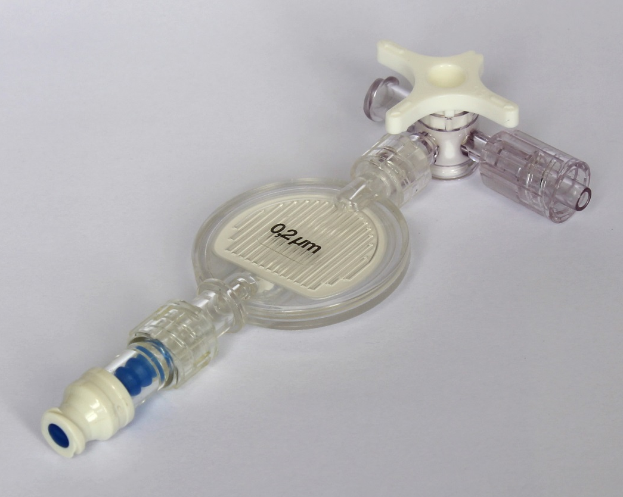
(a)
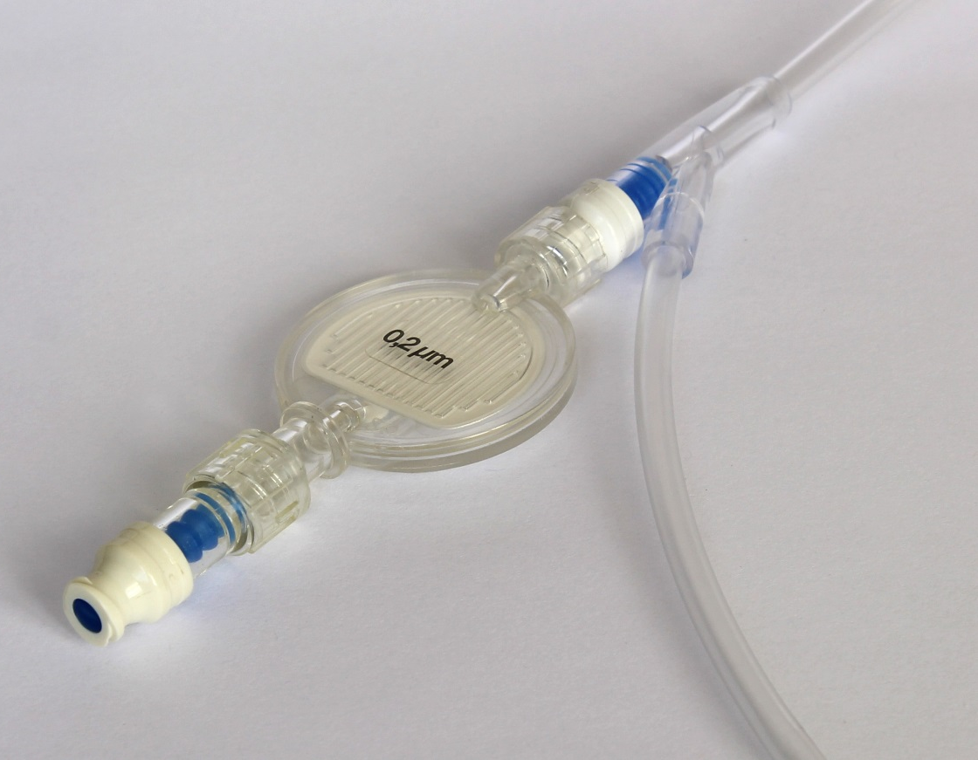
(b)
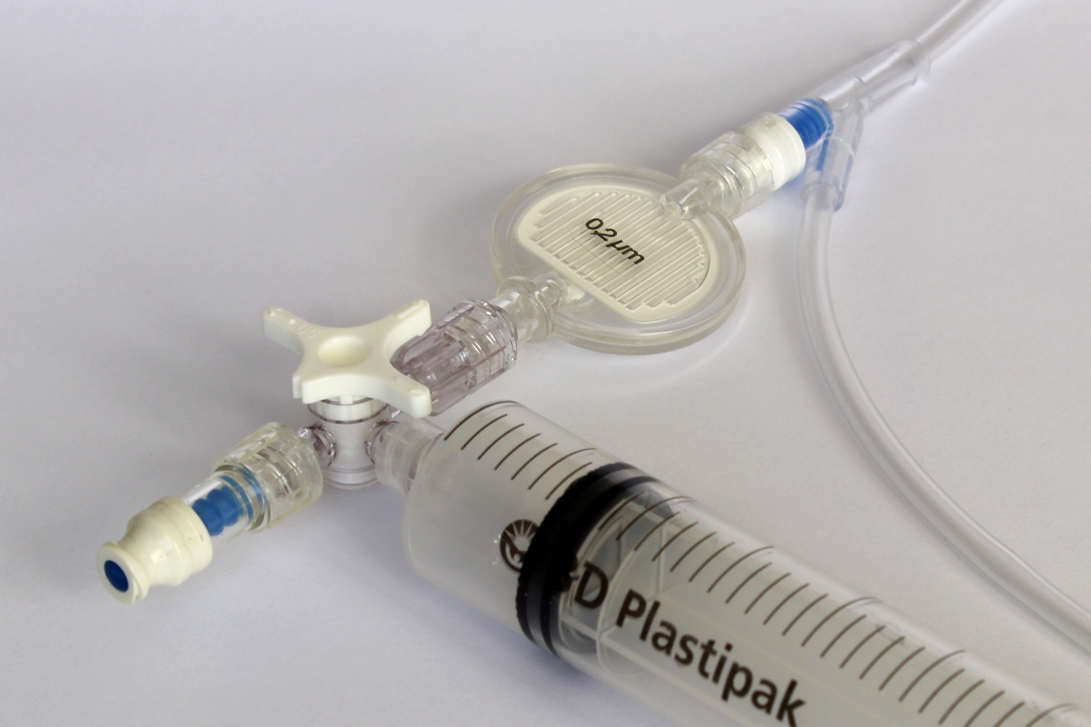
(c)
Figure 1: Three examples of filter configurations for the ABC study: (a) filter and injection port with a 3-way tap to be attached to IV line, (b) filter and injection port attached to a side port on the IV line, and (c) as in b), with a 20mL syringe filled with sterile sodium chloride 0.9% (for easy flushing) attached via a 3 way tap. Any practical approach that permits injection of medications through a filter is acceptable. Note: in these pictures the lines and filter are not primed with fluid.

Control (usual care)
For this study, usual care is defined as the practices usually used by each participating anaesthetist, notably in relation to asepsis. If a participating anaesthetist already uses some of the elements in the bundle, he or she should continue to do so.

Both groups
It is expected that standard hospital policy will be followed in both groups in respect of
- Operating room temperature control.
- Surgical antimicrobial prophylaxis.
- Single patient-use only for all medications and fluids.
- Wiping the anaesthetic machine bench top and medication trolley top between each case.
- The use of new or cleaned medication trays for each case.

Implementation
The implementation will follow the principles of improvement science listed in Table 1.

Development of educational and motivational material.
The following resources will be developed:
- An ABC study website which will include the protocol and online resources for the study, and up to date information on the details and progress of the study.
- A laminated two-sided single sheet outlining the bundle as in Box 2 and including Figure 1. This will also be placed in all participating operating rooms with the agreement of the participating departments, and on the study website.
- Sets of slides (including versions with audio for online viewing) supported by handouts for presentations to participating anaesthetists, outlining the study, its rationale and its intervention.
- Demonstration videos contrasting ideal with imperfect practices in relation to the elements of the bundle. These will be made in the Simulation Centre for Patient Safety of the University of Auckland using highly realistic simulations of illustrative anaesthetic scenarios. The videos will placed on the study website.
- An online register of participants who have attended educational sessions on the study and watched the online videos.

Recruitment of departments and departmental champions
Support in principle for this study has already been obtained from senior leadership in each of the participating hospitals (see Appendix 6). After ethics approval has been obtained, the standard institutional site approval will be sought from each hospital, which will include obtaining the formal support of each department. After these formalities have been completed, the support of the chief executive officers and chief medical officers of each hospital, and permission to cite this for the purposes of the study, will be confirmed in writing. An email outlining the study and seeking support for it, with a copy of the protocol, will then be sent (through departmental administrators) to the staff of all participating departments, including all relevant surgeons and nurses. This will include an invitation for questions to be asked or concerns to be expressed. A study information sheet will be placed on the research notice board at each study centre, with a link to the study website.
One or more champions has already been appointed in each participating department (see Appendix 1). These champions will take part in and support all presentations and communications about the study.
We will then present the study to each participating department (if necessary further presentations will be made to technicians, perfusionists, nurses and surgeons, depending on interest, demand and availability to attend the primary presentations). At these presentations feedback will be sought on any ways to facilitate embedding the intervention and questions will be invited. The aim will be to develop a strong sense of collaboration in the goal of successfully implementing the bundle. The presenters will also inform participating anaesthetists and technicians that observational data (including at baseline) pertaining to aseptic practices and adherence to the bundle once implemented will be collected. The anonymous nature of the data collected through observation will be emphasized.

Roll out of the bundle
During the weeks approaching the initiation date for each department further presentations will be made to that designated department (including technicians), to ensure that all relevant people are aware of the roll out and to identify and address any concerns. In addition, all participants will be sent one or more emails (through departmental administrators) informing them of the planned roll out and inviting them to contact the investigators if they have any concerns or questions.
Posters promoting the study in general terms, and noting that observations may occur, will be distributed to all participating operating rooms at the outset of the study. During the week before the roll out of the bundle, these will be replaced by a different version designed to alert all relevant people to the coming changes and to create some sense of anticipation and excitement. On the day of the roll out these will in turn be replaced with a third version that will for the first time explicitly display the elements of the bundle and indicate that the time has come to change practice.
The study coordinator will liaise with the anaesthetic technicians in each department to ensure that the study consumables are available and that the technicians are informed and ready to include them in patients’ IV lines.
For four weeks following the designated first day of the roll out the study coordinator will be available in the operating rooms for at least some time each day to encourage the roll out, to deal with any difficulties, and to answer any question. Any practical difficulties will be recorded.

Randomisation
The study statistician will generate a randomly ordered list of the numbers 1 to 6. The departments listed in Table 2 will be allocated to Clusters A to E in the sequence in which their number appears in this list. From this, their order and dates of entry into the stepped wedge design will be determined (Table 3). Randomisation of clusters and operating rooms for observation will also be undertaken by the study statistician.

Table 3: Stepped-wedge study design for five sites; UC indicates the usual care of each participating anaesthetist, “bundle” indicates the addition of the infection prevention bundle to this usual care; see text for details of randomization of the clusters.
Time period | Site A | Site B | Site C | Site D | Site E
1 | UC | UC | UC | UC | UC
2 | bundle | UC | UC | UC | UC
3 | bundle | bundle | UC | UC | UC
4 | bundle | bundle | bundle | UC | UC
5 | bundle | bundle | bundle | bundle | UC
6 | bundle | bundle | bundle | bundle | bundle

Blinding, concealment and cross contamination between study phases
Neither blinding nor concealment will be possible. Clusters have been chosen, in part, to minimise as far as possible any overlap of staff working in both control and active phases. If this does occur this will be noted and acknowledged as a limitation of the study.

Outcomes and measures
Our interest in this study lies in demonstrating a reduction in clinically significant postoperative infections of any kind in our targeted high risk patient group. Given our limited funding, we are not able, ourselves, to prospectively measure rates of infection, but we are able to access national and hospital databases of routinely collected relevant outcome data. In addition, we need some indicator of changes in process (i.e. of relevant anaesthetic aseptic practices), which we will collect by direct observation.

Primary outcome
Our primary outcome variable will be days alive and out of hospital to 90 days (DAOH₉₀). We have selected DAOH₉₀ as our primary variable because a) it is sensitive to any postoperative complication (including, but not limited to postoperative infection) that is sufficiently serious to require prolongation of hospitalization or readmission into hospital; b) it is available from NZ’s national minimal dataset, and so can be readily collected for all patients; and c) it is more powerful, statistically, than a binary measure (such as infection vs no infection). With our cluster randomised study design it will be reasonable to attribute any reduction in DAOH₉₀ following implementation of the bundle to a reduction in clinically important postoperative infections of any type, although allowance will have to be made in our analysis for potential confounding by changes unrelated to the study that may occur over its duration.

Secondary outcome
Our secondary (explanatory) outcome will be the rate of specified postoperative infections, as defined and collected by the national surgical site infection surveillance programme for patients undergoing hip or knee arthroplasty or cardiac surgery.

Process measures
The five processes of aseptic practice defined in the bundle will be measured using a simple behaviourally anchored scale (BARS) – see Appendix 7. This will be developed for the study and will have five elements, one for each item in our bundle. Thus, our primary process measure will be the mean score for the five aseptic practices observed in each case. Subsequent analysis of each individual process score will be undertaken on a post hoc explanatory basis. In addition, we will record participation by anaesthetists and technicians in relevant presentations and in watching or reading online resources.

Statistics and sample size
DAOH₉₀ data has a distribution that does not lend itself to parametric analysis. Data from a previous study of 20,000 general surgery procedures indicates that most patients score highly, so comparing measures of central tendency between groups can exclude the patients who are most likely to realise improved outcomes.
To address these predicted characteristics of the data, we will develop a rank-sum test, based on the Wilcoxon-Mann-Whitney U (WMWU) test, but tailored to leverage our stepped wedge design.
The processes and drivers of admission and discharge to hospital, and of data collection for the National Minimal Dataset, do not lend themselves to greater precision than one day in the calculation of DAOH₉₀. We assumed that a difference of one day would, furthermore, be clinically meaningful to patients and of economic relevance to healthcare funders. Empirical sample size estimation from a simpler two-sample WMWU protocol using our earlier data has suggested that we will need at least 2500 participants in each group to detect a difference of this magnitude at α<0.05 and β>0.8 (two-tailed). The extra control of the stepped wedge design will increase the sensitivity of our tests.
If the ranked-sum test establishes a significant difference associated with the intervention, we will further investigate the nature of the difference in distribution by investigating differences in quantiles (especially lower quantiles), and test the significance of these differences using permutation tests. We will provide commentary on interpreting differences where they exist.
Using pilot data for DAOH₉₀ for 150 patients who had procedures as defined for the proposed study we estimated that a total sample of 4500 (2250 per group) would be needed for $∝ = <0.05 and β> 0.8.$(two-tailed). A decision to change practice would only be justified by a reduction in the rate of infection and thus an increase in DAOH₉₀; if there was either no difference or (very improbably) the bundle increased the rate of infection, no change in practice would be justified. This implies that a smaller number of patients would suffice.
However, these numbers will not suffice to show a difference in our secondary outcome, surgical site infection. Reducing SSIs from a base rate of about 1.4% (a reasonable estimate of the overall rate at present) to 0.8% would require approximately 11,000 patients (5500 in each group: 1-tailed α=0.05 and $β> 0.8.$Estimated with MedCalc (MedCalc Software, Ostend, Belgium. These power calculations assume that the intra-class correlation within site blocks is 0.0.)
Pragmatically, with a six month period for each step of our stepped wedge design, we will be able to assess approximately 5000 participants in each group (an average of about 333 per cell of the stepped wedge, although the clusters will not be equal in size). This will be more than enough for our primary outcome variable.
Given the likely proportion of Māori and Pacific patients, we will not be able to power the study adequately to investigate differences between these patients and other subgroups in the study.

Structure of the stepped wedge
All five sites will begin the study simultaneously on the first step, which will consist of normal care. Each step will be six months in duration. Thus, at the end of the first six months the first site randomised will adopt the bundle, whilst the other four continue with normal practice for another six months. The remainder of the sites will sequentially adopt the bundle in randomised order; one every six until the final (sixth) step completes with all sites using the bundle. An illustrative structure for the stepped wedge is shown in Table 4.

Table 4: Illustrative structure of the stepped wedge with sites arranged to adopt the bundle in the least favourable order in respect of the number of 0.2 µm filters (i.e. the maximum filter usage) that will be required over the course of the study. In the most favourable order (i.e. the lowest filter usage) the total number of filters would be 6395. Each cell shows case numbers for the 6 month step, and filter numbers in brackets. Shaded cells indicate those in which the intervention has been implemented. The case numbers have been taken from Surgical Site Infection Improvement Programme, national orthopaedic and cardiac surgical site infection reports (available from www.hqsc.govt.nz).
Site | Step 1 | Step 2 | Step 3 | Step 4 | Step 5 | Step 6 | Total
Auckland  Cardiac | 490  (0) | 490  (1470) | 490  (1470) | 490  (1470) | 490  (1470) | 490  (1470) | 2940  (7350)
StarShip  Cardiac | 176  (0) | 176  (0) | 176  (528) | 176  (528) | 176  (528) | 176  (528) | 1056  (2112)
Waitemata  Arthroplasty | 522  (0) | 522  (0) | 522  (0) | 522  (522) | 522  (522) | 522  (522) | 3132  (1566)
Counties Manukau  Arthroplasty | 332  (0) | 332  (0) | 332  (0) | 332  (0) | 332  (332) | 332  (332) | 1992  (664)
Auckland  Arthroplasty | 302  (0) | 302  (0) | 302  (0) | 302  (0) | 302  (0) | 302  (302) | 1812  (302)
Cases | 1822 | 1822 | 1822 | 1822 | 1822 | 1822 | 10932
Filters | 0 | 1470 | 1998 | 2520 | 2852 | 3154 | 11994
Treated cases | 0 | 490 | 666 | 1188 | 1520 | 1822 | 5686
Control cases | 1822 | 1332 | 1156 | 634 | 302 | 0 | 5246

The six month duration of the steps has been chosen for several reasons. First, it allows recruitment of an adequate number of cases (exceeding the needs of our power calculation). Second, it ensures an adequate period within each new step for the bundle to become properly embedded. Third, it allows sufficient intervals between steps for the rollout plan for each new step to be assiduously followed in an unhurried manner.

Data collection and analysis
Outcome and patient-related data
Data will be requested from the Ministry of Health national minimum dataset, the National Surgical Site Infection Improvement Surveillance Programme database and the databases of participating hospitals, and entered into a password protected secure study database within the Department of Anaesthesiology, University of Auckland. The data will be kept for ten years, and then permanently deleted.
In NZ, each patient has a unique National Health Identification number and each procedure has a specific International Classification of Diseases 10th Revision (ICD-10) code. The National Health Identification number will be used to link data from different sources, and then replaced with a unique study identification number, in the interests of confidentiality.
For this study we will collect: age, gender, ethnicity, weight, height, surgical procedure (including primary or re-operation status) and known comorbidities (with emphasis on those associated with risks of infection and failed wound-healing such as diabetes, severe renal disease, obesity and smoking)¹⁰. Uncontrolled significant differences in rates of these covariates between groups will be statistically accounted for using quantile regression.
Information on surgical site infection will be collected from the National Surgical Site Infection Improvement surveillance programme, which is limited to patients undergoing government funded hip and knee arthroplasty and cardiac surgery. For these patients, a standard set of data is collected by trained hospital personnel, (predominantly infection prevention and control nurses and perioperative nurses), and the data entered via the web into the national database. Strategies to ensure that all infections are identified include reviewing hospital microbiology records, having the ward teams alert the infection prevention and control team about suspected infections and reviewing the medical records of patients re-admitted to hospital within 90 days of the relevant procedures.

Process data
At present, funding limits the extent to which we can evaluate current practices and changes to these after the implementation of the bundle. However, a small sample of cases will be observed in each unit before and after implementation of the bundle. As indicated above, all participating staff (anaesthetists, anaesthetic technicians, surgeons and operating room nurses) will be informed of this aspect of the study at its outset, and information on it will be included in the presentations to the departments and on line. Individual consents will not be obtained.
Depending on availability, our observations will be done by people who are able to spend time in the operating room without necessarily attracting attention (e.g., medical students, nurses, anaesthetists or anaesthetic technicians) and who will be independent of the study in all other respects. Observations will be done on a pragmatic basis at times determined by the availability of these observers. Before starting the collection of baseline study data, preliminary observational data will be obtained to refine the BARS, and establish its key properties, such as usability, reliability and inter-observer repeatability. Within the time periods in which such staff are available for the study, we will randomly allocate the departments and operating rooms to be observed on any particular day, with stratification to ensure coverage of all the departments at each period of observation. As the study progresses we will thus obtain information about both control and active phases of the study over time.
These observers will be trained in the use of the study BARS by one of the investigators. Training will also reinforce operating room etiquette and the need for the observations to be done discretely. Entire cases will be observed, producing one complete BARS form (and score) per case.

Complications attributable to the study
We do not expect any complications to arise from the study itself but in the unlikely event that any do, these will be recorded using an adverse events form and Prof Merry or Prof Mitchell notified. These investigators will liaise with the patient’s primary clinicians to manage any such complication, and the complication will be promptly reported to the study’s steering committee, and the relevant study centres’ research office if required by them, and the filter manufacturer if the filter is involved.

Timeline
The study is expected to run for three years from 1 January 2018. A detailed timeline is provided in Appendix 3.

Discussion
Successful implementation of even modest improvements in aseptic practices associated with anaesthesia has the potential to substantially reduce postoperative infections. If this trial shows a positive change (i.e. an increase) in DAOH₉₀ after implementation of our bundle, this will add substantially to existing evidence that suggests that the practices of anaesthesia providers are a factor in the genesis of PI, and moreover that improved outcomes can be achieved relatively easily. The investigators are well placed to liaise with relevant organisations to promote the subsequent adoption of the bundle throughout NZ. The potential benefits in relation to improved patient harm and the costs associated with this are substantial, and the implications for Māori and Pacific patients may be particularly important.
Our bundle has deliberately been designed to be as simple and practical as possible. Some participants in our focus groups would have liked a more comprehensive bundle, aimed at perfect aseptic practice. In our view, more substantial change in practice would be difficult to achieve even within the context of a trial. Asking for too much may actually impede the readiness of participants to accept the bundle at all. It is also a strength that the evidence supporting our initiative is already known to many of our participants, in part because of previous studies undertaken on this topic in Auckland. In particular, the fact that the research into the potential role of the filters was both local and recent encourages us to believe that there will be little pushback on the reasons for their use. With respect to the other elements of our bundle, we suspect that the main reasons the elements have not been more widely embraced already lie in the fact that infections that follow failures in aseptic practice manifest long after anaesthesia has finished. Thus, a postoperative infection is seldom if ever tracked back to the source and there is no feedback to the anaesthetists about the consequences. To this should be added the fact that it is, in practice, quite difficult to achieve perfect aseptic practice during a dynamic and complex activity in which other much more immediate and sometimes more dangerous threats to the patient have to be given priority by the anaesthestist. Greater motivation is required, and providing that motivation will be a key element of this initiative. Even with greater motivation, the required improvements in practice must be reasonably easy to implement, and as stated, we have strived to ensure that this applies.
What if our trial produces a negative result (no significant change in DAOH₉₀)? On the face of it, our initial sample size calculation (n = 2250 per group) was based on a power of 80% to show a relatively small difference in DAOH₉₀ at P < 0.05. If we cannot show a difference with our planned 5000 patients in each group it will be reasonable to conclude that any contribution to PI by anaesthesia providers, in our institutions at least, is of little clinical importance. Even if there were fewer infections post intervention, this would imply that the clinical impact of these averted infections was slight. The question arises, however, of how small a difference in DAOH₉₀ actually matters? Might we miss a small difference that actually matters? The distribution of this variable is highly skewed, and reflects the fact that most patients do not get infected and so will not experience any change in this outcome. We can expect the change, if it occurs, to be seen in the DAOH₉₀ experienced by patients at lower centiles of the distribution. Thus, the difference at the 50th centile may be very small, but at the 25th centile, patients in the active group may spend several additional days at home and alive within this time frame. For illustration, we might be able to conclude something like, “in the 25% of patients with the lowest values of DAOH_{90,} this measure was x days higher after our intervention – i.e., these patients, on average, spent x days more alive and at home.” With this in mind our analysis will start by testing whether the distributions are significantly different or not (using a ranked sum test tailored for a stepped wedge study that makes no assumptions about nature of the distribution).If so, we will then provide numeric data on DAOH₉₀ at the 10th, 25th, 50th, 75th and 90th centile and graphic representation of both distributions across the entire range to show where the effect lies. This approach avoids multiple testing and at the same time allows the maximum impact to be seen clearly without having to guess at the outset where it may lie (i.e, the 10th, the 25th, or some other centile). Thus we are reasonably confident that we will not miss small but clinically important differences between our groups.
Even though DAOH₉₀ may be a more powerful and more clinically relevant outcome measure for our study than the rate of infections themselves we will utilize national databases to collect data on infections with a view to detecting any signal that supports our basic assumption that our cluster randomised design allows differences in DAOH₉₀ between groups to be attributed to differences in infection.
We believe the trial is well-designed to test its primary hypothesis. The findings of this trial should add substantially to our understanding of postoperative infection. The trial is a direct response to the call by the World Health Assembly for new strategies “leading to strengthened infection prevention and control programmes, including… ...infection prevention practices in surgery”⁵.

Trial status
Recruitment has yet to begin.

Abbreviations
BARS behaviourally anchored rating scale
DAOH₉₀ days alive and out of hospital within the first 90 days after surgery
EDTA Ethylene-diamine-tetra-acetic acid
ICD International Classification of Diseases
bundle infection prevention bundle
IV intravenous
NZ New Zealand
UC usual care (defined as the practices usually used by each participating anaesthetist, notably in relation to asepsis)
WMWU Wilcoxon-Mann-Whitney U

Competing interests

Alan Merry chairs the Board of the Health Quality and Safety Commission, which oversees the New Zealand National Surgical Site Infection Programme and has financial interests in Safer Sleep LLC, which produces a safety system for anaesthesia.

Sally Roberts is the national clinical lead for the Health Quality and Safety Commission Infection Prevention and Control Programme including the National Surgical Site Infection Improvement Programme.

Author’s contributions

All co-authors have aided in the design of the study and will contribute to data analysis, interpretation and dissemination of findings. AFM and SJM are the joint chief investigators of the study, and oversee the whole trial from protocol development to the dissemination of findings, and the integrity of the data collection. DG is the project manager and co-ordinates the study day-to-day, including data collection, training the sites, audit processes and site liaison. MM is responsible for data collection and analysis. CF is the study statistician. All authors approved the final manuscript.

Authors’ information
AFM: Professor, School of Medicine, University of Auckland and Consultant Anaesthetist, Auckland City Hospital, Auckland
SJM: Professor, Department of Anaesthesiology, Univeristy of Auckland and Consultant Anaesthetist, Auckland City Hospital, Auckland
DAG: Senior Tutor, School of Pharmacy and Research Fellow, Department of Anaesthesiology, University of Auckland
IB: Professor, Department of Surgery, University of Auckland and Surgeon, Auckland City Hospital, Auckland
SM: Intensivist, Auckland City Hospital
ET: Paediatric Anaesthetic Specialist, Starship Childrens Health, Auckland
KE: Consultant Anaesthetist, Auckland City Hospital, Auckland
DC: Senior Lecturer, Department of Anaesthesiology, University of Auckland
JH: Lecturer, Department of Pharmacology & Clinical Pharmacology, University of Auckland
RH: Director, Health Quality and Evaluation, Health Quality and Safety Commission
MM: Research Fellow, Department of Anaesthesiology, University of Auckland
PR: Tumuaki, Te Kupenga Hauora Māori, University of Auckland
SR: Clinical Microbiologist and Clinical Head of Microbiology, LabPlus, Auckland City Hospital
CF: Professor of Biostatistics, Department of Psychological Medicine, University of Otago, Christchurch.
Acknowledgements
This study is funded by the Australian and New Zealand College of Anaesthetists and supported by a grant in kind from Becton and Dickson Company. Neither organisation is involved in the design, collection, analysis, or write up of this research.

Authors’ details
¹ Department of Anaesthesiology, School of Medicine, University of Auckland, Private Bag 92019, Auckland 1142, New Zealand.
² Department of Anaesthesia, Auckland City Hospital, PO Box 92024, Auckland 1142, New Zealand.
³ School of Pharmacy, University of Auckland, Private Bag 92019, Auckland 1142, New Zealand.
⁴ Department of Surgery, Auckland City Hospital, Private Bag 92019, Auckland 1142, New Zealand.
⁵ ICU, Auckland City Hospital, Private Bag 92019, Auckland 1142, New Zealand.
⁶ Starship Childrens Health, PO Box 9389, Auckland 1149, New Zealand.
⁷ Department of Pharmacology and Clinical Pharmacology, University of Auckland, Private Bag 92019, Auckland 1142, New Zealand.
⁸ Health Quality & Safety Commission, PO Box 25496, Wellington 6146, New Zealand.
⁹ Te Kupenga Hauora Māori, University of Auckland, Private Bag 92019, Auckland 1142, New Zealand.
¹⁰ LabPLUS, PO Box 110031, Auckland City Hospital, Auckland 1148, New Zealand.
¹¹ Department of Psychological Medicine, University of Otago, PO Box 4345, Christchurch 8140, New Zealand.

List of appendices
Appendix 1: Study Personnel
Appendix 2: Lay Summary
Appendix 3: Administrative Details
Appendix 4: Protocol Amendments
Appendix 5: Feedback on bundle
Appendix 6: Register of Agreement to Support the ABC Study
Appendix 7: ABC-BARS

REFERENCES
1. Graves N, Nicholls TM, Morris AJ. Modeling the costs of hospital-acquired infections in New Zealand. Infection Control and Hospital Epidemiology 2003;24(3):214-23. doi: http://dx.doi.org/10.1086/502192
2. World Health Organization. Report on the Burden of Endemic Health-care Associated Infection Worldwide. 2011. Available from http://wwwwhoint/gpsc/country_work/burden_hcai/en/ Accessed July 2011
3. Mangram AJ, Horan TC, Pearson ML, et al. Guideline for prevention of surgical site infection, 1999. Hospital Infection Control Practices Advisory Committee. Infection control and hospital epidemiology : the official journal of the Society of Hospital Epidemiologists of America 1999;20(4):250-78; quiz 79-80.
4. New Zealand Ministry of Health. New Zealand Health Survey: Annual update of key findings 2012/13. Available from wwwhealthgovtnz/publication/new-zealand-health-survey-annual-update-key-findings-2012-13 Accessed January 2014
5. World Health Organization. EB140.R5 Improving the prevention, diagnosis and management of sepsis. Available from http://appswhoint/gb/e/e_eb140html Accessed July 2017(Web Page)
6. Cohen J, Vincent JL, Adhikari NKJ, et al. Sepsis: a roadmap for future research. The Lancet Infectious Diseases 2015;15(5):581-614. doi: https://dx.doi.org/10.1016/S1473-3099(15)70112-X
7. Health Quality and Safety Commission. Health Quality and Safety Indicators. Available from https://prezicom/xlcud7x7wmgy/health-quality-and-safety-indicators-june-2015/ Accessed September 2015
8. Tatau Kahukura: Māori Health Chart Book. 3rd ed. Wellington: Ministry of Health. 2015.
9. Tupu Ola Moui: Pacific Health Chart Book Wellington: Ministry of Health 2004.
10. Jung P, Morris AJ, Zhu M, et al. BMI is a key risk factor for early periprosthetic joint infection following total hip and knee arthroplasty. New Zealand Medical Journal 2017;130(1461):24-34.
11. Williamson DA, Lim A, Thomas MG, et al. Incidence, trends and demographics of Staphylococcus aureus infections in Auckland, New Zealand, 2001-2011. BMC Infectious Diseases 2013;13 (1) (no pagination)(569) doi: http://dx.doi.org/10.1186/1471-2334-13-569
12. Hill S, Sarfati D, Blakely T, et al. Ethnicity and management of colon cancer in New Zealand: do indigenous patients get a worse deal? Cancer 2010;116(13):3205-14. doi: https://dx.doi.org/10.1002/cncr.25127
13. Davis P, Lay-Yee R, Dyall L, et al. Quality of hospital care for Maori patients in New Zealand: retrospective cross-sectional assessment. Lancet 2006;367(9526):1920-5.
14. Hopf HW. Bacterial Reservoirs in the Operating Room. Anesthesia and Analgesia 2015;120(4):700-02. doi: http://dx.doi.org/10.1213/ANE.0000000000000247
15. Koff MD, Loftus RW, Burchman CC, et al. Reduction in intraoperative bacterial contamination of peripheral intravenous tubing through the use of a novel device. Anesthesiology 2009;110(5):978-85. doi: http://dx.doi.org/10.1097/ALN.0b013e3181a06ec3
16. Loftus RW, Koff MD, Burchman CC, et al. Transmission of pathogenic bacterial organisms in the anesthesia work area. Anesthesiology 2008;109(3):399-407. doi: http://dx.doi.org/10.1097/ALN.0b013e318182c855
17. Loftus RW, Muffly MK, Brown JR, et al. Hand contamination of anesthesia providers is an important risk factor for intraoperative bacterial transmission. Anesthesia and Analgesia 2011;112(1):98-105. doi: http://dx.doi.org/10.1213/ANE.0b013e3181e7ce18
18. Loftus RW, Brindeiro BS, Kispert DP, et al. Reduction in intraoperative bacterial contamination of peripheral intravenous tubing through the use of a passive catheter care system. Anesthesia and analgesia 2012;115(6):1315-23.
19. Loftus RW, Brown JR, Koff MD, et al. Multiple reservoirs contribute to intraoperative bacterial transmission. Anesthesia and Analgesia 2012;114(6):1236-48. doi: http://dx.doi.org/10.1213/ANE.0b013e31824970a2
20. Loftus RW, Patel HM, Huysman BC, et al. Prevention of intravenous bacterial injection from health care provider hands: The importance of catheter design and handling. Anesthesia and Analgesia 2012;115(5):1109-19. doi: http://dx.doi.org/10.1213/ANE.0b013e31826a1016
21. Merry AF, Webster CS, Hannam J, et al. Multimodal system designed to reduce errors in recording and administration of drugs in anaesthesia: prospective randomised clinical evaluation. BMJ 2011;343:d5543. doi: http://dx.doi.org/10.1136/bmj.d5543
22. Cole DC, Baslanti TO, Gravenstein NL, et al. Leaving More Than Your Fingerprint on the Intravenous Line: A Prospective Study on Propofol Anesthesia and Implications of Stopcock Contamination. Anesthesia and Analgesia 2015;120(4):861-67. doi: http://dx.doi.org/10.1213/ANE.0b013e318292ed45
23. Gargiulo DA, Sheridan J, Webster CS, et al. Anaesthetic drug administration as a potential contributor to healthcare-associated infections: A prospective simulation-based evaluation of aseptic techniques in the administration of anaesthetic drugs. BMJ Quality and Safety 2012;21(10):826-34. doi: http://dx.doi.org/10.1136/bmjqs-2012-000814
24. Gargiulo DA, Mitchell SJ, Sheridan J, et al. Microbiological contamination of drugs during their administration for anesthesia in the operating room. Anesthesiology 2016;124(4):785-94. doi: http://dx.doi.org/10.1097/ALN.0000000000001041
25. Allison D. Bacteria. In: Denyer SP, Hodges N, Gorman SP, et al., eds. Hugo and Russell's Pharmaceutical Microbiology. 8th ed. Chichester, West Sussex, UK: Wiley-Blackwell 2011:24-43.
26. Lilley EMM, Isert PR, Carasso ML, et al. The effect of the addition of lignocaine on propofol emulsion stability. Anaesthesia 1996;51(9):815-18.
27. Bach A, Motsch J, Schmidt H, et al. In-use contamination of propofol. A clinical study. European Journal of Anaesthesiology 1997;14(2):178-83.
28. Bennett SN, McNeil MM, Bland LA, et al. Postoperative infections traced to contamination of an intravenous anesthetic, propofol. N Engl J Med 1995;333(3):147-54.
29. Kuehnert MJ, Webb RM, Jochimsen EM, et al. Staphylococcus aureus bloodstream infections among patients undergoing electroconvulsive therapy traced to breaks in infection control and possible extrinsic contamination by propofol. Anesthesia & Analgesia 1997;85(2):420-5.
30. Lorenz IH, Kolbitsch C, Lass-Florl C, et al. Routine handling of propofol prevents contamination as effectively as does strict adherence to the manufacturer's recommendations. Canadian Journal of Anesthesia 2002;49(4):347-52.
31. McHugh GJ, Roper GM. Propofol emulsion and bacterial contamination. Canadian Journal of Anaesthesia 1995;42(9):801-4.
32. Thompson KA, Goodale DB. The recent development of propofol (DIPRIVAN). Intensive Care Medicine, Supplement 2000;26(4):S400-S04.
33. Fukada T, Ozaki M. Microbial growth in propofol formulations with disodium edetate and the influence of venous access system dead space. Anaesthesia 2007;62(6):575-80.
34. Pronovost P, Needham D, Berenholtz S, et al. An intervention to decrease catheter-related bloodstream infections in the ICU. New England Journal of Medicine 2006;355(26):2725-32. doi: http://dx.doi.org/10.1056/NEJMoa061115
35. Lipitz-Snyderman A, Steinwachs D, Needham DM, et al. Impact of a statewide intensive care unit quality improvement initiative on hospital mortality and length of stay: Retrospective comparative analysis. BMJ 2011;342(7792):323. doi: http://dx.doi.org/10.1136/bmj.d219
36. Waters HR, Korn Jr R, Colantuoni E, et al. The business case for quality: Economic analysis of the michigan keystone patient safety program in ICUs. American Journal of Medical Quality 2011;26(5):333-39. doi: http://dx.doi.org/10.1177/1062860611410685
37. Martin LD, Rampersad SE, Geiduschek JM, et al. Modification of anesthesia practice reduces catheter-associated bloodstream infections: A quality improvement initiative. Paediatric Anaesthesia 2013;23(7):588-96. doi: http://dx.doi.org/10.1111/pan.12165
38. World Health Organization. Guidelines on core components of infection prevention and control programmes at the national and acute health care facility level. Available from http://whoint/infection-prevention/publications/core-components/en/ Accessed March 2017(Web Page)
39. Hemming K, Haines TP, Chilton PJ, et al. The stepped wedge cluster randomised trial: rationale, design, analysis, and reporting. BMJ 2015;350:h391. doi: https://dx.doi.org/10.1136/bmj.h391
40. Health Quality and Safety Commission. Implementation Manuals. Available from https://wwwhqscgovtnz/our-programmes/infection-prevention-and-control/projects/surgical-site-infection-improvement/resources/ Accessed February 2018

