Online Questionnaire Items and Response Categories
For each question, please tick one response box to show your answer:

a) I am a …
◻ Girl
◻ Boy

b) At home my parents usually speak …
◻ English
◻ Another language: _________________

c) How many days last week did you have something for breakfast?
◻ No days
◻ 1 day
◻ 2 days
◻ 3 days
◻ 4 days
◻ 5 days
◻ 6 days
◻ 7 days

d) Over the next month, I plan to eat breakfast every day:
◻ Agree
◻ Neither agree or disagree
◻ Disagree

Each picture below shows an example of one serve of fruit:
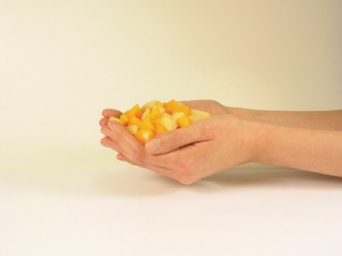
e) How many serves of fruit do you eat every day?
◻ I don’t eat fruit every day
◻ 1 serve
◻ 2 serves
◻ 3 serves or more

f) Over the next month, how many serves of fruit do you plan to eat every day?
◻ I don’t plan to eat fruit every day
◻ 1 serve
◻ 2 serves
◻ 3 serves or more

Each picture below shows an example of one serve of vegetables:
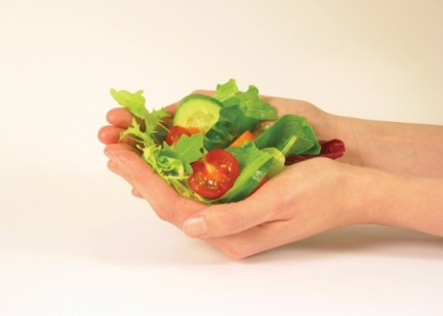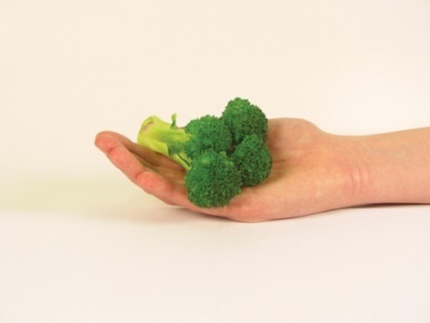

g) How many serves of vegetables do you eat every day?
◻ I don’t eat vegetables every day
◻ 1 serve
◻ 2 serves
◻ 3 serves
◻ 4 serves
◻ 5 or more serves

h) Over the next month, how many serves of vegetables do you plan to eat every day?
◻ I don’t plan to eat vegetables every day
◻ 1 serve
◻ 2 serves
◻ 3 serves
◻ 4 serves
◻ 5 or more serves

i) To help you answer this question take a look at the pictures below:
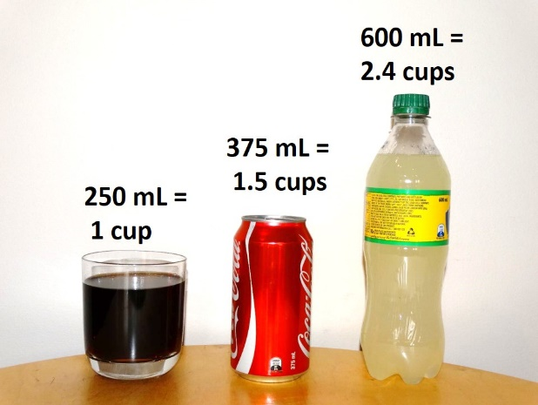

On an average day, how many cups of soft drink, sports drink or cordial do you drink?
◻ I don’t drink these drinks every day
◻ 1 cup
◻ 2 cups
◻ 3 cups
◻ 4 or more cups

j) In the past week, on how many days have you done a total of 60 minutes or more of physical activity, which was enough to make you huff and puff? This may include sport, exercise and brisk walking or cycling for recreation or to get to and from places? Please tick only one box.
◻ No days
◻ 1 day
◻ 2 days
◻ 3 days
◻ 4 days
◻ 5 days
◻ 6 days
◻ 7 days

k) Over the next month, I plan to be physically active on all or most days of the week:
◻ Agree
◻ Neither agree or disagree
◻ Disagree

l) On a normal school day, how much of your free time would you spend sitting and using a mobile phone, iPad, tablet, computer, gaming console or watching TV/DVDs?
◻ 0 to 1 hour
◻ 1 to 2 hours
◻ 2 to 3 hours
◻ More than 3 hours

m) Over the next month, I plan to spend less free time sitting and doing activities involving screens (e.g. mobile phone, tablet, computer, gaming console, TV).
◻ Agree
◻ Neither agree or disagree
◻ Disagree

