HPV Self-Testing: An alternative to the (Pap) smear test for under-screened women

- This booklet gives information about cervical screening, HPV and HPV self-testing.
- You can take this booklet away with you if you wish to.
We know that (for a number of reasons) a lot of Māori women are uncomfortable with going to a clinic to get a smear test. Since smear testing started, research has advanced and we now know that the Human Papilloma Virus, otherwise known as HPV, causes cervical cancer.
As an alternative to the smear test we can test for HPV. A new technology has been developed that allows women to test for HPV themselves using a swab (about cotton bud sized) that is gently inserted into the vagina. This self-test does not require a visit to a clinic and can be done at home, instead of a smear test at the clinic.
The information we collect will inform the next steps the National Screening Unit takes to make self-testing available.
This booklet contains detailed information about doing your own HPV test and will take about 10 minutes to read.
The Human Papilloma Virus (HPV) and Cervical Cancer
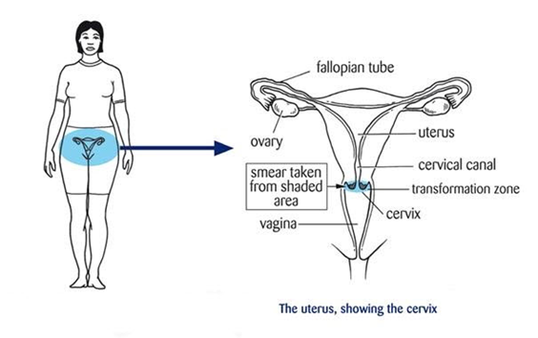
We now know that cervical cancer is caused by certain types of the HPV virus. It starts when some cells on the surface of the cervix (see figure to the right) change and become abnormal. These abnormal cells may return to normal by themselves, but if HPV infection is persistent (stays for a long time) and not treated, they may develop into cancer. Cervical screening detects the abnormal changes in the cells before they develop into cancer.
HPV is very common - about 80 percent of sexually active women will have HPV at some point in their lives. Most HPV infections have no symptoms, so women and men don’t know they have it. In many cases the infection will go away on its own without the person even knowing they had it. Only women with a persistent infection with a high-risk HPV type are at risk of cervical cancer.
Currently there is an HPV vaccine called Gardasil 9 that is free for everyone (male or female) aged 9 - 26 years protecting against 9 types of HPV. It will be offered to boys and girls at school in year 8. However, women who have been vaccinated still need cervical screening.
HPV Self-Testing
A new technology means that women can self-test for HPV using a vaginal swab - rather than attend a clinic for a (Pap) smear test (with a pelvic examination). An HPV self-test can detect what causes cervical abnormalities earlier than a smear.
Internationally HPV self-testing has proven highly acceptable across many populations including Indigenous women in Canada and the United States. The National Screening Unit will use the information from this study to make decisions about how self-testing will be introduced in New Zealand.
A self-test (usually using a swab) can be done by yourself, or you can be accompanied by a health professional for support. It can be done in a clinic, at home, or somewhere where you feel comfortable. Inserting the swab inside the vagina is much like inserting a tampon. It will not damage your vagina or cervix. The self-test will come with easily understandable instructions.
What Happens to the Sample when doing an HPV self-test?
After you have taken a sample and sealed it inside the provided tube, you need to get it to the laboratory (lab) for testing. How you get the sample to the lab will depend on where you do the self-test. In other countries, special courier or post packs have been provided for women to send their samples to the lab.
Your sample will last for at least 2 weeks. So there is time to get it to the lab by courier/post. The lab is able to tell if the sample has become damaged. If that happens, you may be asked to provide another swab for testing.
What about the results?
When you get your results, you will be told whether or not any high risk HPV types (the cancer causing ones) were found in your sample. Figure 1 shows what happens when you get your HPV self-test results. If high risk HPV types are found, that is called a positive test result. If it is a positive test result, it does not mean that you have cancer. It means that you require further testing. You will be asked to have a smear test or colposcopy (a close look at your cervix).
- A smear test is: A smear taker will open the vagina using a speculum and use a small brush/broom to collect some cells from the cervix. A speculum may feel uncomfortable but should not cause pain. A specialist will then look at the cervical cells under a microscope. Figures 2 and 3 show what a speculum is, and what a speculum examination involves.
- Colposcopy is: A hospital specialist will carry out a speculum examination using a colposcope (a type of magnifying tool) to magnify and check your cervix and vaginal walls for changes. This may happen if you have an abnormal result from a smear test. Figure 4 shows what a colposcopy involves.
If cells are found to be abnormal at colposcopy then treatment will be advised by a gynaecologist. The earlier abnormal cells are found and treated the less likely it is that cancer will develop.

Figure 1: HPV Self-Test Results Protocol Figure 2: Speculum examination
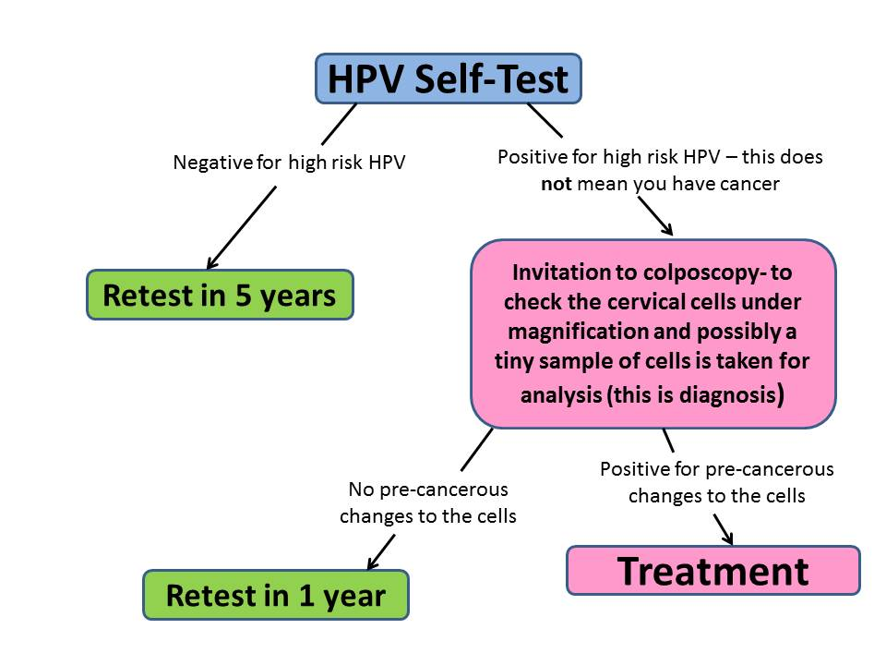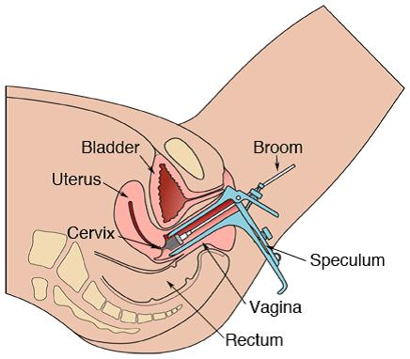
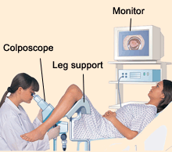
Figure 3: Speculum Figure 4: Colposcopy

