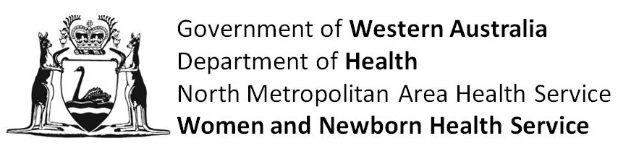

**Patient Information Sheet**

**Effect of pre-caesarean section maternal carbohydrate loading on neonatal glycaemic control: a randomized controlled trial.**

**Why are we doing this study?**

Taking a carbohydrate or electrolyte drink before caesarean section we think will help to speed up your recovery from surgery. Many hospitals worldwide are already offering this to their patients. Before we make this our normal practice here at Kind Edward Memorial Hospital, we wish to be sure that babies are able to control their blood sugar levels once they are born, if their mother has recently had a carbohydrate drink.

**Who is carrying out this study?**

The research team is led by specialist neonatologists, anaesthetists and obstetricians at King Edward Memorial Hospital and includes research midwives and specialist trainee anaesthetists.

**What will you be asked to do if you decide to take part in this study?**

You will be provided with information about the study and asked to sign a consent form. You will then be taken through the forms and asked some questions before your surgery in the day surgery unit.

Being involved in the study will not impact on the surgical or anaesthetic care that you receive. You will be given a drink to have the evening before your caesarean section and another to have on the morning of your surgery. One group of women will receive an electrolyte drink and the other will receive a carbohydrate drink. Which of the two drinks you are given will not be known by the anaesthetist, you, the recovery room nurses or the midwives– it will be provided by the research team in a labeled bottle. This is called “blinding” and is a standard procedure in trials such as this, and is used to minimise the likelihood of errors being introduced into the trial.

During your operation we will test your blood sugar level using a tiny needle and a single drop of blood. After the operation you will be closely monitored in the recovery room. If you are experiencing pain or other side effects then medication will be readily available for you. You will be asked further questions about pain, nausea and other symptoms after your surgery in the recovery room. You will also receive a follow-up interview at around 48-hours after surgery.

Your baby will have their blood sugar level tested twice after birth. Once aged around 4 years old, and again at around 10 hours old. This is a tiny heel prick test that allows us to ensure your baby’s blood sugar level is safe. Many babies have this performed as a routine event and it causes them a very short period of distress.

**Is there likely to be a benefit to other people in the future?**

Yes – we will see whether there is a difference in the time for women like you to recover from caesarean section if given a carbohydrate drink before surgery. We will also make sure carbohydrate drinks given to mothers are safe for babies blood sugar control at birth. This may allow other women to have a better experience of caesarean section surgery and potentially improve the time it takes for women to recover and go home caring fully for their new baby.

**What are the possible risks and/or side effects?**

Both drinks being tested are considered to be safe and you have been approached to participate as your own likelihood of having any serious side effect from these drinks is considered to be low. Many hospitals across the world already routinely give mothers carbohydrate or electrolyte drinks, and there has not been any reports of problems for their babies. There is however a risk that your baby might have a low blood sugar level once born, and we want to be absolutely certain not to miss this.

**Where is your information kept?**The information is confidential, so the forms and the information are stored in a filing cabinet and password-protected computer in a locked room in the secure area of the Department of Anaesthesia and Pain Medicine at King Edward Memorial Hospital.

**What about my privacy?**When your information is collected a code number is used to identify it. Access that can link you to the form will only be available to the investigators, is stored securely and remains confidential. When the study is analysed for the findings, your results are grouped with those who also had the same study drug and these groups then compared. This maintains your privacy when the study results are published.

**Who has approved the study?**

The Women and Newborn Health Service Ethics Committee for King Edward Memorial Hospital for Women has approved the study.

**Who to contact for more information about this study:**

If you would like any more information about this study, please do not hesitate to contact one contact one of the research team. They are very happy to answer your questions.

# Desiree Cavill / Michelle Porteous Contact Number 08 6458 2223

**Who to contact if you have any concerns about the organisation or running of the study?**

If you have any concerns or complaints regarding this study, you can contact the Director of Medical Services at KEMH (Telephone 08 6458 2222). Your concerns will be drawn to the attention of the Ethics Committee who is monitoring the study.

**What to do next if you would like to take part in this research:**

If you would like to take part in this research study, please read and sign the consent form provided.

**THANK YOU FOR YOUR TIME**