**Mandibular advancement splint and positional therapy for the treatment of moderate to severe positional obstructive sleep apnoea: a pilot randomised controlled study (MASPOT)**

**Introduction**

Mandibular advancement with oral devices, in particular mandibular advancement splints (MAS) in adults have been shown to be effective in treating obstructive sleep apnoea (OSA) across a range of severity.[1, 2] They are increasingly being proposed as a non- invasive first-line treatment alternative for continuous positive airway pressure (CPAP) therapy for the treatment of snoring and OSA. Since 2006, the clinical practice parameters of the American Academy of Sleep Medicine have recommended the use of MAS for the treatment of mild to moderate OSA, and for severe OSA when patients refuse or are unable to tolerate CPAP.[2] To date, there have been a substantial number of published randomized controlled trials that have validated the therapeutic efficacy of MAS for the treatment of OSA across the full range of disease severity.[3-5]

However, despite their reported efficacy, complete resolution of OSA (apnoea-hypopnoea Index [AHI] reduced <5/hr) with the use of MAS has been reported to be around 40%. [1] Using a liberal cut-off of AHI < 10/hr, the success improves to only 54%.[6] Although several studies have demonstrated therapeutic efficacy with MAS therapy for severe OSA patients [7-9], not all patients will experience a clinical benefit from this mode of therapy. The prediction as to which patient will benefit from MAS therapy still remains elusive despite technological advances in diagnostic and imaging techniques. For severe OSA patients who refuse or are intolerant to CPAP, MAS therapy poses as a viable treatment option. However, the high cost and uncertainty of MAS treatment for severe OSA patients are significant barriers to the commencement of treatment. Very recently, the use of “boil and bite” trial MAS [10] and remote controlled mandibular positioners [11] have been proposed as an alternative pathway to screen for candidates that are suitable for MAS therapy..

MAS treatment success has been associated with several factors including female gender, younger age, supine-dependent OSA(positional OSA), lower OSA severity and BMI and craniofacial factors.[1] The parameters that influence the treatment outcome are thought to be multi-factorial and may include both patient- device specific, device-specific and titration specific variables.[1]

Body habitus also has been proposed to influence OSA severity and it has been clinically observed that OSA patients experience a worsening in the severity of OSA symptoms when supine (positional sleep apnoea).[12, 13] The prevalence of positional OSA has been estimated to be at 56% when the standard definition proposed by Cartwright (greater or equal to twofold difference between the supine and non-supine AHI) is applied.[13] Over the last few decades, there has been substantial evidence to document the adjunctive role of positional therapy (POT) in improving OSA severity.[14-17] However, there exist limited literature for the use of trial MAS and POT for positional OSA patients who refuse or are intolerant to CPAP therapy.[18]

In this study, we propose a randomised controlled, crossover trial of a custom-made trial MAS with and without POT. Notably, the MAS used will be embedded with an objective compliance monitor, which will assess MAS compliance.

**Aims:**

1. To assess the therapeutic efficacy and objective compliance of a custom fitted trial MAS for moderate to severe positional OSA patients.
2. To investigate if adjunctive treatment with POT in moderate to severe positional OSA patients undergoing MAS therapy, improves treatment outcomes.

**Methods**

**Study Design**

Subjects enrolled in the study will be provided with a trial custom fitted MAS and a positional therapy (POT) sleep positioner during the acclimatization period. They will be informed that the compliance with both MAS and POT will be measured objectively.

The trial profile is shown in Figure 1. A randomized crossover study design (AB/BA will be used).

After 1 week washout period, each patient will be randomized into either Group 1 (sequence AB) or Group II (sequence BA). After 30 days of treatment in the initial treatment phase they will be crossed over to other treatment phase. Patients will undergo a nocturnal polysomnograph during each treatment modality to check the efficacy of the treatment.

**Study Population**

**Eligibility Criteria**

## Twenty adult patients with moderate to severe positional obstructive sleep apnoea will be recruited from the sleep laboratory of John Hunter Hospital.

## Inclusion Criteria

1. Males & Females ages 18 – 60 years

2. Moderate to Severe OSA (Apnoea-Hypopnea Index (AHI) > 15/hr) and

3. Supine dependent OSA (Supine to non-supine AHI ratio > 4)

4. CPAP intolerant/refusal

5. Minimum of ten teeth per dental arch

6. Sufficient dental health (No periodontitis)

7. Free from temporo mandibular joint pain

## Exclusion Criteria

1. Pregnancy

2. BMI > 35 kg/m2

3. Unstable Angina/ Heart Failure (NYHA Class III or IV)/ Stroke

4. Recent (<6months) AMI or Revascularization Procedure.

5. Significant Arrhythmia or Atrial Fibrillation.

6. Recent (<3 months) exposure to OSA therapy with MAS.

7. Severe OSA who are excessively sleepy ( ESS> 16)with increased risk for driving-related accidents.

8. Regular use of sedatives, narcotics, or psychoactive drugs.

9. Contraindications to oral appliance therapy (periodontal disease or dental caries, less than 10 teeth per dental arch, and exaggerated gag reflex).

**Oral Appliance and Positional therapy**

Patients with be fitted with a custom fitted trial mandibular advancement splint (MAS). Additionally, patients will be provided with a positional therapy (POT) device-(Nightshift sleep positioned, Advanced Brain Monitoring, Inc Carlsbad, CA USA), (figures 3,4 and 5).

MAS=Custom fitted trial MAS- monoblock design (Figures 1 and 2).

POT= Positional therapy- Nightshift sleep positioner (Figures 3,4 and 5).

The custom fitted trial MAS will be fitted with a compliance monitoring microsensor (Theramon, IFT Handels-und Entwicklungsgesellschaft GmbH, Handelsagentur Gschladt, Hargelsberg, Austria),­­­­­ (figures 6 and 7) to objectively monitor MAS compliance.

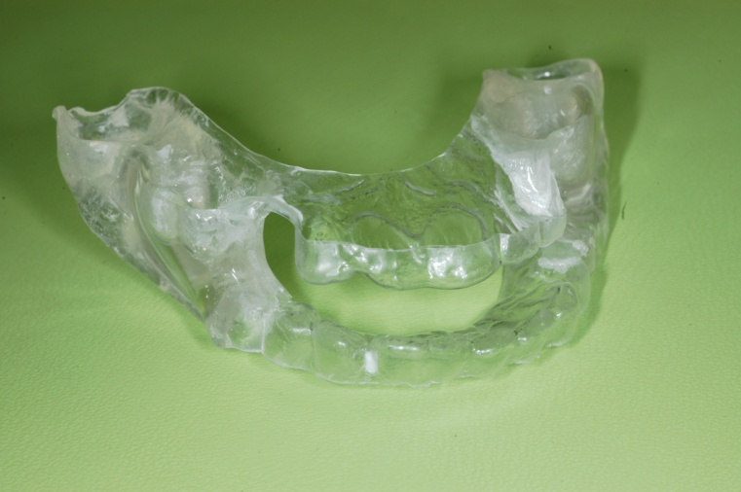

Figure 1.

(A) Trial MAS – monobloc design.

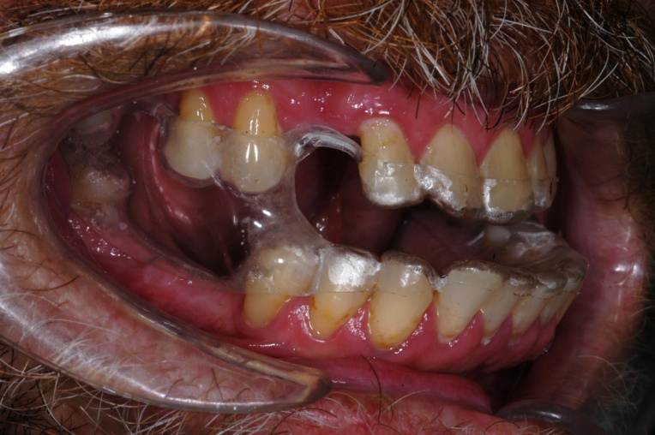

Figure 2.

MAS fitted in the mouth at 80% maximum protrusion

Figure 3.

Positioner therapy (POT) device (Nightshift sleep positioner)

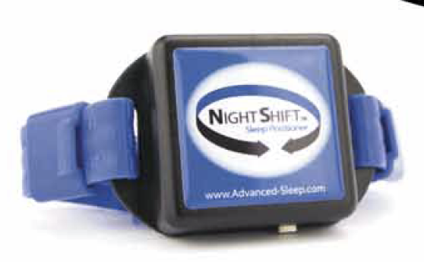



Figure 4.

POT device attached to neck of OSA patient with bedpartner

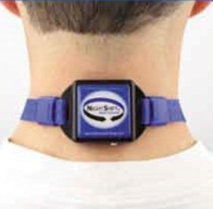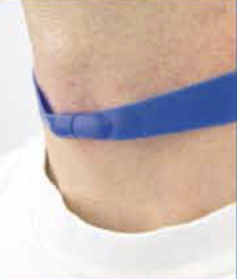

Figure 5.

Posterior and anterior view of POT on patient’s neck

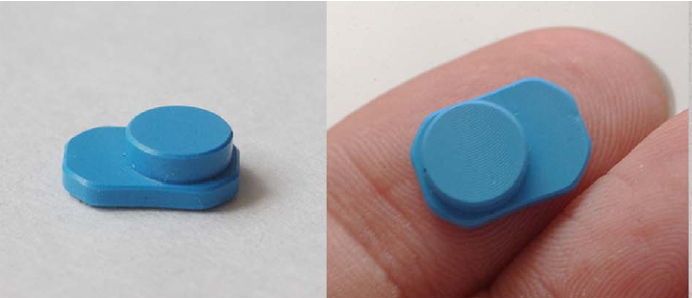

Figure 6.

The microsensor thermometer (MT) with on-chip readout electronics .

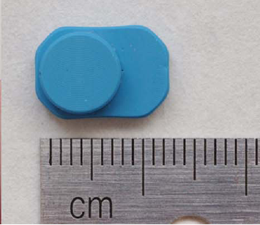

Figure 7.

Microsensor thermometer (MT) has a weight of 0.40+0.01g a length of 13.0+0.1 mm, a width of 9.0+0.1 mm and a height of 4.3+0.1 mm.

**Outcome Measures**

1. Polysomnography – Residual apnoea- hypopnea index(AHI) and residual Oxygen desaturation index(ODI) on each treatment arm)
2. MAS Treatment Outcome.
3. Objective MAS compliance measurements.
4. Other Outcomes ( improvements in ESS)

1. Polysomnographic Outcome

Primary outcome will be the AHI. Both groups of patients (Group 1 and II) will undergo an overnight level I polysomnography with either MAS or MASPOT as randomly allocated. Scoring will be performed by a polysomnographer blinded to the treatment.

Apnoea was defined as cessation of airflow for at least 10 seconds. Hypopnea was defined as a reduction in amplitude of airflow, measured as pressure change at the nares, or thoraco-abdominal wall movement of greater than 50% of the baseline measurement for more than 10 seconds with an accompanying oxygen desaturation of at least 3%, and/or associated with arousal. These events were considered obstructive if they occurred in association with continued diaphragm electromyogram activity and thoraco-abdominal wall movement.

2. MAS Treatment Outcome

A complete response to treatment was defined as a reduction in AHI to < 5 per hour, and a partial response as a reduction of ≥ 50% in AHI compared to baseline, but with the AHI remaining ≥ 5 per hour. Treatment failure was defined as < 50% reduction in AHI compared to baseline.

Therapeutic MAS efficacy was defined as baseline AHI minus AHI with MAS or MASPOT, expressed in percentage.

3. Objective MAS Compliance

The objective MAS compliance data will be expressed as a mean rate of MAS use in number of hours of MAS use per day, and as a percentage of days of MAS use per week. MAS compliance was defined as objective MAS use > or = to 4 hours use per day.

Self-reported MAS compliance and self-reported total sleep time (TST) will be assessed by using a sleep diary filled out by the patient during each week of both MAS devices. The adjusted compliance will be calculated as the objective mean rate of MAS use divided by TST.

4. Other Outcomes

Percentage time supine and non-supine (% S, % NS)

Excessive daytime sleepiness (Epworth Sleepiness Score (ESS) measured at 3 different periods (beginning/ end of 1st arm and end of 2nd arm)

Sleep-related quality of life (Functional Outcomes of Sleep Questionnaire (FOSQ)

**Protocol: AB/ BA design**

Perform Diagnostic Sleep Study.

Assessed for eligibility

Dental Screening, for MAS suitability. If successful enroll into study and commence MAS device (trial MAS) and positional therapy

2 weeks Acclimatization Period

(Trial MAS + Positional therapy)

1 Week Washout

Group 1

Group II

MASPOT

Polysomnography

4 weeks treatment

MAS

1 week

Washout

MAS

Polysomnography

4 weeks treatment

MASPOT

MAS = treatment with trial MAS

MASPOT = treatment with trial MAS + Positional therapy (Nightshift)

**Figure 1- Flow of patients through the trial.­­­­**

**References**

1. Sutherland, K. and P. Cistulli, *Mandibular advancement splints for the treatment of sleep apnea syndrome.* Swiss Med Wkly, 2011. **141**: p. w13276.

2. Kushida, C.A., et al., *Practice parameters for the treatment of snoring and Obstructive Sleep Apnea with oral appliances: an update for 2005.* Sleep, 2006. **29**(2): p. 240-3.

3. Bradley, T.D., et al., *Pharyngeal size in snorers, nonsnorers, and patients with obstructive sleep apnea.* N Engl J Med, 1986. **315**(21): p. 1327-31.

4. Hoekema, A., *Efficacy and comorbidity of oral appliances in the treatment of obstructive sleep apnea-hypopnea: a systematic review and preliminary results of a randomized trial.* Sleep Breath, 2006. **10**(2): p. 102-3.

5. Ferguson, K.A., et al., *Oral appliances for snoring and obstructive sleep apnea: a review.* Sleep, 2006. **29**(2): p. 244-62.

6. Hoffstein, V., *Review of oral appliances for treatment of sleep-disordered breathing.* Sleep Breath, 2007. **11**(1): p. 1-22.

7. Mehta, A., et al., *A randomized, controlled study of a mandibular advancement splint for obstructive sleep apnea.* Am J Respir Crit Care Med, 2001. **163**(6): p. 1457-61.

8. Walker-Engstrom, M.L., et al., *A prospective randomized study comparing two different degrees of mandibular advancement with a dental appliance in treatment of severe obstructive sleep apnea.* Sleep Breath, 2003. **7**(3): p. 119-30.

9. Henke, K.G., D.E. Frantz, and S.T. Kuna, *An oral elastic mandibular advancement device for obstructive sleep apnea.* Am J Respir Crit Care Med, 2000. **161**(2 Pt 1): p. 420-5.

10. Quinnell, T.G., et al., *A crossover randomised controlled trial of oral mandibular advancement devices for obstructive sleep apnoea-hypopnoea (TOMADO).* Thorax, 2014. **69**(10): p. 938-45.

11. Remmers, J., et al., *Remotely controlled mandibular protrusion during sleep predicts therapeutic success with oral appliances in patients with obstructive sleep apnea.* Sleep, 2013. **36**(10): p. 1517-25, 1525A.

12. Oksenberg, A., et al., *Association of body position with severity of apneic events in patients with severe nonpositional obstructive sleep apnea.* Chest, 2000. **118**(4): p. 1018-24.

13. Cartwright, R.D., *Effect of sleep position on sleep apnea severity.* Sleep, 1984. **7**(2): p. 110-4.

14. Levendowski, D.J., et al., *Assessment of a neck-based treatment and monitoring device for positional obstructive sleep apnea.* Journal of clinical sleep medicine : JCSM : official publication of the American Academy of Sleep Medicine, 2014. **10**(8): p. 863-71.

15. Cartwright, R.D., et al., *Sleep position training as treatment for sleep apnea syndrome: a preliminary study.* Sleep, 1985. **8**(2): p. 87-94.

16. Jokic, R., et al., *Positional treatment vs continuous positive airway pressure in patients with positional obstructive sleep apnea syndrome.* Chest, 1999. **115**(3): p. 771-81.

17. Oksenberg, A., et al., *Positional therapy for obstructive sleep apnea patients: A 6-month follow-up study.* Laryngoscope, 2006. **116**(11): p. 1995-2000.

18. Dieltjens, M., et al., *A promising concept of combination therapy for positional obstructive sleep apnea.* Sleep & breathing = Schlaf & Atmung, 2014.

Version 1, 04/10/2016