Child Information Sheet

Scientific Title: Optimising participation in physically active leisure for children with cerebral palsy: A randomised controlled trial
Investigators: Dr Leanne Sakzewski, Professor Catherine Elliott, Professor Roslyn Boyd, Professor Jenny Ziviani, Professor Iona Novak, Professor Stewart Trost, Professor Annette Majnemer
Title: Helping kids with cerebral palsy to be more physically active through doing sports and leisure
It is OK to say no
Introduction
There are two sorts of physical activities. One sort includes ‘proper’ sports you play at a club or at school (swimming, basketball, wheelchair tennis etc.). The other sort includes games you do for fun with your family and friends (bike riding, backyard soccer, chasey, handball etc.). You move your body a lot and might get puffed! Things you do while sitting quietly are NOT physical activities (video games except Nintendo Wii, reading books, watching TV etc.).
Kids with cerebral palsy do not do as many physical activities. There are lots of reasons for this. Doing physical activities is a good way to have fun, keep fit, and make friends. All kids, including kids with cerebral palsy, have the right to do physical activities.
You are reading this sheet because you have cerebral palsy and you might want to do more physical activities. This sheet explains a research study of a sort of therapy. The therapy will help you to do the physical activities you want to do.
Description of Experiment - methods and demands
The study will take a long time but the time will go quickly. First you have to answer some questions on the computer. Then you will come in to the research centre to see a therapist (physio, OT, or exercise physiologist). There, you will talk about physical activities. Then, you will set some goals about physical activities you want to do.
When you are at the research centre, you will open an envelope. Inside it will say if you get to have the therapy NOW, or if you have to WAIT. It doesn’t matter what the answer is.
During one part of the study the therapist will visit you at your house. They will come for one hour each week after school or on the weekend. They will come to your house about 10 times! You will probably spend some time:
- Talking about things (with the therapist and your mum or dad)
- Practicing the sports and games you want to play
- Playing the sports and games, sometimes with other kids
- Learning how to do new things
- Getting new equipment or learning how to use equipment you already have
When this is finished, you will score the goals to see if you did better. You will set some new goals too! You will also answer the same questions on the computer.
You will always be told what you have to do and what is next. You will be told when the study is over. When that happens, you get a certificate to thank you for being in the study.
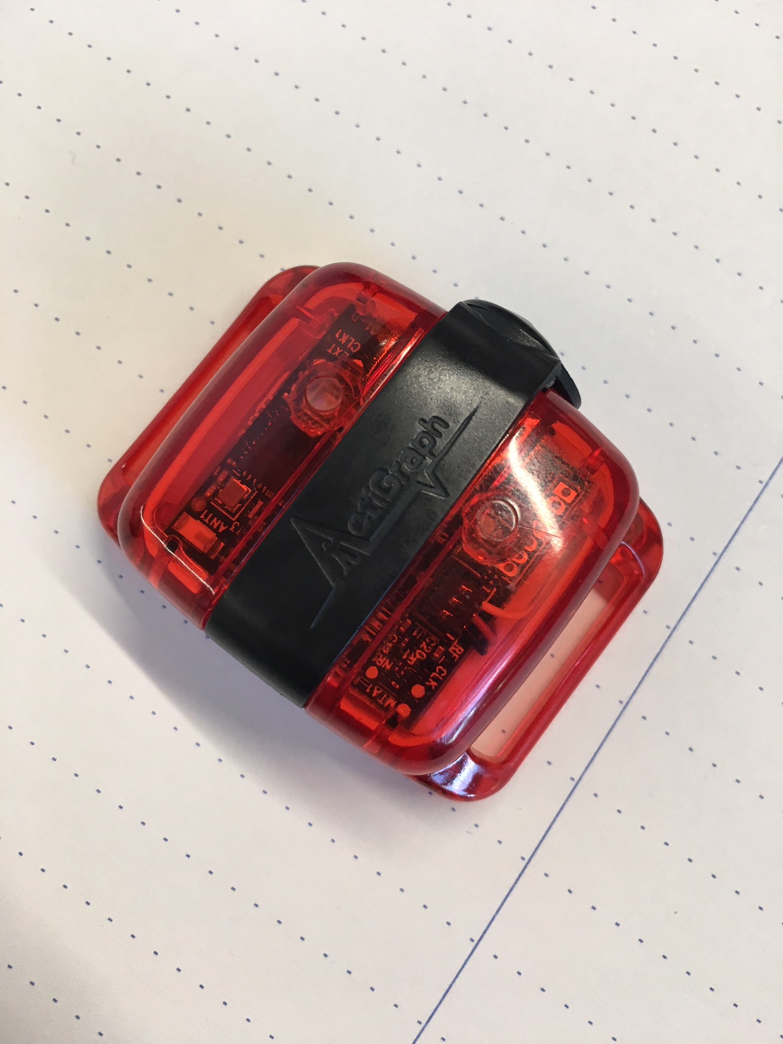
A few times during the study you get to wear an activity tracker. It works like a “Fitbit” or “Garmin” activity tracker.
You have to wear the tracker around your tummy with a stretchy belt. It might feel a bit weird for a while, but you’ll get used to it. You wear it for seven days in a row (Monday, Tuesday, Wednesday, Thursday, Friday, Saturday and Sunday). Then you give it back to the researcher.
It looks like this:
You can hide it under your clothes if you want to.
Risk & Discomfort
Some things could happen that are not nice. These could include:
- Getting sore muscles
- Being annoyed by the activity tracker
- Falling over when you play sports and getting hurt
Your therapist and mum or dad will do their best to keep you safe and stop bad things from happening. It is not likely that you will get hurt.
Benefits
Being in the study could help you do physical activities that are fun and make you feel good. You could learn lots of new things, like how to do a new sport. Being more active could lead to feeling better about yourself, your body, your health and your friendships.
Withdrawing from the Study
You can STOP doing the study at any time. All you have to do is tell your mum or dad that you don’t want to do the study any more. That means the therapist won’t come to visit you and you don’t have to do the questions or wear the activity tracker. If youI STOP doing the study, nothing bad will happen to your regular appointments with other doctors and therapists. Nobody will be mad with you if you say you want to stop.

If you need more information, you can talk to your mum or dad. You can also talk to the local therapist who does the study. Here are their details:
Local therapist name, number and email

