Physical Activity/Executive Function Preschool Pilot Study

Data Collection Protocol

Contents
Table of Contents
1 Project Team 3
2 Project Timeline 3
3 Data Collecion 4
3.1 Checklist 4
3.2 Ethical Considerations 4
3.3 A typical Data Collecton Day 5
3.3.1 Data Collection Sequence 5
3.3.2 At Conclusion of Each Day 6
3.3.3 End of the 2nd Week 6
3.3.4 Equipment 7
3.3.5 Reliability Testing 7

4 Child Measures/testing Procedures 7
4.1 Physical Activity 7
4.2 Executive Function Tests 12
4.2.1 Mr. Ant – Working Memory 12
4.2.2 Not This - Ponological Working Memory 13
4.2.3 Go/No-Go (GNG) - Inhibition 13
4.2.4 Dimensional Change Card Sort (DCCS) - Shifting 13
4.2.5 Documenting Data 13
4.2.6 Other chidren participating 13
4.2.7 Downloading data to the UOW data base 14

5 Electroencephalography (EEG) 14
6 Other Project Information 16
6.1 Troubeshooting 16
6.1.1 Cannot attend 16
6.1.2 Running late 16
6.1.3 Regular meetings 16
7 Equipment Required 17

1. PROJECT TEAM
Primary Investigator | Dr Dylan Cliff
 | University of Wollongong
 | Wollongong NSW Australia 2522
Email: dcliff@uow.edu.au
Ph: +61 2 4221 5929

Chief Investigators | Dr Steven Howard  Dr Stuart Johnstone  Karen Tonge PhD Candidate
Master Students  Co-Investigators | Xiaomeng Wei  Parsa Paiman  Damon Verstappen
Research Staff | Alison Giobbi  agiobbi@uow.edu.au  0421086389
2. TIMELINE 2018

Activity | Jan | Feb | Mar | April | May | June | July | Aug
Ethics approval
Training, recruitment
Baseline data collection
Intervention delivery
Post-test data collection
Data entry, processing and analysis
Report writing

3. DAta collection

3.1 Checklist for preparing for measurement sessions (1 day before):
- Print out the daily run sheet, which contains:
  - Date
  - Data collector names
  - Preschool name
  - Contact person/director from the preschool
  - Preschool address and telephone number
  - Emergency telephone numbers
  - A list of all the children participating in the study from the pre-school you are visiting
  - A checklist of all measures that need to be taken (to make sure nothing is missed)
- Confirm the booked visit with staff from the pre-school.
- Check that all the equipment is ready to go (from equipment list).
- Make sure you have hard copies of all the measurement forms to be completed.
- Make sure you have a working mobile phone with sufficient phone credit (just in case of an emergency)

3.2 Ethical considerations when conducting measurement sessions:
- Always have a staff member from the service supervising when working with children.
- Ensure confidentiality is maintained.
- Data collectors are responsible for the child’s safety throughout the collection process.
- Never take the children out of the pre-school.
- Answer any questions staff or parents may have.
- Wear your identification name badge and UOW T-Shirt

It is IMPERATIVE that UOW staff check Christian AND surnames BEFORE measuring. It is ESSENTIAL that only those children whose parents have given consent (i.e. those who you have completed and signed consent forms for) are measured and fitted with an accelerometer. UNDER NO CIRCUMSTANCES CAN ANY CHILD BE MEASURED OR COMPLETE ACTIVITITES IF YOU DO NOT HAVE A SIGNED PARENT CONSENT FORM WITH YOU OR IF THE PARENT/CARER IS NOT PRESENT. Be aware of more than one “Matt” or “Suzie” in a group. If there are children who have not been given consent but are getting distressed because they cannot join in, let them play the iPad games using TEST as the child’s ID. We can also ask a staff member to phone a parent to receive verbal consent and have the parent sign the consent when they pick the child up.
If the parents have consented and the child refuses, we must respect the child’s right not to participate. The parent or centre staff member may help facilitate the child during measurements/tests. Gather as much information as possible, and record which child it was and what exactly they refused to do. Under no circumstances should the child be forced to do something they are not comfortable with.
We will consult with each individual centre regarding the best method for them to remind parents to return consent forms and also to complete and return parent surveys.

3.3 What would a data collection day look like/ A typical visit?
Prior to each visit you should ensure you have all of the equipment and documentation you require for your child care service. You will hopefully be able to store the equipment in a secure place at the centre throughout the week. Arrive at the location at the arranged time (promptness is vital).

It is recommended you arrive around drop off time so that you can be around if parents need to ask questions and to hand out any information/questionnaire packages or assist parents in completing the questionnaires.

On arrival at the child care service, sign in and introduce yourself to staff and the contact person/director. Discuss with the director/staff where in the venue is the most appropriate area for you to measure the children. If they don’t have a room or space arranged, discuss your requirements with them. Within the play room might be good if a space is available. You will need a reasonably quiet place for the iPad games so the child can hear the instructions and avoid distractions.
Ensure you are sensitive to the day-to-day running of the centre and try to minimise disruption to centre activities.

3.3.1 Data collection sequence for participants.
Some children might need to ‘warm up’ to you, so you might need to discuss any questions with the parent if they are there or take some time to connect with the child. You may need the assistance of the staff to help with any children who are reluctant to be measured etc. Measurements and order of tests may be carried out in different order depending on what you find works best or how you feel the child is reacting.

- Accelerometer Fit [10 mins]
- EEG AND 1 Executive function iPad games[10min]
- Break [10min]
- 3 Executive Function iPad games [15 mins]

At the end of data collection station the child will get a stamp (these will be collected at each ‘station’ during data collection). Data entry will be entered onto either a MASTER data collection sheet or individual data collection sheets and then entered into the data base at the end of each day.

During the visits, the children are in the care of the centre, however throughout the collection process you have a responsibility for their safety. At all times no UOW staff member is to be alone with any children at any time. Do not ever take the child out of the enclosed gated area. You are also unable to measure any children if they do not have a teacher or other carer there to supervise.
Data collectors will be in the child care services for a maximum of a week. It is important they check that the accelerometer is still on the children and provide a new one if necessary.

3.3.2 At the conclusion of each day/visit
- Note any children/parents who were scheduled to be included in the study but who were absent on the day on the data collection form.
- Note any children/parents who refused participation in any part of the study on the data collection form.
- Ensure all measurements are accurately recorded on the data collection form and in the database.
- Ensure all paperwork is in order.
- Return paperwork and equipment to the office/storage room.
- At the end of the week collect all materials and equipment from the centre identify whether any follow up visits will need to be made to collect outstanding data.
- Ensure all data stored on iPads has been sent over Wi-Fi back to the database.
- Thank the centre director and staff for their cooperation in the project.

3.3.3 End of the second week to pick up/follow up on equipment, and missing data
- Collect all the activity monitors from the educators
- Repeat any missing measurements
- Thank all the educators for their cooperation.

3.4 Equipment
All equipment needed to conduct outcome measures will be kept in a kit. Please make sure the equipment used at the allocated pre-schools is the same at each data collection point by checking the serial model numbers.

All equipment will be calibrated before use. [Please see equipment list for everything you need for each data collection]

3.5 Reliability testing
We need to test intra- and inter-tester reliability to ensure that we are consistently measuring the same way. We will test for inter-tester reliability by having two people measure the same participant. We do this to make sure we are all doing things the same way, and therefore that our results are reliable no matter who does the testing and recording.
We will also check for intra-tester reliability by having the tester measure the same participant twice. It is a technique routinely used to validate the results (we need to check that we are measuring in a consistent way).

When you meet the child, ensure that you introduce yourself to the child. Check that the parent has given consent (i.e. those who have completed and signed consent forms). Under no circumstances can any child be measured if they do not have a signed parent consent form or if a staff member is not present.

If the parents have consented and the child refuses to be measured, you need to respect the child’s right not to participate. You may need the assistance of a staff member to help with any children who are reluctant to be measured. Record as much information about why the child refused to be measured. Under no circumstances should the child be forced to be measured.

4 Child Measures / Test Procedures

4.1 Physical activity (Actigraph GT3X+ monitors)
Accelerometry will be used to objectively assess the preschoolers’ physical activity at all measurement time points. The accelerometer used for this project is the Actigraph GT3X+ (See Figure 3 and 4). This is a small, lightweight, triaxial device worn on an elasticized belt around the waist. The monitors capture physical activity by recording time varying accelerations. Each child is required to wear the accelerometer for 7 days, removing only for water activities (including baths/showers, swimming). The child will be asked to wear the monitor while sleeping. The monitor will be placed on the child on the first day they attend the preschool for that week and as soon as he/she arrives. The monitor will be removed 7 days later when the child is picked up from the pre-school at the end of the day.

Equipment
- Actigraph GT3X+ accelerometers
- Elasticized belts
- Serial number labels
- Accelerometer to USB cables
- USB 7 point hubs
- Country power adaptors
- External hard drive (to back up downloaded data)
- Waist monitor instruction sheet (to give to parents)
- Clear lock bags (for accelerometers that need to be returned to the university)
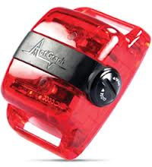
A GT3X+ accelerometer

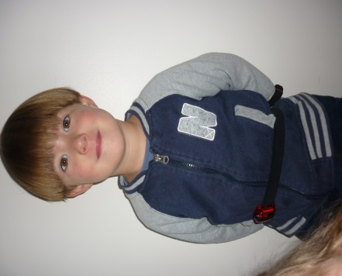
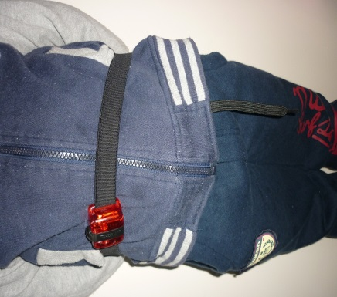

Placement of the GT3X+ accelerometers on a preschool child
The GT3X+ accelerometers features a small LED light that conveys messages depending on the flash sequence.

Fitting the GT3X+ accelerometers
Data collectors will be responsible for fitting the GT3X+ accelerometers to the children.

Before fitting the accelerometers on the children:
- Use the Master data sheet to document the child’s ID, the serial number of the monitor, the date and time the monitors were fitted to the children and taken off the children, the name of the data collectors fitting the accelerometer to the child, if a second monitor is given to the child due to the child forgetting to wear the monitor to service on any given day, and the serial number of the second monitor.
- If a second monitor is given to a child, create a new entry on the tracking log with the new details (i.e. the child’s ID, the serial number of the monitor, the date and time the monitor was fitted and taken off, the name of the data collector fitting the accelerometer).
When fitting the accelerometers to the children:
- The monitor will be fitted as soon as the child arrives at the pre-school.
- Discuss with the child what you are going to do, in simple language they can understand. Offer the monitors to them to let them touch and hold the monitors if they seem a bit hesitant, or just to get familiar with how it feels.
- Discuss with the child how the accelerometer needs to be worn in simple language (call it an activity monitor or an activity counter) they can understand. Explain to the child that the monitor:
- needs to be worn all day and all night
- needs to be taken off when they go in water
- can be worn underneath or over their clothes
- needs to be worn by them and no-one else: “you cannot swap with a friend because that monitor is set specifically for you and if someone else wears it the computer in the monitor will think that they are you”
- tell an adult if it falls off
- The monitor will already be on an elastic belt. To fit the monitor, put the belt around the child’s waist and fasten. Make sure the belt is snug against the child’s body but not digging in to the child’s skin. The monitor should be positioned over the right hip with the button facing upwards.
- One person fits the child with the monitor and another person records the serial number and the time it is put on. It is VERY important that the correct number is recorded for the particular child along with the date it is fitted.
- When the child is picked up from childcare on the first day, give the “Waist monitor instruction sheet” to the parent (see attached sheets).
- Remove the accelerometers from the children after 7 days of wearing

Strategies to increase compliance:
Data collectors should be present in the pre-schools during the first week and check the children are wearing the monitors.
- If the child is not wearing the monitors correctly (e.g. monitor is upside down, wearing on the wrong side of the body), correct the monitor’s position and explain how to wear the monitors again to the child in easy to understand language.
- If the child has left the monitor at home, provide the child with a new monitor and document the details on the accelerometer tracking log.
- Children can also be provided with a story book – with a character who wears a magic belt. This will be read to the child at the service to help increase compliance.

See below for Activity monitor sheet to be sent home to parents.

Thank you for taking part in Preschool PA & Cognition Study – Your child will wear this monitor for a full 7 days. The waist monitor is not waterproof, please remove it from your child for water activities (eg. baths, swimming, and beach visits). The monitor should be worn for daytime naps and while sleeping at night.

- Place the belt around
your child’s waist …
- With the monitor at the front on the right hand side (in line with the right leg) | 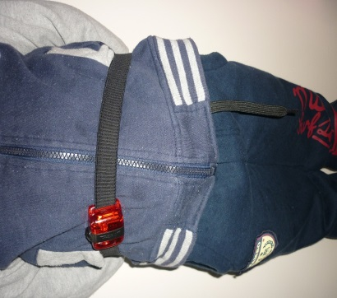
- Ensure that the black circle  on the monitor is facing up | 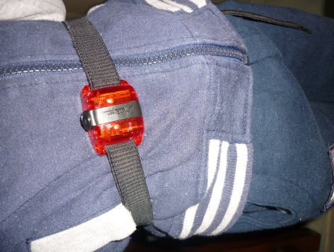
- The monitor can be worn on  top or underneath clothes, whichever is most comfortable | 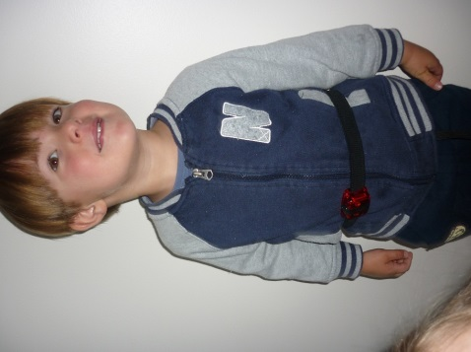

4.2 Executive Function Tests

Equipment
- iPad x 5
- Charging equipment

Protocol for EF tasks:
Before the test: Ensure the volume on the iPad is set to high as all instructions required for the test are included with the App.

To initiate a test: First choose the app for the test you are administering. For each test you should begin by entering:

- Subject ID: centre_ID/ Child_ID/ first name last name
Eg: centre 1, child 5, first name, last name: 0105 sally smith
- DOB
- Sex (Male / Female)
- Select Start

Role of tester: As the tester you should not ‘help’ the child as this will affect the accuracy of their results however you may:

- Attempt to bring their attention back to the task if distracted “Remember to listen” “Are you watching carefully?”
- Offer encouragement “Good Job” “Well Done”

Test Results
- After each test has been completed the screen will indicate this e.g. “Game Over”.
- Results will be saved automatically.
- Whenever possible (ie at the end of each day or more regularly if possible) you should connect the iPad to WiFi to enable the results of the tests to be sent to the university database. The results will be sent automatically when the iPad is connected to WiFi you do not have to do anything.

A brief description of each test is provided below:
4.2.1 ‘Mr Ant’ Task (an iPad-based visual-spatial working memory task): Children will be presented with an image of an ant with a number of coloured dots placed in different spatial locations on its body. After a predetermined time limit these dots disappear and the child is asked to recall the spatial locations of the dots by tapping the corresponding locations on the ant’s body. This game takes no more than 10 minutes to complete.

4.2.2 ‘Not This’ Task (an iPad-based measure of phonological working memory): Children will be presented with an array of shapes that vary in size and colour (e.g., large blue circle). Before the shapes are presented, participants will hear an auditory instruction to point to a shape that does not fulfil a certain descriptive quality (e.g. “Point to a shape that is not red” or “Point to a shape that is not a triangle and is not big”). During each test trial the number of descriptive qualities that must be ignored increases; however, the game ceases after 3 incorrect responses within the same level, to ensure the game does not continue beyond the child’s ability level. This game takes no more than 10 minutes to complete.

4.2.3 ‘Fish/Shark’ Task (an iPad-based measure of inhibition): Children will be presented with fish and sharks, and will be instructed to tap the iPad screen when they see a Fish (‘catch the fish’) and refrain from responding when a Shark appears (‘avoid the sharks’). This game will take no more than 5 minutes to complete.

4.2.4 Dimensional Change Card Sort (an iPad-based measure of shifting): Participants will be presented with cards that vary along two dimensions (e.g., shape and colour) and are asked to sort each card (e.g., red rabbits and blue boats) first by one dimension (e.g., colour) and then, after a number of trials, by another dimension (e.g., shape). This game takes no more than 5 minutes to complete.

4.2.5Documenting Data
The Data collection iPad is to be used to record the height, weight, waist circumference, blood pressure, and to document if participant’s completed the retinal imaging, executive function, social and cognitive tasks. It is important this is filled in correctly as the data will be entered/transferred into a database at a later date. This form can be a paper version or on the iPad.

4.2.6 Other children participating
It is important to be inclusive of children interested in the testing. Many children become keen to play the iPad games if this is the case enter the following on the iPad:-
- Subject ID: TEST
- DOB Leave blank
- Sex (Male / Female) Leave blank
- Select Start
Note date and time the test runs were completed, these data files will be deleted by the data manager. At no point children whom are involved in the study can use the iPad before their test.

4.2.7 Download data to UOW data base
At the end of each day you must connect to wifi open and play each game to the end this will ensure the data is pushed through to the server. Subject ID: TEST
- DOB Leave blank
- Sex (Male / Female) Leave blank
- Select Start
Once complete charge ipads for the following day.

5. Electroencephalography (EEG)

Connecting the BrainBand to the iPad

- If the BrainBand (BB) has not previously been paired with the particular iPad.
This should only need to be done once – if you don’t see BRAINBANDXL listed in the iPad Bluetooth device options, it needs to be done.

- When the BB is off, hold the button down for about 5 seconds - ignore the initial flashes at the 2 second point and keep holding. After 5 seconds the blue light will flash very rapidly.
- Enable Bluetooth in Settings on the iPad - it will search for available devices, and will find BB.
- Press BB button on iPad to connect. Blue light should then flash very slowly.
B. If the BB has already been paired with the iPad:
- Go to Settings, Bluetooth. You should see BB in the list of devices, but it won't be connected.
- Press the button on BRAINBANDXL for about 1-2 seconds - blue light should start to flash.
- Press BRAINBANDXL button on iPad - will connect.

Fitting the BrainBand

- The black box should always be on the left hand side of the child's head
- The two electrodes should be centred with the midline of the head horizontally, and be halfway between the hairline and eyebrows vertically – see below
- The ear-clip electrode should be attached to the left earlobe. Give a gentle squeeze when fitting to ensure connected snugly to skin.
- The device should fit comfortably and not be too tight
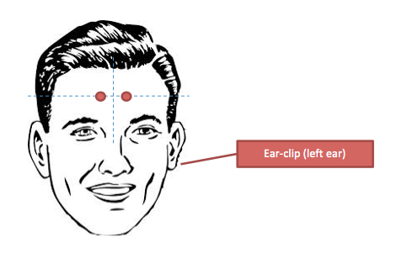

To record EEG using the Myndplayer app
- Fit BB device to the head as per instructions.
- Start the MyndPlayer app to view/record data.
- The raw EEG is shown on the right - it should generally look like below - the vertical lines represent a series of rapid blinks.
- Test the EEG - ask the child to sit still for 15-20 seconds and then ask them to blink rapidly 5 or 6 times.
- The dials on the left show Focus, Relaxation, and Zone.
- You will be making a total of 4 recordings.
  - 2 minutes sitting at rest with eyes open
  - For the duration of Mr Ant task
  - For the duration of Go No Go task
  - For the duration of Dimensional Change Card Sort (Rabbits and Boats) task
- To record press record button (next to signal quality indicator). This should be done at exactly the same time you press Start on the Executive Function task.
- Press the record button again to end the recording when the task is complete.
- At the end of a recording session an email window will be activated.
  - In the subject line add Subject ID (First Initial, Surname, DOB eg AJones010610) and name of task (EyesOpen, MrAnt, GoNoGo, CardSort).
  - Email to UOW database guest92@uow.edu.au and Stuart Johnstone sjohnsto@uow.edu.au
Record on/off
Signal quality

After use:
- Hold button for 5 seconds to turn BRAINBANDXL off
- Don't forget to charge the BRAINBANDXL
- Battery should last about 8-10 hours of recording
If the battery takes more than 4 hours to charge fully (note, fully charged is indicated by the blue solid light turning off while plugged into USB), you should reset the device.
Reset procedure:
• Plug the device into the USB, the light should come on solid
• Whilst plugged in hold down the power button for 5 seconds so it is flashing
• Press the button twice in quick succession
• Press the button a third time and hold down, after 6 seconds the light will go off.
• Unplug and replug into the USB and it will be reset.

EEG measurement and recording is 100% safe and pain-free. EEG recording is a non-invasive and safe way to view and record brain electrical activity. Participants should be made aware that they are able to withdraw at any point without penalty should they experience any discomfort. Note that this form of EEG measurement allows identification of atypical brain functioning at an individual level, and parents will be informed of this if identified by the research, and confirmed by the research supervisor, with referral to a suitable medical professional (e.g. neurologist).

6. Other Project Information

6.1 Troubleshooting

6.1.1 What to do if you can’t attend your daily appointments
Call Alison (0421086389) with as much notice as possible. For example if it’s 7 a.m. on the day that you are supposed to attend and you wake on your deathbed.

6.1.2 If you’re running late
Travel times vary and sometimes you underestimate how long it will take to get to a venue or the traffic is worse than you expect. Also, invariably unexpected things disrupt plans, e.g. alarms not going off! If you’re running late it’s nice to let the person expecting you know. You will have contact details on the sheet given to you at the office. If there is no answer and no answering machine, just let Tamara or Jade.

6.1.3 Regular update/feedback meetings
Regular weekly meetings will occur to evaluate progress of the study share experiences and to discuss and issues.

7. Equipment Required
Accelerometor ‘s (25)
iPads (3)
Chargers (3)
EEG headbands (6)
PA kit (1)
Consent forms (20)
Research Protocol (1)
Data Collection Training Manual (1)
Data recording sheets (1)

