Participant Information Sheet:

|  |  |
| --- | --- |
| **Current Study Title** | The role of the kidneys in acute mountain sickness |
| **Principal Investigator** | Dr Mickey Fan |
| **Contact Number** | 04 918 5395 |
| **Ethics Reference** | 16/NTA/153 |

**Study invitation**

You are invited to take part in a study to investigate the role of the kidneys in acute mountain sickness (AMS). Whether or not you take part is your choice. If you do want to take part now, but change your mind later, you can pull out of the study at any time.

This Participant Information Sheet will help you decide if you’d like to take part. It sets out why we are doing the study, what your participation would involve, what the benefits and risks to you might be, and what would happen after the study ends. We will go through this information with you and answer any questions you may have. We expect this will take about 10 minutes. You may also want to talk about the study with other people, such as family, whānau, friends, or healthcare providers. Feel free to do this.

If you agree to take part in this study, you will be asked to sign the Consent Form on the last page of this document. You will be given a copy of both the Participant Information Sheet and Consent Form to keep.

This document is [*8*] pages long, including the main Consent Form. Please make sure you have all the pages.

1. **Why are we doing the study?**

Acute mountain sickness affects millions of people each year when they ascent to high altitude regions. Unfortunately, there is currently no ways to predict whether someone will develop AMS, because we do not fully understand the cause of it. This study will investigate if differences in kidney functions can account for the development of AMS. During exposure to high altitude, the kidneys work hard to maintain fluid balance in our body. Since maintaining fluid balance is crucial for our body’s wellbeing, and fluid imbalance has been implicated in AMS development. Improving our understanding the role of the kidneys in AMS would be an important step towards understanding how AMS can be better treated at these high altitude regions.

All participants will be required to visit the Centre three times:

1. 2-hour familiarization to the experimental procedures of the study.
2. 10-hour experimental session at sea-level.
3. 10-hour experimental session at simulated high altitude.

Visits 2 and 3 will take place in the Altitude Simulation Suite at the Wellington Medical School. The order of visits 2 and 3 will be randomised, and you will be not be told the condition of the experimental sessions.

This study is a project conducted by the researchers at University of Otago (Dr Mickey Fan & Mr Terry O’Donnell) and Wellington Regional Hospital (Dr Sapi Mukerji). Each affiliated institutions has in part funded the cost of this study.

This study has been granted ethical approval from the Northern A Health and Disability Ethics Committee.

1. **What would your participation involve?**

**Participant Recruitment:**

You are invited to participate in this study, subject to the following criteria:

**Inclusion criteria**

* Healthy individuals (age 18-45 years) of both sex, specifically:
* Free of history of long-term disease
* Not currently taking any medication that may influence measures in this study.

Please ask us if you are unsure whether your medications are relevant

**Exclusion criteria**

* Anyone who has been above 2,500 m in the previous 2 months
* Pregnancy
* Respiratory or cardiovascular diseases
* Renal impairment
* Currently taking diuretics, antacids, proton pump inhibitors, or histamine blockers
* Body mass index greater than 30

If you are deemed eligible, then we ask that you read this information sheet fully and carefully, and once any questions that may have arisen have been answered to your satisfaction, we ask that you sign the relevant consent forms.

**Experimental assessments**

All experimental sessions will take place in the Centre for Translational Physiology at Wellington School of Medicine & Health Sciences – next to the Hospital.

**Part 1: Baseline Health Screening (visit 1 only):**

Initially, we will ask you to complete a Health History Questionnaire where we will ask you various questions, for example, about your smoking history and your family (whānau) members (parents/grandparents) history of coronary artery disease. Then, we will conduct a health screening procedure during which we will measure your height, weight and your waist and hip circumferences. You will also undergo a DXA scan which will assess your body composition.

**The following assessments is anticipated take around 1 hours to complete and will be repeated every two hours over the 10-hour period. Please rest assured that they are all standard procedures and most are non-invasive (except the blood measurements) and are therefore not expected to cause you any discomfort or harm.**

**Part 2: Environmental symptoms questionnaires**

During the experimental sessions, you will be asked to fill out two questionnaires which will assess how you are feeling. In additional to monitoring your wellbeing, these questionnaires will allow the research team to differentiate between those who are susceptible to AMS and those who are not. These questionnaires should take around 5 min to complete.

**Part 3: Brain function test:**

You will also be asked perform a series of brain function tests on a computer during this study. These tests are aimed to assess how well you are able to concentrate over time. These brain function tests will take around 20 min to complete.

**Part 4: Resting blood pressure and blood flow analysis:**

We would like to assess your blood pressure, resting metabolism and the stiffness of the blood vessels in your neck. These measurements will take around 10 min and will be performed non-invasively and includes the following:

* + - * The blood pressure measures will be done using a Pulse Wave Analysis device. This device is very similar in appearance and function to a normal, automated blood pressure device such that it is placed around your upper arm before being inflated to perform a blood pressure measure.
      * Doppler ultrasonography will then be used to measure blood flow in the main arteries that supply your brain. This is a non-invasive measure, which includes placing two ultrasound probes on either side of your head. These probes will be secured in place using a plastic headband (see photo below).
      * The amount of oxygen being supplied to your brain will also be assessed using near-infrared spectroscopy (NIRS). This is a non-invasive measure, which includes the placement of a probe on your forehead.
      * Continuous non-invasive blood pressures will be recorded using finger photoplethysmography (Finometer). This procedure involves attaching a small cuff around your right index finger.
      * Indirect calorimetry will be used to measure the amount of oxygen and carbon dioxide you are breathing out. This will involve you breathing through a facemask. This will help determine how much energy your body is using.

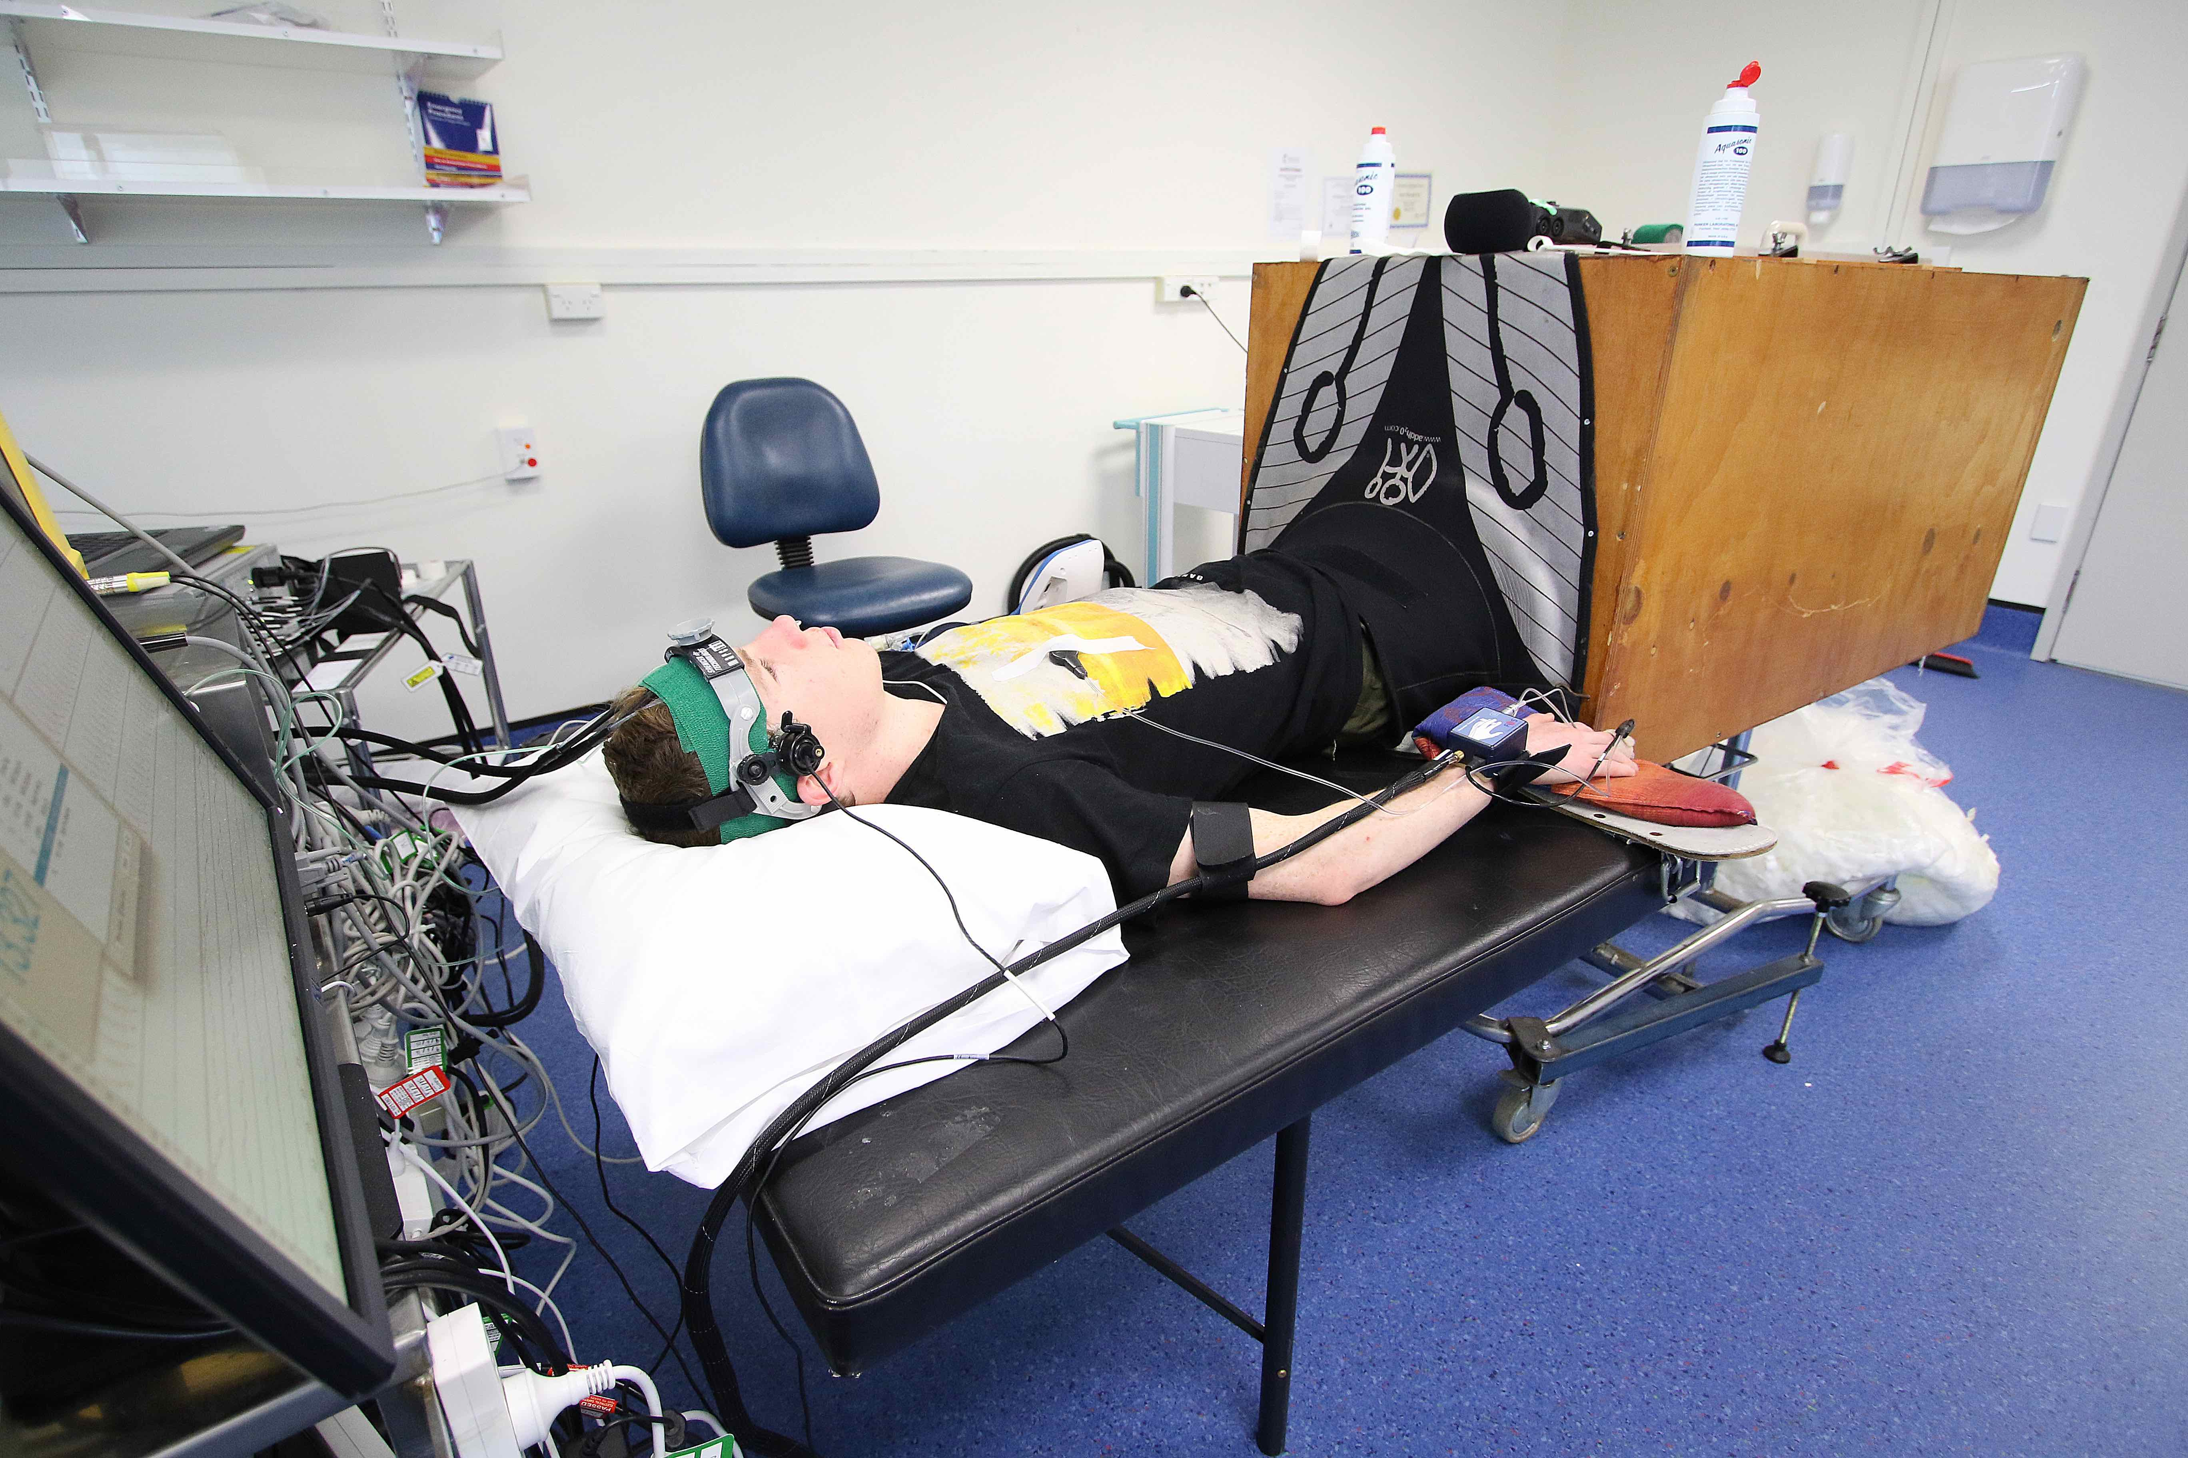

Figure 1. Photo of the transcranial Doppler ultrasound setup.

**Part 5: Cerebral autoregulation and CO2 reactivity test:**

We would like to assess the various changes that occur within the blood vessels of the brain with changes in the composition of air that you breathe in. Whilst lying in a semi-recumbent position, you will be asked to:

* Breathe air with added carbon dioxide from a facemask to moderately increase the blood level of carbon dioxide.
* Immediately after this, we will ask you to breathe deeply to lower the amount of carbon dioxide in your body.
* The changing levels of carbon dioxide are small enough that they should not cause you any harm.
* This test will only take around 3-5 minutes to complete.

**Part 6: Arm blood flow test:**

We would also like to assess the blood flow changes that occur within the blood vessels of the arm. Whilst lying in a relaxed position, we will inflate a standard blood pressure cuff around your arm for 5 minutes. At the end of this 5-minute period, the arm cuff will be released and we will measure the blood flow response using an ultrasound system. You may experience some mild discomfort during the inflation of the blood pressure cuff around the arm. This test will take around 10 minutes to complete.

**Part 7: Blood and urine samples:**

We would like to take a venous blood sample (from a vein in your arm; much like a blood test) in order to conduct some more in-depth blood analyses, such as the acidity level in your body. The purpose of this blood sample is to allow the researchers to assess the changes in acidity level during the hypoxic exposure. These will help identify the cause of AMS.

Some of the blood sample will be stored until the completion of this study**.** We will retain records linking your identity with your samples until the completion of this study by applicable law. Until those records are destroyed, you may also notify Dr Mickey Fan (contact details provided below) that you want to have your samples and material obtained from your samples destroyed at an earlier date.

You will be required to provide urine sample before and during the stay in the chamber. This is done to check the volume and the acidity of the urine only and will help us better understand the role of the kidneys in AMS. Cubicles will be provided for privacy.

1. **What are the possible benefits and risks to you of participating?**

There is no guarantee of benefit for participating in the following study, findings from this study will assist clinicians in the prevention and treatment of AMS. In addition, you will learn whether you are susceptible to developing AMS.

**Risks:**

As most measures in this study are non-invasive, the risks of personal harm are very low. However, you will likely develop symptoms of acute mountain sickness during the simulated altitude exposure (such as headache, lightheadedness, fatigue and breathlessness). These symptoms should subside quickly once you exit the simulation suite. Your wellbeing will be closely monitored during the throughout the experiment.

During the blood sampling, special techniques (i.e. gloves) will be used to reduce the risk of infection. All staff are highly skilled in these techniques, there is a small possibility of bruising and/or discomfort whenever blood is taken.

Our monitoring equipment should cause minimal discomfort. If you should experience discomfort at any stage of the procedure you are welcome to remove the sensor equipment and the study will be terminated.

If at any stage during testing you are uncomfortable and do not wish to continue, you will be able to stop without needing to provide a reason.

You will not be paid to participate in this research project nor will you be charged for participating. However, the research team will show their appreciation in the form of a grocery voucher.

1. **What would happen if you were injured in the study?**

If you were injured in this study, which is unlikely, you may be eligible for compensation from ACC just as you would be if you were injured in an accident at work or at home. You will have to lodge a claim with ACC, which may take some time to assess. If your claim is accepted, you will receive funding to assist in your recovery.

If you have private health or life insurance, you may wish to check with your insurer that taking part in this study won’t affect your cover

1. **What are the rights of participants in the study?**

Your participation in this study is voluntary. You are free to decline to participate, or to withdraw from the research study at any time, without experiencing any disadvantage. You have the right to access any personal information that we obtain on you from the study. You will be told of any new information about adverse or beneficial effects related to the study, which may impact upon your health. Any of your personal information will be de-identified to ensure confidentiality and privacy and will be stored in a locked cabinet in a secure office (Dr Fan’s office at University of Otago).

1. **What will happen after the study ends, or if you pull out?**

Within two weeks of completion of this study, you will be provided information, both verbally and written, concerning any changes to your health status. With the exception of the blood samples which will be stored until the completion of the study, all data will be stored in a locked cabinet in a secure office for a period of 10 years. Should analysis of data require that blood samples are sent overseas, this will only be possible during the study period. You have the right to decide how you wish any remaining blood samples taken from you to be destroyed at the end of the study (i.e., standard disposal or with appropriate Karakia).

1. **Where can you go for more information about the study, or to raise concerns or complaints?**

If you have any questions, concerns or complaints about the study at any stage, please contact:

***Dr Mickey Fan, Research Fellow, University of Otago***

***Telephone number:* (04) 918 5395**

***Email: mickey.fan@otago.ac.nz***

If you want to talk to someone who isn’t involved with the study, you can contact an independent health and disability advocate on:

Phone: 0800 555 050  
Fax: 0800 2 SUPPORT (0800 2787 7678)  
Email: [advocacy@hdc.org.nz](mailto:advocacy@hdc.org.nz)

For māori health support please contact:

***Dr Mark Brunton, Facilitator Research Māori, University of Otago***

***Telephone number: 03 364 1658***

***Email: mark.brunton@otago.ac.nz***

You can also contact the ethics committee that reviewed and approved this study on:

Phone: 0800 4 ETHICS

Email: hdecs@moh.govt.nz

Participant Consent Form:

|  |  |
| --- | --- |
| **Current Study Title** | The role of the kidneys in acute mountain sickness |
| **Principal Investigator** | Dr Mickey Fan |
| **Contact Number** | 04 806 1504 |
| **Ethics Reference** |  |

|  |  |  |  |  |  |  |  |  |
| --- | --- | --- | --- | --- | --- | --- | --- | --- |
| **Declaration by participant:**  I have read, or have had read to me in my first language, and I understand the Participant Information Sheet. I have had the opportunity to ask questions and I am satisfied with the answers I have received.  I understand that my participation in this study is confidential and that no material, which could identify me personally, will be used in any reports on this study.  I freely agree to participate in this study.  I have been given a copy of the Participant Information Sheet and Consent Form to keep.   |  |  | | --- | --- | | Participant’s name: | | | Signature: | Date: |   **Declaration by member of research team:**  I have given a verbal explanation of the research project to the participant, and have answered the participant’s questions about it.  I believe that the participant understands the study and has given informed consent to participate.   |  |  | | --- | --- | | Researcher’s name: | | | Signature: | Date: | |