**Questionnaires and Assessments for the Development of Risk Models for Cognitive Decline and Delirium in Aortic Stenosis and Transcatheter Aortic Valve Implantation Study (2017-2020).**

***Erica Tilley***

***PhD Candidate***

***CAIN lab***

***University of South Australia***

**Dr Hannah Keage**

***Principal Supervisor***

***Co-Director of the CAIN lab***

***University of South Australia***

**CONTENTS:**

Screening Questionnaire: 4

TAVI Group 4

CONTROL Group 4

Population Characteristics: 5

TAVI Group 5

Personal characteristics 5

Education/social/physical activity history 5

General medical history 5

Cardiovascular history 6

Surgical risk scores 6

Current medications 6

Frailty 7

CONTROL Group 8

Personal characteristics 8

Education/social/physical activity history 8

General medical history 8

Current medications 9

Heart murmur screening: 9

Frailty 10

Cognitive Battery: 11

Addenbrooke’s Cognitive Examination 11

CANTAB: 17

Motor Screening Test 17

Reaction Time 17

Pattern Recognition Memory 18

Frontostriatal Battery 19

Geriatric Depression Scale Short Form 19

The Hamilton rating scale for depression 20

Gait 21

Single-task gait velocity 21

Dual-task gait velocity 21

Visual Assessment 22

Visual acuity and diplopia. 22

Blink rate 23

Swallowing 24

Sydney Swallowing Questionnaire 24

Voice 25

Operavox 25

Behaviour/Mood Assessment: 26

Neuropsychiatric Inventory Questionnaire 26

Quality of life 28

Euroquol-5D 28

Functional Activity 31

Barthel index (Modified) 31

Saliva Sample 33

EEG 34

Delirium Assessment for participants in non-ICU wards or discharged home 35

observational Scale of level of arousal 35

Memorial Delirium Assessment Scale 36

Short Confusion Assessment Method 43

Rating Motor Subtypes of Delirium (Meagher, 2008)2 44

DELIRIUM assessment for particpants in icu 45

Hospital Acquired complications 48

Procedural Factors: 49

References: 50

# Screening Questionnaire:

## TAVI Group

***Instructions:*** *complete using medical records and/or in discussion with the prospective participant and their family.*

1. Are you aged over 60 years?
2. Do you have a current or recent (within the past year) alcohol or substance abuse or dependence?
3. Have you used recreational drugs (within the past month)?
4. Do you have a diagnosed learning disability?

Other:

1. Do they have sufficient English language to complete assessment tasks?
2. Do they have sufficient hearing (with aids) and vision (with glasses) to complete assessment tasks?
3. Do they have additional conditions not typically associated with ischemic heart disease likely to affect mobility, voice or swallowing to a significant degree including congenital conditions, structural abnormalities or cancer in pertinent regions of the body?

## CONTROL Group

***Instructions:*** *complete using medical records and/or in discussion with the prospective participant and their family.*

1. Are you aged over 60 years?
2. Do you have a current or recent (within the past year) alcohol or substance abuse or dependence?
3. Have you used recreational drugs (within the past month)?
4. Do you have a diagnosed learning disability?

Other:

1. Do they have sufficient English language to complete assessment tasks?
2. Do they have sufficient hearing (with aids) and vision (with glasses) to complete assessment tasks?
3. Do they have additional conditions likely to affect mobility, voice or swallowing to a significant degree including congenital conditions, structural abnormalities or cancer in pertinent regions of the body?
4. Do they have aortic stenosis?
5. Has the cardiologist identified a heart murmur?
6. Have they had a heart procedure during their adult life?

# Population Characteristics:

## TAVI Group

***Instructions:*** *complete using medical records and in discussion with the participant and their family. May require scales, measuring tape and calculator.*

### Personal characteristics

1. Age:
2. Gender:
3. Height (cm):
4. Weight (kg):
5. Waist (cm):
6. Calculate BMI:
7. Calculate waist-to-height ratio:

### Education/social/physical activity history

1. Number of years in education:
2. Main job/occupation (or prior to retirement):
3. How often do you see a member of your family or friend? (Daily, weekly, fortnightly monthly, less than monthly, never)
4. How often would you take part in physical activity such as sports, gardening or housework? (Daily, weekly, fortnightly monthly, less than monthly, never)

### General medical history

1. Renal disease (Y/N/Don’t know):
2. Creatine clearance:
3. Diabetes Mellitus (Y and type/N/Don’t know):
4. Previous stroke/TIA (Y/N/Don’t know):
5. COPD (Y/N/Don’t know):
6. Dyslipideamia (Y/N/Don’t know):
7. Thyroid dysfunction (Y/N/Don’t know):
8. Smoking status (smoker, previous smoker, never smoked):
9. High sensitivity C-Reactive protein:

### Cardiovascular history

1. Atrial fibrillation (Y/N/Don’t know):
2. Coronary artery disease (Y/N/Don’t know):
3. Myocardial infarction (Y/N/Don’t know):
4. Hypertension (Y/N/Don’t know):
5. Anaemia (Y/N/Don’t know):
6. Peripheral vascular disease (Y/N/Don’t know):
7. Cerebrovascular disease (Y/N/Don’t know):
8. Echocardiogram details (left ventricular ejection fraction %, aortic valve area cm2, aortic mean gradient mmHg)
9. Severity of symptoms (Canadian Cardiovascular Society Functional Classification of Angina Pectoris):

### Surgical risk scores

1. Logistic European System for Cardiac Operative Risk Evaluation:
2. New York Heart Association Functional Classification:
3. Society of Thoracic Surgeons predicted risk of mortality score:
4. American Society of Anaesthesiologists class:

### Current medications

### Frailty

### 

## CONTROL Group

***Instructions:*** *complete using medical records and in discussion with the participant and their family. May require scales, measuring tape and calculator.*

### Personal characteristics

1. Age:
2. Gender:
3. Height (cm):
4. Weight (kg):
5. Waist (cm):
6. Calculate BMI:
7. Calculate waist-to-height ratio:

### Education/social/physical activity history

1. Number of years in education:
2. Main job/occupation (or prior to retirement):
3. How often do you see a member of your family or friend? (Daily, weekly, fortnightly monthly, less than monthly, never)
4. How often would you take part in physical activity such as sports, gardening or housework? (Daily, weekly, fortnightly monthly, less than monthly, never)

### General medical history

1. Renal disease (Y/N/Don’t know):
2. Diabetes Mellitus (Y/N/Don’t know):
3. Previous stroke/TIA (Y/N/Don’t know):
4. COPD (Y/N/Don’t know):
5. Dyslipideamia (Y/N/Don’t know):
6. Thyroid dysfunction (Y/N/Don’t know):
7. Smoking status (smoker, previous smoker, never smoked):
8. Atrial fibrillation (Y/N/Don’t know):
9. Coronary artery disease (Y/N/Don’t know):
10. Myocardial infarction (Y/N/Don’t know):
11. Hypertension (Y/N/Don’t know):
12. Anaemia (Y/N/Don’t know):
13. Peripheral vascular disease (Y/N/Don’t know):
14. Cerebrovascular disease (Y/N/Don’t know):

### Current medications

### Heart murmur screening:

Examination by a medical officer with a stethoscope.

Screening questions:

Do you experience chest pain or chest tightness?

Do you experience shortness of breath?

Do you experience light-headedness?

Do you experience dizzy spells?

Do you have sudden swelling in your legs, feet, ankles or abdomen?

### Frailty

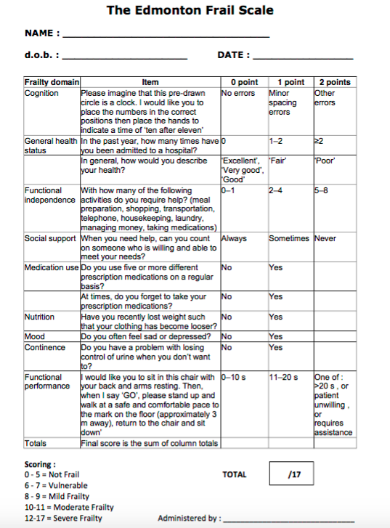

# Cognitive Battery:

## Addenbrooke’s Cognitive Examination

***Instructions:*** *complete the assessment in a quiet environment. Ensure the participant has access to both their hearing aids and glasses as required. A stopwatch will be required.*

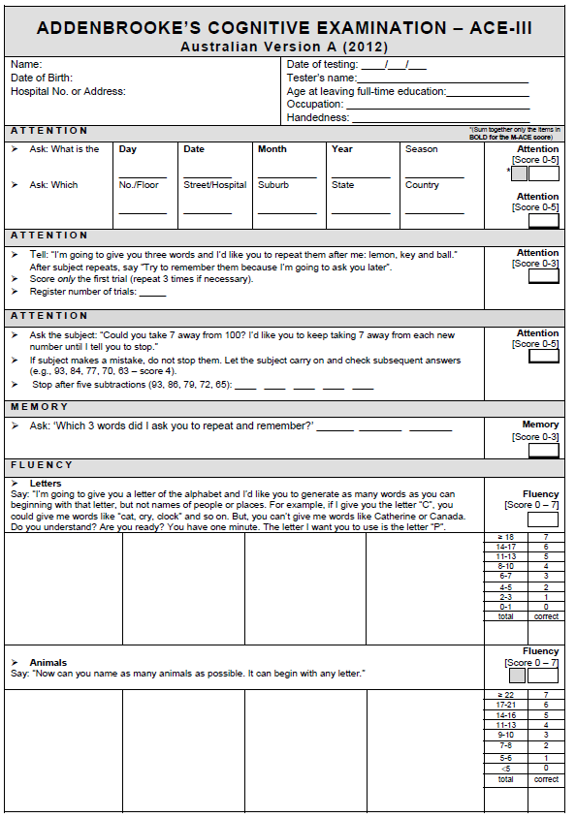

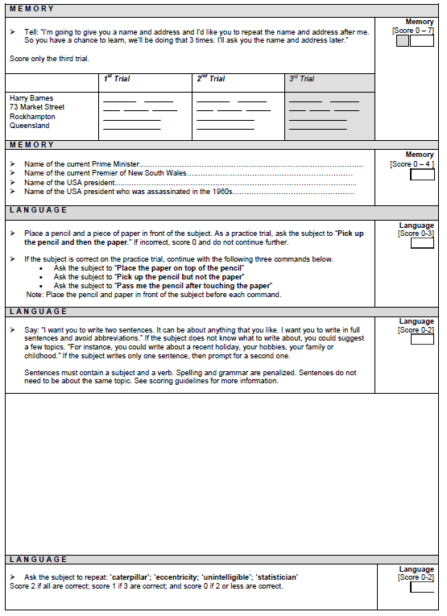

*The Memory Question will be changed from name the current the premier of NSW to name the current premier of South Australia.

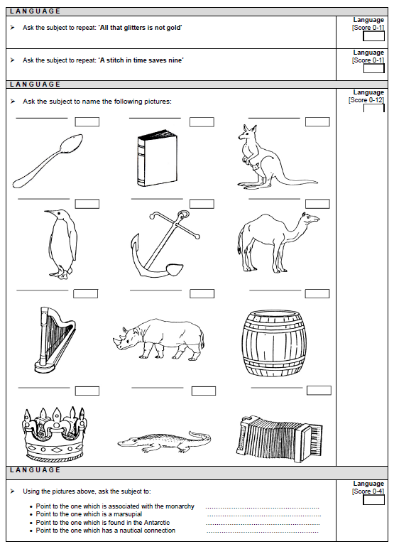

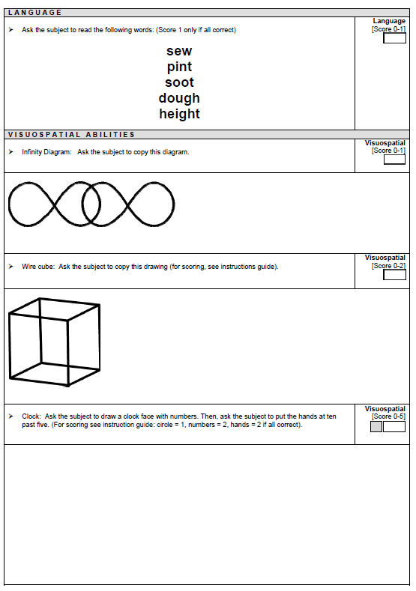

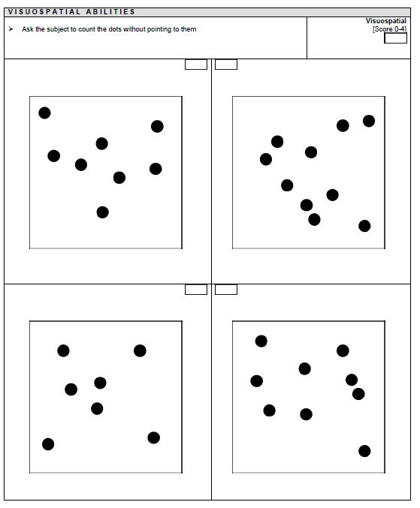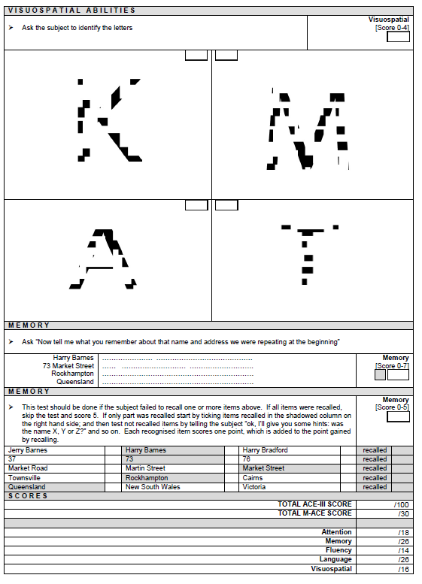

## CANTAB:

***Instructions:*** *Complete the CANTAB assessments using the iPad. The motor screening test is to be performed first. If the participant is unable to complete the motor screening task, discontinue further CANTAB assessments.*

### Motor Screening Test

Coloured crosses are presented in different locations on the screen. The participant must select the cross on the screen as quickly as possible. The assessment takes 2 minutes.

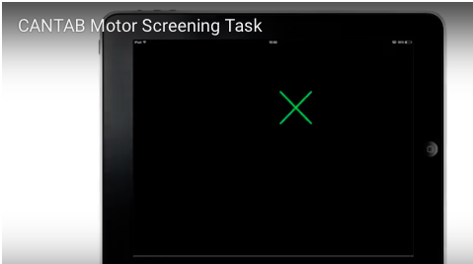

### Reaction Time

The participant must select and hold a button at the bottom of the screen. Circles are presented above. A yellow dot will appear in one of the circles and the participant must react as soon as possible, releasing the button, and selecting the circle in which the dot appeared. The assessment takes 3 minutes.

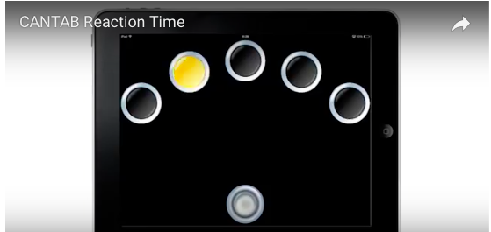

### Pattern Recognition Memory

The participant is presented with a series of visual patterns, one at a time. In the recognition phase, the participant is required to choose between a pattern they have already seen and a novel pattern. The assessment takes 4 minutes.

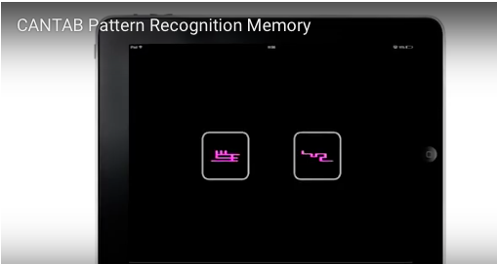

# Frontostriatal Battery

## Geriatric Depression Scale Short Form

***Instructions:*** *Ask the participant the following questions.*

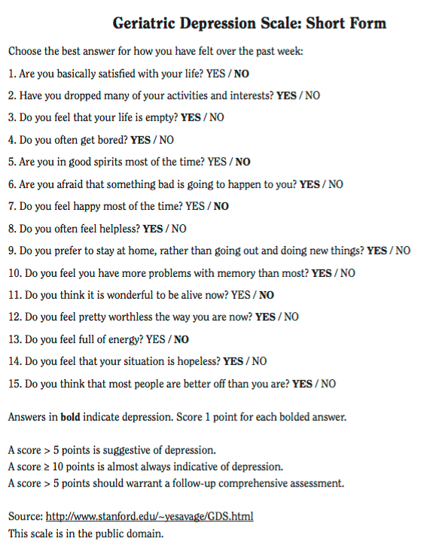

## The Hamilton rating scale for depression

***Instructions:*** *For each item, write the correct number on the line next to the item.*

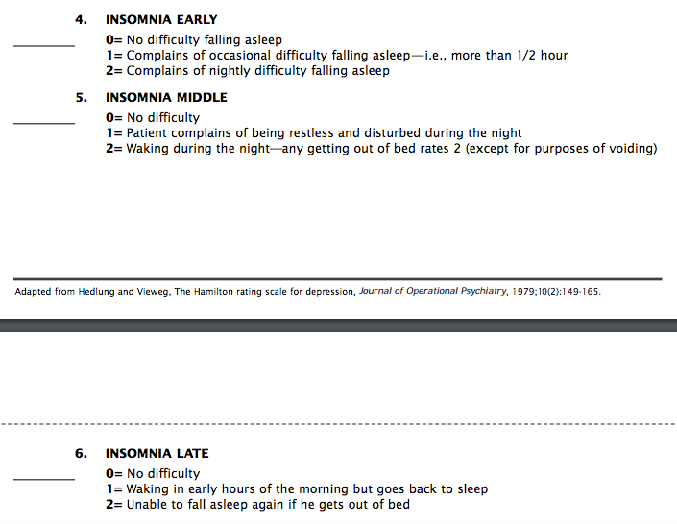

## Gait

***Instructions:***

* Measure 6 metres.
* Assistive devices can be used. List the assistive device if used______________________.
* The assessment is not conducted if the individual requires physical assistance to ambulate.

### Single-task gait velocity

***Verbal instructions for participants:***

“In this task you will be doing some walking. Starting here, walk at a comfortable pace for you.”

Time taken:

Calculate speed:

Number of steps:

Calculate step length:

### Dual-task gait velocity

***Verbal instructions for participants:***

“In this task you will be doing some walking again. Walk at a comfortable pace for you. This time, while you are walking, count backwards from 100. ”

Time taken:

Calculate speed:

Calculate dual-task gait cost (percent):

Single-task gait velocity – dual-task gait velocity/

single-task gait velocity x 100.

## Visual Assessment

### Visual acuity and diplopia.

***Instructions:***

Ask the diplopia screening questions and record the responses:

“Do you see blurry, ghosting or double vision?”

“If so, does it get better if you close one eye?”

Set up the Snellen Eye Chart 6 metres from the participant and ensure there is good lighting in the room. Ask the participant if they use glasses for long distances and ask them to put them on if so. To assess right eye visual acuity, ask the participant to cover the left eye and start from the top line and read as many letters as they can. Repeat the same process by covering the right eye and assess the best corrected visual acuity (BCVA) of the left eye. Each line is considered correct if the participant is able to have at least 4 out of 5 correct letters identified. Record the BCVA and set the fixation target to be 2 lines above the eye with the worse vision.

For the diplopia assessment, ask the participant to look straight ahead at the fixation target (name the letter/line). Ensuring the subject has a clear view of the target. Perform cover test by firstly covering the right eye and watch if the left eye move inwards or outwards. Repeat the same process by covering the left eye. If the eye moves, then there is a manifest strabismus (tropia) and the side that moves is recorded. If the eye moves from in to out, it is a eso-tropia If it moves from out to in, it is an exo-tropia. If it moves from up to down, then it is a hyper-tropia. If it moves from down to up, then it is a hypo-tropia. The cover test will be repeated 3 times to check for consistency.

Next, perform the alternating cover test by moving the occlude between the right and left eye and hold for 1 second in front of each eye. If the eye did not move with the cover test but moved with the alternate cover test, then the patient has a phoria (latent strabismus).

### Blink rate

***Instructions:***

Explain to the participant that this next activity will be video-recorded. Participants will be distracted by asking to “talk about your favourite hobbies or activities”. After 2 minutes has elapsed, participants may stop.

Review the video-recording and calculate rate of eye-blinking using an adaption of the methods described in Fitzpatrick et al. (2002).1 Select three separate 20 second time periods and count the number of blinks for each time period, before calculating the average number of blinks per 20 seconds.

|  |  |
| --- | --- |
|  | **Number of Blinks** |
| **Trial 1** |  |
| **Trial 2** |  |
| **Trial 3** |  |
| **Average** |  |

## Swallowing

### Sydney Swallowing Questionnaire

(Question 7 only)

***Instructions:*** for this question, put an “X” on the line below to indicate how severe your swallowing problem is. For example. Put the “X” towards the **lefthand end** of the line if your problem is only **minor**, in the **middle** if it is **moderate** and at the **righthand end** if you have **severe** difficulty. If you have NO problem or difficulty asked about in the question you should place “X” at the **FAR LEFTHAND** end of the line.

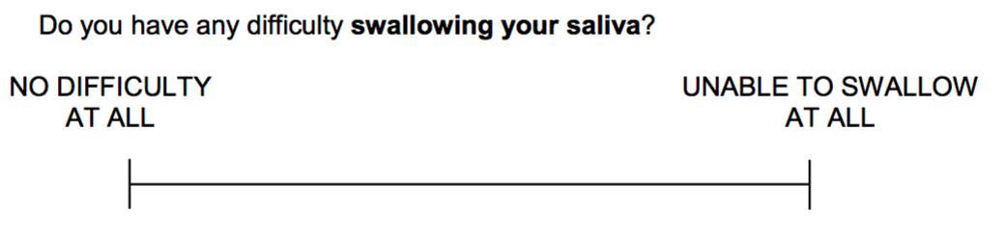

## Voice

### Voice Analyst

***Instructions:*** Perform the assessment in a closed room without background noise. Use the lanyard provided to standardise a 20cm mouth to Voice Analyst distance.

***Verbal instructions for the participant:*** This task will require you to use your voice. Start the test by taking a breath, not a deep one, just a normal breath. Then say ‘ahh’ (as in the words ‘art’ and ‘[art’). I will demonstrate for you first.

When you are ready, use a pitch that is comfortable for you.

***Instructions:*** Have the participant start and then begin recording 1 second afterwards, ensure at least 5 seconds has been recorded and preferably less than 6 seconds. Review the recording and repeat if background noise is identified, the participant stops halfway through or the recordings were not loud enough.

|  |  |  |  |  |
| --- | --- | --- | --- | --- |
|  | **Pitch minimum** | **Pitch maximum** | **Range** | **Average** |
| **Trial 1** |  |  |  |  |
| **Trial 2** |  |  |  |  |
| **Trial 3** |  |  |  |  |
| **Average** |  |  |  |  |



## Behaviour/Mood Assessment:

### Neuropsychiatric Inventory Questionnaire

***Instructions:*** *This questionnaire is to be completed by family members of the participant if they have signed the consent form to participate in the study.*

Name of family member/friend:

Age:

Relationship to primary participant:

### 

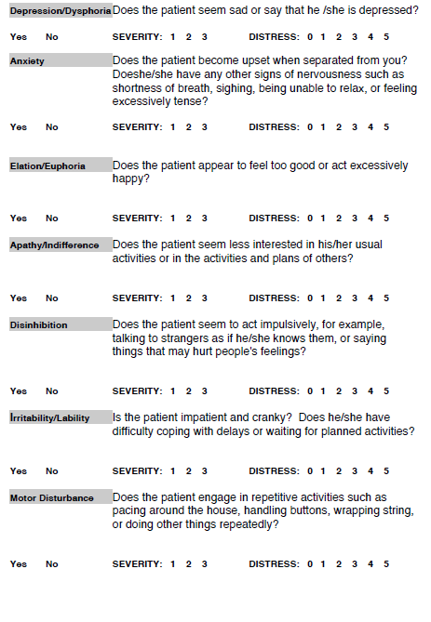

# Quality of life

## Euroquol-5D

***Instructions:*** *To be completed by the participant. Explain to participants that they need to complete these ratings based on how they are today.*

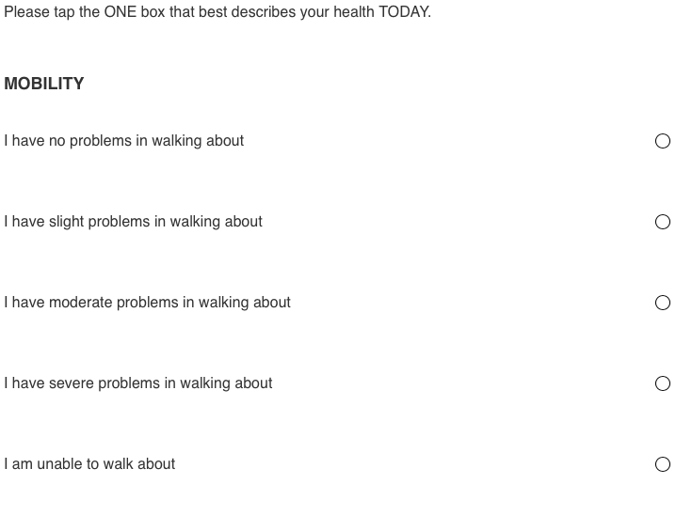

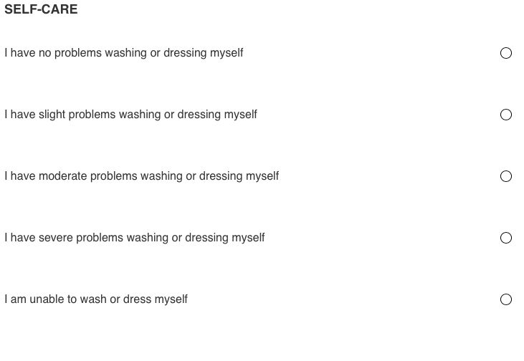

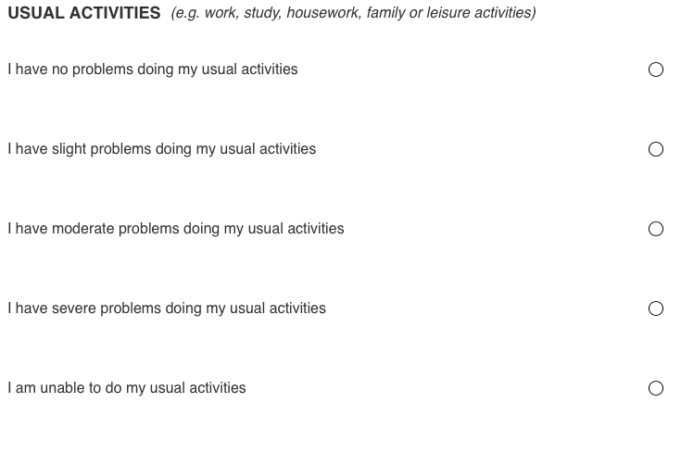 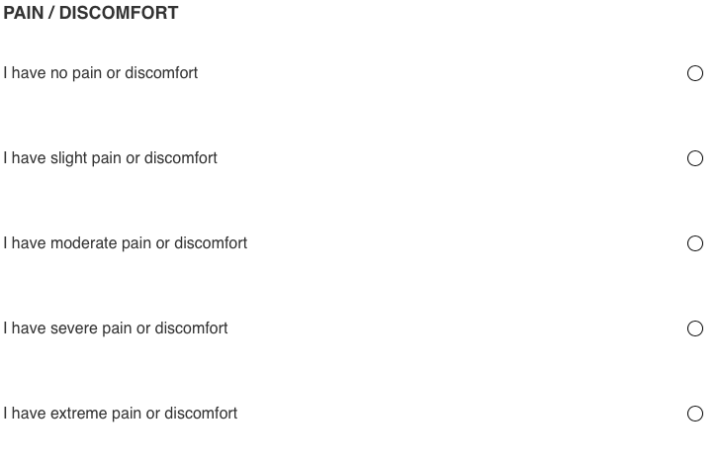 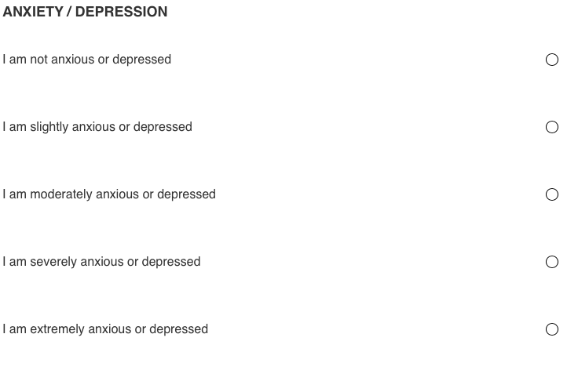 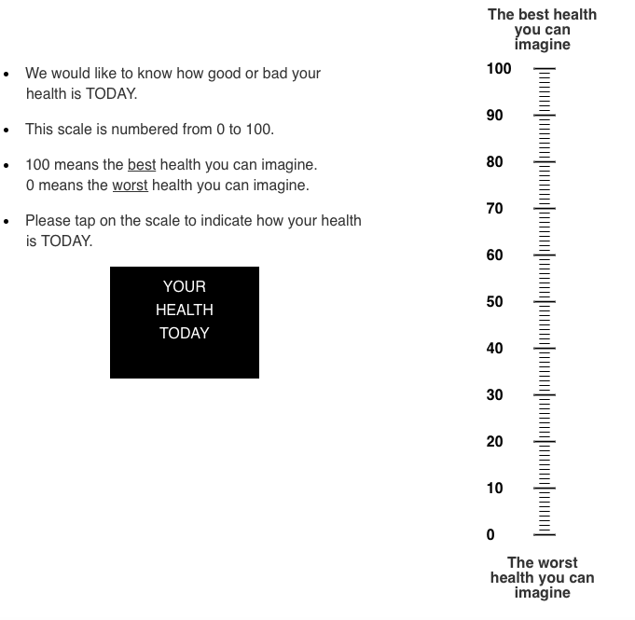

# Functional Activity

## Barthel index (Modified)

***Instructions:***

* The index should be used as a record of what the participant does, not as a record of what they could do.
* The main aim is to establish degree of independence from any help, physical or verbal, however minor and for whatever reason.
* The need for supervision renders the participant not independent.
* Usually the patient’s performance over the preceding 24-48 hours is important.
* Middle categories imply that the participant supplies over 50% of the effort.
* Use of aids to be independent is allowed.
* In discussion with the participant and their family, complete the following table (on the next page).

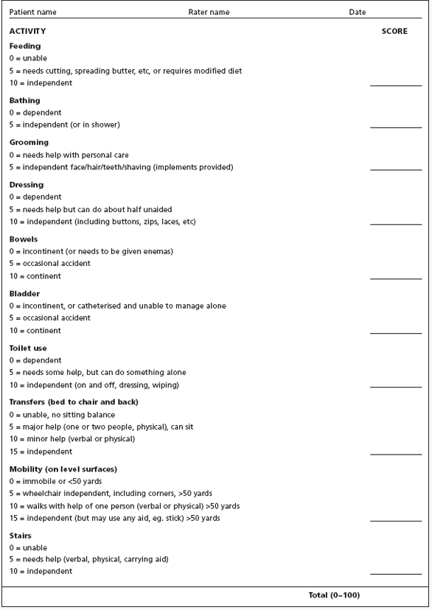

# Saliva Sample

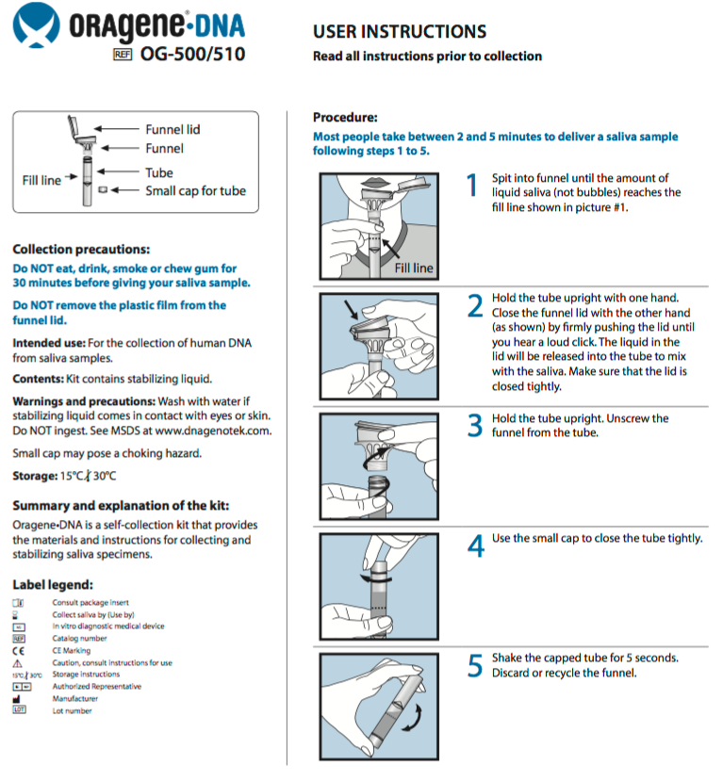

# EEG

We will record 2 minutes of eyes open and 2 minutes of eyes closed data with wet electrode electroencephalogram (EEG).

# Image may contain: 1 person, smiling

# Delirium Assessment for participants in non-ICU wards or discharged home

## observational Scale of level of arousal

## 

## Memorial Delirium Assessment Scale

***Instructions:***

Complete the following assessments with the participant (if they have adequate levels of arousal). Then review the medical file and speak with family and the healthcare team. Score items at the end of the assessment taking all information into account.

**Verbal instructions:**

Hello, my name is **X.** I have come to see how you are going. I will ask you some questions – there may or may not be a ‘right’ answer. Please don’t worry, it doesn’t matter what your exact answers are. But your answers will help us to know how you are.

**DISORIENTATION:**

**ASK:** (*there may be an orientation clock visible, try to hide this by using bedside curtains*)

|  |  |  |  |
| --- | --- | --- | --- |
|  | y/n |  | y/n |
| What date is it? |  | What season is it? |  |
| Which floor are we on? |  | Which hospital is this? |  |
| What day is it? |  | Which city are we in? |  |
| What month is it? |  | Which country are we in? |  |
| What year is it? |  | What time is it? |  |

(*There is no need to ask all 10 questions if 5 are answered incorrectly*)

**SCORING:**

* 0: none (patient knows 9-10 items)
* 1: mild (patient knows 7-8 items)
* 2: moderate (patient knows 5-6 items)
* 3: severe (patient knows no more than 4 items)

**SHORT-TERM MEMORY IMPAIRMENT:**

**SAY:** Listen, and repeat these three words: (***choose ONE set from randomisation page***)

Words: ____________ ____________ ____________

Immediate Recall: ____________ ____________ ____________

**SAY:** Remember those words (*repeat them again if necessary*) – I will ask you to repeat them later

Delayed Recall: ____________ ____________ ____________

**SCORING:**

* 0: none (all 3 words repeated and recalled)
* 1: mild (all 3 repeated, patient fails to recall 1)
* 2: moderate (all 3 repeated, patient fails to recall 2-3)
* 3: severe (patient fails to repeat 1 or more words)

**IMPAIRED DIGIT SPAN:**

**SAY:** Listen to the following numbers. I’d like you to repeat them in the order I say them: (*start with 3, then 4, then 5 digits. Move on only if answers correctly.* ***choose ONE set from randomisation page***)

3-forward: ­_ _ _ □ 4-forward: ­_ _ _ _ □ 5-forward: ­_ ­_ _ _ _ □

**SAY:** Now I’d like you to repeat them backwards, in reverse order to how I say them.

3-backward: ­_ _ _ □ 4-backward: ­_ _ _ _ □

**COMMENTS:**

**SCORING:**

* 0: none (patient can do at least 5 numbers forward and 4 backward)
* 1: mild (patient can do at least 5 numbers forward, 3 backward)
* 2: moderate (patient can do 4-5 numbers forward, cannot do 3 backward)
* 3: severe (patient can do no more than 3 numbers forward)

**REDUCED ABILITY TO MAINTAIN AND SHIFT ATTENTION:**

**SAY:** Please tell me the months of the year in backwards order, starting at December.

(*To assist initial understanding one prompt of “what is the month before December?” is permitted.*)

December □ November □ October □ September □ August □ July □ June □

**SAY:** Now I would like you to take away from 100. Now take 7 away from the number you got. Now keep subtracting 7 until I tell you to stop.

|  |  |  |  |  |  |
| --- | --- | --- | --- | --- | --- |
|  | 1st | 2nd | 3rd | 4th | 5th |
| Record the answers given verbatim |  |  |  |  |  |
| 93, 86, 79, 72, 65 = 5 correct  Or – 93, 80, 73, 66, 40 = 3 correct |  |  |  |  |  |

**SAY:** Earlier, I gave you three words to repeat. Please tell me any that you remember.

(*record answers in delayed recall above*)

**SCORING:**

* 0: none (patient maintains and shifts attention normally)
* 1: mild (the questions need to be rephrased and/or repeated because the patient’s attention wanders, patient loses track, patient is distracted by outside stimuli or over-absorbed in task once or twice without seriously prolonging the interview)
* 2: moderate (above attentional problems occur often, prolonging the interview without seriously disrupting it)
* 3: severe (above attentional problems occur constantly, disrupting and making the interview difficult-to-impossible)

**DISORGANIZED THINKING:**

**ASK:** (*choose one set of questions from left column and 2 from the right column,* ***STEM + A OR B***)

|  |  |  |  |
| --- | --- | --- | --- |
|  | **y/n** |  | **y/n** |
| Will a stone float on water? |  | **STEM QUESTION:** Hold up this many fingers (*hold up 2 fingers*) |  |
| Are there fish in the sea? |  |  |  |
| Does one kilo weigh more than two? |  | **FOLLOW-UP A:** Now do the same thing with the other hand (*do not demonstrate*) |  |
| Can you use a hammer to hit a nail? |  | **FOLLOW-UP B:** Add one more finger |  |

(*for serial assessments, the copying hands questions can be varied from day to day, e.g. starting with 3 fingers, adding 2, subtracting 1 as* ***alternative commands***)

|  |  |
| --- | --- |
|  | **Response:** |
| When you are sick you see a | 1. teacher 2. doctor 3. gardener |
| The bird built a  I went to the bakery to some | 1. tree 2. house 3. nest 4. buttons 5. bread 6. meat |
| The speeding driver was pulled over by the  In Japan they sometimes eat raw |  |
|  |  |
|  |  |

**SCORING:**

* 0: none (patient’s speech is coherent and goal-directed)
* 1: mild (patient’s speech is slightly difficult to follow; responses to questions are slightly off target but not so much as to prolong the interview).
* 2: moderate (disorganized thoughts or speech are clearly present, such that interview is prolonged but not disrupted)
* 3: severe (examination is very difficult or impossible due to disorganized thinking or speech)

**PERCEPTUAL DISTURBANCE:**

**ASK: Below questions:** (*these questions are designed to probe for hallucinations. Ask all of these unless it is completely apparent there are no problems*)

|  |  |
| --- | --- |
|  | **Record verbatim** |
| Have you been sleeping well? |  |
|  |  |
| Have you been bothered by any vivid dreams? |  |
|  |  |
| Have any dreams seemed to continue while you’ve been awake? |  |
| Sometimes in hospital the painkillers can affect the way you see things – have you seen anything unusual? What do you think it was? |  |
| Have you thought things looked too big or too small or they were moving when they weren’t? |  |
| Have you seen / heard anything you think shouldn’t be there? |  |
| Sometimes after the anaesthetic and the painkillers people have quite odd thoughts – have you noticed anything? |  |

**SCORING:**

* 0: none (no misperceptions, illusions or hallucinations)
* 1: mild (misperceptions or illusions related to sleep, fleeting hallucinations on 1-2 occasions without inappropriate behaviour)
* 2: moderate (hallucinations or frequent illusions on several occasions with minimal inappropriate behaviour that does not disrupt the interview)
* 3: severe (frequent or intense illusions or hallucinations with persistent inappropriate behaviour that disrupts the interview or interferes with medical care)

**DELUSIONS:**

**ASK: Below question:** (*this question is designed to probe for delusions).*

|  |  |
| --- | --- |
|  | **Record verbatim** |
| How are you getting on with the staff, friends or family? |  |

**SCORING:**

* 0: none (no evidence of misinterpretations or delusions)
* 1: mild (misinterpretations or suspiciousness without clear delusional ideas or inappropriate behaviour)
* 2: moderate (delusions admitted by the patient or evidenced by his/her behaviour that do not or only marginally disrupt the interview or interfere with medical care)
* 3: severe (persistent and/or intense delusions resulting in inappropriate behaviour, disrupting the interview or seriously interfering with medical care)

**QUESTIONS INVOLVING INPUT FROM HEALTHCARE TEAM AND FAMILY:**

**LEVEL OF CONSCIOUSNESS/AROUSAL:**

Has **X** been difficult to wake or unable to wake? Have they been drowsy? Has **X** been very sensitive to the environment around them? Or have they startled easily?

________________________________________________________________________

________________________________________________________________________

________________________________________________________________________

________________________________________________________________________

**Medical file trigger words (circle if present or add if similar):** lethargy*, non-responsiveness, unrespons*, difficult to arouse, unarousable, drowsy, sleepy, sedat*, altered level of consciousness, diminished level of responsiveness, difficulty with arousal, new onset coma/stupor/lethargy, obtunded, hyperalert, overly sensitive, startles easily.

**SCORING FOR LEVEL OF CONSCIOUSNESS/AROUSAL:** Rate the patient’s current awareness of and interaction with the environment (interviewer, other people/objects in the room; for example ask patients to describe their surroundings).

* 0: none (patient spontaneously fully aware of environment and interacts appropriately)
* 1: mild (patient is unaware of some elements in the environment, or not spontaneously interacting appropriately with the interviewer, becomes fully aware and appropriately interactive when prodded strongly; interview is prolonged but not seriously disrupted).
* 2: moderate (patient is unaware of some or all elements in the environment, or not spontaneously interacting with the interviewer, becomes incompletely aware and inappropriately interactive when prodded strongly, interview is prolonged but not seriously disrupted).
* 3: severe (patient is unaware of all elements in the environment with no spontaneous interaction or awareness of the interviewer, so that the interview is difficult-to-impossible, even with maximal prodding).

**DISORGANISED THINKING:**

Has **X** been focussed during tasks? Do they ramble? Or do they change topics quickly? Has **X** kept coming back to the same topic? Have they been repetitive in conversation?

________________________________________________________________________

________________________________________________________________________

________________________________________________________________________

________________________________________________________________________

**Medical file trigger words (circle if present or add if similar):** tangential, rambling, repetitive.

**PERCEPTUAL DISTURBANCE:**

Has **X** reported seeing things that are not there? Or had any hallucinations?

________________________________________________________________________

________________________________________________________________________

________________________________________________________________________

________________________________________________________________________

**Medical file trigger words (circle if present or add if similar):** hallucinating, hallucinations.

**DELUSIONS:**

Has **X** reported any suspicions to you? These may be about you, other staff or family?

________________________________________________________________________

________________________________________________________________________

________________________________________________________________________

________________________________________________________________________

**Medical file trigger words (circle if present or add if similar):** suspicious, suspicions.

**DECREASED OR INCREASED PSYCHOMOTOR ACTIVITY:**

How is **X** moving around? Have they been moving slowly? Have they been fidgety? Have they been picking at things? Pulling out lines? Combative? Or interfering with assessments or ward care?

________________________________________________________________________

________________________________________________________________________

________________________________________________________________________

________________________________________________________________________

**Medical file trigger words (circle if present or add if similar):** pulling out lines, combative, slow to mobilise, impuls*, agitat*, resist*, refus*, climbing over rails, redirected, restless, uncooperative, out of bed.

**SCORING:**

* 0: none (normal psychomotor activity)
* a b c 1: mild (hypoactivity is barely noticeable, expressed as slightly slowing of movement, hyperactivity is barely noticeable or appears as simple restlessness).
* A b c 2: moderate (hypoactivity is undeniable, with marked reduction in the number of movements or marked slowness of movement; subject rarely spontaneously moves or speaks. Hyperactivity is undeniable, subject moves almost constantly; in both cases, exam is prolonged as a consequence).
* 3: severe (hypoactivity is severe; patient does not move or speak without prodding or is catatonic. Hyperactivity is severe; patient is constantly moving, overreacts to stimuli, requires surveillance and/or restraint; getting through the exam is difficult or impossible).

**SLEEP/WAKE CYCLE DISTURBANCE (question adapted from CAM Long-form):**

Has **X** had any difficulty with their sleep during the past 24 hours such as excessive daytime sleepiness, or difficulty sleeping at night?

________________________________________________________________________

________________________________________________________________________

________________________________________________________________________

________________________________________________________________________

**Medical file trigger words (circle if present or add if similar):** lethargy*, non-responsiveness, unrespons*, difficult to arouse, unarousable, drowsy, sleepy, sedat*, altered level of consciousness, diminished level of responsiveness, difficulty with arousal, difficulty sleeping, awake at night, insomnia.

**SCORING:**

* 0: none (at night, sleeps well; during the day, has no trouble staying awake)
* 1: mild (mild deviation from appropriate sleepfulness and wakefulness states; at night, diffuclty falling asleep or transient night awakenings, needs medication to sleep well; during the day, reports periods of drowsiness or, during the interview, is drowsy but can easily fully awaken him/herself).
* 2: moderate (moderate deviations from appropriate sleepfulness and wakefulness states: at night, repeated and prolonged night awakening; during the day, reports of frequent and prolonged napping or, during the interview, can only be roused to complete wakefulness by strong stimuli)
* 3: severe (severe deviations from appropriate sleepfulness and wakefulness states: at night, sleeplessness; during the day, patient spends most of the time sleeping or, during the interview, cannot be roused to full wakefulness by any stimuli)

## Short Confusion Assessment Method

***Instructions:*** *Using observations from the previous assessments (Observational Scale of Level of Arousal, the Memorial Delirium Assessment Scale, a review of the medical file and discussion with family and the healthcare team) score the Short CAM.*

|  |  |  |  |  |
| --- | --- | --- | --- | --- |
| I | ACUTE ONSET AND FLUCTUATING COURSE | |  | BOX 1 |
|  | 1. Is there evidence of an acute change in mental status from the patient’s baseline? | | No ____ | Yes _______ |
|  | 1. Did the (abnormal) behaviour fluctuate during the day, that is tend to come and go or increase and decrease in severity? | | No ____ | Yes _______ |
| II | INATTENTION | |  |  |
|  | Did the patient have difficulty focussing attention, for example, being easily distractible or having difficulty keeping track of what was being said? | | No ____ | Yes _______ |
|  |  | |  |  |
| III | DISORGANISED THINKING | |  | BOX 2 |
|  | Was the patient‘s thinking disorganized or incoherent, such as rambling or irrelevant conversation, unclear or illogical flow of ideas, or unpredictable switching from subject to subject? | | No ____ | Yes _______ |
| IV | ALTERED LEVEL OF CONCIOUSNESS | |  |  |
|  | Overall, how would you rate the patient’s level of consciousness? | |  |  |
|  | --- Alert | (normal) |  |  |
|  | --- Vigilant | (hyper alert) |  |  |
|  | --- Lethargic | (drowsy, easily aroused) |  |  |
|  | --- Stupor | (difficult to arouse) |  |  |
|  | --- Coma | (unarousable) |  |  |
|  |  |  |  |  |
|  | Do any checks appear in box above?? | | No ____ | Yes _______ |

**If Inattention and at least one other item in Box 1 are checked and at least one item in Box 2 is checked a diagnosis of delirium is suggested.**

**Delirium presence: YES NO**

### Rating Motor Subtypes of Delirium (Meagher, 2008)2

***Instructions:*** *Using observations from the previous assessments (Observational Scale of Level of Arousal, the Memorial Delirium Assessment Scale, a review of the medical file and discussion with family and the healthcare team, or the CAM-ICU) rate the motor subtype of delirium.*

**HYPERACTIVE SUBTYPE** if definite evidence in the previous 24 hours of (and this should be a deviation from pre-delirious baseline) of at least two of:

|  |  |
| --- | --- |
| □ | Increased quantity of motor activity: Is there evidence of excessive level of activity, e.g. pacing, fidgeting, general overactivity? |
| □ | Loss of control of activity: Is the patient unable to maintain levels of activity that are appropriate for the circumstances, e.g. remain still when required? |
| □ | Restlessness: Does the patient complain of mental restlessness or appear agitated? |
| □ | Wandering: Is the patient moving around without clear direction or purpose? |

**HYPOACTIVE SUBTYPE** if definite evidence in the previous 24 hours of (and this should be a deviation from pre-delirious baseline) two or more of* (:*Where at least one of either decreased amount of activity or speed of actions is present)

|  |  |
| --- | --- |
| □ | Decreased amount of activity: Does the patient engage in less activity than is usual or appropriate for the circumstances, e.g. sits still with few spontaneous movements? |
| □ | Decreased speed of actions: Is the patient slow in initiation and performance of movements e.g. walking? |
| □ | Reduced awareness of surroundings: Does the patient show a relative absence of emotional reactivity to the environment, i.e. show a passive attitude to his/her surroundings? |
| □ | Decreased amount of speech: Does the patient have a reduced quantity of speech in relation to the environment, e.g. answers are unforthcoming or restricted to a minimum? |
| □ | Decreased speed of speech: Does the patient speak more slowly than usual, e.g. long pauses and slowing of actual verbal output? |
| □ | Listlessness: Is the patient less reactive to his/her environment, e.g. are responses to activity in surroundings slow or reduced in amount? |
| □ | Reduced alertness/withdrawal: Does the patient appear detached or lacking in awareness of his/her surroundings or their significance? |

**MIXED MOTOR SUBTYPE** if evidence of both hyperactive and hypoactive subtype in the previous 24 hours.

**NO MOTOR SUBTYPE** if evidence of neither hyperactive or hypoactive subtype in the previous 24 hours.

# DELIRIUM assessment for particpants in icu

confusion assessment method- ICU

***Instructions:*** *For participants in the ICU, complete the RASS, the CAM-ICU Worksheet and rate the delirium subtype using the rating system on the previous page.*

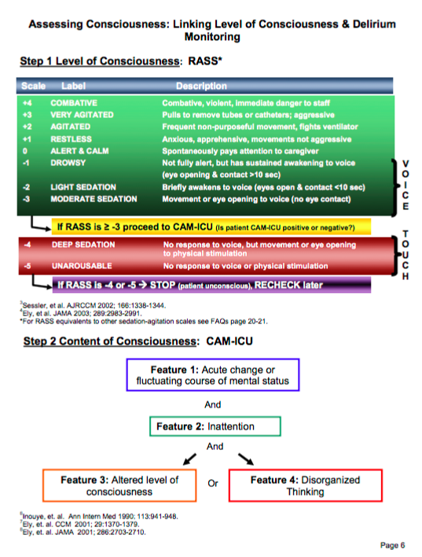

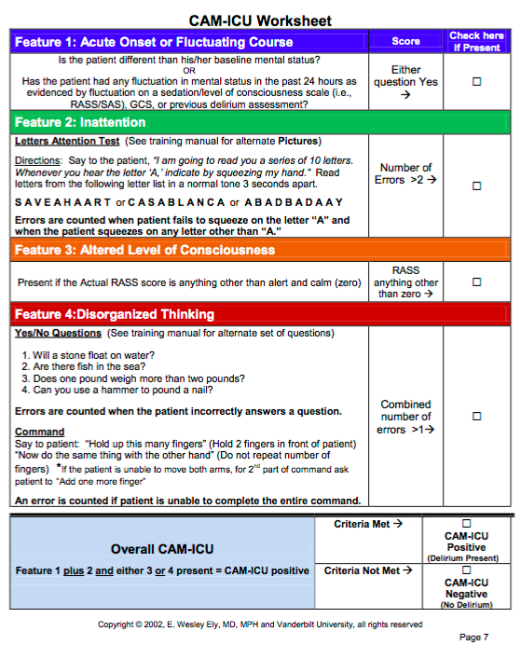

**Motor Subtype of delirium:**

# Hospital Acquired complications

***Instructions:*** *Review the medical records for 30 days post-TAVI. Record any hospital acquired complications.*

|  |  |
| --- | --- |
| omplication | Diagnosis |
| **Pressure injury** | * Stage III ulcer * Stage IV ulcer * Unspecified decubitus ulcer and pressure area |
| **Falls resulting in fracture or intracranial injury** | * Intracranial injury * Fractured neck of femur * Other fractures |
| **Healthcare associated infection** | * Urinary tract infection * Surgical site infection * Pneumonia * Blood stream infection * Central line and peripheral line associated bloodstream infection * Multi-resistant organism * Infection associated with prosthetics/implantable devices * Gastrointestinal infections |
| **Surgical complications requiring unplanned return to theatre** | * Post-operative haemorrhage/haematoma requiring transfusion and/or return to theatre * Surgical wound dehiscence * Anastomotic leak * Vascular graft failure * Other surgical complications requiring unplanned return to theatre |
| **Unplanned intensive care unit admission** | * Unplanned admission to intensive care unit |
| **Respiratory complications** | * Respiratory failure including acute respiratory distress syndrome requiring ventilation * Aspiration pneumonia |
| **Venous thromboembolism** | * Pulmonary embolism * Deep vein thrombosis |
| **Renal failure** | * Renal failure requiring haemodialysis or continuous veno-venous haemodialysis |
| **Gastrointestinal bleeding** | * Gastrointestinal bleeding |
| **Medication complications** | * Drug related respiratory complications/depression * Haemorrhagic disorder due to circulating anticoagulants * Hypoglycaemia |
| **Delirium** | * Delirium |
| **Persistent incontinence** | * Urinary incontinence |
| **Malnutrition** | * Malnutrition |
| **Cardiac complications** | * Heart failure and pulmonary oedema * Arrhythmias * Cardiac arrest * Acute coronary syndrome including unstable angina, STEMI and NSTEMI |

**List hospital acquired complications:**

**________________________________________________________________________________________________________________________________________________________________________________________________________________________________________________________________________________________________**

# Procedural Factors:

**Procedural details:**

**_____________________________________________________________________________________________________________________________________________________________________________________________________________________________________________________________________________________________**

**Complications details:**

**________________________________________________________________________________________________________________________________________________________________________________________________________________________________________________________________________________________________**

# References:

1. Fitzpatrick E, Hohl N, Silburn P, O'Gorman C, Broadley SA. Case-control study of blink rate in Parkinson's disease under different conditions. Journal of neurology. 2012;259(4):739-44.

2. Meagher D, Moran M, Raju B, Leonard M, Donnelly S, Saunders J, et al. A new data-based motor subtype schema for delirium. The Journal of neuropsychiatry and clinical neurosciences. 2008;20(2):185-93.