***Effectiveness of conservative multimodal physiotherapy in chronic whiplash-associated disorders in individuals with or without posttraumatic stress symptoms:***

***A pilot series of Single Case Experimental Designs (SCEDs)***

# FOLLOW-UP QUESTIONNAIRES (FORM FUM3)

We would like to find out how things are going for you. Please answer all questions.

SECTION 1 – GENERAL QUESTIONS

**1.1 Do you have any ongoing symptoms from your whiplash injury? 1** ❑ Yes **2** ❑ No **3** ❑ Unsure

*If* ***NO*** *- Please go to Question 2.*

*If* ***YES*** *- Please mark on the body chart below where you feel pain or any other symptoms e.g. pins and needles or numbness, and indicate what you feel in that spot.*



*If* ***YES*** *- On the scale below please estimate the average intensity of your NECK pain over the past 24 hours.*

|  |  |  |  |  |  |  |  |  |  |  |  |  |
| --- | --- | --- | --- | --- | --- | --- | --- | --- | --- | --- | --- | --- |
| 0 | 1 | 2 | 3 | 4 | 5 | 6 | 7 | 8 | 9 | | 10 | |
| No  Pain | | | | | | | | | |  | | Worst  possible pain |

* 1. With respect to your whiplash injury, compared to **when you entered the study**, how would you describe yourself these days? (circle the most appropriate)

-5 -4 -3 -2 -1 0 1 2 3 4 5

vastly unchanged completely

worse recovered

* 1. **How confident are you in your ability to perform your daily tasks in the presence of your neck pain or disability?**

1. ❑ not at all confident

2. ❑ a little confident

3 ❑ moderately confident

4. ❑ very confident

5 ❑ extremely confident

* 1. **If employed/self-employed/home duties, are you:**

1. ❑ Currently working usual hours (100%)
2. ❑ Working reduced hours due to whiplash injury
3. ❑ Not working due to whiplash injury (0%)
   1. **IF REDUCED,** indicate percentage of usual hours______%

**1.6 Have you lodged a compensation claim for this injury? 1** ❑ Yes **2** ❑ No **3** ❑ In process

**1.7 If you lodged a claim for this injury (i.e. answered ‘yes’ to the previous question), please select what type of compensation claim:**

1 ❑ Compulsory Third Party

2 ❑ Workers Compensation

3 ❑ Other (please specify _____________________________)

**1.8 Has your compensation claim been settled? 1** ❑ Yes **2** ❑ No **3** ❑ In process

**1.9 Have you engaged the services of a solicitor? 1** ❑ Yes **2** ❑ No **3** ❑ Thinking about it

**1.10 What other treatments have you received for your neck pain since you finished the study?**

|  |  |
| --- | --- |
| Types of Treatment | Number of Sessions |
| 1❑ Physiotherapy | **1.9.1** |
| 2❑ Chiropractic | **1.9.2** |
| 3❑ Massage | **1.9.3** |
| 4❑ Acupuncture | **1.9.4** |
| 5❑ Surgical Procedures | **1.9.5** |
| 6❑ Other: | **1.9.6** |
| 7❑ Other: | **1.9.7** |

**1.11 Please list all medications you are taking for your whiplash symptoms, if any:**

|  |  |  |
| --- | --- | --- |
| **Name** | **Frequency** | **Dose** |
| **1.11.1** | **1.12.1** | **1.13.1** |
| **1.11.2** | **1.12.2** | **1.13.2** |
| **1.11.3** | **1.12.3** | **1.13.3** |
| **1.11.4** | **1.12.4** | **1.13.4** |

**Please list any other medications you have taken (for any reason) since the end of the study**

|  |  |  |
| --- | --- | --- |
| **Name** | **Frequency** | **Dose** |
| **1.14.1** | **1.15.1** | **1.16.1** |
| **1.14.2** | **1.15.2** | **1.16.2** |
| **1.14.3** | **1.15.3** | **1.16.3** |
| **1.14.4** | **1.15.4** | **1.16.4** |
| **1.14.5** | **1.15.5** | **1.16.5** |
| **1.14.6** | **1.15.6** | **1.16.6** |

**Please list any medical problems (possible side effects) that limited your daily activities of living over the last 6 months:**

|  |  |  |
| --- | --- | --- |
| **1.17 Side Effect** | **1.18 Severity** | **1.19 Frequency** |
| **1.17.1** | **1.18.1** 1❑ Mild 2❑ Moderate 3❑ Severe  4 ❑ Other: _________________ | **1.19.1** |
| **1.17.2** | **1.18.2** 1❑ Mild 2❑ Moderate 3❑ Severe  4 ❑ Other: _________________ | **1.19.2** |
| **1.17.3** | **1.18.3** 1❑ Mild 2❑ Moderate 3❑ Severe  4 ❑ Other: ________________ | **1.19.3** |
| **1.17.4** | **1.18.4** 1❑ Mild 2❑ Moderate 3❑ Severe  4 ❑ Other: ________________ | **1.19.4** |

**1.21 Have you had any other accidents/injuries since your last follow-up questionnaire?**

**1** ❑ Yes **2** ❑ No

**If yes, please specify: ………………………………………………..………………………………….**

# SECTION 2 – NECK DISABILITY INDEX

**INSTRUCTIONS:** This questionnaire is designed to enable us to understand how much your neck pain has affected your ability to manage everyday activities. Please answer each question by ticking (**✓)** **ONE CHOICE** that most applies to you. We realise that you may feel that more than one statement may relate to you, but **please just tick** (**✓) the one choice, which closely describes your problem right now.**

**Section 1 – Pain Intensity**

* I have no pain at the moment
* The pain is mild at the moment
* The pain comes and goes and is moderate
* The pain is moderate and does not vary much
* The pain is severe but comes and goes
* The pain is severe and does not vary much

**Section 2 – personal care (washing, dressing etc)**

* I can look after myself without causing extra pain
* I can look after myself normally but it causes extra pain
* It is painful to look after myself and I am slow and careful
* I need some help but manage most of my personal care
* I need help every day in most aspects of self care
* I do not get dressed; I wash with difficulty and stay in bed

**Section 3 – Lifting**

* I can lift heavy weights without extra pain
* I can lift heavy weights, but it causes extra pain
* Pain prevents me from lifting heavy weights off the floor but I can if they are conveniently positioned, for example on a table
* Pain prevents me from lifting heavy weights, but I can manage light to medium weights if they are conveniently positioned
* I can lift very light weights
* I cannot lift or carry anything at all.

**Section 4 – Reading**

* I can read as much as I want to with no pain in my neck
* I can read as much as I want to with slight pain in my neck
* I can read as much as I want with moderate pain in my neck
* I can’t read as much as I want because of moderate pain in my neck
* I can hardly read at all because of severe pain in my neck
* I cannot read at all

**Section 5 – Headaches**

* I have no headaches at all
* I have slight headaches which come infrequently
* I have moderate headaches which come infrequently
* I have moderate headaches which come frequently
* I have severe headaches which come frequently
* I have headaches almost all the time

**Section 6 – Concentration**

* I can concentrate fully when I want to with no difficulty
* I can concentrate fully when I want to with slight difficulty
* I have a fair degree of difficulty in concentrating when I want to
* I have a lot of difficulty in concentrating when I want to
* I have a great deal of difficulty in concentrating when I want to
* I cannot concentrate at all

**Section 7 – Work**

* I can do as much work as I want to
* I can only do my usual work, but no more
* I can do most of my usual work, but no more
* I cannot do my usual work
* I can hardly do any work at all
* I can’t do any work at all

**Section 8 – Driving**

* I can drive my car without any neck pain
* I can drive my car as long as I want with slight pain in my neck
* I can drive my car as long as I want with moderate pain in my neck
* I can’t drive my car as long as I want because of moderate pain in my neck
* I can hardly drive at all because of severe pain in my neck
* I can’t drive my car at all

**Section 9 – Sleeping**

* I have no trouble sleeping
* My sleep is slightly disturbed (less than 1 hr sleepless)
* My sleep is mildly disturbed (1-2 hrs sleepless)
* My sleep is moderately disturbed (2-3 hrs sleepless)
* My sleep is greatly disturbed (3-5 hrs sleepless)
* My sleep is completely disturbed (5-7 hrs sleepless)

**Section 10 – Recreation**

* I am able to engage in all my recreation activities with no neck pain at all
* I am able to engage in all my recreation activities, with some pain in my neck
* I am able to engage in most, but not all of my usual recreation activities because of pain in my neck
* I am able to engage in a few of my usual recreation activities because of pain in my neck
* I can hardly do any recreation activities because of pain in my neck
* I can’t do any recreation activities at all

|  |  |  |
| --- | --- | --- |
| **SECTION 3 – DASS-21** | | |
| Please read each statement and circle a number 0, 1, 2 or 3 which indicates how much the statement applied to you *over the past week*. There are no right or wrong answers. Do not spend too much time on any statement. The rating scale is as follows:  0 Did not apply to me at all  1 Applied to me to some degree, or some of the time  2 Applied to me to a considerable degree, or a good part of time   1. Applied to me very much, or most of the time. | | |
| 1 | I found it hard to wind down | 0 1 2 3 |
| 2 | I was aware of dryness of my mouth | 0 1 2 3 |
| 3 | I couldn't seem to experience any positive feeling at all | 0 1 2 3 |
| 4 | I experienced breathing difficulty (e.g., excessively rapid breathing, breathlessness in the absence of physical exertion) | 0 1 2 3 |
| 5 | I found it difficult to work up the initiative to do things | 0 1 2 3 |
| 6 | I tended to over-react to situations | 0 1 2 3 |
| 7 | I had a feeling of trembling (e.g., in the hands) | 0 1 2 3 |
| 8 | I felt that I was using a lot of nervous energy | 0 1 2 3 |
| 9 | I was worried about situations in which I might panic and make a fool of myself | 0 1 2 3 |
| 10 | I felt that I had nothing to look forward to | 0 1 2 3 |
| 11 | I found myself getting agitated | 0 1 2 3 |
| 12 | I found it difficult to relax | 0 1 2 3 |
| 13 | I felt down-hearted and blue | 0 1 2 3 |
| 14 | I was intolerant of anything that kept me from getting on with what I was doing | 0 1 2 3 |
| 15 | I felt I was close to panic | 0 1 2 3 |
| 16 | I was unable to become enthusiastic about anything | 0 1 2 3 |
| 17 | I felt I wasn't worth much as a person | 0 1 2 3 |
| 18 | I felt that I was rather touchy | 0 1 2 3 |
| 19 | I was aware of the action of my heart in the absence of physical exertion (e.g., sense of heart rate increase, heart missing a beat | 0 1 2 3 |
| 20 | I felt scared without any good reason | 0 1 2 3 |
| 21 | I felt that life was meaningless | 0 1 2 3 |
| 3.1 Total Score: | |  |

# SECTION 4 - PCS

Everyone experiences painful situations at some point in their lives. Such experiences may include headaches, tooth pain, joint or muscle pain. People are often exposed to situations that may cause pain such as illness, injury, dental procedures or surgery.

Instructions:

We are interested in the types of thoughts and feelings that you have when you are in pain. Listed below are thirteen statements describing different thoughts and feelings that may be associated with pain. Using the following scale, please indicate the degree to which you have these thoughts and feelings when you are experiencing pain.

|  |  |  |  |  |  |
| --- | --- | --- | --- | --- | --- |
| **RATING** | **0** | **1** | **2** | **3** | **4** |
| **MEANING** | Not at all | To a slight degree | To a moderate degree | To a great degree | All the time |

**When I’m in pain …**

|  |  |  |
| --- | --- | --- |
| **Number** | **Statement** | **Rating** |
| 1 | I worry all the time about whether the pain will end. |  |
| 2 | I feel I can’t go on. |  |
| 3 | It’s terrible and I think it’s never going to get any better |  |
| 4 | It’s awful and I feel that it overwhelms me. |  |
| 5 | I feel I can’t stand it anymore |  |
| 6 | I become afraid that the pain will get worse. |  |
| 7 | I keep thinking of other painful events |  |
| 8 | I anxiously want the pain to go away |  |
| 9 | I can’t seem to keep it out of my mind |  |
| 10 | I keep thinking about how much it hurts. |  |
| 11 | I keep thinking about how badly I want the pain to stop |  |
| 12 | There’s nothing I can do to reduce the intensity of the pain |  |
| 13 | I wonder whether something serious may happen. |  |

# Section 5 – PSEQ

Please rate how confident you are that you can do the following things at present, despite the pain.

To indicate your answer circle one of the numbers on the scale under each item, where 0 = not at all confident and 6 = completely confident. For example

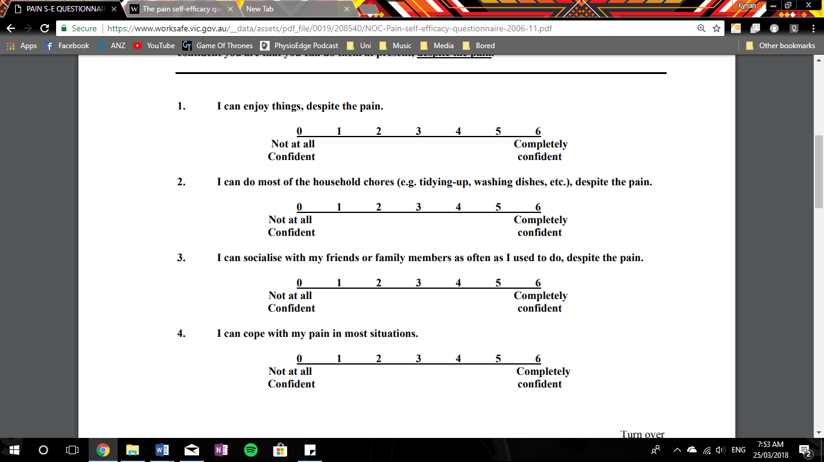

Remember, this questionnaire is not asking whether or not you have been doing these things, but rather how confident you are that you can do them at present, despite the pain.

1. **I can enjoy things, despite the pain.**



1. **I can do most of the household chores (e.g. tidying-up, washing dishes, etc.), despite the pain.**



1. **I can socialise with my friends or family members as often as I used to do, despite the pain.**



1. **I can cope with my pain in most situations.**



1. **I can do some form of work, despite the pain. (“work” includes housework, paid and unpaid work).**



1. **I can still do many of the things I enjoy doing, such as hobbies or leisure activity, despite pain.**



1. **I can cope with my pain without medication.**



1. **I can still accomplish most of my goals in life, despite the pain.**



1. **I can live a normal lifestyle, despite the pain.**



1. **I can gradually become more active, despite the pain.**



# Section 6 – EQ-5D-5L Health Questionnaire

**Under each heading, please tick the ONE box that best describes your health TODAY.**

1. **Mobility**

* I have no problems in walking about
* I have slight problems in walking about
* I have moderate problems in walking about
* I have severe problems in walking about
* I am unable to walk about

1. **Self-care**

* I have no problems washing or dressing myself
* I have slight problems washing or dressing myself
* I have moderate problems washing or dressing myself
* 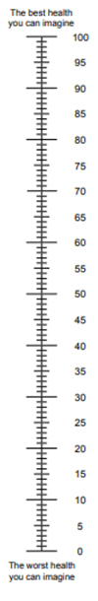I have severe problems washing or dressing myself
* I am unable to wash or dress myself

1. **Usual activities (e.g. work, study, housework, family or leisure activities)**

* I haver no problems doing my usual activities
* I have slight problems doing my usual activities
* I have moderate problems doing my usual activities
* I have severe problems doing my usual activities
* I am unable to do my usual activities

1. **Pain/discomfort**

* I have no pain or discomfort
* I have slight pain or discomfort
* I have moderate pain or discomfort
* I have severe pain or discomfort
* I have extreme pain or discomfort

1. **Anxiety/depression**

* I am not anxious or depressed
* I am slightly anxious or depressed
* I am moderately anxious or depressed
* I am severely anxious or depressed
* I am extremely anxious or depressed
* We would like to know how good or bad your health is TODAY
* This scale is numbered from 0 to 100
* 100 means the best health you can imagine.

0 means the worst health you can imagine

* Mark an X on the scale to indicate how your health is TODAY
* Now, please write the number you marked on the scale in the box below
* Your Health TODAY =

# Section 7 – Patient Global Impression of Change

**How would you describe your whiplash problem now, compared to how it was at the end of the study?**

**1** ❑ Very much improved

**2** ❑ Much improved

**3** ❑ Minimally improved

**4** ❑ No change

**5** ❑ Worse

**6** ❑ Much worse

**7** ❑ Very much worse

# Section 8 – Adverse Events

9.1 Have you had any medical problems that limited your daily activities of living over the past 4 weeks?

❑ Yes

❑ No

If yes, please list below:

9.2 Describe the medical problem:

9.3.1 Severity of the condition (please tick one):

❑ Mild

❑ Moderate

❑ Severe

9.3.2 Describe how often this problem occurred (please tick one)?

❑ More than once daily

❑ Daily

❑ 2-3 times a week

❑ More than 3 times a week

9.4 Describe the medical problem 2:

9.3.1 Severity of the condition (please tick one):

❑ Mild

❑ Moderate

❑ Severe

9.3.2 Describe how often this problem occurred (please tick one)?

❑ More than once daily

❑ Daily

❑ 2-3 times a week

❑ More than 3 times a week

9.5 Describe the medical problem 3:

9.3.1 Severity of the condition (please tick one):

❑ Mild

❑ Moderate

❑ Severe

9.3.2 Describe how often this problem occurred (please tick one)?

❑ More than once daily

❑ Daily

❑ 2-3 times a week

❑ More than 3 times a week

Signature____________________________

Date________________________________

**Thank you for filling out this questionnaire!**

**Please return this form to:**

**Research Assistant, N-of-1 Trial**

**RECOVER Injury Research Centre**

**The University of Queensland**

**Or scan to the following email address: recover@uq.edu.au**

Office use:

Principal Investigator Signature: _________________________ Date: ____/____/____

Research Assistant Signature: __________________________ Date: ____/____/____