***Effectiveness of conservative multimodal physiotherapy in chronic whiplash-associated disorders in individuals with or without posttraumatic stress symptoms: A pilot series of Single Case Experimental Designs (SCEDs)***

# FORM B – BASELINE QUESTIONNAIRE

**Please answer all questions**

## SECTION 1 – ACCIDENT HISTORY

**1.1 Date of Accident: _____/_____/_____ 1.2 Time of accident (24 hr clock) ____:_____**

**1.3. At the time of the accident were you: 1** ❑ The driver 4 ❑ The front seat . passenger

2 ❑ A back seat passenger 5 ❑ Riding a motorbike

3 ❑Riding a bicycle 6 ❑ Other

* 1. **Did you know the accident was coming? 1** ❑ Yes **2** ❑ No 3❑ Unsure

**1.5 Was the collision: 1** ❑ Rear end 4❑ Rear and front end

**2** ❑ Front end 5❑ Side impact

**3** ❑Other 6❑ Not applicable

**1.6 Was the vehicle you were in stationary at the time of impact?**

**1** ❑ Yes **2** ❑ No **3** ❑Not applicable

## SECTION 2 – INITIAL SYMPTOMS

**2.1 Following the accident, did your neck pain start:**  **1** ❑ Immediately

**2** ❑ Within 2-3 hours

**3** ❑ After 3 hours

**4** ❑ Unsure

**2.2 Was your neck movement restricted following the accident? 1** ❑ Not at all

**2** ❑ Mildly

**3** ❑ Moderately

**4** ❑ Severely

**2.3 Did you lose consciousness immediately after the accident?** **1** ❑ Yes **2** ❑ No 3❑ Unsure

## SECTION 3 – MEDICAL HISTORY

**3.1 Have you had any major surgery or other injuries?** **1** ❑ Yes **2** ❑No

*If* ***YES –*** *Please give details:*

|  |  |
| --- | --- |
| **Date** | **Event** |
| **3.1.1** | **3.1.1.1** |
| **3.1.2** | **3.1.2.1** |
| **3.1.3** | **3.1.3.1** |
| **3.1.4** | **3.1.4.1** |
| **3.1.5** | **3.1.5.1** |
| **3.1.6** | **3.1.6.1** |

* 1. **Do you currently suffer from any other medical or mental health conditions? 1** ❑ Yes **2** ❑No

*If* ***YES –*** *Please give details:*

|  |  |
| --- | --- |
| **Medical or Mental Health Condition** | **When did it start?** |
| **3.2.1** | **3.2.1.1** |
| **3.2.2** | **3.2.2.1** |
| **3.2.3** | **3.2.3.1** |
| **3.2.4** | **3.2.4.1** |
| **3.2.5** | **3.2.5.1** |
| **3.2.6** | **3.2.6.1** |

## SECTION 4 – SYMPTOMS

**PAIN INTENSITY**

Please rate your pain on a scale from 0 to 10 where 0 represents no pain and 10 is the worst pain possible. Please circle the number which best describes your current ***neck pain.***

* 1. **On the scale below please estimate the *intensity of your neck pain right now*.**

|  |  |  |  |  |  |  |  |  |  |  |  |  |
| --- | --- | --- | --- | --- | --- | --- | --- | --- | --- | --- | --- | --- |
| 0 | 1 | 2 | 3 | 4 | 5 | 6 | 7 | 8 | 9 | | 10 | |
| No  Pain | | | | | | | | | |  | | Worst  possible pain |

* 1. **How confident are you in your ability to perform your daily tasks in the presence of your neck pain or disability? Please circle the best answer.**

1 *not at all confident*;

2 a little confident

*3 moderately confident*

4 very confident

5 *extremely confident*

* 1. **Do you have any neurological symptoms such as pins and needles and/or numbness?**

**1** ❑ Yes **2** ❑No

**Please mark on the body chart below where you feel pain or any other symptoms e.g. pins and needles or numbness. Please indicate which symptom is where.**



## SECTION 5 – MEDICATIONS

**5.1 Please list medications you are taking for your whiplash symptoms, if any:**

|  |  |
| --- | --- |
| **Name** | **Frequency (eg every 4 hours)** |
| **5.1.1** | **5.1.1.1** |
| **5.1.2** | **5.1.2.1** |
| **5.1.3** | **5.1.3.1** |

* 1. **Please list medications you are taking for any other medical conditions:**

|  |  |  |
| --- | --- | --- |
| **Name of medication** | **Frequency (eg once per day)** | **Condition** |
| **5.2.1** | **5.2.1.1** | **5.2.1.2** |
| **5.2.2** | **5.2.2.1** | **5.2.2.2** |
| **5.2.3** | **5.2.3.1** | **5.2.3.2** |
| **5.2.4** | **5.2.4.1** | **5.2.4.2** |
| **5.2.5** | **5.2.5.1** | **5.2.5.2** |

## SECTION 6 – WORKING STATUS AND EDUCATION

**6.1 Working Status:** 1 ❑ Employed

2 ❑ Self Employed

3 ❑ Home Duties

4 ❑ Unemployed

5 ❑ Semi-retired

6 ❑ Retired

If employed or self-employed, or semi-retired what is your occupation? _______________________________________________________________________________________

**6.2** **Highest educational qualification** you have **completed**:

1 ❑ Year 8 5 ❑ Year 12

2 ❑ Year 9 6 ❑ TAFE/trade qualification

3 ❑ Year 10 7 ❑ Undergraduate qualification

4 ❑ Year 11 8 ❑ Post-graduate qualification

**6.3 Ethnicity**

1 ❑ Caucasian/European 5 ❑ Indian

2 ❑ Australian-Aboriginal 6 ❑ Maori

3 ❑ Torres Strait Islander 7 ❑ Pacific Islander

4 ❑ Asian 8 ❑ Other: ________________

|  |  |  |
| --- | --- | --- |
| **Section 6 – DASS-21** | | |
| Please read each statement and circle a number 0, 1, 2 or 3 which indicates how much the statement applied to you *over the past week*. There are no right or wrong answers. Do not spend too much time on any statement. The rating scale is as follows:  0 Did not apply to me at all  1 Applied to me to some degree, or some of the time  2 Applied to me to a considerable degree, or a good part of time  3 Applied to me very much, or most of the time | | |
| 1 | I found it hard to wind down | 0 1 2 3 |
| 2 | I was aware of dryness of my mouth | 0 1 2 3 |
| 3 | I couldn't seem to experience any positive feeling at all | 0 1 2 3 |
| 4 | I experienced breathing difficulty (e.g., excessively rapid breathing, breathlessness in the absence of physical exertion) | 0 1 2 3 |
| 5 | I found it difficult to work up the initiative to do things | 0 1 2 3 |
| 6 | I tended to over-react to situations | 0 1 2 3 |
| 7 | I had a feeling of trembling (e.g., in the hands) | 0 1 2 3 |
| 8 | I felt that I was using a lot of nervous energy | 0 1 2 3 |
| 9 | I was worried about situations in which I might panic and make a fool of myself | 0 1 2 3 |
| 10 | I felt that I had nothing to look forward to | 0 1 2 3 |
| 11 | I found myself getting agitated | 0 1 2 3 |
| 12 | I found it difficult to relax | 0 1 2 3 |
| 13 | I felt down-hearted and blue | 0 1 2 3 |
| 14 | I was intolerant of anything that kept me from getting on with what I was doing | 0 1 2 3 |
| 15 | I felt I was close to panic | 0 1 2 3 |
| 16 | I was unable to become enthusiastic about anything | 0 1 2 3 |
| 17 | I felt I wasn't worth much as a person | 0 1 2 3 |
| 18 | I felt that I was rather touchy | 0 1 2 3 |
| 19 | I was aware of the action of my heart in the absence of physical exertion (e.g., sense of heart rate increase, heart missing a beat | 0 1 2 3 |
| 20 | I felt scared without any good reason | 0 1 2 3 |
| 21 | I felt that life was meaningless | 0 1 2 3 |
| 7.1 Total Score: | |  |

# Section 7 - PCS

Everyone experiences painful situations at some point in their lives. Such experiences may include headaches, tooth pain, joint or muscle pain. People are often exposed to situations that may cause pain such as illness, injury, dental procedures or surgery.

Instructions:

We are interested in the types of thoughts and feelings that you have when you are in pain. Listed below are thirteen statements describing different thoughts and feelings that may be associated with pain. Using the following scale, please indicate the degree to which you have these thoughts and feelings when you are experiencing pain.

|  |  |  |  |  |  |
| --- | --- | --- | --- | --- | --- |
| **RATING** | **0** | **1** | **2** | **3** | **4** |
| **MEANING** | Not at all | To a slight degree | To a moderate degree | To a great degree | All the time |

**When I’m in pain …**

|  |  |  |
| --- | --- | --- |
| **Number** | **Statement** | **Rating** |
| 1 | I worry all the time about whether the pain will end. |  |
| 2 | I feel I can’t go on. |  |
| 3 | It’s terrible and I think it’s never going to get any better |  |
| 4 | It’s awful and I feel that it overwhelms me. |  |
| 5 | I feel I can’t stand it anymore |  |
| 6 | I become afraid that the pain will get worse. |  |
| 7 | I keep thinking of other painful events |  |
| 8 | I anxiously want the pain to go away |  |
| 9 | I can’t seem to keep it out of my mind |  |
| 10 | I keep thinking about how much it hurts. |  |
| 11 | I keep thinking about how badly I want the pain to stop |  |
| 12 | There’s nothing I can do to reduce the intensity of the pain |  |
| 13 | I wonder whether something serious may happen. |  |

# Section 8 – PSEQ

Pick three (3) questions from the below ten (10) you believe to be most relevant to you and your lifestyle. When completing future questionnaires only answer your chosen three (3) questions.

Please rate how confident you are that you can do the following things at present, despite the pain.

To indicate your answer circle one of the numbers on the scale under each item, where 0 = not at all confident and 6 = completely confident. For example

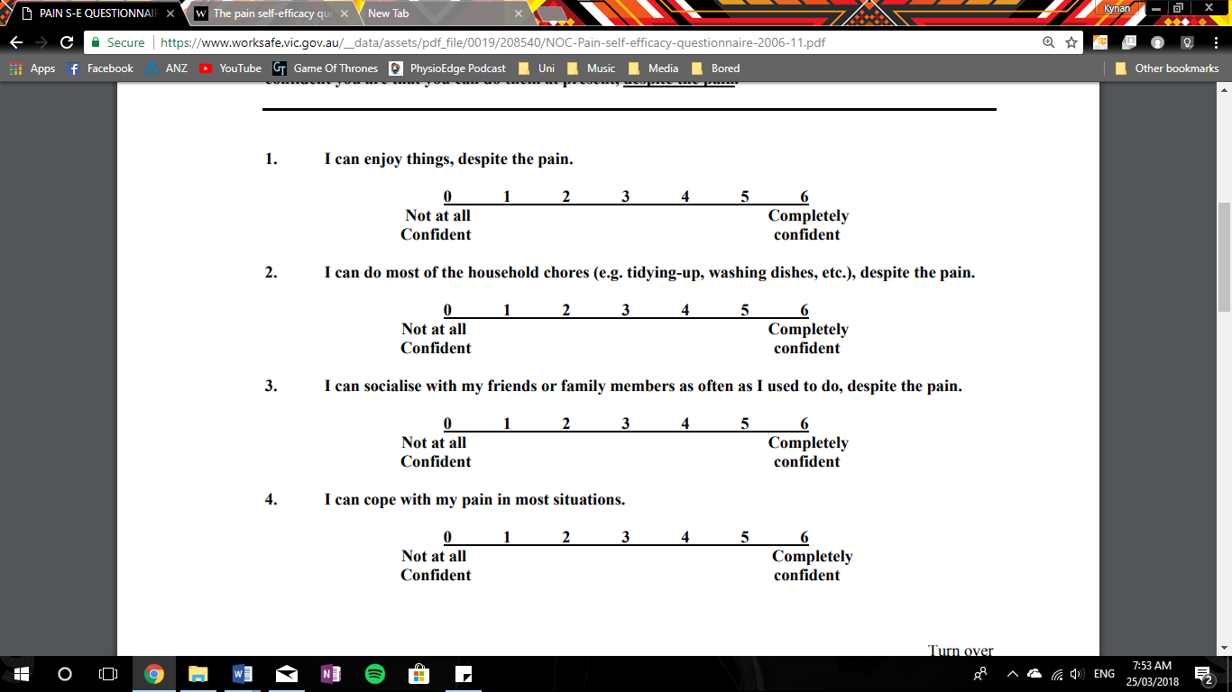

Remember, this questionnaire is not asking whether or not you have been doing these things, but rather how confident you are that you can do them at present, despite the pain.

1. **I can enjoy things, despite the pain.**



1. **I can do most of the household chores (e.g. tidying-up, washing dishes, etc.), despite the pain.**



1. **I can socialise with my friends or family members as often as I used to do, despite the pain.**



1. **I can cope with my pain in most situations.**



1. **I can do some form of work, despite the pain. (“work” includes housework, paid and unpaid work).**



1. **I can still do many of the things I enjoy doing, such as hobbies or leisure activity, despite pain.**



1. **I can cope with my pain without medication.**



1. **I can still accomplish most of my goals in life, despite the pain.**



1. **I can live a normal lifestyle, despite the pain.**



1. **I can gradually become more active, despite the pain.**



# Section 9 – EQ-5D-5L Health Questionnaire

**Under each heading, please tick the ONE box that best describes your health TODAY.**

1. **Mobility**

* I have no problems in walking about
* I have slight problems in walking about
* I have moderate problems in walking about
* I have severe problems in walking about
* I am unable to walk about

1. **Self-care**

* I have no problems washing or dressing myself
* I have slight problems washing or dressing myself
* I have moderate problems washing or dressing myself
* I have severe problems washing or dressing myself
* I am unable to wash or dress myself

1. **Usual activities (e.g. work, study, housework, family or leisure activities)**

* 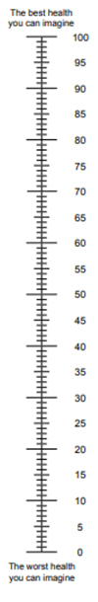I haver no problems doing my usual activities
* I have slight problems doing my usual activities
* I have moderate problems doing my usual activities
* I have severe problems doing my usual activities
* I am unable to do my usual activities

1. **Pain/discomfort**

* I have no pain or discomfort
* I have slight pain or discomfort
* I have moderate pain or discomfort
* I have severe pain or discomfort
* I have extreme pain or discomfort

1. **Anxiety/depression**

* I am not anxious or depressed
* I am slightly anxious or depressed
* I am moderately anxious or depressed
* I am severely anxious or depressed
* I am extremely anxious or depressed
* We would like to know how good or bad your health is TODAY
* This scale is numbered from 0 to 100
* 100 means the best health you can imagine.

0 means the worst health you can imagine

* Mark an X on the scale to indicate how your health is TODAY
* Now, please write the number you marked on the scale in the box below
* Your Health TODAY =

# Section 10 – Patient Health Questionnaire

**Under each heading, please tick the ONE box that best describes your health TODAY.**

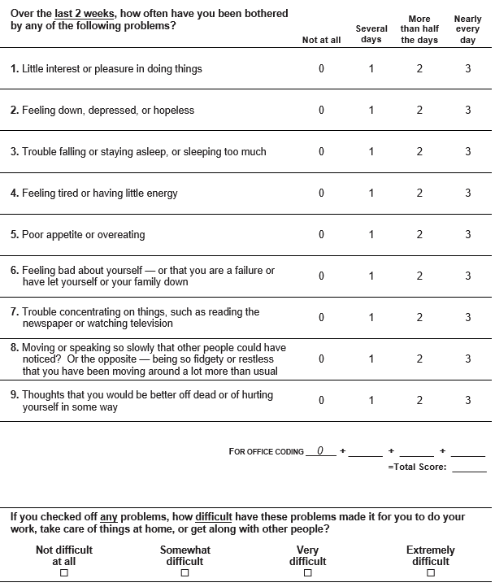

# Section 11 – Expectations for Recovery

**“Do you think that your injury will…**

**1** ❑ Get better soon

**2** ❑ Get better slowly

**3** ❑ Never get better

**4** ❑ Don’t know

**13. Do you expect the physiotherapy treatment to work?**

1❑ No

2❑ Maybe

3❑ Somewhat

4❑ Very much

**Thank you. Please give the questionnaire to the Research Assistant/honours student.**

**Office use:**

**Research Assistant/honours student.**

**Signature: _______________________ Date: ____/____/____**