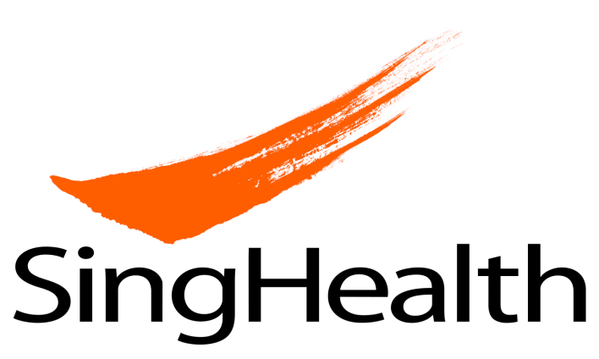
Consent to Photography of Skin Lesions/ Eczema Areas

STUDY INFORMATION
Protocol Title:
A pilot randomised control study of the effectiveness of a customised nanotextile wet garment treatment on moderate and severe atopic dermatitis
Site Principal Investigator:
Dr. Lee Haur Yueh
Department of Dermatology
Singapore General Hospital
6326 6866

Co- Investigator
Ms He Huiling
Duke-NUS Medical School
94736820

PURPOSE OF PHOTOGRAPHY

This study involves photography of skin lesions/ eczema areas of your body during your participation in the research study. The purpose is to provide documentation to support the data collected in this research study.

The study staff will take photographs of your front and back trunk, legs and arms and/or any target skin lesions/ eczema areas, which may include your face and private body parts. Any photos obtained and used in a report published as a result of this study will not identify you by name, and to the extent possible, the photos will be presented so that you are not recognizable (if a photograph bearing your face is required, a black “bar” will be placed over the eyes, and if applicable, other identifying features such as piercing, scars, tattoos, birth marks). Your confidentiality will be protected to the best of our ability. However, absolute confidentiality cannot be guaranteed.

If required, you will need to undress prior to the photographs being taken. All accessories such as watches and necklaces should be removed. You may leave undergarments on.

CONFIDENTIALITY AND DATA SHARING

The study team will take measures to protect the confidentiality of your photos, and your privacy. Photos collected for the purpose of this research study, will not be labeled with your name or identifiable information. Instead, a study number will be assigned and used to label your photos.

The study team may use your photos to:
- Research data collection
- Medical/ scientific journals/ publications

- Withdrawal
You have the right to withdraw your consent at any time, without stating your reasons. Your decision will not result in any penalty or loss of benefits to which you are otherwise entitled.

If you withdraw your consent and decide to leave the research study completely, all photos obtained before you withdrew will still be used and included in the analyses and results of the research study for scientific purposes.

- COMPENSATION AND COSTS

If commercial products or other valuable discoveries result from future research using your samples and/or data, these products and discoveries may be owned, patented, licensed, or otherwise developed for commercial sale by sponsor, other researchers or companies. If this should occur, you or your relatives will not receive any financial benefits or compensation or other proprietary interest from any commercial products or discoveries that may result from such research.

CONSENT BY RESEARCH PARTICIPANT
Details of Research Study
Protocol Title:
A pilot randomised control study of the effectiveness of a customised nanotextile wet garment treatment on moderate and severe atopic dermatitis
Site Principal Investigator:
Dr Lee Haur Yueh, Singapore General Hospital, 6326 6866

Participant’s Particulars
Name: NRIC No.:
Address:
Sex: Female/Male Date of birth _______________
dd/mm/yyyy
Race: Chinese/ Malay/ Indian /Others (please specify) ________________________

I agree to participate in the research study as described and on the terms set out in the Patient Information Sheet.

I have fully discussed and understood the purpose and procedures of this study. I have been given the Participant Information Sheet and the opportunity to ask questions about this study and have received satisfactory answers and information.

I understand that my participation is voluntary and that I am free to withdraw at any time, without giving any reasons and without my medical care being affected.

By participating in this research study, I confirm that I have read, understood and consent to the SingHealth Data Protection Policy. I also consent to the use of my Personal Data for future research.

_______________________ _______________________ ________________
Name of participant Signature/Thumbprint (Right / Left) Date of signing

To be filled by parent / legal guardian / legal representative, where applicable

I hereby give consent for the above participant to participate in the proposed research study. The nature, risks and benefits of the study have been explained clearly to me and I fully understand them.

________________________ __________________________ _______________
Name of participant’s Signature Date of signing
parent /legal guardian

Translator Information (if required)

The study has been explained to the participant/ legal representative in

____________________________________by _____________________________________.
Language Name of translator

To be filled witness, where applicable

An impartial witness should be present during the entire informed consent discussion if a participant or the participant’s legal representative is unable to read. After the written informed consent form and any written information to be provided to participants, is read and explained to the participant or the participant’s legal representative, and after the participant or the participant’s legal representative has orally consented to the participant’s participation in the study and, if capable of doing so, has signed and personally dated the consent form, the witness should sign and personally date the consent form.

Witnessed by: ________________________________ ________________________
Name of witness Designation of witness

________________________________ ________________________
Signature of witness Date of signing

Investigator’s Statement

I, the undersigned, certify to the best of my knowledge that the patient/patient’s legal representative signing this consent form had the study fully explained and clearly understands the nature, risks and benefits of his/her / his ward’s / her ward’s participation in the study.

________________________ _______________________ ________________
Name of Investigator Signature Date

