**Total Cardiac Care:**

**A randomised controlled trial of a comprehensive smartphone application-centric model of care   
to improve outcomes in patients   
with cardiovascular disease**

Version Number: 2.1

Date of Protocol: 12 March 2018

**SYNOPSIS**

Protocol title: Total Cardiac Care – a randomised controlled trial of a comprehensive smartphone application-centric model of care to improve outcomes in patients with cardiovascular disease.

Protocol version: 1.9

LIST OF INVESTIGATORS

Chief Investigator: Dr Sze-Yuan Ooi

Organisation: Department of Cardiology, Prince of Wales Hospital

Address: Level 3 Campus Centre POWH, Barker St, Randwick 2031  
Telephone no.: 02 9382 0700   
Fax no.:02 9382 0799  
Email: szeyuan.ooi@ehc.com.au

Co-Chief Investigator: Professor Nigel Lovell

Organisation: Graduate School of Biomedical Engineering, University of New South Wales

Address: Level 5, Samuels Building, Gate 11, University of New South Wales, Botany St, Randwick 2031

Telephone no: 02 9385 3922

Fax no.: 02 9663 2108

Email: [N.Lovell@unsw.edu.au](mailto:N.Lovell@unsw.edu.au)

Site Principal Investigators

Prince of Wales Hospital PI: Dr Jennifer Yu  
Department of Cardiology, Prince of Wales Hospital  
Address: Level 3 Campus Centre POWH, Barker St, Randwick 2031  
Telephone no.: 02 9382 2222  
Email: Jennifer.yu@health.nsw.gov.au

The Sutherland Hospital PI: Dr Daniel Robaei  
Sutherland Heart Clinic   
Address: Level 2, Sutherland Hospital, The Kingsway Miranda  
Telephone no.: (02) 9540 8555  
daniel.robaei@health.nsw.gov.au

Associate Investigators

Dr Praveen Indraratna  
Department of Cardiology, Prince of Wales Hospital

Address: Level 3 Campus Centre POWH, Barker St, Randwick 2031  
Email: Praveen@unsw.edu.au

A/Prof Stephen Redmond  
Graduate School of Biomedical Engineering, University of New South Wales  
Address: Level 5, Samuels Building, Gate 11, Botany St, Randwick 2031  
Email: [s.redmond@unsw.edu.au](mailto:s.redmond@unsw.edu.au)

Professor Robyn Gallagher  
Professor of Nursing, University of Sydney  
Email : [Robyn.gallagher@sydney.edu.au](mailto:Robyn.gallagher@sydney.edu.au)

Professor Gemma Figtree  
Professor of Medicine, University of Sydney  
Staff Specialist Cardiologist, Royal North Shore Hospital  
Email: gemma.figtree@sydney.edu.au

Professor Siaw-Teng Liaw  
Professor of General Practice, UNSW  
Director of the South Western Sydney Local Health District General Practice Unit  
Email: [siaw@unsw.edu.au](mailto:siaw@unsw.edu.au).

Cate Ferry  
Senior Manager, Clinical Issues  
Heart Foundation  
Email: [Cate.Ferry@heartfoundation.org.au](mailto:Cate.Ferry@heartfoundation.org.au)

Jennifer Fildes  
Clinical Nurse Consultant  
Cardiac Rehabilitation  
Prince of Wales Hospital  
Email: [Jennifer.fildes@health.nsw.gov.au](mailto:Jennifer.fildes@health.nsw.gov.au)

Prof Louisa Jorm  
Centre for Big Data Research in Health  
Email: [l.jorm@unsw.edu.au](mailto:l.jorm@unsw.edu.au)

Prof Gunter Schreier

Senior Scientist

Austrian Institute of Technology

Email: [Guenter.Schreier@ait.ac.at](mailto:Guenter.Schreier@ait.ac.at)

**Summary**

Study title: Total Cardiac Care: A randomised controlled trial of a comprehensive smartphone application-centric model of care to improve outcomes in patients with cardiovascular disease.

Protocol version: 1.9

Objectives Primary objective: To examine the impact of the Total Cardiac Care (TCC), a smartphone application (app) based model of care in addition to standard care, compared with standard care alone, on the incidence of 30 day hospital readmission rates in patients who have recently been discharged following an acute cardiac event.

Secondary objectives: To examine the impact of the use of the TCC app on 6 month outcomes including: major adverse cardiovascular events, symptom variation, medication compliance, management of lipid levels, weight, blood pressure, quality of life, exercise capacity (as measured by 6 minute walk test results), cardiac rehabilitation uptake and completion, healthcare costs and length of hospital stay.

Study design: Multi-centre randomised controlled trial

Planned sample size 1130 participants:

1,080 participants randomised 1:1 to a control group and intervention group.

50 roll-in participants (1st 10 participants at each site) to test usability.

Selection criteria Inclusion criteria: patient at point of discharge from a participating hospital following an acute cardiac event (acute coronary syndrome or decompensated cardiac failure); patient owns a compatible smartphone; age over 18 years; able to provide written informed consent

Exclusion criteria: Inability to use the app or smartphone

Study sites Prince of Wales Hospital, The Sutherland Hospital, Royal North Shore Hospital, Liverpool Hospital, Port Macquarie Base Hospital.

Study procedure Potential participants will be screened on cardiac wards and approached prior to discharge. After informed consent is obtained, the patient will be randomised to either the control or intervention group.

Those in the intervention group will receive access and support to use the TCC app on their own phone. They will also be given devices for measuring blood pressure and weight which have wireless connectivity to the app. Prior to discharge home, individualised thresholds for BP and weight will be determined by the treating team which are used for TCC app alerts once they get home.

Participants in the intervention group will use the app at home. Data from the app is transferred to a web-based online portal (KIOLA eHealth platform, Austrian Institute of Technology). Data will be stored in a secure server at the University of New South Wales and will be centrally monitored by a research team based at Prince of Wales Hospital during business hours. If measured parameters meet the individualised, predetermined criteria (e.g., > 2kg weight gain over 2 days), an alert will be triggered for review by a clinician on the research team. Upon review, the clinician will contact the patient and/or the relevant healthcare team as appropriate. This will be supplementary to and work in conjuction with, the standard cardiovascular care available at each site.

Patients in the control group will receive standard care alone.

All patients will have final in-person follow-up at 6 months.

Statistical considerations Our sample size calculation is based on current estimates of a 15% 30-day readmission rate, based on data from 1754 analogous patients admitted over a recent 12 month period (April 2016 to April 2017) at the study sites. Assuming a similar readmission rate in the control group, 986 patients will need to be randomised to detect a relative risk reduction (RRR) of 40% with 80% power and with two sided type I error of 0.05. Recruitment of 1080 patients is planned to allow for a 10 percent dropout rate.

Duration of the Study The total duration of the study is expected to be 2 years. Each patient will be followed for a minimum of 6 months.

TABLE OF CONTENTS

1. BACKGROUND 7

1.1. Disease Background 7

1.2. Total Cardiac Care Model of Care 8

1.3. Rationale for Performing the Study* 12

2. STUDY OBJECTIVES* 13

2.1. Primary Objective* 13

2.2. Secondary objectives 13

3. STUDY Design* 14

3.1. Design* 14

3.2. Number of participants* 15

3.3. Study sites 15

3.4. Duration 16

4. Participant section 16

4.1. Inclusion Criteria* 16

4.2. Exclusion Criteria* 16

5. STUDY Outline* 17

5.1. Study Flow Chart 17

5.2. Investigation plan* 18

5.3. Study Procedure Risks* 19

5.4. Recruitment and Screening* 20

5.5. Informed Consent Process* 20

5.6. Enrolment Procedure* 20

5.7. Randomisation Procedure 20

6. SAFETY* 21

6.1. Adverse Event Reporting* 21

6.2. Data Safety and Monitoring Board 21

7. STATISTICAL CONSIDERATIONS* 21

8. STORAGE AND ARCHIVING OF STUDY DOCUMENTS* 23

9. REFERENCES* 24

10. APPENDICES 25

# BACKGROUND

## Disease Background

Cardiovascular disease is the leading cause of death and hospital admissions in Australia; secondary events in patients with known cardiovascular disease contribute a significant portion of the overall burden.1 Reductions of over 80% in these events may be achieved through secondary prevention behaviours.2 Cardiac rehabilitation (CR) programmes are proven to reduce repeat events by targeting risk factors. However, CR participation rates are only 15-30%.3

It is well established that early follow-up after hospital discharge, which includes patient assessment and tailored advice and titration of medications, reduces hospital readmission rates4. These strategies, however, may be time and labour intensive and unable to be delivered by community health services, particularly in the context of an ageing population. Other strategies are needed to better triage and redirect the use of available resources. Smartphone application technology provides potential to monitor patients at home for early signs of worsening cardiac failure, such as weight gain. Further, it can provide feedback to the patient for self-monitoring, deliver clinical education to patients regarding therapy, and promote self-care behaviour. It is not known whether the use of such a smartphone application-based model of care in adjunct to available healthcare infrastructure will impact on outcomes such as 30 day readmission rates, and major adverse clinical events.

## Total Cardiac Care Model of Care

“Total Cardiac Care” comprises a smartphone application which collects and transmits health data (blood pressure, weight, activity) to a web-based server, where it can be monitored by a central research team. These data can be used to facilitate early review of participants whose parameters fall outside individualised, preset, parameters (figure 1). Further, it provides summary feedback to the participant about their collected parameters (figure 2) and delivers educational messages regarding the management of their heart disease and heart-healthy behaviours, based on the Heart Foundation *Managing My Heart Health* document.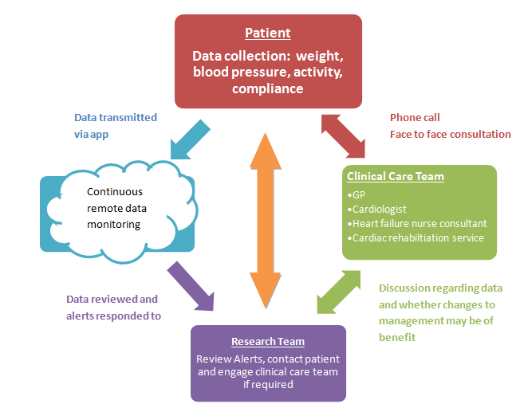

*Figure 1 – Flow diagram of the app and its associated functions*

The Total Cardiac Care virtual hub is comprised of the following components

* The smartphone application
* The peripheral devices – an automatic sphygmomanometer and weighing scales which connect wireless to the smartphone application
* The KIOLA web-based server for collecting and monitoring data

*1.2.1 The Smartphone Application*

The application will have the following features

* Wireless connectivity to the peripheral devices to record blood pressure and weight
* Measurement of physical activity by using either a built-in activity monitor, or the patient’s own wearable activity monitor
* Medication reminders
* Visual display that summarises recorded weight, blood pressure, medication taking and mood.
* Interactive and supportive patient interface with persuasive design elements and notifications to promote engagement and positive behaviour change such as medication adherence, smoking cessation/reduction, checking of BP and weight, physical activity and healthy eating.
* All data recorded by the app will be transmitted to the KIOLA web-based server for review by the research team.

Individualised app settings will be programmed prior to discharge, e.g., medication reminders, clinical parameters for an alert trigger based on weight and BP. The parameters will be determined in consultation with the treating cardiology team prior to hospital discharge.

*1.2.2 Peripheral Devices*

These devices will record the blood pressure and the weight, and wirelessly connect to the smartphone application either via Near Field Communication (NFC, *“tap and go” technology)* or Bluetooth Low Energy (BLE).

1.2.3 *KIOLA*

All incoming data collected by the peripheral devices and smartphone application will be transmitted to the KIOLA web-based interface which will reside on a secure server at the University of New South Wales. KIOLA was developed at the Austrian Institute of Technology (AIT) and has been extensively tested in several Austrian hospitals. Clinical members of the research staff will monitor for abnormalities in the data such as weight gain, or an excessive rise or fall in blood pressure. If a concerning abnormality is detected, the participant may be contacted directly and asked to schedule a visit with their general practitioner, cardiologist, cardiac nurse or even to attend the emergency department. The treating health care provider may also be contacted by the research staff at the participant’s request or if the participant is not able to be contacted by the central research team.

The TCC app-based model of care will serve as an adjunct to standard therapy. All management decisions such as pharmacotherapy, lifestyle modification or procedural interventions will be made by the treating health care providers. Parameters will not be monitored continuously or immediately by research staff and participants will be informed of the same. In the event the patient feels acutely unwell, participants should seek urgent medical attention and not wait to be contacted by research staff.

*Figure 2 – Screenshots of the App*

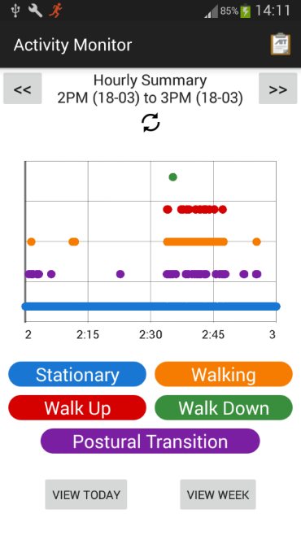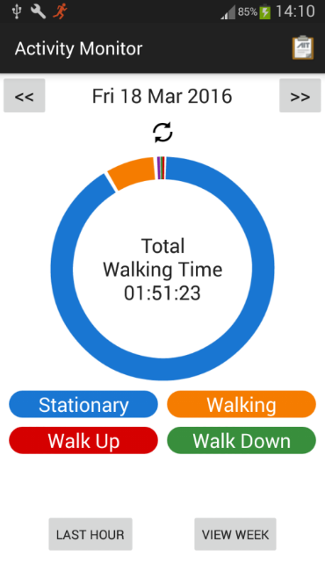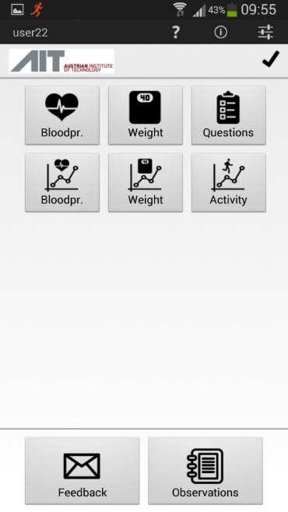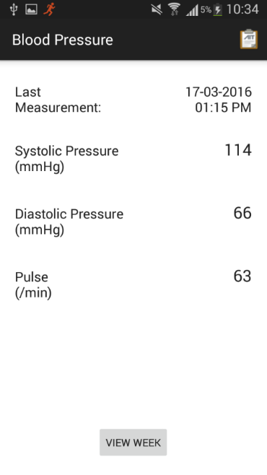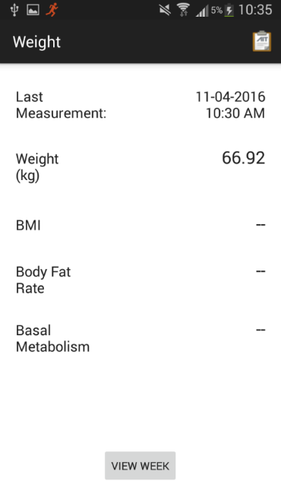

( a )

( b )

( c )

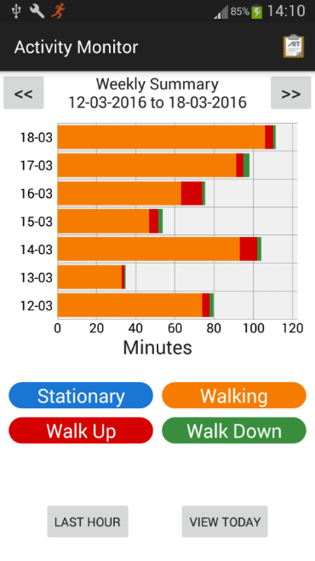

( d )

( e )

( f )

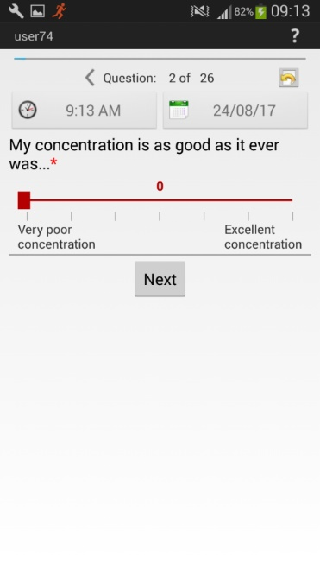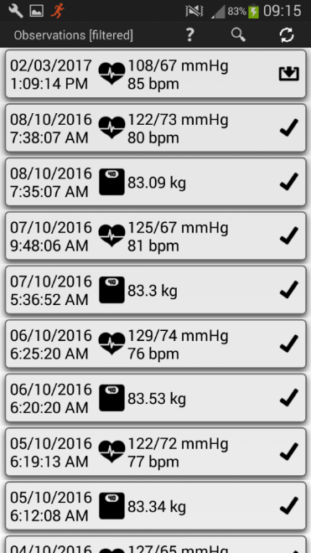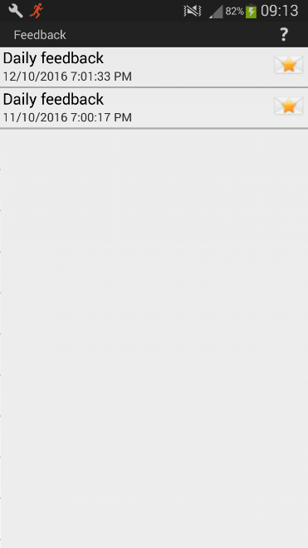

( g )

( h )

( i )

## Rationale for Performing the Study*

Our background work in cardiac patients (n = 285 across 7 NSW Local Health Districts (LHDs)) has established that smartphone use is very common; 80% of cardiac inpatients use a smartphone or tablet and 65% use a device to access health information. Despite this, no large randomised controlled trial (RCT) has studied a smartphone app with the proposed functionality and features targeted at a cardiac patient population. There are currently no openly available smartphone applications (apps) that fulfil these requirements despite strong evidence from pilot studies of the potential for such apps to improve key endpoints in cardiovascular patients including improved engagement in CR5, reduced length of hospital stay6,7, improved quality of life6,8 and physical function and symptomatic benefit9.

The Total Cardiac Care (TCC) app addresses the aforementioned evidence gap through proven efficacy in the local context for the monitoring of patient clinical variables and improving completion of CR. In a pilot RCT based at the Prince of Wales Hospital, the TCC app was associated with improved CR completion rates in a total cohort of 66 patients (66.7% vs. 87.9%, p<0.05)10. This is aligned to the NSW Heart Foundation Managing My Heart Health consumer resource and developed by a multidisciplinary panel of secondary prevention experts and tested in cardiac patients.

The potential benefit of a using a smartphone application in this context is two-fold. First, it can enhance the patient experience by providing easily visualised tracking of key heart health signs such as BP and weight, so that trajectories can be recognised. Second, it enables tracking of actual health behaviours including physical activity, which promotes engagement and behaviour change and reinforcing self-care behaviours. Second, it enables biometric data from a cohort of patients to be remotely monitored at a central hub, filtering for abnormal results and review by a clinician at the hub. Ultimately this means the clinician can 1) discuss the changes with the patient by phone (remotely), 2) where warranted, facilitate early activation of existing services at the respective local site.

# STUDY OBJECTIVES*

## Primary Objective*

Examine the efficacy of the Total Cardiac Care (TCC) smartphone application compared with standard care alone on the incidence of 30-day hospital readmission rates in patients who have recently been discharged following an acute cardiac event including acute coronary syndrome and decompensated congestive cardiac failure.

## Secondary objectives

Examine the impact of the TCC smartphone application on:

* 30 day and 6 month major adverse cardiovascular events (MACE: stroke, myocardial infarction, unplanned coronary revascularisation and death)
* Medication compliance (according to the MMAS-8 score, Appendix B)
* Change in key clinical parameters from baseline to 6 months, namely:
  + Fasting low density lipoprotein and high density lipoprotein levels, blood pressure (BP), waist circumference and body mass index (BMI)
  + Quality of Life score (SF-36)
  + Exercise capacity (6 minute walk test result)
* CR participation and completion rates
* Physical activity participation, as measured in steps per day and duration in minutes
* 6 month planned and unplanned cardiac and all-cause hospital readmissions
* Length of stay in any hospital readmission

Other objectives:

* To determine app engagement (based on log ins, daily entries for each category of parameter being assessed, additional notes by patients
* Patient and clinician (virtual hub) perspectives on acceptability and utility of the patient and clinician interface
* App managers’ documentation of nature and prevalence of any technical issues that resulted in app malfunction

# STUDY Design*

## Design*

This study will be a multi-center randomised controlled trial. Enrolled patients will be randomized 1:1 in an open-label fashion to the intervention or control group, stratified by site and diagnosis (i.e. acute coronary syndrome or congestive cardiac failure).

In addition, we will first enrol 10 patients at each site to test the usability and acceptability of the app among patients and cardiac staff at each site. Feedback from cardiac patients and service providers and app usage data will be considered. The results from these patients will not be included in the final analysis.

* + 1. Study Groups

1. The intervention group will receive the smartphone application, peripheral devices, and training in their use. The intervention group will be monitored centrally in addition to receiving local standard care.
2. Control group will receive local standard care. In general, this will include the following:
   * After discharge from hospital, a visit to the general practitioner within a week of discharge. Here, medications will be reviewed, and the GP will have the opportunity to discuss the diagnosis with the patient and answer any questions the patient may have, and reinforce any required lifestyle modification such as smoking cessation.
   * Follow up with a cardiologist 2-6 weeks following discharge. The urgency of this appointment is dependent on the severity and trajectory of the patients condition.
   * In the community, the heart failure clinical nurse consultant (CNC) will review the patient if appropriate.
   * Patients will be encouraged to attend cardiac rehabilitation where appropriate

The intervention group:

Prior to hospital discharge, participants randomised to the intervention group will be trained in the use of the app and associated peripheral devices. The app settings will be programmed individually prior to discharge, in consultation with the treating cardiology team. These individualised parameters will include timing of medication reminders as well as clinical parameters for alert triggers based on weight and BP.

Default settings for alert triggers are listed below, all of which can be modified to suit individual patients:

* A systolic blood pressure less than 90 mmHg, or above 180 mmHg
* Weight gain of over 2kg in a 2 day period
* Weight gain of over 3kg from the discharge weight

It is expected that where blood pressure or heart rate targets are modified within the hospital (i.e. variances to PACE calling criteria), these will be carried on to the app.

Variances in the monitored parameters will trigger a flag for review. The research team will take appropriate actions that utilises existing support structures within hospital, community services and primary care.

This action plan may include the following steps:

* Contacting the patient to suggest repeating the measurement (if suspected to be erroneous)
* Identifying any new symptoms
* Recommending the patient visit their GP or cardiologist
* Arranging for review of the patient at home by community nursing staff
* Recommending the patient call 000 or attend the emergency department in case of an emergency

Research team members will not make specific medical treatment decisions or recommendations. Patients will be informed that the research team will not be monitoring parameters continuously or immediately and they should follow usual protocol in the event of severe symptoms or illness i.e. call an ambulance and do not the research staff to contact them.

## Number of participants*

1080 patients will be randomised from 5 hospitals across 4 local health districts (LHDs). 50 roll-in participants (10 per site).

## Study sites

Five hospitals will be involved in the study. Anticipating that the recruitment of patients in the trial is proportional to the number of admissions, the estimated number of participants recruited from each site is given in brackets.

* Prince of Wales Hospital (205 participants)
* The Sutherland Hospital (100 participants)
* Port Macquarie Base Hospital (205 participants)
* Royal North Shore Hospital (260 participants)
* Liverpool Hospital (260 participants)

The study procedures and protocols will not vary between sites.

## Duration

24 months

# Participant section

## Inclusion Criteria*

* Patient at point of discharge from hospital of one of the following primary diagnoses:
  1. Acute coronary syndrome (ACS)
  2. Exacerbation or decompensation of congestive cardiac failure (CCF), either with reduced or preserved left ventricular ejection fraction
* Patient owns a smartphone that has the capability to operate the TCC application
* Age over 18 years
* Able to provide written informed consent

## Exclusion Criteria*

* Inability to use the TCC app and peripheral devices due to reasons including but not limited to:
  + Cognitive impairment
  + Impaired dexterity to operate the app
  + Visual impairment that would not allow adequate operation of the app
* Overseas travel
  + Any overseas travel in the first 30 days after enrolment
  + Any overseas travel longer than 1 month duration
  + If travelling overseas for less than 1 month, the involvement of the participant is to be discussed. Options may include not using the app for the period of time spent abroad.

# STUDY Outline*

## Study Flow Chart

## Investigation plan*

The investigation plan showing measurement of participant’s parameters are outlined below:

|  |  |  |  |
| --- | --- | --- | --- |
|  | During hospital admission | Remotely monitored via app (intervention group only) | Final Study Visit (6 months) |
| Informed Consent | ✓ |  |  |
| Inclusion / Exclusion criteria | ✓ |  |  |
| Weight, BP | ✓ | ✓ | ✓ |
| Waist circumference, | ✓ (and height) |  | ✓ |
| Activity |  | ✓ |  |
| Blood tests for lipid studies | ✓ |  | ✓ |
| Six minute walk test | ✓ |  | ✓ |
| Quality of Life Questionnaire | ✓ |  | ✓ |
| Medication Compliance Questionnaire (MMAS-8) and list of current medications | ✓ |  | ✓ |
| Adverse events |  |  | ✓ |

At six months, participants will be followed up at the same hospital where they were enrolled, where their vital signs and weight will be taken, along with completion of questionnaires. Any adverse events such as readmissions to hospital will also be confirmed at this time. A six minute walk test will be performed. If lipid studies have not been taken (or scheduled), these will be arranged at this visit.

Consent will be sought from all participants for linkage of their study data with routinely collected data (including emergency department presentations, hospital admissions, fact and cause of death, PBS claims). This will facilitate follow-up studies to examine medium and long-term patient outcomes through data linkage, for which a separate study protocol and ethics submission will be made.

## Study Procedure Risks*

Use of the smartphone application itself presents minimal risk to the patient, unless it is performed whilst driving or during other tasks where distraction could be dangerous. Participants will be advised of this danger.

Other components of the study include small elements of risk:

• There is a possibility that the participant may suffer a fall that could lead to a serious injury if they slip whilst they are weighing themselves on the weight scale.

• They may misinterpret the readings from the blood pressure monitor, causing themselves unnecessary distress.

• They may perceive their activity levels as inadequate (or insufficient/inaccurate) and may perform additional activities that they would otherwise not perform.

• The phone could potentially heat up in the pants pocket which could lead to discomfort in the surrounding region.

*Blood tests*

Blood testing will be performed during the study, but may not be required where blood has already been taken as a component of standard care (such as if ordered by the treating GP or cardiologist). Blood testing presents a small risk of haematoma, infection and damage to surrounding structures such as peripheral nerves.

*Blood pressure measurement*

Blood pressure measurement can be uncomfortable in some cases but is rarely associated with harm.

*Reliance on data monitoring*

Participants will be told that if they feel unwell or have significantly abnormal parameters, they should contact a medical professional as it may not be possible for the central hub to emergently review or action abnormal parameters. Participants will be clearly instructed that any concerns such as abnormal measurements, or changes in symptoms should be addressed in the same way as usual.

## Recruitment and Screening*

All patients with a diagnosis of ACS or CCF will be screened and eligible patients approached for informed consent. In situations where the treating clinician is part of the research team, a member of the research team who is not directly involved in the patient’s care will approach the potential participant for informed consent. This strategy will be used to minimize the possibility of coercion.

Screening for the study will require a review of the patient’s diagnosis. If the diagnosis is uncertain, then the patient will not be approached for recruitment. Prior to enrolment in the study, patients will provide the make and model of their smartphone so that the research team can see if it is compatible with the TCC app.

## Informed Consent Process*

A member of the research team will explain the aim and nature of the trial to all prospective participants. Written information and consent forms will also be provided. A copy of the patient information sheet and consent form will be kept by the participant and also stored by the research team in the participant’s file.

## Enrolment Procedure*

The research team member will establish whether the patient is suitable for enrolment according to the inclusion and exclusion criteria. If suitable, the study details will be explained to the participant, patient information sheet will be provided and any questions discussed. Once written informed consent is obtained, the participant will be considered enrolled in the study and allocated a study number.

## Randomisation Procedure

After participants have consented to involvement in the trial, randomization into either the control arm or the intervention arm will be performed using a secure web-based application (REDcap).

The randomization process will be completed after registration in the study and before discharge, so that patients in the intervention arm can have the relevant instruction in how to operate the app and the associated peripheral devices and individualized settings can be entered.

# SAFETY*

## Adverse Event Reporting*

As previously stated, there are no inherent risks of using the app or its peripheral devices. Any adverse events that occur during the study are likely to be due to the natural progression of the participant’s cardiovascular disease or an adverse effect of their pharmacotherapy, revascularisation (either percutaneous coronary intervention or cardiothoracic surgery) or device (e.g., pacemaker or defibrillator).

An adverse event includes:

* Mortality
* Any readmission to hospital irrespective of cause
* Major cardiovascular event
  + Myocardial infarction
  + Requirement for revascularization (either with percutaneous coronary intervention OR coronary artery bypass grafting)
  + Stroke / Transient ischaemic attack

## Data Safety and Monitoring Board

As the study intervention involves additional monitoring of participants only, it is not anticipated that a data safety and monitoring board will be required.

# 

# STATISTICAL CONSIDERATIONS*

RCT participants will be randomised in a 1:1 ratio stratified by primary diagnosis and enrolment site. Patients enrolled in the Usability Study will not be included in the final analysis. All tests will be 2-sided with a power of 80% and significance set at 5%. Descriptive statistics will be employed.

**The primary outcome analysis**

28-day readmission rates will be presented as percentages (n/N) in the intention-to-treat population and compared using a logistic regression model with adjustment for primary diagnosis and baseline characteristics.

As a secondary analysis, the primary endpoint will be compared in a per-protocol population, i.e., only patients who demonstrated use of the app in the intervention group will be included in the analysis.

**Secondary endpoints**

Secondary endpoints will be compared using intention-to-treat and per protocol analyses. Categorical variables will be presented as percentages (n/N) and compared using the chi-squared or Fisher’s exact test as appropriate. Continuous variables will be presented as median and interquartile range and compared using Wilcoxon rank-sum test for medians. 28 day MACE events will be presented and percentages. Six month events will be presented as Kaplan-Meier estimates and compared using the log-rank test. Subgroup analyses will be performed for gender, age, geography and primary diagnosis.

***Power Calculations (All supportive tables in Appendix B)***

The 28-day readmission rate among 1754 analogous patients admitted over a recent 12 month period was ~15% (Table 1). Assuming a similar readmission rate in the control group, 986 patients will need to be randomised to detect a relative risk reduction (RRR) of 40% with 80% power and with two-sided type I error of 0.05 (Table 2). We propose recruiting 1080 patients to allow for a 10 percent dropout rate, which represents <30% of the eligible population.

Health Economic Analysis

The health economic analysis will be performed by the UNSW Stats Central service under the oversight of Dr Nancy Briggs, in conjunction with a health economist from Prof Louisa Jorm’s group (Centre for Big Data Research in Health, UNSW).

**Table 1. Readmission rates according to diagnosis at study sites April 2016-March 2017**

|  |  |  |
| --- | --- | --- |
| **Site** | **Admissions, N** | **30 day readmission rate (%)** |
| **Liverpool Hospital\*** |  |  |
| Heart Failure |  |  |
| Acute Myocardial Infarction |  |  |
| **Port Macquarie Base Hospital** |  |  |
| Heart Failure | 203 | 21 |
| Acute Myocardial Infarction | 232 | 19 |
| **Prince of Wales Hospital** |  |  |
| Heart Failure | 212 | 15 |
| Acute Myocardial Infarction | 330 | 12 |
| **Royal North Shore Hospital** |  |  |
| Heart Failure | 228 | 15† |
| Acute Myocardial Infarction | 325 | 12† |
| **The Sutherland Hospital** |  |  |
| Heart Failure | 168 | 18 |
| Acute Myocardial Infarction | 56 | 8 |
| **Eligible Population** | **1754** | **15.2%** |

* promissory data †rates extrapolated from similar demographic hospital (POWH)

**Table 2. Power calculations**

|  |  |  |  |  |  |  |
| --- | --- | --- | --- | --- | --- | --- |
| **Event Rate** | | **RRR** | **Power** | **N each arm** | **Total N** | **% of eligible** |
| **Control** | **Intervention** |  |  |  | **+ 10%\*** | **ppn**† |
| 15% | 10% | ~33% | 80% | 726 | 1597 |  |
| 15% | 9% | ~40% | 80% | 493 | 1084 | 59 |
| 15% | 7.5% | 50% | 90% | 398 | 875 | 50 |

**\*** to account for patient drop out

† excludes Liverpool admissions (promissory data)

# STORAGE AND ARCHIVING OF STUDY DOCUMENTS*

The project will generate data in both paper and electronic forms. Paper forms, specifically the responses to questionnaires, will be uploaded to an electronic data capture system (REDcap) as well as stored in locked, secure filing cabinets within the research units at the respective sites. Only investigators will have access to these.

https://ssl.gstatic.com/ui/v1/icons/mail/images/cleardot.gif App data will be stored in a secure encrypted, password-protected server at the University of New South Wales. Patient identifiers will be stored in a separate file from clinical data, which will be identified only by a unique study number. Only investigators will have access to this server.

The remainder of the data will be captured on electronic case report forms also using REDcap.

All study data (separate files for patient identifiers and clinical data) will be retained for further research and data linkage and co-owned by the UNSW and SESLHD. These electronic files will be kept on a secure server at UNSW in an encrypted format which is password-protected and backed-up for a period of 15 years.

# REFERENCES*

1. AIHW 2011. Cardiovascular disease: Australian facts 2011. Cardiovascular disease series no. 35. Cat. no. CVD 53. Canberra: AIHW. Viewed 25 July 2017 http://www.aihw.gov.au/publication-detail/?id=10737418510.
2. Smith S, Benjamin E, Bonow R, Braun L, Creager M, Franklin B et al. AHA/ACCF secondary prevention and risk reduction therapy for patients with coronary and other atherosclerotic vascular disease: 2011 update: a guideline from the American Heart Association and American College of Cardiology Foundation endorsed by the World Heart Federation and the Preventive Cardiovascular Nurses Association.[J Am Coll Cardiol.](https://www.ncbi.nlm.nih.gov/pubmed/22055990) 2011 Nov 29;58(23):2432-46.
3. [Soo Hoo SY](https://www.ncbi.nlm.nih.gov/pubmed/?term=Soo%20Hoo%20SY%5BAuthor%5D&cauthor=true&cauthor_uid=26858136), [Gallagher R](https://www.ncbi.nlm.nih.gov/pubmed/?term=Gallagher%20R%5BAuthor%5D&cauthor=true&cauthor_uid=26858136), [Elliott D](https://www.ncbi.nlm.nih.gov/pubmed/?term=Elliott%20D%5BAuthor%5D&cauthor=true&cauthor_uid=26858136).Predictors of cardiac rehabilitation attendance following primary percutaneous coronary intervention for ST-elevation myocardial infarction in Australia. [Nurs Health Sci.](https://www.ncbi.nlm.nih.gov/pubmed/?term=Predictors+of+cardiac+rehabilitation+attendance+following+primary+percutaneous+coronary+intervention+for+ST-elevation+myocardial+infarction+in+Australia) 2016 Jun;18(2):230-7
4. Ziaeiana AB, Fonarow GC. The Prevention of Hospital Readmissions in Heart FailureProg Cardiovasc Dis. 2016 Jan-Feb; 58(4): 379–385.
5. Varnfield M; Karunanithi M; Lee CK; Honeyman E; Arnold D; Ding H et al. Smartphone-based home care model improved use of cardiac rehabilitation in postmyocardial infarction patients: results from a randomised controlled trial. Heart. 2014; 100(22):1770-9
6. Hägglund E, Lyngå P, Frie F, Ullman B, Persson H, Melin M et al. Patient-centred home-based management of heart failure. Findings from a randomised clinical trial evaluating a tablet computer for self-care, quality of life and effects on knowledge. [ScandCardiovasc J.](https://www.ncbi.nlm.nih.gov/pubmed/?term=Patient-centred+home-based+management+of+heart+failureFindings+from+a+randomised+clinical+trial+evaluating+a+tablet+computer+for+self-care%2C+quality+of+life+and+effects+on+knowledge) 2015 Aug;49(4):193-9
7. Scherr D, Kastner P, Kollmann A, Hallas A, Auer J, Krappinger H et al. Effect of home-based telemonitoring using mobile phone technology on the outcome of heart failure patients after an episode of acute decompensation: randomized controlled trial. *J Med Internet Res*. 2009;11:e34
8. Koehler F, Winkler S, SchieberM et al. Impact of remote telemedical management on mortality and hospitalizations in ambulatory patients with chronic heart failure: the telemedical interventional monitoring in heart failure study. Circulation 2011; 123(17): 1873–80
9. Piotrowicz E, Jasionowska A, Banaszak-Bednarczyk M, Gwilkowska J, Piotrowicz R. ECG telemonitoring during home-based cardiac rehabilitation in heart failure patients. J. Telemed. Telecare 2012 18(4), 193–197.

# APPENDICES

**Appendix A: Morisky Green Levine Score**

* Do you ever forget to take your medicine?
* Are you careless at times about taking your medicine?
* When you feel better do you sometimes stop taking your medicine?
* Sometimes if you feel worse when you take your medicine, do you stop taking it?

**Appendix B: Quality of Life Questionnaire (SF-36) – submitted as a separate PDF document**

**Appendix C – Case Report Document (submitted as a separate file)**