

**St. Vincent’s SportsMed**

**Measuring the effect of Hyaluronic acid (HA)on tendon healing after arthroscopic rotator cuff repair: A prospective randomized clinical trial**

**2ndcheck point**

(10- 14 days after surgery)

Patient Name: _________________________________________________________

Age:

sex: M F

Hand dominance: R L

Operative shoulder: □ Right □ Left

Investigator: Signature:

Date:

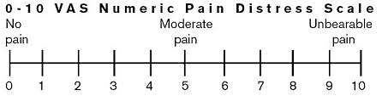

**Please document any adverse events in the adverse events form**