Silicon irregular hexagon pessary versus polyvinyl chloride ring pessary versus for pelvic organ prolapse: a randomized trial.

Principal investigator: Dr Chin Yong
Associate investigator(s): Dr Salwan Al-Salihi, Ann Cornish, Lucy Pizzo, Dr Marcus Carey, Dr Ruchi Singh, Dr Fay Chao, Dr Natharnia Young

Background

Pelvic organ prolapse (POP) is common and troublesome, particularly in developing countries where there is limited access to healthcare. Management options for POP include surgical and non-surgical approaches. Pessaries are the mainstay of non-surgical management.
The use of a vaginal pessary or a support device placed into the vaginal cavity to support prolapsed pelvic organs has been around since ancient times. Hippocrates described the use of vinegar soaked pomegranates placed within the vagina to treat pelvic organ prolapse. From the early 1700’s vaginal pessaries in the shape of a ring and made from a variety of materials were described¹. By the late 1800’s vaginal pessaries had become the treatment of choice for pelvic organ prolapse. However, their popularity declined from the mid 1920’s with the advent of safe surgery and anaesthesia to treat POP. To this day, vaginal pessaries in the shape of a ring remain the most widely used pessaries and are generally made of medical grade silicon or polyvinyl chloride (PVC).
According to the American College of Obstetricians and Gynecologists (ACOG) a pessary should be considered before surgical intervention in all women with symptomatic prolapse. Advantages of pessaries include outpatient insertion by a range of healthcare providers including nurses, low cost, reversible therapy, and suitability for the elderly and women with medical co-morbidity². With an ageing population, the prevalence of pelvic organ prolapse is expected to increase. Vaginal pessaries will continue to play an important role in the management of POP particularly in elderly patients.
However, traditional vaginal pessaries are often associated with chronic vaginal sepsis and discharge. The vaginal discharge is often an unacceptable complication of vaginal pessary use and is a common reason for women to discontinue use ^{1,3}. An intrinsic problem with currently available pessaries is the poor design of the pessary shape (e.g. ring and Gellhorn). These pessaries are often associated with discomfort and offensive vaginal discharge as well as complications such as pain, ulceration, bleeding, constipation, sexual dysfunction and expulsion. These limitations may be a cause of discontinuation or other adverse events and have led to a widespread reluctance by doctors and patients to use a pessary to treat POP.
Compared to surgery, vaginal pessaries have been the subjects of minimal scientific research. In particular, long-term vaginal pessary usage has been poorly studied. A study of Australian women with POP treated by a ring pessary showed that 86% of subjects followed for up to 7 years discontinued pessary use after a median time of 1.4 years³. There is also a paucity of research about the different types of vaginal pessaries in current use. One study that compared a ring pessary to a Gellhorn pessary in a randomised crossover trial found no subjective and objective differences between the two types of pessaries⁴.

Whilst there are various shaped vaginal pessaries available it is standard clinical practice is to use a polyvinyl chloride (PVC) ring pessary that is usually changed or replaced every 6 months. With currently available pessaries, the overall retention rate of vaginal pessaries is low, due to discomfort, inconvenience, vaginal discharge or dislodgement. The failure rate (i.e. discontinuation with pessary usage) vary from 27% to 74% ⁴⁻¹⁰. Prior hysterectomy, short vaginal length (<6cm), widened genital hiatus, and advanced POP (stages 3 and 4) are known risk factors for vaginal pessary failure. There is only one published study which compared ring pessary and Gellhorn pessary in a randomized cross over trial⁴. There was no subjective or objective difference noted between the two types of pessaries.

The limited efficacy of currently available vaginal pessaries is well recognized. In our unit we have conducted two studies relevant to vaginal pessary use. Singh et al evaluated the vaginal dimensions based on vaginal casts taken from 60 women with POP¹¹. Gould et al (2015) identified biofilm formation on vaginal pessaries after 6 months of use and also characterized the typical bacterium associated with pessary biofilm¹². In order to reduce discharge associated with pessary use patients can be instructed in ‘self-care’ of their pessary by learning how to remove, clean and replace their pessary. However, some women find if difficult to remove and replace traditional PVC ring pessaries. Based on the results of these studies, we have developed a more anatomically shaped pessary. The additional ‘fold points’ in the rim of the pessary and a loop at the caudal end of the new pessary were incorporated into the design to enhance patients’ self-care during pessary use. The ‘fold points’ in the new pessary will make it more flexible (relative to the PVC pessary) during removal and replacement. A loop attached to the caudal aspect of the new pessary will facilitate removal of the pessary by the patient. With the above features, we have hypothesized that the new POP pessary will be at least 30% more successful than the conventional PVC ring pessary.

Study aims

The primary aim of this study is to compare the success rates of the new POP pessary compared to the conventional PVC ring pessary. Treatment success will be defined as retention of the pessary at 6 months follow-up. The secondary objectives are to evaluate subjects’ ability to perform self-care during pessary use, subjects’ satisfaction with pessary treatment and complications.

Project design and randomization

This study design will be a prospective, parallel, randomized controlled trial. Suitable subjects who agreed to participate in the study will be randomized to the new POP pessary or the conventional PVC ring pessary using a computer-generated randomization sequence (STAT TREK). The allocation sequence will be concealed in an opaque envelope. Further randomization will be stratified according to whether or not subjects are willing to self-care. The stratification will ensure equal number subjects in the self-care and the non-self care group. The subjects and clinicians will not be blinded to the type of pessary allocated. The trial is registered with the Australian and New Zealand Trial Registry and complies with CONSORT guidelines¹³.

Patients and methods

Consecutive women with symptomatic POP who presented to Royal Women’s Hospital and Box Hill Hospital will be invited to participate in this study. The clinicians will collect participant’s baseline demographic data (age, body mass index) and POP assessment will be undertaken by detailed urogynaecology history including eliciting previous hysterectomy and prolapse surgery. Examination of POP will be performed using the POP-Q system. All the data will be recorded on our standard Urogynaecology proforma on the first visit (see Appendix 1) . The POP definition use will follow International Urogynaecology Association (IUGA)/International Continence Society (ICS) Joint Terminology Report for female pelvic floor dysfunction¹⁴.

The following criteria will be used to assist with participant recruitment:

Inclusions:
- At least 18 years old with symptomatic POP
- Able to speak and read English
- Not previously used a vaginal pessary for POP
- At least stage II POP from any single compartment or a multi-compartment POP
- Willing to use ring pessary
- Willing and able to complete quality of life (QoL) questionnaires and attend follow-up visits

Exclusions:
- Refusal to participate in the study
- Unable to speak or read English
- Women less than 18 years old
- Previous vaginal pessary use
- Prior prolapse surgery
- Contraindicated to topical oestrogen therapy e.g. previous or current history of breast cancer
- Unwilling to use a vaginal pessary
- Unwilling and unable to complete QoL questionnaires and attend follow-up visits

Interventions and outcomes

Subjects meeting the study inclusion criteria will be given the information and consent form before the randomization. The subjects will subsequently receive a concealed allocation to either the new POP pessary or the conventional PVC ring pessary using computer-generated randomization (STAT TREK). This will be a non-blinded trial as it is impossible to blind the investigators or the subjects during the pessary insertion. All subjects will be required to complete the following questionnaires on the first visit before the pessary fitting. They are: (i) Pelvic Floor Distress Inventory Questionnaires (PFDI-20) to assess the severity of pelvic organ prolapse symptoms and impact on bowel and bladder function; (ii) Pelvic Organ Prolapse/Urinary Incontinence Sexual Questionnaires (PISQ-12) to measure sexual function in women with pelvic floor disorders; and (iii) Euro Qol Health Questionnaires (EQ-5D) to assess current health status (see Appendix). These are the recommended questionnaires by the international pelvic floor society, International Consultation on Incontinence (ICI) that have been validated to assess quality of life in women with pelvic floor disorders¹⁵.

After completing the questionnaires, subjects will be fitted with a vaginal pessary. The pessary size will be determined on a ‘best-fit’ basis by the clinician fitting the pessary. Topical vaginal oestrogen therapy will be prescribed from the first visit for post-menopausal subjects unless contraindicated. Subjects will be reviewed at 1 week to assess correct pessary size and the nurse specialist will instruct subjects to perform self-care of the pessary. This will include teaching the subjects methods to remove, clean and replace their pessary once a week. Subjects who are unable to comply with the recommended self-care advice will be considered as failure in self-care. However, patients continuing to use pessary for 6 months will still be considered as a treatment success whether or not they are able to achieve self-care.

For subjects continuing pessary use, further reviews will be undertaken at 6 and 12 months. At these visits, the existing pessaries will be replaced with the same type of pessary that was used. Any adverse events such as vaginal bleeding, discharge, or odour that might indicate vaginal infection and ulceration that is reported by subjects will be recorded at each follow up visits. Subjects with symptomatic vaginal ulceration will have the pessary left out and will be reviewed after 2 weeks to ensure resolution of the problem before replacing the pessary. Subjects with suspected vaginal infection will have a vaginal swab taken and given an antibiotic prescription for treatment. We have appointed Dr Oliver Daly (external Urogynaecologist) to be in Data and Safety Monitoring Committee for this study. However, any serious adverse events will be reported to the Royal Women’s Hospital Ethics Committee, Eastern Health Research Office and Therapeutic Goods Administration (TGA). Dr Daly will perform an interim assessment after recruitment of 20 participants in each arm to determine whether the study is safe to continue.

Subject dropouts will also be documented at the 6 and 12 month visits. The proportion of subject able to self-care their pessary will be assessed by asking subjects whether or not they have issues with performing self-care at home. The amount and acceptability of vaginal discharge associated with pessary use will be assessed at 6 months and 12 months using Pelvic Organ Pessary Symptoms Questionnaires (POP-SQ)(Appendix 5). Dr Felicity Gould (Urogynaecology Fellow) and Dr Suzanne Garland (Head of Microbiology Unit) has previously developed and utilized these questionnaires for assessment of vaginal discharge for the biofilm study on ring pessary¹². Currently there are no validated questionnaires to assess vaginal symptoms with pessary use. The subjects will also need to complete PFDI-20, PISQ-12 and EQ-5D questionnaires during 6 months and 12 months review. The data will be collected by the investigators and recorded on Excel spread sheet for analyses. The information will be stored in a secured, password-protected computer with limited access to other staffs in Urogynaecology department. The data will be analyzed by intention to treat analyses.

The measure of primary outcome will be treatment success for the two pessaries. Treatment success will be defined as retention of the pessary at 6 months follow-up. The secondary outcome will include the proportion of subjects able to perform self-care during pessary use, subjects’ satisfaction with pessary treatment based on quality of life questionnaires (see Appendix), and complications.

Sample size calculation:
Assuming a success rate of 51% for subjects allocated PVC ring pessary and 81% for the new pessary respectively, 90 subjects (45 in each arms) will be required to achieve a power of 0.8 and significance level of 0.05. The success rate for PVC ring pessary is based on a success rate of 51% from the largest published systematic review of pessary use (Coelho et al. Int Urogynecol J 2016). We propose to have an additional 15% subject recruitment to account for potential dropouts and incomplete data collection during the trial. Hence we plan to recruit a total of 104 (52 in each arms) subjects for this study.

We anticipate that we will see approximately 10 subjects per week eligible for the study at the Royal Women’s Hospital and Box Hill Hospital. Assuming a recruitment rate of 50% (i.e. 5 eligible subjects per week), the duration of time required to complete the recruitment process will be around 21 weeks. We therefore propose to conduct this study for a total duration of 24 months (i.e. 12 months of recruitment and then 12 months of follow up)

Participant flow chart through study

Participants assessed for eligibility (n=)

Enrollment

Excluded participants (n=)
- Not meeting inclusion criteria (n=)
- Declined to participate (n=)
- Other reasons (n=)

Randomized (n=)

Allocation
Allocated to silicon irregular hexagon pessary (n=)
- Received allocated intervention (n=)
- Did not receive allocated intervention (reasons) (n=)
Allocated to PVC ring pessary (n=)
- Received allocated intervention (n=)
- Did not receive allocated intervention (reasons)(n=)

Follow-Up
Loss to follow up (n=)
Discontinued intervention (reasons) (n=)
Loss to follow up (n=)
Discontinued intervention (reasons) (n=)

Analysis
Analysed (n=)
- Excluded from analysis (reasons)(n=)

Analysed (n=)
- Excluded from analysis (reasons)(n=)

Appendix 1 (Urogynaecology Proforma)
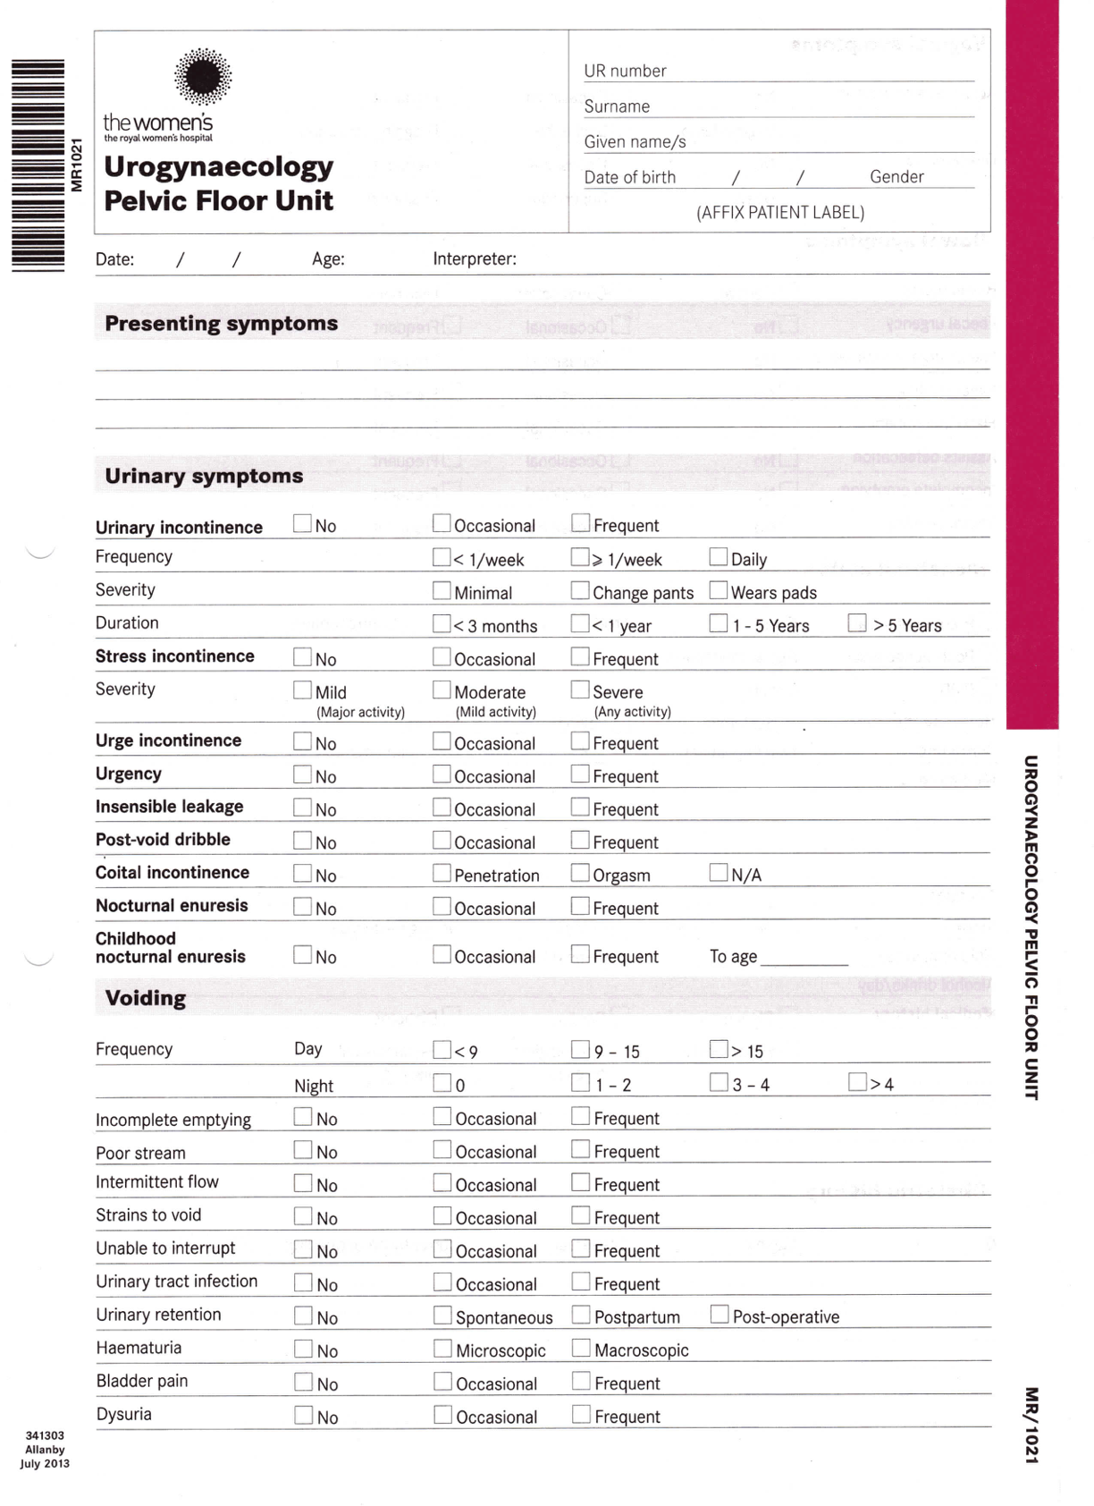
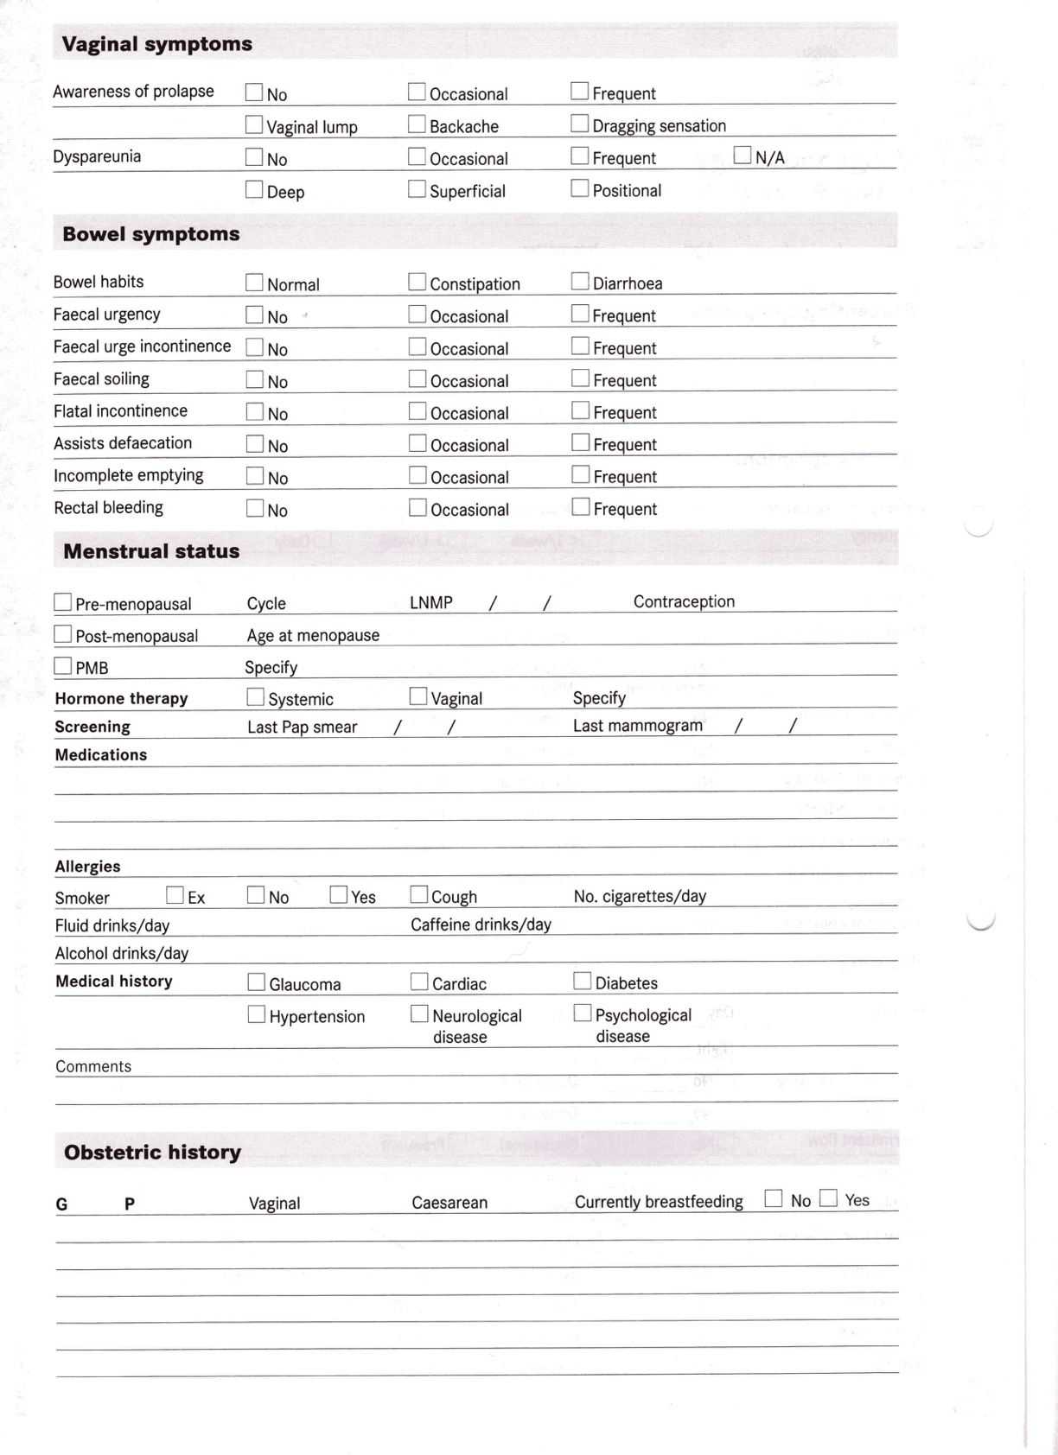

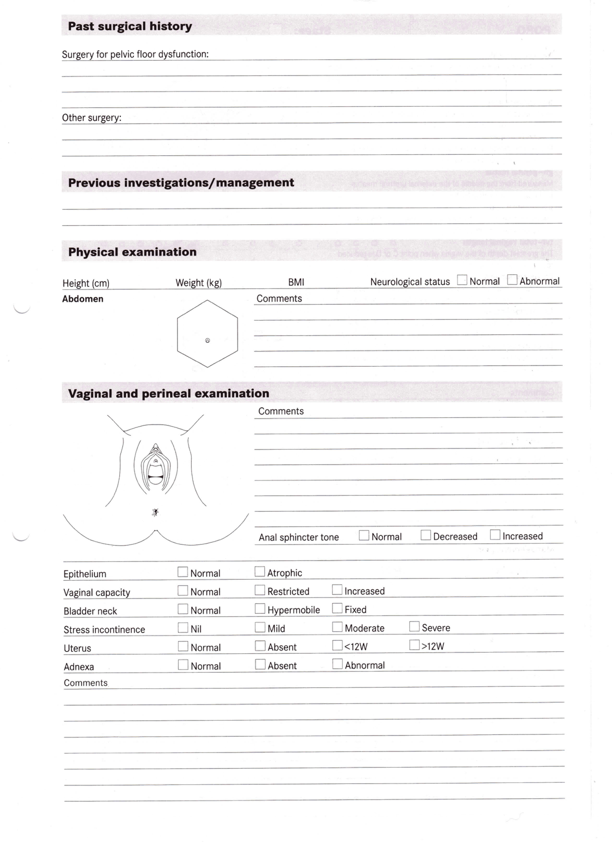

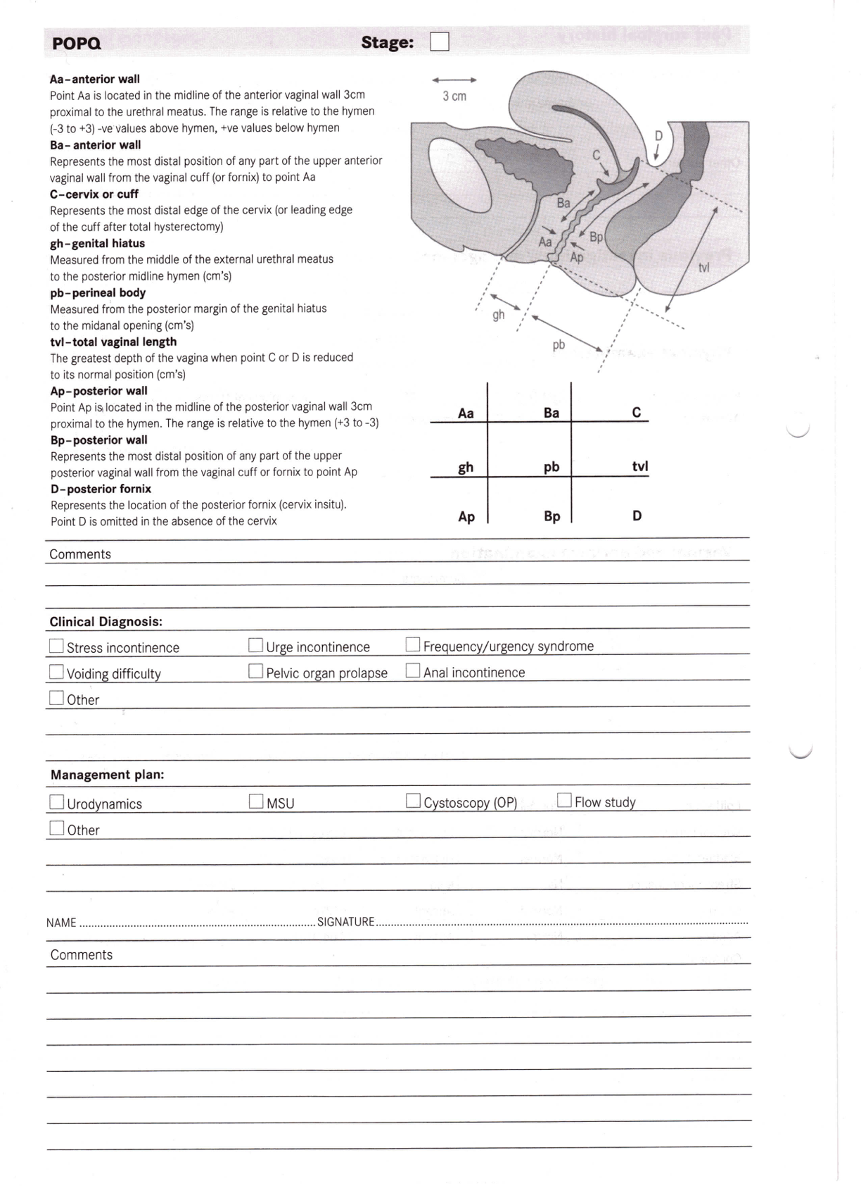

Appendix 2

PELVIC FLOOR DISTRESS INVENTORY - SHORT FORM 20 (PFDI-20)

Instructions: Please answer all of the questions in the following survey. These questions will ask you if you have certain bowel, bladder or pelvic symptoms and if you do how much they bother you. Answer these questions by putting an X in the appropriate box or boxes. If you are unsure about how to answer a question, give the best answer you can. While answering these questions, please consider your symptoms over the last 3 months.

EXAMPLE
For the following question:

If you do not usually have headaches just put an X in the ‘No’ box.
Do you usually experience headaches? | No |  | Yes
If yes, how much does this bother you? | 1  Not at All | 2  Somewhat | 3  Moderately | 4  Quite a Bit

If you do usually have headaches, put an X in the ‘Yes’ box and indicate how much the headaches bother you. (In this example, the headaches were moderately bothersome.)
Do you usually experience headaches? | No |  | Yes
If yes, how much does this bother you? | 1  Not at All | 2  Somewhat | 3  Moderately | 4  Quite a Bit

1. Do you usually experience pressure in the lower abdomen? | No  0 |  | Yes
1a. If yes, how much does this bother you? | 1  Not at All | 2  Somewhat | 3  Moderately | 4  Quite a Bit
2. Do you usually experience heaviness or dullness in the pelvic area? | No  0 |  | Yes
2a. If yes, how much does this bother you? | 1  Not at All | 2  Somewhat | 3  Moderately | 4  Quite a Bit

For Site Personnel Completion Only:
Site ID#: Subject ID#: UPH -
Date of Assessment (DD/MMM/YYYY): ___ ___ /___ ___ ___ /___ ___ ___ Check if Subject Did Not Complete:
Visit Type: Baseline 6 Months 12 Months

3. Do you usually have a bulge or something falling out that you can see or feel in the vaginal area? | No  0 |  | Yes
3a. If yes, how much does this bother you? | 1  Not at All | 2  Somewhat | 3  Moderately | 4  Quite a Bit
4. Do you usually have to push on the vagina or around the rectum to have or complete a bowel movement? | No  0 |  | Yes
4a. If yes, how much does this bother you? | 1  Not at All | 2  Somewhat | 3  Moderately | 4  Quite a Bit
5. Do you usually experience a feeling of incomplete bladder emptying? | No  0 |  | Yes
5a. If yes, how much does this bother you? | 1  Not at All | 2  Somewhat | 3  Moderately | 4  Quite a Bit
6. Do you ever have to push up on a bulge in the vaginal area with your fingers to start or complete urination? | No  0 |  | Yes
6a. If yes, how much does this bother you? | 1  Not at All | 2  Somewhat | 3  Moderately | 4  Quite a Bit
7. Do you feel you need to strain too hard to have a bowel movement? | No  0 |  | Yes
7a. If yes, how much does this bother you? | 1  Not at All | 2  Somewhat | 3  Moderately | 4  Quite a Bit
8. Do you feel you have not completely emptied your bowel sat the end of a bowel movement? | No  0 |  | Yes
8a. If yes, how much does this bother you? | 1  Not at All | 2  Somewhat | 3  Moderately | 4  Quite a Bit
9. Do you usually lose stool beyond your control if your stool is well formed? | No  0 |  | Yes
9a. If yes, how much does this bother you? | 1  Not at All | 2  Somewhat | 3  Moderately | 4  Quite a Bit
10. Do you usually lose stool beyond your control if your stool is loose or liquid? | No  0 |  | Yes
10a. If yes, how much does this bother you? | 1  Not at All | 2  Somewhat | 3  Moderately | 4  Quite a Bit

For Site Personnel Completion Only:
Site ID#: Subject ID#: UPH -
Date of Assessment (DD/MMM/YYYY): ___ ___ /___ ___ ___ /___ ___ ___ Check if Subject Did Not Complete:
Visit Type: Baseline 6 Months 12 Months

11. Do you usually lose gas from the rectum beyond your control? | No  0 |  | Yes
11a. If yes, how much does this bother you? | 1  Not at All | 2  Somewhat | 3  Moderately | 4  Quite a Bit
12. Do you usually have pain when you pass your stool? | No  0 |  | Yes
12a. If yes, how much does this bother you? | 1  Not at All | 2  Somewhat | 3  Moderately | 4  Quite a Bit
13. Do you experience a strong sense of urgency and have  to rush to the bathroom to have a bowel movement? | No  0 |  | Yes
13a. If yes, how much does this bother you? | 1  Not at All | 2  Somewhat | 3  Moderately | 4  Quite a Bit
14. Does a part of your bowel ever pass through the rectum  and bulge outside during or after a bowel movement? | No  0 |  | Yes
14a. If yes, how much does this bother you? | 1  Not at All | 2  Somewhat | 3  Moderately | 4  Quite a Bit
15. Do you usually experience frequent urination? | No  0 |  | Yes
15a. If yes, how much does this bother you? | 1  Not at All | 2  Somewhat | 3  Moderately | 4  Quite a Bit
16. Do you usually experience urine leakage associated with a feeling of urgency; that is, a strong sensation of needing to go to the bathroom? a feeling of urgency; that is, a strong sensation of needing to go to the bathroom? | No  0 |  | Yes
16a. If yes, how much does this bother you? | 1  Not at All | 2  Somewhat | 3  Moderately | 4  Quite a Bit
17. Do you usually experience urine leakage related to coughing, sneezing, or laughing? | No  0 |  | Yes
17a. If yes, how much does this bother you? | 1  Not at All | 2  Somewhat | 3  Moderately | 4  Quite a Bit
18. Do you usually experience small amounts of urine leakage (that is, drops)? | No  0 |  | Yes
18a. If yes, how much does this bother you? | 1  Not at All | 2  Somewhat | 3  Moderately | 4  Quite a Bit

For Site Personnel Completion Only:
Site ID#: Subject ID#: UPH -
Date of Assessment (DD/MMM/YYYY): ___ ___ /___ ___ ___ /___ ___ ___ Check if Subject Did Not Complete:
Visit Type: Baseline 6 Months 12 Months

19. Do you usually experience difficulty emptying your bladder? | No  0 |  | Yes
19a. If yes, how much does this bother you? | 1  Not at All | 2  Somewhat | 3  Moderately | 4  Quite a Bit
20. Do you usually experience pain or discomfort in the lower abdomen or genital region? | No  0 |  | Yes
20a. If yes, how much does this bother you? | 1  Not at All | 2  Somewhat | 3  Moderately | 4  Quite a Bit

Thank you for taking the time to complete this questionnaire.

For Site Personnel Completion Only:
Site ID#: Subject ID#: UPH -
Date of Assessment (DD/MMM/YYYY): ___ ___ /___ ___ ___ /___ ___ ___ Check if Subject Did Not Complete:
Visit Type: Baseline 6 Months 12 Months

Appendix 3

PELVIC ORGAN PROLAPSE/URINARY INCONTINENCE SEXUAL QUESTIONNAIRE (PISQ-12)

LEAD-IN QUESTIONS:
1. Which of the following best describes you? | Not sexually active at all
 | Sexually active with or without a partner (skip to PISQ-12)
2. The following list includes reasons why you might not be sexually active. For each one please indicate how strongly you agree or disagree with it as a reason that you are not sexually active (responses: Strongly agree, Somewhat agree, Somewhat disagree, Strongly disagree).
No Partner | Strongly Agree | Somewhat Agree | Somewhat Disagree | Strongly Disagree
No Interest | Strongly Agree | Somewhat Agree | Somewhat Disagree | Strongly Disagree
Due to bladder or bowel problems (urinary or fecal incontinence) or due to prolapse (a feeling of or a bulge in the vaginal area) | Strongly Agree | Somewhat Agree | Somewhat Disagree | Strongly Disagree
Because of my other health problems | Strongly Agree | Somewhat Agree | Somewhat Disagree | Strongly Disagree
Pain | Strongly Agree | Somewhat Agree | Somewhat Disagree | Strongly Disagree

If answered “not sexually active at all”, and completed #2, participant is done with this questionnaire (does not complete PISQ-12).

For Site Personnel Completion Only:
Site ID#: Subject ID#: UPH -
Date of Assessment (DD/MMM/YYYY): ___ ___ /___ ___ ___ /___ ___ ___ Check if Subject Did Not Complete:
Visit Type: Baseline 6 Months 12 Months

Instructions: Following are a list of questions about you and your partner’s sex life. All information is strictly confidential. Your confidential answers will be used only to help doctors understand what is important to patients about their sex lives. Please check the box that best answers the questions for you. While answering the questions, consider your sexuality over the past six months. Thank you for your help.

PISQ-12
- How frequently do you feel sexual desire? This feeling may include wanting to have sex, planning to have sex, feeling frustrated due to lack of sex, etc.
Daily Weekly Monthly Less than Never
once a month
- Do you climax (have an orgasm) when having sexual intercourse with your partner?
Always Usually Sometimes Seldom Never
- Do you feel sexually excited (turned on) when having sexual activity with your partner?
Always Usually Sometimes Seldom Never
- How satisfied are you with the variety of sexual activities in your current sex life?
Always Usually Sometimes Seldom Never
- Do you feel pain during sexual intercourse?
Always Usually Sometimes Seldom Never
- Are you incontinent of urine (leak urine) with sexual activity?
Always Usually Sometimes Seldom Never
- Does fear of incontinence (either stool or urine) restrict your sexual activity?
Always Usually Sometimes Seldom Never
- Do you avoid sexual intercourse because of bulging in the vagina (either the bladder, rectum or vagina falling out)?
Always Usually Sometimes Seldom Never
- When you have sex with your partner, do you have negative emotional reactions such as fear, disgust, shame or guilt?
Always Usually Sometimes Seldom Never
- Does your partner have a problem with erections that affects your sexual activity?
Always Usually Sometimes Seldom Never
- Does your partner have a problem with premature ejaculation that affects your sexual activity?
Always Usually Sometimes Seldom Never
- Compared to orgasms you have had in the past, how intense are the orgasms you have had in the past 6 months?
Much less intense Less Intense Same intensity More intensive Much more intense

For Site Personnel Completion Only:
Site ID#: Subject ID#: UPH -
Date of Assessment (DD/MMM/YYYY): ___ ___ /___ ___ ___ /___ ___ ___ Check if Subject Did Not Complete:
Visit Type: Baseline 6 Months 12 Months
Appendix 4

EQ-5D-3L – Health Questionnaire

Instructions: By placing a checkmark in one box in each group below, please indicate which statements best describe your own health state today.

1. Mobility: | I have no problems in walking about
 | I have some problems in walking about
 | I am confined to bed
2. Self-Care: | I have no problems with self-care
 | I have some problems washing or dressing myself
 | I am unable to wash or dress myself
3. Usual Activities (e.g. work, study, housework, family, or leisure activities): | I have no problems with performing my usual activities
 | I have some problems with performing my usual activities
 | I am unable to perform my usual activities
4. Pain/Discomfort: | I have no pain or discomfort
 | I have moderate pain or discomfort
 | I have extreme pain or discomfort
5. Anxiety/Depression: | I am not anxious or depressed
 | I am moderately anxious or depressed
 | I am extremely anxious or depressed

For Site Personnel Completion Only:
Site ID#: Subject ID#: UPH -
Date of Assessment (DD/MMM/YYYY): ___ ___ /___ ___ ___ /___ ___ ___ Check if Subject Did Not Complete:
Visit Type: Baseline 6 Months 12 Months

Best Imaginable Health State

To help people say how good or bad a health state is, we have drawn a scale (rather like a thermometer) on which the best state you can imagine is marked 100 and the worst state you can imagine is marked 0.

We would like you to indicate on this scale how good or bad your own health is today, in your opinion. Please do this by drawing a line from the box below to whichever point on the scale indicates how good or bad your health state is today.

Your Own Health State Today

6. Your own Health State Today: | Worst Imaginable Health State

For Site Personnel Completion Only:
Site ID#: Subject ID#: UPH -
Date of Assessment (DD/MMM/YYYY): ___ ___ /___ ___ ___ /___ ___ ___ Check if Subject Did Not Complete:
Visit Type: Baseline 6 Months 12 Months

Appendix 5

PELVIC ORGAN PESSARY SYMPTOMS QUESTIONNAIRES (POP-SQ)

Instructions: Please answer all of the questions in the following survey. These questions will ask you if you have certain vaginal symptoms and if you do how much they bother you. Answer these questions by putting an X in the appropriate box or boxes. If you are unsure about how to answer a question, give the best answer you can. While answering these questions, please consider your symptoms over the last 3 months.

1. Are you usually aware of the pessary in the vagina? | Yes |  | No
1a. If yes, how much does this bother you? | 1  Not at all | 2  Somewhat | 3  Moderately |  | 4  Quite a bit | 5  All the time
2. Do you usually notice some form of vaginal discharge? | Yes |  | No
2a. If yes, how much does this bother you? | 1  Not at all | 2  Somewhat | 3  Moderately |  | 4  Quite a Bit | 5  All the time
2b. How would you describe the consistency of the discharge? | 1  Thin | 2  Creamy |  | 3  Thick/cheesy
2c. How would you describe the colour of the discharge? | 1  Clear | 2  Pinky/brown | 3  White/pale yellow |  | 4  Green
3. Do you usually notice some form of smell associated with the vagina? | Yes |  | No
3a. If yes, how much does this bother you? | 1  Not at all | 2  Somewhat | 3  Moderately |  | 4  Quite a Bit |  | 5  All the time
4. Do you usually notice any itching or irritation of the vagina or vulva? | Yes |  | No
4a. If yes, how much does this bother you? | 1  Not at all | 2  Somewha | 3  Moderately |  | 4  Quite a Bit |  | 5  All the time
5. Have you sought medical help for symptoms of vaginal itch/irritation, discharge or smell since using the pessary? | Yes |  | No

For Site Personnel Completion Only:
Site ID#: Subject ID#: UPH -
Date of Assessment (DD/MMM/YYYY): ___ ___ /___ ___ ___ /___ ___ ___ Check if Subject Did Not Complete:
Visit Type: Baseline 6 Months 12 Months
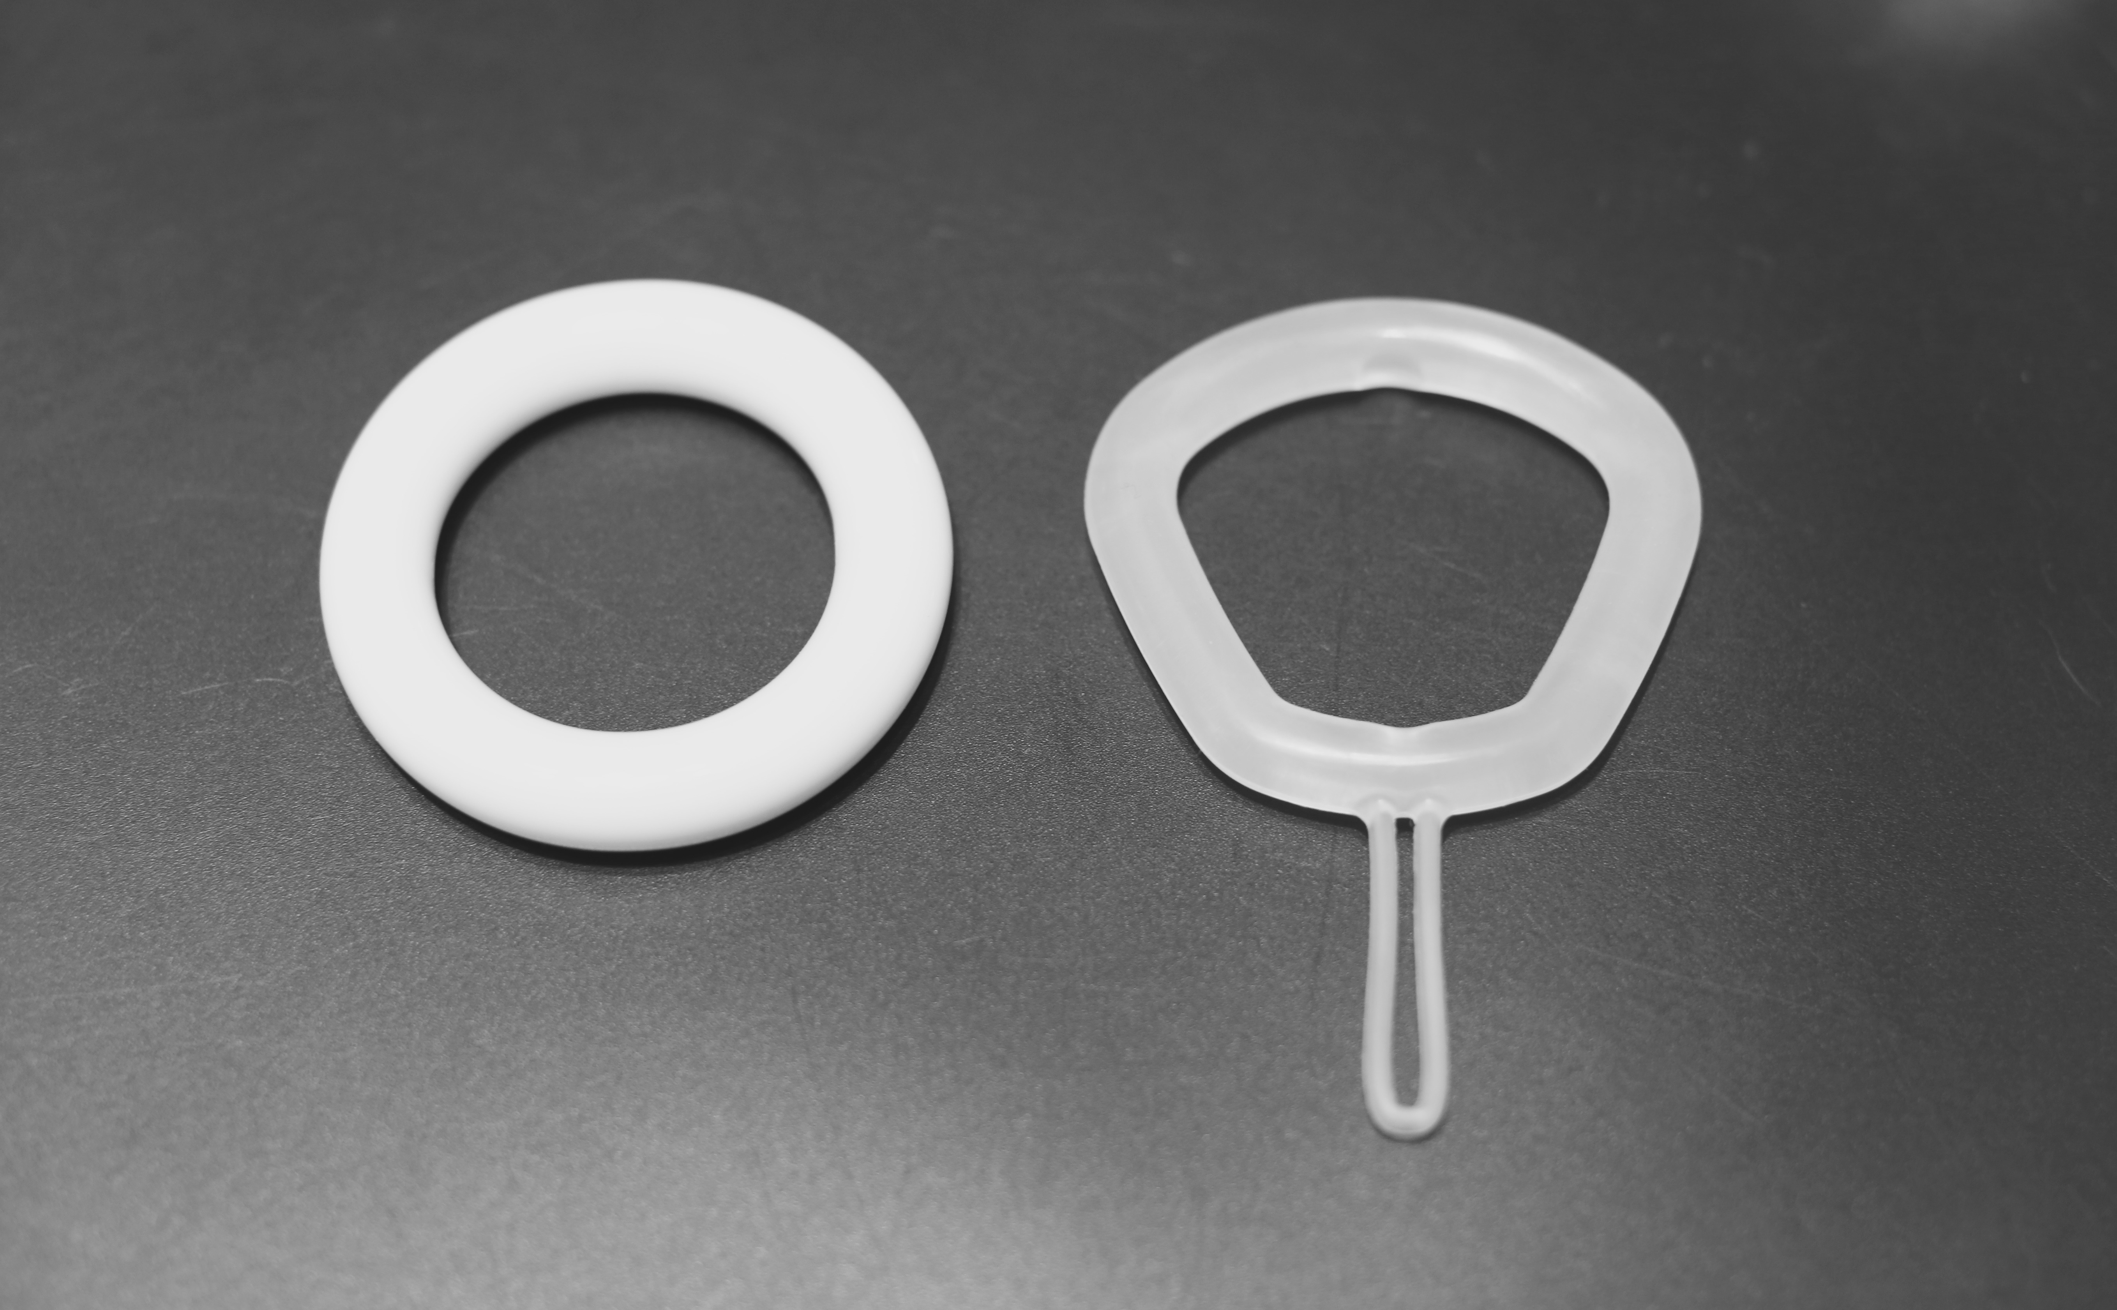
Figure 1: Conventional PVC Ring Pessary (left), Silicon Irregular Hexagon Pessary with loop attached (right)

References:
- Oliver R, Thakar R, Sultan AH. The history and usage of the vaginal pessry: a review. Eur J Obstet Gynecol Reprod Biol 2011; 156: 125-30
- ACOG Practice Bulletin No. 85: Pelvic organ prolapse. Obstetrics & Gynecology. 110(3): 717-29, 2007
- S Sarma, T Yong, K Moore. Long-term vaginal ring pessary use: discontinuation rates and adverse events. BJOG 2009;116:1715-1721
- Cundiff GN, Amundsen CL, Bent AE, Coates KW. The PESSRI study: symptom relief outcome of a randomized crossover trial of the ring and Gellhorn pessaries. Am J Obstet Gynaecol 2007;196:405.e1-405.e8
- JL Clemons, VC Aguilar, TA Tillinghast, ND Jackson, DL Myers. Risk factors associated with an unsuccessful pessary fitting trial in women with pelvic organ prolapse. AJOG 2004;190:345-50
- F Lone, R Thakar, A H Sultan, G Karamalis. A 5 year prospective study of vaginal pessary use for pelvic organ prolapse. Int Journal of Gyn & Obs 2011;114:56-59.
- Wu V, Farrell SA, Baskett TF, Flowerdew G. A simplified protocol for pessary management. Obstet Gynecol 1997;90:990-4.
- Sulak PJ, Kuehl TJ, Shull BL. Vaginal pessaries and their use in pelvic relaxation. J Reprod Med 1993;38:919-23.
- Handa VL, Jones M. Do pessaries prevent the progression of pelvic organ prolapse? Int Urogynecol J 2002;13:349-52.
- Bugge C, Adam EJ, Gopinath D, Reid F. Pessaries (mechanical devices) for pelvic organ prolapse in women (review). Cochrane Database of Systematic Reviews 2013, Issue 2. Art. No.: CD004010. DOI: 10.1002/14651858.CD004010.pub3.
- Singh R, Cornish A, Carey G, Al-Salihi S, Carey M. Vaginal dimensions in women with pelvic organ prolapse using vaginal cast (Abstract) – presented at IUGA (Nice) 2015
- Gould F, Tabrizi S, Twin J, Cornish A, Pizzo L, Garland S, Carey M. Analysis of biofilm on vaginal ring pessaries used for the treatment of pelvic organ prolapse: results from a pilot study (Abstract) – presented at IUGA (Nice) 2015
- CONSORT 2010 flow diagram. http://www.consort-statement.org
- BT Haylen, C Maher, M Barber, S Camargo, V Dandolu et al. An International Urogynaecological Association (IUGA)/International Continence Society (ICS) joint report on the terminology for female pelvic organ prolapse. Standardization and Terminology Committees IUGA and ICS. Joint IUGA/ICS Working Group on Female POP Terminology.
- Donovan J, Bosch R, Gotoh M, Jackson S, Naughton M, Radley S et al. Symptoms and Quality of Life assessment. 5th ICI Book 2013; chapter 10: page 519-584.
- Coelho SCA, Castro EB, Juliato CRT. Female pelvic organ prolapse using pessaries: systematic review. Int Urogynaecol J 2016 (Online)

