High Value Nutrition – Priority Program
Peak Nutrition for Metabolic Health [PANaMAH]

targeting amylin to restore insulin secretion and prevent progression to diabetes: identifying the efficacy of the plant-origin flavonoid rutin

Sally Poppitt¹, Ivana Sequeira¹, Wilson Yip¹, Mike Taylor¹
University of Auckland¹
New Zealand

In collaboration with
Professor Garth Cooper, CADET, University of Manchester, UK;
A/Prof Lindsay Plank, Department of Surgery Body Composition Unit, University of Auckland.

Study protocol

Principal Investigators

Prof. Sally Poppitt, PhD
Professor of Human Nutrition
Director, Human Nutrition Unit (HNU)
School of Biological Sciences & Institute for Innovation in Biotechnology
University of Auckland
s.poppitt@auckland.ac.nz

Dr Ivana Sequeira, PhD
Research Fellow
Human Nutrition Unit
University of Auckland, New Zealand
Email: i.sequeira@auckland.ac.nz

Wilson Yip
PhD Candidate
Human Nutrition Unit
University of Auckland, New Zealand
Email: w.yip@auckland.ac.nz

Jazmyne Xu
Research Associate
Human Nutrition Unit
University of Auckland, New Zealand
Email: yxu209@aucklanduni.ac.nz

Associate Investigators
Dr Rinki Murphy MBChB, PhD
Consultant endocrinologist, diabetes specialist
Senior Lecturer, Department of Medicine
University of Auckland & Auckland City Hospital
r.murphy@auckland.ac.nz

A/Prof. Mike Taylor, PhD
School of Biological Sciences
University of Auckland
m.taylor@auckland.ac.nz

Akarsh Mathrani
PhD Candidate
School of Biological Sciences
University of Auckland
amat116@aucklanduni.ac.nz

Collaborators
Prof. Garth Cooper MBChB, PhD
Professor in Discovery and Experimental Medicine
Centre for Advanced Discovery & Experimental Therapeutics (CADET)
University of Manchester, United Kingdom
garth.cooper@manchester.ac.uk
and
Professor of Biochemistry and Clinical Biochemistry
School of Biological Sciences
University of Auckland, New Zealand
g.cooper@auckland.ac.nz

A/Prof. Lindsay Plank, PhD
Head, Body Composition Unit
Department of Surgery
University of Auckland
l.plank@auckland.ac.nz

Dr. Simon Loveday, PhD
Senior Research Officer
Massey Institute of Food Science and Technology
Massey University
s.loveday@massey.ac.nz

Prof. HArjinder Singh, PhD
Director
Massey Institute of Food Science and Technology
Massey University
h.singh@massey.ac.nz

Public Summary
Weight gain and the poor metabolic health which develops as a consequence is rapidly becoming an important global health concern. More than 1.5 billion adults worldwide struggle to control their weight and are now overweight or obese, with rates rapidly increasing. The National Science Challenge High Value Nutrition (NSC-HVN) program is focused on developing nutritional solutions to maintain optimal health across a range of platforms, including body weight and metabolic health. The HVN program has a particular focus on the Asian region. Throughout Asia, including in China, an estimated 30% of adults are struggling with their body weight, of which 300 million have already been diagnosed with type 2 diabetes (T2D), the most common disease caused by overweight. T2D occurs when the body becomes resistant to the action of a key pancreatic hormone insulin and/or when the insulin secreting cells in the pancreas start to fail. Recent important evidence has now shown that another pancreatic hormone amylin is also important. Amylin circulating in the blood has the propensity to ‘misfold’ and then be deposited as toxic aggregates within the pancreas. This is a common occurance, found in >90% of patients with T2D. These amylin aggregates progressively replace the insulin-producing cells and is a major cause of failure of the pancreas and so the development of T2D.

The HVN Peak Nutrition for Metabolic Health [PANaMAH] platform aims to identify established and novel blood markers of increased T2D risk; and to undertake nutritional interventions that target these biomarkers and so decrease T2D progression in high risk individuals. Amylin ‘misfolding’ is one of these targets.

Plant-derived polyphenols such as the flavonol rutin, commonly found in fruits and a component of buckwheat (soba) noodles, may provide a novel nutrition approach. Our animal studies have shown rutin to prevent misfolding and aggregation of amylin in the pancreas and prevent T2D, but no human studies have yet been conducted. Importantly, dose and form of rutin delivery are key to defining the outcomes in these studies. Our program of research will conduct 2 studies: a pilot study to determine the pharmacokinetics of 2 doses and 2 delivery forms of rutin; and a 3 month rutin intervention in overweight, high risk pre-diabetic individuals to determine whether this polyphenol can improve secretion of insulin and thereby the function of the pancreas.

- Background
Type 2 diabetes - a global health concern
Diabetes and Adverse Metabolic Health have become a critical healthcare and economic problems globally (WHO, 2016) with over 90% of those diagnosed with diabetes classified as type-2 diabetes (T2D) (American Diabetes Association, 2012). The prevalence of T2D has dramatically escalated from 110 million people reported in 1994, to 382 million in 2013, and is predicted to further increase to 592 million by 2035 (Zimmet et al., 2014). This metabolic disorder is responsible for the death of approximately 1.5 million people annually and is a risk factor for cardiovascular disease (CVD), killing 13 million people worldwide each year and accounting for 25% of all-cause mortality (Lozano et al., 2012). T2D is not only a health concern for developed nations such as Western Europe, North America and Oceania, but recent alarming evidence shows increasing prevalence in developing Asian countries as well (Alberti and Zimmet, 2014); particularly China (Zuo et al., 2014, Yan et al., 2012, Wang et al., 2017, Xu et al., 2013), where T2D prevalence is estimated to reach 69% by 2030 in comparison to 20% in developed western countries (Shaw et al., 2010). New Zealand is no exception to these trends with the number of individuals with T2D having more than doubled in the last 10 years, with >250,000 individuals with this metabolic disease (Ministry of Health, 2016).
Weight gain (Ng et al., 2014) and an unhealthy diet and lifestyle (Temelkova-Kurktschiev and Stefanov, 2012) have been identified as the most significant risk factors for developing T2D. They lead to compromised energy homeostasis and lipo-regulation which may adversely promote the accumulation of fat in metabolically ‘risky’ deep subcutaneous and visceral compartments (Sniderman et al., 2007, Tene et al., 2018) rather than ‘safe’ superficial subcutaneous adipose compartments. Increased visceral adiposity - particularly ectopic deposition into key organs such as pancreas and liver may alter normal physiological control and worsen insulin resistance (IR) and pancreatic beta (β) cell dysfunction (Dickinson et al., 2002, Liew et al., 2003) thereby worsening risk of T2D.
Accordingly, ongoing strategies to manage T2D are aimed at diet and lifestyle changes. Several International T2D prevention trials (Knowler et al., 2002, Lindstrom et al., 2006, Ramachandran et al., 2006, Li et al., 2008) have shown that implementing lifestyle interventions in high-risk individuals can prevent or at least delay the progression to T2D by 50% (Liu et al., 2015). Diets characterised by both greater quantities and variety of plant-origin foods have been shown to improve glucose tolerance and decrease T2D risk (McMacken and Shah, 2017). While the precise mechanism by which they exert their beneficial effects are unknown (Kim et al., 2014), the ubiquitous polyphenolic phytochemicals contained within plants have been proposed to contribute to the delay in T2D progression (Dembinska-Kiec et al., 2008).

Amylin and the beta cell
The raised circulating levels of blood glucose, characteristic of T2D, typically occurs when insulin secretion and action is no longer sufficient to regulate glucose metabolism adequately (Ozougwu et al., 2013, Holt, 2004, Festa et al., 2006). In healthy individuals secretion of insulin from the pancreatic β cell in response to an increase in blood glucose maintains glucose levels at normal physiological concentrations, but in those with impaired glucose tolerance (IGT) or T2D the ability of insulin to maintain these levels is decreased. Commonly, when an individual gains adipose mass and develops obesity their tissues may become resistant to the action of insulin which, in addition to the gradual failure of the β cell to secrete sufficient additional insulin to overcome IR, may lead to T2D (Hardy et al., 2012). An adaptive increase in β cell mass can often overcome the problem of IR (Mondal et al., 2017), but when this is deficient it leads to significant hyperglycaemia and T2D. Increased apoptosis and deficient regeneration are cellular processes that have been shown to play a role in the insufficiency of β cell mass (Chen et al., 2017).
Recent studies have shown that the accumulation of islet amyloid polypeptide (IAPP) or human amylin (hA), worsens pancreatic function, observed in > 90% T2D patients (Jaikaran and Clark, 2001). hA is co-secreted with insulin in the pancreatic β cells in response to glucose stimuli. A major hypothesis is that hA metabolism ‘misfolds’ and becomes defective causing it to accumulate and aggregate in β cells (Aitken et al., 2010). Whilst in healthy islet β cells hA monomers have normal biological activity wherein aggregates can form and undergo degradation, it is unclear why this process is dysregulated in IR and T2D (Mukherjee et al., 2015); what predisposes to aggregation and formation of fibrils. The deposition of these amyloid fibrils progressively replace insulin-producing cells and are cytotoxic to pancreatic β cells (Butler et al., 2003, Konarkowska et al., 2006a, Leighton and Cooper, 1988). Furthermore, defective hA metabolism has been shown to up regulate pro-apoptotic genes (Tucker et al., 1998) and increase the expression of apoptotic markers (Saafi et al., 2001) in cultured β cells and transgenic animal models susceptible to hA-evoked diabetes. The use of ttransgenic animal models with β cell-specific hA expression have been key to elucidating amyloid cytotoxicity as they replicate the human T2D phenotype of islet changes to develop a diabetic syndrome. Amylin aggregation and consequent apoptosis and loss of β cell mass disrupts insulin secretion, triggers IR and hyperglycaemia (Zhang et al., 2014) to increase risk of developing T2D (Konarkowska et al., 2006a).

Flavonoids: Quercetin & Rutin
Amyloid deposits are in a dynamic state of turnover and have been shown to regress if fibril formation is inhibited (Gillmore et al., 1997). Preventing or arresting the formation of hA related β cell failure at an early stage of T2D may preserve endogenous insulin secretion and prevent or delay hyperglycaemia. A large body of work conducted by Cooper and colleagues using in vitro, cellular and molecular studies on hA aggregation and cytotoxicity (Green et al., 2003, Aitken et al., 2003, Konarkowska et al., 2006b, Goldsbury et al., 1997, Goldsbury et al., 1999, Zhang et al., 2008, Cooper et al., 1987) have established classes of compounds that can suppress amylin aggregation and cytotoxicity in vitro, and employed transgenic mice to determine in vivo efficacy (Aitken et al., 2010). The antibiotic tetracycline was one such candidate compound (Aitken et al., 2003) that showed powerful anti-diabetic activity in hA transgenic mice via preservation of β cell structure and function, insulin secretion and suppression of β cell death (Aitken et al., 2010). This effect attributed to the unique aromatic ring structure of tetracycline that allows it to bind to hA to inhibit aggregation (Forloni et al., 2001, Stoilova et al., 2013).
Ubiquitous dietary phytochemicals or polyphenols have long since been recognised to have a role in preventing and managing T2D (Bahadoran et al., 2013, Xiao and Hogger, 2015). The mechanisms principally linked to anti-oxidative properties but more recently to beneficial effects in improving pancreatic β cell function (Dall'Asta et al., 2015). In particular are polyphenol flavonoids that have been shown to act as small molecule inhibitors that prevent amyloid formation (Porat et al., 2006, Ngoungoure et al., 2015) with evidence to show that insoluble hA fibrils are amenable to flavonoids (Aitken et al., 2014). Cooper and group have established in vitro studies showing that two key flavonols, rutin and quercetin, are potent inhibitors of hA aggregation (Aitken et al., 2017b) and share structural similarities to tetracycline.
Importantly, rutin and quercetin do not exhibit potential side effects associated with tetracycline. In addition to better risk-profile rutin, in particular, has been shown to exert anti-diabetic activity in hA transgenic mice (Fig 1). Therefore, rutin (and quercetin) supplementation may be important for the development of anti-diabetic medicines and food extracts that could suppress β cell degeneration and T2D in human populations.
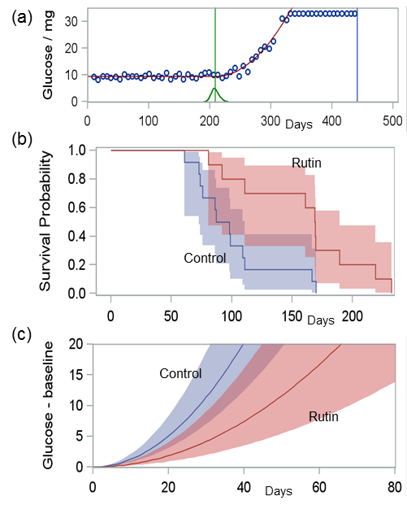
Figure 1: Effect of rutin treatment on survival from diabetes onset in hemizygous hA transgenic mice. Treatment with rutin (n=10, 0.5 mg/ml in drinking water) or control (n=12; water only) was administered from 21 days of age (weaning) and blood glucose measured weekly. Diabetes onset, defined as the point when glucose accelerated from baseline, was inferred by Bayesian change-point regression with SAS 9.3. (a) shows the glucose profile of one mouse with fitted baseline and acceleration phases (red curve); inferred change-point mean (green vertical line) and uncertainty (green posterior distribution); and day of death (blue vertical line). (b) Kaplan-Meier curves illustrate a substantive increase in post-diabetic lifespan from the estimated change-point means (log-rank test; p=0.008). Rutin also delayed onset of polydipsia (p=0.002), and (c) substantively retarded acceleration of post-diabetic glucose levels (t-test; p=0.019) (Aitken et al., 2017a, Aitken et al., 2017b)

Quercetin and rutin are closely related flavonoids, rutin being the glycoside or rutinoside of quercetin (Zhang et al., 2006) and found in a number of fruits and vegetables, e.g. apple skin, raw onion, buckwheat, green tea and cocoa powder (Bhagwat et al., 2014). Bioavailability from dietary sources is however limited (Scalbert and Williamson, 2000, Manach et al., 2005) with quercetin and rutin absorbed in the small and large bowel respectively (Hollman et al., 1999). The beneficial effects of rutin as an antioxidant have been observed in human trials, administered once daily over 6 – 8 weeks, using a 500 mg dose (Boyle et al., 2000, Sattanathan et al., 2011). This concentration is equivalent to that used to ameliorate amyloid deposits in hA transgenic mice (Aitken et al., 2017b) and has been shown to increase circulating rutin and quercetin levels by at least 2.5 fold (Boyle et al., 2000). However there have been no human intervention studies to date that have investigated the effect of this dose of rutin in improving pancreatic β cell function to establish the wider effects that have been observed in vitro and in animal studies. Using flavonoid rutin to target cytotoxic deposits appears to be a rational, promising, novel therapeutic approach, given its favourable ring structure that allows it function as a potent inhibitor of amylin aggregation. Of consideration, however, are key biological processes that could limit the metabolism and absorption of administered rutin.

Safety – dose
Rutin has been consumed within foods for hundreds of years. Extracts have also been consumed as encapsulated supplements for many years, and are widely sold at health food shops in New Zealand and globally. The recommended daily dose for supplements is up to 500mg/day. Commercial sources of encapsulated supplements include Solgar Laboratories Rutin 500mg, Lamberts Rutin and Vitamin C 500mg; also Naturals Activated Quercetin 1000mg. Rutin has also been evaluated in clinical trials investigating skin ailments and wound healing, bone health (osteoarthritis) and diabetes risk, at doses of <50mg-500mg. (See Appendix 1 for list of Clinical studies using rutin).

Microbiome
The gut contains millions of bacteria (gut bugs) which recent research have shown to be associated with good or poor health and are known as the ‘microbiome’. Gut bugs are associated with being either lean or overweight, and healthy or diabetic and have been shown to modulate biological functions in obesity (Haro et al., 2016), T2D (Mejia-Leon and Barca, 2015), and cardiovascular disease (Tang et al., 2017). Although dietary polyphenol intake is varied, bioavailability and bioefficacy is dependent on gut microbial composition (Cardona et al., 2013), this particularly important in relation to rutin which undergoes bacterial fermentation and absorption in the colon (Hollman et al., 1999). Hence characterisation of the microbiome and exploration of its role in metabolic disease is of interest to the program. Most reliable methods to sequence the DNA from the microbiome come from studies that use quantitative polymerase chain reaction (qPCR) (Ott et al., 2004).

- Study Objectives
The objectives of this study are to determine:

- The optimal dose and pharmacokinetics of rutin, through evaluation of bioavailability in the gastrointestinal tract

- The efficacy of rutin to target amylin aggregates in the pancreas and restore insulin secretion and prevent progression to T2D

- The response of T2D-related blood biomarkers to rutin intervention

2.1 Study Aims
The aims of the study are to assess:
- The rate of absorption, distribution, metabolism and excretion of 2 rutin doses, 250 mg and 500mg, in plasma and urine in a pilot cross over pharmacokinetic study in healthy individuals
- Pancreatic β-cell function; where insulin secretion is measured as incremental area under the curve (AUC) for C-peptide and glucose, in response to a 3 month (500 mg/day) rutin intervention in overweight pre-diabetic individuals
- Established (glucose, insulin, amylin, lipid profile) biomarkers related to dysglycaemia and T2D, in response to a 3 month (500 mg/day) rutin intervention in overweight pre-diabetic individuals
- Gut microbiome, at community and ‘species’ (OTU, operational taxonomic unit) level, in response to a 3 month (500 mg/day) rutin intervention in overweight pre-diabetic individuals

- Methods

3.1 Trial Design
This trial will be conducted in 2 phases: the first will characterise and compare the pharmacokinetics (PK) of 2 doses; 250 and 500 mg of rutin (once a day), and 2 delivery methods; encapsulated and within a food, in a cross over pilot study over 24 hours in healthy male and female participants
The second will investigate the efficacy of 500 mg rutin (qd., i.e. once per day), in a double blind randomised 3-arm placebo controlled parallel study over 3 months (12 weeks) in overweight (BMI 23-35kg/m²) male and female participants between 18-65 years of age, with demonstrated prediabetes based on the American Diabetes Association (ADA) criteria (American Diabetes Association, 2016), i.e. fasting plasma glucose (FPG) ≥5.6 - 6.9 mmol/L. Risk of prediabetes will additionally also be determined using the international validated Finnish Diabetes Risk Score (FINDRISC), based on risk measures reported by the participants at pre-screening visit.

3.1.1 PK study
The PK study will be a randomised, 2 x 2 arm cross-over study conducted over 24 hours (1 day) in 6 participants, male or female; with 2 week washout between treatments (Fig.2).
- Rutin, 250 mg
- Rutin, 500mg
- Capsule
- Rutin enriched yogurt.
Participants can complete (2 x encapsulated rutin) or (2 x food supplemented rutin); or 4 treatments . Characterisation and comparison of PK properties of each dose (250 mg and 500 mg) of rutin consumed once a day from an over the counter (OTC) supplement and a food product will be measured over 24 hours.
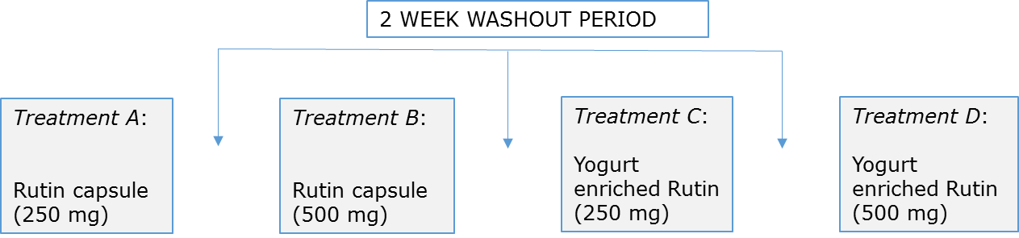

Figure 2: Study design with 4 randomised cross-over treatments.
3.1.2 intervention study
The intervention study will be a double blind randomised, 3-arm placebo controlled parallel-study conducted over 12 weeks (3 months) in 93 participants, 31 participants in each intervention group (Fig. 3). Each participant will be required to consume the assigned intervention once daily over the 12 week period, as part of their breakfast meal.

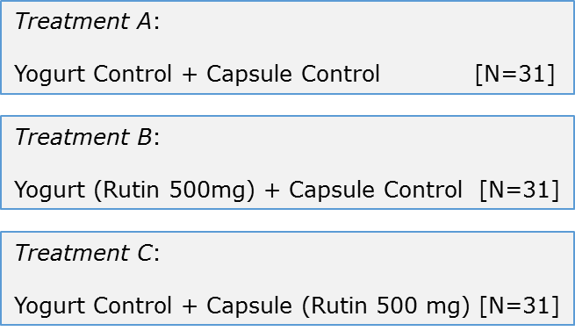
Figure 3: Study design with 3-arm randomised parallel treatments.

3.2 Randomisation

3.2.1 PK study
Each participant will be randomised to receive 1 of 4 rutin treatments administered once a day, at 4 study visits conducted at least 2 weeks apart from each other. This will allow for the participants to be followed up for 1 week following each study visit to monitor adverse events (AE).

3.2.2 intervention study
Participants will be randomised to receive one of the 3 treatments: yogurt control + capsule control, yogurt containing 500 mg rutin + capsule control, 500 mg encapsulated rutin + yogurt control, once daily over 3 months (12 weeks). Therefore this will be a double blind study where each participant will have to consume a capsule and a yogurt.

3.3 Participants

3.3.1 PK study, N = 6
6 healthy adults (male and female) will be recruited based on the following inclusion criteria:
- Aged between 18-65 years
- BMI between 23-35 kg/m²
- Fasting plasma glucose (FPG) < 5.6 mmol/L
- Healthy, as per self-report
Participants will be ineligible if they have low serum ferritin levels (women < 20 μg/L; men < 10 μg/L), if they have donated blood within the last month, or if they meet any exclusion criteria listed in Table 1.

3.3.2 intervention study, N = 93
93 adults will be recruited (31 participants in each group), based on the following inclusion criteria:
- Aged between 18-65 years
- BMI between 23-35kg/m²
- Fasting plasma glucose (FPG) ≥ 5.6 – 6.9 mmol/L (ADA, 2016)
- FINDRISC ≥15 (Silvestre et al., 2017)
- Otherwise healthy by self-report
Participants will be ineligible if they meet any of the exclusion criteria listed in Table 1.

Table 1: Exclusion criteria used during participant screening (telephone pre-screen and screening visit at Human Nutrition Unit) at recruitment
- Type 2 or type 1 diabetes
- Other significant disease including cardiovascular disease, pancreatic disease or cancer; or digestive disease including inflammatory bowel syndrome/disease (IBS/D), ulcerative colitis (UC), Crohn's disease
- Medications controlling glycaemia
- Current use of rutin or quercetin supplements
- Recent body weight loss/gain >10% within previous 3 months or taking part in an active diet program; or current medications for weight loss
- Dislike or unwilling to consume food items included in the study, or hypersensitivities or allergies to these foods, i.e. rutin allergy, lactose intolerant, does not consume yogurt
- Pregnant or breastfeeding women
- Unwilling/unable to comply with study protocol
- Concurrent participation in other clinical studies, or such participation within the last 3 months

3.4 Power calculation
Power calculation for the Intervention study was conducted using SYSTAT 13 (Systat Software Inc., Chicago, IL) (Wilkinson, 2010) and was based on a known mean (±SD) adult incremental area under the curve of C-peptide: glucose (0.53 nmol/mmol ± 0.23) following a standard 75g oral glucose tolerance test (OGTT) (Utzschneider et al., 2007). A sample size of 81 participants in total would have at least 80% power at 5% level of significance to detect a 20% difference in pancreatic β cell function, measured as:
β cell insulin secretion = inc (AUC_{c-peptide})/(AUC_{glucose})
With an estimated 10% dropout rate, a total sample size of 93 participants, 31 participants per group, will be recruited in the Intervention Study.

3.5 Participant Recruitment and Screening
Recruitment will be conducted in the Auckland region. Those individuals interested in participating will be invited to contact the Human Nutrition Unit for written information on the studies. Those participants involved in previous studies as part of the national Science Challenge High Value Nutrition PANaMAH program (HDEC ref: 16/STH/23 and 17/NTA/144), and who consented to being contacted for future studies, will also be invited to participate in this study.
Data on gender, age, ethnicity, reported body weight and height, FINDRISC score (Appendix 2), brief medical record, current medications, supplement intake will be collected via telephone/online screening questionnaire to ensure that inclusion/exclusion criteria are met prior to attendance at the research clinic.

3.6 Clinic Visits
3.6.a Screening Visit
All participants will be fasted overnight prior to attending the screening visit at the Human Nutrition Unit, Mount Eden, Auckland. During the screening visit, a participant information sheet (PIS) will be provided to individuals and the study will be explained by the research staff. Written informed consent will be obtained from each of the participants. They will then be screened for eligibility. Demographics (age, gender, and ethnicity), medical history and medication and supplement intake will be recorded. As the efficacy of rutin will be tested in these studies, diet information will be collected in order to calculate background dietary rutin (and quercetin) intake. Additionally anthropometry (height, body weight, waist and hip circumference, BMI and blood pressure) will be recorded. A blood sample will be collected for either; (i) fasting glucose levels to confirm eligibility to the intervention study, (ii) iron status to confirm suitability for cannulation and repeat blood draws during the PK study. If participants are eligible they will be asked to maintain a low quercetin/rutin diet. Fruits and vegetables containing > 15mg quercetin/kg and beverages containing more than 4 mg quercetin/L will be restricted (Boyle et al., 2000) 5 days prior to and during both study periods. Written and verbal instructions on low rutin (and quercetin) diet including a list of permitted and restricted (moderate – high rutin or quercetin) vegetables, fruits, spices, beverages will be provided.

3.6.b Study Visit
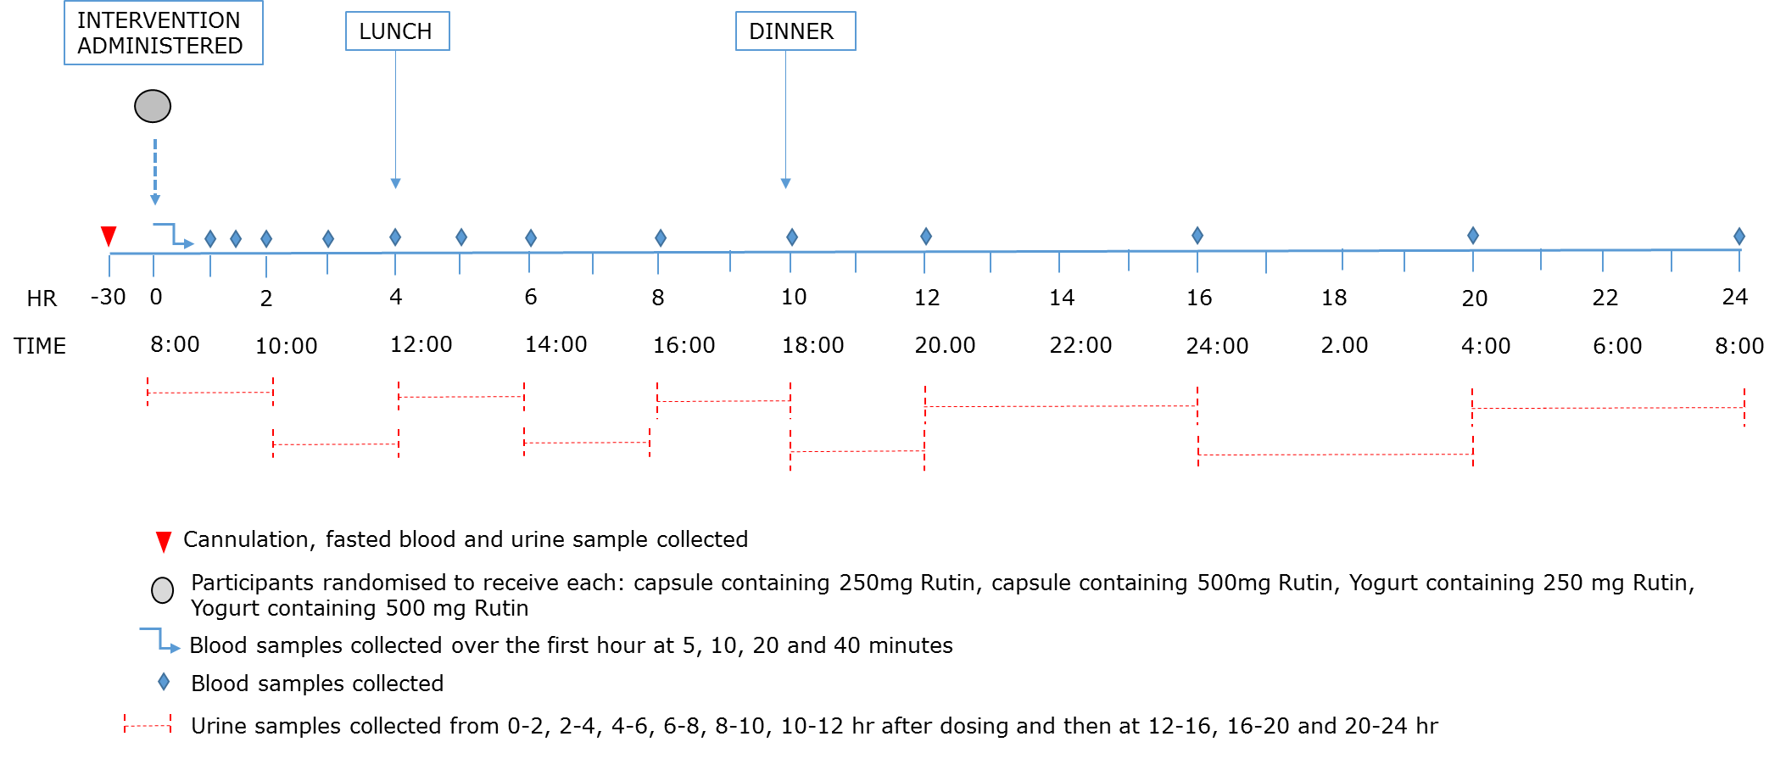
3.6.b.1 PK study
Participants will arrive at the Human Nutrition Unit (HNU) at 7.00 am following an overnight fast (water only) and remain at the facility until 9.00 am the following day. They will be supervised/monitored by Research Staff over the 24 hour study period. Upon arrival, they will be given a 250mL glass of water and anthropometric measurements recorded. A peripheral venous cannula will be inserted by the Research Nurse in order to facilitate repeated blood sampling (Fig. 4), and a fasted baseline blood (3mL) will be collected. Additionally a fasted urine sample will also be collected.

Figure 4: Summary of protocol during clinical visit for the PK study

Treatments (capsule or yoghurt) will be consumed with a glass of water. Blood samples (3mL each) will be collected at baseline and at 5, 10, 20, 40, 60, 90, 120 minutes and thereafter at 3h, 4h, 5h, 6h, 8h, 10h and 12h and then every 4 h, i.e. 16h, 20h and 24 h following the ingestion of rutin (Fig. 4). A total of 54 ml of blood will be collected over these 18 blood collection time points. Participants will also be asked to collect urine samples at baseline and at the following time intervals during the 24 h period after dosing 0-2, 2-4, 4-6, 6-8, 8-10, 10-12 h after dosing and then at 12-16, 16-20 and 20-24 h (Fig. 4).
Participants will receive 250mL water 2h after rutin treatment and a standardised lunch 4h (12 pm) and dinner 10 h (6 pm) post treatment. After the initial 2 hours participants will be allowed unlimited water intake throughout the day. Other drinks will not be allowed. Participants will be followed up by telephone interview for 1 week after each study visit to record any AEs or concomitant medications.

3.6.b.2 Intervention study
At Clinical Investigation Day (CID) 1 (baseline: start of intervention, week 0) and at CID 4 (end of intervention, week 12), participants will arrive at the Human Nutrition Unit between 8am and 9am after an overnight fast (Fig. 5). Upon arrival, the participant will be given 250mL water, anthropometric measurements will be recorded, and a peripheral venous cannula inserted to facilitate repeat blood sampling. A 2h standardised oral glucose tolerance test (OGTT) will be conducted using a 75g glucose drink. Blood will be collected (5mL each) at baseline (fasting t=0) and at 30min (t=30), 60min (t=60), 90min (t=90) and 120min (t=120) following consumption of the glucose drink.
A fasted urine sample will also be collected; and participant provided with a faecal sample kit plus both verbal and written instructions provided according to standard operating procedures. Breakfast will be provided to participants following the OGTT. DXA scan will also be performed to assess body composition at Auckland City Hospital. Compliance to the dietary restrictions and rutin treatment will be assessed at CID 1 and CID 4; participants will be asked to complete a 4 day food record (3 week days and 1 weekend).
Additional visits every 4 weeks: CID 2 (week 4) and CID 3 (week 8) (Fig.5), for anthropometry and fasting blood sample to assess compliance and efficacy outcomes. AEs and change in medication will be recorded. Participants will also collect their assigned intervention to be consumed during the 4 week period.
SCREENING & RANDOMISATON OF ELIGIBLE PARTICIPANTS TO EACH OF THE THREE INTERVENTION ARMS (WEEK -1)
CID 1
CID 2
CID 3
CID 4
WEEK 0
WEEK 4
WEEK 8
WEEK 12
Blood (fasting and post OGTT), urine and faecal samples collected. Anthropometry recorded and body composition assessed by DXA. 4 day food record completed
Fasted blood samples collected. Anthropometry, adverse events (if any) and compliance recorded. Collection of assigned intervention for following 4 weeks

Figure 5: Summary of Clinical visits to be conducted during Intervention study

3.7 Compliance
Compliance will be assessed at each CID. Each participant assigned to each of the interventions (control; 500mg rutin) will retain lids from the yoghurt pottles and retain bottle plus any remaining capsules. Blood samples will be analysed for circulating rutin concentration using a validated method developed on a high resolution Q-Exactive Orbitrap mass spectrometer. Additionally, dietary compliance to low polyphenol, rutin and quercetin, consumption will also be assessed using a 4 day food record (3 week days and 1 week end). Polyphenol intake will be calculated by matching food consumption data with the recently developed Phenol-Explorer database (www.phenol-explorer.eu) (Neveu et al., 2010).

3.8 Dual energy x-ray absorptiometry [DXA]
DXA is based on the 3 component model of body composition, and uses 2 x-ray energies to measure body fat mass, lean mass, and bone mineral density. A rapid scan iDXA (GE-Lunar, Madison, WI) designed to allow scanning of larger individuals with high body weight and BMI will be used. The participant is required to lie recumbent on the open scanner bed for ~10 minutes. Body composition comprising total body fat, fat-free soft tissue and bone mineral content as well as regional fat deposition will be determined from DXA whole-body and segmental scans.

3.9 Microbiome
The test can be done on a very small stool sample. Participants will be given a routine home faecal sample collection kit at screen/CIDs, plus instructions for use. They will return the sample on their next study visit day. The stool sample collection kit will contain a finger vial with scoop into which the faecal sample is collected. This is then sealed within a larger water filled pottle to ensure no external contamination, and frozen at -20°C. Samples are later transferred to a -80°C freezer until analysis. Microbial community composition will be analysed by sequencing of 16S ribosomal RNA (16S rRNA) genes using the Illumina MiSeq platform. In brief, DNA will be extracted from all stool samples and bacterial 16S rRNA genes will be amplified through PCR. By utilising Illumina’s dual-indexing approach, samples will be sequenced. Bioinformatics and statistical analyses of the obtained 16S rRNA gene sequences will be performed using a previously established pipeline. Quantitative PCR (qPCR) will determine potential proportional changes among key taxa and operational taxanomic units (OTU, ‘species’ level).

3.10 Metabolomics platform (if funding available)
Metabolomics allows comprehensive high through-put measurement of a broad spectrum of metabolites with different chemical properties, utilising state of the art gas chromatography-mass spectrometry (GC-MS) and liquid chromatography-high resolution mass spectrometry (LC-HR MS). The platform will utilise a non-targeted mass spectrometry based (MS) approach to measure multiple metabolites from venous blood samples across a large dynamic range.
A combination of multiple extraction solvents and analyses optimised for different metabolite polarity classes i.e. lipids, polar compounds such as amino acids, nucelotides etc., will be used. High resolution LCMS streams will be used for polar, semi-polar and non-polar metabolites, and GCMS for other polar metabolites not measurable by LCMS Identifications performed using in-house and external libraries, plus high resolution MS/MS to determine metabolite class, molecular formula for identification where required. Polar/semi-polar metabolites will be extracted from plasma and measured by LCMS using HILIC (hydrophilic interaction liquid chromatography) system coupled to high resolution Orbitrap MS detector; also TMS derivatisation and metabolites measured by GCMS; also LCMS using C18 (reverse phase) chromatography system coupled to a high resolution Orbitrap MS detector. Non-polar metabolites will be extracted from plasma and measured by LCMS using a CSH (modified reverse phase) chromatography system coupled to high resolution Orbitrap MS detector. In addition to high resolution detection of the molecular ion, this analytical system will collect fragmentation spectra of the major non-polar components to enable in-silico identification using the Thermo Lipid Search software package.

3.11 Outcome Variable

3.11.1 PK Study
Primary
Plasma rutin
- Time to reach maximum plasma concentration [T_{max} (min)]
- Maximum plasma concentration [C_{max} (pg/mL)]
- Terminal elimination half-life [t_{1/2} (min)]
(Erlund et al., 2000)

Secondary
- Area under the concentration curve [AUC (pg/mL)]
- Clearance/bioavailability [CL/F (liters/min)]
- Volume of distribution/bioavailability (Vd/F)
- Terminal elimination rate constant [λ_{n} (min⁻¹)]
(Graefe et al., 2001, Chow et al., 2001)

Other
- Phenolic catabolites such as 3,4-dihydroxyphenylacetic acid, 3-methoxy-4-hydroxyphenylacetic acid and 3-hydroxyphenylacetic acid (methods being developed at the Auckland Medical School, University of Auckland)
- Urine rutin

3.11.2 Intervention study
3.11.2.1 baseline assessments
- Plasma rutin
- Biochemistry panel including glucose, insulin, C-peptide, Hb_{A1c}, amylin, full lipid profile, inflammatory cytokines (TNF-α, IL-6, IL-10), hsCRP, adiponectin, metabolomics profile (if funding available) as well as associated obesity-related biomarkers. Urine analyses, faecal analyses for microbiome profile. Body composition: total fat and lean mass
3.11.2.2 response to intervention
Primary
- Pancreatic β cell insulin secretion assessed as incremental area under the concentration-time (AUC) curve for C-peptide and glucose
β cell insulin secretion = inc (AUC_{c-peptide})/(AUC_{glucose})

Secondary
- Biochemistry panel including glucose, insulin, amylin, C-peptide, Hb_{A1c}, full lipid profile, inflammatory cytokines (TNF-α, IL-6, IL-10), hsCRP, adiponectin, and associated obesity-related biomarkers, as collected at fasted baseline.
- Plasma rutin

Other
- Microbiome: faecal collection
- Metabolomics profile (if funding available)

3.12 Blood Parameters

3.12.1 Pk study
- Rutin
- Phenolic catabolites such as 3,4-dihydroxyphenylacetic acid, 3-methoxy-4-hydroxyphenylacetic acid and 3-hydroxyphenylacetic acid (methods being developed at the Auckland Medical School, University of Auckland)
- Iron studies, including serum ferritin (women < 20 μg/L; men < 10 μg/L)

3.12.2 Intervention study
3.12.2.1 screening (fasted sample)
Inclusion/exclusion criteria will be assessed during screening:
- Glucose

3.12.2.2 baseline (fasted sample)
Biomarkers of cardiovascular and diabetes risk will be measured fasted at the beginning of each test day, including:
- Glucose, Hb_{A1c}
- Insulin, C-peptide, Amylin
- Cholesterol (total-C, LDL-C, HDL-C); triglyceride
- Adiponectin
- Inflammatory markers, including IL-6, IL-10, TNF-α, hsCRP
- Liver function (AST, ALT, ALP, GGT)
- Rutin and metabolites
- Metabolomics profile (if funding available)

3.12.2.3 ogtt samples
Repeat venous blood samples will be collected by cannulation for measurement of:
- Glucose
- Insulin, C-peptide
- Rutin and metabolites
- Metabolomics profile (if funding available)

3.13 Faecal Samples

3.13.1 Intervention study
Faecal samples collected for microbiome analyses at:
- Baseline (week 0)
- Post intervention at week 12
4. Ethics Approval
Human ethics approval to conduct this study will be obtained from the Auckland Health and Disabilities Committee (HDEC), Auckland, New Zealand.

5. Trial Registration
The trial will be registered with the Australia New Zealand Clinical Trials Registry (ANZCTR).

6. Risks and Benefits
Dose of rutin (500 mg/day) used in the studies is considered safe. Previous human trials have administered rutin at this dose over a period of 6-8 weeks with no reported adverse effects. Furthermore, quercetin, obtained from rutin, up to a dose of 500 mg/day has received Generally Recognised as Safe (GRAS) status by the United States Food and Drug Administration (USFDA, 2010). Furthermore, both quercetin and rutin are commercially available in the form of supplements and in enriched food and beverage products (Details listed in Appendix 1).
Collection of blood samples is done by venous cannulation, which may result in mild discomfort for the participant. The participant will be monitored by a research nurse throughout the day and no adverse events are expected. Participants will be continuously monitored at all study visits and following the visits by telephone interview, over the study period, by the research staff.
Dual Energy X-Ray Absorptiometry - DXA uses a low dose of ionizing radiation, similar to the natural radiation exposure of a 1 hour aeroplane flight. The exposure to participants represents a very low risk. Pregnancy in female participants is an exclusion criteria, as is metal implants such as cardiac pacemakers.

7. Data Collection/Privacy/Confidentiality
Data will be de-identified and recorded in hard copy on case report forms (CRF) and also stored in electronic format using Microsoft Excel. All hard copy CRFs will be stored in secure locked cabinets and the electronic data stored on a secure server with an automatic backup facility at the University of Auckland Human Nutrition Unit.

8. Adverse Event Reporting
Adverse events (AEs) are classified as serious or non-serious. The investigator is responsible for reporting and recording adverse events. An adverse event is defined as an event that is undesirable occurring in a participant, whether related or unrelated to the study procedure.
Serious adverse events (SAEs) include:
- Death.
- Life threatening event.
- Serious injury i.e. events which require hospitalisation or medical attention.
Non serious events include:
- All events not defined as serious.
Any reported AEs and SAEs will be recorded at the clinic visit.

9. Data Retention
All data will be retained for a period of 10 years, or as stipulated by the NZ National Human Ethics Committee (HDEC).

10. Clinical Trial Sites – The Human Nutrition Unit
The study will be conducted at the University of Auckland Human Nutrition Unit (www.humannutritionunit.auckland.ac.nz) and the Department of Surgery Body Composition Unit at Auckland City Hospital

11. Appendices

APPENDIX 1: RUTIN – SUMMARY TABLES (SUPPLEMENTS, CLINICAL TRIAL INTERVENTIONS)

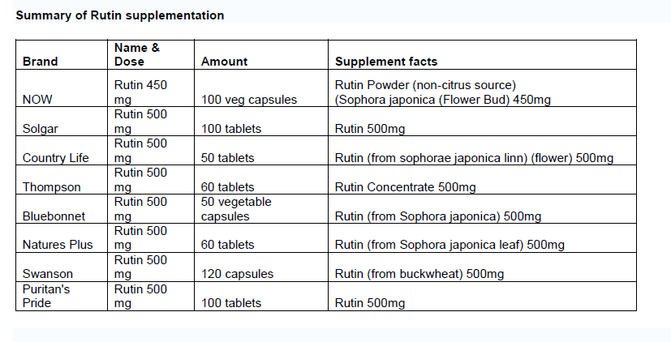
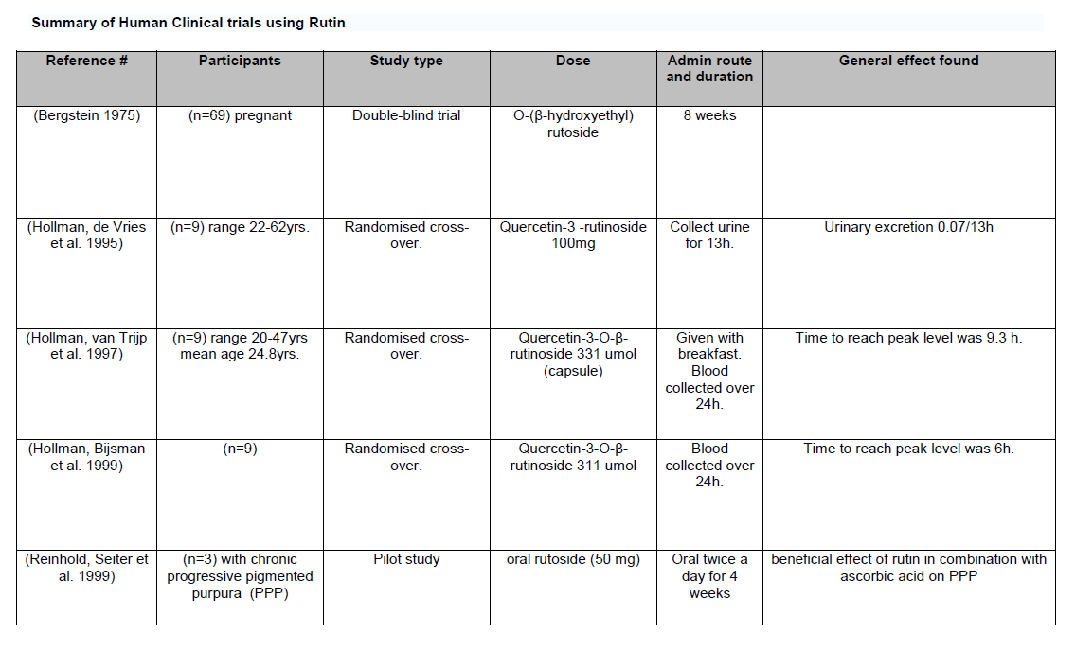
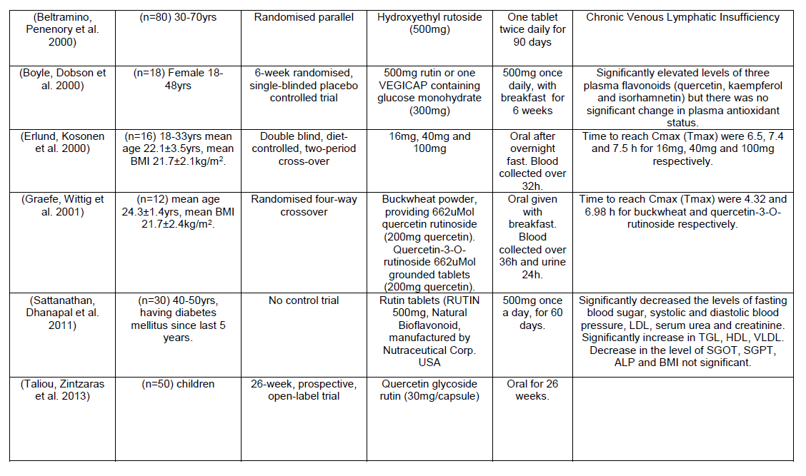
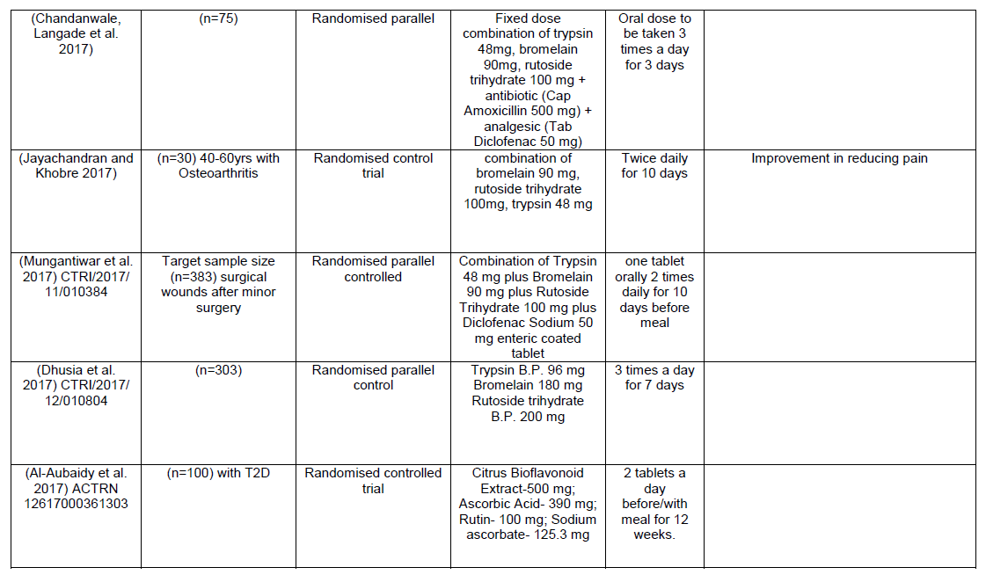
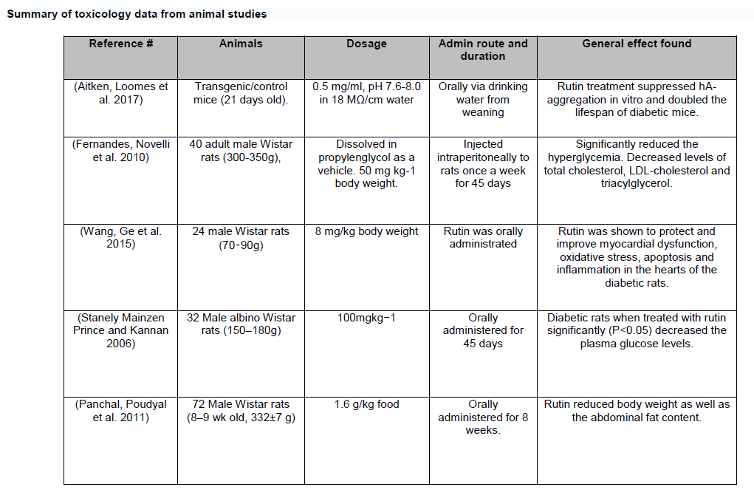
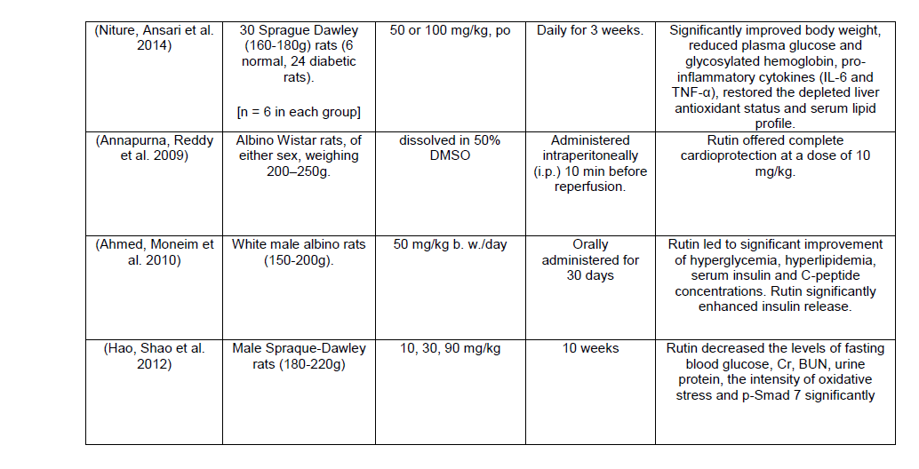
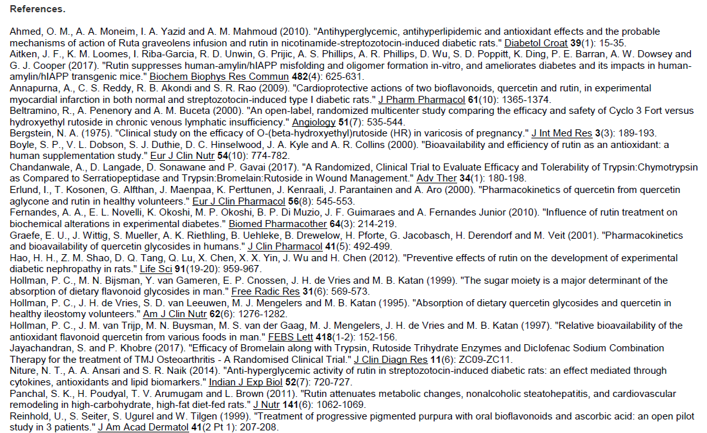
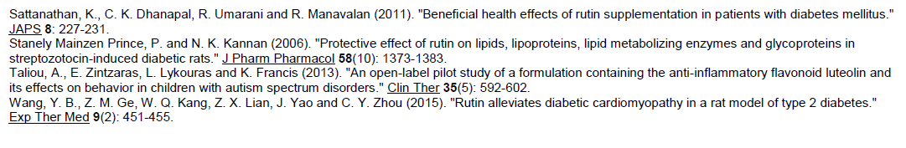

Appendix 2: findrisc form for the assessment of prediabetes

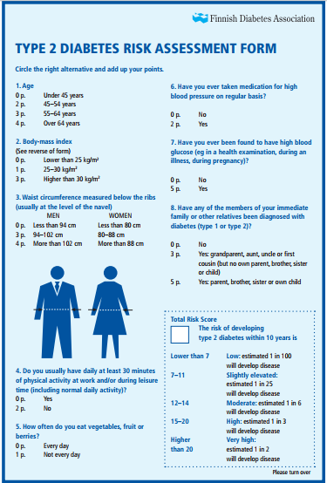

12. References
ADA 2016. American Diabetes Association 2. Classification and Diagnosis of Diabetes. Diabetes Care, 39, S13-22.
AITKEN, J. F., LOOMES, K. M., KONARKOWSKA, B. & COOPER, G. J. S. 2003. Suppression by polycyclic compounds of the conversion of human amylin into insoluble amyloid. Biochem J, 374, 779-84.
AITKEN, J. F., LOOMES, K. M., PRIJIC, G., PHILLIPS, A. R. J. & COOPER, G. J. S. 2014. Rutin treatment suppresses amylin misfolding in vitro and causes marked improvements in metabolic regulation and survival in human-amylin transgenic mice with type-2 diabetes. . Manuscript in Preparation.
AITKEN, J. F., LOOMES, K. M., RIBA-GARCIA, I., UNWIN, R. D., PRIJIC, G., PHILLIPS, A. S., et al. 2017a. Quantitative data describing the impact of the flavonol rutin on in-vivo blood-glucose and fluid-intake profiles, and survival of human-amylin transgenic mice. Data Brief, 10, 298-303.
AITKEN, J. F., LOOMES, K. M., RIBA-GARCIA, I., UNWIN, R. D., PRIJIC, G., PHILLIPS, A. S., et al. 2017b. Rutin suppresses human-amylin/hIAPP misfolding and oligomer formation in-vitro, and ameliorates diabetes and its impacts in human-amylin/hIAPP transgenic mice. Biochem Biophys Res Commun, 482, 625-631.
AITKEN, J. F., LOOMES, K. M., SCOTT, D. W., REDDY, S., PHILLIPS, A. R., PRIJIC, G., et al. 2010. Tetracycline treatment retards the onset and slows the progression of diabetes in human amylin/islet amyloid polypeptide transgenic mice. Diabetes, 59, 161-71.
ALBERTI, K. G. & ZIMMET, P. Z. 2014. Diabetes: a look to the future. Lancet Diabetes Endocrinol, 2, e1-2.
AMERICAN DIABETES ASSOCIATION 2012. Diagnosis and classification of diabetes mellitus. Diabetes Care, 35, S64-71.
AMERICAN DIABETES ASSOCIATION 2016. 2. Classification and Diagnosis of Diabetes. Diabetes Care, 39, S13-22.
BAHADORAN, Z., MIRMIRAN, P. & AZIZI, F. 2013. Dietary polyphenols as potential nutraceuticals in management of diabetes: a review. J Diabetes Metab Disord, 12, 43.
BHAGWAT, S., HAYTOWITZ, D. B. & HOLDEN, J. M. 2014. USDA database for the flavonoid content of selected foods, Release 3.1; US Department of Agriculture: Beltsville, MD, USA.
BOYLE, S. P., DOBSON, V. L., DUTHIE, S. J., HINSELWOOD, D. C., KYLE, J. A. M. & COLLINS, A. R. 2000. Bioavailability and efficiency of rutin as an antioxidant: a human supplementation study. European Journal Of Clinical Nutrition, 54, 774.
BUTLER, A. E., JANSON, J., BONNER-WEIR, S., RITZEL, R., RIZZA, R. A. & BUTLER, P. C. 2003. Beta-cell deficit and increased beta-cell apoptosis in humans with type 2 diabetes. Diabetes, 52, 102-10.
CARDONA, F., ANDRÉS-LACUEVA, C., TULIPANI, S., TINAHONES, F. J. & QUEIPO-ORTUÑO, M. I. 2013. Benefits of polyphenols on gut microbiota and implications in human health. The Journal of Nutritional Biochemistry, 24, 1415-1422.
CHEN, C., COHRS, C. M., STERTMANN, J., BOZSAK, R. & SPEIER, S. 2017. Human beta cell mass and function in diabetes: recent advances in knowledge and technologies to understand disease pathogenesis. Molecular Metabolism, 6, 943-957.
CHOW, H. H., CAI, Y., ALBERTS, D. S., HAKIM, I., DORR, R., SHAHI, F., et al. 2001. Phase I pharmacokinetic study of tea polyphenols following single-dose administration of epigallocatechin gallate and polyphenon E. Cancer Epidemiol Biomarkers Prev, 10, 53-8.
COOPER, G. J., WILLIS, A. C., CLARK, A., TURNER, R. C., SIM, R. B. & REID, K. B. 1987. Purification and characterization of a peptide from amyloid-rich pancreases of type 2 diabetic patients. Proc Natl Acad Sci U S A, 84, 8628-32.
DALL'ASTA, M., BAYLE, M., NEASTA, J., FSCAZZINA, F., BRUNI, R., CROS, G., et al. 2015. Protection of pancreatic β-cell function by dietary polyphenols. Phytochem Rev, 14, 933-959.
DEMBINSKA-KIEC, A., MYKKANEN, O., KIEC-WILK, B. & MYKKANEN, H. 2008. Antioxidant phytochemicals against type 2 diabetes. Br J Nutr, 99, ES109-17.
DICKINSON, S., COLAGIURI, S., FARAMUS, E., PETOCZ, P. & BRAND-MILLER, J. C. 2002. Postprandial Hyperglycemia and Insulin Sensitivity Differ among Lean Young Adults of Different Ethnicities. The Journal of Nutrition, 132, 2574-2579.
ERLUND, I., KOSONEN, T., ALFTHAN, G., MAENPAA, J., PERTTUNEN, K., KENRAALI, J., et al. 2000. Pharmacokinetics of quercetin from quercetin aglycone and rutin in healthy volunteers. Eur J Clin Pharmacol, 56, 545-53.
FESTA, A., WILLIAMS, K., D'AGOSTINO, R., JR., WAGENKNECHT, L. E. & HAFFNER, S. M. 2006. The natural course of beta-cell function in nondiabetic and diabetic individuals: the Insulin Resistance Atherosclerosis Study. Diabetes, 55, 1114-20.
FORLONI, G., COLOMBO, L., GIROLA, L., TAGLIAVINI, F. & SALMONA, M. 2001. Anti-amyloidogenic activity of tetracyclines: studies in vitro. FEBS Letters, 487, 404-407.
GILLMORE, J. D., HAWKINS, P. N. & PEPYS, M. B. 1997. Amyloidosis: a review of recent diagnostic and therapeutic developments. British Journal of Haematology, 99, 245-256.
GOLDSBURY, C., KISTLER, J., AEBI, U., ARVINTE, T. & COOPER, G. J. S. 1999. Watching amyloid fibrils grow by time lapse atomic force microscopy. J Mol Biol, 285, 33-39.
GOLDSBURY, C. S., COOPER, G. J. S., GOLDIE, K. N., MUELLER, S. A., SAAFI, E. L., GRUIJTERS, W. T. M., et al. 1997. Polymorphic fibrillar assembly of human amylin. J Struct Biol, 119, 17-27.
GRAEFE, E. U., WITTIG, J., MUELLER, S., RIETHLING, A. K., UEHLEKE, B., DREWELOW, B., et al. 2001. Pharmacokinetics and bioavailability of quercetin glycosides in humans. J Clin Pharmacol, 41, 492-9.
GREEN, J., GOLDSBURY, C., MINI, T., SUNDERJI, S., FREY, P., KISTLER, J., et al. 2003. Full-length rat amylin forms fibrils following substitution of single residues from human amylin. J Mol Biol, 326, 1147-1156.
HARDY, O. T., CZECH, M. P. & CORVERA, S. 2012. What causes the insulin resistance underlying obesity? Current opinion in endocrinology, diabetes, and obesity, 19, 81-87.
HARO, C., MONTES-BORREGO, M., RANGEL-ZUNIGA, O. A., ALCALA-DIAZ, J. F., GOMEZ-DELGADO, F., PEREZ-MARTINEZ, P., et al. 2016. Two Healthy Diets Modulate Gut Microbial Community Improving Insulin Sensitivity in a Human Obese Population. J Clin Endocrinol Metab, 101, 233-42.
HOLLMAN, P. C. H., BIJSMAN, M. N. C. P., VAN GAMEREN, Y., CNOSSEN, E. P. J., DE VRIES, J. H. M. & KATAN, M. B. 1999. The sugar moiety is a major determinant of the absorption of dietary flavonoid glycosides in man. Free Radical Research, 31, 569-573.
HOLT, R. I. 2004. Diagnosis, epidemiology and pathogenesis of diabetes mellitus: an update for psychiatrists. Br J Psychiatry Suppl, 47, S55-63.
JAIKARAN, E. T. & CLARK, A. 2001. Islet amyloid and type 2 diabetes: from molecular misfolding to islet pathophysiology. Biochim Biophys Acta, 1537, 179-203.
KIM, H. S., QUON, M. J. & KIM, J. A. 2014. New insights into the mechanisms of polyphenols beyond antioxidant properties; lessons from the green tea polyphenol, epigallocatechin 3-gallate. Redox Biol, 2, 187-95.
KNOWLER, W. C., BARRETT-CONNOR, E., FOWLER, S. E., HAMMAN, R. F., LACHIN, J. M., WALKER, E. A., et al. 2002. Reduction in the incidence of type 2 diabetes with lifestyle intervention or metformin. N Engl J Med, 346, 393-403.
KONARKOWSKA, B., AITKEN, J. F., KISTLER, J., ZHANG, S. & COOPER, G. J. 2006a. The aggregation potential of human amylin determines its cytotoxicity towards islet beta-cells. FEBS J, 273, 3614-24.
KONARKOWSKA, B., AITKEN, J. F., KISTLER, J., ZHANG, S. & COOPER, G. J. S. 2006b. The aggregation potential of human amylin determines its cytotoxicity towards islet beta-cells. FEBS J, 273, 3614-3624.
LEIGHTON, B. & COOPER, G. J. 1988. Pancreatic amylin and calcitonin gene-related peptide cause resistance to insulin in skeletal muscle in vitro. Nature, 335, 632-5.
LI, G., ZHANG P FAU - WANG, J., WANG J FAU - GREGG, E. W., GREGG EW FAU - YANG, W., YANG W FAU - GONG, Q., GONG Q FAU - LI, H., et al. 2008. The long-term effect of lifestyle interventions to prevent diabetes in the China Da Qing Diabetes Prevention Study: a 20-year follow-up study.
LIEW, C. F., SEAH, E. S., YEO, K. P., LEE, K. O. & WISE, S. D. 2003. Lean, nondiabetic Asian Indians have decreased insulin sensitivity and insulin clearance, and raised leptin compared to Caucasians and Chinese subjects. International Journal Of Obesity, 27, 784-789.
LINDSTROM, J., ILANNE-PARIKKA P FAU - PELTONEN, M., PELTONEN M FAU - AUNOLA, S., AUNOLA S FAU - ERIKSSON, J. G., ERIKSSON JG FAU - HEMIO, K., HEMIO K FAU - HAMALAINEN, H., et al. 2006. Sustained reduction in the incidence of type 2 diabetes by lifestyle intervention: follow-up of the Finnish Diabetes Prevention Study.
LIU, A. Y., SILVESTRE, M. P. & POPPITT, S. D. 2015. Prevention of type 2 diabetes through lifestyle modification: is there a role for higher-protein diets?
LOZANO, R., NAGHAVI, M., FOREMAN, K., LIM, S., SHIBUYA, K., ABOYANS, V., et al. 2012. Global and regional mortality from 235 causes of death for 20 age groups in 1990 and 2010: a systematic analysis for the Global Burden of Disease Study 2010. Lancet, 380, 2095-128.
MANACH, C., WILLIAMSON, G., MORAND, C., SCALBERT, A. & RÉMÉSY, C. 2005. Bioavailability and bioefficacy of polyphenols in humans. I. Review of 97 bioavailability studies. The American Journal of Clinical Nutrition, 81, 230S-242S.
MCMACKEN, M. & SHAH, S. 2017. A plant-based diet for the prevention and treatment of type 2 diabetes. J Geriatr Cardiol, 14, 342-354.
MEJIA-LEON, M. E. & BARCA, A. M. 2015. Diet, Microbiota and Immune System in Type 1 Diabetes Development and Evolution. Nutrients, 7, 9171-84.
MINISTRY OF HEALTH. 2016. https://www.health.govt.nz/our-work/diseases-and-conditions/diabetes/living-well-diabetes-2015-2020 [Online].
MONDAL, P., PRASAD, A. & GIRDHAR, K. 2017. Interventions to improve β-cell mass and function. Annales d'Endocrinologie, 78, 469-477.
MUKHERJEE, A., MORALES-SCHEIHING, D., BUTLER, P. C. & SOTO, C. 2015. Type 2 diabetes as a protein misfolding disease. Trends in Molecular Medicine, 21, 439-449.
NEVEU, V., PEREZ-JIMÉNEZ, J., VOS, F., CRESPY, V., DU CHAFFAUT, L., MENNEN, L., et al. 2010. Phenol-Explorer: an online comprehensive database on polyphenol contents in foods. Database: The Journal of Biological Databases and Curation, 2010, bap024.
NG, M., FLEMING, T., ROBINSON, M., THOMSON, B., GRAETZ, N., MARGONO, C., et al. 2014. Global, regional, and national prevalence of overweight and obesity in children and adults during 1980–2013: a systematic analysis for the Global Burden of Disease Study 2013. The Lancet, 384, 766-781.
NGOUNGOURE, V. L. N., SCHLUESENER, J., MOUNDIPA, P. F. & SCHLUESENER, H. 2015. Natural polyphenols binding to amyloid: a broad class of compounds to treat different human amyloid diseases. Molecular Nutrition & Food Research, 59, 8-20.
OTT, S. J., MUSFELDT, M., ULLMANN, U., HAMPE, J. & SCHREIBER, S. 2004. Quantification of intestinal bacterial populations by real-time PCR with a universal primer set and minor groove binder probes: a global approach to the enteric flora. J Clin Microbiol, 42, 2566-72.
OZOUGWU, J. C., OBIMBA, K. C., BELONWU, C. D. & UNAKALAMBA, C. B. 2013. The pathogenesis and pathophysiology of type 1 and type 2 diabetes mellitus. J Physiol, 4, 46-57.
PORAT, Y., ABRAMOWITZ, A. & GAZIT, E. 2006. Inhibition of amyloid fibril formation by polyphenols: structural similarity and aromatic interactions as a common inhibition mechanism. Chemical Biology & Drug Design, 67, 27-37.
RAMACHANDRAN, A., SNEHALATHA C FAU - MARY, S., MARY S FAU - MUKESH, B., MUKESH B FAU - BHASKAR, A. D., BHASKAR AD FAU - VIJAY, V. & VIJAY, V. 2006. The Indian Diabetes Prevention Programme shows that lifestyle modification and metformin prevent type 2 diabetes in Asian Indian subjects with impaired glucose tolerance (IDPP-1).
SAAFI, E. L., KONARKOWSKA, B., ZHANG, S., KISTLER, J. & COOPER, G. J. 2001. Ultrastructural evidence that apoptosis is the mechanism by which human amylin evokes death in RINm5F pancreatic islet beta-cells. Cell Biol Int, 25, 339-50.
SATTANATHAN, K., DHANAPAL, C. K., UMARANI, R. & MANAVALAN, R. 2011. Beneficial health effects of rutin supplementation in patients with diabetes mellitus. Journal of Applied Pharmaceutical Science 1, 227-231.
SCALBERT, A. & WILLIAMSON, G. 2000. Dietary intake and boavailability of polyphenols. The Journal of Nutrition, 130, 2073S-2085S.
SHAW, J. E., SICREE, R. A. & ZIMMET, P. Z. 2010. Global estimates of the prevalence of diabetes for 2010 and 2030. Diabetes Res Clin Pract, 87, 4-14.
SILVESTRE, M. P., JIANG, Y., VOLKOVA, K., CHISHOLM, H., LEE, W. & POPPITT, S. D. 2017. Evaluating FINDRISC as a screening tool for type 2 diabetes among overweight adults in the PREVIEW:NZ cohort. Primary Care Diabetes, 11, 561-569.
SNIDERMAN, A. D., BHOPAL, R., PRABHAKARAN, D., SARRAFZADEGAN, N. & TCHERNOF, A. 2007. Why might South Asians be so susceptible to central obesity and its atherogenic consequences? The adipose tissue overflow hypothesis. International Journal of Epidemiology, 36, 220-225.
STOILOVA, T., COLOMBO, L., FORLONI, G., TAGLIAVINI, F. & SALMONA, M. 2013. A new face for old antibiotics: tetracyclines in treatment of amyloidoses. Journal of Medicinal Chemistry, 56, 5987-6006.
TANG, W. H., KITAI, T. & HAZEN, S. L. 2017. Gut Microbiota in Cardiovascular Health and Disease. Circ Res, 120, 1183-1196.
TEMELKOVA-KURKTSCHIEV, T. & STEFANOV, T. 2012. Lifestyle and genetics in obesity and type 2 diabetes. Experimental and clinical endocrinology & diabetes : official journal, German Society of Endocrinology [and] German Diabetes Association, 120, 1-6.
TENE, L., SHELEF, I., SCHWARZFUCHS, D., GEPNER, Y., YASKOLKA MEIR, A., TSABAN, G., et al. 2018. The effect of long-term weight-loss intervention strategies on the dynamics of pancreatic-fat and morphology: An MRI RCT study. Clinical Nutrition ESPEN.
TUCKER, H. M., RYDEL, R. E., WRIGHT, S. & ESTUS, S. 1998. Human amylin induces “apoptotic” pattern of gene expression concomitant with cortical neuronal apoptosis. Journal of Neurochemistry, 71, 506-516.
UTZSCHNEIDER, K. M., PRIGEON, R. L., TONG, J., GERCHMAN, F., CARR, D. B., ZRAIKA, S., et al. 2007. Within-subject variability of measures of beta cell function derived from a 2 h OGTT: implications for research studies. Diabetologia, 50, 2516-2525.
WANG, L., GAO, P., ZHANG, M., HUANG, Z., ZHANG, D., DENG, Q., et al. 2017. Prevalence and Ethnic Pattern of Diabetes and Prediabetes in China in 2013. JAMA, 317, 2515-2523.
WHO 2016. World Health Organization. Global report on diabetes. 2016. Geneva; World Health Organization. http://apps.who.int/iris/
bitstream/10665/204871/1/9789241565257_eng.pdf.
WILKINSON, L. 2010. SYSTAT. Wiley Interdisciplinary Reviews: Computational Statistics, 2, 256-257.
XIAO, J. B. & HOGGER, P. 2015. Dietary polyphenols and type 2 diabetes: current insights and future perspectives. Curr Med Chem, 22, 23-38.
XU, Y., WANG, L., HE, J., BI, Y., LI, M., WANG, T., et al. 2013. Prevalence and control of diabetes in Chinese adults. JAMA, 310, 948-59.
YAN, S., LI, J., LI, S., ZHANG, B., DU, S., GORDON-LARSEN, P., et al. 2012. The expanding burden of cardiometabolic risk in China: the China Health and Nutrition Survey. Obes Rev, 13, 810-21.
ZHANG, S., LIU, H., CHUANG, C. L., LI, X., AU, M., ZHANG, L., et al. 2014. The pathogenic mechanism of diabetes varies with the degree of overexpression and oligomerization of human amylin in the pancreatic islet β cells. FASEB, 19 Aug adv e-pub.
ZHANG, S., LIU, H., LIU, J., TSE, C. A., DRAGUNOW, M. & COOPER, G. J. 2006. Activation of activating transcription factor 2 by p38 MAP kinase during apoptosis induced by human amylin in cultured pancreatic beta-cells. FEBS J, 273, 3779-91.
ZHANG, S., LIU, H., YU, H. & COOPER, G. J. S. 2008. Fas-associated death receptor signaling evoked by human amylin in islet beta-cells. Diabetes, 57, 348-356.
ZIMMET, P. Z., MAGLIANO, D. J., HERMAN, W. H. & SHAW, J. E. 2014. Diabetes: a 21st century challenge. Lancet Diabetes Endocrinol, 2, 56-64.
ZUO, H., SHI, Z. & HUSSAIN, A. 2014. Prevalence, trends and risk factors for the diabetes epidemic in China: a systematic review and meta-analysis. Diabetes Res Clin Pract, 104, 63-72.

