Microbial Shift Analysis clinical trial study PROTOCOL
Version 1, Date: November 2018

Sponsor Institution
RMIT University

Principal Investigators
Associate Professor Danilla Grando (RMIT University)
Dr Kyle Berean (RMIT University)

Contact details:
Danilla Grando
School of Science
RMIT University
Building 223 Level 1 Room 66
Bundoora Campus, Plenty Road Bundoora, 3083
Phone – (03) 9925 7135; Fax – (03) 9925 7100

TABLE OF CONTENTS
TABLE OF CONTENTS 2
1 Background 3
2 rationale 4
3 aims 5
4 METHODS 5
5 Study procedure 7
6 Study material Supplies 8
7 Data analysis 9
8 data management 9
9 Dissemination of Project Results 9
10 Report of Project 9
11 Ethical Conduct of the Trial 10
12 Informed Consent 10
13 Funding 11
14 indemnity 11
15 POTENTIAL significance 11
16 References 11

Background
The complex gut microbiome ecosystem consists of microbial consortia with intricate roles for maintaining health [1-3]. Very recently, a growing number of investigations have emerged with the focus on characterising the composition of gut microbial consortia [1] and how their alterations are associated with specific dietary patterns [4].
As part of a recent study that evaluated a new gas sensing capsule [5], we evaluated the faecal microbiome of participants consuming either a high fibre or low fibre diet. The resulting changes in the microbiome where illustrated using a heat map (Figure 1). As part of the previous study, participants were advised that their microbiome changes would be communicated to them, however as can be seen in Figure 1, these changes are not easily understood by the general public. There is a need to find an alternative means to communicate changes in microbiome that more clearly indicate shifts associated with better health outcomes.
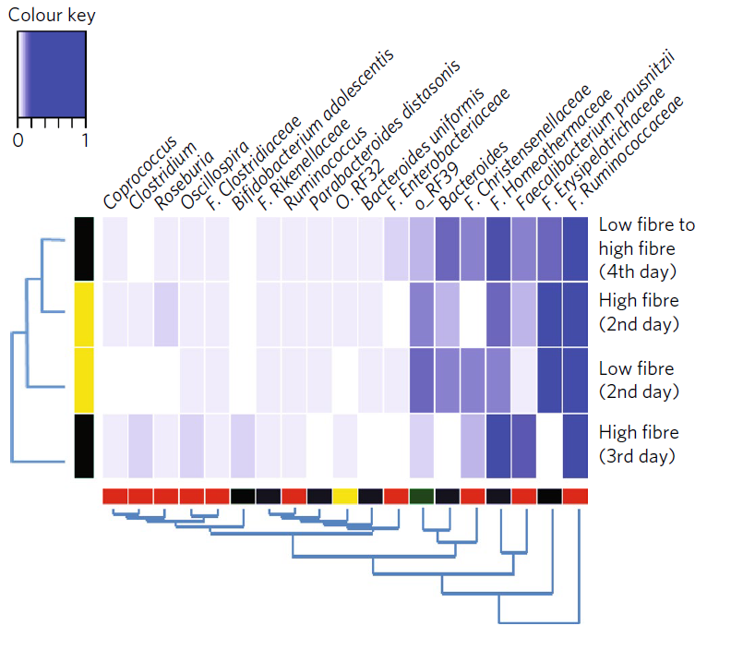
Figure 1 Changes to the gut community after a high fibre and low fibre diet as reported by Kalantar-Zadeh et al. [5]

rationale
During the course of the previous study, Associate Professor Danilla Grando designed a novel algorithm that produced a simplified representation of microbiome changes associated with dietary interventions. The resulting pilot use of this algorithm is shown in Figure 2.
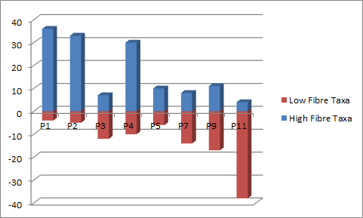
Figure 2: Pilot results Microbial Shift Analysis (unpublished). P1, 2, 4, 5 on 3 day high fibre diet, P3, 7, 9 and 11 on 3 day low fibre diet.
In order to determine whether these results were obtained by chance, it was necessary to repeat testing in order to validate the algorithm. The biosamples collected in the previous study were retrieved from the freezer in 2017 but found to have degraded due to freezer malfunction. An insurance claim was lodged and finalised in September 2018. Funds have now been received to repeat diet administration and biosample collection, however the previous ethics approval has been finalised. In order to validate that the results obtained for the novel algorithm were not chance findings, it will be necessary to administer the diet interventions again, however it will not be necessary for participants to re-ingest the gas capsule.

aims
Although gut microbiome changes can be measured, it is difficult to report those changes in a way that is easily comprehendible to clinicians and the general public. This study aims to validate the promising results of the first round of analysis using the newly trialled algorithm for reporting shifts in microbial communities.

METHODS

Study Design
The clinical trial will involve up to 30 participants who are healthy, not pregnant and aged between 18 and 65. The men-to-women ratio will be split equally (50:50). The clinical trial will be under the governance of RMIT University. Participants from the previous trial will first be approached as they expressed a desire to be contacted for possible future trials of dietary interventions. To ensure the participants are healthy and minimize the risk during the trial, two screening procedures, named “questionnaire screening” and “pre-trial screening”, will be conducted upon the grant of the participant’s consent. The clinical trial will be conducted as two dietary interventions (low fibre and high fibre) at their homes by delivering meals on a daily basis for three days and picking up faeces collected by the participants. Standardised food and drink will be provided to the participant as per the previous trial. After the first dietary intervention, follow-up will be performed to ensure that the participants still wish to continue with the cross-over event which replicates the first dietary intervention of the trial but increases the fibre content on the diet. A two to four week washout period will be used between the two interventions.

Inclusion/exclusion criteria
Inclusion criteria:
- Men and women aged between 18 and 65 years living independently in the community and who consider themselves in good health.
Exclusion criteria:
- Pregnancy (Applied to women only)
- Implantable device such as heart pacemaker
- A history of gastrointestinal disorders or disease
- A history of cardiovascular disease
- A history of kidney/liver/serious infections
- A history of diabetes or other hormone diseases
- A history of abdominal surgery
- A current smoker
- Alcohol consumption exceeding more than two units of alcohol per day for men and more than one unit per day for women (regular alcohol consumption above this may be associated with adverse outcomes for gastrointestinal health)
- Currently suffering from a decreased appetite
- Currently suffering from nausea or vomiting
- Currently suffering from abdominal pain
- Currently suffering from light headedness, shakiness or weakness
- Currently suffering from any chronic condition
- Currently suffering from high blood pressure
- Current participation in a clinical trial (Note: If yes, this is only an exclusion if other trial involves taking a drug or another intervention)
Current alcoholics will have some liver impairment and this is considered a gastrointestinal disorder. This will also lead to altered metabolism and excretion into the GI tract and thus have the potential to be an additional confounder for resulting microbiome changes.

Participant recruitment
The chief investigator will contact the previous participants by email (sample email follows). If participants respond to the email, they will receive a follow up email with plain language statement and consent form.
Dear (participant first name)
I am contacting you as you expressed interest in future studies of the gut microbiome. After our last study, we piloted a new form of analysis that makes it easier to visualise changes to the gut microbiome. This next phase of the study would be to validate that analysis by repeating the diet intervention, but this time you would receive both the low and the high fibre diet on two separate occasions. Participation would involve you receiving daily meals delivered to your home for 3 days and your collecting 3 consecutive faecal samples. This would be repeated one additional time after 2 – 4 weeks. If you would like further details in order to decide if you are interested in participating, we would like to hear from you by return email.

Study procedure

Pre-screening call
After receipt of the plain language statement, potential participants will phone the investigators in what will be a pre-screening call to ensure that their health status has not changed since the previous trial. During the pre-screening call, participants will be assessed for eligibility to be included in the study. This will be based on a few primary questions including age, pregnancy and implantable device information.
A cooling off period of greater than 24 hours will be given before the participant is sent a screening questionnaire.

Questionnaire screening procedure
The questionnaire will be used to screen participants based on their provided health information. This questionnaire should normally take 15 to 20 minutes to complete by the participants. Participants who meet the inclusion criteria and do not fulfil any of the exclusion criteria will be asked to select from participation dates.

First dietary intervention procedure
The evening before Day 1 of the dietary intervention, meals and sample collection kits for Day 1 will be delivered to the participant.
On Day 1 the participant will collect their faecal sample and consume the supplied meals. They will be visited in the evening so that the investigator can collect the faecal sample and deliver meals for Day 2. This procedure will be repeated for Day 2 and 3. The participants will not have any restrictions on their normal daily activities and may withdraw their participation at any time without prejudice. They will fill out a meal diary to record any variations to the supplied diet.
The participant will also be provided with flushable faecal collection sheet and faecal collection containers to collect their stool samples. A purpose built ice mould will be delivered within an esky and participants will store their samples in this esky until collected in the evenings.

Second dietary intervention procedure
In the week following the first dietary intervention the participant will be contacted to ascertain whether they wish to continue with the second dietary intervention. They will be free to withdraw without prejudice at this point. If they decide to continue, a day will be arranged to start the second dietary intervention.

Post-trial follow-up
Participants will be provided with a microbial shift analysis report which will identify the shift in their microbial communities on both their dietary interventions.

Contingency plan for participant well-being
If the participant develops unexplained nausea, abdominal pain or vomiting during the clinical trial study, he/she will need to contact the chief investigator immediately who will advise the participant to cease the diet and visit their GP.

Study material Supplies
- Flushable faecal collection sheet and faecal container: The sheet and container are sourced from local supplier and used for collecting the participants’ stool samples. Investigators provide participants with the collection sheet, container and esky with ice mould.

- Food: The standardised food supplied to the participants in the clinical trial is sourced from a local supermarket and made by a research assistant that holds a certificate in safe food preparation. The research assistant has 20 years of experience in the food preparation industry. Similarly the PI, Danilla Grando also has 20 years’ experience in food preparation and lectures in food safety at RMIT University. All food is based upon healthy eating guidelines and will be prepared and made under hygienic conditions. All food will be stored in a refrigerator at 4°C and transported to participants on ice. Reheating instructions where required will be provided to participants

Data analysis
Samples will be analysed as in the previous trial and the microbial shift analysis will be repeated to validate the designed algorithm. All samples will be de-identified and analysis will form the basis of a publication to be considered for a peer-reviewed journal.

data management
Questionnaire screening stage: The questionnaires from suitable participants will be kept locked in a filing cabinet in Associate Professor Danilla Grando’s office for 15 years. The questionnaires from unsuitable participants will be destroyed after the screening process. Clinical trial data will be stored on Associate Professor Danilla Grando’s office computer.

Dissemination of Project Results
Publications: Study findings and recommendations will be published in appropriate scientific journals to be made available to the scientific community.
Poster and oral presentations: Presentations will be constructed to provide study rationale design, results, and implications. These will be available for formal presentations in scientific conferences, office or departmental seminars, grand rounds, or local medical society meetings. A set of slides will also be developed for presentation to consumers.

Report of Project
A final report of the project will be prepared for the RMIT Human Research Ethics Committee at the completion of the analysis. When the research is completed, published papers and abstracts will inform the Ethics Committees of the outcome.

Ethical Conduct of the Trial
This study will be conducted in accordance with this protocol, the ICH GCP Note for Guidance on Good Clinical Practice (CPMP/ICH/135/95) Annotated with TGA comments, the NHMRC National Statement on Ethical Conduct in Human Research 2007 and in keeping with local regulations.

Informed Consent

Consent Form
Before obtaining consent from each participant, he/she will be informed of the objectives, benefits, risks and requirements of the study. An information sheet will be given to each participant prior to questionnaire screening.
Participants will be giving their own consent after having read all content of the information sheet and consent form. The participant and investigator will each retain a copy of the signed consent form.

Obtaining Consent
The chief investigator and under the chief investigator's responsibility, will fully inform the participant of all pertinent aspects of the dietary intervention trial study including the written participant information sheet.
All participants will be informed to the fullest extent possible about the study, in plain language and in terms they are able to understand.
Participants are expected to give their own consent by reading the content in the information sheet and consent form and giving their signatures by themselves.
- Prior to a subject’s participation in the study, the written Informed Consent Form will be signed, name filled in and personally dated by the participant and by the person who conducted the informed consent discussion.
- A copy of the signed and dated written Informed Consent Form will be provided to the participant. The original consent will be stored in the participant’s individual study file, held by the chief investigator.
- The Participant information Sheet and Consent Form used for obtaining the participant's informed consent will be the current version that has been reviewed and approved by the appropriate Ethics Committee.

Funding
Funding for this trial has been obtained via an insurance claim to replace lost samples of the previous trial.

indemnity
RMIT University shall at all times indemnify the study investigators and their staff from claims that may be made against them for any injury sustained by a study participant as a consequence of the follow-up for this study as outlined in this protocol.

POTENTIAL significance
Validation of the Microbial shift analysis algorithm will enable it to be used to quickly and easily communicate to members of the public how their changed diets contribute to healthier bowel communities. There has been wide interest in the possibility of using this algorithm to enable researchers to more easily interpret microbial community change resulting from other health interventions. It is interesting that the diet intervention used in the previous gas capsule diet easily demonstrated quick changes to microbial communities over a short period of 2 days. Validation of this observation will enable this healthy diet to form the basis of future studies investigating single additives of potential health significance to the basal diet.

References
1. Clemente, Jose C., et al., The impact of the gut microbiota on human health: An integrative view. Cell, 2012. 148(6): p. 1258-1270.
2. Lozupone, C.A., et al., Diversity, stability and resilience of the human gut microbiota. Nature, 2012. 489(7415): p. 220-230.
3. Sommer, F. and F. Bäckhed, The gut microbiota-masters of host development and physiology. Nat. Rev. Microbiol., 2013. 11(4): p. 227-238.
4. Wu, G.D., et al., Linking long-term dietary patterns with gut microbial enterotypes. Science, 2011. 334(6052): p. 105-108.
5. Kalantar-Zadeh, K., et al., A human pilot trial of ingestible electronic capsules capable of sensing different gases in the gut. Nat. Electronics, 2018. 1: p. 79-87.

