**Kick-Start Assessment Protocols**

|  |  |
| --- | --- |
| Well-being | Stirling Children’s Well-being Scale |
| Academic Performance | The One Minute Basic Number Facts Tests |
| Cognition | Cognitive Assessment |
| On-Task Behaviour | Momentary Time Sampling |
| Fitness | 90 Push-Up Test |
| 20m Repeated Shuttle Run Test |
| Standing Broad Jump Test |
| Seated Basketball Throw Test |
| Referencing | |

**Research Project**: Evaluating the efficacy and feasibility of a martial arts-based mathematics intervention program on health, well-being and mathematics ability in primary school students.

**Participant Questionnaire**

Participant Name: _____________________________

School: ____________________________________

ID: ______________________

**To protect your privacy this cover sheet will be removed and destroyed once you have been allocated a study number.**

|  |  |
| --- | --- |
| **Chief Investigator**  **Dr Narelle Eather**  The University of Newcastle  Faculty of Education & Arts  School of Education  Phone: (02) 4921 6800  [Narelle.Eather@newcastle.edu.au﷟](mailto:Narelle.Eather@newcastle.edu.au%22%EF%BF%BDHYPERLINK%20%22mailto:) | **Investigators**  **Dr Nicholas Riley**  **Dr Robert Parkes**  **Mr Louis Burt**  The University of Newcastle  Faculty of Education & Arts  School of Education |

Here are some statements or descriptions about how you might have been feeling or thinking about things over the past couple of weeks. For each one, please circle the number which best describes your thoughts and feelings;

**There are no right or wrong answers.**

|  |  |  |  |  |  |  |
| --- | --- | --- | --- | --- | --- | --- |
| **Statements** | | **Never** | **Not much of the time** | **Some of the time** | **Quite a lot of the time** | **All of the time** |
| **1** | I think good things will happen in my life | **1** | **2** | **3** | **4** | **5** |
| **2** | I have always told the truth | **1** | **2** | **3** | **4** | **5** |
| **3** | I’ve been able to make choices easily | **1** | **2** | **3** | **4** | **5** |
| **4** | I can find lots of fun things to do | **1** | **2** | **3** | **4** | **5** |
| **5** | I feel that I am good at some things | **1** | **2** | **3** | **4** | **5** |
| **6** | I think lots of people care about me | **1** | **2** | **3** | **4** | **5** |
| **7** | I like everyone I have met | **1** | **2** | **3** | **4** | **5** |
| **8** | I think there are many things I can be proud of | **1** | **2** | **3** | **4** | **5** |
| **9** | I’ve been feeling calm | **1** | **2** | **3** | **4** | **5** |
| **10** | I’ve been in a good mood | **1** | **2** | **3** | **4** | **5** |
| **11** | I enjoy what each new day brings | **1** | **2** | **3** | **4** | **5** |
| **12** | I’ve been getting on well with people | **1** | **2** | **3** | **4** | **5** |
| **13** | I always share my sweets | **1** | **2** | **3** | **4** | **5** |
| **14** | I’ve been cheerful about things | **1** | **2** | **3** | **4** | **5** |
| **15** | I’ve been feeling relaxed | **1** | **2** | **3** | **4** | **5** |

**Academic Performance**

Children’s academic performance in Mathematics will be assessed using The One Minute Basic Number Facts Tests (1995).

This test will be administered by the research team:

**Marking:**

1: correct answers

0: wrong answers

Total: number of correct answers

**Instruction for administration**

* Ensure that the test material has been prepared using a size of type large enough for the children to read easily. If necessary, enlarge the test on a photocopier and, for young children or those with coordination difficulties, considerably increase the space between test items.
* Administer at most only two tests at a time, with a break (e.g. recess) between the addition/subtraction tests and the multiplication/division tests. The multiplication and division tests would not normally be given to children below the age of seven years.
* Place the test sheet face down on the children's tables.
* The children write their name on the back of the sheet.
* You will later need to check the children's age in years and months.
* Say: `When you turn over the page you will find some addition (etc.) questions.
* When I say "start now" I want you to write down the answer to each question as quickly as you can. Don't worry if you don't finish them all.
* Work down the page.
* Pencils ready. Now turn over the page. Find the addition (adding) questions.'
* As soon as the children are ready, say `Start now'.
* After exactly one minute say `Stop! Pencils down'.
* Repeat the procedure for the subtraction, multiplication and division tests.
* Say `Don't forget, this is subtraction. You are taking the number away this time. One minute, starting now', or similar for the corresponding test.
* After one minute say `Stop! Pencils down'.

**Cognitive Outcomes**

The modified Eriksen flanker task will provide a measure of cognitive control. The Dimensional Change Card Sort Test is a measure of cognitive flexibility and attention.

**Ipad: Entering information:**

**Add new participant**

1. ID number (see checklist, e.g., 1)
2. Initials (e.g., John Smith = JS)
3. Choose gender
4. Include children’s birthdate (if they don’t know, include at least the month and year – or ask the teacher)
5. Highest Education Complete (e.g., Grade 4)
6. Mother’s, Father’s, Legal Guardian’s Education: Unknown
7. Handedness: choose left or right
8. Race: White
9. Ethnicity: Hispano or Latino

**Add New Assessment:**

Add instrument: Kick-Smart (then press “**Done**” – top right)

When finished: press **Start** (top right)

* **NIH Toolbox Flanker Inhibitory Control and Attention Test**

The NIH Toolbox Flanker Inhibitory Control and Attention Test is a measure of inhibitory control and attention. The Flanker requires the participant to focus on a particular stimulus while inhibiting attention to the stimuli flanking it.

Equipment and materials needed: ipad, Home Base

Detailed information on equipment and materials needed for all tests can be found in Appendix i.

Younger participants first see a fish flanked by two other fish on each side. If they perform well enough, they continue to a version with an arrow flanked by other arrows on each side.

Older participants (ages 8-85 years) are always presented with arrows instead of fish.

All participants are instructed to choose one of two buttons on the screen that corresponds to the direction in which the MIDDLE fish or arrow is pointing.

On congruent trials, all the fish or arrows are pointing in the same direction. On incongruent trials, the flanking fish or arrows are pointing in the opposite direction of the middle fish or arrow. Congruent and incongruent trials are mixed.

The word middle appears on the screen for all participants; for younger participants (ages 3-11), an audio recording also says "MIDDLE," to remind participants where to focus (a star in the middle of the screen).

All the instructions are on the iPad screen. The examiner reads them to and/or with the participant and points out the relevant aspects of the stimuli on the screen.

There are two versions of this measure for ages 3-7. The first is the standard NIH Toolbox Flanker test for ages 3-7. The second is an experimental version (with "developmental extension," or DEXn that was designed to extend the range of assessment downward, for those participants who have difficulty understanding the standard task. Both versions yield a score for the standard measure, and the DEXT version provides simple raw scores and percentages for the experimental items.

Standard administration (all ages):

Practice items

In this version, all participants are first presented with four practice trials. If the participant responds incorrectly, an audio recording provides feedback and highlights the correct choice. Similarly, a separate audio file plays each time the participant gets a practice item correct. Participants must get at least three out of four practice trials correct to advance to the test items. If these participants get fewer than three out of four practice trials correct, they can complete up to two more sets of four practice trials, with the same cutoff to advance to the test trials.

This table outlines the item content read by as well as the actions for the examiner.

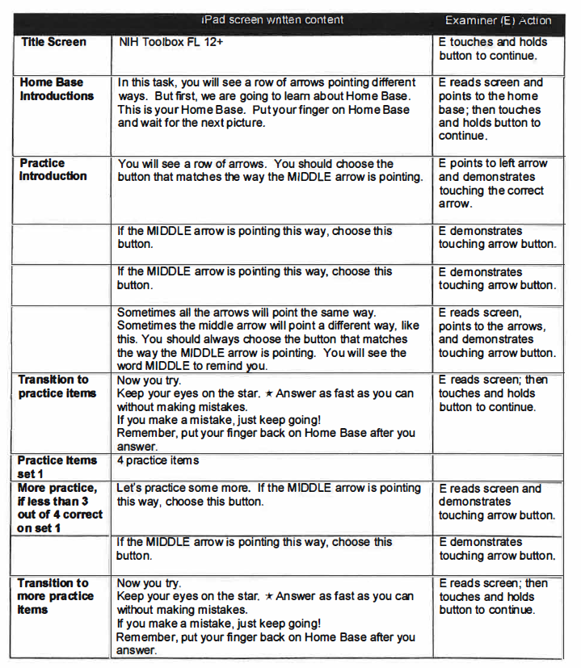

* **NIH Toolbox Dimensional Change Card Sort Test (DCCS)**

The NIH Toolbox Dimensional Change Card Sort Test is a measure of cognitive flexibility and attention. Two target pictures are presented that vary along two dimensions (e.g., shape and color). Participants are asked to match a series of bivalent test pictures (e.g., yellow balls and blue trucks) to the target pictures, first according to one dimension (e.g., color) and then, after a number of trials, according to the other dimension (e.g., shape).

The relevant dimension for sorting is indicated by a cue word (e.g., "shape" or "color'') that appears on the screen for all participants and that, for young children ages 3-11, is also spoken by a prerecorded audio file.

Equipment and materials needed: ipad, Home Base

Detailed information on equipment and materials needed for all tests can be found in Appendix 4.

Practice items use white and brown colors and a Rabbit and Sailboat as shapes. Test items use blue and yellow colors and a Ball and Truck as shapes.

All instructions are on the IPad screen: The examiner reads them to and/or with the participant and points out the relevant aspects of the stimuli on the screen. The next screen appears when either the examiner or participant makes a choice.

There are two versions of this measure for ages 3-7. The first is the standard NIH Toolbox DCCS test for ages 3-7. The second is an experimental version (with "developmental extension," or DEXT) that was designed to extend u,e range of assessment dc'. .. m·:ard, fer those participants who have difficulty understanding the standard task. Both versions yield a score for the standard measure, and the DEXT version provides simple raw scores and percentages for the experimental items.

Standard administration:

Practice Items:

• Participants must get at least three out of four practice trials correct to advance to the practice trials for the next dimension and then to the test trials.

• If a participant of any age gets fewer than three out of four practice trials correct, he/she will complete up to two more sets of four practice trials, with the same cutoff to advance to the test trials.

• If a participant of any age does not meet the cutoff, the task will automatically discontinue.

If the participant does not respond after five seconds, the examiner should prompt him/her, saying: Choose one of the pictures.

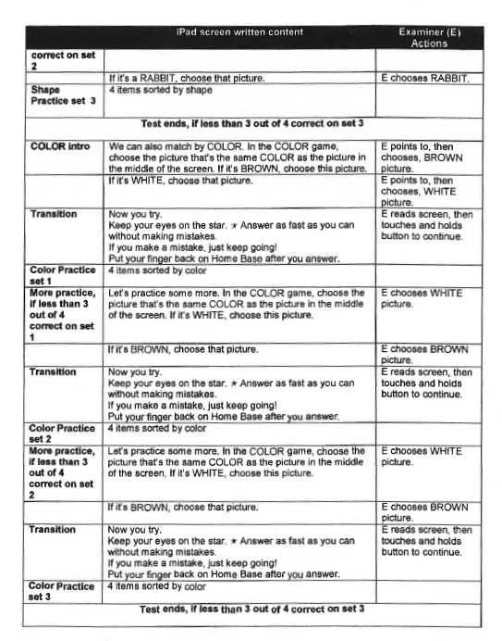

**On-Task Behaviour**

**On-task behaviour** within Mathematics lessons will be assessed using a momentary time sampling procedure. This observational tool has been adapted from the Behaviour Observation of Students in Schools (Shapiro & Cole, 1994) and the Applied Behaviour Analysis for Teachers (Alberto & Troutman, 2003). Classroom behaviour will be reported as a percentage of lesson time. Trained research assistant will conduct the observations of pupils for 30 min in total (6 children).

**Kick-Smart Momentary Time Sampling Observation Form**

**Observer: _________________**

**Date: _____________**

**Time Start: ________**

**Time End: _________**

**Class: _______________**

|  |  |  |  |  |  |  |
| --- | --- | --- | --- | --- | --- | --- |
| Time period(15 second intervals) | Child A | Child B | Child C | Child D | Child E | Child F |
| 00.15-1.30 | AE PE  OM OV OP | AE PE  OM OV OP | AE PE  OM OV OP | AE PE  OM OV OP | AE PE  OM OV OP | AE PE  OM OV OP |
| 1.45-3.00 | AE PE  OM OV OP | AE PE  OM OV OP | AE PE  OM OV OP | AE PE  OM OV OP | AE PE  OM OV OP | AE PE  OM OV OP |
| 3.15.4.30 | AE PE  OM OV OP | AE PE  OM OV OP | AE PE  OM OV OP | AE PE  OM OV OP | AE PE  OM OV OP | AE PE  OM OV OP |
| 4.45-6.00 | AE PE  OM OV OP | AE PE  OM OV OP | AE PE  OM OV OP | AE PE  OM OV OP | AE PE  OM OV OP | AE PE  OM OV OP |
| 6.15-7.30 | AE PE  OM OV OP | AE PE  OM OV OP | AE PE  OM OV OP | AE PE  OM OV OP | AE PE  OM OV OP | AE PE  OM OV OP |
| 7.45-9.00 | AE PE  OM OV OP | AE PE  OM OV OP | AE PE  OM OV OP | AE PE  OM OV OP | AE PE  OM OV OP | AE PE  OM OV OP |
| 9.15-10.30 | AE PE  OM OV OP | AE PE  OM OV OP | AE PE  OM OV OP | AE PE  OM OV OP | AE PE  OM OV OP | AE PE  OM OV OP |
| 10.45-12.00 | AE PE  OM OV OP | AE PE  OM OV OP | AE PE  OM OV OP | AE PE  OM OV OP | AE PE  OM OV OP | AE PE  OM OV OP |
| 12.15-13.30 | AE PE  OM OV OP | AE PE  OM OV OP | AE PE  OM OV OP | AE PE  OM OV OP | AE PE  OM OV OP | AE PE  OM OV OP |
| 13.45-15.00 | AE PE  OM OV OP | AE PE  OM OV OP | AE PE  OM OV OP | AE PE  OM OV OP | AE PE  OM OV OP | AE PE  OM OV OP |
| 15.15-16.30 | AE PE  OM OV OP | AE PE  OM OV OP | AE PE  OM OV OP | AE PE  OM OV OP | AE PE  OM OV OP | AE PE  OM OV OP |
| 16.45-18.00 | AE PE  OM OV OP | AE PE  OM OV OP | AE PE  OM OV OP | AE PE  OM OV OP | AE PE  OM OV OP | AE PE  OM OV OP |
| 18.15-19.30 | AE PE  OM OV OP | AE PE  OM OV OP | AE PE  OM OV OP | AE PE  OM OV OP | AE PE  OM OV OP | AE PE  OM OV OP |
| 19.45-21.00 | AE PE  OM OV OP | AE PE  OM OV OP | AE PE  OM OV OP | AE PE  OM OV OP | AE PE  OM OV OP | AE PE  OM OV OP |
| 21.15-22.30 | AE PE  OM OV OP | AE PE  OM OV OP | AE PE  OM OV OP | AE PE  OM OV OP | AE PE  OM OV OP | AE PE  OM OV OP |
| 22.45-24.00 | AE PE  OM OV OP | AE PE  OM OV OP | AE PE  OM OV OP | AE PE  OM OV OP | AE PE  OM OV OP | AE PE  OM OV OP |
| 24.15-25.30 | AE PE  OM OV OP | AE PE  OM OV OP | AE PE  OM OV OP | AE PE  OM OV OP | AE PE  OM OV OP | AE PE  OM OV OP |
| 25.45-27.00 | AE PE  OM OV OP | AE PE  OM OV OP | AE PE  OM OV OP | AE PE  OM OV OP | AE PE  OM OV OP | AE PE  OM OV OP |
| 27.15-28.30 | AE PE  OM OV OP | AE PE  OM OV OP | AE PE  OM OV OP | AE PE  OM OV OP | AE PE  OM OV OP | AE PE  OM OV OP |
| 28.45-30.00 | AE PE  OM OV OP | AE PE  OM OV OP | AE PE  OM OV OP | AE PE  OM OV OP | AE PE  OM OV OP | AE PE  OM OV OP |

**Adapted from: Alberto.P and Troutman.A (2003) Applied Behaviour Analysis for Teachers-6th edition, Pearson Education, Australia.**

**Observer Code**

**AE Actively engaged:** Children are carefully listening to the teacher and are actively involved.

**PE Passively engaged:** Children are not disturbing the class but they are not doing what the teacher has asked.

**OM Off task motor:** Children are moving around the class while they shouldn’t.

**OV Off Task Verbal:** Children are chatting with each other.

**OP Off task passive:** Children are “staring into space”.

**Marking: Raw Score**

_ /20 AE

_ /20 PE

_ / Off- task behaviour

**Converting Answers to Percentages**

|  |  |  |  |
| --- | --- | --- | --- |
| **Raw Score** | **Percentage** | **Raw Score** | **Percentage** |
| **1** | 5% | **11** | 55% |
| **2** | 10% | **12** | 60% |
| **3** | 15% | **13** | 65% |
| **4** | 20% | **14** | 70% |
| **5** | 25% | **15** | 75% |
| **6** | 30% | **16** | 80% |
| **7** | 35% | **17** | 85% |
| **8** | 40% | **18** | 90% |
| **9** | 45% | **19** | 95% |
| **10** | 50% | **20** | 100% |

***90° Push-Up (Welk & Merideth, 2008)***

* The 90° push-up to an elbow angle of 90° is the recommended test for upper body strength and endurance. Test administration requires little or no equipment; multiple students may be tested at one time, and few zero scores result. This test also teaches students an activity that can be used throughout life as a conditioning activity as well as in self-testing. The 90° push-up has generally been shown to produce consistent scores but reliability depends on how it is administered.

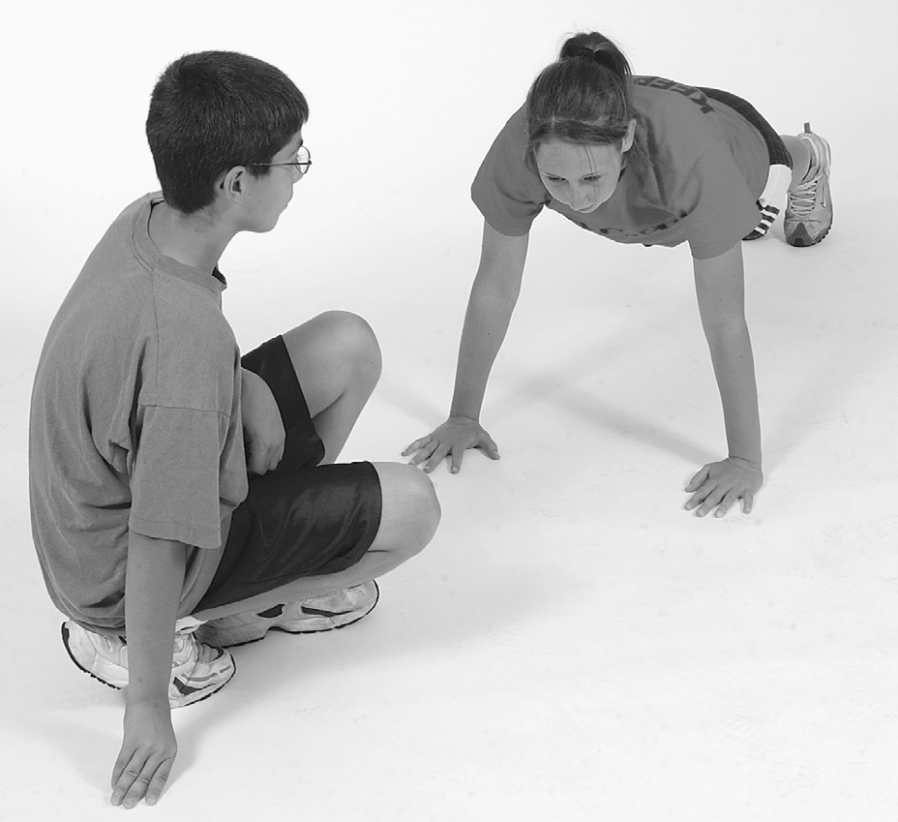

***Test Objective***

* To complete as many 90° push-ups as possible at a rhythmic pace.

***Equipment and Facilities***

**PHOTO 7.7**  Starting position for the 90° push-up

test.

* The only equipment necessary is an audiotape with the recorded cadence or a metranome. The correct cadence is 20 90° push-ups per minute (1 90° push-up every 3 seconds).

***Test Instructions***

* The student being tested assumes a prone position on the mat with hands placed under or slightly wider than the shoulders, fingers stretched out, legs straight and slightly apart, and toes tucked under. The student pushes up off the mat with the arms until arms are straight, keeping the legs and back straight. The back should be kept in a straight line from head to toes throughout the test (photo 7.7). The student then lowers the body using the arms until the elbows bend at a 90° angle and the upper arms are parallel to the floor (photo 7.8). This move- ment is repeated as many times as possible. The student should push up and continue the movement until the arms are straight on each repetition. The rhythm should be approximately 20 90° push-ups per minute or 1 90° push-up every 3 seconds.

***When to Stop***

* Students are stopped when the second form correction (mistake) is made. Only one form correction is allowed.

***Form Corrections***

* Stopping to rest or not maintaining a rhythmic pace
* Not achieving a 90° angle with the elbow on each repetition
* Not maintaining correct body position with a straight back
* Not extending arms fully

***SCORING***

The score is the number of 90° push-ups performed. For ease in administration, it is permissible to count the first incorrect 90° push-up. It is important to be consistent with all

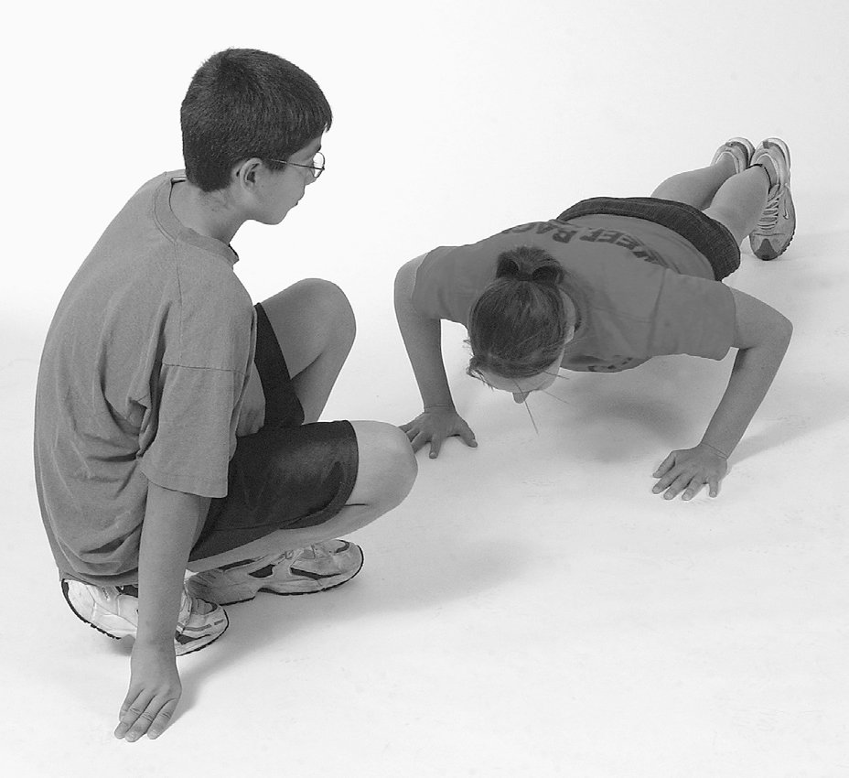

**PHOTO7.8** Student in the “down” position for 90° push-up test.

***20m repeated shuttle run test (maximal effort test)***

* The 20m Shuttle Run Test provides percentile scores for students aged 11-14 years. It is an international test adopted by the Australian Institute of Sport. The Australian Fitness Education Award provides standards to be achieved for students aged 9-18 years (ACHPER, 2004).

**Student Objective**

To run back and forth between two lines, 20m apart, within a set time limit. Running speed is increased by 0.5km/hr each minute using the 20m Shuttle Run Test cadence CD.



20 metres

**Notes**

* The test requires maximal effort.
* The shuttles increase progressively - students are required to run until they can no longer keep up with the speed set by the tape.
* Students should not be discouraged if they finish earlier than others.
* Do not push students to exhaustion.

**Interpretation of Results**

* A score of 4.1 indicates a student has run one shuttle at Level 4. Record the level and the number of shuttles into that level.
* Scores should be compared with the appropriate sex and age related standards (see below).
* Students scoring at or above the set standard are considered to have the level of cardiorespiratory endurance needed to gain health benefits. These students should be encouraged to maintain or increase their cardiorespiratory endurance.
* Students scoring below the standard need to increase their cardiorespiratory endurance towards the criterion based standard.
* A low score may be determined by numerous factors. These include: aerobic capacity, growth, inability to pace, running/walking efficiency, unknown injury, motivation and environmental conditions.

**Criterion-based Standards - (level** & **shuttle) - PAZ 1**

|  |  |  |  |  |  |  |  |  |  |  |
| --- | --- | --- | --- | --- | --- | --- | --- | --- | --- | --- |
| **Age** | 9 | 10 | 11 | **12** | **13** | 14 | 15 | **16** | 17 | **18** |
| M | 3.4 | 3.6 | 5.1 | 5.4 | 5.9 | 6.6 | 7.8 | 8.5 | 8.5 | 8.5 |
| F | 2.7 | 3.4 | 3.5 | '' 4.1 | 4.3 | 5.1 | 5.3 | 5.5 | 5.5 | 5.5 |

**Criterion-based Standards - (level** & **shuttle) - PAZ 2**

|  |  |  |  |  |  |  |  |  |  |  |
| --- | --- | --- | --- | --- | --- | --- | --- | --- | --- | --- |
| **Age** | 9 | 10 | 11 | **12** | 13 | 14 | 15 | **16** | 17 | 18 |
| M | 4.1 | 4.6 | 6.0 | 6.4 | 6.6 | 7.5 | 8.8 | 9.3 | 9.6 | 9.6 |
| F | 3.4 | 3.9 | 4.4 | 4.8 | 5.3 | 5.7 | 6.0 | 6.3 | 6.6 | 6.6 |

**Criterion-based Standards - (level** & **shuttle) - PAZ 3**

|  |  |  |  |  |  |  |  |  |  |  |
| --- | --- | --- | --- | --- | --- | --- | --- | --- | --- | --- |
| **Age** | **9** | **10** | 11 | 12 | 13 | 14 | 15 | 16 | 17 | 18 |
| M | 4.8 | 5.6 | 6.9 | 7.4 | 8.1 | 8.4 | 9.8 | 10.1 | 10.7 | 10.7 |
| F | 4.1 | 4.4 | 5.3 | 5.5 | 6.1 | 6.3 | 6.7 | 7.1 | 7.7 | 7.7 |

***Standing broad jump test (muscular fitness lower limb [3,4]***

**Purpose:**

To evaluate explosive strength of the lower limb body muscles

**Student Objectives:**

To jump as far as possible using a double foot jump from a standing / static start.

**Equipment:**

* Measuring tape

* Chalk / tape to mark starting line

**Procedure**

1. The athlete stands behind a line marked on the ground with feet slightly apart. A two foot take-off and landing is used, with swinging of the arms and bending of the knees to provide forward drive. The subject attempts to jump as far as possible, landing on both feet without falling backwards. The start of the jump must be from a static position.
2. The result will be recorded in metres.
3. A non-slip hard surface, chalk and a tape measure are used to perform the test.
4. 2 attempts will be performed with the longest jump being recorded. The measurement is taken from take-off line to the nearest point of contact on the landing (back of the heels).

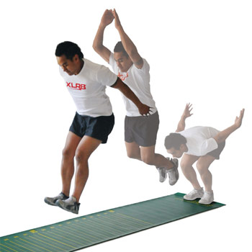

***Seated Basketball Throw Test***

**Purpose:**

To evaluate explosive strength of the upper body muscles

**Student Objectives:**

To throw the basketball as far as possible using a chest pass from a static start.

**Equipment:**

* Measuring tape * Basketball * Chalk / tape to mark * Wall

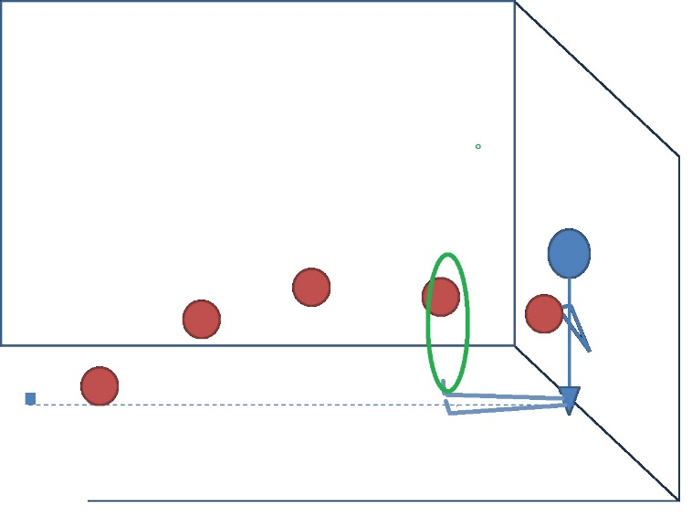**Procedure**

1. The participant sits on the floor with their buttocks, back, shoulders and head remaining against the wall and their legs straight with feet together.
2. An assistant places a hoop on top of the participant's toes and the participant assumes the chest pass position with elbows touching the wall.
3. The participant will perform a two-handed chest pass through the hoop
4. the distance from the wall to the ball's first point of contact on the ground is measured in metres (m).
5. Each participant performs two trials.

(Brumitt, Meira, En Gilpin, & Christiansen, 2011)

**Referencing:**

ACHPER. (2004). *Australian Fitness Education Award: Teacher's Handbook and Curriculum Ideas* (2nd ed.). South Australia: The Australian Council of Health Physical Education and Recreation.

Alberto, P., & Troutman, A. (2003). *Applied Behaviour Analysis for Teachers* (6 ed.). Boston: Pearson Education.

B Ortega, F., Artero, E., Ruiz, J., Vicente-Rodríguez, G., Bergman, P., Hagstromer, M., . . . Castillo, M. (2008). *Reliability of health-related physical fitness tests in European adolescents. The HELENA Study* (Vol. 32 Suppl 5).

Brumitt, J., Meira, E., En Gilpin, H., & Christiansen, M. (2011). *Comprehensive strength training program for a recreational senior golfer 11-months after a rotator cuff repair* (Vol. 6).

Mackenzie, B. (2005). *Performance evaluation tests*. London: Electric Word.

Shapiro, E. S., & Cole, C. L. (1994). *Behavior Change in the Classroom: Self-management Interventions*: Guilford Publications.

Welk, G. J., & Merideth, M. D. (2008). *FITNESSGRAM / ACTIVITYGRAM: Reference Guide* (3rd, Edition ed.). Dallas, TX: The Cooper Institute.