A PROSPECTIVE OBSERVATIONAL STUDY OF PERIPHERAL INTRAVENOUS VOLUME ANALYSIS (PIVA) IN PATIENTS RECEIVING INVASIVE HAEMODYNAMIC MONITORING

Short title: PIVA MONITORING

Protocol: Version 4, 3rd April 2019

Investigators

- Professor Rinaldo Bellomo
Director, Intensive Care Research

- Dr Fumitaka Yanase
Research Fellow, Department of Intensive Care, Austin Hospital

- Dr Laurent Bitker
Research Fellow, Department of Intensive Care, Austin Hospital

- Dr Glenn Eastwood
Research Manager, Department of Intensive Care, Austin Hospital

- A/Prof Laurence Weinberg
Director, Department of Anaesthesia, Austin Hospital.

Principal Investigator

Prof Rinaldo Bellomo
Director, Intensive Care Research
Austin Hospital, Studley Road Heidelberg
Victoria, Australia, 3084
Email. rinaldo.bellomo@austin.org.au
T: 9496 5992

1. Lay Summary
The monitoring of blood volume status in patients requiring advanced monitoring in the operating theatres or the intensive care unit is fundamental to patient protection and treatment. However, it is currently difficult and only partly addressed by the use invasive monitoring devices. As a consequence, multiple treatments (fluids; drugs to increase blood pressure; drugs to increase the pumping strength of the heart) are applied by doctors without a real-time assessment of whether they are achieving the ultimate goal of maintaining optimal effective blood volume. The development of new technique called peripheral intravenous volume analysis (PIVA) has recently been shown in animal experiments and dialysis patients to provide a continuous, reliable, reproducible, safe, and non-invasive assessment of blood volume state. PIVA can be performed at the bedside by simply connecting the drip line used to give fluids with a device that uses mathematical calculations to adjust for the pressure inside the hand or arm veins. A side arm of the drip line continuously transmits such vein pressure data to the monitor. The monitor then does mathematical modifications of the pressure waves to calculate a blood volume signal. Then it displays such information about the pressure generated by the volume of blood in the veins to the treating doctor. Finally, the monitor allows the collection of such pressure information every minute, which can then be used for detailed analysis.

In this study, we simply want to connect this device to the existing drip line in a group of patients having major surgery or admitted to ICU for advanced haemodynamic monitoring. The aim of this study is to see if the PIVA monitoring delivers similar information to that which we currently obtain with more invasive, more expensive, and more complex technology. Moreover, we aim to ask clinicians whether easy to use; and achieves the reliable delivery of good quality data. Finally, we wish to see if all these aspects of PIVA prove correct, as we will then seek approval to conduct further and more advances studies of PIVA.

2. Background and rationale
The clinical challenge of evaluating fluid volume status
The determination of circulatory volume status remains a clinical challenge in medicine. Patients may develop hypovolemia (too little fluids in the vascular space) due to conditions such as haemorrhage, dehydration, or infection with vascular leak. Alternatively, patients may become hypervolemic (too much fluids in the vascular space), due to conditions such as heart failure, renal failure, or iatrogenic over-resuscitation all of which overwhelm the kidney’s ability to regulate intravascular volume status. In clinical practice, clinicians strive to return patients to euvolemia (the “right” volume status) through the administration of intravenous fluids or diuretics which remove fluids to achieve homeostasis. While there are a number of proposed clinical examination findings (e.g. dry mucous membranes or skin turgor or capillary return or urine output), invasive measurements (e.g. central venous pressure, blood pressure, cardiac output), or laboratory tests (e.g. blood urea nitrogen, creatinine, haematocrit, lactate), none are precise or universally accepted as reliable methodologies to assess volume status.

The feasibility of Peripheral IntraVenous waveform Analysis (PIVA)
Much physiological evidence suggests that the venous system can provide useful information on intravascular filling (1-6). A promising evolving technology called Peripheral IntraVenous waverform Analysis (PIVA), utilizes spectral analysis of the peripheral venous waveform to assess volume status. This method continuously measures peripheral venous pressure using a transducer through a side arm of a standard intravenous catheter, and then uses Fast Fourier transformation to assess the amplitude of the waveform which, through an algorithm, is transformed into a metric that, in animal experiments, appears to be a surrogate for volume status (7). This is accomplished by a mathematical parsing and manipulation of the pulse wave related amplitudes, and using these amplitudes to estimate volume status, driven primarily by a proposed proportional relationship of the amplitudes with intravascular volume. Initial haemorrhage, porcine shock (8), and dialysis studies (see below) have provided preliminary evidence that support the feasibility of this approach and a correlation between these values and volume status.
Recent studies have demonstrated that the amplitude of the venous waveform (and harmonics), is highly sensitive to changes in venous compliance due to changes in volume. Mild hypovolemia leads to modulation of the cardiac frequency of the peripheral venous waveform (6). In central hypovolemia induced in human subjects by lower extremity negative pressure, changes in venous waveform features occur earlier than decreases in arterial blood pressure (6). Work performed by others confirmed these findings in humans undergoing cardiac surgery (9, 10) as well as in a pig model. Changes in volume status due to blood removal in humans or pigs led to changes in the venous waveform signal before changes in blood pressure or pulse rate suggesting that the venous waveform signal is more sensitive to changes in intravascular volume than standard vital signs.

PIVA uses a proprietary signal analysis algorithm. This proprietary algorithm using venous waveform analysis provides useful information for clinical monitoring of potential abnormalities of clinical hemodynamic (volume) status. Unlike some technologies, like pulse pressure variation using arterial waveform analysis, PIVA measures peripheral intravenous waveforms and can detect volume changes in spontaneously breathing as well as mechanically ventilated individuals. The design and method involves a sensor integrated into IV tubing that interfaces with a microcontroller platform for real time signal processing. This approach appears inexpensive, non-invasive, and easy to use.

This technique has so far been assessed in animal studies of volume removal and volume administration and, in the setting of cardiac surgery, its volume signal has been correlated with data obtained with the pulmonary artery catheter. Moreover, in human studies involving dialysis patients who are receiving volume removal during the dialysis treatment, it has been shown remarkably robust in predicting and responding to such volume changes.

The technology

PIVA is a non-invasive technology that takes advantage of commonly inserted catheters into any peripheral vein and derives the necessary signal using mathematical analysis.

As far as the patient is concerned, this devise has literally no need for skin contact and is less invasive than a pulse oximeter.

The non-invasive nature of the device is illustrated in the following photographs.

Figure 1: Peripheral venous catheter

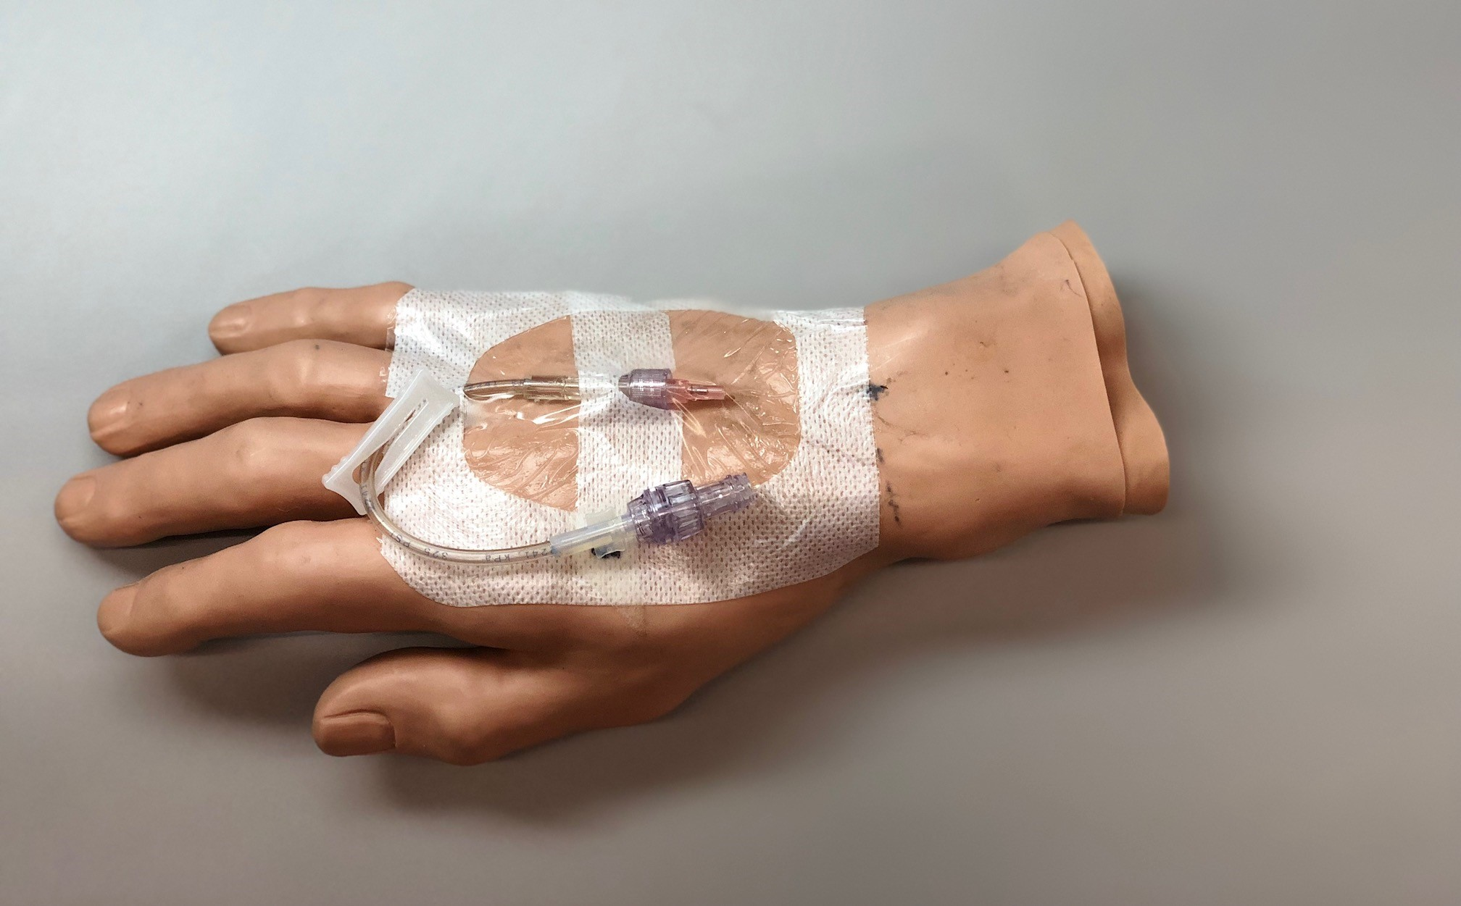

Figure 2: Connection of peripheral catheter to monitor

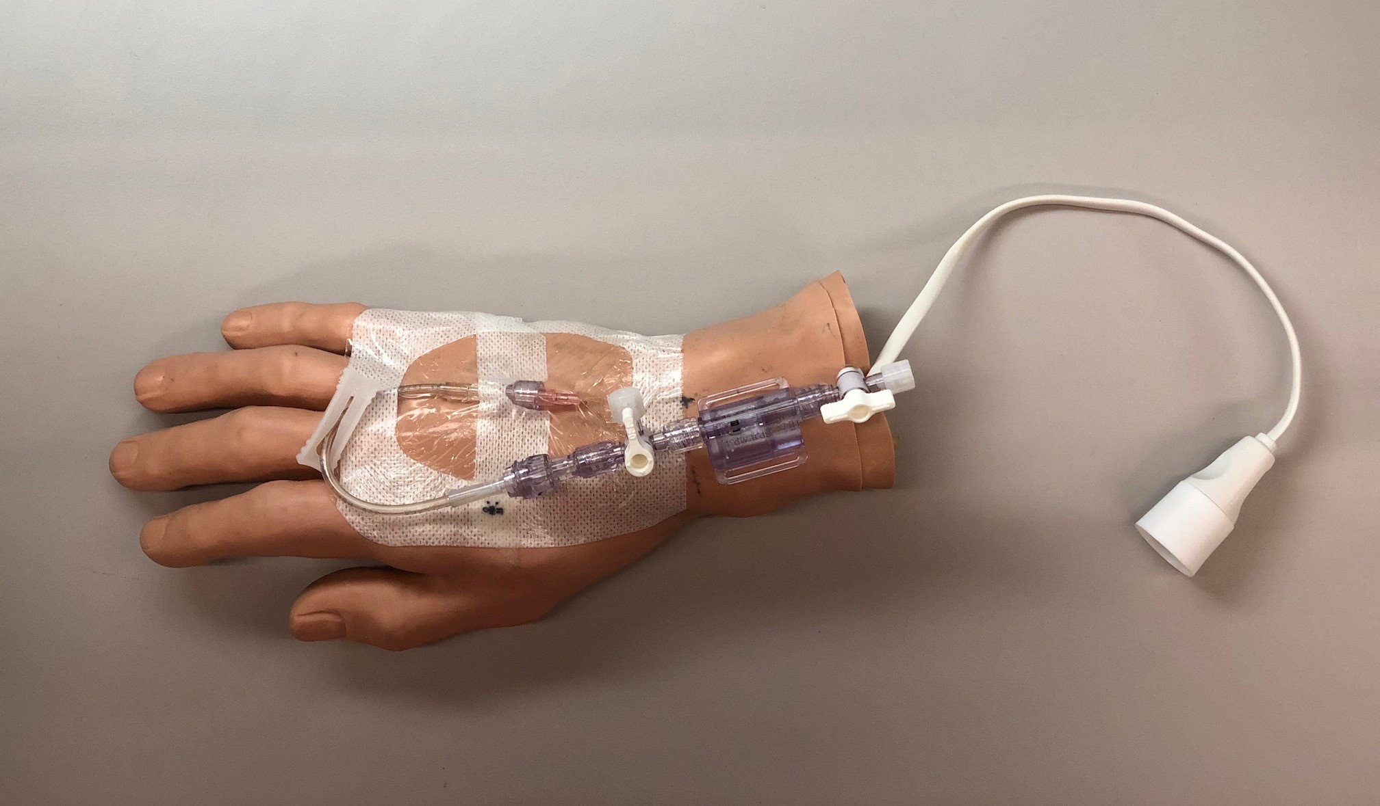
This catheter set-up is then connected to the PIVA monitor (prototype shown below)

Figure 3: Prototype of PIVA monitor with connection port
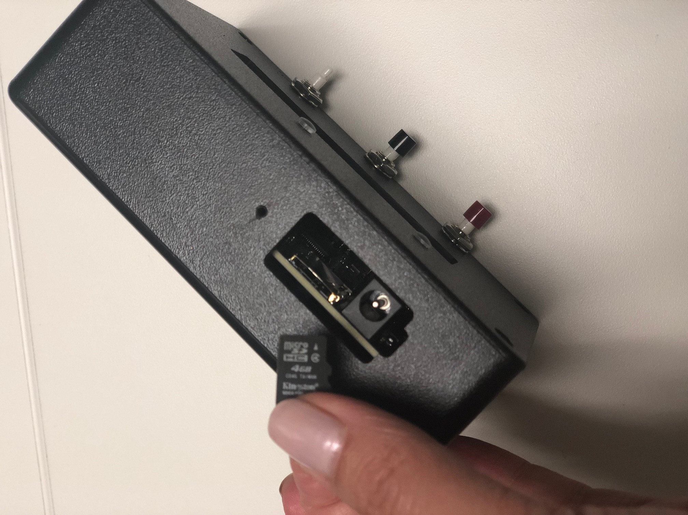
The data from the monitor can be downloaded for analysis at high frequency

Figure 4: Example of data download from the PIVA monitor
Time | Pressure Reading | Flag Number
12:00:01:000 | 24.102412 | 0
12:00:01:002 | 24.102412 | 0
12:00:01:004 | 24.102412 | 1
12:00:01:006 | 24.102412 | 1
12:00:01:008 | 24.102412 | 1
12:00:01:010 | 24.102412 | 1
12:00:01:012 | 24.102412 | 1
12:00:01:014 | 24.102412 | 1
12:00:01:016 | 24.102412 | 1
12:00:01:018 | 24.102412 | 1
12:00:01:020 | 24.102412 | 1
12:00:01:022 | 24.102412 | 1
12:00:01:024 | 24.102412 | 2
12:00:01:026 | 24.102412 | 2
12:00:01:028 | 24.102412 | 2
12:00:01:030 | 24.102412 | 2
12:00:01:032 | 24.102412 | 2
12:00:01:034 | 24.102412 | 2
12:00:01:036 | 24.102412 | 2

The information obtained can be recorded every second and can be downloaded to a USB for data transfer into statistical programs for assessment and analysis.

It is important to note that PIVA does not require the insertion of a dedicated catheter in most cases.
This is because the mathematical algorithm can adjust for fluid inflow into the vein in many cases. Thus the PIVA connection can be attached to a side arm of the peripheral line system. As a consequence, PIVA requires no interaction with the patients themselves. In this way PIVA is totally non-invasive, less invasive than attaching an ECG sticker to the chest of a patient or swabbing the skin with alcohol or placing a pulse oximeter on the finger. This totally non-invasive set up is displayed on Figure 5.

Figure 5: PIVA set up showing the side arm of a peripheral line, which can derive the PIVA signal even during fluid infusion.
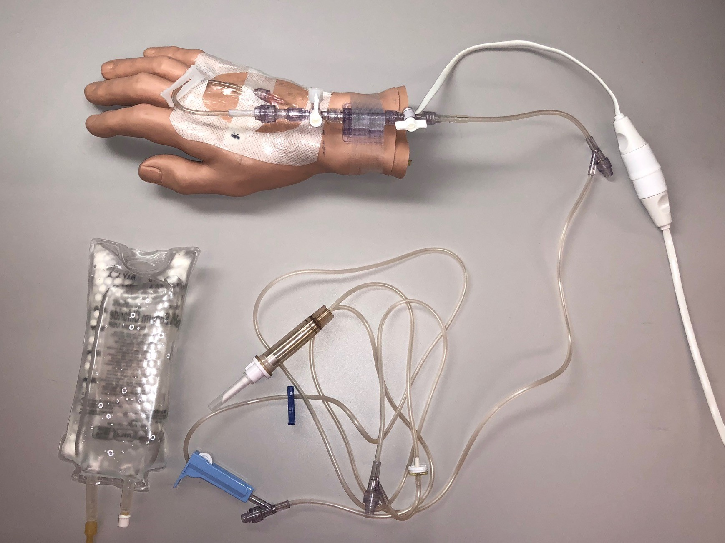

3. Main Research question
The main aim of this observational study is to record PIVA output in patients receiving invasive circulatory monitoring as part of their medical care and to relate such output to other measures of intravascular volume status. Such monitoring may occur in the operating theatre (OT) or the Intensive Care Unit (ICU).

Hypothesis
In patients receiving various forms of invasive circulatory monitoring, PIVA-derived assessment of the state of intravascular volume will be feasible and show a significant and logical correlation with such invasive measurements (cardiac index, central venous pressure, pulmonary artery pressure, stroke volume variation, pulse pressure variation etc.) in response to hemodynamic modification as initiated and performed by clinicians in the usual care of their patients.

2. Additional Study Objectives

- To characterize the normal range of PIVA values in seemingly euvolemic pre-operative patients
- To assess the effect of age and comorbid disease (diabetes, hypertension, and vascular disease) on a “normal” PIVA measurement taken during a state of presumed euvolemia (as above)
- To estimate the nature of the association between PIVA measurements, volume administration, and hemodynamic monitoring assessment in patients receiving invasive hemodynamic monitoring during surgery or ICU treatment
- To assess the feasibility of PIVA by measuring the signal acquisition success rate, the signal transmission success rate, the signal display of data success rate, and the downloading of data success rate all as percentage of patients connected to the PIVA monitor.
- To evaluate the user-friendliness of the monitor by clinicians in relation to the ease of use and whether or not they believe that the monitor is providing good quality data.

3. Research Methods

Overall Study Design
This is a prospective, observational cohort study that will enrol a convenience group of 100 patients in the Operating Theatres and Intensive Care Unit to further assess the performance of PIVA in tracking volume status. All patients will receive usual care are prescribed by their treating clinicians and PIVA measurements will be made and clinical, fluid administration, and hemodynamic data gathered.

Research Measurements

PIVA measurements
This study will use the PIVA intravenous line with sensor for the procedure. A peripheral intravenous line is routinely placed as part of the clinical care and will be used. The PIVA intravenous line with sensor will be connected to the PIVA monitor. PIVA signals will be obtained and stored in the monitor for subsequent analysis. PIVA data will not be used to inform patient treatment.

Inclusion criteria:
- age > 18 years of age
- expected to undergo surgery with invasive hemodynamic monitoring
- admitted to ICU and receiving invasive hemodynamic monitoring

Exclusion criteria
- No invasive hemodynamic monitoring planned
- No invasive hemodynamic monitoring present
- No peripheral venous catheter present
- Female patients who are pregnant or lactating
- Active irregular heart rhythm
- Congenital heart disease
- Restrictive cardiomyopathy (e.g. due to amyloidosis)
- Severe mitral stenosis, moderate or severe aortic stenosis, or mitral or aortic valve replacement
- Extracorporeal circulation (e.g. cardiopulmonary bypass, LVAD, ECMO, or active dialysis during measurement)
- Dual lung ventilation
- Use of vasopressors, starches, lipids (including propofol), or dextrose solutions greater than 5% concentration through the IV line.

We will collect data on a total of 100 patients during the Monday to Friday period.

Data Collection
PIVA Measurements
PIVA values will be collected continuously as feasible; assuring a minimum of values every minute for 2 hours (surgery). PIVA data will be retrieved from the monitor after each patient. We will record the day and time-of day in which the observations by PIVA monitoring are made. We will then use this information to evaluate interventions, such as diuretic use, fluid therapy or haemodynamic change via medical record audit. PIVA monitoring will occur for a minimum of 2 hours but may be longer depending on the location and clinical status of the patient.

Clinical Data
We will collect data on the reason for admission, demographics, and any fluid administration during the measurement.
We will collect data on the timing, rate, amount and duration of any fluid boluses. We will also include data on the administration of vasopressors, urine output, laboratory data. Such data are obtained as part of routine care via an audit of the patient’s medical record.

Ease of use
We will assess clinical user-friendliness of the PIVA monitor. Specifically, we will ask clinicians to use a Likert scale to describe the ease of use and if the monitor is providing good quality data.

Statistical approach

First, we will use descriptive statistics to characterize the patients as has been done for other techniques (11-14). Then, we will describe the cohort specific PIVA measurements (normal range among euvolemic pre-surgery patients in this study, effect of fluid administration on PIVA, and association of PIVA with fluid removal by diuretics group and overall fluid balance). Then, we will evaluate the relationship between PIVA derived data with the following markers of intravascular volume status: arterial blood pressure; central venous pressure (if available); cardiac index (if available); pulse pressure variation (if available); stroke volume variation (if available); pulmonary artery pressure (if available), and fluid balance (output minus input)

To describe the patients, we will use means and standard deviations, medians and interquartile ranges, or counts and percentages as appropriate. Then, we will characterize the distribution of PIVA values at baseline. Beyond visual characterization using a histogram, we will estimate parameters of the distribution, including the mean, standard deviation and percentiles. We will use the family of generalized linear models with a linear link function to model PIVA as a function of time, we will ensure the covariance estimates take into account the repeated within-patient measurements. We will consider the possibility that the relationship with time is non-linear. If we find a systematic effect of time on PIVA among euvolemic subjects at rest, this will be informative for establishing normative values as well as for interpreting subsequent analyses. Secondary to ascertaining whether there is systematic variation, we will estimate the random within-subject variation. Finally, we will include age and comorbidity in the model to determine whether they affect the absolute PIVA values and the variation in PIVA values within subjects. If there are significant effects of age or comorbidities, separate normal ranges may be provided for these groups.

During treatment, we will include either fluids administered (for the hypovolemic group model) or measures of fluid loss (for the hypervolemic group model) as the primary predictor. As before, we will model PIVA as a function of fluids taking into account the repeated within-patient measurements. We will consider the possibility that the relationship is non-linear. We expect to find a systematic association between fluids and PIVA that can be used for establishing the normal response of persons to either fluid administration or fluid loss. We will include age, comorbidity and baseline PIVA values in the model to determine whether they affect the change in PIVA values. We will also evaluate the effect of vasopressors on PIVA values and on the change in PIVA with fluid administration. To compare the changes in PIVA (ΔPIVA) to the changes in other hemodynamic measurements we will evaluate the correlation between scores as a gross characterization of association within each cohort. Then, we will model ΔPIVA as a function of changes in cardiac index, arterial blood pressure, central venous pressure, pulse pressure variation, stroke volume variation and pulmonary pressure variation (as available) taking into account baseline values. Finally, we will compare the repeatability of ΔPIVA to that Δ in the above measures by comparing standardized limits of agreement. In addition to modelling approaches above, we will explore other associations of interest. Bivariate methods (such as difference tests and cross tabulations) will be used as exploratory investigations. We do not plan to adjust such analyses for multiplicity as they are hypothesis generating, not hypothesis testing. All analyses will be interpreted recognizing the possibility of false positive findings. The strength of evidence will be tempered by biological plausibility and patterns of association. The results of these exploratory analyses may inform the generation of previously specified models, but we are not using a stepwise modelling approach.

Sample size considerations
The PIVA is a new measurement and its properties in cohorts of patients such as we are enrolling are not yet known. To that end, we have balanced the sample size to maximize our ability to characterize the relationships of interest in this exploratory analysis with the smallest possible sample and feasibility issues. It is generally accepted that to estimate a normal range, approximately 100 participants are needed. This is also a sufficient sample size to estimate repeatability and limits of agreement with confidence (15). With this group size, it is also generally accepted that about 5 variables can be included in a statistical model. While this is a gross generalization, without the data to be collected in this study it is not possible to feasibly compute a required sample size. The use of a within-subjects design for measuring the effects of fluids also maximizes power.

5. Ethical, privacy and confidentiality, indemnity considerations and funding support
The proposed study does not pose major ethical issues. There are strong promising data to justify the view that the planned evaluation of practice in the best interest of patients requiring high levels of haemodynamic monitoring. It is, however, imperative to evaluate changes of practice in the care of this subgroup of patients. We believe that it would be unscientific and unethical to introduce the new practice without rigorous evaluation of this change.

We believe that ALL significant practice changes of this kind at the Austin Hospital should be allowed only with a requirement to perform such prospective observational study and that it is unethical to allow major practice or patient care or patient management changes (medical or surgical or administrative) without appropriate evaluation of the effects of such introduction.

As a matter of prudent study oversight and surveillance, for the purpose of this prospective study, any serious adverse effects will be reported to the Chairperson of the Research Ethics Committee within 72 hours of them occurring.

Consent
This is an observational study which introduces a safe non-invasive monitoring tool which is free of physical contact and less so than pulse oximetry. Its use of this monitoring tool carries no conceivable risk and will not be used to modify patient care.

Privacy and confidentiality
Data pertaining to PIVA values will not interfere with or influence patient care decisions. Anonymity and confidentiality will be preserved.

Indemnity
This is an investigator-initiated study and, accordingly, no commercial sponsor’s indemnity has been provided.

Funding support
This investigator-initiated study has received funding support from Baxter Healthcare Corporation (Baxter). A collaborative research agreement details the nature of this collaboration. In simple terms, the agreement enables Baxter to provide to the investigators the PIVA device and associated consumables. In return, and to facilitate statistical analysis of haemodynamic data, only de-identified device-retained data will be provided via electronic file transfer. The electronic file transfer does not require any identifiable patient-level data to be included. Baxter will not have a role in the study design, data collection or writing of the manuscript.

6. Data retention, storage, destruction and publication
All data will be stored in electronic databases on password-protected computers. All data collected will be kept for a minimum of 7 years as required for adult non-drug studies. All electronic data will be backed up and stored electronically in password secured computers. All paper data will be archived and stored in a locked cabinet in the Research Office of the Department of Intensive Care, Austin Hospital. At the end of 15 years, information will be disposed of securely, i.e. paper documents will be shredded and electronic files be will be permanently erased according to Austin Hospital protocols for the destruction of confidential material in place at the time. Additionally, we plan to publish the audit findings in an international journal relevant to critical care. Participant anonymity and confidentiality will be preserved as only aggregated findings will be presented or reported.

7. Study time-line
- October 2018: Submit final protocol to the Austin Health Human Research Ethics Committee.
- March-Dec 2019: participant recruitment and data collection.
- Jan 2020: Analysis of study data and generation of results report.
- March 2020: submit manuscript for peer-review publication.

8. References
1. Takatsu H, Gotoh K, Suzuki T, et al. Quantitative estimation of compliance of human systemic veins by occlusion plethysmography with radionuclide--methodology and the effect of nitroglycerin. Jpn Circ J 1989;53:245-54.
2. Alfie J, Waisman GD, Galarza CR, Camera MI. Contribution of stroke volume to the change in pulse pressure pattern with age. Hypertension 1999;34:808-12.
3. Bouwmeester JC, Belenkie I, Shrive NG, Tyberg JV. Genesis of the characteristic pulmonary venous pressure waveform as described by the reservoir-wave model. J Physiol 2014;592:3801-12.
4. Brawley RK, Oldham HN, Vasko JS, Henney RP, Morrow AG. Influence of right atrial pressure pulse on instantaneous vena caval blood flow. Am J Physiol 1966;211:347-53.
5. Mynard JP, Smolich JJ. One-dimensional haemodynamic modeling and wave dynamics in the entire adult circulation. Ann Biomed Eng 2015;43:1443-60.
6. Alian AA, Galante NJ, Stachenfeld NS, Silverman DG, Shelley KH. Impact of lower body negative pressure induced hypovolemia on peripheral venous pressure waveform parameters in healthy volunteers. Physiol Meas 2014;35:1509-20.
7. Sileshi B, Hocking KM, Boyer RB, et al. Peripheral venous waveform analysis for detecting early hemorrhage: a pilot study. Intensive Care Med 2015;41:1147-8.
8. Hocking KM, Baudenbacher FJ, Sileshi B, et al. Peripheral Venous Waveform Analysis for Detecting Hemorrhage and Iatrogenic Volume Overload in a Porcine Model. Shock 2016.
9. Ryan JJ, Rich JD, Thiruvoipati T, Swamy R, Kim GH, Rich S. Current practice for determining pulmonary capillary wedge pressure predisposes to serious errors in the classification of patients with pulmonary hypertension. Am Heart J 2012;163:589-94.
10. Sharma GV, Woods PA, Lambrew CT, et al. Evaluation of a noninvasive system for determining left ventricular filling pressure. Arch Intern Med 2002;162:2084-8.
11. Bergese SD, Mestek ML, Kelley SD, et al. Multicenter Study Validating Accuracy of a Continuous Respiratory Rate Measurement Derived From Pulse Oximetry: A Comparison With Capnography. Anesth Analg 2017;124:1153-9.
12. Lakhal K, Ehrmann S, Boulain T. Noninvasive BP Monitoring in the Critically Ill: Time to Abandon the Arterial Catheter? Chest 2017.
13. Ameloot K, Van De Vijver K, Broch O, et al. Nexfin noninvasive continuous hemodynamic monitoring: validation against continuous pulse contour and intermittent transpulmonary thermodilution derived cardiac output in critically ill patients. ScientificWorldJournal 2013;2013:519080.
14. Ma TS, Paniagua D, Denktas AE, et al. Usefulness of the Sum of Pulmonary Capillary Wedge Pressure and Right Atrial Pressure as a Congestion Index that Prognosticates Heart Failure Survival (from the Evaluation Study of Congestive Heart Failure and Pulmonary Artery Catheterization Effectiveness Trial). Am J Cardiol 2016;118:854-9.
15. Lu MJ, Zhong WH, Liu YX, Miao HZ, Li YC, Ji MH. Sample Size for Assessing Agreement between Two Methods of Measurement by Bland-Altman Method. Int J Biostat 2016;12.

9. Appendix A
Appendix A relates to the ‘ease of use’ and ‘data quality’ evaluation of PIVA in practice as self-reported by physicians caring for patients in which PIVA in place. This evaluation will be performed once per shift by the primary physician or delegated physician (amongst a team-based approach to care) that is caring for the patient. The reporting physician will be asked to circle one response per question.

Please see supporting document:
PIVA study – PIVA ease of use and data quality assessment – V1 – 12th December 2018

