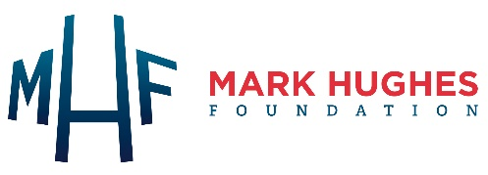

Participant Consent Form – Informal Caregivers

COPING: COgnitive impairment in People with glioma and distress in their INformal care-Givers
Version #1: 12/03/19

By giving my consent I confirm that:
I have read the Participant Information Sheet (Version #1: 12/03/19) for the above research project. I have had the opportunity to consider the information, ask questions, and have had these answered satisfactorily.
I have had an opportunity to discuss this study with someone like family or friends to support me choose whether or not I would like to participate.
I understand that members of my significant person’s healthcare team will not be made aware of my decision to participate or not to participate in this study and my decision will not affect my significant person’s medical treatment or my relationship with the staff who are caring for my significant person.
I understand that my participation is voluntary and that I am free to withdraw at any time without giving any reason and without my or my significant person’s medical care, relationship with the staff who is caring for us, or legal rights being affected.
I agree that research data gathered from the results of the study may be published, provided that I cannot be identified.
Please provide contact details:
Address:
Suburb: State: Postcode:
Telephone number:
Email:

I agree to take part in the above research project.

Participant Name:
Signature Date

I would like a copy of the research project’s results sent to me when available. I understand that my name and contact details will be provided to the University of Newcastle for this purpose.
Yes via email Yes via post No

Please return form in the enclosed pre-paid envelope.

