Participant Information Sheet
Interventional Study - Adult providing own consent

Title | Colorectal Anti-Bacterial Eradication (CABE) Trial: The effect of pre-operative antibiotics on post-operative wound infections in Colorectal Surgery
Short Title | CABE Trial
Protocol Number | TBA
Project Sponsor | Colorectal Surgery Unit, Monash Health
Coordinating Principal Investigators/ Principal Investigators | Dr Asiri Arachchi
Location | Dandenong Hospital, Monash Health

Part 1: What does my participation involve?

1 Introduction

You are invited to take part in this research project called the Colorectal Anti-Bacterial Eradication (CABE) trial. You have been invited because you are undertaking an elective Colorectal surgery. Your details were obtained by the trial investigators, from Monash Health Colorectal unit. This Participant Information Sheet tells you about the research project. It explains the process involved with taking part in this trial. Knowing what is involved will help you decide if you want to take part in the research.
Please read this information carefully. Ask questions about anything that you don't understand or want to know more about. Before deciding whether or not to take part, you might want to talk about it with a relative, friend or local health worker. Participation in this research is voluntary. If you don't wish to take part, you don't have to. Your refusal will not have any effect on your surgery or the care that you receive. Your refusal will be noted only to make sure that we don't ask you again. If you decide you want to take part in the research project, you will be asked to sign the consent section.
By signing it you are telling us that you:
- Understand what you have read
- Consent to take part in the research project
- Consent to be involved in the research described
- Consent to the use of your personal health information as described.

You will be given a copy of this Participant Information and Consent form to keep.
2 What is the purpose of this research?
To examine the effect of pre-operative oral antibiotics (Neomycin and Metronidazole) on post-operative risks of surgical site infections (SSI). Overseas studies have shown that oral antibiotics together with mechanical bowel preparation reduces the risk of SSI and internationally, pre-operative antibiotics are the standard of care. Although at Monash Health, pre-operative antibiotics are used in selected cases, this practice is not widely accepted in the Australian context. The investigators would like to further substantiate the evidence that a pre-operative standard of care that includes Neomycin and Metronidazole reduces the risk of SSI. Prior to the operation, the investigating team would randomise patients to 2 arms, one receiving the antibiotics with the other receiving placebo. The participants would receive the same level of care that would be expected in the colorectal unit. The study will stop after the participants are reviewed at the 30-days post-operative mark. From there, participants will resume regular follow-ups with their respective colorectal surgeons/teams.
What are SSIs?
Surgical site infections (SSIs) remain a persistent and morbid problem in colorectal surgery with rates ranging from 7 to 25%. Negative outcomes of SSIs include significant increase in patient morbidity, prolonged length of hospital stay, readmission to hospital and healthcare-associated cost. Hence, strategies to reduce the incidence of SSIs following colorectal surgery are important to improve overall patient specific outcomes and provide value-based healthcare to surgical patients.
The World Health Organization (WHO) defines Surgical Site Infections based on the Centre for Disease Control and Prevention (CDC) National Healthcare Safety Network (NHSN) in the USA. It can be divided into 3 categories: Superficial Incisional, Deep Incisional and Organ Space.
Type of wound | Definition
Superficial Incisional | Involves skin or subcutaneous tissue of the incision and rarely leads to systemic toxicity.
Deep Incisional | Includes tissues down to and including fascia and muscle.
Organ Space | Involves any body cavity that was opened or manipulated during surgery.

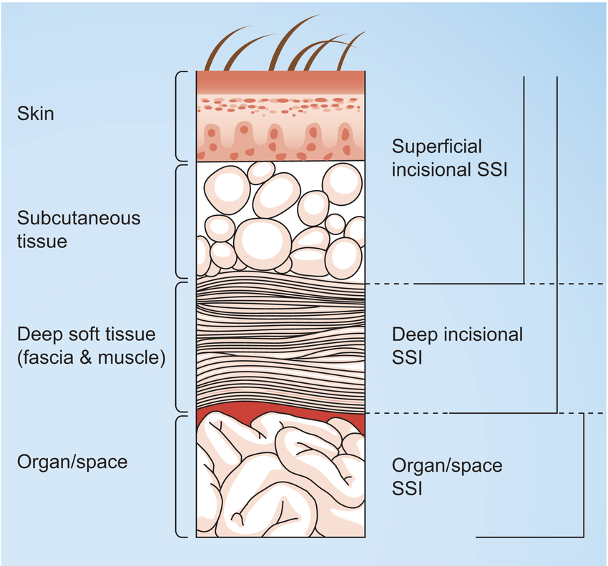
Figure 1 Source - https://www.researchgate.net/figure/Classification-of-surgical-site-infections-according-to-CDC-National-Nosocomial_fig1_44670847
Symptoms include (but are not limited to)
- Pain or tenderness
- Fevers, Chills or Sweats
- Nausea and/or Vomiting
- Localized swelling over incision site
- Heat or redness over incision site
- Purulent Discharge (white, milky, thick discharge)
Management of SSIs
- Most superficial SSIs can be managed with antibiotics
- Localised collections secondary to SSIs would need drainage either radiologically or surgically

3 What does participation in this research involve?
Recruitment and allocation to treatment group
Your consent will be obtained, and a consent form signed, before any study assessments or further information about you is obtained by the researchers. If you consent to participate, you will be asked a number of questions to ensure you meet the criteria to be included in the project. You will be asked for information related to your medical background, which is relevant to the study as many medical conditions affect your susceptibility to pain or infection.
Inclusion criteria:
- Patients undergoing elective open or laparoscopic colorectal resection
- Able to give informed consent
- Male or female patients from 18-60 years of age

Exclusion criteria:
- Pregnancy – determined through blood tests done 2-3 days before the surgery
- Terminal organ impairment
- Patients that must return to theatre for pathology unrelated to surgical wound site infection such as anastomotic leaks, revisions or re-look laparotomy washouts
- Evidence, preoperatively, of any of the following: sepsis, severe sepsis, or septic shock. Including antibiotic usage in the last 2 weeks
- Patients with pre-existing renal failure – CrCl< 50mL/min
- BMI > 40 as patients with morbid obesity will have higher mortality and SSI rates
- Current abdominal wall infection/surgical site infection secondary to previous laparotomy/laparoscopy or from any other cause (including enterocutaneous fistulas)
- History of laparotomy within the last 60 days
- Immunological disease (e.g. HIV/AIDS)
- Systemic steroid use or other immunosuppressant medication as they are at an increase risk of SSIs
- ASA score ≥4
- Uncontrolled diabetes mellitus
- Emergency Surgery
- Allergy to aminoglycoside or nitroimidazole
- Previous neoadjuvant chemotherapy within the last 4 weeks
- Hearing loss
- If antibiotics were not taken correctly prior to the surgery

All patients who are deemed eligible to provide informed consent and whom require elective Colorectal surgery performed by the Colorectal unit are eligible for the trial (eligibility criteria stated above). Pre-operatively, eligible participants would be randomised into 1 of 2 groups, the case group (receiving the oral antibiotics*) or the control group (receiving placebo tablets**). Along with the tablets, patients would receive a standard bundle of care that would not differ. This bundle of care is identical to the one used in our colorectal unit for elective colorectal operations. Participants will receive a set of instructions that outlines the protocol required prior to surgery.
* Oral Antibiotics group
- Osmotic laxatives [PICOPREP ®]
  - 3 x Satchets of PICOPREP – each packet to be drunk with 250ml of water 1 day before the operation at 1200, 1400 and 1600
- PO antibiotics
  - 1g Neosulf (Neomycin Sulphate) and 400mg Flagyl (Metronidazole) at 1300, 1400 and 2200
- Soap packets for MRSA decolonisation
  - 2 x (4% Chlorhexidine soap packets) – patients to use shower with 1 packet night before surgery and morning of surgery
  - If soap packets were used incorrectly, Chlorhexidine wipes were used on the day of the surgery
- Patient to remain on clear fluids day before surgery

** No Oral antibiotics group
- Osmotic laxatives [PICOPREP ®]
  - 3 x Satchets of PICOPREP – each packet to be drunk with 250ml of water 1 day before the operation at 1200, 1400 and 1600
- Soap packets for MRSA decolonisation
  - 2 x (4% Chlorhexidine soap packets) – patients to use shower with 1 packet night before surgery and morning of surgery
  - If soap packets were used incorrectly, Chlorhexidine wipes were used on the day of the surgery
- Placebo pills
  - 2 green coloured pills and 1 pink coloured pills to be taken at 1300, 1400 and 2200 day before surgery.
- Patient to remain on clear fluids day before surgery

Consented patients are encouraged to report wound discharge, or suspicion of infection during and after their inpatient stay. Symptoms or signs of infection may involve, tenderness beyond what is expected, discharging of pus, or fevers and general unwellness that is a dramatic change from their overall progression in the recovery period.
Major complications and readmissions details will be collected from the patients, treating team, and confirmed by examinations of the medical records. Routine follow-up usually includes a review to check on a patient’s progress (including their wound) after an operation, and for further appointments if indicated from this initial review (such as for any concerns or further plans deemed required for your care). As part of the research study, we request that patients would be reviewed at two particular timepoints - at 14 days and at 30 days post-operatively. If you are required to attend a second follow-up appointment purely for the purpose of this study, we will notify you of this reason and will reimburse parking costs required for the visit. Otherwise, if you are unable to attend the hospital in person for this additional study follow-up, then a phone review can be conducted.
Data will be stored by research investigators, data tabulated into database, that will be stored with limited and well-guarded access for 15 years after the trial then deleted, and data stored in the form of paper will also be shredded once transferred into this electronic format. This project stores patients, surgical, anaesthetic, and post-operative data in a de-identified format. Database will be in a format of Microsoft Excel suitable for statistical analysis.
Choosing to participate in this research does not guarantee that you will receive the antibiotics. As the research is a randomised trial, it will be by chance that you are allocated to the case group in the study.
How your treatment will be affected
Your surgery will proceed exactly as it would if you were not in the trial, meaning that you will still receive a general anaesthetic and be given pain relief after the surgery. If you required oral opioid pain relief in hospital, then you would also be sent home with oral opioid pain relief. We will monitor your blood tests at regular intervals, and perform wound reviews as per normal. You will receive antibiotics as per our protocols that are normally employed by the treating team post-operatively. Should you develop a wound infection, then you will be treated just like any other patient. The doctors that are treating you, will be blinded to the results of each individual patient, meaning that their treatment of you won’t be biased in anyway.

Other things to be aware of
Pregnancy testing will be undertaken to ensure that the participant is not pregnant prior to participation, unless otherwise confirmed by participants. Participants advised to use an effective form of contraception, whilst participating in the study, as pregnancy will change your outcome and the model of healthcare you receive, thus making the data ineligible for this study.
Members of the research team may access your medical records within the hospital system to enable us to gather the information we need for this study. We will not use any information that is not relevant to the research we are undertaking.
If English is not your first language, you may request the services of an interpreter to assist with finding out about this research, consent and at any follow up appointments. Follow up appointments will all take place at Dandenong Hospital.
4 What do I have to do?
The research team from Dandenong Hospital will contact you with all the information you require to participate in the study. You should take your regular medication unless specified otherwise e.g. diabetic or heart medications. In specific relation to this particular study, if any form of antibiotics have been taken in the last 2 weeks, please inform the treating physician. You should inform us of any significant changes to your health.
You would otherwise undergo normal post-operative pathway i.e. selective use and early removal of nasogastric tubes, and early mobilisation and enteral feeding. They would be receiving routine post-operative oral or parenteral analgesia.
You will be required to report to either ward staff or treating team should you suspect you have a wound infection. The treating team then will take the appropriate measures to assess and treat you if required.
5 Do I have to take part in this research project?
No. Participation in any research project is voluntary. If you do not wish to take part, you do not have to. If you decide to take part and later change your mind, you are free to withdraw from the project at any stage.
If you do decide to take part, you will be given this Participant Information and Consent Form to sign and you will be given a copy to keep, as well as a copy in your medical records, should an unforeseen, adverse event occur in regards to the device (there have been no reported adverse events from use of this device).
Your decision to participate, or refusal to participate, or withdrawal from the trial, will not affect your routine care, your relationship with professional staff of your relationship with Monash Health.
6 What are the alternatives to participation?
The alternative is to not consent to participate in the trial. This is your choice and will not affect your healthcare journey.
7 What are the possible benefits of taking part?
We cannot guarantee or promise that you will receive any benefits from this research. It is possible that if you are in the randomised group that receives the antibiotics you may reduce your risk of surgical wound site infection, however we do not know this, and that’s why we are conducting this trial.
8 What are the possible risks and disadvantages of taking part?
Potential risks
The trial intervention of using pre-operative neomycin and metronidazole includes the potential adverse effects that comes with the usage of any medication. The potential risk of adverse effects is listed by not limited to table 1:
Table 1 Possible side effects
 | Neosulf (Neomycin Sulphate) | Flagyl (Metronidazole)
Common (1-10%) | . Nausea and vomiting  . Diarrhea  . Bloating  . Headaches  . Ototoxicity  . Nephrotoxicity  . Anaphylaxis
Uncommon (0.1% - 1%) |  | . Pheripheral neuropathy  . Anaphylaxis

Follow-up
We request for people participating in the trial to attend a clinic follow-up review at 14 days and 30 days after the surgery to review the wound and ask some questions about whether there have been any issues since the surgery. At 30 days, if you are unable to attend an in-person clinic review, we are able to complete this review via a phone call. We understand that your time is valuable, and appreciate your assistance with this study.
Psychological distress
You may feel that some of the questions we ask are stressful or upsetting. If you do not wish to answer a question, you may skip it and go to the next question or you may stop immediately. If you become upset or distressed as a result of your participation in the research project, the research team will be able to arrange for counselling or other appropriate support. Any counselling or support will be provided by qualified staff, who are not members of the research team. This counselling will be provided free of charge.
9 What if new information arises during this research project?
Sometimes during the course of a research project, new information becomes available about the treatment that is being studied. If this happens, your study doctor will tell you about it and discuss with you whether you want to continue in the research project. If you decide to withdraw, your study doctor will make arrangements for your regular health care to continue. If you decide to continue in the research project you will be asked to sign an updated consent form.
Also, on receiving new information, your study doctor might consider it to be in your best interests to withdraw you from the research project. If this happens, he/ she will explain the reasons and arrange for your regular health care to continue.

10 Can I have other treatments during this research project?
Whilst you are participating in this research project, you will still receive standard painkillers and anti-nausea medication as required.
It is important to tell your study doctor and the study staff about any treatments or medications you may be taking, including over-the-counter medications, vitamins or herbal remedies, acupuncture or other alternative treatments. You should also tell your study doctor about any changes to these during your participation in the research project. Your study doctor should also explain to you, which treatments or medications need to be stopped for the time you are involved in the research project.
11 What if I withdraw from this research project?
If you do consent to participate, you may withdraw at any time. If you decide to withdraw from the project, please notify a member of the research team before you withdraw. You will find contact details for the research team at the end of this information sheet. If you do withdraw, you will be asked to complete and sign a “Withdrawal of Consent” form.
If you decide to leave the research project, the researchers will not collect additional personal information from you, although personal information already collected will be retained to ensure that the results of the research project can be measured properly and to comply with law. You should be aware that data collected up to the time you withdraw would form part of the research project results. If you do not want your data to be included, you must tell the researchers when you withdraw from the research project.
12 Could this research project be stopped unexpectedly?
We do not anticipate that this research project will be stopped unexpectedly. In this very unlikely situation you would be advised immediately and your ongoing care would continue in a standard manner.
13 What happens when the research project ends?
You will still have follow up arrangements with your surgeon, which will be exactly the same as if you had not been a part of the research project. You can request a summary of the final results on the attached form, or by asking a member of the research team at any time.
Part 2: How is the research project being conducted?
14 What will happen to information about me?
By signing the consent form you consent to the research team collecting and using personal information about you for the research project. Any information obtained in connection with this research project that can identify you will remain confidential. The information will be kept in a password-protected file, which only essential members of the research team will have access to. Once all the information about you has been collected, your name and personal details by which you could be identified will be removed permanently from the records. When the results are published, there will be no identifying details of any participant in the reports. Information about you may be obtained from your health records held at this health organisation for the purpose of this research. Data from this study will be retained for at least 15 years following completion of the study.

By signing the consent form you agree to the research team accessing health records if they are relevant to your participation in this research project. It is anticipated that the results of this research project will be published and/or presented in a variety of forums. In any publication and/or presentation, information will be provided in such a way that you cannot be identified, except with your express permission. This is because the published information will consist of summary statistics, rather than referring to specific cases. It is possible that a particular case might be referred to if there was a significant complication, but in this case, only the complication will be reported, with no reference to any personal details, which might identify the participant.
In accordance with relevant Australian and/or Victorian privacy and other relevant laws, you have the right to request access to the information about you that is collected and stored by the research team. You also have the right to request that any information with which you disagree be corrected. Please inform the research team member named at the end of this document if you would like access to your information.
Any information obtained for the purpose of this research project that can identify you will be treated as confidential and securely stored. It will be disclosed only with your permission, or as required by law. Data from this study will be stored for at least fifteen years after completion of the study. Computer files will then be destroyed and paper information will be securely disposed of by a company, which specialises in this, used by the hospital for disposal of all confidential information.
15 Complaints and compensation
If you suffer any injuries or complications as a result of this research project, you should contact the study team as soon as possible and you will be assisted with arranging appropriate medical treatment. If you are eligible for Medicare, you can receive any medical treatment required to treat the injury or complication, free of charge, as a public patient in any Australian public hospital.
You can contact Ms Deborah Dell for complaints directed towards the study
16 Who is organising and funding the research?
The research is organised by a team of clinicians (doctors and nurses) and is funded by Monash Health. The tax payer does not fund this project, and the investigators nor the treating medical professionals do not receive financial compensation for accommodating the trial.
17 Who has reviewed the research project?
This project has been reviewed and approved by an independent group called the Monash Health Human Research Ethics Committee (HREC) and the Head of Department of the Colorectal Surgical Unit at Dandenong Hospital, Monash Health.
This project will be carried out according to the national statement on ethical conduct in human research (NHMRC 2018). This statement has been developed to protect the interests of people who agree to participate in human research studies.

18 Further information and who to contact
The person you may need to contact will depend on the nature of your query.
If you would like any further information concerning this project or if you have any medical problems which may be related to your involvement in the project (for example, any side effects), you can contact the principal study doctor on (03) 9554 1000 or any of the following people:
Dr Asiri Arachchi
Via Dandenong Hospital Switchboard (03) 9554 1000
If you have any complaints, questions or concerns about your rights as a participant in the study, please contact the Monash Health Human Research Ethics Committee (HREC).
- Ms Deborah Dell
  - Manager, Monash Health HREC
  - (03) 9594 4611
  - Email: Deborah.dell@monashhealth.org

Title | Colorectal Anti-Bacterial Eradication (CABE) Trial: The use of pre-operative antibiotics in preventing post-operative wound infections in Colorectal Surgery
Principal Investigator | Asiri Arachchi, Vladimir Bolshinksy
Associate Investigator (s) | Amos Liew, Alice Lee
Location | Dandenong Hospital (Monash Health), Frankston Hospital (Peninsula Health), Austin Hospital (Austin Health)

Consent agreement
- I have read the Participant Information Sheet or someone has read it to me in a language that I understand.
- I understand the purposes, procedures and risks of the research described in the project.
- I understand that I will be required to be followed up at 14 days and 30 days post operation
- I have had an opportunity to ask questions and I am satisfied with the answers I have received.
- I freely agree to participate in this research project as described and understand that I am free to withdraw at any time during the project without affecting my future health care
- I understand that I will be given a signed copy of this document to keep.

Declaration by Participant – for participants who have read the information

Name of Participant (please print):___________________________________________

Signature:_________________________________ Date:________________________

Declaration by Study Doctor/Senior Researcher
I have given a verbal explanation of the research project, its procedures and risks and I believe that the participant has understood that explanation.

Name of Study Doctor/Senior Researcher (please print):__________________________

Signature:_________________________________ Date:________________________

