Clinical Protocol CABE-001
Colorectal Anti-Bacterial Eradication (CABE) Trial: The effect of pre-operative antibiotics on post-operative wound infections in Colorectal Surgery
Monash Health Reference: RES-20-0000-777A ; ERM Reference No: 68162
Protocol Version 5: 15 November 2021

CONFIDENTIALITY STATEMENT
Part or all of the information in this protocol may be unpublished material. Accordingly, this protocol is to be treated as confidential and restricted to its intended use. This material is the property od the Department of Colorectal Surgery, Monash Health and must not be disclosed or used except as authorized in writing by the Department of Colorectal Surgery, Monash Health.

Table of Contents
STUDY TITLE | 4
SPONSOR INFORMATION | 4
INVESTIGATORS  - Principal Investigators  - Co-Investigators  - Site Specific Investigators | 4  4  5  6
REVISIONS | 7
LIST OF ABBREVIATIONS | 8
STUDY SYNOPSYS | 9
EVENT SCHEDULE | 14
INTRODUCTION  - Background Information  - Study Drug  - Preclinical Experience  - Funding | 15  15  15  16  16
STUDY OBJECTIVES  - Primary Objective  - Secondary Objective | 16  16  16
INFORMED CONSENT | 16
STUDY POPULATION  - Recruitment  - Inclusion Criteria  - Exclusion Criteria  - Restricted concomitant medications  - Study Design  - Stopping Rules  - Responsibilities and data storage  - Investigational Supplies  - Packaging  - Investigational Product Dispensing  - Dosage preparation and administration  - Storage Requirements  - Investigational Product Accountability  - Randomisation and Blinding  - Study Visits  - Screening (within 2 weeks prior to visit 1)  - 24 hours prior to surgery (Visit 1)  - Day of Surgery (Visit 2)  - Inpatient stay (Visit 4)  - Outpatient review (D14 and D30, Visit 4 and 5 respectively) | 17  17  17  17  18  18  19  19  19  19  20  20  20  20  20  21  21  22  22  23  24
ADVERSE EVENT REPORTING  - Foreseeable Adverse Events  - Serious Adverse Events  - Unexpected Adverse Event  - Assessment of relationship to study drug  - Assessment of severity  - Breaking the Blind | 24  24  24  25  25  25  26
STATISTICAL CONSIDERATIONS  - Criteria for Evaluation  - Sample size and study duration  - Statistical rational and analysis  - Sample Size Calculations | 26  26  27  28  28
WITHDRAWAL FROM STUDY | 29
DATA MANAGEMENT | 29
ETHICAL CONSIDERATIONS | 30
GENERAL CONSIDERATIONS | 30
AGREEMENTS WITH PROTOCOL | 31
REFERENCES | 32
APPENDIX  - Appendix A. Classification of Surgical Site Infections from the CDC/NHSN  - Appendix B. TGA Public Summary for NEOSULF (Neomycin Sulphate 500mg Tablet)  - Appendix C. TGA Public Summary for Flagyl (Metronidazole 400mg Tablet)  - Appendix D. Patient Consent Form and Information Booklet  - Appendix E. Validated Bluebelle Wound Healing Questionnaire  - Appendix F. Delegation of Authority Log Template | 34  34  35  37  39  50  52

- STUDY TITLE
Colorectal Anti-Bacterial Eradication (CABE) Trial: The effect of pre-operative antibiotics on post-operative wound infections in Colorectal Surgery.
Trial Registration:
Monash Health Reference: RES-20-000-777A ; ERM Reference No: 68162
- This trial was first registered with the Monash Health HREC on the 12 Oct 2020.
Australian New Zealand Clinical Trials Registry (ANZCTR) Reference Number: 380165 (Pending confirmation from Monash Health HREC)
- SPONSOR INFORMATION
On behalf of the Primary investigator Mr Asiri Arachchi, we would like to declare that this is a non-commercially sponsored clinical trial in collaboration with other Victorian Hospitals, Peninsula Health and Austin Health. We will seek funding from the Colorectal Department of the individual healthcare networks for the research project. No a
- Investigators
3.1 Principal Investigators:
- Mr Asiri Arachchi
CSSANZ Fellow, Colorectal Surgery Unit, Dandenong Hospital, Monash Health
Email: asiri.arachchi@monashhealth.orgasiri
Mobile no: 0406018279

Roles: Lead Investigator, Study Design, Data Collection, Management, Decision to submit the report for publication

Mr Asiri Arachchi is the lead investigator for the CABE trial. He is a CSSANZ Fellow under the Colorectal Surgical Unit, Dandenong hospital, Monash Health. He is an accomplished researcher with many years of research. He will oversee the study design, data collection and coordinate the efforts between the different healthcare networks. He will have ultimate authority over the conduct of this research.

- Mr Vladimir Bolshinsky
Colorectal and General Surgery Consultant, Colorectal Surgery Unit, Peninsula Private Hospital
Email: bolshinskyv@gmail.com
Mobile no: 0412690694

Roles: Lead Investigator, Study Design, Data Collection, Interpretation of data

Mr Vladimir Bolshinksy is an accomplished Colorectal Consultant working under Peninsula Private Hospital. He has authored 4 book chapters, and multiple peer reviewed journal articles. He will oversee the study design, data collection and interpretation of data.

- Mr Hanumant Chouhan
Colorectal Surgery Consultant, Dandenong Hospital, Monash Health
Email: Hanumant.chouhan@monashhealth.org
Mobile no: 0423678467

Roles: Lead Investigator, Study Design, Data Collection, Interpretation of data

Mr Hanumant Chouhan is an accomplished Colorectal Consultant under the Colorectal Surgery Unit, Monash Health. He has authored over 30 peer-reviewed publications. He will oversee the study design, data collection and writing of the report.

3.2 Co-Investigators:

- Dr Amos Nepacina Liew
General Surgery Registrar, Colorectal Surgery Unit, Dandenong Hospital, Monash Health
Email: amos.liew@monashhealth.org
Mobile no: 0413358053

Roles: Data collection, Data Management, Writing of report

Dr Amos Liew is an unaccredited General Surgery Registrar under Monash Health. He has authored several papers and will be charge of data collection, management and writing of the report.

- Dr Alice Lee
General Surgery Registrar, Colorectal Surgery Unit, Dandenong Hospital, Monash Health
Email: alice.lee2@monashhealth.org
Mobile no: 0423284418

Roles: Data collection, Data Management, Writing of report

Dr Alice Lee is an accredited General Surgery Registrar under Monash Health. She has authored several papers and will be charge of data collection, management and writing of the report.

- Mr William Teoh
Colorectal Surgery Consultant, Colorectal Surgery Unit, Dandenong Hospital, Monash Health
Email: William.teoh@monashhealth.org
Mobile no: 0421623791

Roles: Co-investigator, Study Design, Interpretation of Data

Mr William Teoh is an accomplished Colorectal Consultant under the Colorectal Surgery Unit, Monash Health. He is has supervised the colorectal unit in many of their research undertakings. He will oversee the study design and the interpretation of data

- Ms Vicky Tobins
Research Co-ordinator, Department of Surgery, Frankston Hospital, Peninsula Health\
Email: Vtobin@phcn.vic.gov.au
Mobile no: 0397848416

Roles: Data Management, Interpretation of Data, Study Design

Ms Vicky Tobins is an experienced clinical researcher who has authored and supervised many peer-reviewed papers. She will be the principal supervisor for data management, interpretation of data and study design.

  - Site Specific Investigators

- Mr James Lim
Colorectal Surgery Consultant, Colorectal Surgery Unit, Dandenong Hospital, Monash Health
Email: James.lim@monashhealth.org
Site Investigator for:
Dandenong Hospital
135 David St, Dandenong VIC 3175, Australia
Colorectal Surgery Unit

- Mr Stewart Skinner
Colorectal and General Surgery, Frankston hospital, Peninsula Health
Email: Yvonne.cabrini@gmail.com
Site Investigator for:
Frankston Hospital
2 Hastings Rd, Frankston VIC 3199, Australia
Colorectal Surgery Unit

- Ms Adele Burgess
Colorectal Surgery Consultant, Austin Hospital, Austin Health
Email: admin@heidelbergsurgical.com.au
Site Investigator for:
Austin Hospital
145 Studley Rd, Heidelberg VIC 3084, Australia
Colorectal Surgery Unit

- Revisions
No | Date | Version | Revision
1 | 15/11/2021 | Version 5 – 15/11/2021 | - Title change  - Corrected CrCl from <30 to <50  - Added average length of stay (5 to 7 days) in page 19  - Serum b-HCG will be taken 2-3 days prior to surgery to ensure patient is not pregnant  - Contraception is recommended prior to surgery for female of childbearing age  - Patient information sheet updated  - BPB removed – Oral antibiotics vs no oral antibiotics  - % risk of adverse effects for neomycin and metronidazole included  - Statistical methodology revised  - Delegation log included

- LIST OF ABBREVIATIONS

Abbreviation | Definition
SSI | Surgical Site Infection
BPB | Bowel Preparation Bundle
AE | Adverse Events

- STUDY SYNOPSIS
Name of Active Ingredients:  Neomycin Sulfate  Metronidazole | Date of Study Synopsis:  15 November 2021
Protocol Title:
Colorectal Anti-Bacterial Eradication (CABE) Trial: The use of pre-operative anti-microbial pharmacoprophylaxis in preventing post-operative surgical site infections.
Investigation Sites:
- Dandenong Hospital, Monash Health, Victoria, Australia
- Frankston Hospital, Peninsula Health, Victoria, Australia
- Austin Hospital, Austin Health, Victoria, Australia
Study Objectives:
The overall objective is to utilise pre-operative antibiotics along with standard mechanical bowel preparation with an aim to reduce surgical site infection (SSI) in bowel resection surgery.

Primary outcome:
- SSI incidence, either superficial incision or deep incisional as per CDC modifications by Horan et al at 14 days and 30 days [1].

Secondary outcome:
- Time fit for discharge (as documented by the medical team)
- Return to theatre for SSI debridement or washout
- Post-surgical complications/Infections
  - Pulmonary embolisms / Deep Vein Thrombosis
  - Urinary Tract Infections
  - Respiratory infections
  - Gastrointestinal infections
- Mortality
Study Design:

This is a single blinded, randomised control trial, conducted under the Colorectal Surgery Unit of multiple health centres including Monash Health, Austin Health, Peninsula Health. This follows the National Statement on Ethical Conduct in Human Research of the National Health and Medical Research Council.
Given this is a single blinded trial, blinding will occur at the level of the patient. It is not practically feasible to blind surgeons from the intervention. No subjective outcomes are assessed by the surgeon so not being blinded will not introduce any bias. The study will comprise a total of 500 adult patients undergoing laparoscopic or open colorectal surgery for elective operations. Participants that are included will be randomly allocated to 1:1, to one of two groups (n = 250 per group) ; Bowel Preparation Bundle 1 (BPB1)* or Bowel Preparation Bundle 2 (current standard of care in most Australian Health Institutes)**.
*Bowel Preparation Bundle 1 (BPB1) – PO Antibiotics group
- Osmotic laxatives [PICOPREP ®]
  - 3 x Satchets of PICOPREP – each packet to be drunk with 250ml of water 1 day before the operation at 1200, 1400 and 1600
- PO antibiotics
  - 1g Neosulf (Neomycin Sulphate) and 400mg Flagyl (Metronidazole) at 1300, 1400 and 2200
- Soap packets for MRSA decolonisation
  - 2 x (4% Chlorhexidine soap packets) – patients to use shower with 1 packet night before surgery and morning of surgery
  - If soap packets were used incorrectly, Chlorhexidine wipes were used on the day of the surgery
- Patient to remain on clear fluids day before surgery

** Bowel Preparation Bundle 2 (BPB2) / Standard of Care – No PO antibiotics group
- Osmotic laxatives [PICOPREP ®]
  - 3 x Satchets of PICOPREP – each packet to be drunk with 250ml of water 1 day before the operation at 1200, 1400 and 1600
- Soap packets for MRSA decolonisation
  - 2 x (4% Chlorhexidine soap packets) – patients to use shower with 1 packet night before surgery and morning of surgery
  - If soap packets were used incorrectly, Chlorhexidine wipes were used on the day of the surgery
- Placebo pills
  - 2 green coloured pills and 1 pink coloured pills to be taken at 1300, 1400 and 2200 day before surgery.
- Patient to remain on clear fluids day before surgery
Number of Subjects to be Enrolled:
Approximately 500 subjects are planned to be enrolled and randomised 1:1 to the BPB1, and BPB2 groups (n=250/group)
Inclusion Criteria/Exclusion Criteria:

A. Inclusion criteria:
- Patients undergoing elective open or laparoscopic colorectal resection
- Able to give informed consent
- Male or female patients from 18-60 years of age

B. Exclusion criteria:
- Pregnancy – determined through serum b-HCG take 2-3 days prior to surgery
- Terminal organ impairment
- Patients that must return to theatre for pathology unrelated to surgical wound site infection such as anastomotic leaks, revisions or re-look laparotomy washouts
- Evidence, preoperatively, of any of the following: sepsis, severe sepsis, or septic shock. Including antibiotic usage in the last 2 weeks
- Patients with pre-existing renal failure – an arbitrary value of CrCl< 50mL/min
- BMI > 40 as patients with morbid obesity will have higher mortality and SSI rates
- Current abdominal wall infection/surgical site infection secondary to previous laparotomy/laparoscopy or from any other cause (including enterocutaneous fistulas)
- History of laparotomy within the last 60 days
- Immunological disease (e.g. HIV/AIDS)
- Systemic steroid use or other immunosuppressant medication as they are at an increase risk of SSIs
- ASA score ≥4
- Uncontrolled diabetes mellitus
- Emergency Surgery
- Allergy to aminoglycoside or nitroimidazole
- Previous neoadjuvant chemotherapy within the last 4 weeks
- Hearing loss
- If antibiotics were not taken correctly prior to the surgery
C. Restricted concomitant medications
- Systemic steroids
- Other immunosuppressant medications
Drug, Dose and Mode of Administration:

In the BPB1 group, a total of 6 tablets of Neosulf 500mg (Neomycin Sulphate) and 6 tablets of Flagyl 200mg (Metronidazole) will be given to the patient. 1g of Neosulf and 400mg of Flagyl are to be taken at 1300, 1400 and 2200 the day before the procedure.

In the BPB2group, a total of 6 red placebo tablets and 6 white placebo tablets will be given to the patient. 2 tablets of each colour are to be taken at 1300, 1400 and 2200 the day before the procedure.
Study Duration:

The study duration is approximately 30 days per subject.
Criteria for Evaluation:

Efficacy assessments include the following:
- Classification of SSI, based on CDC/NHSN surveillance definitions for specific type of infections
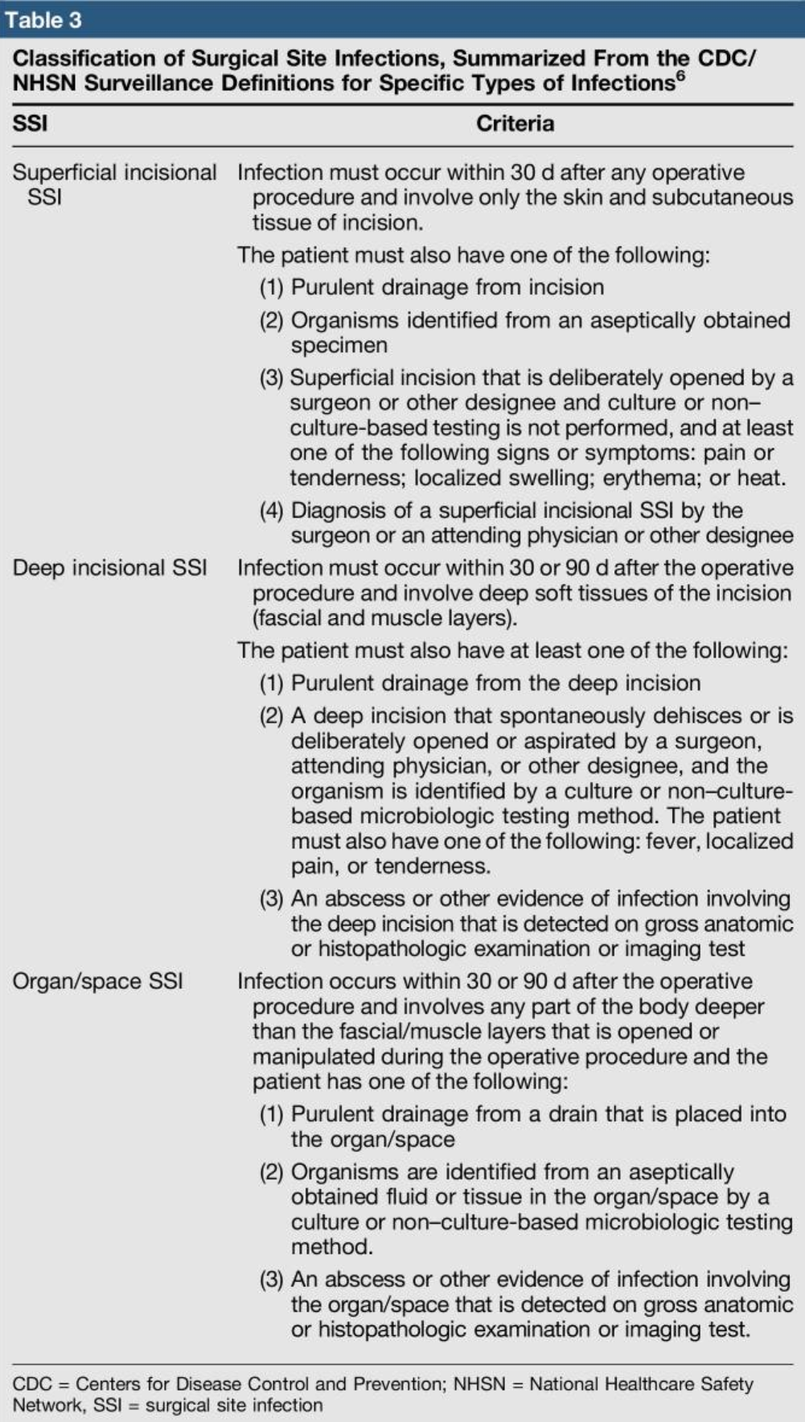
- Hospital length of stay
- Readmission rate
Statistics:
All continuous variable data will be tested using the Shapiro Wilks test for normality, all data which have a normal distribution will be described using mean ± standard deviation. Data that is not normally distributed will be described with median and the intra-quartile range. Comparisons between groups, for example patients treated with standard of care versus BPB1 will be made by t-tests and analysis of variance (ANOVAs) for normally distributed data or the non-parametric equivalents Wilcoxon–Mann Whitney and Kruskal Wallis test for non-normally distributed data. Alternatively, we may use regression analysis (Generalised linear mixed models (GLMM) which can be used with non-normally distributed data.

Categorical data will be described as frequency (percentage) and compared using Fisher’s exact test or Chi squared test as appropriate. Investigation of what factors may statistically significantly modify or predict outcomes such as the patient’s recent medical history or their post-operative care will be investigated using regression analysis. The type of regression analysis will depend on the nature of the variables (whether continuous, interval or categorical, and their distribution) and how many independent and dependent variables are being compared (multivariate and/or multiple regression). Only 2-sides tests will be used, and p values of <0.05 deemed significant.

Sample Size Estimate:

Using Power and Sample Size Program (PS vs 3.1.6 ©), we calculated a sample size of 500 participants (N=500) split into 2 arms, with 250 subjects (n=250) per treatment group. The recruitment rate of >90% and a dropout rate of <10% is factored into this calculation.

- EVENT SCHEDULE
Visit | Visit 0 (Screening) | Visit 1 | Visit2 | Visit 3 | Visit 4 | Visit 5
Procedure / Time Point | Within 2 weeks prior to visit 0 | 24 hours prior to surgery | D0 | Inpatient stay | D14 | D30
Informed Consent | X
Patient Eligibility | X
Demographics | X
Medical History | X |  | X | X
Physical Examination | X |  | X | X | X | X
Weight and BMI | X |  | X
Vital Signs | X |  | X | X
Biochemistry | X |  |  | X | X | X
Study drug administration |  | X | X
Surgery
Adverse events | X | X | X
Outpatient Review |  |  |  |  | X | X

- INTRODUCTION
8.1 Background Information

Surgical site infections (SSI) are infections that develop in a body site involved in a surgical operation. It is a potential complication after surgery resulting in increased morbidity, mortality, hospital stay and costs to the healthcare system [2]. Despite measures to reduce SSI, postoperative infections are still common. The incidence of SSI is reported to be between 0.73% to 9.30% for open gastrointestinal procedures [3]. The development of SSI depends on several factors and is best conceptualised according to the following relationship: (dose of bacterial contamination x virulence)/resistance of the host patient = risk of SSI [4]. The magnitude of the bacterial load is the factor over which the surgical team has the most influence. It therefore seems logical to apply countermeasures to reduce the potential bacterial load during surgery.
The large intestine is colonised by up to 10¹¹ bacteria, predominantly anaerobes such as bacteroides, anaerobic streptococci, and clostridia [5, 6]. The human microflora plays a very important role for its host, including maintaining the integrity of the mucosal barrier, providing nutrients such as vitamins and to protect against other pathogens [6]. However, many of these microflorae are opportunistic pathogens as well and if outside the confines of the mucosal barrier (i.e during colorectal surgery), can cause complications that might lead to morbidity and mortality.
The notion of pre-operative oral antibiotics prior to elective colorectal surgery has been around for decades. Internationally, pre-operative antibiotics are the standard of care. However, in Australia, the issue is still contentious and is not ubiquitous amongst Colorectal surgeons. The standard of care at our institution for pre-operative bowel preparation includes a clear fluid diet the day before the surgery, in addition to polyethylene glycol aperients for bowel clearance. Oral antibiotic usage as part of bowel preparation has been adopted only in selected cases. Currently, there are no local studies looking into the effect of pre-operative oral antibiotics as part of mechanical bowel preparation in the Australia context. Hence, we aim to be the first of its kind in Australia to determine the efficacy of such a protocol for pre-operative colorectal preparation.
8.2 Study Drug
Neosulf (Neomycin Sulphate) is an aminoglycoside that binds to the 30s ribosomal subunits and irreversibly inhibits protein synthesis. They are effective against gram-positive and gram-negative bacteria as well as some mycobacteria. They are poorly absorbed in the gastrointestinal system. Major side effects include nephrotoxicity and ototoxicity (deafness in adults with impaired renal function) [7].
Flagyl (Metronidazole) is a nitroimidazole antiprotozoal medication that inhibits bacterial topoisomerase II and topoisomerase IV. It is well absorbed orally (bioavailability of 80-95%) and distributed widely in body tissues and fluid. They are particularly effective against anaerobes. Generally well tolerated, some side effects includes photosensitivity, nausea and vomiting [8].
The hypothesis for pre-operative antibiotic administration is to reduce bacterial load prior to colorectal surgery, consequently reducing the risk of post-operative surgical site infection. Several studies have already shown that the relative risk for SSI was between 0.27 to 0.57 [9, 10] for patients receiving pre-operative oral antibiotics as compared to those who hadn’t. We will examine patients 14 days and 30 days post initial operation date to quantify the actual risk reduction and number needed to treat.
8.3 Preclinical Experience
There are multiple research globally that has shown that pre-operative non-absorbable oral antibiotics has a clinically significant impact on reducing the rates of post-operative Surgical Site Infections (SSIs) [10-13]. That is why the World Health Organisation has recommended the use of oral antibiotics as part of standard of care for pre-operative bowel preparation for elective gastrointestinal surgery[14]. There are multiple antibiotics that have been researched and utilised, for example Neosulf (Neomycin Sulphate), kanamycin, erythromycin and Flagyl (Metronidazole). However, most research has focus around the non-absorbable aminoglycoside Neosulf (Neomycin Sulphate). This was first propagated by Nichols et al in 1973 [15], where he combined the use of Neosulf (Neomycin Sulphate) and erythromycin (macrolide) for bowel preparation prior to colorectal surgery. Multiple studies have been produced since then justifying the use pre-operative oral antibiotic administration as part of the bowel preparation care package. Internationally, pre-operative antibiotics are the standard of care. However, why this has not been adopted by colorectal surgeons in Australia is still not known.
Through our study, we hope to implement an improved standard of care that colorectal surgeons can follow globally.
8.4 Funding
It is estimated that approximately 400 AUD will be self-funded from the Colorectal unit for the purchase of placebo tablets. No additional funding is required as the research analysis will be conducted from our own personal time. There is no additional EFT or financial interest.
- STUDY OBJECTIVES
To utilise pre-operative antibiotics along with standard mechanical bowel preparation with an aim to reduce surgical site infection (SSI) in bowel resection surgery.
9.1 Primary outcome:
SSI incidence, either superficial incision or deep incisional as per CDC modifications by Horan et al at 14 days and 30 days [1].

9.2 Secondary Outcome:

- Time fit for discharge (as documented by the medical team)
- Return to theatre for SSI debridement or washout
- Post-surgical complications/Infections
  - Pulmonary embolisms / Deep Vein Thrombosis
  - Urinary Tract Infections
  - Respiratory infections
  - Gastrointestinal infections
- Mortality

- INFORMED CONSENT
After providing the patients with the general information on benefits of pre-operative oral antibiotics and the reduction of post-operative SSI and obtaining their written consent to the surgery, the patients will be instructed on the possibility of participating in the study. The patient briefing on the study participation will exclusively be conducted by either the principle investigator, the member of the treating team, or assigned supplementary trial investigators. The patients will be provided the Participant Information Sheet and Informed Consent form (PIS/ICF) that has received favourable Ethical Approval by the Monash Research Ethics Committee. Patients will be provided sufficient time to decide in favour of or against the study participation and will have the opportunity to ask any questions concerning the study participation. If English is not the subject’s primary language, the subject will be consented using an approved interpreter who is fluent in the language and able to answer any scientific or procedural questions raised by a non-English speaking subject.
The PIS/ICF shall be completed and signed by the patients personally and of their own free will and will be provided with a copy of the signed document. The subjects are entitled to terminate their participation in the study and withdraw their consent at any time without statement of any reasons. The withdrawal of consent will not entail any disadvantages for the patients’ further medical treatment.
- STUDY POPULATION
11.1 Recruitment
We plan to recruit suitable patients from the various health network sites via outpatient colorectal clinics and patients seen at specialist rooms who are booked for an operation at a public healthcare hospital. Patients who fulfil the criteria will be offered the chance to enrol in our CABE study. The study design and outcome will be thoroughly explained to the patient and possible risks involved would be outlined. If the patient is agreeable to partake in the study, the trial consent form, in addition to the operation consent form, must be signed and uploaded onto the medical health record. A patient information pamphlet will be given to the patient as well. If the patient requires more time for consideration of enrolment, a follow-up appointment in 1-2 weeks should be organised for their decision to be made. Upon enrolment, the Surgical Liaison Nurse at each site will schedule the appropriate time, date, and surgeon. Patients will need to be seen at pre-admission clinic (PAC) 2 weeks prior to surgery.
11.2 Inclusion criteria:
- Patients undergoing elective open or laparoscopic colorectal resection
- Able to give informed consent
- Male or female patients from 18-60 years of age

11.3 Exclusion criteria:
- Pregnancy – determined through serum b-HCG: this would be measured 1 week before surgery.
  - It will be highly recommended for female patients of child bearing age to start a contraceptive prior to surgery unless previous history of bilateral salphingoophorectomy or hysterectomy.
- Terminal organ impairment
- Patients that must return to theatre for pathology unrelated to surgical wound site infection such as anastomotic leaks, revisions or re-look laparotomy washouts
- Evidence, preoperatively, of any of the following: sepsis, severe sepsis, or septic shock. Including antibiotic usage in the last 2 weeks
- Patients with pre-existing renal failure – an arbitrary value of CrCl< 50mL/min
- BMI > 40 as patients with morbid obesity will have higher mortality and SSI rates
- Current abdominal wall infection/surgical site infection secondary to previous laparotomy/laparoscopy or from any other cause (including enterocutaneous fistulas)
- History of laparotomy within the last 60 days
- Immunological disease (e.g. HIV/AIDS)
- Systemic steroid use or other immunosuppressant medication as they are at an increased risk of SSIs
- ASA score ≥4
- Uncontrolled diabetes mellitus
- Emergency Surgery
- Allergy to aminoglycoside or nitroimidazole
- Previous neoadjuvant chemotherapy within the last 4 weeks
- Hearing loss
- If antibiotics were not taken correctly prior to the surgery

11.4 Restricted concomitant medications
- Systemic steroids
- Other immunosuppressant medications

11.5 Study Design
This is a single blinded, randomised control trial, conducted under the Colorectal Surgery Unit of multiple health centres including Monash Health, Austin Health, Peninsula Health. This follows the National Statement on Ethical Conduct in Human Research of the National Health and Medical Research Council.
Given this is a single blinded trial, blinding will occur at the level of the patient. It is not practically feasible to blind surgeons from the intervention. No subjective outcomes are assessed by the surgeon so not being blinded will not introduce any bias. The study will comprise a total of 500 adult patients undergoing laparoscopic or open colorectal surgery for elective operations. Participants that are included will be randomly allocated to 1:1, to one of two groups (n = 250 per group) ; Bowel Preparation Bundle 1 (BPB1)* or Bowel Preparation Bundle 2 (current standard of care in most Australian Health Institutes)**.

*Bowel Preparation Bundle 1 (BPB1) – PO Antibiotics group
- Osmotic laxatives [PICOPREP ®]
  - 3 x Satchets of PICOPREP – each packet to be drunk with 250ml of water 1 day before the operation at 1200, 1400 and 1600
- PO antibiotics
  - 1g Neosulf (Neomycin Sulphate) and 400mg Flagyl (Metronidazole) at 1300, 1400 and 2200
- Soap packets for MRSA decolonisation
  - 2 x (4% Chlorhexidine soap packets) – patients to use shower with 1 packet night before surgery and morning of surgery
  - If soap packets were used incorrectly, Chlorhexidine wipes were used on the day of the surgery
- Patient to remain on clear fluids day before surgery

** Bowel Preparation Bundle 2 (BPB2) / Standard of Care – No PO antibiotics group
- Osmotic laxatives [PICOPREP ®]
  - 3 x Satchets of PICOPREP – each packet to be drunk with 250ml of water 1 day before the operation at 1200, 1400 and 1600
- Soap packets for MRSA decolonisation
  - 2 x (4% Chlorhexidine soap packets) – patients to use shower with 1 packet night before surgery and morning of surgery
  - If soap packets were used incorrectly, Chlorhexidine wipes were used on the day of the surgery
- Placebo pills
  - 2 green coloured pills and 1 pink coloured pills to be taken at 1300, 1400 and 2200 day before surgery.
- Patient to remain on clear fluids day before surgery

The average length of stay for an elective colonic resection in our stay ranges between 5 to 7 days, pending post-operative complications and recovery.

11.5.1 Stopping rules
There are no pre-established stopping rules for this study.
11.6 Responsibilities and data storage:
Patient responsibility during surgery will lie with the consulting surgeon who will be performing the surgery and is responsible for trial conduct in theatre and assuring the trial device is set up. The consulting surgeon will also be responsible for monitoring the patient’s safety during the surgery and at have the discretion to stop the investigation or the use of the investigational device if there are any safety concerns. If any safety concerns are raised by the surgeon the device will be turned off and the diffuser removed immediately. Patient confidentiality will be maintained and data on the case report forms re-identified.
Data will be stored by research investigators, data tabulated into a password protected and encrypted database, and paper form of the diary will then be shredded. This project stores patients, surgical, anaesthetic, and post-operative data in a re-identified format. The database will be formed using Microsoft Excel in a format suitable for statistical analysis. Data will be kept for at least 15 years following completion of the study.
11.7 Investigational Supplies
Participants will be randomised to receive Neosulf (Neomycin Sulphate) 1g TDS PO and Flagyl (Metronidazole) 500mg TDS PO or placebo 1 day prior to surgery.
11.7.1 Packaging
Neosulf (Neomycin Sulphate) will be supplied as 500mg white tablets with a breakline on one side. A total of 6 tablets will be supplied to each participant in the case arm. Neosulf is supplied by Alphapharm Pty Ltd.
Flagyl (Metronidazole) will be supplied as 400mg white tablets, with one side impressed with ‘MTZ400’ and breakline on reverse. A total of 3 tablets will be supplied to each participant in the case arm. Flagyl is supplied by Sanofi-Aventis Australia, Pty Ltd.
White sucrose tablets will be dispensed as a placebo for the control group.
11.7.2 Investigational Product Dispensing
All investigational products will be dispensed by designated site pharmacy staff.
11.7.3 Dosage preparation and administration
Study drugs will be administered PER ORAL at 1300, 1400 and 2200. 2 tablets of Neosulf 500mg and 1 tablet of metronidazole 400mg will be taken by the case group on the day prior to the surgery at home, or if admitted pre-operatively, as an inpatient.
Subjects would then be told to monitor for any signs and symptoms for 30 minutes after each administration. They will be adviced to present to hospital if there are any concerns after administration of medication.
11.7.4 Storage requirements
Neosulf and Flagyl should be stored in a storage space below 25 ºC away from light.
11.7.5 Investigational Product Accountability
The Investigator or a trained designee is responsible for maintaining accurate records accounting for the dispensing of all investigational products using the appropriate investigational product logs provided by the Principal Investigator
11.8 Randomisation and Blinding
Sequence Generation
Randomisation for the allocated group will occur after consent is obtained and after the patient’s eligibility is confirmed based on the inclusion and exclusion criteria. Random allocation using Microsoft Excel will be used to allocate the subjects to either group 1 (BPB1) or group 2 (BPB2) prior to their PAC. At PAC, the Principle Investigator or supplementary investigator will present the bundle package labelled ‘Group 1’ or ‘Group 2’ to the patient with an instruction sheet. These will be prepared by the PI before the commencement of the study
Using Microsoft Excel. A randomised sequence dividing participants into either the Case or Control group will be developed prior to the recruitment of participants. This will be done using the function on excel =CHOOSE(RANDBETWEEN(1,2)), where 1 would be the case group, while 2 would be the control group. Study participants will then be allocated onto either groups in sequential order on the excel sheet.
The study will be only single-blinded. Only the participants will be blinded to the care package that they will receive. This is to ensure that if any adverse effect happens, medical professionals can promptly manage any medical emergencies. Unblinding is permissible if the treating physician deems that the participant is experiencing a medical-emergency situation secondary to the medications administer as part of the trial. All unblinded participants will be recorded.
Each subject will be assigned an identification number by the site after the subject provides written informed consent.
The identification number will consist of 3-letters followed by 3-numbers:
- The first 3 letters will designate the site as assigned.
  - MON – Dandenong Hospital
  - PEN – Frankston Hospital
  - AUS – Austin Hospital
- The 3 numbers will designate the order of the subject at the site.
  - The first subject at the site is assigned the identification number 001, followed by 002 etc.
  - Subjects will maintain the same identification number throughout the entire study.
11.9 Study Visits
11.9.1 Screening (within 2 weeks prior to visit 1)
Study candidates will be evaluated for eligibility for study entry according to the stated inclusion and exclusion criteria (section 9.1 and 9.2, respectively). The following will be performed during Screening to establish each candidate’s eligibility for enrolment into the study:
- Obtained signed, written consent. A copy must be given to the participant.
- Record Demographic information
- Record Medical Information
- Thorough physical examination conducted
- Weight and BMI taken
- Vital signs taken
- Pre-operative bloods taken – this will be done 2-3 days prior to surgery
  - FBE, UEC, CMP, LFTs, Coagulation Profile, Group and Hold
  - Serum bHCG for females
Screening Assessment:
After the patient has consent for the trial, they must be screened for eligibility 2 weeks prior and the day of surgery. Screening will be completed at pre-admission clinic (PAC) by the Principle Investigator and Supplementary investigators delegated to the study by the PI.
Interested and eligible patients will then be consented. Subjects who meet all the inclusion criteria, and none of the exclusion criteria and who have consented for participation will have the following screening information documented. The following information will be recorded and seen by the investigators:
General:
Age, gender, height and weight, BMI, smoking status, American Society of Anesthesiologists (ASA) classification of physical status score.

Medical History:

History of radiotherapy in the operative field, current and previous medications (within 30 days of the operation), history of diabetes, history of recent infection (wisdom teeth removal, upper or lower respiratory tract infection, urinary tract infection, etc.), and history of connective tissue disorders. Previous abdominal surgery will be noted as this may contribute to slow healing and therefore higher likelihood of infection, and previous colonisation of virulent bacteria such as methicillin-resistant Staphylococcus aureus will also be noted.
11.9.2 24 hours prior to surgery (Visit 1)
The following procedures will be performed 24 hours prior to procedure:
- The intended medication/placebo will be taken as per instructed to subjects
- Subjects will monitor for any adverse reactions for 30 minutes after ingestion of medication.
- Preoperative Showering.
Subjects are to shower using the provided chlorhexidine soap packets on the night before and the morning of the operation.
11.9.3 Day of Surgery (Visit 2)
The following procedures will be performed
- During initial admission, a medical history, physical examination, vital signs will be taken.
- The following procedures will take place peri-operatively
Procedural details:
Type of procedure, pathology or reason for operation / diagnosis, per-operative haemoglobin, date and time of pre-operative shower, any hair clipping of surgical site, antibiotic prophylaxis type and dose, type of surgical skin cleansing preparation, use of antimicrobial surgical patient drape (e.g 3M Ioban ™) time of induction, time of incision, length of incision, use of diathermy to divide skin or peritoneum, IV glucose-insulin0 potassium (GIK) regimen, core temperature during surgery, operative blood loss, use of drain, surgery end time, standardised dressing and operative time
Patients will follow the standard antimicrobial skin preparation.
Intraoperative bundle elements:
- Antibiotics Prophylaxis (Cefazolin + Flagyl (Metronidazole)) given within 20 minutes prior to incision. If the patient is allergic to above antibiotics, aztreonam or imipenem are used as prophylactic antibiotics.
- The usage of wound protector and the placement and removal of blue towels under the Alexis wound protectors.
- Use chlorhexidine gluconate and isopropyl alcohol for preoperative skin preparation
- Wound irrigated with 100cc of fresh saline.
- Separate instrument tray used for closing the incision.
- Gloves changed before closing the incision.
- Suction tip changed before closing the incision.
The following information is to be collected (these will be found in the CRF):
- Start and end time of surgery
- Time of induction of anaesthesia
- Time of incision
- Incision length (cm)
- Size of subcutaneous abdominal fat layer (cm) [16]
- Use of diathermy on skin edge or peritoneum
- General location of diffuser
- Total number of personnel in the theatre
- IV glucose-insulin-potassium infusion regimen (GIK) during surgery (Y/N)
- Use of antimicrobial prophylaxis (Y/N), Time administered, type of antibiotics administered (adjusted for patient’s weight and creatinine clearance), any repeated doses in surgery
- Core temperature (°C) via oesophageal temperature probe
- Oxygen saturation (%) via pulse oximetry and recorded with temperature at 15-minute intervals
- Tissue oxygen saturation (SaO₂)
- Length of preoperative stay (days)
- Pre-operative haemoglobin
- Total operative blood loss (mL)
- Transfusion required in surgery (Y/N)
- Volume of blood products used(mL)
- Time of wound closure
- Use of drain (Y/N) and date removed
- Use of wound protector (Y/N)
- Type of drape used? (Surgidrape or Ioban)
- Clipping (Y/N), Location on subject, when and where clipping was completed i.e. theatre, wards
- Skin preparation used
- Gross contamination events

Other recordings if applicable:
- Length of stay in ICU (Hours)
- Hospital stay (days) and whether this was associated with SSI

Use of intra-operative antimicrobial prophylaxis:
Intra-operative surgical anti-microbial prophylaxis would include 2g IV cefazolin 20 minutes prior to skin incision. Additional 2g of IV cefazolin to be given 4 hours after the initial incision time. The same antibiotic should be used on all subjects in this investigation

Surgical Wound Dressing:
Surgical wound to be covered with a hydrocolloid dressing such as ‘Comfeel’ or ‘Duoderm’ (standardised across all patients) for a period of at least 48 hours unless otherwise clinically indicated. The same type of dressing is to be used on all subjects in the investigation.
11.9.4 Inpatient stay (Visit 4)
During the patient’s in-patient stay in hospital, the following procedures will be performed on a daily basis.
- Daily physical examinations will be done as per standard unit protocol.
- Vital signs will be taken as per ward protocol. Ideally it should be taken every 4 hours in a haemodynamically stable patient. For patients in intensive care, it will be as ICU protocol
- Daily bloods to be taken includes
  - FBE, UEC, CMP
- 2nd daily bloods should include
  - CRP
11.9.5 Outpatient review (D14 and D30, Visit 4 and 5 respectively)
The patient will be reviewed in person as an outpatient at 14 days and followed up with a questionnaire at 30 days following surgery for wound assessment. This is to ensure that patients are safe and treated appropriately should they develop an SSI. The validated Bluebelle Wound Healing Questionnaire form will be provided to participants to be filled up at these specific post-operative dates [17]. Participants will be required to upload a picture (following a standard template that will be provided). The questionnaire and picture will be blinded and assessed by a Consultant Surgeon who will determine if the patient had a surgical site infection.
- ADVERSE EVENT REPORTING
Any adverse event that occurs during the intervention including if the event occurs in theatre will be immediately recorded on the CRF and reported, without unjustified delay, to the hospital and ethics committee as required. The primary investigator/supplementary investigator/operating surgeon will have the authority to stop the intervention at any time if he feels that the intervention may cause harm or has led to an adverse event. If an adverse advent is identified, the patient will be asked to present to the emergency department for further work-up of complication. A meeting of the research team will be convened as soon as possible to discuss necessary actions. All adverse events will be reported in the final report of the clinical investigation. Definitions of adverse events and reporting instructions are listed below.
Aminoglycoside is a category D teratogen as per AU TGA, with a risk of nephrotoxicity or ototoxicity to the foetus [18]. To reduce any potential foetal harm, pregnant patients will be excluded from this study. A pre-operative quantitative serum b-HCG would be done to assess pregnancy.
12.1 Foreseeable Adverse Events
There are possible side effects from the administration of oral Neosulf (Neomycin Sulphate) and Flagyl (Metronidazole). Although the rates of adverse effects for Neosulf (Neomycin Sulphate) and Flagyl (Metronidazole) are unknown, the most common side effects include nausea and vomiting. Rarely do patients get anaphylaxis. The extensive (but not complete) list of side effects are listed below for both Neosulf (Neomycin Sulphate) and Flagyl (Metronidazole).

 | Neosulf (Neomycin Sulphate) | Flagyl (Metronidazole)
Common (1-10%) | . Nausea and vomiting  . Diarrhea  . Bloating  . Headaches
Uncommon (0.1% - 1%) | . Ototoxicity  . Nephrotoxicity  . Anaphylaxis |  | . Pheripheral neuropathy  . Anaphylaxis

12.2 Serious Adverse Event
A serious adverse event is adverse event that
- led to death
- led to serious deterioration in the health of the subject, that either resulted in:
- life-threatening illness or injury or,
- a permanent impairment of a body structure or a body function or,
- in-patient or prolonged hospitalization or,
- medical or surgical intervention to prevent life-threatening illness or injury or permanent impairment to a body structure or a body function,
- led to foetal distress, foetal death or a congenital abnormality or birth defect

NOTE: Planned hospitalization for a pre-existing condition, or a procedure required by the CIP, without serious deterioration in health, is not considered a serious adverse event.
SAE’s will be followed up until resolution or until the Day 30 follow up visit. AE’s should be assessed with regards to their severity. The following information should also be collected: Related to Medical Device (Y/N); Related to Study Procedures (Y/N); Date and Time of onset; Date and Time of Resolution.
12.3 Unexpected Adverse Event
An adverse event is considered “unexpected” if it is not listed in the Investigator’s Brochure or is not listed at the specificity or severity that has been observed.
All unexpected adverse events would need to be reported to the Principal Investigator in accordance to section 10.
12.4 Assessment of relationship to study drug
The following criteria must be used to characterise the relationship or association between the study drug and adverse event:
Unrelated: There is no relationship between the even to study drug; the event is related to other etiologies.
Unlikely: The relationship suggests an unlikely association between the event and study drug.
Possible: The relationship suggests a possible contribution between the study drug and the event. The event follows a reasonable temporal sequence from administration of study drug to response pattern. However, the event might also be produced by other factors.
Related: Relationship suggests a definite causal relationship to the study drug; the event follows a known response pattern to the study drug and cannot be reasonably explained by other confounders such as the subject’s clinical state or other modes of therapy administered to the subject.
12.5 Assessment of Severity
The following criteria must be used to rate the intensity of the adverse evet:
Mild: Awareness of signs or symptoms, but easily tolerated and are of minor irritant type, which do not require therapy or medical evaluation; signs and symptoms are transient.
Moderate: Events introduce a low level of inconvenience or concern to the subject and may interfere with daily activities but are usually improved by simple therapeutic measures.
Severe: The events interrupts the subjects’ normal daily activities and generally require systemic drug therapy or other treatment; they are usually incapacitating.
12.6 Breaking the blind
This is a single-blind study. Breaking the blind in a clinical trial on an emergency basis by the site should only occur when knowledge of the treatment to which a subject was allocated would have implications for the emergency medical management of the subjection or if required for regulatory reporting. Reason of unblinding, person conducting the unblinding, person(s) who know the unblinded treatment, and date/time of unblinding will be recorded.
In the event of an adverse event that results in the postponement of the surgery, the patient will be admitted as an in-patient. Their operation will be re-scheduled at an appropriate time within the next 2 weeks from original date.
- STATISTICAL ANALYSIS
13.1 Criteria for Evaluation
Efficacy assessments include the following:
- Classification of SSI, based on CDC/NHSN surveillance definitions for specific type of infections
  - The patient will be reviewed in person as an outpatient at 14 days and followed up with a questionnaire at 30 days following surgery for wound assessment. This is to ensure that patients are safe and treated appropriately should they develop an SSI. The validated Bluebelle Wound Healing Questionnaire form will be provided to participants to be filled up at these specific post-operative dates [17]. Participants will be required to upload a picture (following a standard template that will be provided). The questionnaire and picture will be blinded and assessed by a Consultant Surgeon who will determine if the patient had a surgical site infection.
- Hospital length of stay
- Readmission rate

  - Sample size and study duration
Using Power and Sample Size Program (PS vs 3.1.6 ©), we calculated a sample size of 500 participants (N=500) split into 2 arms, with 250 subjects (n=250) per treatment group. The recruitment rate of >90% and a dropout rate of <10% is factored into this calculation. The study plan is for independent cases and controls with one control per case (m=1). This number was calculated using an α of 0.05 (P<0.05 for clinical significance), power of 0.8, correlation coefficient set to 0.20 and an odds ratio of 0.44 (based off a 0.2 rate of getting an SSI in the control group, and a 0.1 rate of getting a SSI in the case group). The study period is 60 months depending on recruitment since an average of 5-7 patients per week will undergo open elective or emergency colon resection surgery.
13.3 Statistical rational and analysis
All continuous variable data will be tested using the Shapiro Wilks test for normality, all data which have a normal distribution will be described using mean ± standard deviation. Data that is not normally distributed will be described with median and the intra-quartile range. For comparison between groups, normally distributed data will be analysed by t-tests of analysis of variance (ANOVAs), or the non-parametric equivalents Wilcoxon-Mann Whitney and Kruskal Wallis test for non-normally distributed data. Alternatively, we may use regression analysis (Generalised linear mixed models (GLMM) which can be used with non-normally distributed data.
Categorical data will be described as frequency (percentage) and compared using Fisher’s exact test or Chi squared test as appropriate. Investigation of what factors may statistically significantly modify relationships or group memberships in patient’s recent medical history or their post-operative care will be investigated using regression analysis. The type of regression analysis will depend on the nature of the variables (whether continuous, interval or categorical, and their distribution) and how many independent and dependent variables are being compared (multivariate and/or multiple regression). Only 2-sides tests will be used, and p values of <0.05 deemed significant.
Primary outcome:
SSI incidence at 14 days and 30 days: will be investigated using Chi squared or Fisher’s exact test at each time point and logistic regression to compare the two time points for each treatment and between treatments (BPB1 vs standard of care)
Secondary outcome:
The time patients are fit for discharge and temperature (core and local), will be compared by either t-test or Wilcoxon-Mann Whitney test for BPB1 versus standard of care. Further comparison such as difference within each treatment group according to for example medical history or demographic data or post-surgical care will use multiple regression or GLMM.
The frequency for Return to Theatre for SSI debridement or washout, other post-operative complications and mortality will use chi squared or Fisher’s exact tests to compare between treatments (BPB1 vs standard of care). They may also be investigated by logistic regression analysis to determine if they had statistically significant influence on the SSI incidence.
In general, data will be entered into an excel spreadsheet including identifying data to ensure accuracy of data entry at different time points. Following completion of data entry, data will be checked for any duplicates of data entry. The identifying data will be removed except for the Study ID number and then given to statistician for analysis. Where necessary, data will be recorded for statistical analysis (e.g females identified as 0 and males as 1) and imported into SPSS v25 for statistical analysis.
13.4 Sample Size Calculations
The current SSI rate for open colorectal surgery at our centre is approximately 15%. Globally, it has been reported that the SSI rates is >20% for selective colorectal procedures [19]. To aim for a reduction down to 5%, which is infection rate for all surgical site infections, we calculate we will need to have 250 experimental and 250 control participants to reject the null hypothesis that the infection rate for the experimental versus control participants are equal with a probably (power) of 500. This sample size calculation was based on an assumption that either the chi-square or Fischer’s exact test will be used to evaluate the null hypothesis [20].
- BPB1/Group 1: Standard of care with the addition of pre-operative Oral antibiotics (Neosulf (Neomycin Sulphate) 2g and Flagyl (Metronidazole) 2g at 1900 and 2300, 1 day before the operation)

- BPB2/Group 2: Standard of care

At the conclusion of this study, we are aiming to formulate a Number Needed to Treat (NNT) and a Relative Risk Reduction (RRR) as well as any differences in subgroups as odd ratios.
- WITHDRAWAL FROM STUDY
A patient can discontinue their participation in the trial at any time and without reason. All efforts will be made by Investigators and site staff to follow up with the patient for a final End of Study assessment (should the patient permit) and attempts made to document their reason for withdrawal

A patient will be discontinued from the study if they require perioperative blood transfusion, and/or they are shaved for hair removal prior to the time of the surgery. Such conditions increase the risk of developing an SSI and should be removed from analysis. Their exclusion will be at the discretion of the PI, and they will be followed-up and monitored as per routine clinical practice. The investigators will recruit additional participants to ensure the integrity and power of the study if there are withdrawals
- DATA MANAGEMENT
Patient responsibility during surgery will lie with the consulting surgeon who will be performing the surgery and is responsible for trial conduct in theatre and assuring the trial device is set up. The consulting surgeon will also be responsible for monitoring the patient’s safety during the surgery and at have the discretion to stop the investigation or the use of the investigational device if there are any safety concerns. If any safety concerns are raised by the surgeon the device will be turned off and the diffuser removed immediately. Patient confidentiality will be maintained and data on the case report forms re-identified.
Data will be stored by research investigators, data tabulated into a password protected and encrypted database, and paper form of the diary will then be shredded. This project stores patients, surgical, anaesthetic, and post-operative data in a re-identified format. The database will be formed using Microsoft Excel in a format suitable for statistical analysis. Data will be kept for at least 15 years following completion of the study.

- ETHICAL CONSIDERATIONS
This study will be conducted in full conformance with principles of the “Declaration of Helsinki” and Good Clinical Practice (GCP) and within the laws and regulations, and upon approval of ethical conduct as stated in the National Statement on Ethical Conduct in Human Research (10). Significant protocol modifications will be communicated to investigators, clinical support staff, and out local HREC. Informed consent will be obtained prior to surgery by a study investigator or treating team. Each study participants will be required to read and sign a Patient Information and Consent Form (PICF). All participants have the right to withdraw from the study at any time without prejudice. All personal information about and potential and enrolled participants can only be accessed by hospital staff through password accessed Scanned Medical Records (SMR). Data collected in study database is de-identified and password protected. Any adverse events throughout the process of this study will be reported to the Monash Health New Devices committee and HREC department.
- GENERAL CONSIDERATIONS
The Principle Investigator reserves the right to discontinue this study for safety or administrative reasons at any time.

- AGREEMENT WITH PROTOCOL
I have read this protocol and agree to conduct this clinical study as outlined herein. I will ensure that all sub-investigators and other study staff members have read and understand all aspects of this protocol. I will adhere to all revised Declaration of Helsinki and other applicable regulations and guidelines regarding clinical trials on a study drug during and after study completion
Principal Investigator:

Printed Name: _________________________________________

Signature: _________________________________________

Date: _________________________________________
Protocol CABE-001

- REFERENCES
1. Horan, T.C., et al., CDC definitions of nosocomial surgical site infections, 1992: a modification of CDC definitions of surgical wound infections. Infect Control Hosp Epidemiol, 1992. 13(10): p. 606-8.
2. Coello, R., et al., Adverse impact of surgical site infections in English hospitals. J Hosp Infect, 2005. 60(2): p. 93-103.
3. de Lissovoy, G., et al., Surgical site infection: Incidence and impact on hospital utilization and treatment costs. American Journal of Infection Control, 2009. 37(5): p. 387-397.
4. Altemeier, W.A., Principles in the management of traumatic wounds and in infection control. Bull N Y Acad Med, 1979. 55(2): p. 123-38.
5. Gorbach, S.L., Microbiology of the Gastrointestinal Tract, in Medical Microbiology, th and S. Baron, Editors. 1996: Galveston (TX).
6. Thursby, E. and N. Juge, Introduction to the human gut microbiota. Biochem J, 2017. 474(11): p. 1823-1836.
7. neomycin sulfate - Drug Summary. 2020; Available from: https://www.pdr.net/drug-summary/Neomycin-Sulfate-neomycin-sulfate-819#:~:text=Neomycin%20is%20bactericidal%20in%20action,the%2030%20S%20ribosomal%20subunit.
8. metronidazole - Drug Summary. 2020; Available from: https://www.pdr.net/drug-summary/Flagyl-Capsules-metronidazole-1047.8330.
9. Cannon, J.A., et al., Preoperative oral antibiotics reduce surgical site infection following elective colorectal resections. Dis Colon Rectum, 2012. 55(11): p. 1160-6.
10. Bellows, C.F., et al., Combination of oral non-absorbable and intravenous antibiotics versus intravenous antibiotics alone in the prevention of surgical site infections after colorectal surgery: a meta-analysis of randomized controlled trials. Tech Coloproctol, 2011. 15(4): p. 385-95.
11. Toh, J.W.T., et al., Association of Mechanical Bowel Preparation and Oral Antibiotics Before Elective Colorectal Surgery With Surgical Site Infection: A Network Meta-analysis. JAMA Netw Open, 2018. 1(6): p. e183226.
12. Vo, E., et al., Association of the Addition of Oral Antibiotics to Mechanical Bowel Preparation for Left Colon and Rectal Cancer Resections With Reduction of Surgical Site Infections. JAMA Surg, 2018. 153(2): p. 114-121.
13. Ohman, K.A., et al., Combination of Oral Antibiotics and Mechanical Bowel Preparation Reduces Surgical Site Infection in Colorectal Surgery. J Am Coll Surg, 2017. 225(4): p. 465-471.
14. Summary of a systematic review on mechanical bowel preparation and the use of oral antibiotics. Available from: https://www.who.int/gpsc/appendix6.pdf?ua=1.
15. Nichols, R.L., et al., Effect of preoperative neomycin-erythromycin intestinal preparation on the incidence of infectious complications following colon surgery. Ann Surg, 1973. 178: p. 453-62.
16. Nyström, P., et al., Incisional infection after colorectal surgery in obese patients. Acta Chir Scand, 1987. 153(3): p. 225-7.
17. Bluebelle Study, G., Validation of the Bluebelle Wound Healing Questionnaire for assessment of surgical-site infection in closed primary wounds after hospital discharge. Br J Surg, 2019. 106(3): p. 226-235.
18. Administration, D.o.H.T.G. https://www.tga.gov.au/prescribing-medicines-pregnancy-database#searchname. 2020; Available from: https://www.tga.gov.au/prescribing-medicines-pregnancy-database#searchname.
19. Edwards, J.R., et al., National Healthcare Safety Network (NHSN) Report, data summary for 2006 through 2007, issued November 2008. Am J Infect Control, 2008. 36(9): p. 609-26.
20. Kane, S.P. Sample Size Calculator. ClinCalc 2019; Available from: https://clincalc.com/stats/samplesize.aspx. .

20. APPENDIX
20.1 Appendix A. Classification of Surgical Site Infections from the CDC/NHSN

20.2 Appendix B. TGA Public Summary for NEOSULF (Neomycin Sulphate 500mg Tablet)
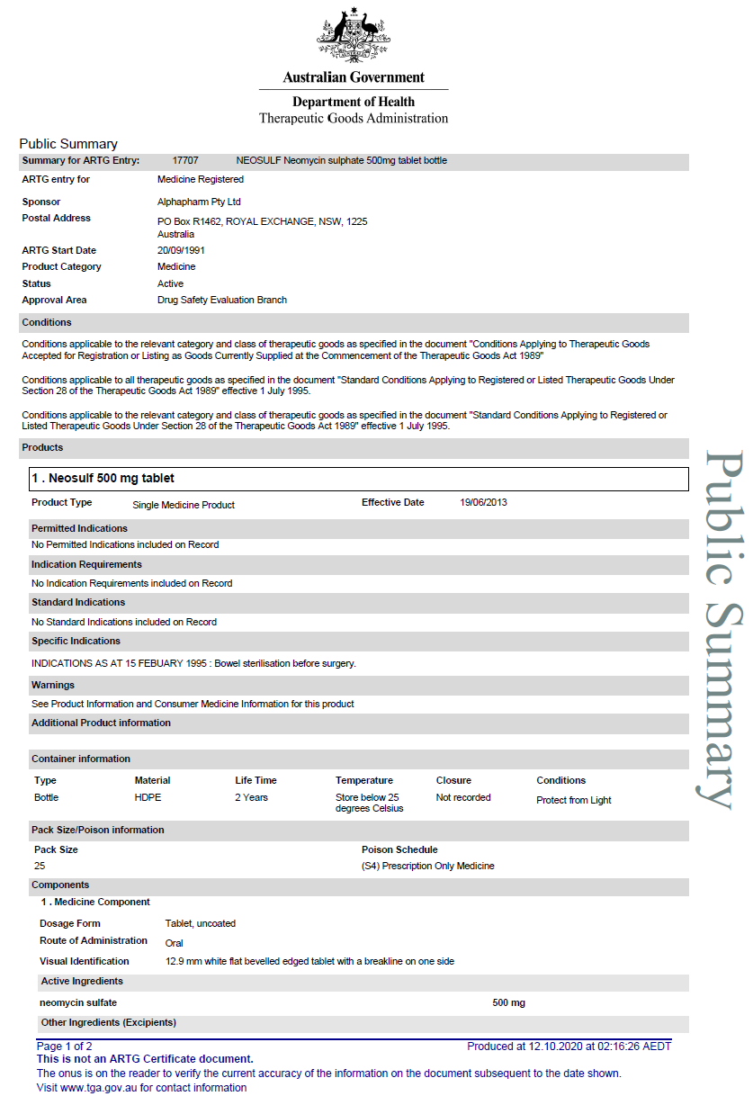
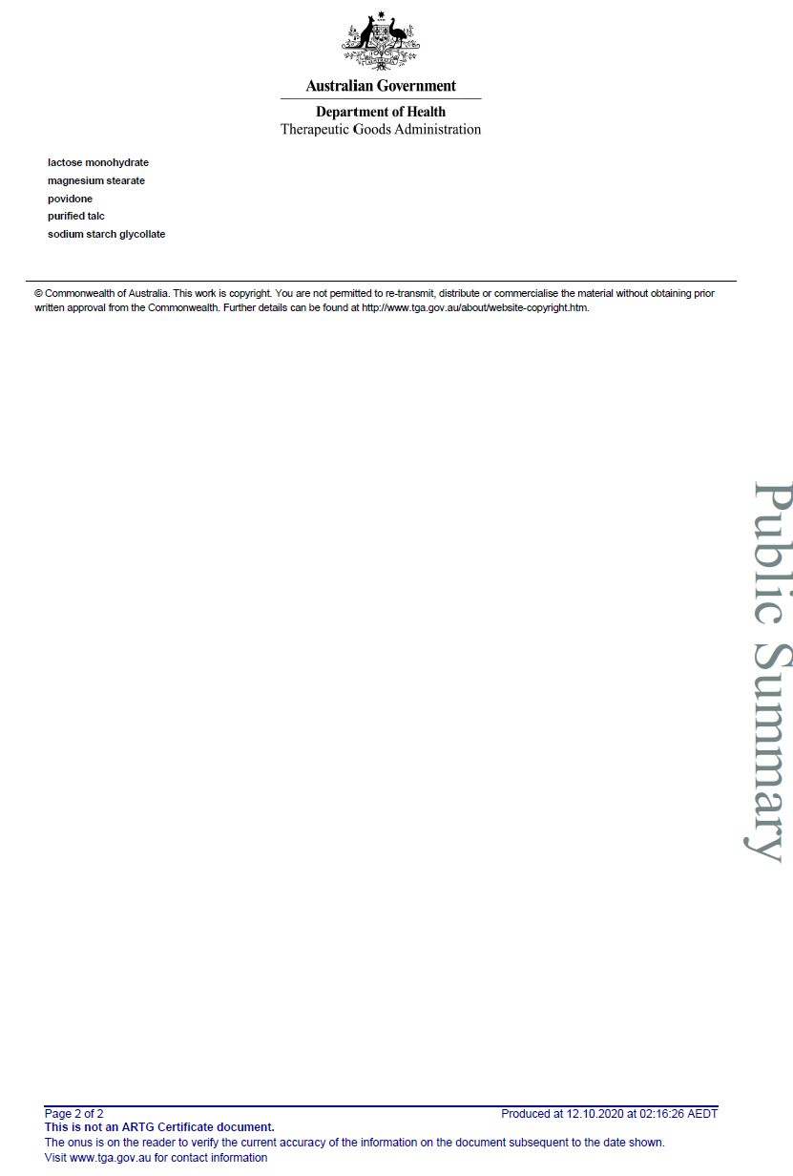

20.3 Appendix C. TGA Public Summary for Flagyl (Metronidazole 400mg Tablet)
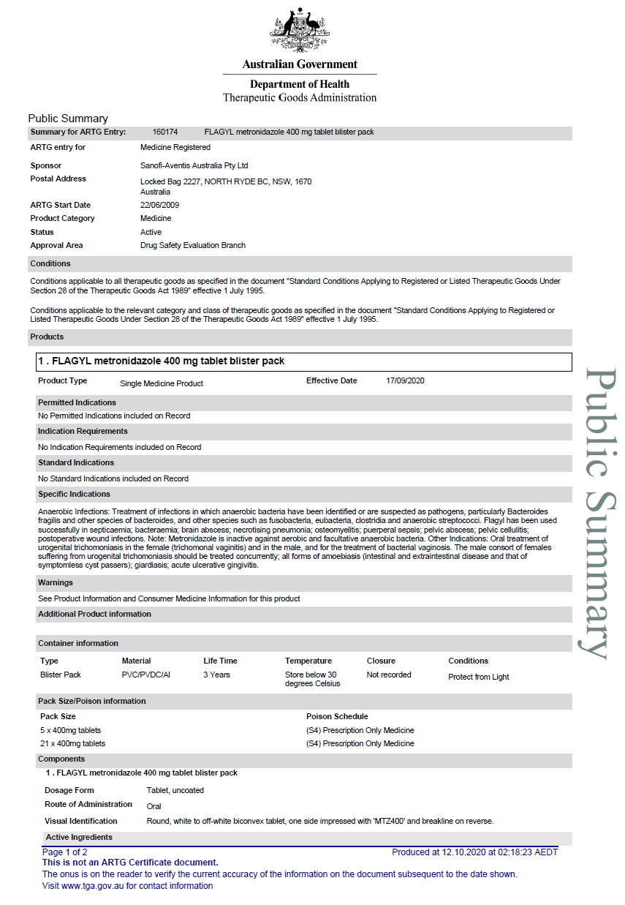
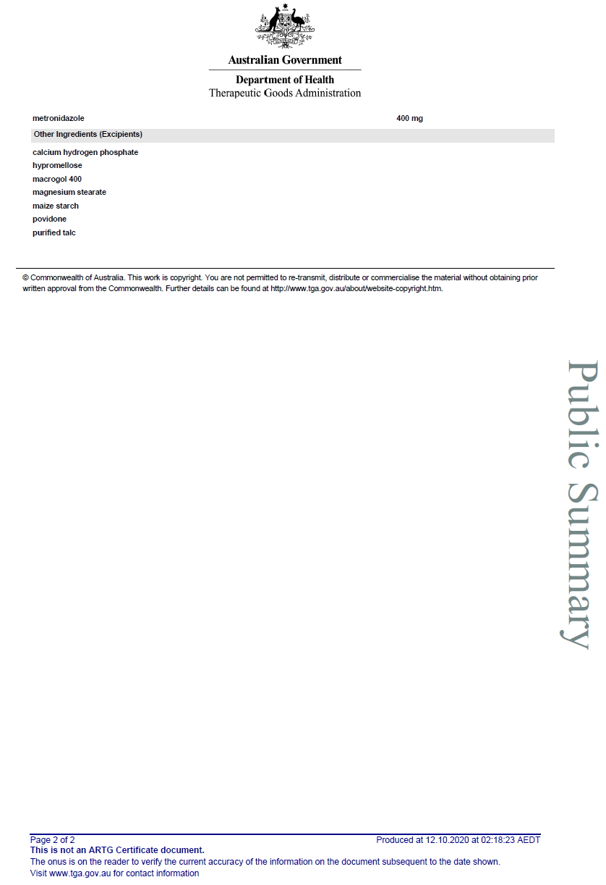

20.4 Appendix D. Patient Consent Form and Information Booklet

Participant Information Sheet
Interventional Study - Adult providing own consent

Title | Colorectal Anti-Bacterial Eradication (CABE) Trial: The effect of pre-operative antibiotics on post-operative wound infections in Colorectal Surgery
Short Title | Pre-operative Antibiotics to reduce wound infections after elective Colorectal Surgery.
Protocol Number | TBA
Project Sponsor | Colorectal Surgery Unit, Monash Health
Coordinating Principal Investigators/ Principal Investigators | Dr Asiri Arachchi
Location | Dandenong Hospital, Monash Health

Part 1: What does my participation involve?

1 Introduction

You are invited to take part in this research project called the Colorectal Anti-Bacterial Eradication (CABE) trial. You have been invited because you are undertaking an elective Colorectal surgery. Your details were obtained by the trial investigators, from Monash Health Colorectal unit. This Participant Information Sheet tells you about the research project. It explains the process involved with taking part in this trial. Knowing what is involved will help you decide if you want to take part in the research.
Please read this information carefully. Ask questions about anything that you don't understand or want to know more about. Before deciding whether or not to take part, you might want to talk about it with a relative, friend or local health worker. Participation in this research is voluntary. If you don't wish to take part, you don't have to. Your refusal will not have any effect on your surgery or the care that you receive. Your refusal will be noted only to make sure that we don't ask you again. If you decide you want to take part in the research project, you will be asked to sign the consent section.
By signing it you are telling us that you:
- Understand what you have read
- Consent to take part in the research project
- Consent to be involved in the research described
- Consent to the use of your personal health information as described.

You will be given a copy of this Participant Information and Consent form to keep.
2 What is the purpose of this research?
To examine the effect of pre-operative oral antibiotics (Neomycin and Metronidazole) on post-operative risks of surgical site infections (SSI). Overseas studies have shown that oral antibiotics together with mechanical bowel preparation reduces the risk of SSI and internationally, pre-operative antibiotics are the standard of care. Although at Monash Health, pre-operative antibiotics are used in selected cases, this practice is not widely accepted in the Australian context. The investigators would like to further substantiate the evidence that a pre-operative standard of care that includes Neomycin and Metronidazole reduces the risk of SSI. Prior to the operation, the investigating team would randomise patients to 2 arms, one receiving the antibiotics with the other receiving placebo. The participants would receive the same level of care that would be expected in the colorectal unit. The study will stop after the participants are reviewed at the 30-days post-operative mark. From there, participants will resume regular follow-ups with their respective colorectal surgeons/teams.
What are SSIs?
Surgical site infections (SSIs) remain a persistent and morbid problem in colorectal surgery with rates ranging from 7 to 25%. Negative outcomes of SSIs include significant increase in patient morbidity, prolonged length of hospital stay, readmission to hospital and healthcare-associated cost. Hence, strategies to reduce the incidence of SSIs following colorectal surgery are important to improve overall patient specific outcomes and provide value-based healthcare to surgical patients.
The World Health Organization (WHO) defines Surgical Site Infections based on the Centre for Disease Control and Prevention (CDC) National Healthcare Safety Network (NHSN) in the USA. It can be divided into 3 categories: Superficial Incisional, Deep Incisional and Organ Space.
Type of wound | Definition
Superficial Incisional | Involves skin or subcutaneous tissue of the incision and rarely leads to systemic toxicity.
Deep Incisional | Includes tissues down to and including fascia and muscle.
Organ Space | Involves any body cavity that was opened or manipulated during surgery.

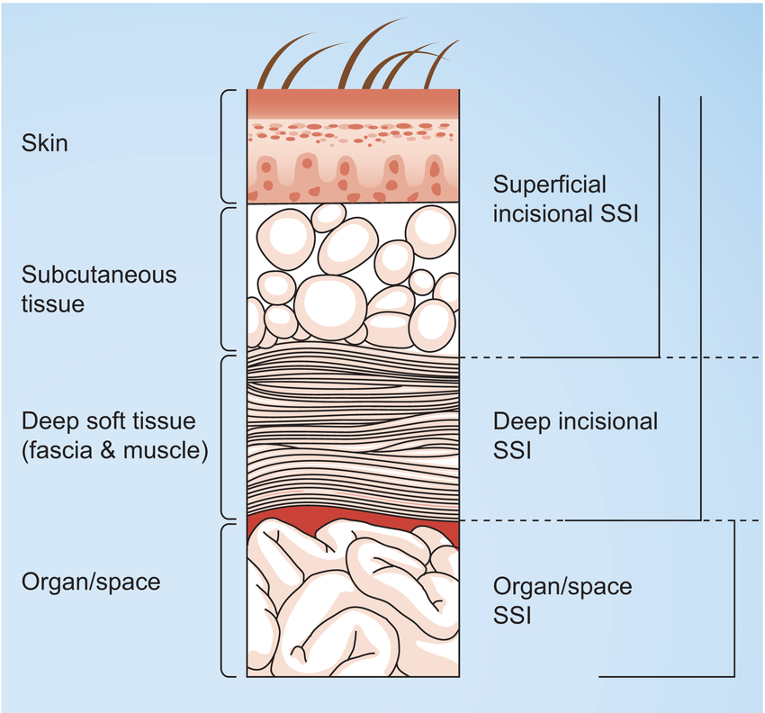
Figure 1 Source - https://www.researchgate.net/figure/Classification-of-surgical-site-infections-according-to-CDC-National-Nosocomial_fig1_44670847
Symptoms include (but are not limited to)
- Pain or tenderness
- Fevers, Chills or Sweats
- Nausea and/or Vomiting
- Localized swelling over incision site
- Heat or redness over incision site
- Purulent Discharge (white, milky, thick discharge)
Management of SSIs
- Most superficial SSIs can be managed with antibiotics
- Localised collections secondary to SSIs would need drainage either radiologically or surgically

3 What does participation in this research involve?
Recruitment and allocation to treatment group
Your consent will be obtained, and a consent form signed, before any study assessments or further information about you is obtained by the researchers. If you consent to participate, you will be asked a number of questions to ensure you meet the criteria to be included in the project. You will be asked for information related to your medical background, which is relevant to the study as many medical conditions affect your susceptibility to pain or infection.
Inclusion criteria:
- Patients undergoing elective open or laparoscopic colorectal resection
- Able to give informed consent
- Male or female patients from 18-60 years of age

Exclusion criteria:
- Pregnancy – determined through blood tests done 2-3 days before the surgery
- Terminal organ impairment
- Patients that must return to theatre for pathology unrelated to surgical wound site infection such as anastomotic leaks, revisions or re-look laparotomy washouts
- Evidence, preoperatively, of any of the following: sepsis, severe sepsis, or septic shock. Including antibiotic usage in the last 2 weeks
- Patients with pre-existing renal failure – CrCl< 50mL/min
- BMI > 40 as patients with morbid obesity will have higher mortality and SSI rates
- Current abdominal wall infection/surgical site infection secondary to previous laparotomy/laparoscopy or from any other cause (including enterocutaneous fistulas)
- History of laparotomy within the last 60 days
- Immunological disease (e.g. HIV/AIDS)
- Systemic steroid use or other immunosuppressant medication as they are at an increase risk of SSIs
- ASA score ≥4
- Uncontrolled diabetes mellitus
- Emergency Surgery
- Allergy to aminoglycoside or nitroimidazole
- Previous neoadjuvant chemotherapy within the last 4 weeks
- Hearing loss
- If antibiotics were not taken correctly prior to the surgery

All patients who are deemed eligible to provide informed consent and whom require elective Colorectal surgery performed by the Colorectal unit are eligible for the trial (eligibility criteria stated above). Pre-operatively, eligible participants would be randomised into 1 of 2 groups, the case group (receiving the oral antibiotics*) or the control group (receiving placebo tablets**). Along with the tablets, patients would receive a standard bundle of care that would not differ. This bundle of care is identical to the one used in our colorectal unit for elective colorectal operations. Participants will receive a set of instructions that outlines the protocol required prior to surgery.
* Oral Antibiotics group
- Osmotic laxatives [PICOPREP ®]
  - 3 x Satchets of PICOPREP – each packet to be drunk with 250ml of water 1 day before the operation at 1200, 1400 and 1600
- PO antibiotics
  - 1g Neosulf (Neomycin Sulphate) and 400mg Flagyl (Metronidazole) at 1300, 1400 and 2200
- Soap packets for MRSA decolonisation
  - 2 x (4% Chlorhexidine soap packets) – patients to use shower with 1 packet night before surgery and morning of surgery
  - If soap packets were used incorrectly, Chlorhexidine wipes were used on the day of the surgery
- Patient to remain on clear fluids day before surgery

** No Oral antibiotics group
- Osmotic laxatives [PICOPREP ®]
  - 3 x Satchets of PICOPREP – each packet to be drunk with 250ml of water 1 day before the operation at 1200, 1400 and 1600
- Soap packets for MRSA decolonisation
  - 2 x (4% Chlorhexidine soap packets) – patients to use shower with 1 packet night before surgery and morning of surgery
  - If soap packets were used incorrectly, Chlorhexidine wipes were used on the day of the surgery
- Placebo pills
  - 2 green coloured pills and 1 pink coloured pills to be taken at 1300, 1400 and 2200 day before surgery.
- Patient to remain on clear fluids day before surgery

Consented patients are encouraged to report wound discharge, or suspicion of infection during and after their inpatient stay. Symptoms or signs of infection may involve, tenderness beyond what is expected, discharging of pus, or fevers and general unwellness that is a dramatic change from their overall progression in the recovery period.
Major complications and readmissions details will be collected from the patients, treating team, and confirmed by examinations of the medical records. Routine follow-up usually includes a review to check on a patient’s progress (including their wound) after an operation, and for further appointments if indicated from this initial review (such as for any concerns or further plans deemed required for your care). As part of the research study, we request that patients would be reviewed at two particular timepoints - at 14 days and at 30 days post-operatively. If you are required to attend a second follow-up appointment purely for the purpose of this study, we will notify you of this reason and will reimburse parking costs required for the visit. Otherwise, if you are unable to attend the hospital in person for this additional study follow-up, then a phone review can be conducted.
Data will be stored by research investigators, data tabulated into database, that will be stored with limited and well-guarded access for 15 years after the trial then deleted, and data stored in the form of paper will also be shredded once transferred into this electronic format. This project stores patients, surgical, anaesthetic, and post-operative data in a de-identified format. Database will be in a format of Microsoft Excel suitable for statistical analysis.
Choosing to participate in this research does not guarantee that you will receive the antibiotics. As the research is a randomised trial, it will be by chance that you are allocated to the case group in the study.
How your treatment will be affected
Your surgery will proceed exactly as it would if you were not in the trial, meaning that you will still receive a general anaesthetic and be given pain relief after the surgery. If you required oral opioid pain relief in hospital, then you would also be sent home with oral opioid pain relief. We will monitor your blood tests at regular intervals, and perform wound reviews as per normal. You will receive antibiotics as per our protocols that are normally employed by the treating team post-operatively. Should you develop a wound infection, then you will be treated just like any other patient. The doctors that are treating you, will be blinded to the results of each individual patient, meaning that their treatment of you won’t be biased in anyway.

Other things to be aware of
Pregnancy testing will be undertaken to ensure that the participant is not pregnant prior to participation, unless otherwise confirmed by participants. Participants advised to use an effective form of contraception, whilst participating in the study, as pregnancy will change your outcome and the model of healthcare you receive, thus making the data ineligible for this study.
Members of the research team may access your medical records within the hospital system to enable us to gather the information we need for this study. We will not use any information that is not relevant to the research we are undertaking.
If English is not your first language, you may request the services of an interpreter to assist with finding out about this research, consent and at any follow up appointments. Follow up appointments will all take place at Dandenong Hospital.
4 What do I have to do?
The research team from Dandenong Hospital will contact you with all the information you require to participate in the study. You should take your regular medication unless specified otherwise e.g. diabetic or heart medications. In specific relation to this particular study, if any form of antibiotics have been taken in the last 2 weeks, please inform the treating physician. You should inform us of any significant changes to your health.
You would otherwise undergo normal post-operative pathway i.e. selective use and early removal of nasogastric tubes, and early mobilisation and enteral feeding. They would be receiving routine post-operative oral or parenteral analgesia.
You will be required to report to either ward staff or treating team should you suspect you have a wound infection. The treating team then will take the appropriate measures to assess and treat you if required.
5 Do I have to take part in this research project?
No. Participation in any research project is voluntary. If you do not wish to take part, you do not have to. If you decide to take part and later change your mind, you are free to withdraw from the project at any stage.
If you do decide to take part, you will be given this Participant Information and Consent Form to sign and you will be given a copy to keep, as well as a copy in your medical records, should an unforeseen, adverse event occur in regards to the device (there have been no reported adverse events from use of this device).
Your decision to participate, or refusal to participate, or withdrawal from the trial, will not affect your routine care, your relationship with professional staff of your relationship with Monash Health.
6 What are the alternatives to participation?
The alternative is to not consent to participate in the trial. This is your choice and will not affect your healthcare journey.
7 What are the possible benefits of taking part?
We cannot guarantee or promise that you will receive any benefits from this research. It is possible that if you are in the randomised group that receives the antibiotics you may reduce your risk of surgical wound site infection, however we do not know this, and that’s why we are conducting this trial.
8 What are the possible risks and disadvantages of taking part?
Potential risks
The trial intervention of using pre-operative neomycin and metronidazole includes the potential adverse effects that comes with the usage of any medication. The potential risk of adverse effects is listed by not limited to table 1:
Table 1 Possible side effects
 | Neosulf (Neomycin Sulphate) | Flagyl (Metronidazole)
Common (1-10%) | . Nausea and vomiting  . Diarrhea  . Bloating  . Headaches  . Ototoxicity  . Nephrotoxicity  . Anaphylaxis
Uncommon (0.1% - 1%) |  | . Pheripheral neuropathy  . Anaphylaxis

Follow-up
We request for people participating in the trial to attend a clinic follow-up review at 14 days and 30 days after the surgery to review the wound and ask some questions about whether there have been any issues since the surgery. At 30 days, if you are unable to attend an in-person clinic review, we are able to complete this review via a phone call. We understand that your time is valuable, and appreciate your assistance with this study.
Psychological distress
You may feel that some of the questions we ask are stressful or upsetting. If you do not wish to answer a question, you may skip it and go to the next question or you may stop immediately. If you become upset or distressed as a result of your participation in the research project, the research team will be able to arrange for counselling or other appropriate support. Any counselling or support will be provided by qualified staff, who are not members of the research team. This counselling will be provided free of charge.
9 What if new information arises during this research project?
Sometimes during the course of a research project, new information becomes available about the treatment that is being studied. If this happens, your study doctor will tell you about it and discuss with you whether you want to continue in the research project. If you decide to withdraw, your study doctor will make arrangements for your regular health care to continue. If you decide to continue in the research project you will be asked to sign an updated consent form.
Also, on receiving new information, your study doctor might consider it to be in your best interests to withdraw you from the research project. If this happens, he/ she will explain the reasons and arrange for your regular health care to continue.

10 Can I have other treatments during this research project?
Whilst you are participating in this research project, you will still receive standard painkillers and anti-nausea medication as required.
It is important to tell your study doctor and the study staff about any treatments or medications you may be taking, including over-the-counter medications, vitamins or herbal remedies, acupuncture or other alternative treatments. You should also tell your study doctor about any changes to these during your participation in the research project. Your study doctor should also explain to you, which treatments or medications need to be stopped for the time you are involved in the research project.
11 What if I withdraw from this research project?
If you do consent to participate, you may withdraw at any time. If you decide to withdraw from the project, please notify a member of the research team before you withdraw. You will find contact details for the research team at the end of this information sheet. If you do withdraw, you will be asked to complete and sign a “Withdrawal of Consent” form.
If you decide to leave the research project, the researchers will not collect additional personal information from you, although personal information already collected will be retained to ensure that the results of the research project can be measured properly and to comply with law. You should be aware that data collected up to the time you withdraw would form part of the research project results. If you do not want your data to be included, you must tell the researchers when you withdraw from the research project.
12 Could this research project be stopped unexpectedly?
We do not anticipate that this research project will be stopped unexpectedly. In this very unlikely situation you would be advised immediately and your ongoing care would continue in a standard manner.
13 What happens when the research project ends?
You will still have follow up arrangements with your surgeon, which will be exactly the same as if you had not been a part of the research project. You can request a summary of the final results on the attached form, or by asking a member of the research team at any time.
Part 2: How is the research project being conducted?
14 What will happen to information about me?
By signing the consent form you consent to the research team collecting and using personal information about you for the research project. Any information obtained in connection with this research project that can identify you will remain confidential. The information will be kept in a password-protected file, which only essential members of the research team will have access to. Once all the information about you has been collected, your name and personal details by which you could be identified will be removed permanently from the records. When the results are published, there will be no identifying details of any participant in the reports. Information about you may be obtained from your health records held at this health organisation for the purpose of this research. Data from this study will be retained for at least 15 years following completion of the study.

By signing the consent form you agree to the research team accessing health records if they are relevant to your participation in this research project. It is anticipated that the results of this research project will be published and/or presented in a variety of forums. In any publication and/or presentation, information will be provided in such a way that you cannot be identified, except with your express permission. This is because the published information will consist of summary statistics, rather than referring to specific cases. It is possible that a particular case might be referred to if there was a significant complication, but in this case, only the complication will be reported, with no reference to any personal details, which might identify the participant.
In accordance with relevant Australian and/or Victorian privacy and other relevant laws, you have the right to request access to the information about you that is collected and stored by the research team. You also have the right to request that any information with which you disagree be corrected. Please inform the research team member named at the end of this document if you would like access to your information.
Any information obtained for the purpose of this research project that can identify you will be treated as confidential and securely stored. It will be disclosed only with your permission, or as required by law. Data from this study will be stored for at least fifteen years after completion of the study. Computer files will then be destroyed and paper information will be securely disposed of by a company, which specialises in this, used by the hospital for disposal of all confidential information.
15 Complaints and compensation
If you suffer any injuries or complications as a result of this research project, you should contact the study team as soon as possible and you will be assisted with arranging appropriate medical treatment. If you are eligible for Medicare, you can receive any medical treatment required to treat the injury or complication, free of charge, as a public patient in any Australian public hospital.
You can contact Ms Deborah Dell for complaints directed towards the study
16 Who is organising and funding the research?
The research is organised by a team of clinicians (doctors and nurses) and is funded by Monash Health. The tax payer does not fund this project, and the investigators nor the treating medical professionals do not receive financial compensation for accommodating the trial.
17 Who has reviewed the research project?
This project has been reviewed and approved by an independent group called the Monash Health Human Research Ethics Committee (HREC) and the Head of Department of the Colorectal Surgical Unit at Dandenong Hospital, Monash Health.
This project will be carried out according to the national statement on ethical conduct in human research (NHMRC 2018). This statement has been developed to protect the interests of people who agree to participate in human research studies.

18 Further information and who to contact
The person you may need to contact will depend on the nature of your query.
If you would like any further information concerning this project or if you have any medical problems which may be related to your involvement in the project (for example, any side effects), you can contact the principal study doctor on (03) 9554 1000 or any of the following people:
Dr Asiri Arachchi
Via Dandenong Hospital Switchboard (03) 9554 1000
If you have any complaints, questions or concerns about your rights as a participant in the study, please contact the Monash Health Human Research Ethics Committee (HREC).
- Ms Deborah Dell
  - Manager, Monash Health HREC
  - (03) 9594 4611
  - Email: Deborah.dell@monashhealth.org

Title | Colorectal Anti-Bacterial Eradication (CABE) Trial: The use of pre-operative antibiotics in preventing post-operative wound infections in Colorectal Surgery
Principal Investigator | Asiri Arachchi, Vladimir Bolshinksy
Associate Investigator (s) | Amos Liew, Alice Lee
Location | Dandenong Hospital (Monash Health), Frankston Hospital (Peninsula Health), Austin Hospital (Austin Health)

Consent agreement
- I have read the Participant Information Sheet or someone has read it to me in a language that I understand.
- I understand the purposes, procedures and risks of the research described in the project.
- I understand that I will be required to be followed up at 14 days and 30 days post operation
- I have had an opportunity to ask questions and I am satisfied with the answers I have received.
- I freely agree to participate in this research project as described and understand that I am free to withdraw at any time during the project without affecting my future health care
- I understand that I will be given a signed copy of this document to keep.

Declaration by Participant – for participants who have read the information

Name of Participant (please print):___________________________________________

Signature:_________________________________ Date:________________________

Declaration by Study Doctor/Senior Researcher
I have given a verbal explanation of the research project, its procedures and risks and I believe that the participant has understood that explanation.

Name of Study Doctor/Senior Researcher (please print):__________________________

Signature:_________________________________ Date:________________________

  - Appendix E: Validated Bluebelle Wound Healing Questionnaire
Wound Healing Questionnaire
We are interested in knowing how your wound(s) have healed since you left hospital after having surgery. Please complete this short questionnaire yourself. It is fine to ask someone else to write the answers for you or help answer some of the questions, for example if you have not been able to see your wound(s).
If you have more than one wound, please answer the questions thinking about just one wound — either your main wound or another wound if there have been any concerns about how it has been healing. We would like you to think about the wounds on your skin rather than any wounds that may be inside your body.
The following questions ask about how your wound has healed and wound care since you left hospital after having surgery. It includes some problems that may occur with wound healing. Please note these are only possibilities and do not occur for many people. The words in brackets are the medical terminology. Next to each question, please tick the box that is most relevant to your experience.
Since you left hospital after having surgery.…
 |  | Not at all | A Little | Quite a bit | Alot
1 | Was there redness spreading away from the wound? (erythema/cellulitis)
2 | Was the area around the wound warmer than the surrounding skin?
3 | Has any part of the wound leaked clear fluid? (Serous exudate)
4 | Has any part of the wound leaked blood-stained fluid? (haemoserous exudate)
5 | Has any part of the wound leaked thick and yellow/green fluid? (Pus/purulent exudate)
6 | - Have the edges of any part of the wound separated/gaped open on their own accord? {spontaneous dehiscence}
Please answer the next question only if you have said the edges of the wound separated/gaped open:
- Did the deeper tissue also separate
7 | Has the are around the wound become swollen?
8 | Has the wound been smelly?
9 | Has the wound been painful to touch?
10 | Have you had, or felt like you have had a raised temperature or fever (fever >38ºC)

 |  | Yes | No
11 | Have you sought advice because a problem with your wound, other than at a planned follow-up appointment? | Y
12 | Has anything been put on the skin to cover the wound? (Dressing)
13 | Have you been back into hospital for treatment of a problem with your wound?
14 | Have you been given antibiotics for a problem with your wound?
15 | Have the edges of your wound been deliberately separated by a doctor or nurse?
16 | Has your wound been scraped or cut to remove any unwanted tissue? (debridement of wound)
17 | Has your wound been drained? (drainage of pus/abscess)
18 | Have you had an operation under general anaesthetic for treatment of a problem with your wound

20.6 Appendix F: Delegation of Authority Log Template
Study No. | Study Title | SITE ID | SITE NAME | PRINCIPAL RESEARCHER
1 | CABE Trial | MON | Monash Health | James Lim
2 | CABE Trial | PEN | Peninsula Health | Steven Skinner
3 | CABE Trial | AUS | Austin Health | Adele Burgess

Subject No. | Name | Designation | Role in the Study | Researcher Initials
1 | Asiri Arachchi | PI | 01,04,05,06,10,13 (Submission of report for publication) | AA
2 | Vladimir Bolshinsky | PI | 01,04,05,06,10,13 (Submission of report for publication) | VB
3 | Hanumant Chouhan | PI | 01,04,05,06,10,13 (Submission of report for publication) | HC
4 | Amos Liew | CI | 01,02,03,04,05,06,07,11 | AN
5 | Alice lee | CI | 01,02,03,04,05,06,07,11 | AL
6 | William Teoh | CI | 06,07,08,11,12 | WT
7 | Vicky Tobins | CI | 03 | VT
8 | James Lim | SI | 01,03,05 | JL
9 | Stewart Skinner | SI | 01.03.05 | SS
10 | Adele Burgess | SI | 01,03,05 | AB

Designation | Abbreviation
Principle Investigator | PI
Co-Investigator | CI
Site Specific Investigator | SI

CODE | RESPONSIBILITY | CODE | RESPONSIBILITY
01 | Screening and Enrolling Participants | 08 | CRF Completion and Correction
02 | Taking Medical History and Vitals Data | 09 | Laboratory Sample Collection
03 | Data Collection | 10 | Dispensing and Accountability
04 | Randomising Procedures | 11 | Reporting of Adverse Events and Severe Adverse Events
05 | Data Collecting and Storage | 12 | IRB Communications
06 | Query Resolution | 13 | Other, specified
07 | Informed Consent Processing

