Parent / Guardian Information Sheet

Project Title ACTIVE STRIDES-CP: Effect of Intensive rehabilitation for children with moderate to severe cerebral palsy on gross motor skills and physical activity participation

HREC Number

Investigators A/Prof Leanne Sakzewski, Prof Roslyn Boyd, Prof Catherine Elliott, Prof Iona Novak, Dr Dayna Pool, Prof Stewart Trost, Prof Robert Ware, A/Prof Tracy Comans, Dr Rachel Toovey, A/Prof Mark Peterson, A/Prof Jane Valentine, Dr Ellen Armstrong, Ms Megan Kentish, Dr Sarah Reedman, Dr Sean Horan, Dr Sian Williams, Mr Ben O’Rourke, Miss Tayla Taseff.

Research Staff There will be other experienced physiotherapists or exercise scientists in each state who will be trained to provide the intervention. Allied Health Assistants will be involved to work with the physiotherapist during the treadmill training part of the program.
Version Number: 2.0 Version Date: 17 AUGUST 2021

Thank you for taking the time to read this Parent/Guardian Information Statement and Consent Form. We would like to ask your child to participate in a research project that is explained below.

It is ok to say no

What is an Information Statement?

These pages tell you about the research project. It explains to you clearly and openly all the steps and procedures of the project. The information is to help you decide whether or not you would like your child to take part in the research. Please read this Information Statement carefully.

Before you decide if you want your child to take part or not, you can ask us any questions you have about the project. You may want to talk about the project with your family, friends or health care worker.

Important things to know

- It is your choice whether or not your child can take part in the research. You do not have to agree if you do not want to.

- If you decide you do not want your child to take part, it will not affect the treatment and care your child receives through [insert site name].

If you would like your child to take part in the research project, please sign the consent form provided by the Researcher. By signing the consent form you are telling us that you:

- understand what you have read
- had a chance to ask questions and received satisfactory answers
- consent to your child taking part in the project

We will give you a copy of this information and consent form to keep.

There are 5 pages of this information sheet. Please check to see if you have all the pages.

Body of Information Sheet:

What is the research project about?

This project is for children and teenagers with moderate to severe cerebral palsy (CP) aged between 5 and 15 years who have difficulties with movement on both sides of their body (bilateral CP). We are trying to see if a new rehabilitation approach, called ACTIVE STRIDES-CP will improve children’s gross motor skills, and physical activity at home. The approach combines a package of walking training using treadmills, overground walking using assistive devices, cycling and practice of gross motor goals with a total of 32 hours of therapy provided over an eight-week period.

Unfortunately, most of the existing evidence for effective therapies are for children with milder cerebral palsy who can walk. As much less research has been conducted with children with moderate to severe cerebral palsy this research will focus on this much needed area. We are looking to see if Active Strides-CP can help children achieve their gross motor goals, improve their mobility around home and adaptive cycling in their community

- Who is funding the research project?

This study being is funded by a project grant from the National Health and Medical Research Council (NHMRC) APP2006867.

- What is involved?

This project has three parts. 1. The Therapy. 2. Measuring Movement with Devices 3. Health Economic Evaluation

Why is my child being asked to take part?
We are asking your child to take part because he/she meets the following criteria:
- Is 5-15 years of age
- Has a diagnosis of CP and experiences difficulties with movement of both legs and one or both arms
- Is classified using the Gross Motor Function Classification System III or IV.
- Have goals to improve mobility, cycling, sit-to-stand or stepping transfers;
- Able to attend training, testing and follow-up sessions;
- Is able to understand instructions and complete all the tests
- Has not had any orthopaedic or neurosurgical surgery in the 12 months prior to the study period
- Medically fit to undertake moderate intensity exercise;
- Adequate range of motion in their hips, knees and ankles to ride a specially designed cycle/bike;
- Able to verbally or non-verbally communicate pain or discomfort.

Children who have the following characteristics are not eligible:

- Has epilepsy uncontrolled by medication
- Has had surgery, trauma or fractures in the preceding 12 months and does not have medical clearance to participate;
- Has a cardiovascular or pulmonary disease and does not have medical clearance
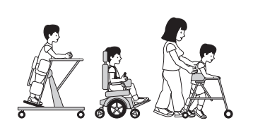
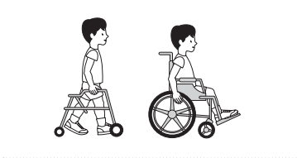
GMFCS III GMFCS IV

- What is involved in the study?

If you provide your consent, you have the right for your information to be treated confidentially. You also have a responsibility to do your best to meet the commitments of the study.

Because we need to compare the new therapy to something else, we have 2 groups. One group gets the therapy right away (NOW), and one group gets put on a wait-list (WAIT). Families who are on the wait-list will still get to have the therapy at the end of 6 months of waiting. By having one group who receives ACTIVE STRIDES-CP and one group who continues with routine regular therapy, this will help us to understand whether ACTIVE STRIDES-CP leads to better outcomes than usual care.

The main things involved are:
- Being in the study for between 6 and 9 months
- Coming to the research/therapy centre 2 x weekly for therapy sessions (1.5hrs each)
- Having the therapist come to your house every fortnight for 4 visits to do therapy at home (1 hour each)
- Having the therapist contact you for a telehealth session on the alternate weeks to home visits for 4 sessions (1 hour each)

Because it is for research, we ask you and your child to do more things than you would do if you were getting this therapy in a normal way. These extra things include:
- Filling out surveys at the beginning, middle (9 weeks) and end (26 weeks) of the study. These surveys can take between 30 and 90 minutes to complete each time
- Your child wearing an activity tracker around their waist at the beginning, middle (9 weeks) and end (26 weeks) of the study. They must wear it for 7 days straight each time
- Committing to attend as many of the appointments as possible (but we will work around your availability and make it as easy as we can for you)

What does my child need to do in this research project?

Part 1. The Therapy

If you agree to be in the study, there are a number of steps:

- We will contact you with a 10-15 minute telephone call to talk about the project and ask you some questions to help us see whether your child meets the above inclusion criteria of the study.
- If we are not sure if your child meets these criteria we will organize an appointment to see you and your child to see whether he/she would benefit from ACTIVE STRIDES-CP.
- Your child will attend a baseline assessment at [insert site name]. You will be asked to provide written consent in the presence of the researcher and a witness after having any questions you have answered. As part of the baseline assessment, the physiotherapist will spend some time with you and your child to find out what your child’s goals are. After the baseline assessments are finished, your child will then be randomly assigned to a group as by the flip of a coin, completely by chance, to either ACTIVE STRIDES-CP (NOW) or a waitlist ACTIVE STRIDES-CP group (WAIT) who will receive the therapy after waiting 6 months. There is a 50% chance of getting in each group. It is totally random, like flipping a coin, so it is FAIR for everyone. It is not possible to know which group you will be in until after the first assessment. Families who are on the waitlist will still get to have the therapy at the end of 6 months of waiting.
- ACTIVE STRIDES-CP runs over 8 weeks. There will be 2 sessions at a therapy service each week of about 1.5 hours each. During these sessions, your child will do 30 minutes each of (i) Functional Electrical Stimulation (FES) powered cycling, (ii) partial body weight support treadmill training/ over ground walking, and (iii) goal directed training (e.g. sit to stand and gross motor goals) and 4 fortnightly 1hr home visits to practice recreational cycling (individualized adapted bike), over ground walking (using gait trainers) and practice your child’s goals at home. On the alternating weeks, they will have 4 x fortnightly 1hr telehealth sessions with their therapist.
- What is FES powered cycling?
FES powered cycling uses a motorized stationary cycle while at the same time receiving electrical stimulation to the leg muscles. Small electrical impulses are delivered to the leg muscles used for cycling from electrodes placed on the skin over the muscles. This causes the leg muscles to contract enough for your child to push the pedals. In this study, FES cycling is used as a first step to help children learn to contract the muscles they need to pedal a cycle, before moving onto recreational cycling. We will look at specially designed cycles and adapt them to suit your child. This could include putting on a back rest, foot straps or modified handlebars. During the home visits, we will work with you and your child to find the best cycle set up and help solve problems so that your child can cycle at home and in your community.

- What is partial body weight support treadmill training?
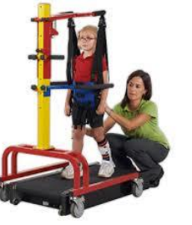
Using a treadmill and harness is one form of walking training. The harness helps children stay in an upright walking position so that they can really focus on their stepping. As children improve their stepping, the harness can be adjusted so that it supports less of the child’s weight.
- What is goal directed training?
During the baseline assessment, we will ask you and your child to think about 2 to 3 goals that you would like to work on. These will relate to mobility or cycling. For example, this could include your child improving their transfers from their wheelchair or a chair to their walker, steering their walker, mounting, dismounting, or steering their cycle, etc. Your therapist will work with you and your child to find solutions for these goals and give you some activities and strategies to practice at home in between your therapy sessions.
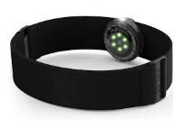
We will monitor your child’s heart rate during all parts of ACTIVE STRIDES-CP so we can adjust the speed of the treadmill and FES cycle so we can improve fitness levels. Your child will wear a Polar OH1 Optical heart rate sensor on one arm. It is a coin-sized device with green flashing lights that point towards the skin. It is secured on an elastic band. This tells us how hard they are exercising.

- Therapists will be a physiotherapist or exercise scientist who has experience in working with children with CP and an allied health assistant to help with the treadmill training. Physiotherapists will do specific training to be able to provide the ACTIVE STRIDES-CP therapy. All therapists are registered health practitioners.

- To help us work out if ACTIVE STRIDES-CP is effective for children and teenagers with bilateral CP, your child will complete a number of tests and we will get you to do some questionnaires. This will happen at your child’s first assessment, before starting therapy, then again 9 weeks later (one week after the therapy finishes) and then 6 months later. The tests your child will do will be:

- Gross Motor Function Measure (GMFM): This measures how your child does different motor skills like rolling, sitting, standing and walking. The test takes about 30 minutes to do.
- Six Minute Walk Test (6MWT): This short 6-minute test measures walking endurance. Your child will walk as far as possible in six minutes around a 10-metre track.
- Ten Metre Fast Walk Test (10mFWT): This test measures your child’s maximal walking speed
- Canadian Occupational Performance Measure (COPM): asks your child to identify areas of difficulty in everyday activities and rate how they feel they are doing that activity and how satisfied they are with how they do it. This helps to identify goals to work on in therapy and see if their goals are met as a result of the therapy. This takes about 15-20 minutes.

We will ask you to do two questionnaires at the first assessment only and three questionnaires at each appointment:
- Study Baseline Questionnaire: This questionnaire will be completed at the first assessment time only. We will ask questions about your child and family.
- Baseline Participation and Environment Measure for Children and Youth (PEM-CY): This survey is a parent-reported instrument that measures participation and environment across home, school and community settings.
- Pediatric Evaluation of Inventory Computer Adapted Test (PEDI-CAT): You can do this questionnaire electronically on a laptop or tablet. The questionnaire gets you to rate your child’s mobility. This will take you up to 15 minutes to do.
- Child Health Utility (CHU-9D): is a short questionnaire to measure health-related quality of life in children. The CHU-9D will be completed by both you and your child.
- The Cerebral Palsy Quality of Life-child (CPQOL-child): This survey assesses wellbeing using parent-report (4-12 years) and child self-report from 9 years.

Part 2. Measuring Movement with Devices

In Part 3, we want to measure any changes in how much physical activity your child does. To do this, we need to use small devices with sensors inside. These sensors are the same as what are inside commercial smartwatches.

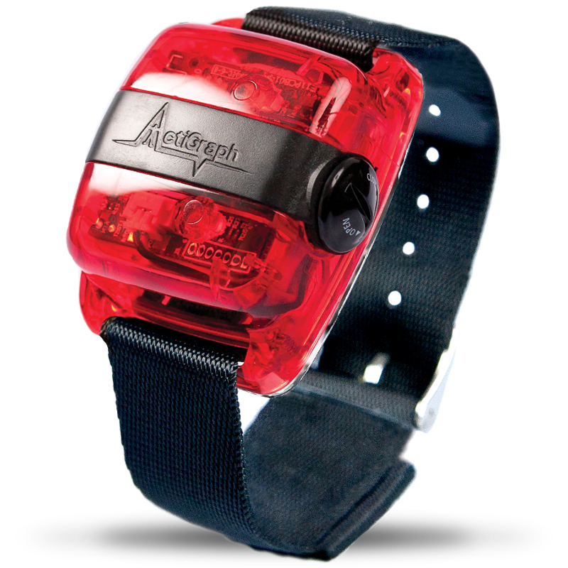
Just like a smartwatch, the devices do not emit anything harmful, sits on top of the skin, and do not cause any pain. Sometimes they can be uncomfortable if too tight, but we will do everything we can to fit them properly so your child does not experience any discomfort. We sanitise the devices between users.
- ActiGraph GT3X-wBT: a watch-sized device with red plastic housing, secured on an elastic belt or watchband. The ActiGraph contains a motion sensor inside which records information about how the device is moving in space. We will ask your child to wear two devices:
  - One on their less affected wrist and one on the less affected ankle
We will ask your child to wear the devices for 7 consecutive days at each assessment timepoint

We will show your child how safe and comfortable the devices are and allow them to try wearing them. If, after this, they still do not want to wear the devices, we will not put the devices on your child.

Part 3. Health Economic Evaluation

The health economic evaluation will measure the cost effectiveness of ACTIVE STRIDES-CP. The economic analysis will include an estimate of all health care costs, including medical and pharmaceutical services used by your child in the 12 months before ACTIVE STRIDES-CP. We will be asking your permission for Medicare Australia to release two years of your child’s use of medical and medicines (One year before starting the study and one year after finishing the study).

Your child can still be involved in Part 1 (The Therapy) and Part 2 Measuring with devices, even if you do not want them to participate in Part 3. Health Economic Evaluation. We will ask you which parts of the study you agree to participate in.

- What if I wish to withdraw from the research project?

My decision whether or not my child participates will not prejudice their future relations with XXXXXXXXX. If I decide for my child to participate, I am free to withdraw my consent and to discontinue participation at any time. The decision to withdraw from the study will not affect their routine medical treatment or their relationship with the person treating them.
You can withdraw from the study at any time by completing and signing the ‘Participant Withdrawal of Consent Form’. This form is provided at the end of this document, and is to be completed by you and supplied to the research team if you choose to withdraw at a later date.
If you withdraw from the study, you will be able to choose whether the study will destroy or retain the information it has collected about you. You should only choose one of these options. Where both boxes are ticked in error or neither box is ticked, the study will destroy all information it has collected about you

- What are the possible benefits for my child and other people in the future?

Regardless of the group your child is in, they will receive ACTIVE STRIDES-CP that may help improve gross motor skills and level of physical activity. If we show ACTIVE STRIDES-CP is helpful, then physiotherapists working with other children with bilateral CP to improve their gross motor skills and level of physical activity can use it.

- Alternative Treatment

At the moment, some therapy centres may provide treadmill training. A limited number of therapy centres will have FES cycling machines. There are no other therapy approaches which will at the same time focus on mobility, recreational cycling and gross motor goals to improve mobility and participation for children with moderate to severe bilateral cerebral palsy.

- What are the possible risks, side-effects, discomforts and/or inconveniences?

The assessments will happen at [insert site name]. These appointments will be planned to minimize any inconvenience to you. The only inconvenience to you and your child is the time that the assessment and therapy will take – The assessments will take approximately 1-1/2 hours in total. If your child is in the immediate ACTIVE STRIDES-CP group, this will mean there will be 3 assessment times. If your child is in the waitlist ACTIVE STRIDES group, it will mean 4 assessment times. The risks of the intervention are similar to those encountered during usual care physiotherapy and participation in physical activities and sports. The physiotherapist is trained in first aid and CPR, and has experience in minimising risk of injury in sports participation for children with physical disabilities. The risks associated with FES are no different to the risk of using electrical stimulation in a regular physiotherapy appointment. The physiotherapist is trained in its proper use and will conduct safety tests to minimize the risk of any adverse effects. During the therapy sessions, your child will be exercising, and over time resistance will be added to cycling. Your child may experience stiff or sore muscles after the therapy sessions which will disappear in one to two days.

- What will be done to make sure my child’s information is confidential?

Confidentiality
- All results of assessments/questionnaires will be stored without your child’s name on them.
- A number is used to identify the assessments. This number is linked to your child’s name but the linking file will be kept confidential and only made available to the researchers.
- We will use electronic forms and all information will be kept on a database at the Queensland Cerebral Palsy and Rehabilitation Research Centre, South Brisbane Queensland. Any paper forms that we use to record the assessments and questionnaires will be stored in a secure filing cabinet and only the researchers will have access to this information. The paper forms containing assessment or questionnaire results will be kept at each therapy site until the end of the study and will then be held at the Queensland Cerebral Palsy and Rehabilitation Research Centre in Brisbane in a locked filing cabinet until your child is 21 years old, and then destroyed.
- Videos of the therapy sessions and assessments will be kept at the Queensland Cerebral Palsy and Rehabilitation Centre on a secure University of Queensland server.
- If we give talks or write about the results of this project, we will not use any names or identifying details.
- Your child’s Medicare and Pharmaceutical Benefits Scheme data information will remain confidential and will not be disclosed without your permission, except as required by law. You can withdraw your consent later. Your child’s coded Medicare and Pharmaceutical Benefits Scheme data will be held securely and confidentially by our study team members at the Queensland Cerebral Palsy and Rehabilitation Research Centre to enable us to calculate costs. The Medicare and Pharmaceutical Benefits Scheme data cannot be used for any other purposes other than the study approved. The cost data from this study will be stored securely for at least 15 years from the end of the study, after which it will be destroyed securely.

- Compensation

This trial is covered by standard clinical trials insurance. That means you may be entitled to make a claim if you believe your child suffers an injury as a result of their participation in the study. You may request a copy of the terms of this insurance.

- Who should I contact for more information?

If you would like more information about the project or if you need to speak to a member of the research team in an emergency please contact:

Name: | Dr Leanne Sakzewski
Contact telephone: | 07 30697345
Email: | l.sakzewski1@uq.edu.au

The Children’s Health Queensland Hospital and Health Service Human Research Ethics Committee (HREC) has approved this study. If you have any concerns and/or complaints about the project, the way it is being conducted or your child’s rights as a research participant, and would like to speak to someone independent of the project, please contact the HREC Coordinator on:
3069 7002 or email CHQETHICS@health.qld.gov.au

