Protocol Guidance

1. Study Title:
Impact of perfusion with Methylene Blue on perioperative bleeding in simultaneous pancreas kidney transplant recipients

2. Setting:
Westmead Hospital, Westmead, NSW, Australia, 2145

3. Investigators
Professor Henry Pleass
Dr. Lawrence Yuen
Dr. Taina Lee
Dr. Peter Yoon
Dr. Amy Hort
Mr. Paul Robertson
Mr. Renan Gaspi
Mr. Christopher Zhang
Ms. Kathy Kable
Ms. Kerry Hitos
Professor Wayne Hawthorne
Professor Germaine Wong
Professor Natasha Rogers

4. Background/Introduction:
Simultaneous pancreas transplantation (SPK) is the treatment of choice for patients with end stage renal disease (ESRD) secondary to type 1 diabetes mellitus (T1DM). These patients often have impaired haemostasis due to platelet dysfunction or coagulation defects and have cardiovascular co-morbidities requiring anticoagulation therapy(1). These factors can increase their risk of developing haematological complications, particularly thrombosis or significant bleeding(1). Whilst creatinine clearance, glycaemic control and amylase/lipase levels are the optimal predictor of graft function, anaemia has also been demonstrated to be associated with graft loss and increased mortality risk(1, 2). Therefore, achieving adequate haemostasis in these patients is of significant importance.
Of particular interest is the difficulty in adequately assessing the haemostasis of deceased donor grafts on the back table, which can lead to unnecessary blood loss. For example, surface oozing often occurs from the vascular branches of the peri-nephric or peri-pancreatic fat when the graft is re-vascularised(1). Currently, standard intra-operative interventions, such as sutures, clips and electrocautery, are used following revascularisation to control sources of bleeding from the graft. However, there exists a lack of research into potential methods that can be utilised to identify these sources of bleeding on the back table prior to revascularisation in order to minimise blood loss.

Currently, the standard back table preparation of the pancreas for SPK transplantation involves the use of a Soltran flush. Recently there has been increasing interest on the use of methylene blue flush in its place to potentially reduce the risk of perioperative blood loss in these high-risk SPK recipients. Currently, the Soltran is flushed through the donor artery, circulates through the arterioles, capillaries, venules and vein. Whilst the Soltran flush is being passed through this circulatory system, the surgical team monitor the vessels and organ for potential leaks. However it is a clear solution, meaning sources of bleeding may be missed. On the other hand, methylene blue has a distinguishable colour, which would more clearly identify these sources and facilitate haemostasis with sutures, clips or thermal instruments, such as a harmonic scalpel. Case series have demonstrated that intra-operative methylene blue injection can be safely used to identify and localise obscure vessels that are the sources of gastrointestinal bleeding and guide surgeons in controlling obscure haemorrhages(3-5). However, no studies to date have evaluated its role in SPK operations, particularly the role in identifying obscure blood vessels on the donor graft that could potentially lead to significant blood loss or haematoma formation.

5. Hypotheses/Aims
5.1. Hypothesis:
We hypothesise that the use of methylene blue will facilitate identification of potential sources of bleeding and reduce the perioperative blood loss compared to the standard Soltran flush.

We therefore predict that it will reduce the postoperative haematoma formation, rates of postoperative transfusions and associated mortality.

5.2. Aims
The primary aim of this study is to determine the effectiveness of methylene blue compared to the standard Soltran flush in reducing perioperative blood loss in SPK recipients. The secondary aims are to determine if it reduces post-operative haematoma formation, post-operative transfusion requirements and post-operative mortality.

6. Research Plan
6.1. Study Design
Following Ethics approval from HREC, a single-centre, single blinded, randomised control trial will be undertaken at Westmead Hospital over a minimum of 24 months. As part of the routine workup and planning for SPK transplantation, potential participants will be provided with the participant information sheet by a member of their treating team who is not a member of the research team. Once they have provided informed consent to proceed, they will be registered in the secure REDCAP online database controlled by the study investigators, which will randomly allocate them to either the standard back table preparation with Soltran flush or to the use of Methylene Blue during the back table preparation. The preparation of the donor pancreas will proceed as per standard protocols and operator preference, with the only difference being at the time of flushing the pancreas with either solution. The clinician responsible for the randomisation will be a member of the surgical team and it will be performed at the time of back table preparation of the graft. Therefore, they, the operating and treating teams will not be blinded. The patient will be blinded to the results. The randomisation will be to either standard Soltran flush or Methylene Blue flush. If methylene blue is to be used then 0.5mL (5mg) of the methylene blue (50mg/5mL) solution will be diluted in a 1-litre bag of the Soltran solution, with approximately 300mL flushed through the pancreas. Therefore, the overall dose will be ~0.15mL. An example of the prepared solution, and effective colour change with the low dose, is provided in Figure 1. Note that there are no changes to the routine backtable preparation of the kidney.

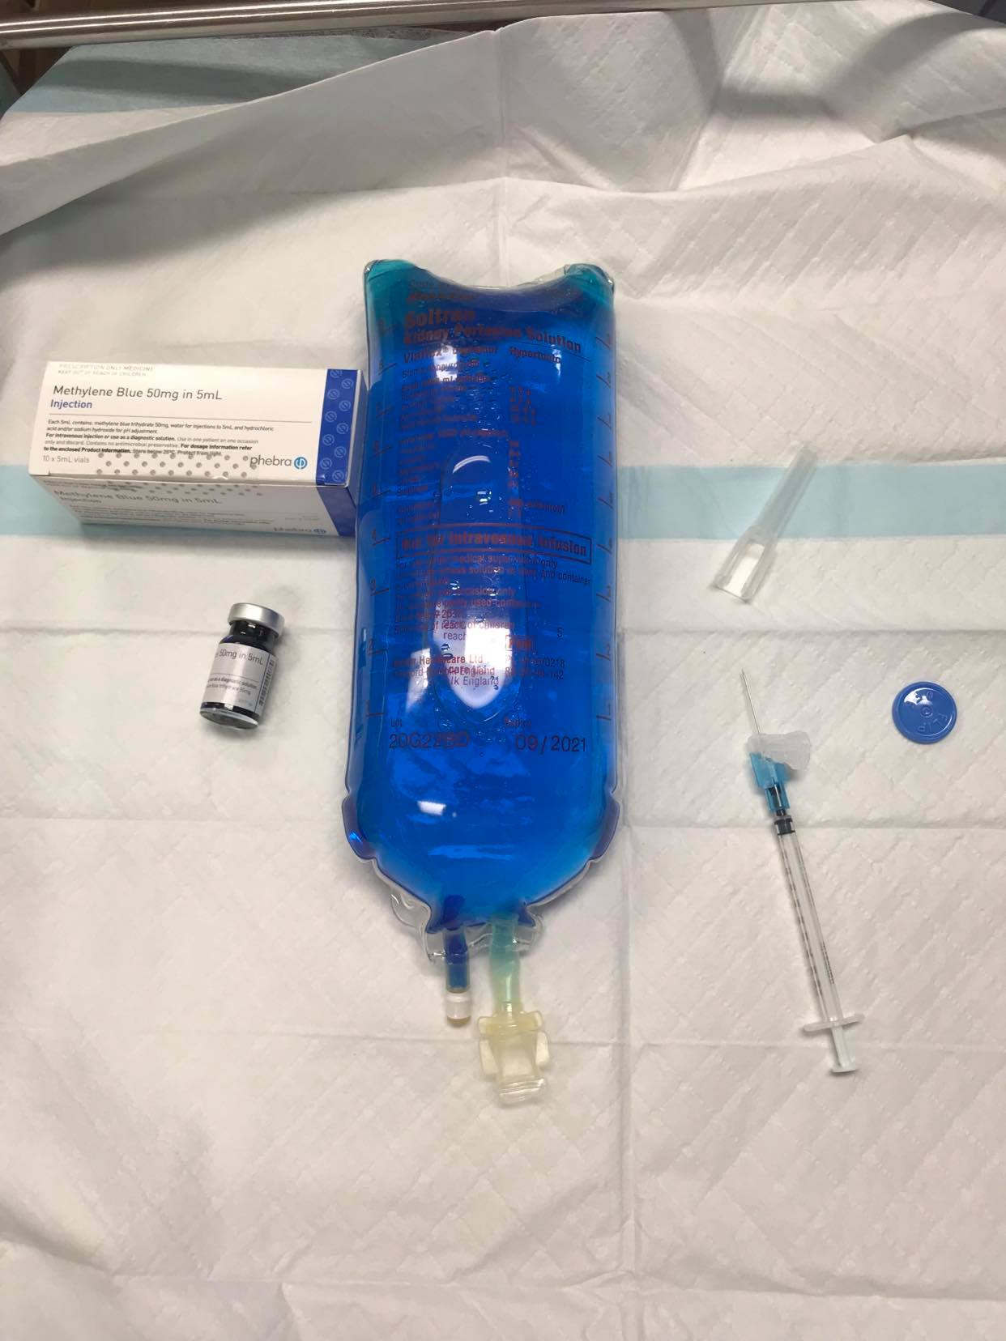

Figure 1 – 0.5mL of the 50mg/5mL methylene blue solution combined with 1L bag of Soltran perfusate solution.
6.2. Selection Criteria
All donor pancreases used for a SPK transplant at Westmead Hospital. Only participants who provide informed consent will be enrolled in the study. The patient will be provided with the participant information sheet and discuss the study with a member of their treating team who is not part of the research team. If they are willing to participate then they will provide written informed consent. They will be able to withdraw their consent at any point during the study.

Exclusion criteria is any patients with previous adverse reactions or anaphylaxis to Methylene Blue and those who are being re-transplanted.

6.3. Planned Sample Size
We approximate standard mean intra-operative blood loss in SPKs at Westmead to be 500mL and anticipate that the mean intra-operative blood loss for those given methylene blue to be 200mL. With the standard probability of a type-I error being 0.05 and power of 80% we would need a minimum of 14 patients in total (7 in each group). The calculations are included below. Note that, on average Westmead performs 30 SPKs per annum, so we anticipate that higher numbers will be recruited, ideally up to 50 patients.

6.4. Statistical Procedures
Data will be expressed as the mean + standard deviation (SD), median with range, or n (%), as appropriate. Differences among continuous and categorical variables will be examined for statistical significance using the Student t test (or Mann-Whitney’s test) and the chi-squared test (or Fisher’s exact test). Univariate and Multivariate Cox regression will be performed to identify prognostic features for outcomes after pancreas transplantation (including overall survival, graft survival, blood loss, transfusion requirements, etc). The statistically significant level will be p < 0.05, and all analysis will be processed by SPSS (version 23).

6.5. Sample Size Calculation

6.6. Data Collection Procedures
Patient data variables including demographic data, medical co-morbidities and pathology results will be recorded from the electronic medical records. Details of the donor pancreas will also be recorded, including donor demographics, anatomical characteristics, ischaemic time and time of retrieval. Whether the organ was randomised to routine Soltran flush or Methylene Blue flush and how much was given of each will be recorded. Intra-operative blood loss will be recorded. The remainder of their operation will be otherwise identical for both arms and proceed as per surgeon preference. Their postoperative monitoring will be identical for both arms. They will undergo their routine daily monitoring whilst they remain an inpatient in hospital and then their routine daily monitoring in transplant clinic up to 30 days postoperatively. This monitoring will include the routine monitoring of the daily drain output until removal, the routine monitoring of the characteristic of the drain fluid and the routine monitoring of the haemoglobin value. This has been outlined on the data collection form. The data will then be de-identified and secured in a password protected file and on the secure REDCAP system that only members of the research team can access.

6.7. Ethical considerations:
The study will request approval from the WSLHD Human Research Ethics Committee. The study will not commence until all necessary documentation has been approved. In obtaining informed consent, the participants will be provided with information about the purposes, methods, possible risks and benefits of participating in the study. All potential participants will have an opportunity to discuss the study with the study investigators. Participation in the study is voluntary and all participants are free to withdraw at any time, without affecting their future care. All amendments to the protocol, participant information sheet or consent form will be submitted to the ethics committee for approval. Study amendments will only be implemented once ethical approval has been obtained. All data generated by the study will remain strictly confidential and no report will obtain any information that would allow an individual participant in the study to be identified.

6.7.1. Data Integrity and Privacy
Once informed consent has been obtained, data will be collected from electronic medical records of the patients. All relevant data will be stored within an encrypted file in which only the investigators will have access and on the secure REDCAP system. Both of these will require a password that only the investigators will have access too.

Post intervention data will be collected using the data collection template. The data will be kept for 5 years after collection and will be destroyed after that period of time. Patient medical record numbers will be eliminated, consenting patients will be allocated a unique study identification number. The file that allows for re-identification of patients will be kept secured by the Data Manager in a separate file on a password protected computer, which will be based on a secure server. Only the study investigators will have access to the data. Any hard copes will be kept in a secure filing cabinet in the Transplantation Department at Westmead Hospital. This cabinet can only ever be access by the research personnel listed in this application. The study Chief-Investigators will adhere to a data cleaning schedule and conduct regular data audits to ensure data integrity. Basic checks will be conducted to identify data entry errors and any errors identified in this process will be corrected.

6.7.2. Safety of Methylene Blue
Methylene blue has been safely established for its use in patients, with the most well known being its use in toxicology for patients with methemoglobinaemia at a dose of 1-2mg/kg of 1% solution intravenously(6). Other well established uses include in catecholamine refractory vasoplegia, heptapulmonary renal syndrome, as an antimalarial, for isosfamide neurotoxicity and as a dye/stain for localising abnormal parathyroid glands, sentinel lymph node marking in breast cancer intra-luminal lesion marking(7). Additionally it has established use in patients in septic shock, with a recent systematic review of patients in demonstrating that methylene blue administration increased mean arterial pressure and systemic vascular resistance while decreasing vasopressor requirements and had no adverse effects(7, 8). More recent research has observed its safe and effective use in marking of pulmonary nodules, guiding anatomical hepatic resections, localising obscure gastrointestinal bleeding and guiding their management, for defining atypical pancreatic anatomy and for treating renal parapelvic cysts(5, 9-14),

Methylene blue is safe when used in therapeutic doses of <2mg/kg and as the dosing provided will be below this, we do not anticipate any harmful effects to the organs or patient(7)s. It can cause green-blue discolouration of the skin, mucosa and urine, however this is self-limiting(7). As it is safely established for numerous uses in patients and there will be not other changes to patient case, this will be a low risk alteration to the preparation of the organs with potentially significant benefits.

The authors note it is important to discuss the potential of a severe reaction of anaphylaxis. A recent systematic review noted that the risk of anaphylaxis with methylene blue injection is 0.0006% and that this was lower than other blue dyes used(15). This risk will be clearly communicated to the potential participants prior to obtaining informed consent and is included in the participant information sheet. If this rare complication were to occur then the patient would be treated as per the hospital protocol for anaphylaxis in conjunction with the anaesthetic team. Additionally, as we routinely implant the pancreas first, if this patient were to be for a SPK then, once stabilised, their renal transplant will proceed as usual as this organ has not been in contact with methylene blue.

6.8 Publications and reports
The study results will be submitted for publication in pee-reviewed journals with all collaborators acknowledged. Results will also be disseminated through conference presentations and general media.

7. Expected Outcomes
The likely impact of the results of the project on individual patient care and health service delivery are:
- Anticipated reduced perioperative blood loss
- Reduced perioperative morbidity including blood transfusion requirements
- Potentially reduced length of stay
- Reduced cost of care delivery for the health service

8. Dissemination plan, timetable/milestone, predicted outcomes
Task | March/April | May 2020-May 2022 | June 2022 | August 2022
Literature Review | X
Protocol | X
Ethics | X
Recruitment /data collection |  | X
Data entry /check |  | X
Data analysis |  |  | X | X
Write report /article |  |  |  | X

References
1. Kapoor A WE, Vasisth G, Guo Y, Hassan F, Tajzler C, Hansra S, Piercey K, Lambe S. A prospective, randomized, pilot trial of a polyethylene glycol (PEG)-coated collagen patch (Hemopatch®) for intraoperative hemostasis during deceased donor renal transplant. Canadian Urological Association Journal. 2020;14(1):E1-E5.
2. Schechter A G-GA, Shepshelovich D, Rahamimov R, Gafter U, Mor E, Chagnac A, Rozen-Zvi B. Post renal transplant anemia: severity, causes and their association with graft and patient survival. BMC Nephrology. 2019;20(51).
3. Turner G PA, Sharma P. Bleeding small bowel: methylene blue guided resection. ANZ Journal of Surgery. 2018;89(11):1499-500.
4. Frydman J BH, Leiderman M, Ofer A, Kluger Y. Methylene Blue injection via superior mesenteric artery microcatheter for focused enterectomy in the treatment of a bleeding small intestinal arteriovenous malformation. World Journal of Emergency Surgery. 2014;9(17).
5. Pai M FA, Virk J, Nehru N, Kyriakides C, Limongelli P, Jackson J, Jiao L. Preoperative Superselective Mesenteric Angiography and Methylene Blue Injection for Localization of Obscure Gastrointestinal Bleeding. JAMA Surgery. 2013;148(7):665-8.
6. Clifton J LJ. Methylene blue. American Journal of Therapeutics. 2003;10(4):289-91.
7. Ginimuge P JS. Methylene Blue: Revisited. Journal of Anaesthesiology and Clinical Pharmacology. 2010;26(4):517-20.
8. Kwok E HD. Use of Methylene Blue in Sepsis: A Systematic Review. Journal of Intensive Care Medicine. 2006;21(6):359-63.
9. Aoun H LP, Heath K, Adam B, Prus M, Beydoun R, Baciewcz F. Methylene Blue/Collagen Mixture for CT-Guided Presurgical Lung Nodule Marking: High Efficacy and Safety. Journal of Vascular Interventional Radiology. 2020;31(10):1682.e1-.e7.
10. Kleedehn M KD, Lee F, Lubner M, Robbins J, Ziemlewicz T, Hinshaw J. Preoperative Pulmonary Nodule Localization: A Comparison of Methylene Blue and Hookwire Techniques. American Journal of Roentgenology. 2016;207(6):1334-9.
11. Shou-Wang C S-ZY, Wen-Ping L, Geng C, Wan-Qing G, Wei-Dong D, Wei-Yi W, Zhi-Qiang H, Jia-Hong D. Sustained methylene blue staining to guide anatomic hepatectomy for hepatocellular carcinoma: Initial experience and technical details. Surgery. 2015;158(1):121-7.
12. Bhuller S LM, Ismail N, Woods B. Obscure gastrointestinal bleeding localization using preoperative super-selective mesenteric angiography and intraoperative methylene blue injection: A case report and literature review. Int J Surg Case Rep. 2019;65(69-72).
13. Ma Z LS, Chen F, Yu D, Zhang X, Li K, Zhang M, Tang S, Wang The preliminary experience of methylene blue assisted laparoscopy in the treatment of renal parapelvic cysts. Scientific Reports. 2020;10(1).
14. Park S dBM, McHenry L, Fogel E, Lazzell L, Bucksot L, Sherman S, Lehman G. Use of methylene blue to identify the minor papilla or its orifice in patients with pancreas divisum. Gastrointestinal Endoscopy. 2003;57(3):358-63.
15. Perenyei M BZ, Gibson J, Hemington-Gorse S, Dobbs T. Anaphylactic Reaction Rates to Blue Dyes Used for Sentinel Lymph Node Mapping: Systematic Review and Meta-analysis. Annals of Surgery. 2020;Online ahead of print.

