Protocol: Increasing COVID-19 testing intentions and behaviour with enhanced messaging

Investigators: Carissa Bonner, Carys Batcup, Julie Ayre, Kristen Pickles, Erin Cvejic, Kirsten McCaffery
Funding: Marie Bashir Institute grant

BACKGROUND
In Australia we are fortunate to have efficient and freely accessible testing for COVID-19 widely available. Testing clinics have been set up all around the country including drive through options where you have no contact with other patients, and results are generally sent by text message within 3 days. Despite the required systems being set up early in the pandemic, national data indicate suboptimal testing uptake. A survey in August found 85% of people with relevant symptoms (cough, fever, sore throat) did not get tested¹, and flu symptom tracking data in September found 51%². Our national Australian COVID-19 survey (June 2020) found only 49% of people had strong intentions to get tested if they had COVID-19 symptoms but most (96%) agreed to some extent, while 69% strongly agreed they would stay home if they had symptoms³. Testing barriers were related to all three drivers of behaviour in the COM-B model⁴, for example:
- Capability: 7.1% don’t know how/when/where to get tested, 2.4% would forget to get tested (psychological capability)
- Opportunity: 2.3% worried what others will think (social opportunity), 2.1% said it was too difficult/expensive to get tested (physical opportunity)
- Motivation: 11.2% think testing is painful, 5.9% worried they will get infected at the clinic (reflective motivation)
We also found that certain groups are less likely to understand and act on COVID-19 prevention advice. For example, people with lower health literacy and those who speak a language other than English were less likely to be able to identify COVID-19 symptoms and prevention measures⁵. Younger people, men and those with less education were more likely to agree with misinformation about COVID-10 prevention, management and cure⁶. These groups likely need different communication strategies to ensure everyone understands the message and takes action based on the message. Various approaches to COVID-19 prevention have been proposed⁷, but these have neglected testing as an outcome, and have not addressed gaps between intentions and behaviours.
The management of COVID-19 prevention in Australia has primarily been through public health communication. Communication interventions can address behavioural barriers with education, persuasion and enablement, using the following principles proposed by international experts⁷. See Table 1.
Table 1: Proposed principles of COVID-19 messaging
Principle | Recommendation
Education | should focus on promoting understanding of the benefits of the behaviours and on how and when to enact them effectively, address concerns about the potential costs, and provide specific guidance on how to minimise adverse spill-over effects. It should take into account varying levels of educational level and varying circumstances.
Persuasion | should focus on generating a feeling of responsibility toward others in families and the community and a sense that the behaviours are valued by groups with which the target group identifies. It should promote concern and active engagement rather than anxiety and defensive avoidance.
Enablement | should include a range of interventions for improving capability, such as therapeutic interventions to address mental health barriers to adherence, as well as interventions to extinguish or build habits and create if-then rules.

AIM
This study aims to improve the uptake of COVID-19 testing using education, persuasion and enablement principles to address individual testing barriers.

RESEARCH QUESTIONS
We will test the following research questions:
- Can we improve understanding of government testing messages using health-literate design principles (education)?
- Can we improve testing intentions by tailoring Australian government prevention information to individual testing barriers and increasing salience of community risk/benefit (education + persuasion)?
- Can we improve testing behaviours using action plans tailored to individual testing barriers (enablement)?

STUDY 1: Addressing top 10 barriers in general population using a tailored intervention

METHOD

Recruitment
We will recruit an online sample via Dynata and Qualtrics (large market research organisations with whom we have a strong track record of collaboration). We will oversample participants with lower education as a proxy for lower health literacy, as our research has identified COVID-19 misinformation is more prevalent in these groups.

Design
Various trial designs were considered taking into account the budget constraints on sample size (which limits the number of groups to test individual behaviour change techniques) and implementation strategies (which limits the amount of tailoring within the intervention). The final study design is presented in Figure 1, which will allow us to isolate the effect of components designed to increase intentions versus those designed to increase behaviour (reducing the intention-behaviour gap) through a 2 x 2 factorial design. For each stage of decision making, participants will be randomised to receive control information (based on government information about COVID testing) or enhanced information (based on principles of education and persuasion).

Outcomes
We will measure demographics and covariates shown to be associated with lower understanding of COVID-19 symptoms and prevention measures in our longitudinal survey (age, gender, language, health literacy, trust, living alone, prior COVID test). Our primary outcome is intention to undergo testing for COVID-19 if symptomatic (measured after intention intervention and before behaviour intervention). Secondary outcomes include intentions about other prevention behaviours (self-isolation if symptomatic, social distancing 1.5 meters, washing hands regularly, wearing masks in crowded indoor areas), understanding of messaging, risk perceptions, social stigma, and self-efficacy (i.e. confidence in overcoming perceived barriers to testing). Self-reported prevention behaviour and intentions will be assessed after 1 month, with our prior survey data suggesting >20% of participants would experience symptoms over that time. We will use validated and widely used measures, with adaption to COVID-19 context where required (see survey questions document).

Analyses
Statistical analysis will be conducted using planned contrasts between the intervention arm and control arm, implemented in regression models. Analyses will control for baseline testing intentions. The influence of age, gender, language, health literacy, trust, and living alone will be examined by including appropriate interaction terms within the regression models. The total sample size required is 1430. This is based on the primary outcome of intention, with the assumption that in the control arm for intention (group 1 & 2), only 50% will have strong positive testing / self-isolation intention, and that the intervention (group 3 & 4) will increase this to 65%. This equates to odds ratios of ~1.5 for either intervention component. Detection of odds ratios of 1.5 for each intervention component (with 80% power and 5% alpha level) requires a total sample size of n=812 (i.e., 203 randomly to each study arm). Allowing for up to 20% loss to follow-up, a total of n=1016 should be recruited. To account for multiple comparisons using an adjusted alpha level of 0.013 requires n=1144, increased to 1430 to account for dropout.

Figure 1: Study design
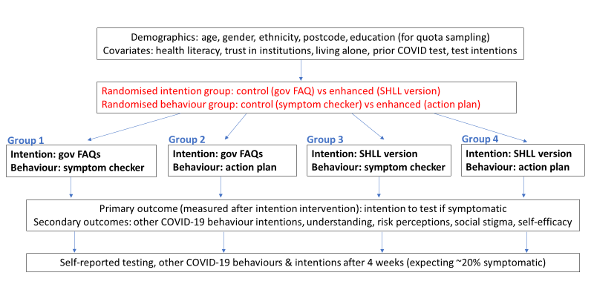

Hypotheses

- Compared to control (gov FAQs: group 1 & 2) the enhanced intention intervention (SHLL version: group 3 & 4) will result in:
- Higher intentions to get tested if symptomatic (Likert scale)
- Higher understanding of COVID-19 (more symptoms identified, less myths identified)
- Higher risk perceptions (average across Likert scales)
- Higher self efficacy (average across Likert scales)
- No effect on social stigma (average across Likert scales)
- No effect on other behaviours

- Compared to control (symptom checker: group 1 & 3) the enhanced behaviour intervention (action plan: group 2 & 4) will result in:
- Higher self-reported COVID-19 tests over the past 4 weeks (yes/no)
- No effect on other behaviours or intentions

Procedure
Eligible panel members will be invited to participate by Dynata/Qualtrics through their usual channels. This will include any adults aged 18+, with quota sampling based on age, gender and education groups. Once quotas are met no further recruitment for that group will be done. Participants will read the PIS and click a button to indicate consent to participate. They will complete a 10 minute online survey including baseline measures, viewing the intention intervention, completing intention outcomes, and viewing the behaviour intervention. Those in the enhanced condition (group 2 & 4) will receive weekly reminders with a screenshot of their action plan by email. After 4 weeks all participants will receive a 5 minute online survey with final questions for the behaviour outcomes, and open feedback about the information they received.

Results
No differences found between groups.

Discussion
The intervention may have been too heterogenous due to the use of tailoring to focus on top 3 concerns for intentions and top 1 concern for behaviour – which meant that few participants received the same intervention. It is possible there were ceiling effects for intentions when participants assumed they would get tested when they were not currently or recently thinking about the logistics of getting tested (see Figure 2 below). It is also possible that participants did not engage with the text-based intervention content. We will address these issues in study 2 by focusing on one category of barriers in a more targeted group (younger, lower education), using a more engaging standard intervention format (animation with text and audio), measuring self and other intentions to get around possible biases (optimistic bias and self presentation bias), and making the decision more tangible by recruiting people who have recently experienced symptoms and presenting them with a hypothetical scenario to consider.

Figure 2: Answers to the question ‘Over the next 4 weeks, I plan to get tested if I have COVID-19 symptoms (cough, sore throat, fever)’

STUDY 2: Addressing top symptom-related barriers in a targeted population using a standard animation

METHOD

Recruitment
We will recruit an online sample via social media, targeting younger participants aged 18-39 with lower education (no university), as our research has identified COVID-19 misinformation is more prevalent in these groups.
Advertisement text: Over 18? We want to hear from you! Complete a short survey about COVID-19 and be in with the chance to win a $20 gift card.
PIS (explain draw and choice of voucher) and consent button
Eligibility questions: age 18-39, no university education
Screened out page or survey

Design
A simplified design will be used comparing the same control group (NSW health FAQ text) with the animations and measuring all outcomes immediately post-intervention. As per study 1, participants will be randomised to receive control information (based on government information about COVID testing) or enhanced information (based on principles of education and persuasion in an animation). There will be two animations: one will be based on a scenario where someone wakes up with a sore throat and is considering whether to get tested and miss a social event, with key barriers raised in a discussion with a friend who debunks them. The other will be more fact-based, with more direct messaging around the barriers. The barriers are:
- I know what symptoms I have and don't believe they are COVID-19 ones e.g. hayfever/normal cold
- I'm not sure my symptoms are bad enough
- It is unlikely I have COVID-19 because there aren't many cases in my area
- I’m not sure this symptom needs testing

Outcomes
We will measure demographics and covariates shown to be associated with lower understanding of COVID-19 symptoms and prevention measures in our longitudinal survey (age, gender, language, health literacy, trust, prior COVID test). Our primary outcomes are intention to undergo testing for COVID-19 if symptomatic for self AND other (measured before and after intention intervention). Secondary outcomes include intentions about other prevention behaviours (self-isolation if symptomatic, social distancing 1.5 meters, washing hands regularly, wearing masks in crowded indoor areas), understanding of messaging, self-efficacy (i.e. confidence in overcoming perceived barriers to testing), perceived effectiveness of the intervention/control messaging, credibility of the message, personal relevance of the message.

Measures:

Please show below how you felt about the information/video you just saw. The information/video was…
[5 point scale from Strongly disagree to Strongly agree]
a. worth remembering
b. attention-grabbing
c. powerful
d. informative
e. meaningful
f. convincing

How well do the following adjectives describe the content you just read/watched?
[7 point scale from Describes very poorly to Describes very well]
a. accurate
b. authentic
c. believable

Imagine you woke up with a sore throat tomorrow. Would you get tested straight away?
[7 point scale from Strongly disagree to Strongly agree]

Most people my age would get tested after seeing this information/video.
[7 point scale from Strongly disagree to Strongly agree]

What are the 6 main COVID-19 symptoms you should get tested for? select from the list
Sore throat; Headache; Loss of taste or smell; Fever; Digestive issues; Conjunctivitis; Cough; Runny nose; Muscle aches; Shortness of breath or difficulty breathing; Vomiting; Diarrhea

When do you need to get tested? (1 point per correct answer, max 3)
a. Any mild/slight symptoms, moderate/uncomfortable symptoms, symptoms are severe/disrupt your plans
b. any length of time with symptoms / symptoms lasting 2 days / symptoms lasting 3 days
c. 1 symptom in a single day / 2 symptoms in a single day /3 or more symptoms in a single day

If you have symptoms of COVID-19, you should get tested when… Select all that apply (1 point if all selected or c only)
a. there are hotel quarantine cases in your state
b. there are local cases in your community
c. there are no local cases in your community

Should you get tested if you have unusual or new cold-like symptoms that you think are due to:
[5 point scale from Yes definitely to No definitely not]
a. Cold weather
b. A cold
c. Flu
d. Hayfever
e. Allergies

Show how much you agree with the following:
[7 point scale from Strongly disagree to Strongly agree]
a. I found the information was created personally for me
b. I felt that the information was relevant to me
c. I felt that the information was designed specifically for me

Over the next 4 weeks, I plan to:
[7 point scale from Strongly disagree to Strongly agree]
a. Get tested if I have COVID-19 symptoms (cough, sore throat, fever)
b. Stay home if I have COVID-19 symptoms (cough, sore throat, fever)
c. Stay 1.5m away from others that I don’t live with where I can
d. Wash my hands or use sanitiser to protect me and others from COVID-19
e. Wear a mask in crowded indoor areas

In the next week, do you agree that...
[7 point scale from Strongly disagree to Strongly agree]
a. It is mostly up to me whether I get tested for COVID-19
b. I have complete control over whether I get tested for COVID-19
c. It would be easy for me to get tested for COVID-19
d. I am confident that I could get tested for COVID-19
Analyses
Statistical analysis will be conducted using planned contrasts between the intervention arm and control arm, implemented in regression models. Analyses will control for baseline testing intentions. The influence of age, gender, language, health literacy, risk perception, and trust will be examined by including appropriate interaction terms within the regression models. The total sample size required is 1500. This is based on 50% of participants having strong positive intention, increasing to 60% in intervention group (which corresponds to an OR of 1.50), which would require 466 per group (so 1398 in total) to have 80% power to detect pairwise differences at a multiple-comparison adjusted alpha level of 0.025. The 1500 is to allow for some wriggle room from the 1398.

Figure 3: Study design

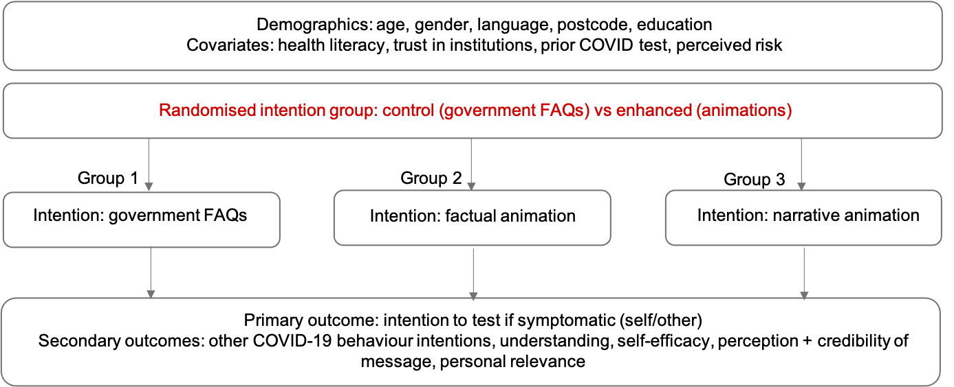
Hypotheses

1. Compared to control (gov FAQs: group 1) the enhanced intention interventions (animation: groups 2 and 3) will result in:
- Higher intentions to get tested if symptomatic (Likert scale)
- Higher understanding of COVID-19 (new knowledge scale for symptom barriers)
- Higher self efficacy (average across Likert scales)
- Higher perceived effectiveness of the message
- Higher credibility in the message
- Higher feeling of personal relevance of the message
- No effect on other COVID-19 behaviours (self-isolation if symptomatic, social distancing, washing hands, wearing masks indoors)

2. Compared to the fact-based animation (group 2), the narrative-based animation (group 3) will result in:
- Higher intentions to get tested if symptomatic (Likert scale)
- Higher understanding of COVID-19 (new knowledge scale for symptom barriers)
- Higher self efficacy (average across Likert scales)
- Higher perceived effectiveness of the message
- Higher credibility in the message
- Higher feeling of personal relevance of the message
- No effect on other COVID-19 behaviours (self-isolation if symptomatic, social distancing, washing hands, wearing masks indoors)

Procedure
Social media users aged 18-39 on Facebook and Instagram who have experienced symptoms in the last 2 weeks will be targeted with ads, with quota sampling based on age, gender and education groups. Once quotas are met no further recruitment for that group will be done. Participants will read the PIS and click a button to indicate consent to participate. They will complete a 10 minute online survey including baseline measures, viewing the intention intervention, completing intention outcomes, and viewing the behaviour intervention.

Materials
Example intervention content is shown below, with input from a consumer representative.

Control condition
We conducted a rapid review of Australian federal and state government COVID-19 testing information on official websites, and determined that NSW Health had the most comprehensive FAQ information from which we could draw the most barriers (https://www.health.nsw.gov.au/Infectious/covid-19/Pages/frequently-asked-questions.aspx). We therefore used this as the control condition for intentions.

Who should get tested for COVID-19?

Australian health departments now recommend that anyone displaying any COVID-19 symptoms should be tested for COVID-19. You must self-isolate until you are advised of the result of your test in line with Home isolation guidance for people suspected to have COVID-19 (Coronavirus) infection

This is especially important for:

- anyone who lives or works in a high risk setting, including healthcare facilities, aged care and other residential facilities, schools, prisons, and other closed settings
- Aboriginal and Torres Strait Islander people
- people who are close contacts of a confirmed case or who have returned from overseas in the last 14 days
- anyone admitted to hospital
- people who reside in areas for increased testing and surveillance

Samples for testing can be taken directly by GPs, at your local COVID-19 testing or drive-through clinic, at a range of private pathology sites across the state that are suitable for collection of COVID-19, or at public hospitals across the country.

What is "asymptomatic testing"?

Asymptomatic testing is testing people who do not exhibit symptoms of COVID-19. Symptoms of COVID -19 include:

- fever (37.5 ° or higher)
- cough
- sore throat
- shortness of breath (difficulty breathing)
- runny nose
- loss of taste
- loss of smell.

Other reported symptoms of COVID-19 include fatigue, muscle pain, joint pain, headache, diarrhoea, nausea/vomiting, loss of appetite, unexplained chest pain and conjunctivitis.

Should people with no symptoms get tested for COVID-19?

Testing of asymptomatic people (that is, people with no symptoms) is not recommended routinely. In certain high risk outbreak settings, PHU may consider testing asymptomatic contacts to inform management of the outbreak.

Immunocompromised people who were confirmed cases, must have two PCR negative respiratory specimens collected at least 24 hours apart at least 7 days after symptom onset, in addition to meeting the release from isolation criteria.

Who should have an asymptomatic test?

Asymptomatic people do not require testing, except in special circumstances e.g. in certain high risk outbreak settings or returned travellers.

Currently, Australian health departments recommend testing if you:

- exhibit symptoms of COVID-19
- have been to a location during the time associated with a confirmed COVID-19 case
- if you live in an area or suburb with increased testing and exhibit COVID-19 symptoms

However, you may be required to undergo asymptomatic testing if:

- your flight requires you to have a negative test result
- your employer requires you to have a negative test result

Where would I go for asymptomatic testing?

Asymptomatic testing can be completed at a private facility. You would need a referral from your GP to get tested there.

Asymptomatic testing at a private facility will not be covered by Medicare and will be at your own expense.

If you have been identified as a close contact of a confirmed COVID-19 case and don't have symptoms, please follow the directions and testing advice given to you by a Health official.

Note: If you go to see a doctor make sure you wear a surgical mask while you go there. You should travel directly to the doctor or COVID-19 clinic by foot (where practical) or private car. You are advised not to use public transport.

For further advice, please see the COVID-19 control guideline for public health units or call your local Public Health Unit.

Is it safe to get tested for COVID-19?
Yes, it’s safe to get tested. All medical staff wear protective gear and there’ll be a safe place to wait.

Is COVID-19 testing painful?

Testing for COVID-19 can be uncomfortable but shouldn’t be painful.

What does a COVID-19 test actually test for?

Swabs are tested for COVID-19 and sometimes other viruses only. The COVID-19 swabs are not tested for drugs, cancer or anything else.

What does a negative COVID-19 test result mean?

A negative result means that COVID-19 is unlikely to be the cause of someone's current symptoms.

However, a negative test result in someone who is well does not guarantee that they have not been infected as it may still be early in their illness.

If you are in home isolation because you have had close contact with a confirmed COVID-19 case, a negative test result does not mean you can end your home isolation. You need to remain in home isolation for a total of 14 days after your last close contact with a COVID-19 case.

Do I need to get retested for COVID-19 if I get symptoms again but my first test result was negative?

A negative test result only means that you did not have COVID-19 at the time of testing. However, that does not mean you will not get COVID-19. If you experience symptoms again, such as a fever, cough, sore/scratchy throat, change in taste or smell, stuffy nose or shortness of breath, get tested.

How will I receive my COVID-19 test results?

COVID-19 test results are automatically delivered directly to patients via SMS (text message).

If you’ve been tested for COVID-19 at a public hospital fever clinic, COVID-19 clinic or emergency department you can sign up for the new secure SMS service. Your local hospital health team will provide you with details on the simple steps to register.

Your sample will go to a specialist Pathology COVID-19 laboratory for testing. Typically you will receive your results in 24 - 48 hours, but please allow for up to 72 hours.

Public healthcare professionals will continue to contact patients who test positive for COVID-19 as a priority.

If you had your COVID-19 test sample taken in the community by your GP or a private pathology provider, you will need to contact your doctor for your COVID-19 results.

Do I need a medical certificate clearing me for work, school, university or other settings?

No. Doctors are unable to issue medical clearance certificates because if you do not have any symptoms, there is no test that can be done to predict whether or not you will become unwell.

People who have recovered from a COVID-19 infection, and people identified as close contacts who have completed their 14-day quarantine may be provided letters to confirm their isolation or quarantine period has finished.

For people who have tested negative to COVID-19, the SMS text that is sent with your test results can be provided to an employer, school, university or other setting, if they request it.

What if I don’t have Medicare?

You don't need a Medicare card to get tested for COVID-19.

The costs associated with procedures for ambulance transfers of people suspected to have COVID-19 infection, who are taken to Health facilities for assessment and who are not eligible for Medicare will be waived.

If you test positive to COVID-19 and require treatment, these costs will also be waived. This includes waiving payment and debt recovery procedures for people seeking treatment at Health facilities.

Is COVID-19 testing free?

Testing is free at public testing clinics, even if you’re from overseas. Testing is also free at private testing sites, however a referral is required for some private providers. Where a referral is required, your General Practitioner (GP) may charge a fee for the initial consultation, and then again to receive the result from the GP.

Intervention condition 1
“It’s easy to think that you don’t have to get tested for symptoms of COVID-19. Waking up with a sore throat is easy to write off as just a cold or nothing serious. But the symptoms of COVID-19 could be easily mistaken for a cold or hayfever, so it’s important to still get tested.
Even if you only have one cold-like symptom, and it’s not that bad, you still need to get tested straight away.
It’s true that there haven’t been many cases in Australia, which is great. But for it to stay that way, every case needs to be found so that we can quickly let everyone in the community know. This means it won’t spread any further. If you do have COVID-19 but don’t get tested, you could spread it to other people without knowing. You might be the first case in your community.”
You should get tested straight away for any of the following symptoms: fever, sore throat, cough, shortness of breath, runny nose, loss of taste or smell. Even if the signs are mild or haven’t lasted very long.
Remember, every new outbreak of COVID-19 starts with one new case.
Next screen has the message:
We’ve done so well so far – let’s keep it up
Intervention condition 2
Person wakes up in bed and holds throat, gets out phone and messages a friend.

FRIEND A
Hey (waving hand)
Got a bit of a sore throat... (feeling sick thermometer emoji)
Not sure I can meet you today…

FRIEND B
Ahhh no worries!
Shake it off meet me there
You’ll be fine!

FRIEND A
Idk…
Was thinking…probs a cold but should get tested
Y’know – covid... (shrug emoji)

FRIEND B
Nah!
Don’t be ridiculous!
No-one we know has it!

FRIEND A
(brain exploding emoji)
That’s exactly how it spreads.
Remember that guy who got it and they had no idea how?

FRIEND B
Nope (thumbs down + eyeroll)

FRIEND A
Whatever dude,
Not gonna be ‘that guy’ that starts a new outbreak.
catch u later

Screen fills with a message saying:

You should get tested straight away for any of the following signs: fever, sore throat, cough, shortness of breath, runny nose, loss of taste or smell. Even if the signs are mild or haven’t lasted very long.
Remember, every new outbreak of COVID-19 starts with one new case.

Next screen has the message:

We’ve done so well so far – let’s keep it up
Figure 4: Study 1 intention control (example of government information about testing in SHLL Editor)

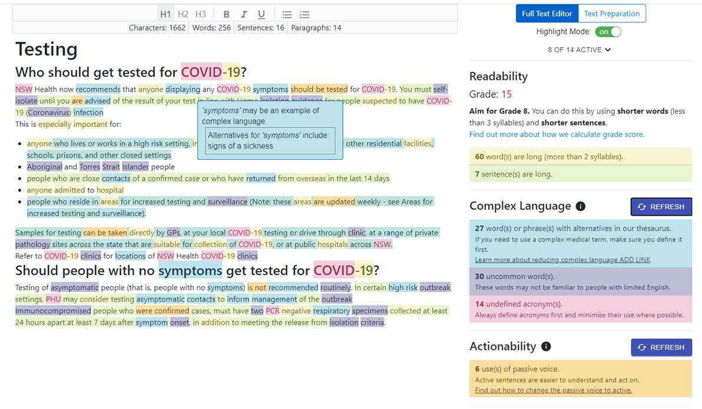

Figure 5. Study 1 Behaviour control (Healthdirect symptom checker: testing not recommended – top, vs required - bottom)

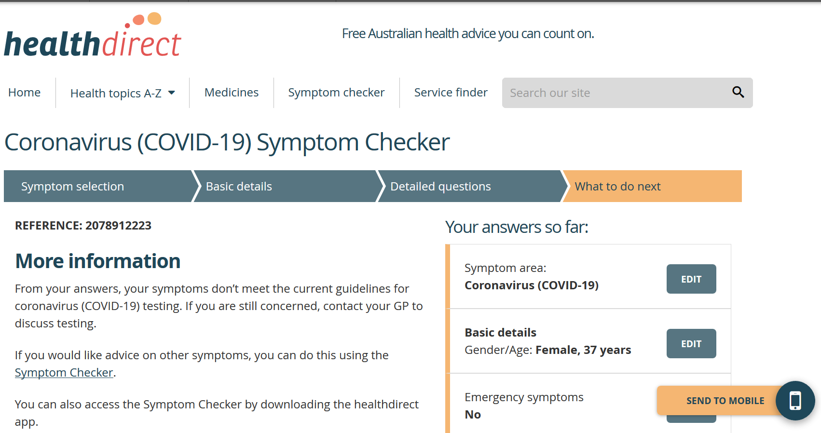

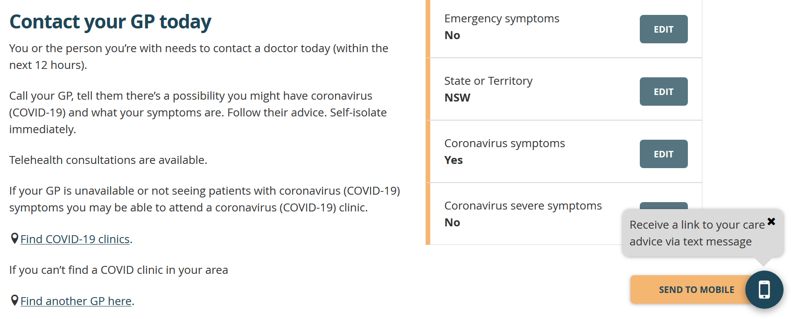

Table 2: Intention enhanced (example of selecting key barriers to getting tested in yellow)
COM-B driver of behaviour | Are you worried about any of these issues? (pick top 3) | Government information to be enhanced using SHLL editor in Study 1 (Figure 4) and image (Figure 6)
Physical capability | I can’t drive to access a testing centre  I require ramp access to the testing centre  My past trauma or disability means I can’t get a swab | You only need one symptom to get tested, and it can be mild. If you have a symptom, don’t delay, please get tested and self-isolate straight away.  Testing is free at public testing clinics, even if you’re from overseas. Testing is also free at private testing sites, however, as a referral is required, the General Practitioner (GP) may charge a fee for the initial consultation, and then again to receive the result from the GP.  Yes, it’s safe to get tested. All medical staff wear protective gear and there’ll be a safe place to wait.
Psychological capability | I’m not sure if my symptoms are bad enough  I’m not sure if this symptom needs testing  I’m not sure how to get tested
Physical opportunity | I can’t access my GP to get a referral  I don’t have childcare  I can’t miss work
Social opportunity | I’m worried what other people will think  No one else is getting tested  I don’t want to cancel my social plans
Reflective motivation | I don’t think I have COVID  I’m worried I’ll catch COVID  I don’t want to get tested if it’s painful
Automatic motivation | I’ll forget to get tested  I usually go to work even if I have a cold  I usually go out even if I have a cold

Figure 6: Intention enhanced (image to increase salience)
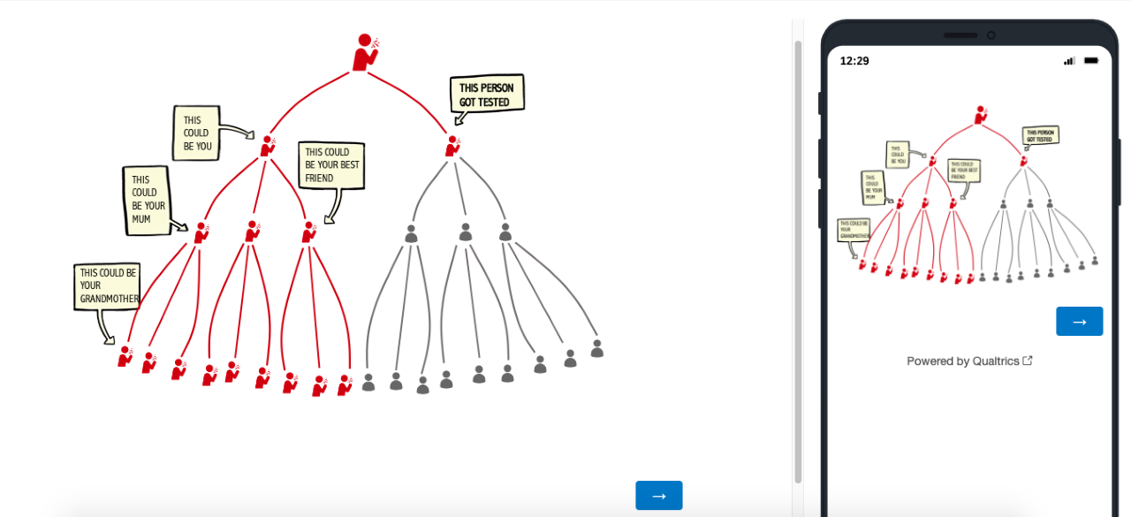

Table 3: Behaviour enhanced (example of selecting if-then action plan options in yellow)

COM-B driver of behaviour | If I… (pick 1) | Then I will… (pick 1)
Physical capability | cant drive to the testing centre  can’t get a swab | Get practical help (self efficacy):  ask someone to come with me to help (housemate/family member/friend)  use the Healthdirect symptom checker at www.  Check the current list of test centres at www.  Talk to my supervisor about how to rearrange work  ask my doctor about non-swab testing options  remind myself it is a very quick process  bring a mask and hand sanitiser  Remind myself about the risk (risk perception):  COVID-19 might not seem serious to me, but it could be for others (older people, and people with other medical conditions)  COVID-19 is much deadlier than the flu  COVID-19 spreads more easily than the flu  even if I don’t go to hospital with COVID-19 there might be long-term complications  even young healthy people have died of COVID-19  Remind myself about the benefits of testing (outcome expectancies):  getting tested helps to protect my community  getting tested helps protect my family and friends  getting tested keeps my workplace safe  testing is one of the main ways of keeping COVID-19 numbers low  getting tested will help life get back to normal more quickly  businesses, cafes, gyms and places of worship can only stay open if we all get tested when we have symptoms  most people in my community support COVID-19 prevention measures  my test could help warn others if they need to get tested (if we both went to the same place)  Remind myself about the consequences if I don’t get tested (outcome expectancies):  my workplace/community might be reported in the news if I spread it  my workplace might close for ‘deep cleaning’ if I spread it  places I visit might close for ‘deep cleaning’ if I spread it  I/someone I see might get very sick if I spread it  I/someone I see could die if I spread it
Psychological capability | don’t know if my symptoms need testing  don’t know where to get tested
Physical opportunity | don’t want to take time off work  feel like I don’t have time to get tested
Social opportunity | am worried that people will judge me for getting tested  am worried that people will judge me if I test positive  don’t want to cancel my social plans
Reflective motivation | don’t think I have COVID-19  am worried about catching COVID at the testing centre  am worried about catching COVID on my way to the testing centre  am worried about spreading COVID on my way to the testing centre
Automatic motivation | usually go out with a cold  am scared about the testing process

Figure 7. Behaviour enhanced in Study 1 (example action plan, based on our previous intervention trial – see reference⁸)
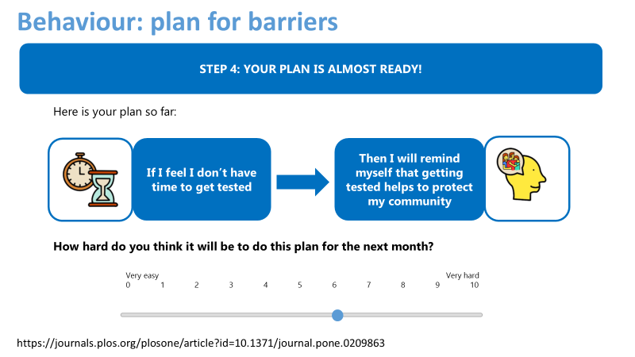

REFERENCES

1. Grundy E, Mangiarulo M, Slattery P. SCRUB COVID-19 Survey Wave 7: How the health and compliance of Australians is changing over time - BehaviourWorks Australia. Behaviour Works Australia. https://www.behaviourworksaustralia.org/scrub-covid-19-survey-wave-7-how-the-health-and-compliance-of-australians-is-changing-over-time/. Published September 2, 2020. Accessed September 22, 2020.
2. Australia Reports | Flutracking.net. FluTracking. https://info.flutracking.net/reports-2/australia-reports/. Accessed September 22, 2020.
3. Bonner C, Batcup C, Ayre J, et al. Behavioural barriers to COVID-19 testing in Australia [Preprint]. medRxiv, Prepr Serv Heal Sci. September 2020. doi:10.1101/2020.09.24.20201236
4. Michie S, van Stralen MM, West R. The behaviour change wheel: A new method for characterising and designing behaviour change interventions. Implement Sci. 2011;6(1):42. doi:10.1186/1748-5908-6-42
5. McCaffery K, Dodd R, Cvejic E, et al. Disparities in COVID-19 related knowledge, attitudes, beliefs and behaviours by health literacy. Public Heal Res Pract. 2020;30(4):30342012. doi:https://doi.org/10.17061/phrp30342012
6. Pickles K, Cvejic E, Nickel B, et al. COVID-19: Beliefs in misinformation in the Australian community. medRxiv Prepr Serv Heal Sci. August 2020:2020.08.04.20168583. https://www.medrxiv.org/content/10.1101/2020.08.04.20168583v1. Accessed September 8, 2020.
7. West R, Michie S, Rubin GJ, Amlôt R. Applying principles of behaviour change to reduce SARS-CoV-2 transmission. Nat Hum Behav. 2020;4(5):451-459. doi:10.1038/s41562-020-0887-9
8. Ayre J, Bonner C, Cvejic E, Mccaffery K. Randomized trial of planning tools to reduce unhealthy snacking: Implications for health literacy. PLoS One. 2019;14(1):e0209863. doi:10.1371/journal.pone.0209863

