

**College of Health**

**Protocol Document**

*Applicant name:* Dr David Rowlands

*Title of proposal*: Effect of Carbohydrate Energy Replacement on Glycaemic Control Following High-Intensity Interval Training. Does Lactose Improve Glycaemic Control in Comparison to Sucrose?

**RESEARCH DESIGN**

# methods. planning & timeline

**Methods**

***Participants.*** A sample size of 18 untrained, lactose tolerant males and females (VO2max ≤ 43.9 ml·kg·min-1) was estimated using a previously outlined effect size, which calculates the difference of the subsequent days postprandial glucose area under the curve following continuous exercise of moderate intensity with or without post-exercise carbohydrate replenishment [1]. To detect a significant difference (*p*≤0.05) between conditions with 80% power, it was calculated that *n*=18 was required. Participants will conduct these trials one month apart to ensure a satisfactory washout period between exercise trials (lactose and sucrose) to reduce the training effect which could occur on glycaemic response. Participants and researchers involved in face-to-face procedures will be required to be non-symptomatic to COVID-19 or other colds or flus. If participants or researchers have tested positive for COVID-19 or are unwell, they will be excluded and participation postponed until a later date when well again, which is also normal practice outside of current pandemic conditions

***Setting and Location.***  Research will be conducted within the exercise science laboratory at Massey University, Albany, Auckland.

***Design***. The design will be a double-blind, block randomized (Williams design), cross over design (lactose, sucrose, placebo) conducted over 3 months per participant, comprising of 3 trials and 10 visits to the laboratory. This consists of three 2-day trials per participant, 1 day baseline testing one week prior to experimental trials and insertion of continuous glucose monitor the day before each trial begins (Figure 1).

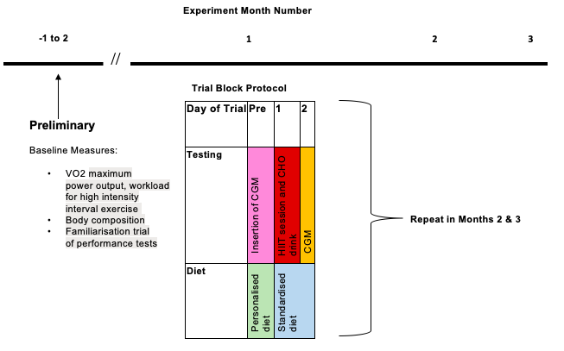

**Figure 1.** Research design and partition of exercise intervention and diet standardization.

Initial meeting, study explanation and screening for inclusion/exclusion criteria will be provided by a telephone or online consultation. Participants will be able to ask any questions and have the questions answered. If parties are happy, participants will be invited to sign the consent form. Following which, participants will be asked to complete the health screening questionnaire. If no health issues are revealed, then a date and time for the Visit 1 will be arranged.

Visit 1, 1. Study introduction, discussion, questions, consent. Laboratory and cycle ergometer familiarization with a short 3-5 min low intensity ride after bike fit.

Visit 2, will consist of body composition measurements in order to determine body mass and body fat percentage as well as, VO2max/Wmax test and familiarization trial of the performance test. During all exercise sessions, participants will breathe through an on-line gas analysis facemask that covers the mouth and nose, and is attached to a 0.2 micro filter system, which filters virus. At other times, participant will need to comply with the University requirements for COVID, at the time.

Visit 3, will be conducted at the laboratory either between 48 or 24 hours before experimental trials at 17:00h 2 days or ~9:00h the day prior to Trial Day 1 continuous glucose monitor (CGM) (Dexcom) will be inserted into the subcutaneous tissue of the abdomen. A standardized diet will be provided to participants to consume over the following 2-day metabolic trial.

Visit 4, Day 1 of the metabolic trial, under free living conditions participants will consume a standardized mixed-macronutrient meal at standarised times; 9:00hr (breakfast), 12:00hr (lunch) and 15:00hr (snack).

Participants will report to the laboratory at 17:00hr, whereby they will perform a supervised session of high intensity interval exercise (10x1-min cycle intervals at 80% maximal power); if there are multiple participants tested per day, start and meals times will be staggered + or – 30 min. Post-exercise (10 min), the test drink or placebo will be ingested. The lactose and sucrose will be consumed from an artificially-flavoured 500-ml beverage (lemonade flavour) at a quantity equivalent to the exercise-induced energy expenditure (aerobic metabolism) determined from a regression equation of oxygen consumption to bike power output established during the VO2max test on Visit 2. The control (no sugar) condition will comprise a taste-matched non-caloric placebo beverage, with the exercise calories added as fat to the evening meal (see LCHF). After exercise and drink ingestion, participants will shower (if desired) and rest seated in the laboratory prior to consuming a low-carbohydrate high-fat (LCHF) dinner meal at 19:00hr. Participants will then leave the laboratory at 20:00hr, under instructions to abstain from consuming any food or drink other than water for the rest of the evening. On Day 2 of the metabolic trial, the participants will consume standardised meals at the given times; 7:00hr, 10:00hr, 13:00hr and 18:00hr. Breakfast at 7:00hr, will be a high glucose meal consisting of 75g of glucose in the form of white bread, butter and jam. The remaining meals will be mixed macronutrient meals following the same macronutrient split as day 1. Some of the study meals will contain animal products (meat, dairy) are not suitable if you are following a vegetarian or vegan diet.

Blood glucose will be monitored via GCM with special note to post-prandial responses to all meals throughout day 2.

***Protocols***. Exercise tests will be conducted using the electronically braked cycle ergometers (VeloTron, Racer Mate, Seattle, WA) and gas analysis using a calibrated Moxus MaxII Metabolic System (AEI Technologies, Naperville, IL).

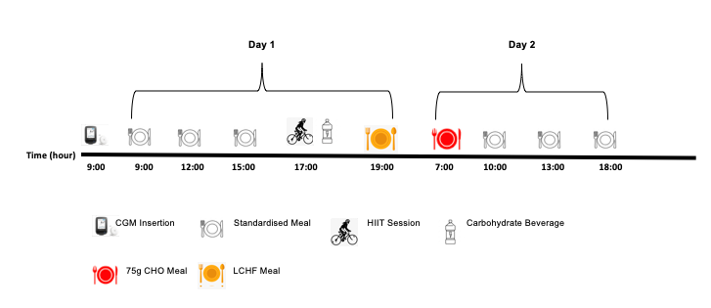

**Figure 2.** Metabolic test protocol.

***Exercise Protocol.*** A 5 minute warm-up at 50 W will be completed before the participants complete 10x1-min sprint intervals at ~80% Wmax spaced between 1-min recovery intervals which will involve slow riding at 50W. The exercise will finished with a 5 minute cool down at 50 W [2]. The rating of perceived exertion (RPE) will be recorded after each 1 minute interval using the Borg Scale of RPE [3].

***Carbohydrate drinks.*** The drinks will comprise lactose or sucrose (Danisco, Manukau, NZ) added to half-diluted (water) artificially-sweetened and flavoured diet drink (Sprite). The placebo will be Sprite without any sugars added. The energy of the carbohydrate beverages will match the exercise-induced energy expenditure measured from the VO2-power regression established during the VO2max test.

***Standardised Diet.*** Each participant will receive the same food, the quantity will be relative to resting energy expenditure (REE). To individualise diets to each participant, daily energy intake is calculated by the Cunningham equation will be used (4), with energy from basal physical activity accounted for with 1.4*RRE (5). On day 1, 90% of daily energy was provided at main meals: 30% at each breakfast, lunch, and dinner and 10% of daily energy was a mid-afternoon snack. The macronutrient composition of the breakfast, lunch and snack meals will be followed; ~55% carbohydrate, ~30% fat and ~15% protein. All meals provided will be pre-packaged (e.g., yoghurt, muesli bars, pre-made meals etc) items purchased from local supermarkets.

The day 1 dinner will be consumed at 19:00h in the lab and is LCHF dinner, which consists of tuna, steamed veges, butter, almonds (~5/80/15% carbohydrate/fat/protein). All subsequent meals will be consumed under free-living conditions and will be pre-packaged mixed-macronutrient meals following the same macronutrient slit as day 1. Breakfast at 7:00h, which will be a high glucose meal consisting of 75g of glucose in the form of white bread, butter and jam. Participants will be asked to record the actual exact start time and food they ate/drank under free living conditions through diet recall sheets provided. Water and other non-caloric beverages will be allowed within a prescribed maximum quantity of caffeinated beverages of 3 per test day.

***Continuous Glucose Monitoring.*** To measure blood glucose levels, CGM will be used throughout each of the 2-day trials. GCM is a tool to identify glycaemic response to food and exercise outside of the laboratory setting (6). The sensors (dexcom) which record interstitial blood glucose concentration will be inserted into the upper arm 24 hours prior to the first meal of the trial to be consumed. Blood glucose information recorded on the sensor will be read through a transmitter and recorded through the dexcom clarity software.

***Statistical analysis.*** Treatment effects on outcomes will be estimated with mixed models in SAS. All data except psychometric will be log-transformed prior to analysis. Fixed effects will be treatment, period and sequence accounting for familiarization, adaptation, or fatigue effects between consecutive trials and the order of exposure. For repeated-measures data, the x-axis variable will be centered for linear modeling. GCM data will be adjusted for the Day 1 prior to exercise glycaemic response, as a baseline covariate.

**Planning, Timeline, Milestones, and Personnel Involvement**

Student, staff, and budget planning are complete and represented in the Gantt chart below. The applicant and Drs Wendy O’Brien and Claire Badenhorst will supervise and assist Miss Rose Stirling, Master student.



**Contributions of Researchers**

|  |  |
| --- | --- |
| Researcher | Contribution |
| Rose Stirling – MSc Nutrition and Dietetics Student | Thesis primary author, HDEC ethics application data collection, data analysis, write up. |
| Dr David Rowlands | Supervision throughout entire research process, MURF funding application, HDEC ethics application, assistance with data collection, write up. |
| Dr Claire Badenhorst | Supervision throughout the research process and assistance with data collection, write up. |
| Dr Wendy O’Brien | Supervision throughout the research process and assistance with data collection, write up. |

**Adverse Events Management**

If an adverse reaction were to occur we would record any adverse event if it was to occur with the participants data using into electronic spreadsheets and stored in a secure server and kept by the researchers indefinitely. All storage will comply with local and/or international data security guidelines. This will include; a summary of the event and the severity, time the event occurred and symptoms of the patient.

Each event will have a specific code this will allow easy inputting of the data as well as keeping a record of the rate in which each event occurs.

Adverse events that might occur during testing could include: a reaction to the preparation, fainting, exhaustion, dehydration, diarrhea, and vomiting.

If the participant were to react to the preparation, the participants symptoms will be monitored for the next 30 minutes to ensure that symptoms did not progress. If symptoms were to progress and a severe reaction was occurring then the participant would be taken to the urgent doctors or the emergency department (A&E) or 111 depending on severity.

If the participant were to vomit, we would get the participant a bucket and clean up the vomit if it missed the bucket. After the vomiting episode ended then the participant would be monitored for the next 30 minutes to ensure that all vomiting episodes ended and the participant felt fine to leave the laboratory.

If the participant were to faint, we would lie the participant in the recovery position to ensure that the participant was safe until wakening. The participant would then be monitored for the next 30 minutes with food and drink provided to ensure that they were in a fit state to leave.

If the participant were to feel exhausted, the participant would be offered food and water. Energy levels would be monitored for the next 30 minutes to ensure that they were in a fit state to leave.

If the participant were to be dehydrated, they would be provided with water and electrolytes. After consuming they would be monitored for the next 30 minutes to ensure that they were in a fit state to leave.

An adverse event which could occur due to our findings is gastrointestinal distress due to consuming lactose products whilst exercising. This may cause stomach cramps, nausea, vomiting and loose bowels.

Other unpredicted adverse events will be managed using first aid procedures. All researchers will have current first aid certificate.

**References**

1. Taylor, H. L., Wu, C. L., Chen, Y. C., Wang, P. G., Gonzalez, J. T., & Betts, J. A. (2018). Post-exercise carbohydrate-energy replacement attenuates insulin sensitivity and glucose tolerance the following morning in healthy adults. *Nutrients*, *10*(2), 123

2. Gillen, J. B., Percival, M. E., Ludzki, A., & Tarnopolsky, M. a., & Gibala, MJ (2013). Interval training in the fed or fasted state improves body composition and muscle oxidative capacity in overweight women

3. Borg, G. A. (1982). Psychological bases of physical exertion. *Med Sci Sports Exerc*, *14*(5), 377-81

4. Harris, J. A., & Benedict, F. G. (1918). A biometric study of human basal metabolism. Proceedings of the National Academy of Sciences of the United States of America, 4(12), 370

5. Dietitians New Zealand Clinical Handbook 2016 Eleventh Edition. (1988)

6. Nardacci, E. A., Bode, B. W., & Hirsch, I. B. (2010). Individualizing Care for the Many. *The Diabetes educator*, *36*(1_suppl), 4S-19S