Title: Improving self-management for people with chronic kidney disease through a patient activation approach: A cross-sectional survey protocol

Investigator details

- Ms Laura Lunardi
Nephrology Nurse Practitioner
Speciality Medicine 1, Central Northern Adelaide Renal and Transplantation Service, Royal Adelaide Hospital
Email: laura.lunardi@sa.gov.au
Role: Principal Investigator (PI) Laura Lunardi will have complete oversight of the project; she will lead the research team and will be responsible for the delivery of the completed project.

- Anne Britton
Central Northern Adelaide Renal & Transplantation Service
CALHN
Email: anne.britton@unisa.edu.au
Role: Associate Investigator (AI) Anne Britton, as clinical practice coordinator, support the implementation of nurse-led questionnaires of the project across the service, essential for nursing staff allocation to the project for back-fill of nurse time.

- Dr Richard Le Leu
Central Northern Adelaide Renal & Transplantation Service
CALHN
Email: Richard.Leleu@unisa.edu.au
Role: AI Richard Le Leu, as coordinator of the CNARTS Clinical Research Group, will provide project oversight, manage ethics and governance approvals, and provide administrative support. He will also contribute to progress meetings, study design, data analysis and reporting.

- Monique Borlace
Central Northern Adelaide Renal & Transplantation Service
Central Adelaide Local Health Network (CALHN)
Email: Monique.borlace@unisa.edu.au
Role: AI Monique Borlace as Nephrology Nurse Practitioner will be involved in patient screening/recruitment as well as contributing to the study design, analysis and reporting.

- Dr Andie Xu
University of South Australia
Email: Andie.Xu@unisa.edu.au
Telephone: (08) 83022531
Role: AI Andie Xu will contribute to study design, analysis and reporting.

- A/Prof Paul Bennett
University of South Australia
Email: Paul.Bennett@unisa.edu.au
Telephone: (08) 83022662
Role: AI Paul Bennett will contribute to study design, analysis and reporting and provide supervision and support to the PI implementing the study.

- A/Prof Shilpa Jesudason
Central Northern Adelaide Renal & Transplantation Service
Central Adelaide Local Health Network (CALHN)
Email: Shilpa.Jesudason@unisa.edu.au
Role: AI Shilpa Jesudason will contribute to study design, analysis and reporting of results

Abstract

Background: Globally, chronic kidney disease (CKD) is a leading cause of illness associated with high mortality, reduced quality of life and an important driver of health system utilisation and spending. The chronicity of this disease necessitates that individual actively self-manage to maximise health outcomes. CKD people require the knowledge, confidence, and skills to self-manage their health. This is referred to as patient activation. A better understanding of patient activation in CKD may contribute to improved patient activation and self-management.
Aim: To identify the current status of patient activation levels in people with CKD stage 5 and its association with patient sociodemographic characteristics and other health-related clinical variables.
Methods/design: We will use a prospective cross-sectional design to measure patient activation in 280 adults with CKD stage 5 not receiving dialysis over a 9-month period in a large Australian’s renal service using the 13 item Patient Activation Measure (PAM-13) validated instrument. We will determine any associations with sociodemographic variables, immunization and medication adherence unattended renal appointments and hospitalization. Responses from participants and data extracted from medical records will be examined using univariate analysis, independent sample t-tests, Mann-Whitney tests, linear regression and generalized linear modelling where appropriate.
Results: There are no presentation of results in this protocol presentation.
Discussion: This study will serve as a platform for developing further studies to investigate components that work to increase patient engagement in positive health behaviours for an active role in self-manage their CKD and decision-making to negotiate their treatment to maximise health outcomes.

Funding secured
This study has funding secured by the RAH Research Committee - 2022 RRC Allied Health, Pharmacy and Nursing Clinical Research Grant. MYIP: 15816. Total Grant Funding Value for 12 months ($35,000) PI Laura Lunardi.

Background

Chronic kidney disease (CKD) affects over 500 million people and accounts for approximately 850 million deaths every year world-wide.⁽¹⁾ In Australia, one in three Australians are at an increased risk of developing CKD.⁽²⁾ When CKD progresses to advanced stages it is associated with debilitating symptoms, increased morbidity and mortality, and reduced quality of life.^{(3, 4)} When people reach the most advanced CKD stage, they require renal replacement therapy (RRT-dialysis or transplantation) to reduce symptoms and sustain life.

There is increasing recognition of the potential benefits associated with empowering people with CKD to self-manage their own health to reduce modifiable risk factors and slow disease progression.⁽⁵⁾ This ultimately reduces unnecessary health care utilization costs and poor health outcomes, largely from the failure of patients to effectively self-manage their CKD in response to medical recommendations.^{(6, 7)}

An important antecedent to self-management is patient activation; it refers to the skills, knowledge and confidence that relate to the willingness and ability of a person to manage their own health.⁽⁸⁾ In 2004, the Patient Activation Measure (PAM) instrument, consisting of a 13-items (PAM-13) questionnaire, was developed and psychometrically validated to measures a person’s level of activation.⁽⁸⁾ The relationship between patient activation and improvement of health outcomes has been established in chronic conditions such as diabetes ⁽⁹⁻¹¹⁾, heart failure⁽¹¹⁾, end stage kidney disease (ESKD) in patients undergoing haemodialysis ⁽¹²⁾ and chronic obstructive pulmonary disease ^{(11, 13)}. However, there are limited studies measuring patient activation in the CKD pre-dialysis population.

Patients with higher level of patient activation are more likely to participate in self-management behaviours, have less unmet medical care needs and greater support from health professionals for self-management of chronic conditions.^{(8, 14)} Conversely, individuals with lower level of activation are more likely to be hospitalised, have poorer adherence to treatment, greater health-costs⁽¹⁵⁾ and have worse care experiences compared to those with higher activation level.^{(16, 17)}

Patients with CKD are intensive and persistent users of health care services due to their complex health conditions.⁽¹⁸⁾ The success of treatments has historically been assessed using measures considered necessary by the health professionals delivering care as part of their regular practice. However, these measures do not always capture many other outcomes that are of great importance to patients, such as readiness to engage in their care and symptom burden. Collecting patient-reported measures have great potential value in health care providing support for: (1) shared decision making about the choice of renal treatment modalities (haemodialysis, peritoneal dialysis, kidney transplantation or conservative management); and (2) participation in self-management to improve health outcomes. Patients with advanced CKD, even more those undergoing dialysis (especially those receiving home dialysis), require a self-management burden that is unseen in any other patient cohort. Therefore, the CKD population chosen for this study is ideal for studying the feasibility of collecting measures and evaluating the potential benefits in preparation for dialysis initiation.

A Kidney Care Program introduced in 2020 at Central Northern Adelaide Renal and Transplantation Service (CNARTS), is a multidisciplinary renal model of care for patients with CKD stages 4-5 not receiving dialysis. Renal patients are referred to this program by CNARTS nephrologists and renal registrars only. This program, led by two CKD Nurses Consultant and three Nurse Practitioners working collaboratively with the patient’s nephrologist and the multidisciplinary renal team, has the aim to improve patient’s renal journey providing a single point of contact for the patient at any point of their advanced CKD in the transition to dialysis and transplantation. Hence, the CKD population followed by the Kidney Care Program is ideal for capturing patient-reported measures, such as patient activation, which has never been measured at CNARTS before.
We seek to measure the patients’ level of knowledge, skill, and confidence using PAM-13 in patients with CKD stage 5 not receiving dialysis and examine the potential association between with patient activation level and patient demographic and clinical characteristics, adherence to treatment and health care utilization in our cohort of in CNARTS population.

Anticipated start and finish dates

The anticipated start date is 1st July 2022. Finish date for the evaluation of this study is 30 June 2023

Purpose

Aims & objectives

This study aims to identify:

- the current status of patient activation levels in people with CKD stage 5 referred to the Kidney Care Program who manage patients on a dialysis or conservative care pathway
- measure the association between patient activation and patient sociodemographic characteristics, clinical variables, treatment adherence and emergency visits/hospital admission rate.

Study design

We will conduct a pragmatic prospective cohort study of people with CKD receiving care by the Kidney Care Program.

Figure 1: Study schema
Study Population
- CKD Stage 5 (Stage 5 = eGFR below 15 ml/min/1.73 m² )
- Age >18
- Referred to the KCP

- Demographic and health-related variables will be collected from patients & electronic medical records

- Participant surveys: PAM-13 & Morisky Medication Adherence Scale (MMAS)

data collection

Outcome measures
Primary outcome:
Patient activation level – PAM-13
Predictor variables:
- Sociodemographic variables
- Treatment adherence to:
- recommended immunization
- MMAS
- Treatment non-adherence: sum of all outpatients’ renal appointments unattended in the last 12 months
- Emergency visits and hospitalization admission rate over the last 12 months

Participants

Inclusion criteria:
- CKD stage 5, also called End Stage Kidney Disease
  - Stage 5 = eGFR below 15 ml/min/1.73 m²
- Aged ≥18
- Referred to the Kidney Care Program (new and existing)

Exclusion criteria:
- Unable to provide informed consent and/or participate in the study
- Patients admitted in hospital
- Kidney transplanted patients
- Patients undergoing dialysis

Sample size

It is calculated from the KCP database that there are over 350 patients with CKD stage 5. We intend to invite all patients under the KCP to participate in this study. We anticipate approximately 10-20% based on patients’ refusal to participate; therefore, our predicted sample size will be between 280-315.

Recruitment and informed consent

All patients who meet the inclusion criteria will be approached by the KCP nurse involved in the patient’s care. Potential participants will be approached:

(1) in-person when they attend the renal appointments at CNARTS outpatient settings (RAH, QEH, Hampstead & LMH) to provide information of the study and invite to participate. The nurse will provide the potential participant with the Participant Information and Consent Form (PICF) with details of the study and sufficient time to read this form and ask questions. If the individual accepts to participate, the patient will be asked to sign the Consent Form prior to commencing in the study.
(2) via telehealth or telephone: detailed information of the study will be provided. If the individual accepts to participate, the Remote Informed Consent Confirmation Form (Form RC) will be verbally consented prior or after the participant review of the PICF that will be forwarded to the participant via email or via post. The participant must be given sufficient time to read PICF and ask questions.

Participants will be informed that they are free to decide not to participate, and to withdraw from the study at any time. Participants will be informed that their decision will not in any way affect their current or future care by their treating renal team. The participant will have LL (principal investigator) contact details to contact if a question arises.

Outcome measure

Primary outcome variable
- Patient activation level using PAM-13
Predictor variables:
- Sociodemographic variables: age, gender, marital status, ethnicity (using the Australian New Zealand Data Registry (ANZDATA) definition), residence location (metro or rural based on person’s residential postcode), home supported living, level of education and socio-economic status. (Data will be collected from patients and the electronic medical records (EMR)) (Appendix 1)
- Treatment adherence to:
  - recommended immunization (COVID vaccine and flu vaccine) (data from EMR or asked to participants)
  - medication adherence questionnaire using the 8-item self-reported Morisky Medication Adherence Scale (MMAS).⁽¹⁹⁾
      - treatment non-adherence: sum of all missed number of renal outpatients’ appointments in the last 12 months (data from EMR), and cause of the missed appointment as reported in the EMR.
- Emergency visits and hospitalization admission rate over the last 12 months (data from EMR)

Data Instruments:

- 13-point PAM-13⁽⁸⁾ is a validated 13-questionnaire scored against a Guttman scale (1 = disagree strongly, 2 = disagree, 3 = agree, 4 = agree strongly and 5 = not applicable). The scores for this tool are then converted from the continuous Rasch item response theory logit scale to an overall activation score between 0–100 by Insignia Health. Scores are transformed to a scale from 0 to 100: Level 1 (0.0–47.0) low activation suggesting that the person does not yet understand their role in healthcare; Level 2 (47.1–55.1) indicating that the person does not yet have the knowledge and confidence to take action; Level 3 (55.2–72.4) indicating that the person is beginning to engage in positive health behaviours; Level 4 (72.5–100) indicating that the person is proactive and engaged in recommended health behaviours. (Appendix 2)

- 8-point MMAS-8⁽¹⁹⁾ will be used to assess adherence to medication. This scale consists of seven items with binary response and one item with Likert scale response. Cumulative score based on 8 items were used to obtain final adherence score ranging from 0 to 8. Adherence was defined accordingly as low (score 0-5), medium (score 6-7) and high (score 8). MMAS-8 scale had been validated in studies with good reliability and predictive value. (Appendix 3)

Data collection

Survey responses, demographic, clinical and outcome data will be extracted by local investigators from participants and electronic medical records in paper and then into a pre-developed SA Health-based REDCap program. All data will be de-identified in REDCap before being analysed by local investigators (LL, MB, RL and a research assistance to recruit).

Analysis of results

The statistical analysis and reporting of results will be coordinated by AX. AX is a current candidate for Masters in Biostatistics with Biostatistics Consortium Australia.

Analysis for research aim 1
The transformed patient activation score will be generated according to the scoring protocol of PAM-13. The transformed score ranges from 0 to 100. Patients with transformed score of less than or equal to $55.1$ are classified as having low activation. The proportion of CKD patients assessed having low activation will be calculated.

Analysis for research aim 2.
Relationship between sociodemographic factors and PAM
Socio-economic status will be calculated using the 2016 Australian Bureau of Statistics data; Postcodes will be classified in accordance with the Index of Relative Social Disadvantage (IRSD), an index that provides a summary on a variety of data about the socio- economic conditions of people living in an area.
Appropriate univariate analysis will be performed to explore the relationship between each sociodemographic factor and patient activation level. Contingency table will be used for testing relationship between two categorical variables; independent sample t-test (or Mann-Whitney test as the corresponding non-parametric test) will be used in the combination of continuous and categorical variables.

Relationship between PAM and medication adherence
Linear regression will be used to examine the relationship between patient activation and medication adherence level. Modified Morisky score will be the outcome variable, and PAM-13 score the predictor variable. Assumptions of linear regression including constant variance, normality of the Modified Morisky score, and linearity between PAM and medication adherence will be checked.

Relationship between PAM and treatment adherence; PAM and ED visits.
Generalized linear model will be used to model the relationship between 1) PAM and treatment non-adherence; and 2) PAM and yearly hospital visits. The number of treatment non-adherence, and the number of hospital visits are both count data. Accordingly, in implementing the generalized linear model, a link function suitable for count data, such as negative binomial distribution, will be selected.
The ultimate choice of link function will be informed by the assessment of the distribution of the number of treatment nonadherence, and the number of hospital visits within the sample.

Table 1 - STUDY TIMELINE

Timeline  2022/2023 | Feb to June | July | Aug | Sept | Oct | Nov | Dec | Jan | Feb | March | April | May | Jun
Protocol sent to ethics | X
Recruitment/  informed consent |  | X | X | X | X | X | X | X | X | X
Data collection & Surveys (PAM-13/ MMAS-8) |  | X | X | X | X | X | X | X | X | X
Analysis of results |  |  |  |  |  |  |  |  |  |  | X | X
Paper/ Report write up |  |  |  |  |  |  |  |  |  |  |  | X | X

Confidentiality, data storage and security

Identified participant data will be collected in paper first and the transferred into REDCap database which is only accessible on SA Servers and is password protected. In REDCap data will be de-identified and participants will be assigned unique codes; they will be re-identifiable only by this project investigators to allow collection of follow-up data. Only the project investigators will have access to the information. Data will be kept for five years and then destroyed.

Publication

The results of this study will be reported by:
- Presentation to CNARTS Clinical research Group
- Presentation to consumer and participants through consumer forums
- Presentation at national and international renal conferences and meetings
- Submission for publication to peer reviewed renal journals
- Incorporation into design of future intervention trials

Ethical considerations

This project will be carried out according to the National Statement on Ethical Conduct in Human Research (2007), incorporating all updates.

Benefits of the study

This novel project will substantially advance the limited evidence in identifying and measuring renal patients’ knowledge, skill, and confidence (patient activation) and contribute to the evidence-based regarding systematic identification of CKD population with low activation level.

Although self-management approaches require upfront education and motivation efforts by health professionals, these efforts can be prioritized for patients with low activation level. Furthermore, these efforts will be rewarded with the increased ownership of care required to reduce the burden in the transition to dialysis initiation, improve treatment adherence, reduce hospital admissions rate, and ultimately costs downstream in the CNARTS CKD population.

The integration of patient activation measures into regular clinical practice could significatively improve renal patient care but could also be highly transferrable to other renal services and other chronic disease conditions. This study is the platform for further investigation of components that increase engagement in positive health behaviours for a more active role in self-management. Therefore, integrating patient activation measures into the regular clinical practice in advanced CKD population could make CNARTS a nationally and internationally leader in this field.

Risk mitigation

The only mitigation risk is that some data may have not been capture in the EMR. Otherwise, we do not anticipate any other risks for the participants, researchers, or local community.

Conflict of interest

There are no conflicts of interest to declare.

References

1. Silva RARd, Souza VLd, Oliveira GJNd, Silva BCOd, Rocha CCT, Holanda JRR. Coping strategies used by chronic renal failure patients on hemodialysis. Escola Anna Nery revista de enfermagem. 2016;20(1).
2. Australia KH. Chronic Kidney Disease (CKD) Management in Primary Care 2020 [
3. Stenvinkel P, Fouque D, Wanner C. Life/2020—the future of kidney disease. Nephrology Dialysis Transplantation. 2020;35(Suppl 2):ii1-ii3.
4. Levin A, Tonelli M, Bonventre J, Coresh J, Donner JA, Fogo AB, et al. Global kidney health 2017 and beyond: a roadmap for closing gaps in care, research, and policy. Lancet (London, England). 2017;390(10105):1888-917.
5. Welch JL, Johnson M, Zimmerman L, Russell CL, Perkins SM, Decker BS. Self-management interventions in stages 1 to 4 chronic kidney disease: an integrative review. Western journal of nursing research. 2015;37(5):652-78.
6. Chen SH, Tsai YF, Sun CY, Wu IW, Lee CC, Wu MS. The impact of self-management support on the progression of chronic kidney disease - A prospective randomized controlled trial. Nephrology Dialysis Transplantation. 2011;26(11):3560-6.
7. Novak M, Costantini L, Schneider S, Beanlands H. Approaches to self-management in chronic illness. Semin Dial. 2013;26(2):188-94.
8. Hibbard JH, Stockard J, Mahoney ER, Tusler M. Development of the Patient Activation Measure (PAM): conceptualizing and measuring activation in patients and consumers. Health Serv Res. 2004;39(4 Pt 1):1005-26.
9. Zimbudzi E, Lo C, Ranasinha S, Kerr PG, Polkinghorne KR, Teede H, et al. The association between patient activation and self‐care practices: A cross‐sectional study of an Australian population with comorbid diabetes and chronic kidney disease. Health Expectations. 2017;20(6):1375-84.
10. Begum N, Donald M, Ozolins IZ, Dower J. Hospital admissions, emergency department utilisation and patient activation for self-management among people with diabetes. Diabetes Research and Clinical Practice. 2011;93(2):260-7.
11. Bos-Touwen ID, Schuurmans M, Monninkhof EM, Korpershoek Y, Spruit-Bentvelzen L, Ertugrul-van der Graaf I, et al. Patient and disease characteristics associated with activation for self-management in patients with diabetes, chronic obstructive pulmonary disease, chronic heart failure and chronic renal disease. PLoS One. 2015;10(5):e0126400.
12. Van Bulck L, Claes K, Dierickx K, Hellemans A, Jamar S, Smets S, et al. Patient and treatment characteristics associated with patient activation in patients undergoing hemodialysis: a cross-sectional study. BMC Nephrol. 2018;19(1):126.
13. Blakemore A, Hann M, Howells K, Panagioti M, Sidaway M, Reeves D, et al. Patient activation in older people with long-term conditions and multimorbidity: correlates and change in a cohort study in the United Kingdom. BMC Health Services Research. 2016;16(1):582.
14. Bonner A, Havas K, Douglas C, Thepha T, Bennett P, Clark R. Self-management programmes in stages 1-4 chronic kidney disease: a literature review. J Ren Care. 2014;40(3):194-204.
15. Johnson ML, Zimmerman L, Welch JL, Hertzog M, Pozehl B, Plumb T. Patient activation with knowledge, self-management and confidence in chronic kidney disease. J Ren Care. 2016;42(1):15-22.
16. Hibbard JH, Greene J, Overton V. Patients with lower activation associated with higher costs; delivery systems should know their patients' 'scores',. Health Aff (Millwood). 2013;32(2):216-22.
17. Zimbudzi E, Lo C, Misso ML, Ranasinha S, Kerr PG, Teede HJ, et al. Effectiveness of self-management support interventions for people with comorbid diabetes and chronic kidney disease: a systematic review and meta-analysis. Syst Rev. 2018;7(1):84.
18. Hussein WF, Bennett PN, Abra G, Watson E, Schiller B. Integrating patient activation into dialysis care. American Journal of Kidney Diseases. 2021.
19. Okoro RN, Ummate I, Ohieku JD, Yakubu SI, Adibe MO, Okonta MJ. Evaluation of medication adherence and predictors of sub-optimal adherence among pre-dialysis patients with chronic kidney disease. Medicine Access @ Point of Care. 2020;4:239920262095408.

Attachments

- Participant Information Data collection sheet
- Survey Tools: PAM-13 & MMAS
- Recruitment Flyer
- Participant Information and Consent Form (PICF) and Remote Informed Consent Confirmation Form (Form RC)

Attachment 1 – PATIENT INFORMATION DATA COLLECTION SHEET

ID:
1)Gender  - Male  - Female | 2) Age
3) self-reported Ethnicity  - European or other  - Australian Aboriginal or Torrence Strait Islander  - New Zealand Maori or Pacifica  - Asian | 4) Residence location  - Central Adelaide  - Northern Adelaide  - Rural based
5) Formal education  - Year 8 or below  - Year 9-12  - Certificate, diploma, or bachelor  Postgraduate degree | 6) Relationship status  - Married  - De facto  - Separated  - Divorced  - Widowed  - Single
7) Care needs/assistance  - With others  - Alone | 8) Socio-economic status (SEIFA – disadvantage score) quintile based on residential postcode  - 1st quintile  - 2nd quintile  - 3rd quintile  - 4rd quintile  - 5th quintile
9) Renal Treatment Option pathway chosen  - Haemodialysis  - Home therapies  - Conservative Management  - Undecided | 10) Recommended immunization  COVID vaccine  - Completed 2 dose + booster  - Completed 2 doses  - Complete 1 dose  - Booked in  - Not yet booked in – specify the reason  Flu vaccine  - Complete dose  - Booked in  - Not yet booked in – specify the reason
11) PAM-13  - Score 0.0–47.0  - Score 47.1–55.1  - Score 55.2–72.4  - Score 72.5–100 | 11) MMAS (Medication adherence)  - Score 0-5  - Score 6-7  - Score 8
12) Number of renal outpatients’ appointments missed in the last 12 months (data from EMR) | 13) Number of Emergency visits in the last 12 months
14) Number of hospitalization admission rates over the last 12 months

Attachment 2 – SURVEYS TOOL

Patient Activation Measure -13
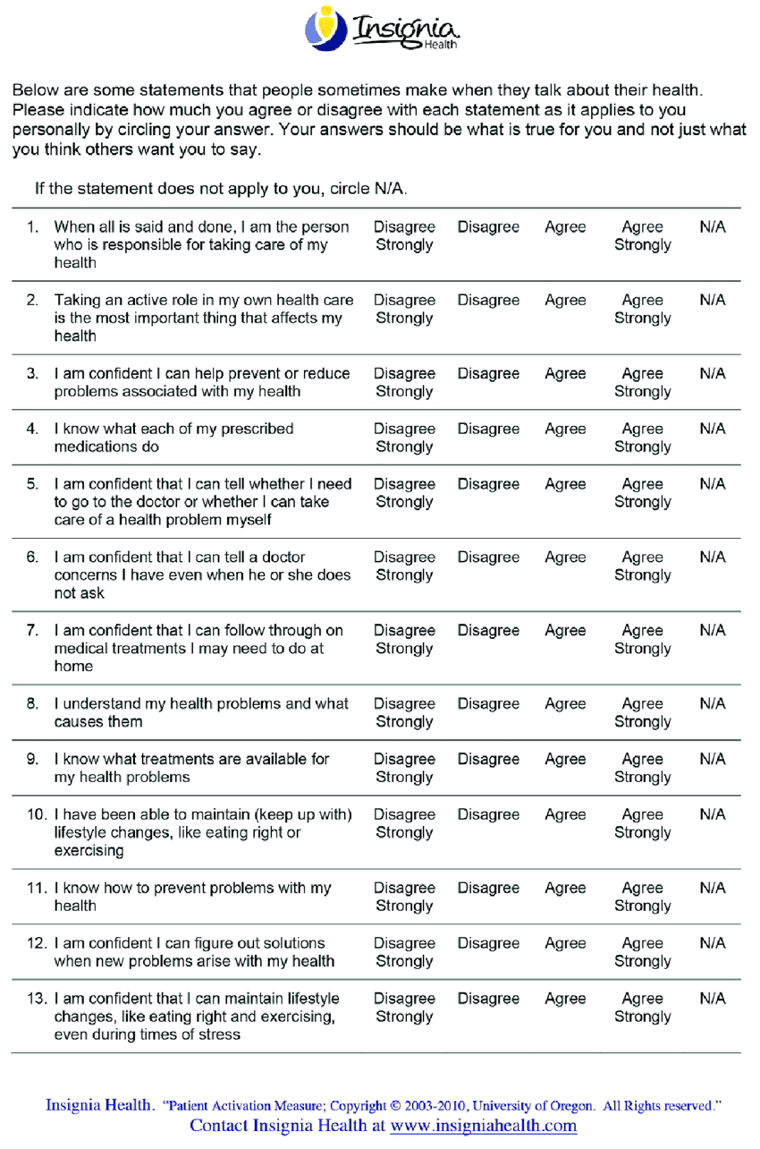

Morisky Medication Adherence Scale (MMAS)

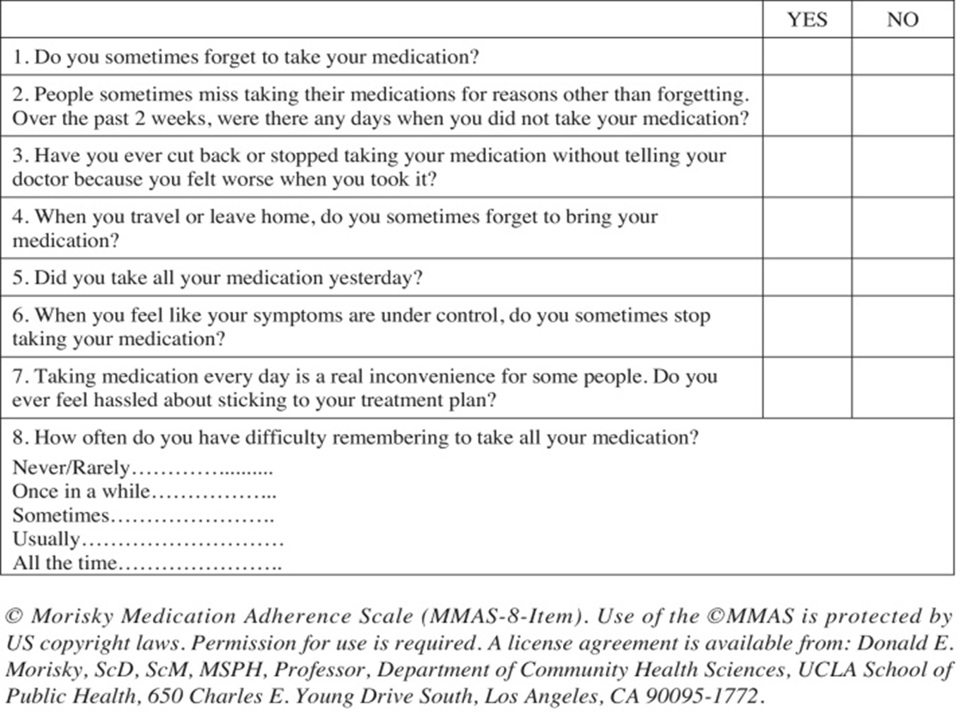

Attachment 3: RECRUITMENT FLYER

Attachment 4: PATIENT INFORMATION AND CONSENT FORM(PICF) AND REMOTE INFORMED CONSENT CONFIRMATION FORM (FORM RC)

