Protocols:

Ultrasound Scan Protocol:

The ultrasound machine will be set to a previously optimised “foot” pre-set for a consistent image setting across participants, with further optimisation of machine controls with regards to the participants individual acoustic characteristics. The participant will be seated erect on an electric plinth, with the bed raised to a comfortable height for the operator. The knee and hip of the participant will be placed at 90 degrees flexion, with the participants foot in a neutral position for the operator to scan. Bony landmarks will be palpated and marked with an erasable pen to ensure accurate, reproducible measurements are taken and to reduce measurement bias and operator dependence. This is to ensure the exact anatomical region is measured, as opposed to the widest or thickest aspect of the muscle.

For the Abductor Hallucis muscle, the medial sesamoid bone and navicular tuberosity will be marked and palpated. The probe will be placed longitudinally to the medial sesamoid bone, and the muscle will be tracked to the navicular tuberosity. Here, the operator will ensure the probe is perpendicular to the participants foot in contact with the region and turn the probe 90 degrees, where the participant will be asked to flex their 1st digit downwards against the operators hand, with the movement reflected on real time imaging, to ensure the correct muscle body is measured. Images will be taken in the transverse plane, and this process will be repeated three times, with average measurements taken for increased reliability.

For the Flexor Digitorum Brevis muscle, the probe is placed perpendicularly to the plantar aspect of the foot. The probe is then positioned to the mid-point of the true foot length, which is between the end of the 1st metatarsal and the end of the calcaneus. The participant will be asked to flex their 2nd-5th digits downwards against the operators hand to ensure the correct muscle body is measured. Images are acquired and this process will be repeated three times, with average measurements taken for increased reliability.

Archercise Measurement Protocol:

Participants will be shown the Archercise device and receive an explanation on how it functions. They will then be guided to perform four main exercises measuring:
1. Speed: Rapid raising and lowering of the arch
2. Endurance: Holding of the raised arch
3. Arch Elevation: Slowing raising the arch
4. Arch Lowering: Raising the arch and then slowing lowering it

An explanation and demonstration of each exercise will be performed before measuring, with participants able to practice before testing to ensure correct measurements are taken. Each exercise will be performed three times with average measurements taken to ensure reliability, with a 5-minute break provided in-between exercises to recover or until the participant is ready to continue to the next exercise.

Safety Protocol:

The risk to participants is low in this study as per the National Statement on Ethical Conduct in Human Research standards of risk (NSECHR) guidelines (National Health and Medical Research Council, 2018). This is because only minor discomfort may be experienced and the measurement tools are non-invasive and non-damaging to the participants health. There is the possibility of slight discomfort from the application of ultrasound gel or the slight chance of inducing a cramp while using the Archercise device. To minimise this, the ultrasound gel will be heated to room temperature and carefully removed at the end, with only light pressure applied during imaging. Further, warm-up activities on the Archercise device will be done before the measurements being completed. The researcher will be beside the participant for the duration of the data collection process, stopping the test immediately if discomfort is felt or sensation that a cramp is about to occur. Verbal warning will also be given to the participant before commencement of each activity. Participants will also be given time to regain balance after having their ultrasound scan and Archercise exercises performed to ensure no falls occur.

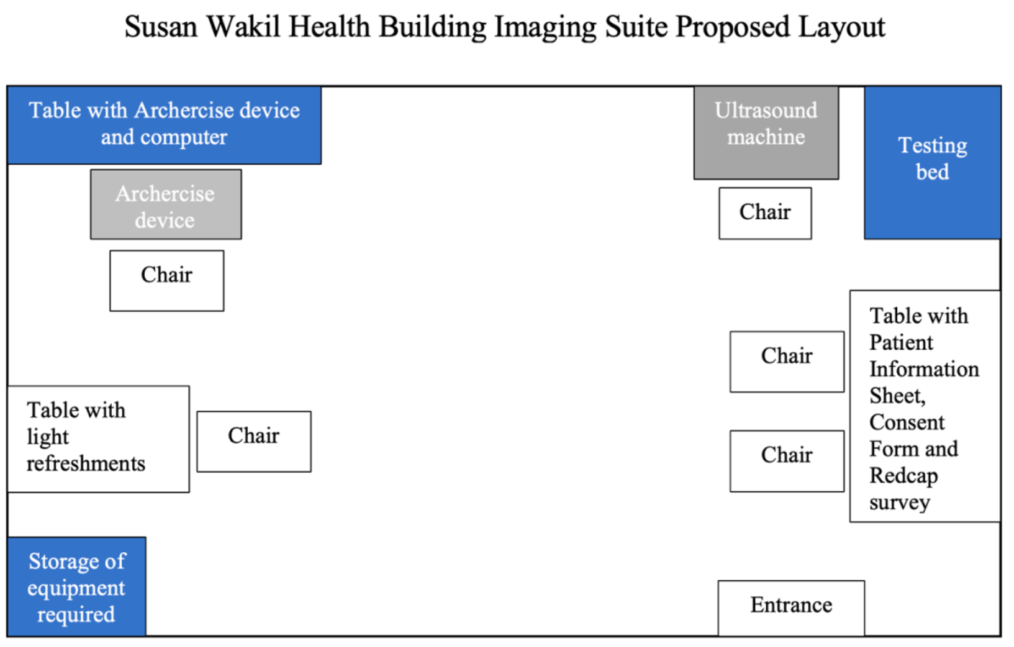

National Health and Medical Research Council. (2018). National Statement on Ethical Conduct in Human Research (2007) - Updated 2018 | NHMRC. https://www.nhmrc.gov.au/about-us/publications/national-statement-ethical-conduct-human-research-2007-updated-2018

