STATISTICAL ANALYSIS PLAN

Laryngeal oxygen concentration and apnoea time during microlaryngeal surgery using transnasal humidified rapid-insufflation ventilatory exchange (THRIVE) with different oxygen concentrations: A randomised controlled clinical trial.

Principal Investigator | A/Prof. Daniel Novakovic  Dr Liang Voice Program  Faculty of Medicine and Health  The University of Sydney
Coordinating Principal Investigator | Dr Duy Duong Nguyen  Dr Liang Voice Program  Faculty of Medicine and Health  The University of Sydney
Protocol number | X23-0013 & 2023/ETH00115
Author of SAP | Dr Duy Duong Nguyen
SAP version | 0.1

SIGNATURES

Principal Investigator | Dr Daniel Novakovic
Author (CPI) | Dr Duy Duong Nguyen

List of abbreviations
ASA | American Society of Anaesthesiologists
BMI | Body mass index
RCT | Randomised controlled clinical trial
SAP | Statistical analysis plan
THRIVE | Transnasal humidified rapid-insufflation ventilatory exchange

Contents
I. Introduction 5
II. Aims 5
III. Study design 5
IV. Sample size calculation 6
V. Outcome measures 7
5.1. Primary outcome measures 7
5.2. Secondary outcome measures 7
VI. Study groups 7
6.1. Populations for analysis 7
6.2. Sub-groups 7
VII. Randomisation 8
VIII. Statistical analysis 8
8.1. Descriptive statistics 8
8.2. Linear mixed models 9
8.3. Parametric tests 9
8.4. Correlation analysis 9
8.5. Non-parametric tests 9
8.6. Significance level 9
IX. Missing data 9
References 9

I. Introduction
This is a multi-centre randomised controlled clinical trial (RCT) on the use of the transnasal humidified rapid-insufflation ventilatory exchange (THRIVE) in microlaryngeal surgery using two different oxygenation concentrations: apnoeic oxygen concentration (group A) and 30% oxygen concentration (group B). This RCT is supported/sponsored by the Dr Liang Voice Program, The University of Sydney, NSW, Australia. The University of Sydney has completed a comprehensive process of risk assessment. Relevant clinical trial research agreements have been signed prior to recruitment of trial participants. This RCT has been ethically approved by the Sydney Local Health District Ethics Review Committee (RPAH Zone) at its meeting held on 12 April 2023. This trial has been registered in the Australian New Zealand Clinical Trials Registry (ANZCTR) and the identification number is ACTRN12623000575639. This statistical analysis plan (SAP) outlines the details regarding sample size calculation, outcome measures, and specific statistical methods used to analyse the data.

II. Aims
1) To compare apnoea time and real-time laryngeal oxygen concentration between 30% oxygen and apnoeic conditions following pre-oxygenation with THRIVE at 100% oxygen concentration

2) Explore patient factors which predict successful application of THRIVE at 100% and 30% oxygenation vs apnoeic conditions during microlaryngeal surgery.

III. Study design
This study is a randomised controlled clinical trial. Study participants will be recruited from populations undergoing surgical treatment for voice, airway, and laryngeal conditions at Sydney centres including Canterbury Hospital, North Shore Private Hospital, Hunters Hill Private Hospital, East Sydney Private Hospital, and Chris O’Brien Lifehouse, and at Adelaide centres including Flinders Medical Centre and Flinders Private Hospital. Inclusion criteria include age > 18 years old, elective microlaryngeal surgeries, and willingness of the participant’s treating anaesthetist to enrol the participant.
Recruited patients indicated to undergo microlaryngeal surgery are randomly allocated to one of two groups, either Group A: ‘Apnoea Group’ (no delivery of high-flow oxygen, environmental room air oxygen only) or Group B: ‘30% Oxygen Group’ (Delivery of high-flow oxygen at 30% concentration). Both groups will have initial pre-oxygenation at 100% oxygen concentration with THRIVE. Laryngeal oxygen concentration, oxygen saturation data, and vital parameters will be collected during the procedure and will be compared between the two groups.
Flow chart of study process:
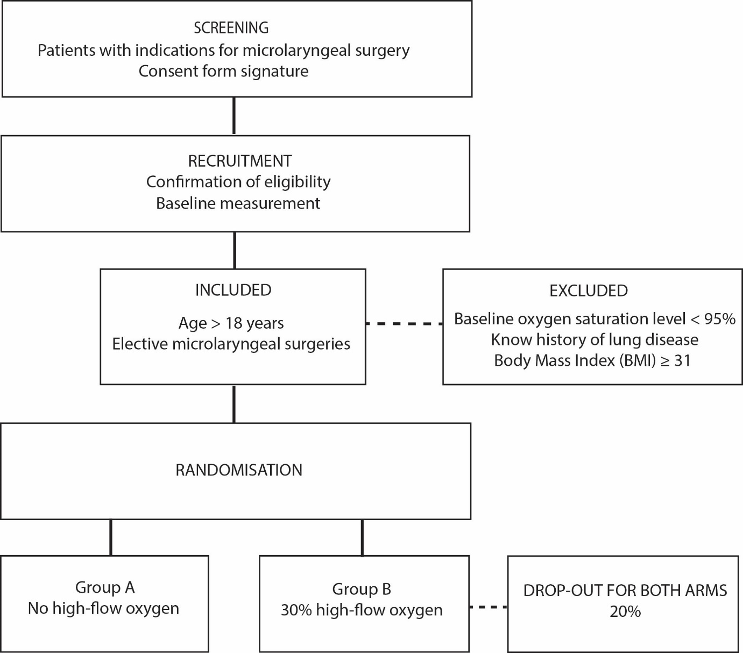

IV. Sample size calculation
The primary outcome measures used for sample size calculation is the apnoeic time. The study design will be comparison of two study groups. Apnoea time will be used in the formula to calculate the required sample size based on previously published data. The “known population” mean is the mean apnoea time to rescue (the duration from dropping oxygen to 30% until rescue started). As such, the known apnoeic time from the literature for the 30% high-flow group are taken from a study by Novakovic et al [1], which was 4.3 minutes (standard deviation = 1.37). The anticipated mean for the apnoeic group in this study is predicted at 3.5 minutes. Alpha value is set at 0.05, and power of test is set at 80%. The result of calculation is 46 patients for each group. To compensate for potential missing data or low-quality data, 10% is added for each group. Therefore, the required sample size would be 51 (patients) for each group. The total sample size would be 102 patients for both groups.

V. Outcome measures

5.1. Primary outcome measures
1. Apnoea time between 30% oxygen concentration and apnoeic conditions following pre-oxygenation with 100% oxygen with THRIVE (ie. Time from reducing oxygen delivery concentration to “laser-safe” level until rescue ventilation is required)
2. Time from reducing oxygen delivery concentration with THRIVE to “laser-safe” concentration of oxygen in the larynx.

5.2. Secondary outcome measures
- Rescue ventilation – total time, number of jet ventilations/other intervention as clinically indicated and oxygen concentration, required to increase oxygen saturations.
- Rate of desaturation following reduction of 100% oxygen with THRIVE to either 30% oxygen concentration or apnoeic conditions.
- Vital parameters (heart rate, blood pressure, end tidal CO₂)
- Demographic factors – age, gender, BMI, comorbidities including respiratory disease, airway stenosis, smoking, Charlson Comorbidity Index (CCI), and ASA grade.
- Duration of surgery
- Anaesthetic agents used and dosage.

VI. Study groups

6.1. Populations for analysis
All randomised participants who completed the trial.

6.2. Sub-groups
- Gender: All randomised participants will be divided into male and female groups.
- BMI groups: All randomised participants will be analysed based on different BMI ranges (<25 and ≥ 25).

VII. Randomisation
The present trial will use stratified randomisation [2, 3] to control for the potential effects of two covariates: gender and BMI on outcome measures. We have n = 102 with two study arms: Arm 1 is study group A and arm 2 is study group B. We will create blocks of four patients including two levels for gender (male/female) and two levels for BMI (<25 and ≥ 25). Within each block, simple randomisation will be used to allocate patient of a given gender and BMI range to each trial arm using output from an online randomisation tool in this web page: https://ctrandomization.cancer.gov/tool/. Each arm will have 12 blocks of four as shown in the following table:

BMI | Male | Female | Total
<25 | 24 | 24 | 48
≥ 25 | 24 | 24 | 48
Total | 48 | 48 | 96

The six remaining patients will be allocated using simple randomisation to either of the two arms. Using an allocation ratio for each arm of 3/3, each patient will be randomly allocated to an arm immediately prior to the microlaryngeal laser surgery using THRIVE.
The estimated number of participants to be allocated to each of the centres is as follows: Canterbury Hospital (20), North Shore Private Hospital (20), Hunters Hill Private Hospital (20), East Sydney Private Hospital (20), Chris O’Brien Lifehouse (20), Flinders Medical Centre (1) and Flinders Private Hospital (1).

VIII. Statistical analysis

8.1. Descriptive statistics
All primary and secondary outcomes will be analysed using descriptive statistics. For normally distributed data, the followings will be calculated: Mean, 95% confidence interval for the mean, standard deviation, minimum, and maximum. Data will be checked for normal distribution prior to performing parametric statistical tests. Non-normal data will be presented using median and interquartile range (IQR). Categorical variables will be analysed using counts and percentages. Non-parametric tests will be used for data that are not normally distributed. Tables and charts will be used to present the data.

8.2. Linear mixed models
The changes in the primary and secondary outcome measures over different time points during surgery using THRIVE will be evaluated using linear mixed models in which study participants will be treated as random effects whilst time and intervention methods (the two oxygenation concentration deliveries) will be fixed effects.

8.3. Parametric tests
Apart from the linear mixed model analysis, parametric test will be performed specifically for each time points. Mean data at different time points will be compared using t-test and analysis of variances (ANOVA) and multivariate analysis of variance (MANOVA).

8.4. Correlation analysis
- Correlations between continuous variables will be calculated using Pearson’ r correlation coefficient.

8.5. Non-parametric tests
- Categorical data will be analysed using the Chi-square test.

8.6. Significance level
- Significance level is two-tailed p ≤ 0.05. Where there are multiple calculations on a single or set of variables, a relevant method of adjustment to the p value will be applied to avoid statistical errors.

IX. Missing data
For both primary and secondary outcomes, model-based multiple imputation will be used for both groups in cases of missing data points.

References
1. Novakovic D, Sheth M, Fellner A, Zoszak A, Liew S, Nguyen DD. Microlaryngeal Laser Surgery Using High-flow Nasal Ventilation at Two Oxygen Concentration Deliveries. Laryngoscope. 2022.
2. Kang M, Ragan BG, Park JH. Issues in outcomes research: an overview of randomization techniques for clinical trials. J Athl Train. 2008;43(2):215-21.
3. Altman DG, Bland JM. How to randomise. Bmj. 1999;319(7211):703-4.

