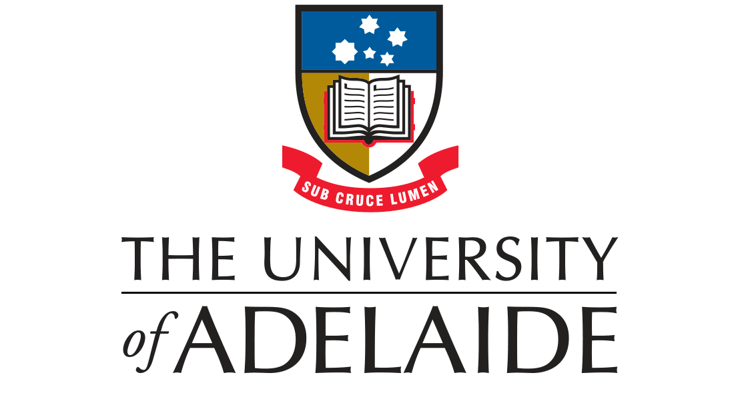
PARTICIPANT INFORMATION SHEET

Cone beam Computed Tomography guided radial Endobronchial Ultrasound (EBUS) for the diagnosis of peripheral pulmonary lesions
Principal Investigator: Dr Michael Brown (University of Adelaide)
Principal Investigator: Professor Phan Nguyen (Central Adelaide Local Health Network)
Associate investigators: Associate Professor Arash Badiei, Professor Hubertus Jersmann, Kyle Harty, Tristan Jones

- Introduction
You have been referred to the Thoracic Procedure Suite to undergo a bronchoscopy. This involves the passage of a small, soft, flexible fibreoptic tube into the lungs and is a routine diagnostic procedure in the work up of lung lesions in order to obtain biopsies from the lesion in question. A tissue diagnosis is imperative – not only does it confirm the nature of the lesion but also often impacts ongoing management.

Typically, biopsies are obtained by using thin flexible forceps which are passed through the bronchoscope to reach the lesion. The lesion is then sampled under the guidance of 2D fluoroscopy (Xray). This has diagnostic accuracy of about 70%. This study will assess a new method of tissue sampling. Instead of 2D fluoroscopy, a 3D cone beam CT will be used to guide the forceps into the lesion. The aim is to increase the accuracy of our sampling process, leading to a more accurate and timely diagnosis for our patients.

- What is the purpose of this research?
We intend to use Radial EBUS using 3D guided Computed-Tomography cone beam. Our intention is to assess the feasibility of this diagnostic technique and to see whether we can improve on the current navigational and diagnostic accuracy.

This research will also contribute to a Masters of Philosophy qualification for one of the Investigators.

- Who is undertaking this research?
This research is being undertaken by the Royal Adelaide Hospital Interventional Pulmonology unit. Procedures will be performed by Consultants and fellows training in this procedure.

- Do I have to take part in this research project?
This is a research project and you do not have to be involved. If you do not wish to participate, your medical care will not be affected in any way. Also, you may withdraw from the project at any time after you have commenced.

- What does participation in this research involve?
Information about you will be taken from online hospital database medical records (date of birth, age, sex). Your diagnostic CT chest will be also be used to collect data on the size of your lesion and location of your lesion. This information will be deidentified and kept confidentially. Instead, a unique hospital number will be assigned to you. This information about you will be accessed only by the investigators in this study.

Should you choose not to participate in the study, your biopsies will be performed using the 2D fluoroscopy guided biopsy as per our current departmental practice.

Your biopsy will be conducted at the Royal Adelaide Hospital in the Bronchoscopy technical suites as is common practice for all of our bronchoscopy procedures. You will be prepared and recover in this setting also which is standard practice. You will wear a hospital gown for the duration of the procedure which is a requirement for all bronchoscopy procedures and you not be expected to undress beyond that.

- What do I have to do?
No additional action is required in order for you to participate in this study. You will be excluded if you are pregnant.

- What are the possible benefits of taking part?
If the CT cone beam guided biopsy consistently produces a higher navigational and diagnostic yield than those with traditional fluoroscopy, then patients may have a more timely diagnosis and more confidence in a negative or inconclusive biopsy result. Another potential benefit is a reduction in bronchoscopies needing to be repeated if our navigational accuracy and diagnostic yield increases. We predict this will have positive implications on patient management. We cannot guarantee that you will directly benefit from this research.
- Possible Risks
There is no significant difference in procedure related risks between CT cone beam and standard of care (fluoroscopy) guided procedures. This is because the sampling process within the lung is the exact same between this procedure and the standard of care and only the imaging is different.

The main risks involved include drop in oxygen levels, bleeding and collapse of the lung (pneumothorax).

Oxygen levels will be monitored continuously throughout the procedure – if they are noted to fall below a specified level, you will have supplemental oxygen applied. It is not unusual for bleeding to sometimes occur after biopsies. This is usually minor and usually settles spontaneously or with the application of medication or iced saline. Bleeding may be more common if you are taking medication which thins the blood or affects its ability to clot. You may be told by your doctor that these medications need to be held prior to the procedure date. A pneumothorax may occur up to 24 hours post biopsy. It may present as shortness of breath or chest pain following the procedure and is usually confirmed on chest x-ray. If the amount of collapse is small, no intervention may be needed but for larger pneumothoraces, a tube may need to be inserted to drain the air out and let the lung reinflate. If the latter occurs, this will usually require subsequent admission to hospital

If you were to have a standard of care fluoroscopy guided approach the diagnostic yield is likely to be ~70%. An inconclusive biopsy result may lead to the need for a repeated procedure. This risk also applies to the use of cone beam CT, however we propose that the confidence in an inconclusive result may be greater if there is 3D CT confirmation of the forceps sampling the lesion.

This research study involves exposure to a small amount of radiation. As part of everyday living, everyone is exposed to naturally occurring background radiation and receives a dose of about 2 millisieverts (mSv) each year. The effective dose from this study is upto15 mSv. The dose from this study is comparable to that received from many diagnostic medical x-ray and nuclear medicine procedures. At this dose level, no harmful effects of radiation have been demonstrated as any effect is too small to measure. In this particular study, the risk is low and the estimated risk of such harm is about 1 in 650. For comparison, this risk is about 150 times lower than the cancer mortality rate in the general population (about one case in every four people), and is equivalent to the risk of death associated with travelling 300,000 km on Australian roads in a passenger vehicle.

Lastly, if you undergo a CT guided biopsy in this trial your procedure will be performed under general anaesthetic and you will be intubated with an endotracheal tube – a safety precaution given this is a new diagnostic procedure and will allow for safer control of your airways during the procedure. There is risk associated with general anaesthesia specifically – please see separate information sheet regarding this as attached below.

- Can I have other treatments during this research project?
You can continue your usual treatment course. There is no restriction to your other treatments

- What will happen to information about me? Confidentiality and Data security
Data will be collected recording baseline research participant characteristics (eg sex, age, smoking history), CT imaging results, procedure type (CT cone beam), results from the analysis of the lung biopsy and record of any complications incurred.
Any information obtained in relation to this study and that can identify you will remain confidential – all data relating to you and other research participants will be de-identified and referred to only by a unique record number. This will be stored on a spreadsheet on work-related computers at the Royal Adelaide Hospital and will only be accessible by the investigators of this study with their personal log-ins. Data will be stored in a manner similar to storage of medical records for up to 15 years.
‘In accordance with relevant Australian and/or South Australian privacy and other relevant laws, you have the right to request access to your information collected and stored by the research team. You also have the right to request that any information with which you disagree be corrected. Please contact the study team member named at the end of this document if you would like to access your information.’

You have a right to ask that any stored specimens be destroyed but should be aware that data which has already been derived from those specimens may not be able to be destroyed. We intend to publish the results of this study in a peer reviewed medical journal and present it at the thoracic scientific annual meeting. Participants will not be identifiable in any publications.
- What will happen to my test samples?
Any information obtained in relation to this study and that can identify you will remain confidential and deidentified. Your data will be referred to only by a unique record number. The data will be accessed only by the investigators of this study and your treating respiratory physician. Data will be stored on a spreadsheet on work-related computers at the Royal Adelaide Hospital and will only be accessible by the investigators of this study with their personal log-ins. Data will be stored in a manner similar to storage of medical records for 15 years.
Your biopsy samples will be processed at SA pathology and will be made available to your treating thoracic physician to guide the next step of your care. This is standard practice. No additional biopsies for research purposes only will be taken during the procedure.

- What happens if I withdraw from the research?
Participants are free to withdraw any time.

- What happens if I am injured from taking part in the study
Your participation in this study shall not affect any right to compensation you may have under common law.

- Complaints and contacts (investigators and ethics committee)
This project will be carried out according to the National Statement on Ethical Conduct in Human Research (2007) incorporating all updates. This statement has been developed to protect the interests of people who agree to participate in human research studies. The study has been approved by the Central Adelaide Local Health Network Human Research Ethics Committee. If you wish to speak to someone not directly involved in the study about your rights as a volunteer, or about the conduct of the study, you may also contact the CALHN HREC Chairperson, on 7117 2229.

Should you wish to speak with an investigator on the study please contact:

Name | Michael Brown
Position | Interventional pulmonology research fellow
Phone | 7074 0000
Email | MichaelV.Brown@sa.gov.au

Should you wish to contact the Human research Ethics Committee (HREC) please contact
Name | Central Adelaide Local Health Network Human Research Ethics Committee (CALHN HREC)
Position | HREC Support Officer
Phone | 08 7117 2229
Email | Health.CALHNResearchEthics@sa.gov.au

PARTICIPANT INFORMATION SHEET
General Anaesthesia
Principal Investigator: Dr Michael Brown (University of Adelaide)’
Principal Investigator: Professor Phan Nguyen (Central Adelaide Local Health Network)
Associate investigators: Associate Professor Arash Badiei, Professor Hubertus Jersmann, Kyle Harty, Tristan Jones

General anaesthesia involves the administration of a combination of different medications in order to keep you asleep during a procedure, as well as pain-free. The anaesthetist looking after you during the procedure will either give you the medication either via an injection through a vein, or have you inhale it through a mask. Once you are asleep, a tube will be inserted through the back of your mouth in order to help you breathe.

Australia is one of the safest countries to undergo treatment and procedures, with modern anaesthesia now generally very safe. However, there is still always potential risks involved in taking multiple medications and altering the body’s normal function, which range from mild through to potentially life threatening.

Allergic Reactions
Most commonly this is usually caused by reactions to antibiotics or latex. The former is not applicable to your current procedure. If you have had previous reactions to latex in the past, it is important that you inform the anaesthetist and bronchoscopy suite staff. Allergic reactions can also occur secondary to the anaesthetic medication – the incidence of severe life threatening reaction (anaphylaxis) in Australia is 1 in 10,000 to 1 in 20,000.

Damage to Teeth
This potentially occurs during the insertion of the breathing tube, or during the procedure if a suction tube is inserted into your mouth to remove fluid. As part of the pre-procedure examination, the anaesthetist will look in your mouth to assess for any loose teeth, caps/crowns or dentures. The risk of damage has been quoted as less than 1 in 100 cases.

Sore Throat
This potentially occurs in 20% (1 in 5 patient) who have a breathing tube inserted into the back of the throat. The sore throat is usually self-limiting but may take several days. Should it persist longer than this, you should consult your doctor.

Blindness
The risk of this is extremely rare and has been quoted as an approximately 1 in 1,250,000 chance of patients receiving anaesthesia. Patients identified to be at higher risk are those who smoke, have high blood pressure or diabetes. Certain types of surgery also carry higher risk (spinal and heart surgery). Should you develop any change in your vision after your operation, you should immediately arrange review in emergency department.

Death
The risk of death secondary to anaesthesia is now very rare. The risk of a health patient dying after undergoing surgery is approximately 1 in 100,000. When taking into account all patients with different medical and physical conditions, including those who are not expected to survive regardless of operation, risk of death is 1 in 50,000.
Reference: Australian and New Zealand College of Anaesthetists http://www.anzca.edu.au/

CONSENT FORM
Cone beam Computed Tomography guided radial Endobronchial Ultrasound (EBUS) for the diagnosis of peripheral pulmonary lesions

A Feasibility and Safety Study
Investigators: Dr Michael Brown, Associate Professor Arash Badiei, Professor Hubertus Jersmann, Kyle Harty, Tristan Jones, Professor Phan Nguyen
HREC reference number:
Department of Thoracic Medicine, Royal Adelaide Hospital

- I have read, or have had read to me in a language that I understand, this document and I understand the purposes, procedures and risks as described within it.
- I have had an opportunity to ask questions and I am satisfied with the answers I have received
- I freely agree to participate in this research project as described and understand that I am free to withdraw at any time during the project without affecting my future health care
- I understand that I will be given a signed copy of this document to keep
- I understand that I must not be pregnant or become pregnant during the course of the study.
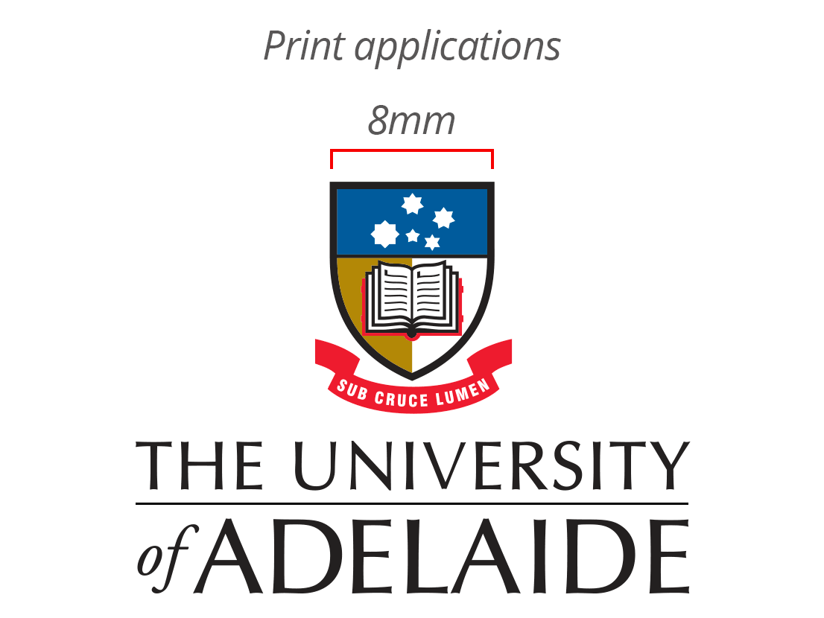
Participant’s Name (printed) ……………………………………………………
Signature Date

I certify that I have explained the study to the patient and consider that he/she understands what is involved.
Researcher’s Name (printed) ……………………………………………………
Signature Date
Note: All parties signing the Consent Form must date their own signature.

Consent via Interpreter:
I have provided a verbal translation of the Form in the language that the patient understands, which is ……………………………………………………………

Interpreter’s Name (printed) ………………………………………...................
Signature Date

