Seeking research participants to look at the effect of a nursing educational intervention

Seeking RPAH nurses for a short research study.
Receive 1 CPD hour.

Study will involve:
- Completion of eConsent form and 6x surveys via REDCap
- Review a 60-minute educational presentation exploring best practice nursing care for patients/clients with Haemophilia

Contact:
- Principal investigator: Miles Kenny
- Mob: 0415 302 043
- Tel: 02 9515 8453
- Email: Miles.Kenny@health.nsw.gov.au

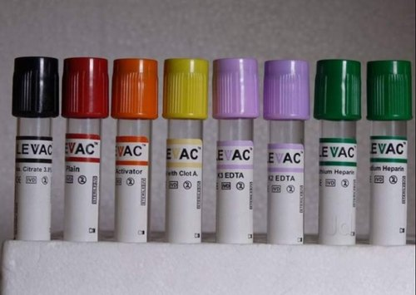
**If you are interested in participating, please scan the QR code below to access the study information and REDCap eConsent form. You can also contact the above email address if you wish to learn more about the study**

