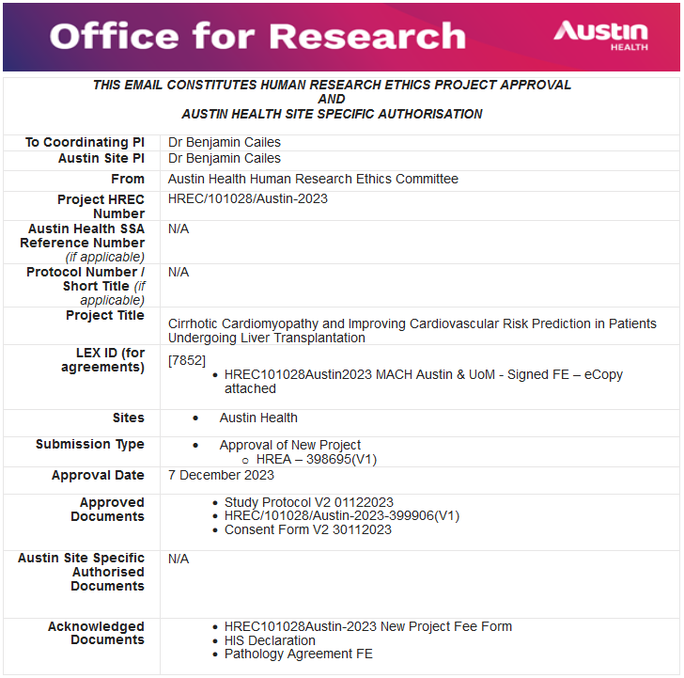
Thank you for submitting the above for Human Research Ethics Approval. This submission has been reviewed and approved by the Austin Health Human Research Ethics Committee (HREC), subject to the following conditions being met.
You are required to submit to the HREC:
o An Annual Progress Report (that covers all sites listed on approval) for the duration of the project. This report is due on the anniversary of HREC approval. Continuation of ethics approval is contingent on submission of an annual report, due within one month of the approval anniversary. Failure to comply with this requirement may result in suspension of the project by the HREC.
o A Final Report upon completion of the project.
· Submit to the reviewing HREC for approval of any proposed amendments to the project including any changes to the Protocol, Participant Information and Consent Form/s and the Investigator Brochure.
· Notify the reviewing HREC of any adverse events that have a material impact on the conduct of the research in accordance with the NHMRC Position Statement: Safety monitoring and reporting in clinical trials involving therapeutic goods November 2016.
· Notify the reviewing HREC of your inability to continue as Coordinating Principal Investigator.
· Notify the reviewing HREC of the failure to commence the study within 12 months of the HREC approval date or if a decision is taken to end the study at any of the sites prior to the expected date of completion.
· Notify the reviewing HREC of any matters, which may affect the conduct of the project.
· If your project involves radiation, you are legally obliged to conduct your research in accordance with the Australian Radiation Protection and Nuclear Safety Agency Code of Practice ‘Exposure of Humans to Ionizing Radiation for Research Purposes’ Radiation Protection series Publication No.8 (May 2005) (ARPANSA Code).

This HREC is organised and operates in accordance with the National Health and Medical Research Council’s (NHRMC) National Statement on Ethical Conduct in Human Research (2023), and all subsequent updates, and in accordance with the Note for Guidance on Good Clinical Practice (CPMP/ICH/135/95), the Health Privacy Principles described in the Health Records Act 2001 (Vic) and Section 95A of the Privacy Act 1988 (and subsequent Guidelines).

The HREC may conduct an audit of the project at any time.
If you have any questions or concerns, please contact the Office for Research on:
· research@austin.org.au
· +61 3 9496 4090

